**Vidyavardhini’s College of Engineering & Technology**

**Department of Information Technology**

**Academic year (2021-22)**

**NAME:** Sanskruti Rajkumar Kokare

**BRANCH:** IT

**ROLLNO:** 45

**SUBJECT:** JPL

**CLASS:** SE IT

**Experiment no:** 14

**Date of Experiment:** 29/11/2021

**Date of Submission:** 02/12/2021

**EXPERIMENT NO 14**

**Aim:**

To write an Applet Program in Java.

**Description:**

An applet is a Java program that runs in a Web browser. An applet can be a fully functional Java application because it has the entire Java API at its disposal.The java.applet.Applet class 4 life cycle methods and java.awt.Component class provides 1 life cycle methods for an applet.

**Life Cycle of an Applet**

Four methods in the Applet class gives you the framework on which you build any serious applet −

* **init** − This method is intended for whatever initialization is needed for your applet. It is called after the param tags inside the applet tag have been processed.
* **start** − This method is automatically called after the browser calls the init method. It is also called whenever the user returns to the page containing the applet after having gone off to other pages.
* **stop** − This method is automatically called when the user moves off the page on which the applet sits. It can, therefore, be called repeatedly in the same applet.
* **destroy** − This method is only called when the browser shuts down normally. Because applets are meant to live on an HTML page, you should not normally leave resources behind after a user leaves the page that contains the applet.
* **paint** − Invoked immediately after the start() method, and also any time the applet needs to repaint itself in the browser. The paint() method is actually inherited from the java.awt.

**NOTE :** Applet is not supported for the JDK’s with version greater than 9.

**Source Code:**

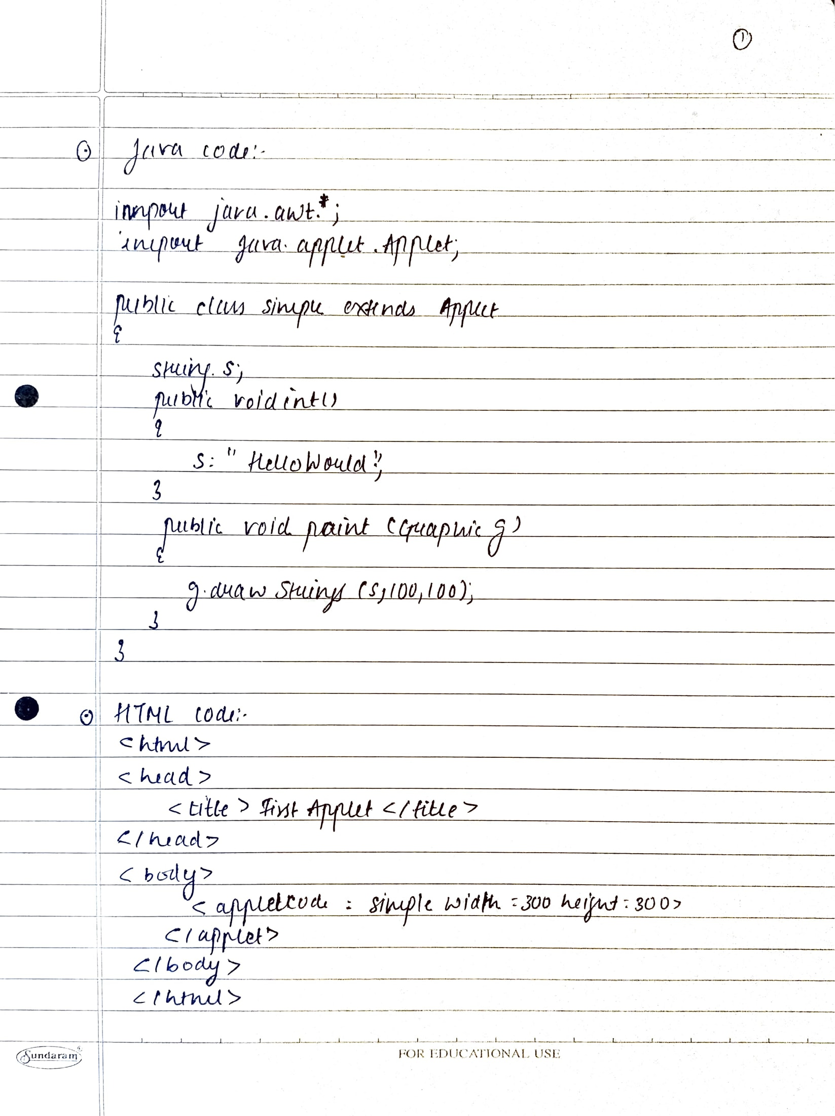

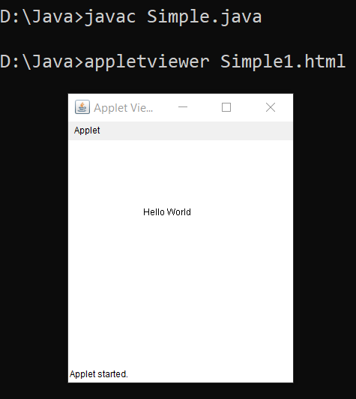**Output :**

**Conclusion: :**

An Applet program has been successfully implemented.