**Vidyavardhini’s College of Engineering & Technology**

**Department of Information Technology**

**Academic year (2021-22)**

**NAME:** Sanskruti Rajkumar Kokare

**BRANCH:** IT

**ROLLNO:** 45

**SUBJECT:** JPL

**CLASS:** SE IT

**Experiment no:** 9

**Date of Experiment:** 12/11/2021

**Date of Submission:** 14/10/2021

**Experiment No. 9**

**Aim:**

Stack ADT implementation using inheritance (Interface).

**Description:**

To design a Java application to implement array implementation of stack using the concept of

Interface and Exception handling.

**ALGORITHM**

1. Start

2. Create the interface Stack operation with method declarations for push and pop.

3. Create the class Astack which implements the interface and provides implementation for

the methods push and pop. Also define the method for displaying the values stored in the

stack. Handle the stack overflow and stack underflow condition.

4. Create the class teststack. Get the choice from the user for the operation to be performed

and also handle the exception that occur while performing the stack operation.

5. Create the object and invoke the method for push, pop, display based on the input from the

user.

6. Stop.

**Source Code: -**

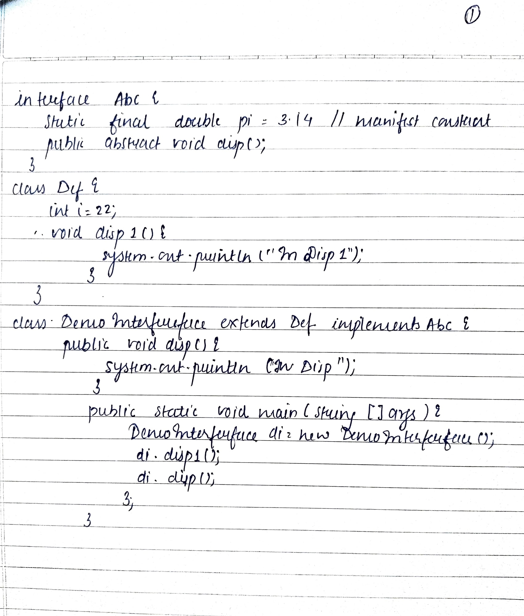

**Output: -**

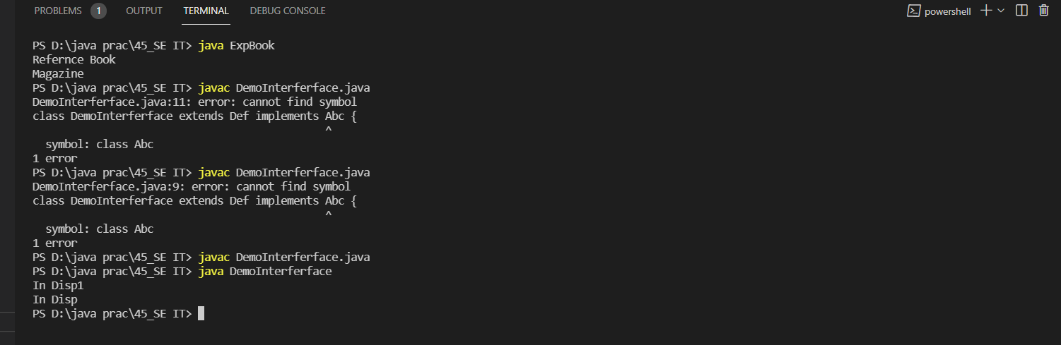

**Conclusion:** Able to implement interface.