**Vidyavardhini’s College of Engineering & Technology**

**Department of Information Technology**

**Academic year (2021-22)**

**NAME:** Sanskruti Rajkumar Kokare

**BRANCH:** IT

**ROLLNO:** 45

**SUBJECT:** JPL

**CLASS:** SE IT

**Experiment no:** 7

**Date of Experiment:** 29/10/2021

**Date of Submission:** 30/10/2021

**Experiment No. 7**

**Aim:**

Print Reverse Array list in java by writing our own function.

**Description:**

reverseArrayList () method in RevArrayList class contains logic for reversing an array list with integer objects. This method takes an array list as a parameter, traverses in reverse order and adds all the elements to the newly created array list. Finally, the reversed array list is returned.

**ALGORITHM**

1. Start
2. Create class Book and define method display.
3. Create class Reference Book extends Book and define method display.
4. Create class Magzine extends Book and define method display.
5. Create main class TestInheritance and create object of each class from a Book class. Call display method of each class.
6. Stop.

**Source code:**

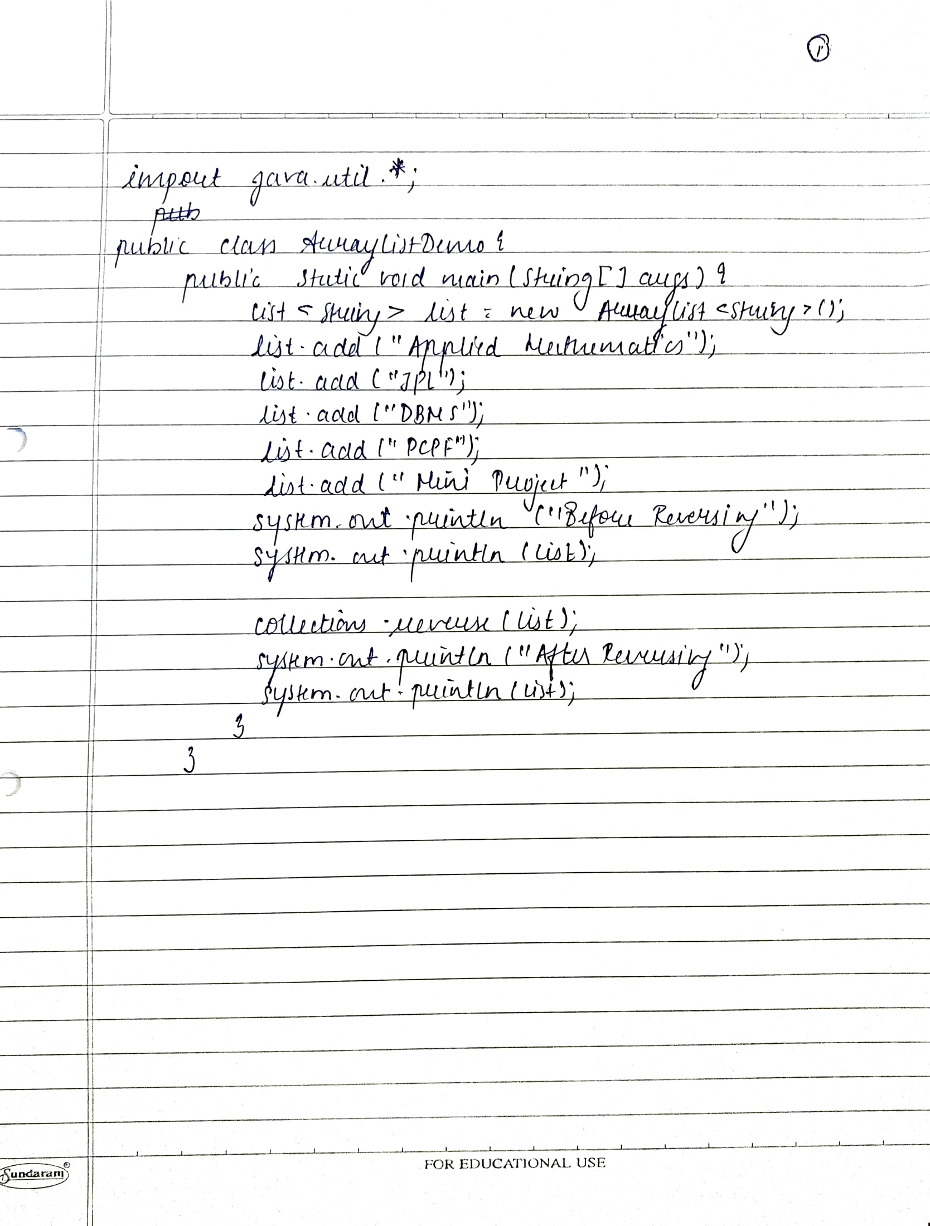

**Output:**

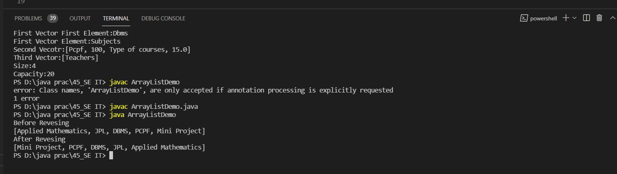

**Conclusion:**

Able to implement the reverse array list.