
PROJECT REPORT
AI-Based Hostel Room Allocation System
A web portal for bed booking with a grounded, tool-calling AI assistant

Presented by: Krish
Programme: B.Tech Computer Science and Engineering (AI/ML)
Institution: Lovely Professional University
Registration number: 12523448
Date: November 2026
Live demo: https://hostel-allocation-system-inky.vercel.app
Table of Contents

- Abstract
- Introduction
- Objective & Scope
- Problem Statement & Solution
- Methodology
- Results
- Future Work
- Referance
- Appendix: A
- Appendix :B
Abstract
Allocating hostel beds by hand or with spreadsheets invites double bookings, inconsistent cancellation rules and little visibility for administrators. This project builds a live web application in which administrators manage buildings, rooms and individual beds, and students browse availability, book a specific bed, view their bookings and cancel until a configurable cutoff. A Gemini-powered assistant lets students describe what they want in plain language. It can only search live inventory and propose a bed. The student must confirm before anything is booked.
The central design decision is that the browser and the language model are never trusted. Every rule is enforced by PostgreSQL functions, row-level security and unique partial indexes on Supabase, so a booking is atomic and a bed can never have two active bookings. The assistant calls three allow-listed tools, each executed as the signed-in student, and a proposal expires after five minutes and is revalidated through the same booking function. A deterministic backtracking allocation engine reports feasible, partial or infeasible assignments.
Ten automated integration scenarios ran against a real Supabase project and all passed, including a concurrent two-student race for one bed in which exactly one booking succeeded. Three solver tests also passed. The system is deployed on Vercel with Supabase as the backend. This report describes the requirements, design, implementation, test results, the engineering problems met along the way, and the work that remains.

1. Introduction

1.1 Background
Every academic year a college has to place thousands of students in hostel accommodation. In many institutions this still depends on forms, spreadsheets and manual lists. The work is slow, and it fails in predictable ways. Two staff members can give the same bed to two students. A student can end up holding more than one reservation. Cancellation deadlines are applied inconsistently, and administrators cannot easily see how full each building is.
A web application with a proper database removes most of these problems, provided the booking rules live in the database itself rather than in the user interface. Interfaces can be bypassed, refreshed at the wrong moment, or called from two browsers at once. Only a constraint enforced inside the database holds under every one of those conditions.

1.2 Motivation
Large language models make it possible to ask for a room in ordinary language: "a double room in Building A with a study desk". That is friendlier than a set of filters, but it brings a new risk. A model that is allowed to answer from memory can invent rooms, facilities or policies that do not exist, and a model with write access could create bookings the student never agreed to. The motivation for this project was to show that an AI assistant can be useful in a transactional system without being trusted: it reads live data through narrow tools, it explains only what those tools returned, and it cannot commit anything on its own.

1.3 Overview of the system
The system has two portals served by one React application. The admin portal manages buildings, rooms (each room creates its individual beds), all bookings with student contact details, and the college start date and cancellation lead time. The student portal lets a student browse rooms by building, choose a bed, confirm the booking, see booking history with the exact cancellation cutoff, and cancel an eligible booking. A separate AI assistant page accepts natural-language requests and shows room cards with the evidence behind each recommendation.
Behind the interface, Supabase provides authentication, PostgreSQL and serverless Edge Functions. Twelve SQL functions and a set of row-level-security policies hold the business rules. A Python module implements the allocation search. The front end is deployed on Vercel, and the AI function calls the Gemini API with a key that never reaches the browser.

1.4 Organisation of this report
Chapter 2 states the objectives, users and scope and records which requirements were met. Chapter 3 states the problem and the solution principles. Chapter 4 describes the methodology: architecture, database, booking and cancellation logic, security model, AI design, allocation engine, front end, testing and deployment. Chapter 5 reports results, including the problems encountered. Chapter 6 lists future work and concludes.

2. Objectives and Scope

2.1 Objectives
ID | Objective | How it is checked
O1 | Manage buildings, rooms and individually bookable beds, with totals derived from the database. | Admin dashboard; test 14
O2 | Let a student reserve one specific available bed, and prevent overbooking even under concurrent requests. | Tests 1, 2
O3 | Allow only one active booking per student by default. | Test 3
O4 | Allow cancellation until the configured cutoff (10 days before college starts), keep history and release the bed. | Tests 7, 8
O5 | Protect privacy: a student must not see another student's bookings or contact details. | Tests 4, 5
O6 | Provide an AI assistant that searches live inventory, cannot invent rooms and cannot book without confirmation. | Test 10; tool design
O7 | Demonstrate constraint search with an explainable allocation engine that reports infeasible cases. | Solver tests
O8 | Keep manual booking working when the AI provider is unavailable, and deploy a live demo with synthetic data. | Test 1; Vercel deployment

2.2 Users and permissions
Role | Permitted actions
Student | Browse active buildings, rooms and free beds; book one bed for themselves; confirm an AI-proposed bed; view their own booking history; cancel their own booking before the cutoff. Cannot see other students' bookings or contact details.
Admin | Create buildings and rooms (beds are created with the room); view occupancy metrics and all bookings with student name, number and phone; set the college start date, lead time and timezone. Cannot bypass database constraints or create invalid bookings.

2.3 Scope
In scope: inventory management, manual booking, cancellation with a server-enforced cutoff, an administrative dashboard, a grounded AI assistant with proposal and confirmation, an allocation engine, automated tests, and a public deployment with synthetic data.
Out of scope (non-goals): payments, deposits or fee management; integration with college production systems; trained roommate-compatibility models; native mobile apps; and any booking made autonomously without the student's explicit confirmation.

2.4 Requirements coverage
The specification defined 26 functional requirements (FR-01 to FR-26). The table groups them and states honestly what was delivered. Multi-provider comparison (FR-24, FR-25) was deliberately descoped to keep the project focused on one provider.

Requirements | Status | Notes
FR-01 to FR-06 Inventory | Mostly met | Buildings and rooms are created with beds; room numbers unique per building; capacity cannot drop below occupied beds. Edit and deactivate screens are not built (the room function supports edits, no UI yet). Dashboard shows buildings, rooms, beds, occupied beds and occupancy.
FR-07 to FR-14 Booking | Met | Live availability, one booking per student, atomic bookings, unique indexes, own-booking visibility, history kept, stable reference such as HST-AB12CD.
FR-15 to FR-19 Cancellation | Met | Start date and lead time configurable in the admin settings page; cutoff computed on the server in the college timezone; bed released on cancellation.
FR-20 to FR-23 AI | Mostly met | Read-only search tool, propose-only booking tool, calls authorized as the student. Explanations are grounded in room data and rules. Solver output is not yet fed into explanations.
FR-24, FR-25 Provider comparison | Descoped | Only Gemini is wired in. No adapter for further providers and no comparison page.
FR-26 Manual fallback | Met | Browsing and booking use only database functions, so they work when the AI is down.

3. Problem Statement and Solution

3.1 Problem statement
Hostel allocation systems must answer one question reliably: which student holds which bed right now. A manual or loosely checked process cannot guarantee this. At the same time, adding a conversational AI to such a system introduces a second problem, because a language model can state things that are false with complete confidence. The problem addressed here is how to build a hostel booking system that is correct under concurrent use, private by default, and able to offer natural-language help without letting the language model become a source of truth or a source of unauthorised actions.

3.2 Challenges
Challenge | Consequence if unaddressed
Concurrent requests | Two students see the same bed as free and both press Book; without atomic checks both bookings could be stored.
Duplicate reservations | One student holds several beds and denies them to others.
Inconsistent cancellation rules | Different outcomes for identical cancellations; disputes about deadlines and timezones.
Untrusted clients | A modified browser can send any student ID, role or booking status.
Privacy | Contact details and booking history of other students become visible.
LLM hallucination | The assistant recommends non-existent rooms or claims facilities that are absent.
LLM action risk | A prompt-injected or confused model books or cancels on behalf of a student.
Provider limits and outages | Model retirement, rate limits or downtime would stop all booking if booking depended on the AI.

3.3 Proposed solution and design principles
- The database is the authority. Booking, cancellation, capacity changes and settings go through PostgreSQL functions that verify identity and rules. The student ID always comes from the authenticated session.
- Constraints as the last line of defence. Two unique partial indexes forbid a second active booking for a bed and a second active booking for a student. Even a bug in the application cannot break these rules.
- Least privilege. Row-level security restricts reads, and no client write policies exist on inventory or bookings. Admin functions check the admin role inside the database.
- The AI is untrusted. It reaches data only through three allow-listed tools, each run with the caller's own credentials, with validated arguments and a bounded loop. It can propose but not book.
- Confirmation and revalidation. A proposal is bound to one student and one bed, expires after five minutes, and is revalidated by the same booking function when the student confirms.
- Graceful degradation. Manual booking never depends on the AI. Provider errors produce clear messages, not failures elsewhere.

3.4 How each problem is addressed
Problem | Mechanism in the solution
Concurrent booking | create_booking inserts inside one transaction; the unique index rejects the loser, who receives BED_UNAVAILABLE and a refreshed list.
Duplicate reservations | Unique index on student_id where status is active, reported as ALREADY_HAS_ACTIVE_BOOKING.
Cancellation rules | A single cancel_booking function computes the cutoff from stored start date, lead time and timezone, and sets status to cancelled.
Untrusted clients | auth.uid() inside security-definer functions; role changes blocked by an RLS check; admin role set only in SQL.
Privacy | Students read only their own bookings; availability uses a function that returns counts and bed IDs, never identities; admin contact data comes from an admin-only function.
Hallucination | Tools return real rows; the system prompt forbids invention; the UI shows the evidence and time checked.
Action risk | propose_booking only inserts a short-lived proposal; booking happens in a separate, user-triggered call.
Provider limits | Configurable model name, request budget under the provider's per-minute limit, retries with backoff, and clear busy messages.

3.5 Risk analysis
Risk | Mitigation | Residual issue
LLM invents availability | Tool-grounded answers; prompt rules | Prompts are not security controls; the database stays authoritative
Overbooking race | Transaction plus unique indexes | None observed in tests
Provider outage or retirement | Manual booking independent; model set by secret | Model names change often; needs periodic checks
API cost and limits | Per-user limit, request budget, bounded tool rounds | Limiter is per function instance, not global
Data leak | RLS, role checks, no contact data sent to the LLM | Admin accounts must be protected
Demo inconsistency | Seed script and synthetic data | Reset is manual (SQL), not an admin action

4. Methodology

4.1 Development approach
The project followed a specification-driven, database-first approach with short build-and-verify cycles. The PRD, API, database, design and configuration documents defined the target. The work then proceeded in this order: schema and trusted functions; the student and admin interface; the AI assistant; admin tools and seed data; an automated test suite; visual polish; and deployment. After each stage the behaviour was checked against the real Supabase project, and defects found at that point (Section 5.6) were fixed with numbered migrations, so the database history stays reproducible.

4.2 Technology stack
Layer | Technology | Role
Front end | React 18, TypeScript, Vite, React Router | Student and admin portals; route guards for usability only
Backend and data | Supabase: PostgreSQL, Auth, Row Level Security | Inventory, bookings, identity and access control
Business rules | PL/pgSQL functions (security definer) | Atomic booking, cancellation, room and settings changes
AI service | Supabase Edge Function (Deno) and Gemini API | Tool-calling loop; proposals; rate and request budgets
Allocation engine | Python 3 | Deterministic backtracking search; pytest tests
Testing | Vitest 2 integration suite, pytest | Scenario tests against a real Supabase project
Hosting | Vercel (site), Supabase (data, functions) | Public demo; secrets held in environment settings

4.3 System architecture
The browser talks to Supabase with the public anon key only. Reads pass through row-level security. Every state change is a call to a database function, and the AI Edge Function reuses those same functions on the student's behalf. Gemini is an external service reached only from the Edge Function.
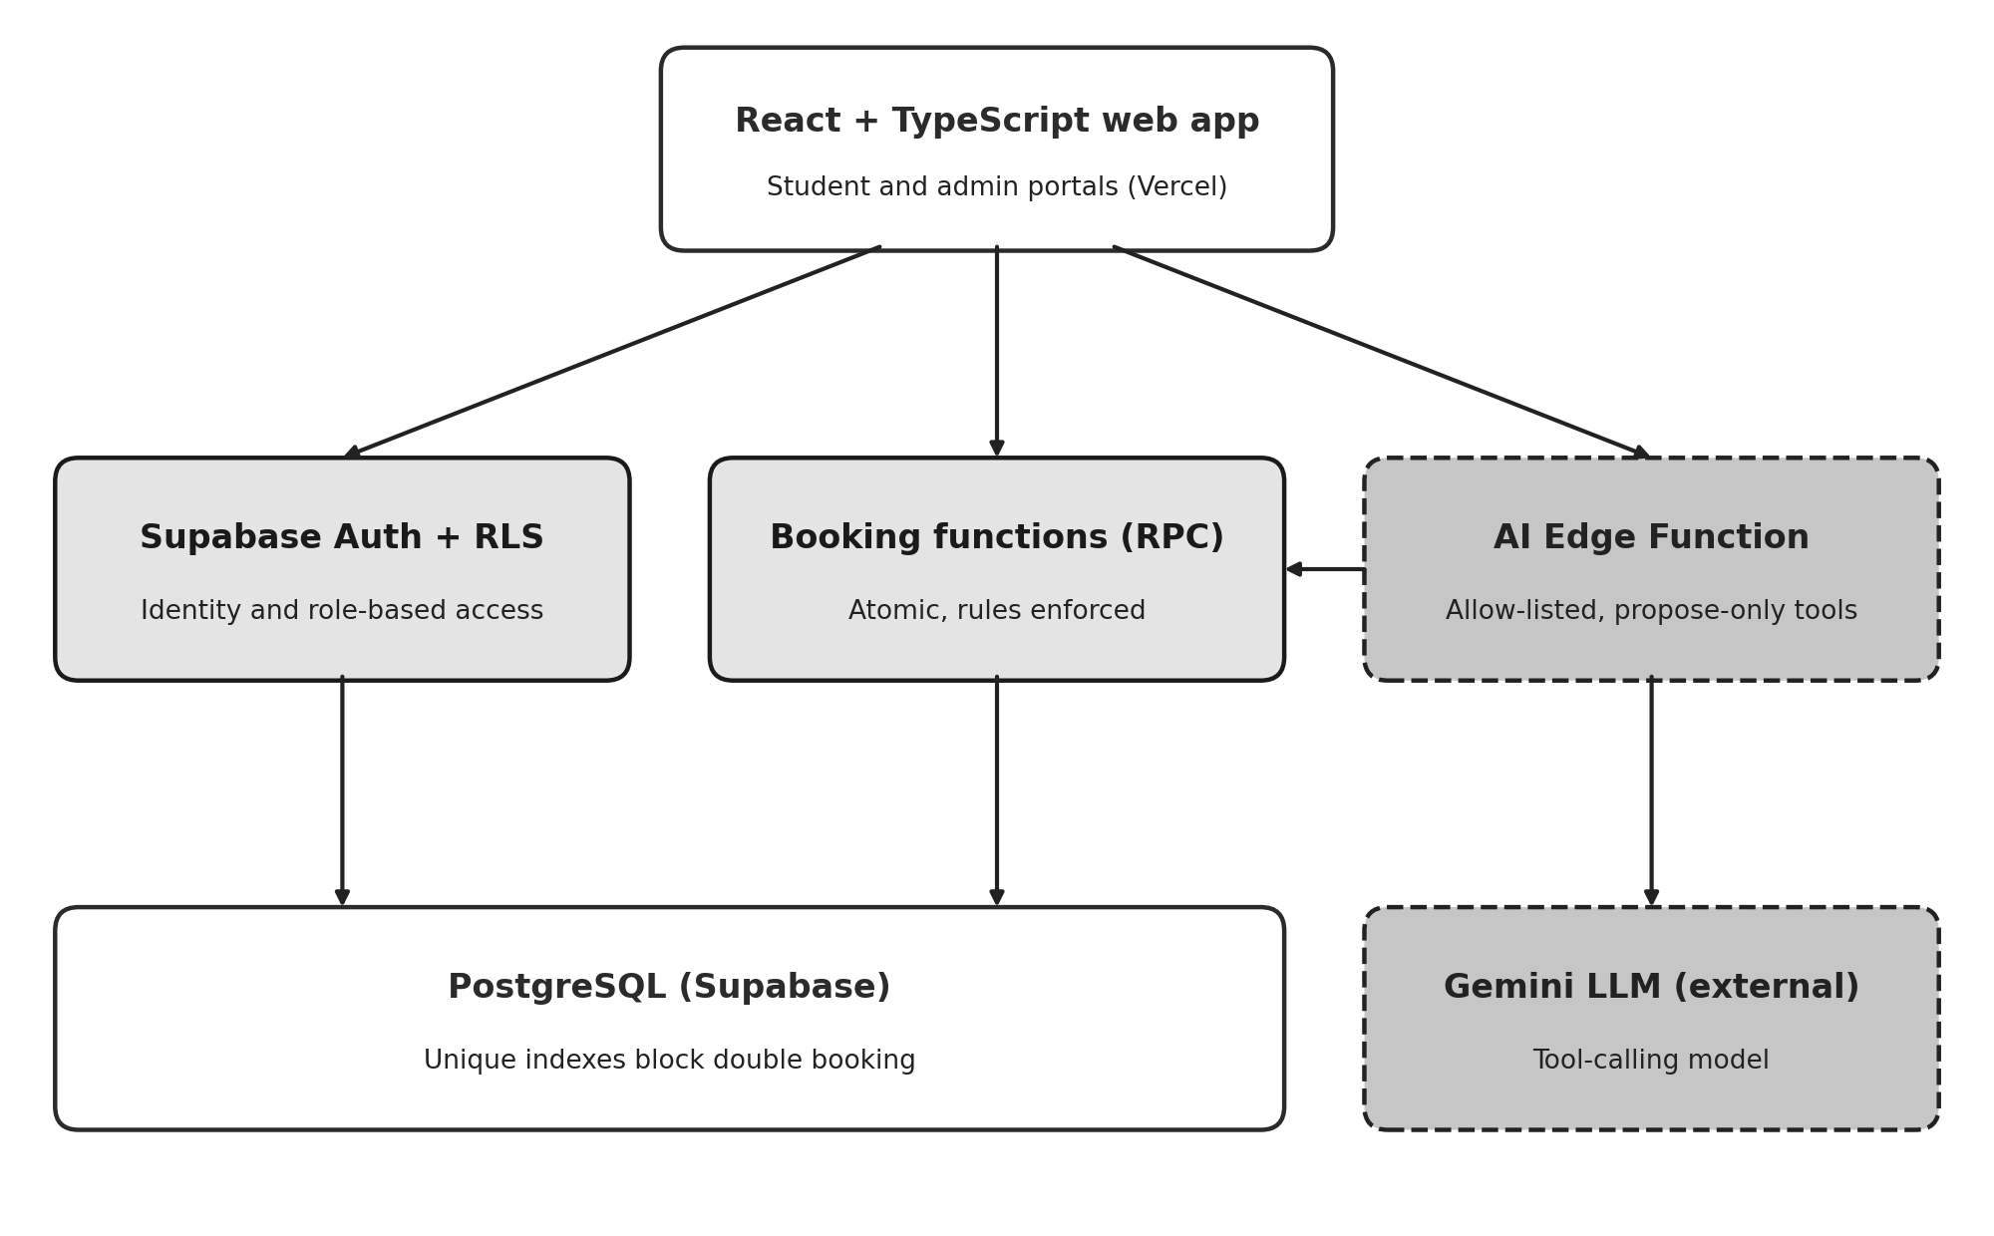
Figure 1: System architecture. Shaded boxes mark server-enforced rules; dashed boxes mark the AI layer.

4.4 Database design
PostgreSQL holds nine tables: profiles, buildings, rooms, beds, bookings, app_settings, audit_events, ai_proposals and ai_evaluations (the last was prepared for the provider comparison and is unused). A room with capacity N always has N bed rows, created in the same transaction. Availability is never stored. It is derived as the count of active beds without an active booking, so it cannot go stale.
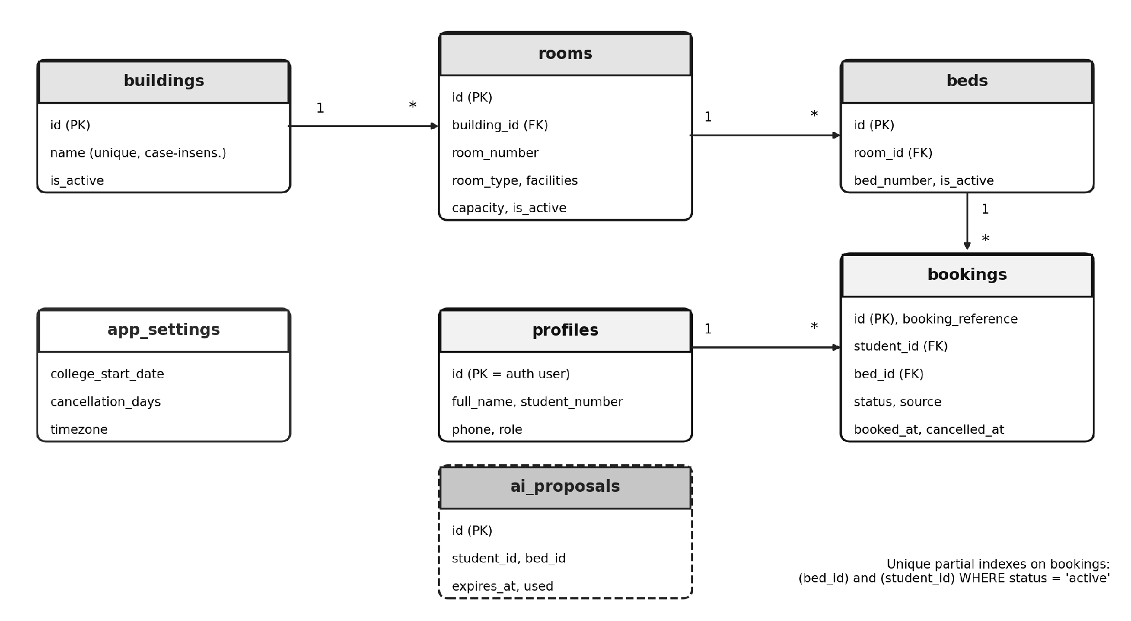
Figure 2: Entity relationships and the unique partial indexes that guarantee booking integrity.
The trusted functions are listed below. All run as the database owner but identify the caller from the session, and each is granted only to authenticated users.
Function | Purpose
create_booking(bed, source) | Validates bed, room and building are active; inserts the booking; maps unique violations to clear errors.
cancel_booking(id, reason) | Locks the row, checks ownership and status, applies the cutoff, sets status and cancelled_at.
get_availability() | Rooms with at least one free bed, with counts, for students and the AI.
get_taken_bed_ids(room) | Bed IDs already booked in a room, with no student identity.
create_proposal(bed) / confirm_proposal(id) | Create and confirm a five-minute AI proposal; confirmation calls create_booking.
admin_upsert_room, admin_create_building | Admin-only inventory changes; room function keeps beds consistent with capacity.
admin_list_bookings, admin_update_settings | Admin-only paginated search with contact details; validated settings update.
is_admin(), handle_new_user() | Role check used by policies; trigger that creates a student profile at sign-up.

4.5 Booking transaction and concurrency control
A booking runs as one function call. It confirms the caller is signed in, confirms the bed and its parent room and building are active, then inserts the row. If two students submit the same bed at the same moment, PostgreSQL lets exactly one insert commit; the other receives a unique violation, which the function converts to BED_UNAVAILABLE. The interface then refreshes availability and shows: "This bed was just booked by another student." The check in the function is therefore a courtesy, and the index is the guarantee.
insert into bookings (booking_reference, student_id, bed_id, source)
values ('HST-' || upper(substr(replace(gen_random_uuid()::text,'-',''),1,6)),
auth.uid(), p_bed_id, p_source);
-- unique (bed_id) where status = 'active' -> BED_UNAVAILABLE
-- unique (student_id) where status = 'active' -> ALREADY_HAS_ACTIVE_BOOKING

4.6 Cancellation policy
The cutoff date is the college start date minus the lead time (default 10 days). Cancellation is allowed while today's date in the configured timezone is before the cutoff date, and blocked on that date and afterwards. For a start date of 1 August 2027 and a 10-day lead time, the cutoff is 22 July 2027 in Asia/Kolkata, and a cancellation on 21 July succeeds while one on 22 July fails. Cancelling sets the status to cancelled and records the time; the row is never deleted. Because availability counts only active bookings, the bed is free again immediately. The interface shows the exact cutoff, but only the server decides.
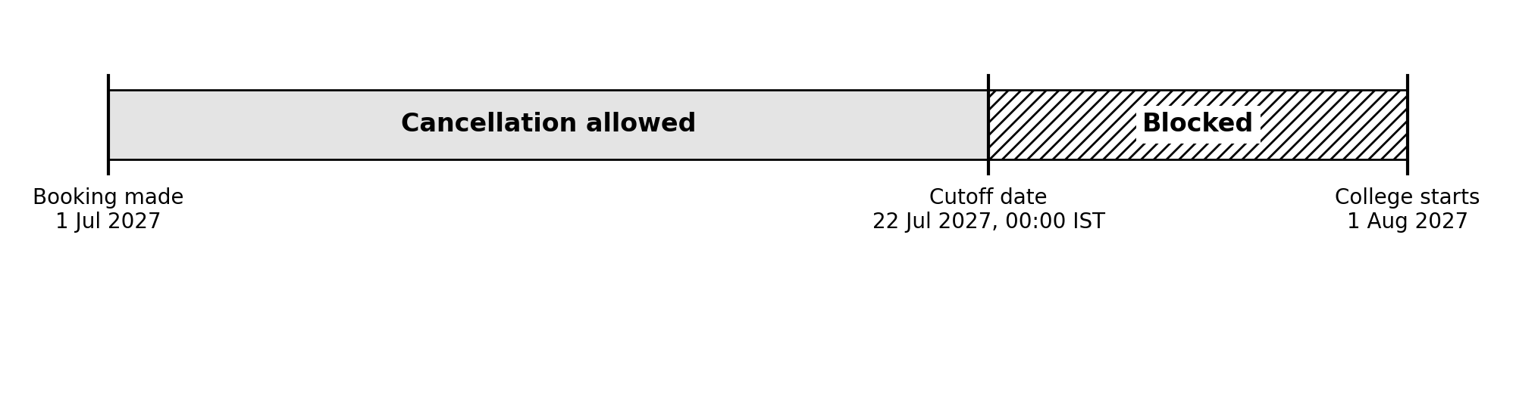
Figure 3: Worked example of the cancellation window (start date 1 August 2027, 10-day lead time).

4.7 Security model
- Identity: Supabase Auth; a trigger creates a student profile at sign-up. The admin role can only be granted by SQL, and an RLS check stops users editing their own role.
- Row-level security is on for every table. Students read active inventory and their own bookings and profile; they have no insert, update or delete rights on inventory or bookings.
- Keys: only the public anon key is in the browser. The Gemini key is a Supabase secret read inside the Edge Function. The service-role key is used only by the Node test runner and never ships to the browser.
- Privacy toward the LLM: the model receives search results and bed IDs, never names, student numbers or phone numbers.
- Input validation: message length, history length, tool names and UUID formats are checked in code, not in the prompt.

4.8 AI assistant design
The assistant is a tool-calling loop in an Edge Function. The student's message and up to eight prior turns go to Gemini together with three function declarations. If the model asks for a tool, the server validates the arguments, runs the tool as the signed-in student and returns the result to the model. Search results are also returned to the interface, so the room cards come from data and not from the model's text.
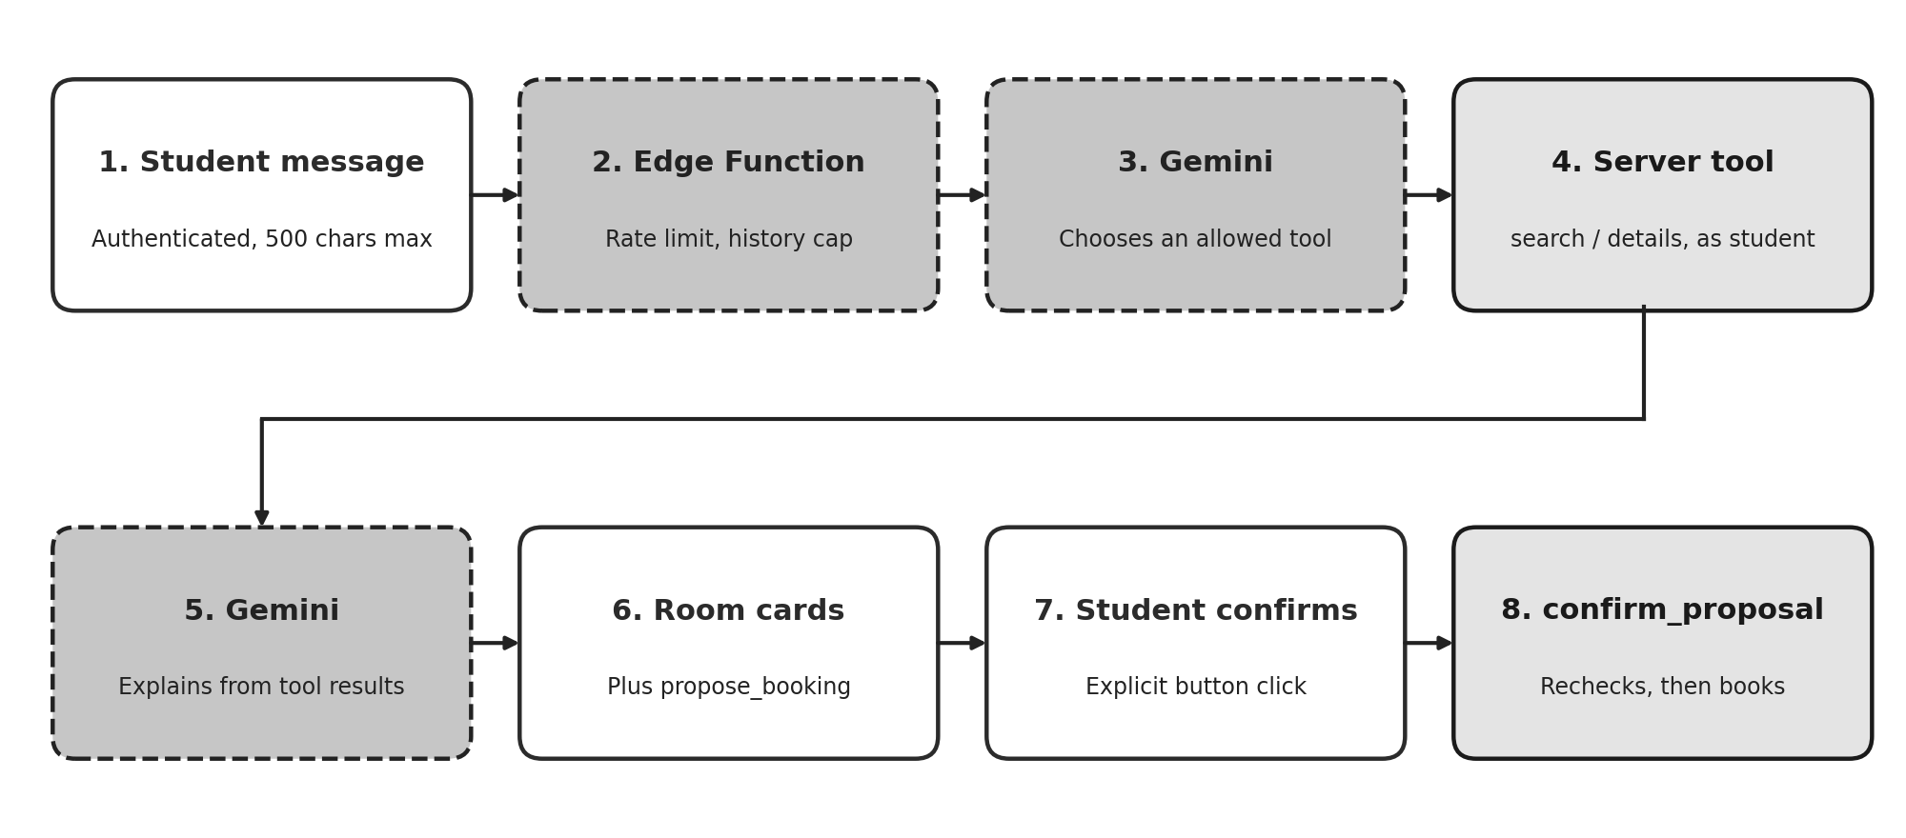
Figure 4: The AI request flow, from message to confirmed booking.

Tool | Access | Behaviour
search_rooms | Read-only | Calls get_availability and filters by building, room type and facilities in code; returns at most ten rooms with beds free, facilities, time checked and evidence tags.
get_room_details | Read-only | Returns the free beds (IDs and numbers) of one room; the room ID is validated as a UUID.
propose_booking | Proposal only | Creates a five-minute proposal for one free bed. It is not a booking; the interface asks the student to confirm.

The system prompt requires the model to use tools for current availability, to avoid inventing any building, room, bed, facility or policy, to ask when a request is ambiguous, to say it cannot verify a detail when evidence is missing, and never to claim a booking exists. The prompt is treated as guidance, not security: arguments and authorisation are enforced in code. Any tool name outside the allow-list is rejected.

Operational controls
- Tool loop capped at three rounds; each message limited to 500 characters.
- Per-student limit of six messages a minute; a provider request budget (default 12 a minute) kept below the model's limit, so the function stops before the provider rejects calls.
- Retries with a short backoff for temporary 429 and 503 responses; a 20-second request timeout.
- The model name is a secret setting, because model versions are retired quickly (Section 5.6).
- On failure the student sees "busy" or "unavailable" and can still book manually; logs record the status code only, never keys or student data.

4.9 Allocation engine
The allocation engine is a pure Python function that takes students (with optional preferences for building, room type and facilities) and rooms (with free beds), and returns assignments, scores, unassigned students and the constraints each assignment passed. It never writes bookings; the booking function independently revalidates the database. The search is a depth-first backtracking algorithm over students in a fixed order. For each student it tries eligible rooms from best to worst score, decrements the room's free beds, recurses, and restores the state on return. It also tries leaving a student unassigned, and it keeps the best result found, preferring more assigned students and then a higher total score. Results are reported as feasible, partial or infeasible. Backtracking is exponential in the worst case, which is acceptable for the small, explainable instances the project demonstrates; OR-Tools CP-SAT is the natural next step for scale.

4.10 Front end
The interface has the routes defined in the design specification: login and registration, student rooms, bookings and AI assistant, and admin dashboard, bookings and settings. Every data-driven page has loading, empty, error, success and conflict states. Status is always shown in text as well as colour (for example "Active" with a tick and "Cancelled" with a cross), dialogs are keyboard accessible, and focus outlines are visible. Room cards show a bed meter and facility chips with icons and text labels, and loading shows skeleton placeholders. The theme follows the device's light or dark setting.

4.11 Testing methodology
Scenario tests were written for the 14 cases in the API specification. Ten run as Vitest integration tests against a real Supabase test project. A test creates its own users, building and room through the admin API, signs in as each user with the public key, exercises the real functions and policies, and removes its data afterwards, restoring the original settings. Testing against the real database, not mocks, is what lets the race condition and the row-level-security rules be verified honestly.
# | Scenario | Automation
1 | Student books an available bed | Vitest
2 | Two concurrent requests for one bed; only one succeeds | Vitest
3 | Second active booking rejected | Vitest
4 | Another student's booking is not visible | Vitest
5 | Non-admin cannot create a building | Vitest
6 | Capacity below occupied beds rejected | Vitest
7 | Cancel before cutoff succeeds and frees the bed | Vitest
8 | Cancel on or after cutoff fails | Vitest
9 | AI returns no invented rooms for a nonexistent building | Vitest, optional (needs live AI)
10 | Proposal for a bed that gets taken fails at confirmation | Vitest
11 | Provider outage; manual booking still works | Covered by test 1 (no AI in the booking path)
12 | AI claims a facility that does not exist | Manual check in the assistant
13 | Solver reports impossible case as infeasible | pytest
14 | Dashboard totals match database counts | Vitest

4.12 Deployment
The database was built by running five numbered migrations in order (initial schema, front-end functions, a booking fix, AI proposals, admin tools) and a seed script that adds two buildings, seven rooms and fourteen beds of synthetic data. The Edge Function is deployed with the Supabase CLI and reads the Gemini key from a secret. The React app is built by Vercel from the repository's web folder, with the Supabase URL and anon key as environment variables and a rewrite rule so deep links survive a refresh. Supabase Auth was configured with the live site URL for redirects.

5. Results

5.1 Integration test results
The recorded run executed 11 tests: 10 passed and 1 was skipped by design (the optional live AI test). The whole file took about 60 seconds, mostly because every test creates real users and rooms on a hosted database.

# | Behaviour verified | Result | Time (s)
1 | A student books an available bed; status active with an HST- reference | Passed | 4.0
2 | Two simultaneous bookings for one bed: exactly one succeeds, the other gets BED_UNAVAILABLE, and only one active row exists | Passed | 4.5
3 | A second active booking by the same student is rejected | Passed | 3.7
4 | A second student cannot read the first student's booking; the owner can | Passed | 4.6
5 | A non-admin is refused by the admin function and cannot insert a building directly | Passed | 1.5
6 | Reducing capacity below occupied beds is rejected | Passed | 5.7
7 | Cancelling before the cutoff succeeds, the bed reappears in availability and history remains | Passed | 5.0
8 | Cancelling on the cutoff date and after it fails | Passed | 6.1
9 | AI returns no rooms for a nonexistent building | Skipped (optional) | n/a
10 | A proposed bed taken by someone else is rejected at confirmation, and an occupied bed cannot be proposed | Passed | 5.5
14 | Admin counts of active rooms, beds and bookings equal the database counts | Passed | 4.7

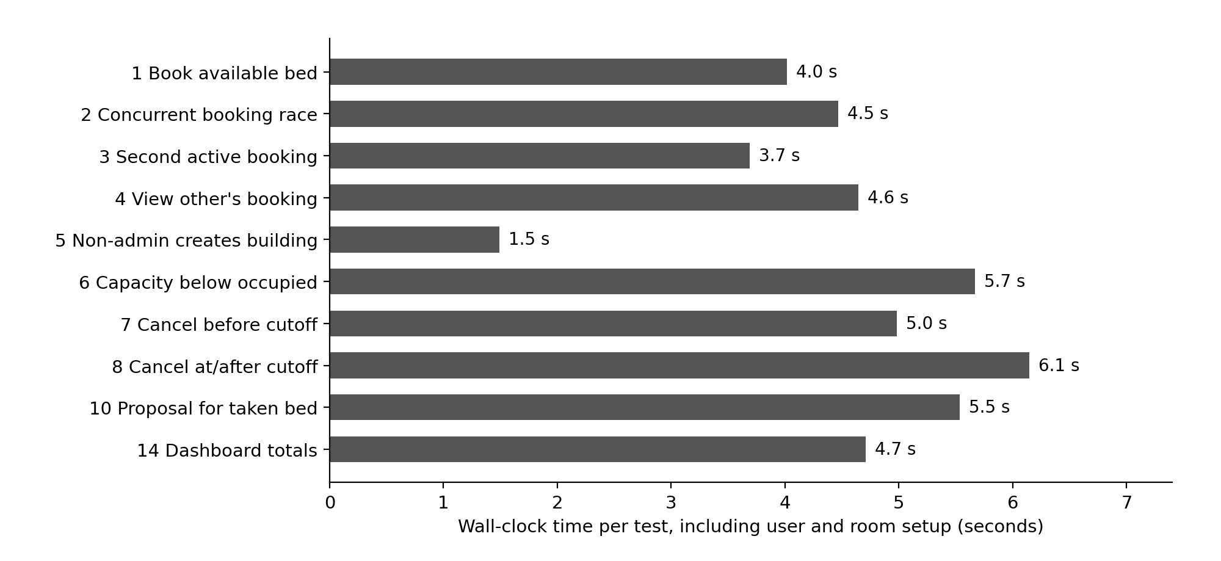
Figure 5: Wall-clock time of each passing test. Times include creating users and rooms and are not API latency.

5.2 Allocation engine results
Three pytest cases passed: a feasible allocation with no unassigned students, an infeasible request (a double room requested when only a single room exists) reported as infeasible with the student listed as unassigned, and a capacity case in which two students compete for one bed and exactly one is assigned. This satisfies the requirement that an impossible allocation produces a clear result.

5.3 Acceptance criteria
Criterion (PRD section 8) | Status | Evidence
Admin can create buildings and rooms with bed capacity | Met | Admin page; room function creates beds
Inventory totals match database records | Met | Test 14
Two students cannot book the same bed, including concurrent attempts | Met | Test 2
Unauthorized access to private records is denied | Met | Tests 4 and 5
Manual booking works without AI | Met | Test 1; booking path has no AI call
AI searches live inventory and cannot invent rooms | Met by design | Tool-only data; automated test 9 not executed in the recorded run
AI booking requires explicit confirmation | Met | Proposal and confirm flow; test 10
Cancellation works before cutoff and fails after | Met | Tests 7 and 8
Cancellation preserves history and releases the bed | Met | Test 7
Impossible allocation returns a clear result | Met | Solver test
Public deployment uses environment secrets and synthetic data | Met | Vercel variables, Supabase secrets, seed script

5.4 Success metrics
- Core booking and cancellation tests: 10 of 10 executed tests passed (100 percent).
- Duplicate active bookings for a bed: none; the concurrency test counted exactly one active booking for the contested bed.
- Unauthorized access attempts: both tested attempts (reading another student's booking, non-admin building creation) were denied.
- AI recommendation validity, explanation grounding and latency: not measured systematically, because the planned provider comparison was descoped. This is a limitation, not a result.
- Manual booking with AI disabled: confirmed by design and by test 1, which never touches the AI service.

5.5 Deployment outcome
The application is live at https://hostel-allocation-system-inky.vercel.app, backed by a Supabase project containing the migrations and synthetic seed data. After the model setting was corrected (Section 5.6), the AI assistant answered requests in manual checks on both laptop and phone. Registration, booking, cancellation and the admin pages were exercised on the live site.

5.6 Engineering problems and fixes
Several real defects surfaced during integration and deployment. They are recorded because they shaped the final design.

Problem | Cause | Fix
Every booking failed in the app | The reference generator used a function that lives in Supabase's extensions schema and was invisible to a function with a fixed search path | Migration 0003 uses the built-in gen_random_uuid(); profile row created if missing; real errors now logged to the console
AI assistant stopped answering | The default Gemini model had been retired; later, the free-tier limit of about 15 requests a minute was a second likely cause | Model name moved to a secret; request budget, retries and a friendly busy message added; message loop shortened
One chat message used several requests | Search, details and the final answer are separate model calls | Prompt asks for fewer calls; per-instance budget stops the function before the provider rejects
Confirmation emails would not reach users | Supabase's built-in email sender is limited to a few emails an hour and to team addresses | Email confirmation turned off for the demo, with the trade-offs documented (unverified identities, bot sign-ups)
Test runner failed to start | loadEnv was imported from the wrong package in the test configuration | Imported from vite; suite then ran cleanly
Production build needs types | Environment variables were untyped | Added vite-env.d.ts; build verified

5.7 Discussion and limitations
- The strongest result is that integrity rules hold in the real database under a genuine concurrent race, not just in the interface.
- The AI layer is safe by construction, but its answer quality was checked manually rather than measured. The grounding test for facilities that do not exist (scenario 12) remains manual.
- The rate limiters are per function instance. They protect a small demo but are not a hard global cap or cost control.
- Email confirmation was disabled for the demo; a real deployment needs verified email, ideally restricted to the college domain, plus a CAPTCHA.
- The allocation engine works and is tested, but is not yet used by the assistant or by an admin bulk-allocation feature.
- Tests ran against a hosted project and are slower than local tests; they must never be pointed at production data.

6. Future Work

6.1 Evaluate several language-model providers
Add a provider-neutral adapter and an admin-only evaluation page that runs fixed synthetic scenarios against two or three providers, recording latency, tool-call validity, recommendation validity and explanation grounding in the prepared ai_evaluations table. This would turn the current manual impression of AI quality into measured evidence and remove dependence on one model name.

6.2 Use the allocation engine in the product
Expose the solver through a protected endpoint so the assistant can explain trade-offs from solver output, and add an admin bulk-allocation workflow that previews assignments, shows constraint evidence and unassigned students, and commits through the validated booking function. For larger batches, compare backtracking with OR-Tools CP-SAT.

6.3 Complete the admin and student experience
- Edit and deactivate buildings and rooms, with a warning when active bookings exist, and a per-room bed status view with occupancy by building.
- A landing page, student dashboard showing the current booking, room and booking detail pages, and filters for room type and facilities.
- Notifications, a waitlist for full rooms, and an audit viewer built on the existing audit_events table.

6.4 Strengthen identity and abuse protection
Re-enable email confirmation with custom SMTP, restrict sign-up to the college email domain, add a CAPTCHA, and verify student numbers against an official roster so that one student cannot claim another's number.

6.5 Richer allocation
Add optional roommate preferences, accessibility needs and fairness rules, modelled as soft constraints with explainable scores. Trained compatibility models remain out of scope until privacy and fairness review are in place.

6.6 Operations and measurement
- Replace per-instance limiters with a database or Redis limiter and spending caps; add monitoring of provider status codes and latency.
- Add a health-check endpoint, an admin-only demo reset action, and a scheduled check that the configured model name is still valid.
- Automate the facility-grounding test (scenario 12) with a scripted conversation and an assertion that unverifiable facilities are not claimed.
- Run the test suite in continuous integration against a disposable Supabase project.

6.7 Conclusion
The project shows that a conversational assistant can be added to a booking system without weakening it, provided correctness lives in the database and the model is confined to read-only tools and proposals. The delivered system meets its core acceptance criteria: bookings are atomic and cannot be duplicated, private data is protected by row-level security, cancellation follows a server-enforced cutoff, and the AI cannot invent availability or book on its own. The main gaps are the descoped provider comparison, limited measurement of AI quality, and some administrative screens. These are well defined and can be addressed without changing the architecture.
References
- Supabase documentation: Auth, Row Level Security, Database Functions and Edge Functions. https://supabase.com/docs (accessed November 2026).
- Google AI for Developers: Gemini API, function calling and rate limits. https://ai.google.dev/gemini-api/docs (accessed November 2026).
- PostgreSQL documentation: partial indexes, transactions and security-definer functions. https://www.postgresql.org/docs/ (accessed November 2026).
- React documentation. https://react.dev (accessed November 2026).
- Vite and Vitest documentation. https://vite.dev and https://vitest.dev (accessed November 2026).
- Google OR-Tools: constraint programming (CP-SAT). https://developers.google.com/optimization (accessed November 2026).
- Vercel documentation: deployments and environment variables. https://vercel.com/docs (accessed November 2026).
Appendix A: Project structure
hostel-allocation/
engine/allocator.py backtracking solver + pytest tests
supabase/
seed.sql synthetic demo inventory
migrations/0001_init.sql ... 0005_admin_tools.sql
functions/ai-chat/index.ts Gemini tool-calling Edge Function
web/
package.json, vite.config.ts, vitest.config.ts, vercel.json
tests/integration.test.ts scenario tests
src/ App.tsx, lib.ts, components.tsx, styles.css
src/pages/ Login, Rooms, MyBookings, AIAssistant,
Admin, AdminBookings, AdminSettings

Appendix B: Configuration names (no secrets)

Name | Where | Purpose
VITE_SUPABASE_URL, VITE_SUPABASE_ANON_KEY | Vercel / web .env | Public client settings
GEMINI_API_KEY | Supabase secret | Server-side model access
GEMINI_MODEL | Supabase secret | Model name, changed without redeploying code
GEMINI_RPM | Supabase secret | Request budget under the provider limit (default 12)
TEST_SUPABASE_URL, TEST_SUPABASE_ANON_KEY, TEST_SERVICE_ROLE_KEY | web .env.test | Test project only; service key never in browser code

