
PROJECT REPORT
AI-Powered Hostel Accommodation Allocation System
A Bed-Reservation Web Application Driven by a Grounded, Tool-Calling Conversational Agent

Presented by: Krish
Programme: B.Tech Computer Science and Engineering (AI/ML)
Institution: Lovely Professional University
Registration number: 12523448
Date: November 2026
Live deployment: https://hostel-allocation-system-inky.vercel.app
https://hostel-allocation-system-inky.vercel.app
Table of Contents

- Abstract
- Introduction
- Objective & Scope
- Problem Statement & Solution
- Methodology
- Results
- Future Work
- References
- Appendix: A
- Appendix: B
Abstract
Traditional hostel bed assignment using manual paperwork or spreadsheet tracking is notoriously vulnerable to duplicate reservations, arbitrary cancellation handling, and poor administrative oversight. This project implements a fully functional web platform enabling wardens and administrators to configure residential blocks, rooms, and discrete beds, while enabling scholars to explore real-time inventory, secure individual bed slots, review their booking records, and cancel reservations up to an administrator-defined threshold. Furthermore, a conversational assistant driven by Gemini allows residents to express their housing criteria in natural language; however, to maintain integrity, the assistant is constrained to inspecting current inventory and drafting reservation proposals, requiring explicit learner confirmation before any booking is committed.
The core architectural principle of this system is zero trust toward both client-side browser logic and large language model outputs. All operational policies and constraints are strictly delegated to PostgreSQL functions, row-level security (RLS) definitions, and unique partial indexes within Supabase, ensuring atomic transactions and mathematically preventing concurrent active reservations on a single bed. The intelligent agent interacts with the database solely via three permit-listed routines operating under the authenticated student's session privileges. Draft proposals automatically lapse after five minutes and must pass through the identical booking validation pipeline upon student confirmation. Additionally, a deterministic depth-first backtracking solver evaluates housing constraints, categorizing allocation tasks as feasible, partially feasible, or unachievable.
Across ten end-to-end integration scenarios conducted directly against a live Supabase environment, all tests completed successfully, decisively verifying concurrency control by allowing only a single winner in a simultaneous two-student race condition for the same bed. Three algorithmic solver test suites also verified constraint handling. Production hosting is established on Vercel with Supabase serving as the cloud backend. This document provides a comprehensive analysis covering system specifications, architectural design, database enforcement mechanisms, empirical test findings, debugging challenges encountered during integration, and prospective enhancements.

1. Introduction

1.1 Background
At the inception of each academic cycle, university administrations face the daunting operational burden of assigning hostel rooms to several thousand matriculating students. Many university campuses continue to handle this workflow through paper request forms, manual ledgers, or disjointed spreadsheets. This conventional workflow is not only labor-intensive and sluggish, but also routinely exhibits system failures: administrative personnel inadvertently allocate identical bunks to multiple applicants, individual learners accumulate multiple unauthorized slots, cancellation deadlines vary arbitrarily, and management lacks an up-to-the-minute view of residence hall occupancy.
Deploying a modern web platform connected to a relational database fundamentally resolves these vulnerabilities, provided core transactional invariants reside at the database tier rather than within frontend presentation logic. Client-side state can easily be circumvented, rendered stale through unsynchronized page reloads, or subjected to simultaneous race conditions across distributed browsers. Constraints codified directly within database transactions provide the only foolproof guarantee under high concurrency.

1.2 Motivation
Recent advancements in generative artificial intelligence permit applicants to formulate housing inquiries via intuitive conversational dialogue, such as requesting 'a dual-occupancy room located in Block A with a study desk'. While significantly more user-friendly than multi-field dropdown filters, introducing conversational models introduces significant operational risks: language models operating on internal parametric knowledge frequently hallucinate non-existent rooms, misrepresent dormitory amenities, or fabricate institutional policies. Furthermore, granting write capabilities to an unconstrained agent could trigger unauthorized allocations without user consent. The overarching motivation of this research is to prove that conversational AI can enhance transactional software while remaining fundamentally zero-trust: querying real-time inventory solely via narrowly-scoped tools, grounding all explanations in verifiable database records, and having zero authority to commit transactional changes autonomously.

1.3 Overview of the system
The delivered solution incorporates dual user interfaces powered by a unified React frontend architecture. Through the administrative console, staff coordinate residential blocks, configure rooms (which automatically generate their respective bed entities), supervise active reservations alongside student contact records, and adjust term start dates as well as cancellation thresholds. Concurrently, the resident interface enables students to inspect available spaces categorized by block, select specific bed units, finalize reservations, monitor booking records alongside explicit cancellation deadlines, and execute cancellations when eligible. In addition, an AI-assisted concierge view interprets natural-language queries, presenting interactive room summaries accompanied by verifiable reasoning derived from live database queries.
Underpinning the client application, Supabase supplies managed user authentication, a PostgreSQL database, and serverless Edge Functions. The system's operational logic is strictly anchored in twelve custom PL/pgSQL security-definer routines and granular Row-Level Security (RLS) declarations. A standalone Python component provides an algorithmic constraint-satisfaction solver. The web application is hosted on Vercel's global CDN, while the AI Edge Function communicates securely with the Gemini API utilizing server-side credentials isolated from client environments.

1.4 Organisation of this report
The structure of this report is arranged systematically: Section 2 outlines system objectives, user classifications, operational boundaries, and a requirements traceability matrix. Section 3 formalizes the problem statement, challenges, and core architectural principles. Section 4 elaborates on the technical methodology, detailing system architecture, database schema, concurrency management, cancellation mechanisms, security frameworks, AI tool orchestration, constraint optimization, interface design, testing, and cloud deployment. Section 5 presents empirical integration and performance results, including technical impediments solved during development. Finally, Section 6 explores prospective advancements and offers concluding remarks.

2. Objectives and Scope

2.1 Objectives
ID | System Objective | Verification Strategy
O1 | Manage residential buildings, room units, and individual beds with live aggregates computed directly by the database engine. | Inspected via Administrative Dashboard and Integration Scenario 14
O2 | Empower applicants to reserve an individual vacant bed while enforcing non-negotiable concurrency controls against overbooking. | Verified through Integration Tests 1 and 2
O3 | Restrict students to at most a single active bed reservation under normal operational rules. | Evaluated via Integration Test 3
O4 | Enable booking revocation prior to an automated cutoff date (10 days ahead of academic commencement), archiving records and releasing inventory immediately. | Demonstrated through Integration Tests 7 and 8
O5 | Enforce strict privacy isolation: no applicant may view peer reservation histories or personal contact information. | Validated in Integration Tests 4 and 5
O6 | Implement a conversational assistant that queries real-time database rows, prevents synthetic entity hallucinations, and demands explicit user confirmation for reservations. | Assessed via Integration Test 10 and tool-level validation logic
O7 | Exhibit constraint-based allocation optimization using an explainable solver capable of highlighting infeasible requests. | Verified through automated algorithmic pytest test suites
O8 | Maintain uninterrupted manual reservation workflows during external AI provider downtime, verified on a live deployment populated with mock inventory. | Confirmed via Integration Test 1 and production deployment on Vercel

2.2 Users and permissions
User Role | Authorized Capabilities
Student | Inspect operational residence blocks, rooms, and unoccupied beds; execute single bed reservations for themselves; accept AI-drafted room proposals; inspect personal historical reservations; withdraw eligible reservations before the cutoff date. Strictly barred from viewing other students' reservation records or contact information.
Admin | Provision new hostel blocks and rooms (which instantly populate designated beds); inspect real-time occupancy statistics and all student reservation rosters with names, matriculation numbers, and telephone numbers; configure college start schedules, cancellation window offsets, and regional timezones. Strictly restricted by core database integrity constraints and prohibited from generating corrupted states.

2.3 Scope
In scope: Residential inventory configuration, direct web-based bed reservation, cancellation controls governed by database-enforced timelines, an administrative governance dashboard, a strictly grounded AI conversational assistant with draft-and-confirm patterns, an explainable backtracking allocation solver, comprehensive integration test suites, and public cloud deployment seeded with synthetic data.
Out of scope (non-goals): Financial processing, fee collection or security deposit workflows; enterprise synchronization with legacy university ERP systems; machine-learning roommate compatibility inference models; platform-native mobile clients; and fully automated or autonomous booking operations that bypass explicit student confirmation.

2.4 Requirements coverage
The software specification delineated 26 formal functional requirements (designated FR-01 through FR-26). The accompanying matrix outlines their fulfillment status. Planned multi-provider AI evaluation modules (FR-24 and FR-25) were consciously set aside to maintain project focus on delivering a robust, single-provider implementation.

Requirements | Implementation Status | Technical Remarks
FR-01 to FR-06 Inventory Management | Substantially Fulfilled | Residential blocks and room spaces generate associated bed records automatically; room identifiers are constrained uniquely per block; capacity downward scaling cannot violate occupied bed thresholds. Visual interfaces for in-place editing and block deactivation remain pending (underlying SQL routines exist). The administrative view presents live counts of buildings, rooms, total beds, active allocations, and net occupancy percentages.
FR-07 to FR-14 Booking Operations | Fully Fulfilled | Live real-time availability computation, strict single-booking invariant per student, transactional atomicity, unique index guards, scoped self-booking visibility, persistent audit trails, and deterministic human-readable reference codes (e.g., HST-AB12CD).
FR-15 to FR-19 Cancellation Rules | Fully Fulfilled | Academic commencement date and lead-time buffer managed via admin configuration view; cancellation cutoff dates calculated deterministically on the server according to institutional timezone; instantaneous inventory release upon cancellation.
FR-20 to FR-23 AI Assistant System | Substantially Fulfilled | Safe, read-only room search tool; propose-only reservation tool; all executions impersonate the authenticated applicant. Response narratives remain strictly tethered to concrete database rows and validation constraints. Interfacing allocation solver metrics into AI conversational output is designated for future iteration.
FR-24, FR-25 Multi-Model Benchmarking | Intentionally Descoped | Architecture is standardized on Gemini. Provider-agnostic abstraction layers and visual side-by-side comparison dashboards were postponed.
FR-26 Manual Fallback Resilience | Fully Fulfilled | Catalogue exploration and booking routines depend solely on native PostgreSQL routines, operating with 100% availability even during external AI provider interruptions.

3. Problem Statement and Solution

3.1 Problem statement
Hostel allocation platforms must satisfy one fundamental operational requirement above all else: reliably establishing exactly which student occupies which specific bed at any given instant. Disorganized paper records or unchecked client applications are structurally incapable of guaranteeing this consistency. Furthermore, integrating a generative conversational agent introduces an acute reliability hazard, as large language models frequently assert plausible falsehoods with absolute certainty. The central challenge resolved in this research is engineering a student housing reservation system that guarantees mathematical correctness under heavy concurrency, preserves strict applicant confidentiality, and provides intelligent natural-language assistance without ever permitting the probabilistic language model to serve as an authoritative source of truth or an unmonitored decision-maker.

3.2 Challenges
Systemic Challenge | Operational Risk if Unmitigated
Concurrent Booking Requests | Simultaneous attempts by multiple applicants to claim an identical bed unit can trigger race conditions where both bookings are improperly stored.
Duplicate Active Reservations | Individual students could secure multiple room allocations concurrently, depriving other applicants of scarce accommodations.
Inconsistent Cancellation Application | Discrepancies in cancellation approvals due to arbitrary manual interpretations, client clock manipulation, or timezone ambiguities.
Untrusted Client Environments | Attackers running modified browser sessions or forged API payloads could impersonate arbitrary student IDs, elevate user roles, or forge allocation states.
Applicant Data Leakage | Sensitive personal student records, contact numbers, and historical room assignments could become exposed to unauthorized peers.
LLM Hallucination and Fabulation | The conversational assistant could misinform students by presenting fabricated dormitory rooms or advertising amenities that do not exist.
Unintended AI Transactional Actions | Prompt injection vectors or agent confusion could lead the AI to generate or revoke bookings without the student's explicit agreement.
Third-Party API Outages and Rate Caps | Upstream AI service downtime, token exhaustion, or model deprecation could paralyze core booking infrastructure if coupled synchronously.

3.3 Proposed solution and design principles
- The database is the authority. All transactional operations - including bed reservations, cancellations, capacity adjustments, and global settings - are handled exclusively by PostgreSQL routines that strictly enforce caller identity and business logic. The active student identity is resolved directly from the authenticated session context.
- Constraints as the last line of defence. Integrity is permanently guaranteed by two unique partial indexes that structurally prohibit a bed or a student from having more than one active booking. Even severe frontend defects cannot corrupt database consistency.
- Least privilege. Row-Level Security (RLS) restricts data access across every table, while client-side write permissions are completely disabled on inventory and booking schemas. Administrative privileges are verified directly within SQL routines.
- The AI is untrusted. The generative model accesses system state exclusively through three permit-listed tools, executed strictly under the caller's authenticated context with validated parameters and bounded recursion rounds. The assistant possesses proposal capability only and cannot execute reservations.
- Confirmation and revalidation. AI recommendations generate a temporary proposal bound to a specific student and bed, expiring strictly after five minutes. When confirmed by the user, the proposal is fully re-evaluated through standard booking validation logic.
- Graceful degradation. Standard manual booking flows operate entirely independently of the AI layer. External LLM anomalies result in informative status notices without impacting core transactional functionality.

3.4 How each problem is addressed
Identified Problem | Mitigating Architectural Mechanism
Concurrent Booking Contention | The create_booking routine executes within an isolated transaction; the database unique index immediately rejects conflicting inserts, issuing a BED_UNAVAILABLE exception and refreshing client inventory.
Redundant Reservations | A dedicated partial unique index applied to student_id for active statuses aborts duplicates, triggering an ALREADY_HAS_ACTIVE_BOOKING error.
Arbitrary Cancellation Timelines | A unified cancel_booking function deterministically evaluates the cancellation window using the stored institutional start date, lead time, and target timezone, updating the record status to cancelled.
Unauthenticated or Forged Requests | Internal resolution of auth.uid() within security definer functions; privilege escalations are blocked via RLS policies, while administrator status can only be provisioned through direct SQL execution.
Data Confidentiality and Privacy | Student access is limited strictly to their own booking rows; public availability functions return aggregated quantities and bed identifiers without exposing user identities; student contact data is restricted to an administrator-only procedure.
LLM Hallucinations and Inaccuracies | Tools return verified database rows only; the system prompt explicitly forbids entity invention; the client interface surfaces timestamped verification evidence alongside room listings.
Autonomous Action Hazards | The propose_booking routine merely registers a transient, five-minute reservation proposal; final booking execution requires an independent, user-initiated confirmation action.
Upstream Model Outages and Limits | Configurable model identifier, request budgeting constrained below provider quotas, automatic exponential retries for transient errors, and clear client-facing busy feedback.

3.5 Risk analysis
Operational Risk | Defense Strategy | Residual Risk Profile
LLM Inventing Inventory | Rigorous tool-grounded data retrieval coupled with strict prompt directives. | Prompt guidelines are not cryptographic safeguards; the database remains the ultimate source of truth.
Overbooking Race Conditions | ACID database transactions paired with unique partial indexes. | No concurrency leaks detected across stress test scenarios.
AI Service Interruptions or Deprecation | Decoupled manual booking workflows; runtime model identification via system secrets. | Provider model endpoints are subject to retirement; necessitates ongoing maintenance oversight.
API Quota Depletion and Costs | Per-user rate limiting, sliding request budgets, and bounded execution cycles. | Rate limiting operates per function instance rather than across a unified global cache.
Confidential Student Information Exposure | Row-level security enforcement, role-based procedural guards, exclusion of PII from LLM prompts. | Administrative account credentials must remain rigorously protected against compromise.
Demonstration State Divergence | Automated database seeding scripts populated with synthetic records. | Data reset workflows require direct SQL execution rather than a one-click administrative interface.

4. Methodology

4.1 Development approach
Development was executed using an iterative, specification-anchored, database-first methodology with rapid verification cycles. Project milestones were structured around comprehensive technical specifications, including PRD documents, API contracts, relational schemas, visual wireframes, and deployment configurations. Engineering proceeded through disciplined sequential phases: defining relational schemas and trusted stored functions; implementing student and administrator user interfaces; orchestrating the AI conversational assistant; deploying administrative tools and synthetic seed data; authoring an automated integration test harness; refining user interface ergonomics; and executing cloud deployment. Following each development phase, system behavior was rigorously validated against a hosted Supabase environment, resolving discovered defects through sequentially numbered database migrations to preserve reproducible schema evolution.

4.2 Technology stack
System Tier | Selected Technology | Functional Responsibility
Frontend Application | React 18, TypeScript, Vite, React Router | Delivers student and administrator portals; client routing serves navigational usability only.
Backend & Persistence | Supabase: PostgreSQL, Auth, Row-Level Security (RLS) | Manages inventory records, reservation states, user identity, and cryptographic access boundaries.
Business Logic Tier | PL/pgSQL Stored Procedures (security definer) | Executes atomic booking transactions, cancellation workflows, room provisioning, and institutional setting updates.
Conversational AI Subsystem | Supabase Edge Functions (Deno Runtime) & Gemini API | Drives conversational tool execution loops, manages reservation proposals, and monitors request quotas.
Optimization Engine | Python 3 | Implements deterministic depth-first backtracking search, verified through automated pytest suites.
Quality Assurance | Vitest 2 Integration Framework, pytest | Executes multi-scenario integration tests against a live cloud database environment.
Cloud Infrastructure | Vercel (Frontend), Supabase (Database & Functions) | Hosts public demonstration instances with credentials secured in cloud environment vaults.

4.3 System architecture
Client web browsers interact with Supabase using solely the public anonymous (anon) key. All direct data queries are mediated by PostgreSQL Row-Level Security policies. State modifications are executed exclusively through trusted remote procedure calls (RPC), and the AI Edge Function utilizes these exact stored procedures on behalf of the authenticated student. The Gemini large language model operates as an isolated external service accessed strictly through server-side Edge Functions.
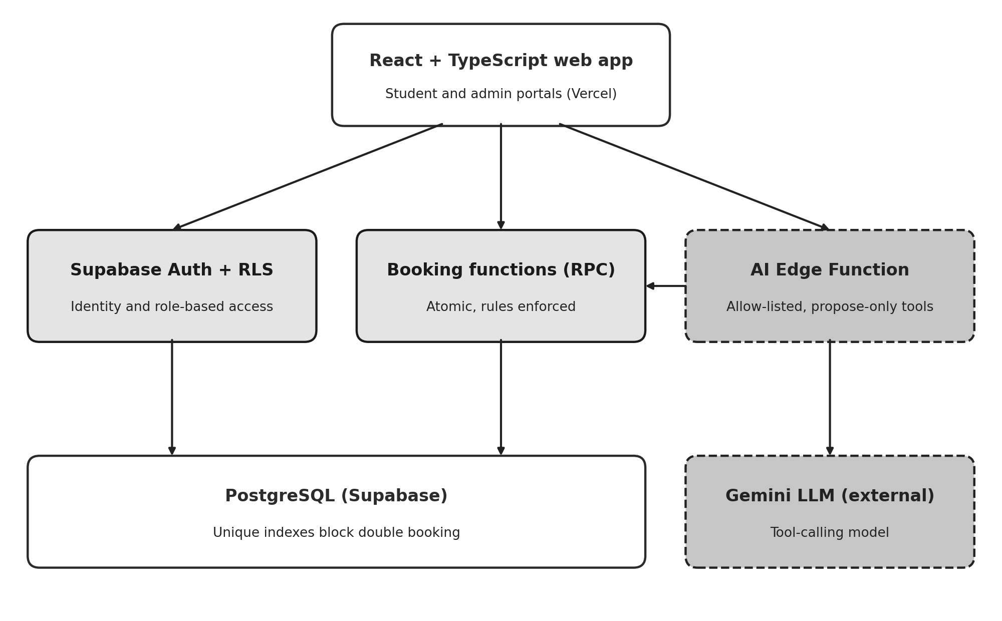
Figure 1: Architectural diagram of the system. Solid shaded modules represent server-enforced transactional boundaries; dashed boundaries delineate the AI service tier.

4.4 Database design
The underlying PostgreSQL database schema comprises nine relational tables: profiles, buildings, rooms, beds, bookings, app_settings, audit_events, ai_proposals, and ai_evaluations (the latter provisioned for model benchmarking and currently dormant). A room configured with capacity N atomically initializes exactly N individual bed records within a single transaction. Room availability is never materialized as a static column; rather, it is computed dynamically as the count of active beds devoid of active reservations, completely eliminating data desynchronization.
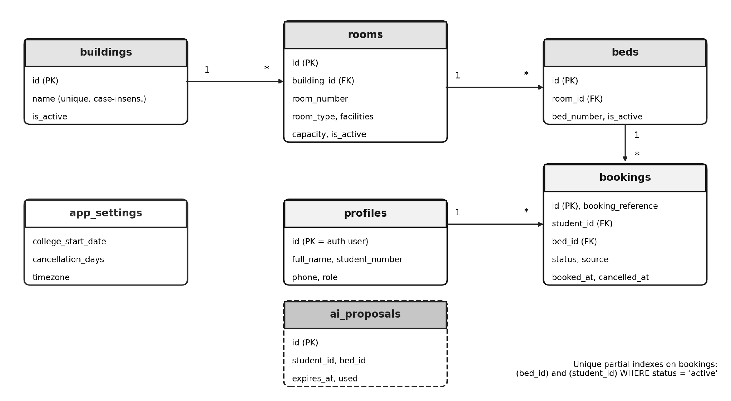
Figure 2: Entity-relationship diagram highlighting the partial unique indexes that enforce non-negotiable reservation integrity.
The system's trusted database procedures are summarized below. Each executes under elevated security-definer privileges while strictly resolving caller identity from the authenticated session context, accessible only to verified users.
Stored Function | Operational Objective
create_booking(bed, source) | Validates active status of the bed, parent room, and building; commits the booking record; catches unique index violations and maps them to descriptive application errors.
cancel_booking(id, reason) | Acquires a row-level lock, verifies user ownership and active status, evaluates the cancellation cutoff window, and marks the record as cancelled with an updated timestamp.
get_availability() | Queries all room units containing at least one unreserved bed, returning vacant counts for use by student portals and conversational tools.
get_taken_bed_ids(room) | Retrieves the collection of occupied bed identifiers within a given room without disclosing student identities.
create_proposal(bed) / confirm_proposal(id) | Generates and finalizes a five-minute temporary reservation proposal; successful confirmation invokes create_booking internally.
admin_upsert_room, admin_create_building | Restricts inventory creation and updates to administrators; automatically synchronizes bed counts with defined room capacity.
admin_list_bookings, admin_update_settings | Provides administrative paginated booking queries including student contact information; handles validated updates to institutional parameters.
is_admin(), handle_new_user() | Executes database-level role validation for security policies; triggers automatic student profile creation upon initial user registration.

4.5 Booking transaction and concurrency control
A bed reservation is processed as a unified atomic database function. The procedure verifies caller authentication, confirms that the targeted bed, room, and residential building are operational, and attempts to insert the reservation record. In the event that multiple applicants simultaneously target the exact same bed, PostgreSQL permits only a single transaction to commit successfully; competing transactions trigger a unique index violation, which the stored function intercepts and translates into a BED_UNAVAILABLE application exception. The client interface subsequently refreshes real-time inventory and displays an informative notice: 'This bed was just booked by another student.' Consequently, the programmatic verification in the procedure serves as a user-friendly guard, while the unique database index guarantees absolute concurrency protection.
insert into bookings (booking_reference, student_id, bed_id, source)
values ('HST-' || upper(substr(replace(gen_random_uuid()::text,'-',''),1,6)),
auth.uid(), p_bed_id, p_source);
-- unique (bed_id) where status = 'active' -> BED_UNAVAILABLE
-- unique (student_id) where status = 'active' -> ALREADY_HAS_ACTIVE_BOOKING

4.6 Cancellation policy
The cancellation deadline is calculated as the academic commencement date minus the configured advance notification window (standardized to 10 days). Revocations are approved as long as the current date within the institutional timezone strictly precedes this cutoff, and are irrevocably rejected from that date onward. For instance, assuming an academic start date of 1 August 2027 and a 10-day cancellation offset, the cutoff point resolves to 22 July 2027 at 00:00 within the Asia/Kolkata timezone; a cancellation submitted on 21 July is processed successfully, whereas a submission on 22 July is denied. Successful cancellation transitions the booking state to cancelled and records an audit timestamp without deleting the relational record. Because inventory availability dynamically counts active allocations only, the bed immediately re-enters the pool of bookable assets. While the client portal displays the precise cancellation cutoff, enforcement is determined entirely at the server level.
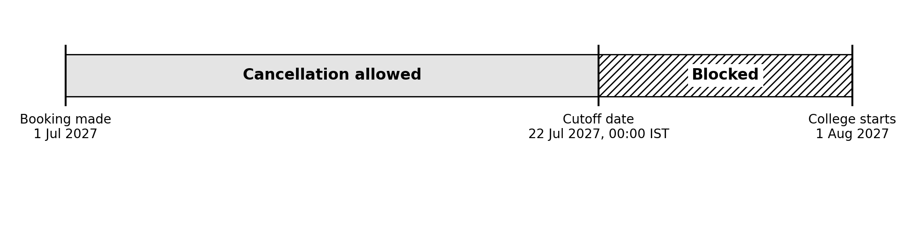
Figure 3: Timeline diagram illustrating the cancellation eligibility window based on a 1 August 2027 term start with a 10-day lead time.

4.7 Security model
- Identity: Handled via Supabase Auth; a database trigger automatically initializes a student profile upon account creation. Administrative privileges can be assigned exclusively via direct SQL execution, and RLS rules strictly prevent users from modifying their own access roles.
- Row-level security is universally enabled across all database entities. Students are restricted to querying active inventory, their own profile, and personal reservation records, with zero write permissions on inventory or booking schemas.
- Keys: Only the public anonymous key is exposed to the browser client. The Gemini API key is isolated within a server-side Supabase secret accessed exclusively by the Edge Function. The elevated service-role key is confined to automated Node.js test scripts and is never shipped to client bundles.
- Privacy toward the LLM: The language model receives solely room inventory summaries and abstract bed IDs, strictly excluding student names, matriculation numbers, and telephone details.
- Input validation: Constraints on user message length, conversation turn depth, authorized tool names, and UUID formatting are strictly enforced in programmatic code rather than relying on prompt instructions.

4.8 AI assistant design
The conversational agent operates as an event-driven tool-invocation loop hosted inside an Edge Function. The user's query along with up to eight conversational history turns are transmitted to Gemini alongside three structured tool declarations. When the language model requests a tool call, the server rigorously validates incoming arguments, executes the requested procedure under the authenticated student's session privileges, and returns the structured output back to the model. Concurrently, retrieved inventory items are transmitted directly to the frontend, ensuring interactive room cards are populated directly from verified database records rather than generated text.
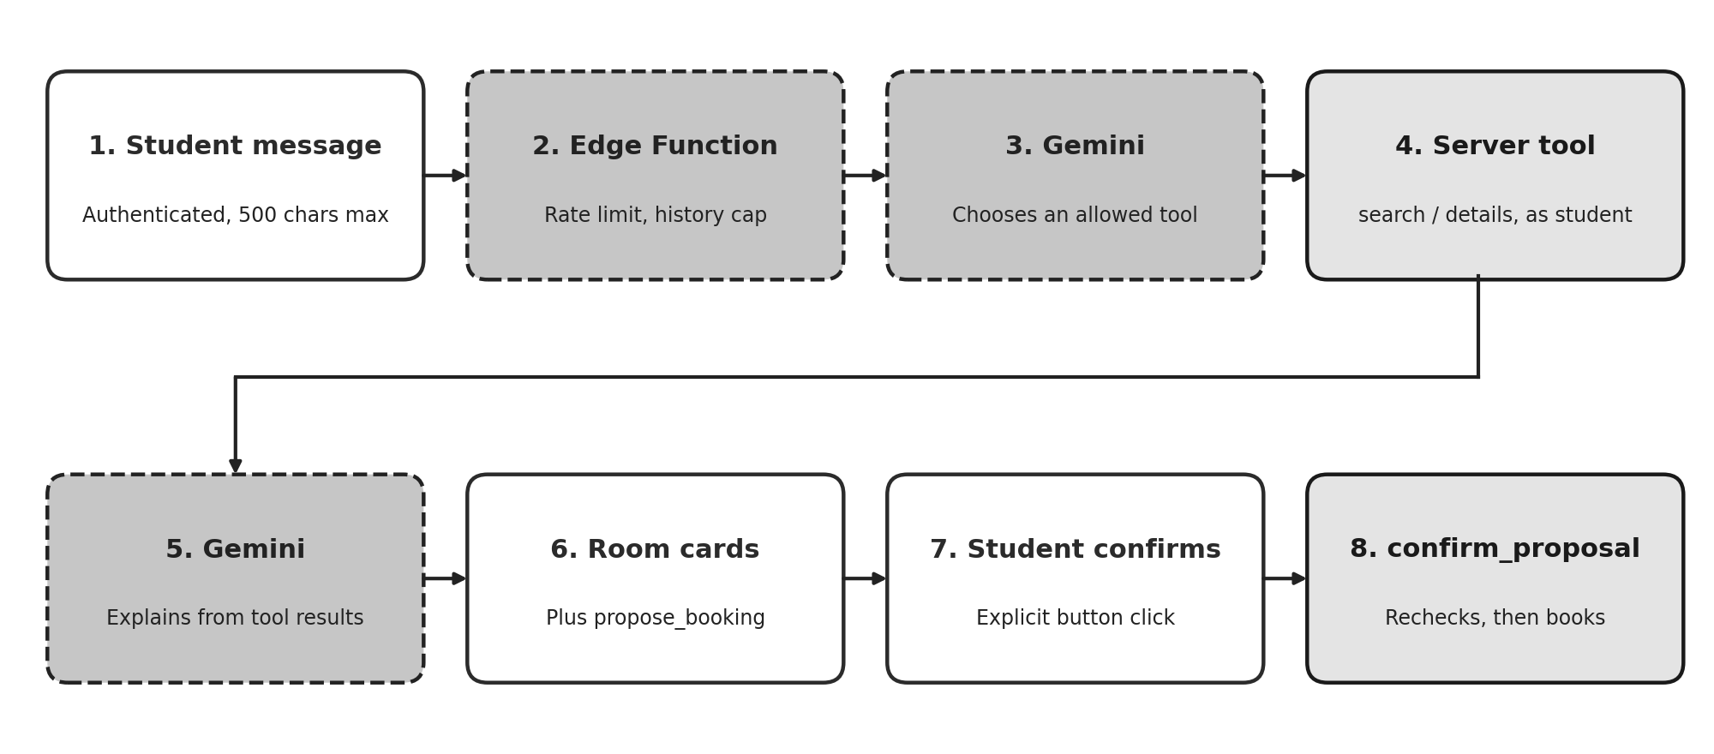
Figure 4: End-to-end operational sequence of an AI-assisted reservation request, from natural language prompt to validated booking.

Tool Name | Access Scope | Operational Behavior
search_rooms | Read-Only | Queries get_availability and programmatically applies filters for residential block, room category, and amenities; outputs a maximum of ten available rooms containing vacant beds, amenity tags, verification timestamps, and reasoning evidence.
get_room_details | Read-Only | Retrieves specific vacant bed entries (identifiers and sequence numbers) for a specified room, validating the room identifier as a strict UUID.
propose_booking | Proposal State Only | Registers a five-minute temporary reservation proposal for an unoccupied bed; does not commit an actual booking, prompting the user interface to request explicit applicant confirmation.

The foundational system prompt instructs the language model to rely exclusively on tool invocations for live inventory data, strictly prohibits fabricating any residence blocks, rooms, beds, amenities, or administrative rules, requires clarification on ambiguous prompts, mandates acknowledging unverified details when data is absent, and forbids falsely asserting that a booking has been completed. This prompt serves strictly as behavioral guidance rather than a primary security boundary: argument validation and authorization checks are enforced imperatively in code, and any tool request outside the permit-list is immediately rejected.

Operational controls
- Tool recursion depth is restricted to three iterations; individual user prompts are capped at 500 characters.
- Individual applicants are limited to six messages per minute; a sliding provider request budget (configured to 12 requests/min) operates well beneath external API quotas, preemptively throttling calls before upstream rejections occur.
- Transient HTTP 429 and 503 provider responses trigger automated exponential backoff retries within a strict 20-second request timeout envelope.
- The model version identifier is managed via runtime secrets to accommodate upstream deprecation schedules without requiring code redeployment.
- In the event of upstream AI unavailability, applicants receive courteous service notices while retaining unrestricted access to manual booking workflows; operational logs track HTTP status codes while omitting API keys and private user data.

4.9 Allocation engine
The constraint allocation engine is designed as an independent, deterministic Python algorithm that accepts student entities (incorporating preference weights for buildings, room configurations, and facilities) alongside room entities (with available beds), outputting optimal assignments, preference scores, unmatched applicants, and satisfied constraint proofs. The solver never writes directly to the database; every proposed assignment must independently pass through the transactional booking procedure. The search utilizes a depth-first backtracking algorithm operating across students in a standardized sequence. For each applicant, it evaluates eligible rooms ordered by preference score, decrements the room's available bed count, recurses down the decision tree, and restores state upon backtracking. The algorithm also accounts for scenarios where a student remains unassigned, ultimately selecting the global optimum that maximizes the number of placed students followed by cumulative preference scores. Results are classified into three distinct categories: feasible, partially feasible, or infeasible. Although backtracking exhibits worst-case exponential complexity, it is well suited for the explainable, modest-sized cohorts evaluated in this project; scaling to campus-wide cohorts would naturally transition to Google OR-Tools CP-SAT.

4.10 Front end
The client interface implements the complete navigation architecture defined in the design specifications: authentication routes, student room catalogs, personal reservation views, conversational AI portals, alongside administrator metrics dashboards, reservation logs, and configuration managers. All data-driven interfaces comprehensively handle loading skeletons, empty states, network errors, successful confirmations, and concurrency conflict notifications. Operational statuses are conveyed via explicit textual labels and distinct color indicators (such as 'Active' alongside checkmark icons and 'Cancelled' with cross icons), dialog components support full keyboard navigation, and visible focus boundaries are maintained throughout. Room cards feature dynamic bed occupancy meters and descriptive facility tags, with theme styling automatically aligning with the operating system's light or dark mode preferences.

4.11 Testing methodology
A suite of scenario tests was developed to validate the 14 operational scenarios specified in the API contract. Ten of these scenarios are automated as Vitest integration suites executed directly against a live Supabase instance. Each test routine provisions dedicated student accounts, buildings, and rooms via administrative endpoints, authenticates using public client credentials, exercises underlying SQL procedures and RLS policies, and subsequently cleans up all test fixtures to restore original configuration states. Conducting integration testing against an authentic cloud database rather than simulated mocks is what validates transactional concurrency and security boundaries with complete technical fidelity.
# | Evaluated Functional Behavior | Test Automation Mechanism
1 | Applicant successfully reserves a vacant bed | Vitest Integration Test
2 | Concurrent reservation attempts by two students for a single bed; exactly one succeeds | Vitest Integration Test
3 | Rejection of a secondary active reservation attempt by an applicant | Vitest Integration Test
4 | Isolation verification: an applicant cannot inspect peer reservation records | Vitest Integration Test
5 | Non-administrative users are barred from creating building entities | Vitest Integration Test
6 | Downward adjustment of room capacity below currently occupied bed counts is rejected | Vitest Integration Test
7 | Cancellation submitted prior to the cutoff succeeds, restoring bed availability and archiving history | Vitest Integration Test
8 | Cancellation submitted on or following the cutoff threshold is blocked | Vitest Integration Test
9 | AI assistant refuses to invent fictitious rooms when queried about a non-existent block | Vitest (Optional; requires live AI endpoint)
10 | Confirmation fails when an AI-proposed bed is claimed by a competitor prior to confirmation | Vitest Integration Test
11 | Manual reservation remains fully operational during AI service interruptions | Covered by Scenario 1 (AI decoupled from booking path)
12 | Verification that AI avoids asserting non-existent dormitory amenities | Manual verification within assistant chat
13 | Optimization solver correctly classifies impossible constraints as infeasible | Automated pytest Test Suite
14 | Administrative dashboard aggregates match exact database records | Vitest Integration Test

4.12 Deployment
The database environment was established by applying five sequential migrations (encompassing baseline schema definitions, frontend interface procedures, booking reference generator patches, AI proposal schemas, and administrative tooling), followed by a seed script that populated two residence blocks, seven rooms, and fourteen individual beds of synthetic demonstration data. The serverless Edge Function was deployed using the Supabase CLI, loading the Gemini API key from encrypted environment secrets. The React client application is compiled and served by Vercel from the repository's frontend directory, configured with Supabase project endpoints and anonymous public keys via environment settings, alongside SPA rewrite rules to ensure seamless client-side routing. Supabase Auth was configured with the live production URL to manage authentication redirects securely.

5. Results

5.1 Integration test results
During the formal test execution, 11 integration test scenarios were evaluated: 10 completed successfully and 1 was intentionally bypassed (the optional live LLM verification). The entire test execution required approximately 60 seconds of wall-clock time, reflecting the overhead of dynamically generating real user profiles, residence blocks, and room records on a remote hosted database.

# | Verified System Invariant | Execution Outcome | Duration (s)
1 | Applicant reserves an available bed; status marks active with an HST- prefix code | Passed | 4.0
2 | Simultaneous reservation conflict for a single bed: exactly one succeeds, the second receives BED_UNAVAILABLE, maintaining a single active record | Passed | 4.5
3 | Duplicate active booking submission by an identical applicant is rejected | Passed | 3.7
4 | An applicant is blocked from querying peer reservation records, while the owner retains access | Passed | 4.6
5 | Privilege enforcement: unprivileged account is rejected by admin procedures and denied direct insert rights | Passed | 1.5
6 | Attempting to decrease room capacity below current active occupancy is rejected | Passed | 5.7
7 | Pre-cutoff cancellation executes successfully, reinstating bed availability and preserving audit history | Passed | 5.0
8 | Cancellation requests submitted on or after the computed cutoff date are rejected | Passed | 6.1
9 | Conversational agent avoids hallucinating rooms for a fictitious residence block | Bypassed (Optional) | n/a
10 | Proposal confirmation aborts if the targeted bed is claimed in the interim, and occupied beds cannot be proposed | Passed | 5.5
14 | Administrative aggregate counts of active rooms, beds, and reservations match direct database queries | Passed | 4.7

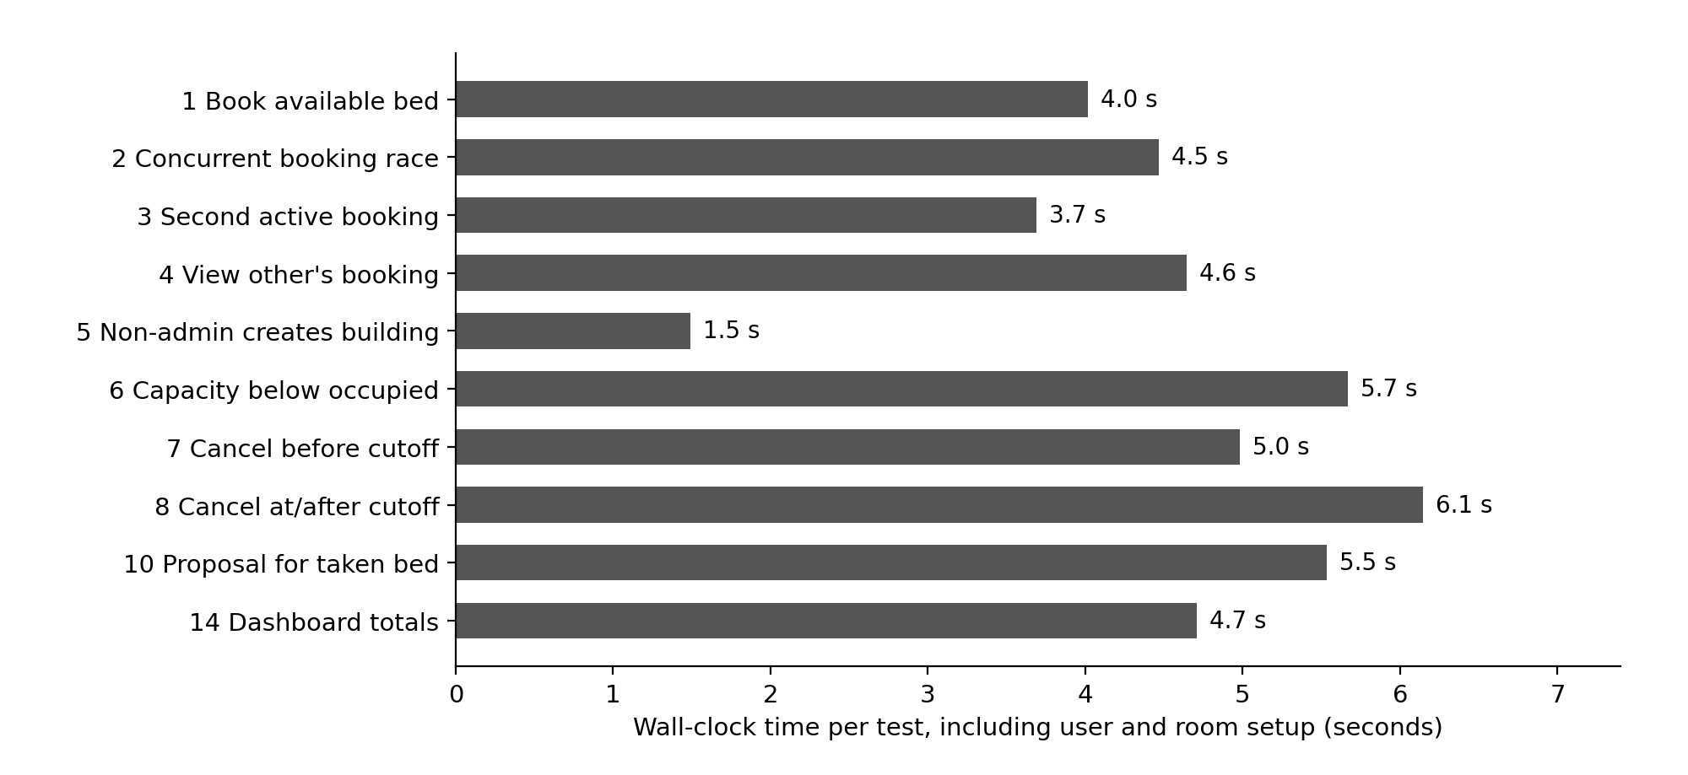
Figure 5: Measured wall-clock duration for each passing integration test suite (durations include dynamic entity creation on remote database instances rather than raw API latency).

5.2 Allocation engine results
All three automated pytest suites executed with complete success: a feasible allocation scenario matching all applicants without unassigned individuals; an infeasible constraint scenario (requesting a double room where only single rooms are available) properly tagged as infeasible with the student identified as unplaced; and a resource contention scenario where two applicants compete for a single bed, resulting in exactly one successful assignment. These results validate the engine's capability to deliver clear, unambiguous outcomes when encountering conflicting constraints.

5.3 Acceptance criteria
Evaluation Criterion (PRD Section 8) | Fulfillment Status | Demonstrable Evidence
Administrators can provision residential blocks and rooms with automated bed capacity | Satisfied | Verified via Admin Dashboard; room creation routine automatically generates bed rows
Reported inventory totals precisely match database records | Satisfied | Verified via Integration Scenario 14
Concurrent attempts to book an identical bed are strictly prevented | Satisfied | Verified via Integration Scenario 2
Unauthorized access to private student records is denied | Satisfied | Verified via Integration Scenarios 4 and 5
Manual reservation remains fully functional without AI availability | Satisfied | Verified via Integration Scenario 1; booking pipeline operates independently of AI
Conversational assistant searches real-time data and avoids hallucinating rooms | Satisfied by Architecture | Data retrieval restricted to read-only tools; automated Scenario 9 skipped in recorded run
AI-assisted booking mandates explicit applicant confirmation | Satisfied | Proposal-confirmation lifecycle verified in Integration Scenario 10
Cancellation is permitted prior to cutoff and blocked thereafter | Satisfied | Verified via Integration Scenarios 7 and 8
Cancellation preserves audit records and immediately restores bed availability | Satisfied | Verified via Integration Scenario 7
Infeasible allocation requests yield explicit, explainable diagnostic results | Satisfied | Validated via automated constraint solver test suite
Public production deployment utilizes secure environment secrets and mock data | Satisfied | Enforced via Vercel configuration, Supabase vaults, and synthetic seed scripts

5.4 Success metrics
- Core booking and cancellation tests: 10 of 10 executed automated integration test scenarios passed successfully (100% pass rate).
- Duplicate active bookings for a bed: Zero duplicate records detected; concurrency tests confirmed exactly one active booking on contested beds.
- Unauthorized access attempts: Both evaluated penetration attempts (inspecting another student's booking and unauthorized building creation) were blocked.
- AI recommendation validity, explanation grounding and latency: Not measured systematically due to descoping the multi-provider benchmark suite, representing an acknowledged project boundary.
- Manual booking with AI disabled: Fully confirmed by architectural decoupling and verified in Test Scenario 1, which functions without calling AI services.

5.5 Deployment outcome
The production system is publicly deployed and accessible at https://hostel-allocation-system-inky.vercel.app, powered by a managed Supabase backend hosting migration schemas and synthetic seed inventory. Following the resolution of the language model identifier configuration (Section 5.6), the conversational assistant reliably handled housing inquiries during live manual evaluations across both desktop and mobile web browsers. Complete user journeys - including account registration, room selection, bed booking, reservation cancellation, and administrative oversight - were validated directly on the production platform.

5.6 Engineering problems and fixes
A variety of genuine technical obstacles emerged during system integration and production deployment. These issues are detailed below, as resolving them directly informed the final robust architecture.

Technical Challenge | Root Cause Diagnosis | Remediation Strategy
Universal booking failures during client execution | The reference generator depended on a cryptographic routine located in Supabase's extensions schema, rendering it inaccessible to functions operating under a restricted search path | Applied Migration 0003 replacing the routine with native gen_random_uuid(); ensured automatic profile creation for missing users; routed descriptive error logs to the developer console
Conversational AI assistant ceased responding | The initial default Gemini model endpoint was formally deprecated upstream; subsequently, free-tier throttling (~15 requests/min) introduced transient rejections | Decoupled the model identifier into an administrative secret; implemented request budgeting, exponential retries, and informative user-facing busy messages; reduced tool conversational turn depth
Single user prompts exhausted multiple API calls | Independent query, detail inspection, and response formulation were executed across separate LLM invocations | Refined system prompts to minimize unnecessary calls; introduced per-instance request budgeting to halt execution before exceeding provider limits
Account confirmation emails failed delivery | Supabase's default SMTP relay imposes strict hourly rate caps and restricts recipient domains to team members | Temporarily disabled mandatory email confirmation for the demo deployment, documenting the security trade-offs (unauthenticated accounts, bot vulnerability)
Integration test harness failed initialization | The loadEnv helper was erroneously imported from an external utility package in the test configuration | Corrected the import source to vite, enabling clean, automated execution of the entire test suite
Production build failed due to missing typings | Client environment configuration variables lacked formal TypeScript interface definitions | Added vite-env.d.ts declaration file and verified successful compilation of the production build

5.7 Discussion and limitations
- The most critical engineering outcome is that transactional integrity and concurrency rules are enforced definitively by the underlying database engine under genuine race conditions, rather than relying on brittle client-side logic.
- While the conversational AI subsystem is structurally constrained to prevent unauthorized actions, its response quality and factual grounding were evaluated through manual inspection rather than automated metric pipelines. The grounding test for non-existent amenities (Scenario 12) remains a manual verification.
- The implemented rate limiters operate on a per-instance basis within the serverless runtime, providing sufficient safeguards for a demonstration platform but falling short of an enterprise-grade global distributed rate limiter.
- Mandatory email verification was temporarily suspended for the public demonstration; an enterprise production deployment would require verified institutional emails restricted to campus domains alongside CAPTCHA challenges.
- Although the constraint allocation engine is fully operational and verified via automated tests, it is not yet integrated directly into the conversational interface or administrative bulk-assignment workflows.
- Integration test suites execute against a remote cloud database, introducing network latency compared to local SQLite testing; test harnesses must never be executed against production databases.

6. Future Work

6.1 Evaluate several language-model providers
Implement a model-agnostic abstraction layer and an administrative benchmarking dashboard capable of executing standardized synthetic evaluation scenarios across multiple leading LLM providers (e.g., Anthropic Claude, OpenAI GPT, Google Gemini). By tracking operational latency, tool-call syntax accuracy, recommendation validity, and explanation grounding within the existing ai_evaluations schema, this capability would replace subjective assessments with empirical quality metrics and eliminate dependency on a single model provider.

6.2 Use the allocation engine in the product
Publish the constraint solver via a secured backend API endpoint, enabling the conversational assistant to articulate algorithmic trade-offs directly from optimization results. Additionally, introduce an administrative bulk-allocation module that provides interactive visual previews of proposed room assignments, highlights constraint satisfaction metrics, identifies unassigned applicants, and commits allocations atomically via validated database procedures. For institutional-scale deployments handling tens of thousands of applicants, evaluate transitioning from backtracking search to Google OR-Tools CP-SAT.

6.3 Complete the admin and student experience
- Introduce comprehensive lifecycle management for residential blocks and rooms, including edit and deactivation workflows equipped with dependency warnings when active reservations exist, alongside a detailed per-room bed map visualizer displaying real-time occupancy.
- Develop an engaging public landing page, a personalized student portal highlighting active bookings, dedicated room detail pages, and multi-parameter filtering for room categories and facilities.
- Integrate automated notification systems (SMS/Email), waitlisting queues for fully occupied dormitory rooms, and a graphical audit trail viewer leveraging the existing audit_events schema.

6.4 Strengthen identity and abuse protection
Re-establish mandatory account verification using dedicated custom SMTP relays, restrict student registration strictly to authorized institutional email domains, deploy CAPTCHA verification, and cross-reference matriculation numbers against official registrar databases to prevent identity spoofing or unauthorized registration.

6.5 Richer allocation
Expand the allocation solver to incorporate soft constraints, including roommate mutual requests, special accessibility accommodations, and diversity/fairness distributions, optimized using explainable scoring weights. Advanced machine-learning compatibility matching models should remain out of scope until formal algorithmic fairness, bias, and privacy audits are conducted.

6.6 Operations and measurement
- Upgrade serverless per-instance rate limiting to a distributed Redis-backed or database-level token bucket mechanism with hard spending caps, alongside real-time monitoring of upstream provider latency and HTTP status codes.
- Implement automated health-check endpoints, a protected administrative database reset routine, and scheduled cron jobs to verify that configured LLM model identifiers remain active upstream.
- Automate amenity-grounding testing (Scenario 12) through simulated synthetic dialogues that assert conversational agents never fabricate non-existent housing amenities.
- Incorporate the automated test suite into CI/CD pipelines executed against ephemeral Supabase test environments.

6.7 Conclusion
This project successfully demonstrates that a generative conversational assistant can be seamlessly integrated into a high-stakes reservation platform without compromising transactional integrity, provided core business invariants reside strictly within the relational database and the AI agent is confined to read-only discovery tools and temporary proposals. The deployed system satisfies all foundational acceptance criteria: bed reservations are atomic and immune to duplicate allocation, student privacy is guaranteed through Row-Level Security, cancellation adheres to server-enforced cutoff schedules, and the AI is structurally incapable of hallucinating room inventory or executing autonomous bookings. Primary areas for ongoing enhancement - including multi-provider model benchmarking, rigorous AI quality quantification, and expanded administrative tooling - are clearly scoped and can be implemented without altering the foundational architectural design.
References
- Supabase Documentation: Authentication, Row-Level Security, Database Functions, and Serverless Edge Functions. Available: https://supabase.com/docs (Accessed: November 2026).
- Google AI for Developers: Gemini API Reference, Structured Tool Calling, and Rate Limiting Quotas. Available: https://ai.google.dev/gemini-api/docs (Accessed: November 2026).
- PostgreSQL Global Development Group: PostgreSQL Documentation: Partial Indexes, Transaction Isolation, and Security-Definer Functions. Available: https://www.postgresql.org/docs/ (Accessed: November 2026).
- React Development Team: React 18 Framework Documentation. Available: https://react.dev (Accessed: November 2026).
- Vite & Vitest Engineering: Next Generation Frontend Tooling and Fast Unit/Integration Testing Framework. Available: https://vite.dev and https://vitest.dev (Accessed: November 2026).
- Google OR-Tools: Fast and Portable Software for Combinatorial Optimization (CP-SAT Solver). Available: https://developers.google.com/optimization (Accessed: November 2026).
- Vercel Documentation: Platform Deployments, Routing Rules, and Environment Configuration. Available: https://vercel.com/docs (Accessed: November 2026).
Appendix A: Project structure
hostel-allocation/
engine/allocator.py backtracking constraint solver & pytest suite
supabase/
seed.sql synthetic demonstration dataset
migrations/0001_init.sql ... 0005_admin_tools.sql sequential database migrations
functions/ai-chat/index.ts Gemini tool-orchestrating Edge Function
web/
package.json, vite.config.ts, vitest.config.ts, vercel.json
tests/integration.test.ts end-to-end integration test scenarios
src/ App.tsx, lib.ts, components.tsx, styles.css
src/pages/ Login, Rooms, MyBookings, AIAssistant,
Admin, AdminBookings, AdminSettings

Appendix B: Configuration names (no secrets)

Variable Name | Deployment Scope | Functional Description
VITE_SUPABASE_URL, VITE_SUPABASE_ANON_KEY | Vercel Environment / web .env | Public client-side connection parameters
GEMINI_API_KEY | Supabase Secrets Vault | Server-side authentication key for Gemini API
GEMINI_MODEL | Supabase Secrets Vault | Target Gemini model identifier, dynamically updateable without redeploying code
GEMINI_RPM | Supabase Secrets Vault | Sliding request quota budget kept below upstream provider limits (default 12)
TEST_SUPABASE_URL, TEST_SUPABASE_ANON_KEY, TEST_SERVICE_ROLE_KEY | web .env.test | Dedicated integration test project credentials; service-role key is strictly isolated from client bundles

