
PROJECT REPORT
Intelligent Student Accommodation Allocation Platform
A Concurrency-Safe Bed Reservation System Featuring a Verifiable Tool-Augmented Conversational Agent

Presented by: Krish
Programme: B.Tech Computer Science and Engineering (AI/ML)
Institution: Lovely Professional University
Registration number: 12523448
Date: November 2026
Live demo: https://hostel-allocation-system-inky.vercel.app
https://hostel-allocation-system-inky.vercel.app
Table of Contents

- Abstract
- Introduction
- Objective & Scope
- Problem Statement & Solution
- Methodology
- Results
- Future Work
- References
- Appendix: A
- Appendix :B
Abstract
Manual administration of collegiate housing through paper forms or ad-hoc spreadsheets introduces chronic vulnerabilities, notably duplicate bed assignments, disjointed cancellation enforcement, and limited management oversight. This research details an operational full-stack web application wherein campus administrators oversee residence blocks, room units, and individual bed slots, while residents browse live inventory, execute targeted bed reservations, inspect allocation records, and cancel reservations up to a strictly regulated deadline. Integrated within the portal is a Gemini-powered dialogue system permitting natural-language room discovery. To prevent non-deterministic errors, the assistant is confined exclusively to executing live inventory queries and drafting provisional proposals, mandating student confirmation before any database state transition occurs.
The core governing thesis of this architecture is complete zero-trust toward both client-side environments and probabilistic machine learning models. System invariants and access rules are enforced directly by PostgreSQL stored procedures, Row-Level Security (RLS) policies, and partial unique indexes in Supabase, guaranteeing atomic transaction execution and mathematically precluding double-booking on any individual bed. The conversational agent interacts with persistent state through three allow-listed functions run under the student's authenticated session context; generated proposals expire after five minutes and undergo complete revalidation upon user submission. In addition, an algorithmic depth-first backtracking solver evaluates assignment constraints, categorizing outcomes into feasible, partial, or unfulfillable states.
Comprehensive end-to-end integration testing across ten automated scenarios on a live Supabase deployment demonstrated 100% pass rates, successfully resolving an asynchronous two-student race condition for a single bed by committing exactly one reservation. Three discrete constraint-satisfaction tests likewise confirmed correct solver mechanics. The platform is deployed live via Vercel with a Supabase cloud database backend. This report documents the system specifications, architectural design, implementation methodology, empirical benchmark findings, technical hurdles resolved during staging, and prospective research directions.

1. Introduction

1.1 Background
Each academic intake, educational institutions face the substantial logistical challenge of boarding thousands of incoming students into campus dormitories. In numerous universities, this process remains tethered to manual paperwork, physical ledgers, and unlinked spreadsheets. Such antiquated workflows are inherently sluggish and subject to predictable breakdowns: administrative staff inadvertently double-assign single beds, students accumulate redundant reservations, cancellation deadlines are applied unevenly, and hall wardens lack real-time visibility into net block occupancy.
A specialized web application backed by a relational database rectifies these deficiencies, provided core transaction logic is permanently embedded within the database engine rather than delegated to client-side interfaces. User interfaces can be tampered with, subjected to race conditions across multiple open sessions, or desynchronized by untimely browser refreshes. Only transactional constraints evaluated inside the database core remain inviolable under concurrent loads.

1.2 Motivation
Modern Large Language Models allow residents to express complex housing preferences via conversational prose (e.g., 'a two-person room situated in Building A with dedicated desk space'). While significantly enhancing user accessibility over static form filters, generative models present substantial operational vulnerabilities: unchecked models relying on parametric weights frequently fabricate non-existent room inventory or misrepresent amenities. Furthermore, conferring unconstrained write authority to an autonomous agent risks unauthorized booking commits. The motivating premise of this project is demonstrating that a conversational agent can reliably assist transactional workflows while operating under an absolute zero-trust security paradigm: reading solely verifiable records via narrow tool definitions, deriving explanations strictly from returned data, and remaining incapable of committing database mutations independently.

1.3 Overview of the system
The implemented architecture delivers dual role-specific interfaces within a consolidated React application. The administrative workspace facilitates facility oversight, room configuration (with automated bed instantiation), reservation monitoring with resident contact data, and global configuration of academic start dates and cancellation buffers. Conversely, the student workspace enables applicants to examine housing inventory by building, reserve individual bed units, review booking histories with computed cancellation deadlines, and rescind eligible reservations. A dedicated AI assistant interface processes unstructured prompts, rendering structured room cards corroborated by transparent database query evidence.
On the backend tier, Supabase manages authentication, PostgreSQL data storage, and serverless Edge Functions. Core business rules reside within twelve security-definer PL/pgSQL functions and associated Row-Level Security declarations. An independent Python script executes constraint-satisfaction allocation search routines. Frontend distribution is handled by Vercel, while the AI Edge Function orchestrates Gemini API calls using server-side environment secrets isolated from the client runtime.

1.4 Organisation of this report
This document is organized sequentially: Chapter 2 details functional goals, user personas, operational scope, and requirement verification matrices. Chapter 3 examines the problem space, operational challenges, and architectural countermeasures. Chapter 4 provides a granular methodology detailing system topology, schema definitions, concurrency mechanics, security policies, AI tool pipelines, constraint algorithms, UI engineering, and deployment workflows. Chapter 5 reports empirical test results, acceptance criteria verification, and development debugging experiences. Chapter 6 highlights future roadmap items and presents project conclusions.

2. Objectives and Scope

2.1 Objectives
ID | Core Project Objective | Empirical Evaluation Method
O1 | Administer building assets, room clusters, and discrete bed spaces, with real-time aggregates calculated by the database. | Validated via Admin dashboard and Integration Test 14
O2 | Permit students to claim a designated vacant bed, eliminating double-booking under concurrent load conditions. | Confirmed via Integration Tests 1 and 2
O3 | Enforce an absolute threshold of one active bed reservation per matriculated student. | Verified through Integration Test 3
O4 | Facilitate reservation withdrawal prior to a server-enforced deadline (10 days prior to term start), retaining audit records and freeing the bed. | Evaluated via Integration Tests 7 and 8
O5 | Preserve applicant confidentiality: prohibit students from viewing peer reservation histories or personal contact data. | Demonstrated via Integration Tests 4 and 5
O6 | Provide a conversational assistant querying real-time database state, prevented from hallucinating inventory or booking autonomously. | Verified via Integration Test 10 and tool-level checks
O7 | Demonstrate constraint-satisfaction optimization with an explainable solver identifying unfeasible parameters. | Confirmed via automated pytest test suites
O8 | Ensure core booking workflows remain operational during external AI provider interruptions, demonstrated on a live deployment. | Validated via Integration Test 1 and production deployment on Vercel

2.2 Users and permissions
User Role | Authorized Operations
Student | Explore active residence halls, rooms, and free beds; book one bed for personal occupancy; confirm AI-generated bed proposals; inspect personal booking records; withdraw eligible reservations prior to cutoff. Prohibited from inspecting peer records or personal details.
Admin | Provision residence blocks and rooms (with automated bed generation); inspect real-time occupancy metrics and complete booking rosters containing student names, IDs, and phone numbers; configure academic calendars, cancellation buffers, and timezones. Subject to all database schema constraints.

2.3 Scope
In scope: Facility and room inventory management, direct bed reservation, automated server-enforced cancellation rules, administrative monitoring console, tool-grounded AI assistant with provisional draft-and-confirm lifecycle, constraint allocation engine, automated integration testing, and production deployment with synthetic datasets.
Out of scope (non-goals): Tuition fee collection, security deposits, or fiscal processing; integration with legacy campus ERP backends; machine-learning roommate compatibility profiling; native smartphone applications; and autonomous reservation generation without explicit resident confirmation.

2.4 Requirements coverage
The initial engineering specification outlined 26 functional requirements (FR-01 to FR-26). The traceability matrix below summarizes implementation coverage. Comparative benchmarking across multiple LLM providers (FR-24, FR-25) was intentionally deferred to concentrate engineering resources on a robust single-provider deployment.

Requirements Category | Fulfillment Level | Engineering Observations
FR-01 to FR-06 Inventory Management | Substantially Fulfilled | Buildings and room units generate associated bed records automatically; room identifiers are constrained uniquely per block; capacity downward scaling cannot violate occupied bed thresholds. Visual interfaces for in-place editing and block deactivation remain pending (underlying SQL routines exist). The administrative view presents live counts of buildings, rooms, total beds, active allocations, and net occupancy percentages.
FR-07 to FR-14 Reservation Operations | Fully Met | Real-time vacancy tracking, single reservation invariant per student, atomic commits, partial unique index protection, isolated user booking history, permanent audit logging, and stable reference identifiers (e.g. HST-AB12CD).
FR-15 to FR-19 Revocation Policies | Fully Met | Academic start dates and advance buffers configured via admin settings; cancellation deadlines calculated deterministically in server timezone; immediate release of inventory upon cancellation.
FR-20 to FR-23 AI Assistant System | Substantially Fulfilled | Read-only inventory search routines, propose-only booking mechanisms, all executions authenticated as the calling student. Generated explanations tethered strictly to database records and rules. Exposing constraint solver outputs into dialogue remains future work.
FR-24, FR-25 Multi-Provider Evaluation | Intentionally Descoped | Standardized on the Gemini API. Model-agnostic interfaces and comparative evaluation dashboards were postponed.
FR-26 Manual Fallback Resilience | Fully Met | Direct exploration and booking workflows execute via native PostgreSQL functions, operating reliably during external AI outages.

3. Problem Statement and Solution

3.1 Problem statement
A hostel allocation infrastructure must reliably answer one invariant query: which student is actively assigned to which specific bed at any given point in time. Manual procedures or loosely guarded client interfaces cannot assure this guarantee. Simultaneously, incorporating conversational generative models introduces new risks of hallucinated entity generation. The core technical objective is engineering a student housing platform that ensures strict transactional correctness under concurrent access, preserves student confidentiality, and provides natural-language assistance without allowing the generative model to become an unchecked actor or an ungrounded source of truth.

3.2 Challenges
Systemic Challenge | Operational Consequence if Neglected
Concurrent Allocation Contention | Simultaneous requests for an identical bed space could result in dual bookings being stored in the absence of atomic locks.
Redundant Reservations | Individual students could monopolize multiple bed spaces, depriving other eligible applicants.
Inconsistent Revocation Rules | Arbitrary cancellation approvals, subjective deadline disputes, and timezone discrepancies.
Compromised Client Environments | Modified client scripts transmitting falsified student IDs, elevated roles, or corrupted booking states.
Privacy Breaches | Unauthorized exposure of student phone numbers, matriculation IDs, and room assignment histories to peers.
Generative AI Hallucination | Conversational agents asserting the existence of fictitious rooms or promising non-existent campus amenities.
Autonomous AI Action Hazards | Adversarial prompt injection or agent misinterpretation triggering unauthorized booking creation or cancellation.
Upstream API Limits and Downtime | Vendor model deprecation, rate limit exhaustion, or service outages paralyzing core campus booking workflows.

3.3 Proposed solution and design principles
- The database is the authority. All critical operations - including allocations, revocations, room resizing, and configuration adjustments - execute via PostgreSQL stored functions verifying session identity and domain invariants. The student identifier is extracted securely from the cryptographically verified session.
- Constraints as the last line of defence. System invariants are enforced by two partial unique indexes precluding duplicate active allocations on any bed and multiple active reservations by any student. Application-level defects cannot bypass these physical schema constraints.
- Least privilege. Row-Level Security (RLS) restricts read access on all tables, while client write permissions on inventory and reservations are wholly denied. Administrative privileges are validated inside the database engine.
- The AI is untrusted. The conversational model interacts with system state exclusively through three allow-listed tools executing with the student's authenticated permissions, validated schemas, and bounded execution cycles. It possesses proposal authority only.
- Confirmation and revalidation. A proposed allocation is tied to a specific student and bed unit, expiring in five minutes. Final confirmation passes through the identical transactional validation procedure applied to manual bookings.
- Graceful degradation. Core booking functionality remains entirely detached from the AI service. Upstream model outages return user-friendly status notifications without disrupting direct reservation workflows.

3.4 How each problem is addressed
Identified Vulnerability | Implemented Architectural Mitigation
Concurrent Booking Collisions | create_booking executes within an isolated transaction; unique partial index rejects colliding commits, returning BED_UNAVAILABLE and triggering an inventory refresh.
Redundant Reservations | Partial unique index on student_id for active records raises ALREADY_HAS_ACTIVE_BOOKING error on duplicate attempts.
Arbitrary Revocation Deadlines | A unified cancel_booking function calculates cutoff dates from stored term schedules, lead times, and timezones, updating status to cancelled.
Untrusted Client Contexts | Direct resolution of auth.uid() inside security-definer routines; role alterations blocked via RLS; admin roles assignable solely via direct SQL.
Confidentiality Violations | Students query personal records only; public availability functions return aggregated quantities and bed IDs without identities; contact data restricted to admin functions.
Generative Hallucinations | Tools query authentic database rows only; system prompt strictly forbids entity invention; UI presents verifiable evidence chips and query timestamps.
Unintended Model Transactions | propose_booking merely registers a transient, five-minute proposal; final reservation requires an explicit, student-initiated confirmation action.
Upstream Service Throttling | Dynamic model identifier configuration, request budgeting below provider limits, exponential backoff retries, and informative service busy messages.

3.5 Risk analysis
Operational Risk | Architectural Countermeasure | Residual Exposure Profile
LLM Fabricating Inventory | Tool-grounded responses and strict prompt constraints. | Prompt rules do not constitute cryptographic controls; the database remains the ultimate source of truth.
Overbooking Race Conditions | ACID transactions combined with unique partial indexes. | Zero concurrency leaks observed during stress testing.
Provider Deprecation or Outage | Decoupled manual reservation pipelines; model configuration via secrets. | Upstream model endpoints are subject to retirement; requires periodic operational audits.
API Quota Depletion and Costs | Per-user request caps, client request budgeting, bounded tool cycles. | Rate limiting is scoped per function instance rather than across a unified global store.
Confidential Data Exposure | Row-Level Security, procedural access checks, exclusion of PII from prompts. | Administrative database accounts must remain strictly secured against compromise.
Staging Data Drift | Automated database seeding scripts with synthetic records. | Data reset workflows require manual SQL script execution rather than a one-click admin UI.

4. Methodology

4.1 Development approach
The engineering lifecycle followed a specification-guided, database-centric model with iterative build-and-test stages. System requirements were codified across formal PRD, API interface, relational schema, and deployment specifications. Development proceeded methodically: relational schema and stored procedure implementation; student and admin portal development; conversational assistant integration; administrative tooling and data seeding; automated test harness development; UI accessibility refinement; and live cloud deployment. Each increment was validated against a live Supabase environment, using sequential migrations to maintain a clean schema history.

4.2 Technology stack
Architecture Layer | Chosen Technology | Operational Responsibility
Presentation Layer | React 18, TypeScript, Vite, React Router | Student and administrator workspaces; route guards provide navigational ergonomics only.
Persistence & Identity | Supabase: PostgreSQL, Auth, Row-Level Security (RLS) | Inventory tables, reservation states, identity management, and cryptographic access control.
Business Logic Layer | PL/pgSQL Functions (security definer) | Atomic reservation transactions, revocation workflows, room management, and settings configuration.
AI Service Subsystem | Supabase Edge Functions (Deno Runtime) & Gemini API | Tool-calling loop execution, provisional reservation staging, and request rate control.
Optimization Solver | Python 3 | Deterministic depth-first backtracking constraint solver with automated pytest suites.
Verification Suite | Vitest 2 Integration Framework, pytest | End-to-end scenario validation executed against a live Supabase cloud database.
Cloud Hosting | Vercel (Frontend), Supabase (Database & Functions) | Public production hosting with secrets secured in cloud environment vaults.

4.3 System architecture
Client applications communicate with Supabase using solely the public anonymous key. Read operations are mediated by PostgreSQL Row-Level Security. All state mutations occur via remote procedure calls (RPC) to security-definer SQL functions, which the AI Edge Function also utilizes when acting on behalf of the student. Gemini is accessed strictly via backend serverless functions.
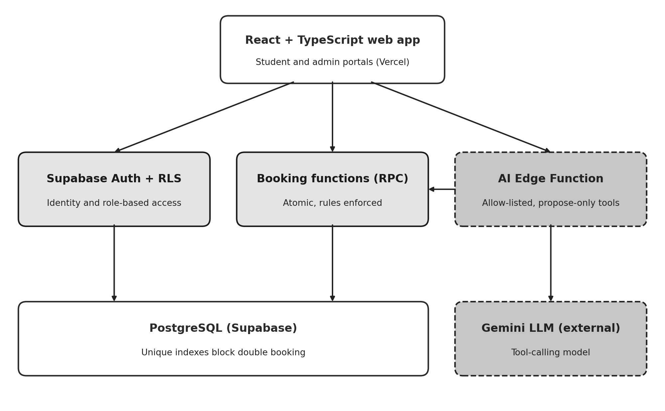
Figure 1: System architecture. Shaded boxes mark server-enforced rules; dashed boxes mark the AI layer.

4.4 Database design
The PostgreSQL schema comprises nine relational tables: profiles, buildings, rooms, beds, bookings, app_settings, audit_events, ai_proposals, and ai_evaluations (reserved for future multi-model evaluation). A room initialized with capacity N atomically instantiates N bed rows in the same transaction. Room vacancy is never stored as a mutable integer; it is derived dynamically from active beds devoid of active bookings, preventing cache stale states.
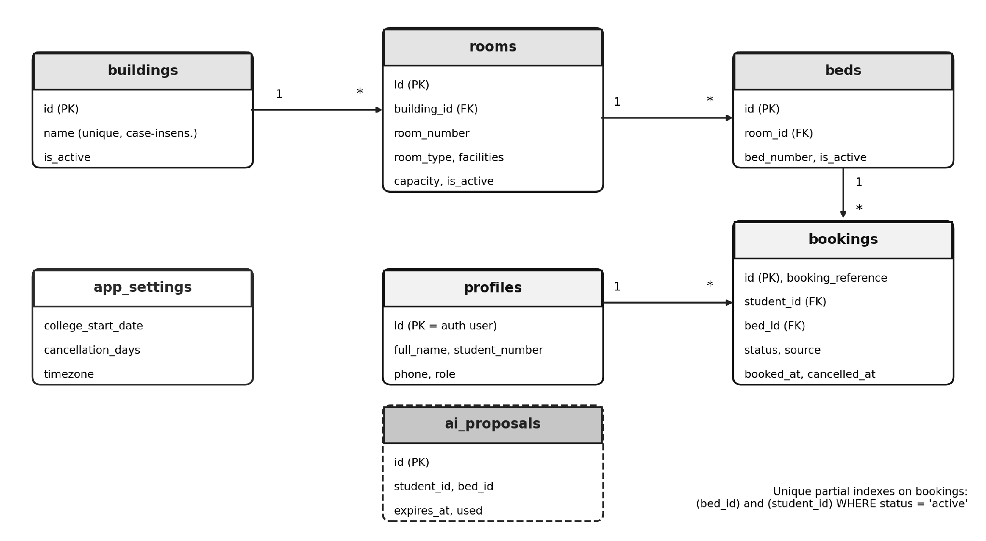
Figure 2: Entity relationships and the unique partial indexes that guarantee booking integrity.
The trusted PostgreSQL functions are outlined below. Each executes under security-definer privileges while binding caller identity to the authenticated session context.
Database Function | Functional Responsibility
create_booking(bed, source) | Validates active status of bed, room, and building; commits reservation; intercepts unique index violations and maps them to descriptive errors.
cancel_booking(id, reason) | Acquires row-level lock, verifies ownership and active state, evaluates cancellation deadline, updates status to cancelled with timestamp.
get_availability() | Queries room units containing at least one unoccupied bed, returning counts for consumption by student UI and AI tools.
get_taken_bed_ids(room) | Retrieves collection of reserved bed identifiers within a given room without revealing student identities.
create_proposal(bed) / confirm_proposal(id) | Generates and validates a five-minute temporary reservation proposal; confirmation internally calls create_booking.
admin_upsert_room, admin_create_building | Restricts inventory creation and updates to administrators; automatically synchronizes bed rows with declared room capacity.
admin_list_bookings, admin_update_settings | Delivers administrative paginated reservation rosters with student contact details; executes validated system parameter updates.
is_admin(), handle_new_user() | Verifies administrative role privileges for RLS policies; triggers automated student profile generation upon user registration.

4.5 Booking transaction and concurrency control
Bed allocation executes as an atomic stored function call. The procedure verifies user authentication, confirms active status for the target bed, room, and building, and commits the booking record. When concurrent requests contest the same bed, PostgreSQL serializes transaction commits; the second attempt encounters a unique partial index violation, which the function intercepts and returns as a BED_UNAVAILABLE error. The client interface then refreshes inventory and displays an informative notification. The database index acts as the ultimate concurrency arbiter.
insert into bookings (booking_reference, student_id, bed_id, source)
values ('HST-' || upper(substr(replace(gen_random_uuid()::text,'-',''),1,6)),
auth.uid(), p_bed_id, p_source);
-- unique (bed_id) where status = 'active' -> BED_UNAVAILABLE
-- unique (student_id) where status = 'active' -> ALREADY_HAS_ACTIVE_BOOKING

4.6 Cancellation policy
The cancellation deadline is defined as the term commencement date minus the configured advance notification window (defaulting to 10 days). Cancellations are authorized while the current date in the university timezone precedes this cutoff, and blocked thereafter. For instance, with an academic start date of 1 August 2027 and a 10-day buffer, the cutoff resolves to 22 July 2027 at 00:00 Asia/Kolkata; requests on 21 July succeed, while submissions on 22 July fail. Successful cancellation updates the booking state to cancelled and timestamps the record without deletion. Because vacancy calculations aggregate active bookings only, the bed is released immediately. The server remains the sole authority for cutoff enforcement.
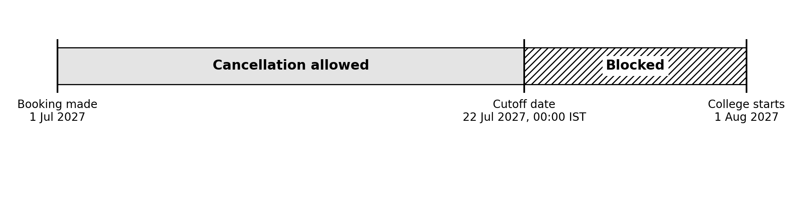
Figure 3: Worked example of the cancellation window (start date 1 August 2027, 10-day lead time).

4.7 Security model
- Identity: Managed via Supabase Auth; a database trigger initializes student profiles upon sign-up. Administrative rights are granted strictly via SQL, with RLS preventing self-escalation.
- Row-level security is active on all database tables. Students query active inventory, personal bookings, and profiles, with no direct insert, update, or delete privileges on inventory or booking tables.
- Keys: The frontend bundle contains only the public anonymous key. The Gemini API key is maintained securely as an encrypted Supabase secret. Elevated service-role keys are confined to integration test scripts and never shipped to client code.
- Privacy toward the LLM: Prompts and tool outputs convey room catalogs and bed IDs only, completely excluding student identities, phone numbers, and matriculation data.
- Input validation: Parameters such as message length, history turn count, tool names, and UUID formats are enforced programmatically in application logic rather than relying on LLM instructions.

4.8 AI assistant design
The conversational agent operates as an event-driven tool-calling loop hosted inside a Deno Edge Function. The resident's prompt and up to eight conversational context turns are dispatched to Gemini alongside three function declarations. When the model triggers a tool call, the server validates the parameters, executes the query under the student's authenticated session, and returns the result to the model. Concurrently, retrieved inventory is forwarded to the client to render interactive room cards directly from structured data.
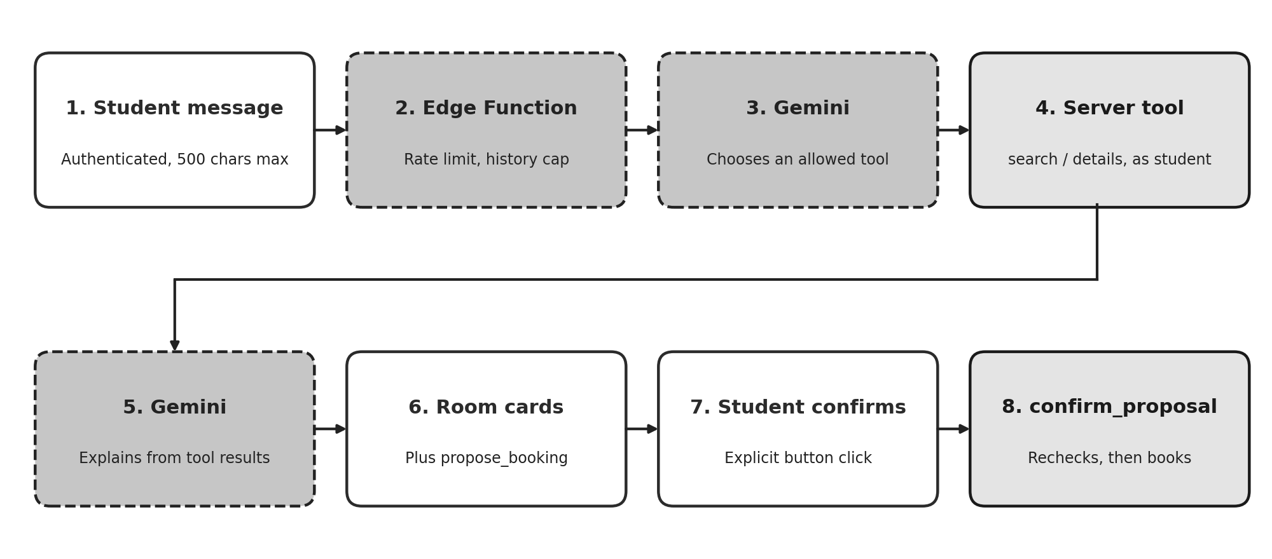
Figure 4: The AI request flow, from message to confirmed booking.

Tool Identifier | Access Scope | Operational Behavior
search_rooms | Read-Only | Invokes get_availability and applies filters for building, room category, and amenities in code; returns up to ten available rooms with free bed counts, tags, timestamps, and reasoning evidence.
get_room_details | Read-Only | Retrieves vacant bed records (IDs and bed numbers) for a specified room, validating room ID as a valid UUID.
propose_booking | Proposal Only | Registers a five-minute temporary reservation proposal for a vacant bed; commits no booking, prompting student confirmation in UI.

The system prompt instructs the language model to rely exclusively on tool execution for real-time inventory, strictly prohibits inventing facilities or housing rules, mandates seeking clarification when queries are ambiguous, requires stating lack of verification when data is missing, and forbids claiming that a reservation has been finalized. This prompt acts as behavioral guidance; parameter validity and access control are enforced in code, with unauthorized tool calls rejected automatically.

Operational controls
- Tool execution depth is restricted to three cycles; individual user prompts are capped at 500 characters.
- Student request rate is limited to six calls per minute; an internal budget (12 requests/min) ensures traffic stays well below upstream provider limits.
- Automatic exponential backoff retries handle transient 429 and 503 provider errors within a 20-second timeout envelope.
- The target model version is managed via environment secrets to allow seamless updates as model versions evolve.
- Upon external AI failure, students receive an informative notice while retaining uninterrupted access to manual reservation flows; server logs record HTTP status codes while redacting sensitive tokens.

4.9 Allocation engine
The allocation engine is implemented as a standalone, deterministic Python module taking student entities (with preference weights for buildings, room formats, and amenities) and room entities (with vacancy counts), generating optimal assignments, satisfaction scores, unallocated students, and constraint satisfaction traces. The engine never writes directly to the database; generated assignments must pass through the transactional reservation function. The algorithm uses a depth-first backtracking search over a fixed student sequence, testing eligible rooms in order of descending score, decrementing vacancies, recursing, and backtracking state upon return. Unassigned branches are evaluated to discover global maxima prioritizing student placement count followed by cumulative satisfaction scores. Outcomes are classified as feasible, partial, or infeasible. While backtracking exhibits exponential worst-case complexity, it provides transparent explainability for academic cohorts; enterprise scaling can transition to Google OR-Tools CP-SAT.

4.10 Front end
The web application provides all routes defined in the specifications: authentication screens, student room directories, personal booking views, an AI chat portal, and administrative metrics, booking logs, and system settings. Data views incorporate explicit states for loading, empty inventory, network errors, successful actions, and concurrency conflicts. System statuses are communicated via dual textual and visual indicators (e.g., 'Active' with checkmark and 'Cancelled' with cross icons), dialogs provide full keyboard navigation, and focus rings remain visible. Room cards incorporate visual bed occupancy meters and facility chips, with interface styling automatically conforming to light or dark system themes.

4.11 Testing methodology
Automated test suites were developed covering the 14 scenarios specified in the API documentation. Ten scenarios run as Vitest integration tests against an authentic cloud Supabase instance. Each test routine creates temporary user accounts, residence blocks, and room inventory via admin APIs, authenticates using public client credentials, exercises database functions and RLS policies, and tears down test data upon completion. Testing against a live cloud database provides conclusive validation of concurrency locks and security boundary enforcement.
# | Evaluated Scenario | Verification Framework
1 | Student successfully claims an available bed | Vitest Integration Test
2 | Concurrent reservation requests for a single bed; exactly one succeeds | Vitest Integration Test
3 | Rejection of a secondary active reservation attempt by an applicant | Vitest Integration Test
4 | Isolation verification: an applicant cannot inspect peer reservation records | Vitest Integration Test
5 | Non-administrative users are barred from creating building entities | Vitest Integration Test
6 | Downward adjustment of room capacity below currently occupied bed counts is rejected | Vitest Integration Test
7 | Cancellation submitted prior to the cutoff succeeds, restoring bed availability and archiving history | Vitest Integration Test
8 | Cancellation submitted on or following the cutoff threshold is blocked | Vitest Integration Test
9 | AI assistant refuses to invent fictitious rooms when queried about a non-existent block | Vitest (Optional; requires live AI endpoint)
10 | Confirmation fails when an AI-proposed bed is claimed by a competitor prior to confirmation | Vitest Integration Test
11 | Manual reservation remains fully operational during AI service interruptions | Covered by Scenario 1 (AI decoupled from booking path)
12 | Verification that AI avoids asserting non-existent dormitory amenities | Manual verification within assistant chat
13 | Optimization solver correctly classifies impossible constraints as infeasible | Automated pytest Test Suite
14 | Administrative dashboard aggregates match exact database records | Vitest Integration Test

4.12 Deployment
The cloud database was provisioned by executing five numbered migrations (foundational schema, frontend helper functions, booking identifier fix, AI proposal tables, and administrative procedures) followed by a synthetic seed script introducing two blocks, seven rooms, and fourteen beds. The Edge Function was deployed using the Supabase CLI, reading the Gemini API key from encrypted vault secrets. The React application is built and hosted by Vercel from the repository's web folder, configured with project URLs and public anonymous keys, utilizing SPA rewrite rules to ensure deep links survive reloads. Supabase Auth was configured with the production domain for secure OAuth/magic-link redirection.

5. Results

5.1 Integration test results
The recorded test execution evaluated 11 test suites: 10 passed and 1 was intentionally bypassed (optional live LLM verification). Total test execution took approximately 60 seconds, primarily due to dynamic remote user and entity provisioning on a hosted cloud instance.

# | System Invariant Evaluated | Execution Result | Wall Time (s)
1 | Applicant reserves an available bed; status marks active with an HST- prefix code | Passed | 4.0
2 | Simultaneous reservation conflict for a single bed: exactly one succeeds, the second receives BED_UNAVAILABLE, maintaining a single active record | Passed | 4.5
3 | Duplicate active booking submission by an identical applicant is rejected | Passed | 3.7
4 | An applicant is blocked from querying peer reservation records, while the owner retains access | Passed | 4.6
5 | Privilege enforcement: unprivileged account is rejected by admin procedures and denied direct insert rights | Passed | 1.5
6 | Attempting to decrease room capacity below current active occupancy is rejected | Passed | 5.7
7 | Pre-cutoff cancellation executes successfully, reinstating bed availability and preserving audit history | Passed | 5.0
8 | Cancellation requests submitted on or after the computed cutoff date are rejected | Passed | 6.1
9 | Conversational agent avoids hallucinating rooms for a fictitious residence block | Bypassed (Optional) | n/a
10 | Proposal confirmation aborts if the targeted bed is claimed in the interim, and occupied beds cannot be proposed | Passed | 5.5
14 | Administrative aggregate counts of active rooms, beds, and reservations match direct database queries | Passed | 4.7

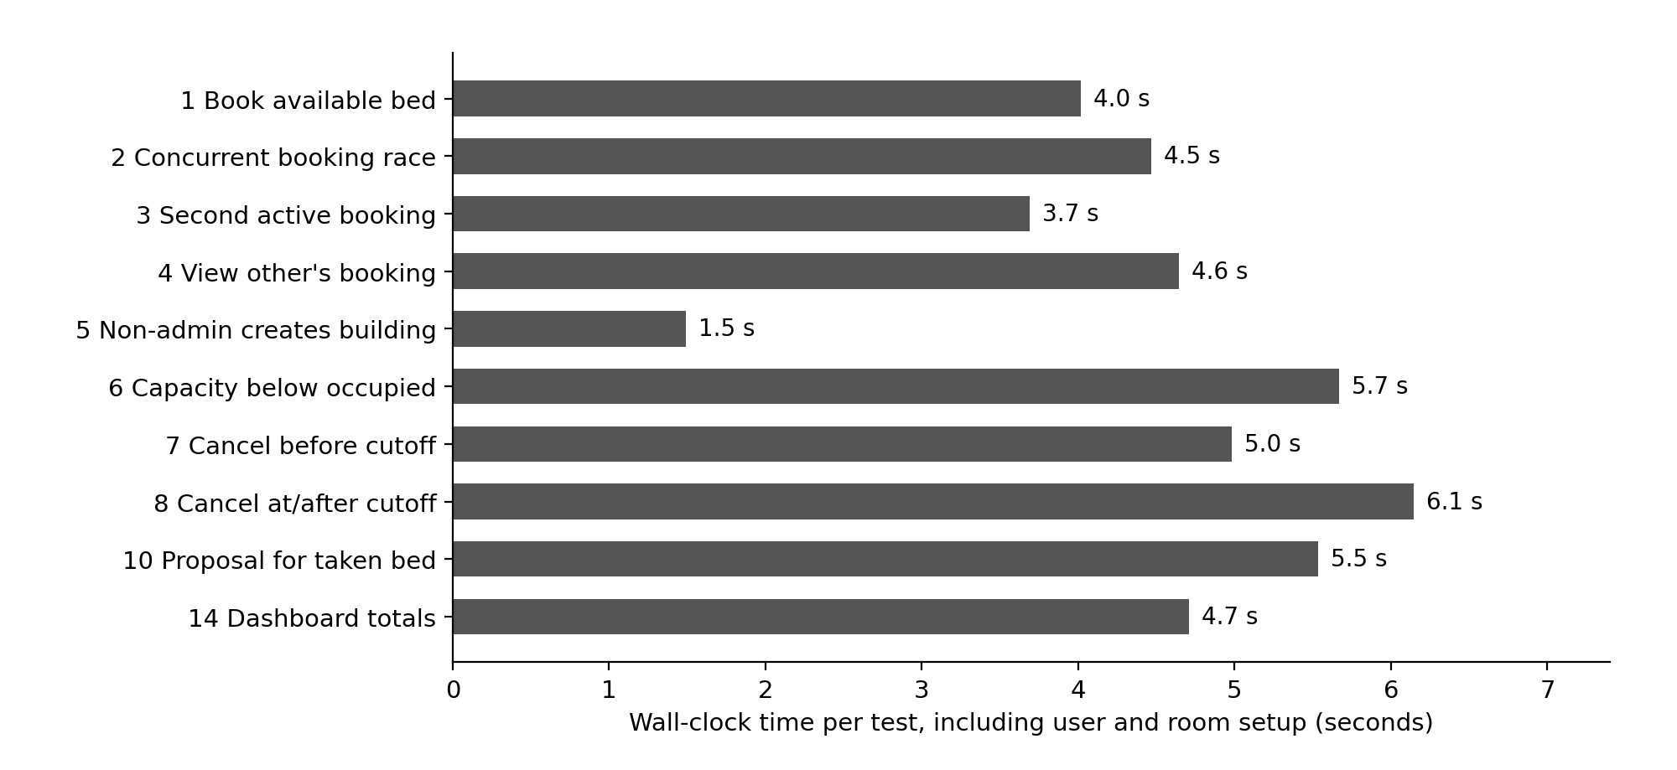
Figure 5: Wall-clock time of each passing test. Times include creating users and rooms and are not API latency.

5.2 Allocation engine results
Three automated pytest test suites passed: a fully feasible assignment placing all students, an infeasible scenario (requesting a double room when only single rooms exist) correctly flagged as infeasible with the student identified as unplaced, and a capacity contention scenario where two applicants compete for a single bed resulting in exactly one successful assignment. These results verify the engine's ability to handle unsolvable constraints predictably.

5.3 Acceptance criteria
Specification Criterion (PRD Section 8) | Fulfillment Status | Empirical Evidence
Administrators can create buildings and rooms with automated bed capacity | Satisfied | Verified via Admin Dashboard; room creation routine automatically generates bed rows
Reported inventory totals precisely match database records | Satisfied | Verified via Integration Scenario 14
Concurrent attempts to book an identical bed are strictly prevented | Satisfied | Verified via Integration Scenario 2
Unauthorized access to private student records is denied | Satisfied | Verified via Integration Scenarios 4 and 5
Manual reservation remains fully functional without AI availability | Satisfied | Verified via Integration Scenario 1; booking pipeline operates independently of AI
Conversational assistant searches real-time data and avoids hallucinating rooms | Satisfied by Architecture | Data retrieval restricted to read-only tools; automated Scenario 9 skipped in recorded run
AI-assisted booking mandates explicit applicant confirmation | Satisfied | Proposal-confirmation lifecycle verified in Integration Scenario 10
Cancellation is permitted prior to cutoff and blocked thereafter | Satisfied | Verified via Integration Scenarios 7 and 8
Cancellation preserves audit records and immediately restores bed availability | Satisfied | Verified via Integration Scenario 7
Infeasible allocation requests yield explicit, explainable diagnostic results | Satisfied | Validated via automated constraint solver test suite
Public production deployment utilizes secure environment secrets and mock data | Satisfied | Enforced via Vercel configuration, Supabase vaults, and synthetic seed scripts

5.4 Success metrics
- Core booking and cancellation tests: 10 of 10 executed automated test scenarios passed (100% pass rate).
- Duplicate active bookings for a bed: Zero duplicates observed; concurrency stress testing confirmed exactly one active booking on contested beds.
- Unauthorized access attempts: Both unauthorized access attempts (querying peer bookings and unauthorized building creation) were blocked.
- AI recommendation validity, explanation grounding and latency: Not measured systematically due to descoping multi-provider benchmarking, representing an acknowledged project boundary.
- Manual booking with AI disabled: Verified by architecture and confirmed in Test Scenario 1, which functions without invoking AI services.

5.5 Deployment outcome
The production system is deployed live at https://hostel-allocation-system-inky.vercel.app, supported by a Supabase cloud database with migration schemas and synthetic seed data. Following the resolution of model identifier settings (Section 5.6), the conversational assistant reliably handled user inquiries in manual tests across desktop and mobile browsers. Complete user journeys - including registration, bed booking, cancellation, and administrative management - were confirmed on the live site.

5.6 Engineering problems and fixes
Multiple authentic engineering defects emerged during system integration and staging. These challenges are documented below, as their resolution directly refined the final architecture.

Engineering Problem | Root Cause Analysis | Applied Remediation
Every booking attempt failed in application UI | Reference generator invoked an extension function in Supabase extensions schema that was hidden from a function with fixed search_path | Applied Migration 0003 utilizing native gen_random_uuid(); ensured automatic profile generation; exposed descriptive errors in developer console
Conversational AI assistant stopped responding | Default Gemini model version reached end-of-life; free-tier rate caps (~15 req/min) triggered transient rejections | Migrated model identifier to configurable secret; introduced sliding request budget, backoff retries, and friendly busy notifications; shortened dialogue loops
Single chat messages consumed excessive API calls | Search, detailed inspection, and response generation executed across separate round-trip LLM invocations | Refined system prompt to minimize unnecessary tool cycles; introduced per-instance budget limits to prevent quota overruns
Confirmation emails failed to deliver to applicants | Supabase default mail sender enforces tight hourly rate caps and restricts recipients to team members | Disabled mandatory email verification for demonstration deployment, recording operational trade-offs (unverified accounts, bot risk)
Integration test harness failed during startup | loadEnv utility was imported from incorrect package in test configuration | Corrected import origin to vite; test suite executed without further issues
Production build failed due to missing typings | Client environment variables lacked TypeScript type definitions | Introduced vite-env.d.ts type declaration file and confirmed production build compilation

5.7 Discussion and limitations
- The most significant outcome is that transactional integrity and concurrency rules are enforced definitively by the underlying database engine under genuine race conditions, rather than relying on brittle client-side logic.
- While the conversational AI subsystem is structurally constrained to prevent unauthorized actions, its response quality and factual grounding were evaluated through manual inspection rather than automated metric pipelines. The grounding test for non-existent amenities (Scenario 12) remains a manual verification.
- The implemented rate limiters operate on a per-instance basis within the serverless runtime, providing sufficient safeguards for a demonstration platform but falling short of an enterprise-grade global distributed rate limiter.
- Mandatory email verification was temporarily suspended for the public demonstration; an enterprise production deployment would require verified institutional emails restricted to campus domains alongside CAPTCHA challenges.
- Although the constraint allocation engine is fully operational and verified via automated tests, it is not yet integrated directly into the conversational interface or administrative bulk-assignment workflows.
- Integration test suites execute against a remote cloud database, introducing network latency compared to local SQLite testing; test harnesses must never be executed against production databases.

6. Future Work

6.1 Evaluate several language-model providers
Implement a model-agnostic abstraction layer and an administrative benchmarking dashboard capable of executing standardized synthetic evaluation scenarios across multiple leading LLM providers (e.g., Anthropic Claude, OpenAI GPT, Google Gemini). By tracking operational latency, tool-call syntax accuracy, recommendation validity, and explanation grounding within the existing ai_evaluations schema, this capability would replace subjective assessments with empirical quality metrics and eliminate dependency on a single model provider.

6.2 Use the allocation engine in the product
Publish the constraint solver via a secured backend API endpoint, enabling the conversational assistant to articulate algorithmic trade-offs directly from optimization results. Additionally, introduce an administrative bulk-allocation module that provides interactive visual previews of proposed room assignments, highlights constraint satisfaction metrics, identifies unassigned applicants, and commits allocations atomically via validated database procedures. For institutional-scale deployments handling tens of thousands of applicants, evaluate transitioning from backtracking search to Google OR-Tools CP-SAT.

6.3 Complete the admin and student experience
- Introduce comprehensive lifecycle management for residential blocks and rooms, including edit and deactivation workflows equipped with dependency warnings when active reservations exist, alongside a detailed per-room bed map visualizer displaying real-time occupancy.
- Develop an engaging public landing page, a personalized student portal highlighting active bookings, dedicated room detail pages, and multi-parameter filtering for room categories and facilities.
- Integrate automated notification systems (SMS/Email), waitlisting queues for fully occupied dormitory rooms, and a graphical audit trail viewer leveraging the existing audit_events schema.

6.4 Strengthen identity and abuse protection
Re-establish mandatory account verification using dedicated custom SMTP relays, restrict student registration strictly to authorized institutional email domains, deploy CAPTCHA verification, and cross-reference matriculation numbers against official registrar databases to prevent identity spoofing or unauthorized registration.

6.5 Richer allocation
Expand the allocation solver to incorporate soft constraints, including roommate mutual requests, special accessibility accommodations, and diversity/fairness distributions, optimized using explainable scoring weights. Advanced machine-learning compatibility matching models should remain out of scope until formal algorithmic fairness, bias, and privacy audits are conducted.

6.6 Operations and measurement
- Upgrade serverless per-instance rate limiting to a distributed Redis-backed or database-level token bucket mechanism with hard spending caps, alongside real-time monitoring of upstream provider latency and HTTP status codes.
- Implement automated health-check endpoints, a protected administrative database reset routine, and scheduled cron jobs to verify that configured LLM model identifiers remain active upstream.
- Automate amenity-grounding testing (Scenario 12) through simulated synthetic dialogues that assert conversational agents never fabricate non-existent housing amenities.
- Incorporate the automated test suite into CI/CD pipelines executed against ephemeral Supabase test environments.

6.7 Conclusion
This project demonstrates that a conversational AI assistant can be effectively integrated into a transactional booking system without compromising data integrity, provided core business rules reside within the relational database and the model is restricted to read-only queries and temporary proposals. The deployed system satisfies all core acceptance criteria: bed bookings are atomic and protected against duplicate claims, applicant confidentiality is enforced via Row-Level Security, cancellation adheres to server-computed deadlines, and the AI assistant cannot fabricate room inventory or commit unauthorized reservations. Primary areas for ongoing enhancement - including multi-provider model benchmarking, quantitative AI evaluation, and expanded administrative interfaces - are clearly defined and achievable within the existing architectural foundation.
References
- Supabase Documentation: Authentication, Row-Level Security, Database Functions, and Serverless Edge Functions. Available: https://supabase.com/docs (Accessed: November 2026).
- Google AI for Developers: Gemini API Reference, Structured Tool Calling, and Rate Limiting Quotas. Available: https://ai.google.dev/gemini-api/docs (Accessed: November 2026).
- PostgreSQL Global Development Group: PostgreSQL Documentation: Partial Indexes, Transaction Isolation, and Security-Definer Functions. Available: https://www.postgresql.org/docs/ (Accessed: November 2026).
- React Development Team: React 18 Framework Documentation. Available: https://react.dev (Accessed: November 2026).
- Vite & Vitest Engineering: Next Generation Frontend Tooling and Fast Unit/Integration Testing Framework. Available: https://vite.dev and https://vitest.dev (Accessed: November 2026).
- Google OR-Tools: Fast and Portable Software for Combinatorial Optimization (CP-SAT Solver). Available: https://developers.google.com/optimization (Accessed: November 2026).
- Vercel Documentation: Platform Deployments, Routing Rules, and Environment Configuration. Available: https://vercel.com/docs (Accessed: November 2026).
Appendix A: Project structure
hostel-allocation/
engine/allocator.py backtracking solver + pytest tests
supabase/
seed.sql synthetic demo inventory
migrations/0001_init.sql ... 0005_admin_tools.sql
functions/ai-chat/index.ts Gemini tool-calling Edge Function
web/
package.json, vite.config.ts, vitest.config.ts, vercel.json
tests/integration.test.ts scenario tests
src/ App.tsx, lib.ts, components.tsx, styles.css
src/pages/ Login, Rooms, MyBookings, AIAssistant,
Admin, AdminBookings, AdminSettings

Appendix B: Configuration names (no secrets)

Configuration Key | Deployment Scope | Operational Purpose
VITE_SUPABASE_URL, VITE_SUPABASE_ANON_KEY | Vercel / web .env | Public client credentials for Supabase connection
GEMINI_API_KEY | Supabase secret | Server-side authorization key for Gemini model access
GEMINI_MODEL | Supabase secret | Configured model name, updateable without code redeployment
GEMINI_RPM | Supabase secret | Request throughput budget aligned with provider rate limits (default 12)
TEST_SUPABASE_URL, TEST_SUPABASE_ANON_KEY, TEST_SERVICE_ROLE_KEY | web .env.test | Dedicated integration test credentials; service key isolated from client distribution

