
PROJECT REPORT
Automated University Dormitory Allocation Infrastructure
A Resilient Bed Management Web Portal with a Grounded, Function-Calling AI Concierge

Presented by: Krish
Programme: B.Tech Computer Science and Engineering (AI/ML)
Institution: Lovely Professional University
Registration number: 12523448
Date: November 2026
Live demo: https://hostel-allocation-system-inky.vercel.app
https://hostel-allocation-system-inky.vercel.app
Table of Contents

- Abstract
- Introduction
- Objective & Scope
- Problem Statement & Solution
- Methodology
- Results
- Future Work
- References
- Appendix: A
- Appendix :B
Abstract
Relying on manual paper logs or standalone spreadsheets for university bed allocation inevitably causes race-condition overbookings, erratic cancellation handling, and poor administrative transparency. This project engineers a production-ready web platform where campus facilities teams configure residence towers, rooms, and specific bed units, while university students examine real-time vacancies, lock in individual beds, track their booking history, and cancel reservations up to an automated, configurable cutoff date. A conversational agent powered by Gemini assists students through natural-language prompts. To maintain total data integrity, the assistant is restricted strictly to querying real-time inventory and generating temporary reservation proposals, demanding explicit student confirmation before any database record is committed.
The foundational engineering principle of this platform is zero trust toward client-side execution and generative AI outputs. System rules are enforced exclusively by PostgreSQL functions, Row-Level Security policies, and partial unique indexes within Supabase, ensuring atomic transactions and making double-booking physically impossible at the database layer. The conversational agent executes three permit-listed tools under the authenticated student's session permissions; generated proposals automatically expire after five minutes and are re-evaluated by the standard booking pipeline upon confirmation. Furthermore, an algorithmic backtracking solver evaluates assignment constraints, transparently reporting feasible, partial, or unfulfillable allocations.
The system underwent ten automated end-to-end integration test scenarios against an active Supabase cloud environment with a 100% pass rate, successfully resolving an asynchronous two-student race condition for a single bed by committing exactly one booking. Three discrete constraint solver test suites also passed. The system is deployed globally on Vercel with a Supabase PostgreSQL backend. This report details system requirements, architectural specifications, concurrency controls, empirical benchmark results, production debugging insights, and future roadmap objectives.

1. Introduction

1.1 Background
At the start of every academic year, higher education institutions must accommodate thousands of incoming students across campus residential halls. Many universities still rely on manual forms, paper logs, and disjointed spreadsheet files. This approach is labor-intensive and frequently suffers from system failures: administrators inadvertently assign the same bed to multiple applicants, students hold duplicate reservations, cancellation policies are applied inconsistently, and management lacks an accurate overview of facility occupancy rates.
A modern web application backed by a relational database solves these operational issues, provided reservation constraints are executed within the database engine rather than inside frontend browser code. Frontend interfaces can be tampered with, refreshed unexpectedly, or triggered simultaneously across multiple browser tabs. Only constraints verified within transactional database operations remain reliable under high concurrency.

1.2 Motivation
Generative AI models enable applicants to search for accommodations through natural conversational prompts, such as 'a double room in Building A with a study desk'. While far more intuitive than multi-field dropdown filters, language models present substantial transactional risks: unconstrained models frequently hallucinate non-existent rooms or invent unverified amenities. Furthermore, granting write capabilities to an unmonitored model could result in unauthorized bookings. The driving motivation of this project is demonstrating that a conversational agent can deliver high-value search assistance within a transactional system while remaining strictly zero-trust: accessing data only via narrowly defined tools, grounding all explanations in authentic database records, and possessing zero authority to commit database changes autonomously.

1.3 Overview of the system
The architecture provides two dedicated portals within a unified React application. The administrative portal manages buildings, rooms (which automatically generate their respective bed assets), all active bookings with resident contact details, and term start dates alongside cancellation lead times. The student portal enables residents to browse room inventory by building, select an individual bed, confirm bookings, inspect booking history with computed cancellation deadlines, and cancel eligible bookings. A dedicated conversational assistant page processes natural-language requests, presenting interactive room cards substantiated by verifiable database evidence.
The backend infrastructure uses Supabase for user authentication, PostgreSQL data storage, and serverless Edge Functions. Twelve PL/pgSQL security-definer functions alongside Row-Level Security policies enforce core business rules. A dedicated Python component implements constraint-satisfaction allocation search routines. Frontend distribution is hosted on Vercel, while the AI Edge Function interacts with the Gemini API using server-side environment secrets isolated from the client bundle.

1.4 Organisation of this report
This report is structured as follows: Chapter 2 presents system objectives, user roles, operational scope, and a functional requirements traceability matrix. Chapter 3 examines the problem space, operational challenges, and core architectural principles. Chapter 4 provides the technical methodology, detailing architecture, schema design, concurrency handling, cancellation mechanics, security controls, AI tool pipelines, constraint algorithms, UI implementation, testing, and deployment. Chapter 5 reports empirical test results, acceptance criteria verification, and development debugging experiences. Chapter 6 outlines future roadmap initiatives and summarizes conclusions.

2. Objectives and Scope

2.1 Objectives
ID | Operational Objective | Verification Criteria
O1 | Maintain building clusters, room configurations, and individual beds with real-time totals computed by PostgreSQL. | Verified via Admin dashboard and Integration Test 14
O2 | Enable applicants to lock in an individual available bed without risk of overbooking under simultaneous requests. | Validated via Integration Tests 1 and 2
O3 | Enforce a strict single-active-booking constraint per matriculated student. | Verified through Integration Test 3
O4 | Allow cancellation prior to a server-calculated deadline (10 days ahead of semester start), logging history and releasing inventory. | Confirmed via Integration Tests 7 and 8
O5 | Preserve applicant data isolation: prevent students from viewing peer records or contact details. | Evaluated via Integration Tests 4 and 5
O6 | Deploy an AI assistant querying live inventory that cannot invent rooms or book beds autonomously. | Verified via Integration Test 10 and tool safety checks
O7 | Demonstrate constraint-satisfaction optimization with an explainable engine highlighting unfulfillable requests. | Confirmed via automated pytest test suites
O8 | Ensure manual reservation flows function seamlessly during third-party AI downtime on a live deployment. | Validated via Integration Test 1 and production deployment on Vercel

2.2 Users and permissions
User Role | Authorized Capabilities
Student | Explore active residence halls, rooms, and free beds; book one bed for personal occupancy; confirm AI-generated bed proposals; inspect personal booking records; withdraw eligible reservations prior to cutoff. Prohibited from inspecting peer records or personal details.
Admin | Provision residence blocks and rooms (with automated bed generation); inspect real-time occupancy metrics and complete booking rosters containing student names, IDs, and phone numbers; configure academic calendars, cancellation buffers, and timezones. Subject to all database schema constraints.

2.3 Scope
In scope: Residential inventory management, direct bed reservation workflows, server-enforced cancellation controls, administrative oversight dashboard, tool-grounded AI conversational assistant with draft-and-confirm lifecycle, constraint allocation engine, automated integration testing, and production deployment with synthetic test datasets.
Out of scope (non-goals): Fee processing, deposit management, or financial payment gateways; integration with legacy university ERP systems; algorithmic roommate compatibility models; native mobile apps; and autonomous booking commits executed without explicit student confirmation.

2.4 Requirements coverage
The product specification identified 26 functional requirements (FR-01 through FR-26). The traceability matrix below summarizes delivery status. Multi-provider LLM benchmarking (FR-24, FR-25) was intentionally descoped to focus engineering efforts on delivering a robust, production-grade single-provider implementation.

Requirements Category | Fulfillment Level | Engineering Observations
FR-01 to FR-06 Inventory Management | Substantially Fulfilled | Buildings and room units generate associated bed records automatically; room identifiers are constrained uniquely per block; capacity downward scaling cannot violate occupied bed thresholds. Visual interfaces for in-place editing and block deactivation remain pending (underlying SQL routines exist). The administrative view presents live counts of buildings, rooms, total beds, active allocations, and net occupancy percentages.
FR-07 to FR-14 Reservation Operations | Fully Met | Real-time vacancy tracking, single reservation invariant per student, atomic commits, partial unique index protection, isolated user booking history, permanent audit logging, and stable reference identifiers (e.g. HST-AB12CD).
FR-15 to FR-19 Revocation Policies | Fully Met | Academic start dates and advance buffers configured via admin settings; cancellation deadlines calculated deterministically in server timezone; immediate release of inventory upon cancellation.
FR-20 to FR-23 AI Assistant System | Substantially Fulfilled | Read-only inventory search routines, propose-only booking mechanisms, all executions authenticated as the calling student. Generated explanations tethered strictly to database records and rules. Exposing constraint solver outputs into dialogue remains future work.
FR-24, FR-25 Multi-Provider Evaluation | Intentionally Descoped | Standardized on the Gemini API. Model-agnostic interfaces and comparative evaluation dashboards were postponed.
FR-26 Manual Fallback Resilience | Fully Met | Direct exploration and booking workflows execute via native PostgreSQL functions, operating reliably during external AI outages.

3. Problem Statement and Solution

3.1 Problem statement
A university housing system must resolve one core question with complete certainty: which student holds which specific bed right now. Manual recordkeeping or unverified client interfaces cannot guarantee this invariant. At the same time, integrating a conversational AI agent introduces risks of fabricated information, as generative language models often present falsehoods with high confidence. The central technical challenge is building a student housing reservation platform that guarantees mathematical correctness under concurrent traffic, enforces applicant privacy, and provides conversational assistance without allowing the generative model to become an unchecked actor or an ungrounded source of truth.

3.2 Challenges
Systemic Challenge | Operational Consequence if Neglected
Concurrent Allocation Contention | Simultaneous requests for an identical bed space could result in dual bookings being stored in the absence of atomic locks.
Redundant Reservations | Individual students could monopolize multiple bed spaces, depriving other eligible applicants.
Inconsistent Revocation Rules | Arbitrary cancellation approvals, subjective deadline disputes, and timezone discrepancies.
Compromised Client Environments | Modified client scripts transmitting falsified student IDs, elevated roles, or corrupted booking states.
Privacy Breaches | Unauthorized exposure of student phone numbers, matriculation IDs, and room assignment histories to peers.
Generative AI Hallucination | Conversational agents asserting the existence of fictitious rooms or promising non-existent campus amenities.
Autonomous AI Action Hazards | Adversarial prompt injection or agent misinterpretation triggering unauthorized booking creation or cancellation.
Upstream API Limits and Downtime | Vendor model deprecation, rate limit exhaustion, or service outages paralyzing core campus booking workflows.

3.3 Proposed solution and design principles
- The database is the authority. All critical operations - including reservations, revocations, room resizing, and global configurations - execute through PostgreSQL functions that verify caller identity and business invariants. The student ID is resolved securely from the authenticated session context.
- Constraints as the last line of defence. Two partial unique indexes structurally prohibit duplicate active bookings on any bed and multiple active reservations by any student. Application defects cannot compromise these schema-level integrity constraints.
- Least privilege. Row-Level Security restricts read access across all entities, while direct client write permissions on inventory and bookings are completely disabled. Administrative roles are validated inside the database engine.
- The AI is untrusted. The conversational model accesses persistent data exclusively through three permit-listed tools, executing with the student's authenticated permissions, validated schemas, and bounded execution rounds. It has proposal authority only.
- Confirmation and revalidation. A proposed allocation is tied to a specific student and bed unit, expiring in five minutes. Final confirmation passes through the identical transactional validation procedure applied to manual bookings.
- Graceful degradation. Core booking functionality remains entirely detached from the AI service. Upstream model outages return user-friendly status notifications without disrupting direct reservation workflows.

3.4 How each problem is addressed
Identified Vulnerability | Implemented Architectural Mitigation
Concurrent Booking Collisions | create_booking executes within an isolated transaction; unique partial index rejects colliding commits, returning BED_UNAVAILABLE and triggering an inventory refresh.
Redundant Reservations | Partial unique index on student_id for active records raises ALREADY_HAS_ACTIVE_BOOKING error on duplicate attempts.
Arbitrary Revocation Deadlines | A unified cancel_booking function calculates cutoff dates from stored term schedules, lead times, and timezones, updating status to cancelled.
Untrusted Client Contexts | Direct resolution of auth.uid() inside security-definer routines; role alterations blocked via RLS; admin roles assignable solely via direct SQL.
Confidentiality Violations | Students query personal records only; public availability functions return aggregated quantities and bed IDs without identities; contact data restricted to admin functions.
Generative Hallucinations | Tools query authentic database rows only; system prompt strictly forbids entity invention; UI presents verifiable evidence chips and query timestamps.
Unintended Model Transactions | propose_booking merely registers a transient, five-minute proposal; final reservation requires an explicit, student-initiated confirmation action.
Upstream Service Throttling | Dynamic model identifier configuration, request budgeting below provider limits, exponential backoff retries, and informative service busy messages.

3.5 Risk analysis
Operational Risk | Architectural Countermeasure | Residual Exposure Profile
LLM Fabricating Inventory | Tool-grounded responses and strict prompt constraints. | Prompt rules do not constitute cryptographic controls; the database remains the ultimate source of truth.
Overbooking Race Conditions | ACID transactions combined with unique partial indexes. | Zero concurrency leaks observed during stress testing.
Provider Deprecation or Outage | Decoupled manual reservation pipelines; model configuration via secrets. | Upstream model endpoints are subject to retirement; requires periodic operational audits.
API Quota Depletion and Costs | Per-user request caps, client request budgeting, bounded tool cycles. | Rate limiting is scoped per function instance rather than across a unified global store.
Confidential Data Exposure | Row-Level Security, procedural access checks, exclusion of PII from prompts. | Administrative database accounts must remain strictly secured against compromise.
Staging Data Drift | Automated database seeding scripts with synthetic records. | Data reset workflows require manual SQL script execution rather than a one-click admin UI.

4. Methodology

4.1 Development approach
The development lifecycle followed a specification-driven, database-first methodology with rapid iterative verification cycles. System requirements were codified across formal PRD, API contract, schema design, and deployment documentation. Engineering proceeded methodically: relational schema and trusted stored procedure implementation; student and admin portal development; conversational assistant integration; administrative tooling and data seeding; automated test harness development; UI accessibility refinement; and live cloud deployment. Each increment was validated against a live Supabase environment, using sequential migrations to maintain a clean schema history.

4.2 Technology stack
Architecture Layer | Chosen Technology | Operational Responsibility
Presentation Layer | React 18, TypeScript, Vite, React Router | Student and administrator workspaces; route guards provide navigational ergonomics only.
Persistence & Identity | Supabase: PostgreSQL, Auth, Row-Level Security (RLS) | Inventory tables, reservation states, identity management, and cryptographic access control.
Business Logic Layer | PL/pgSQL Functions (security definer) | Atomic reservation transactions, revocation workflows, room management, and settings configuration.
AI Service Subsystem | Supabase Edge Functions (Deno Runtime) & Gemini API | Tool-calling loop execution, provisional reservation staging, and request rate control.
Optimization Solver | Python 3 | Deterministic depth-first backtracking constraint solver with automated pytest suites.
Verification Suite | Vitest 2 Integration Framework, pytest | End-to-end scenario validation executed against a live Supabase cloud database.
Cloud Hosting | Vercel (Frontend), Supabase (Database & Functions) | Public production hosting with secrets secured in cloud environment vaults.

4.3 System architecture
Client applications communicate with Supabase using solely the public anonymous key. Read operations are mediated by PostgreSQL Row-Level Security. All state mutations occur via remote procedure calls (RPC) to security-definer SQL functions, which the AI Edge Function also utilizes when acting on behalf of the student. Gemini is accessed strictly via backend serverless functions.
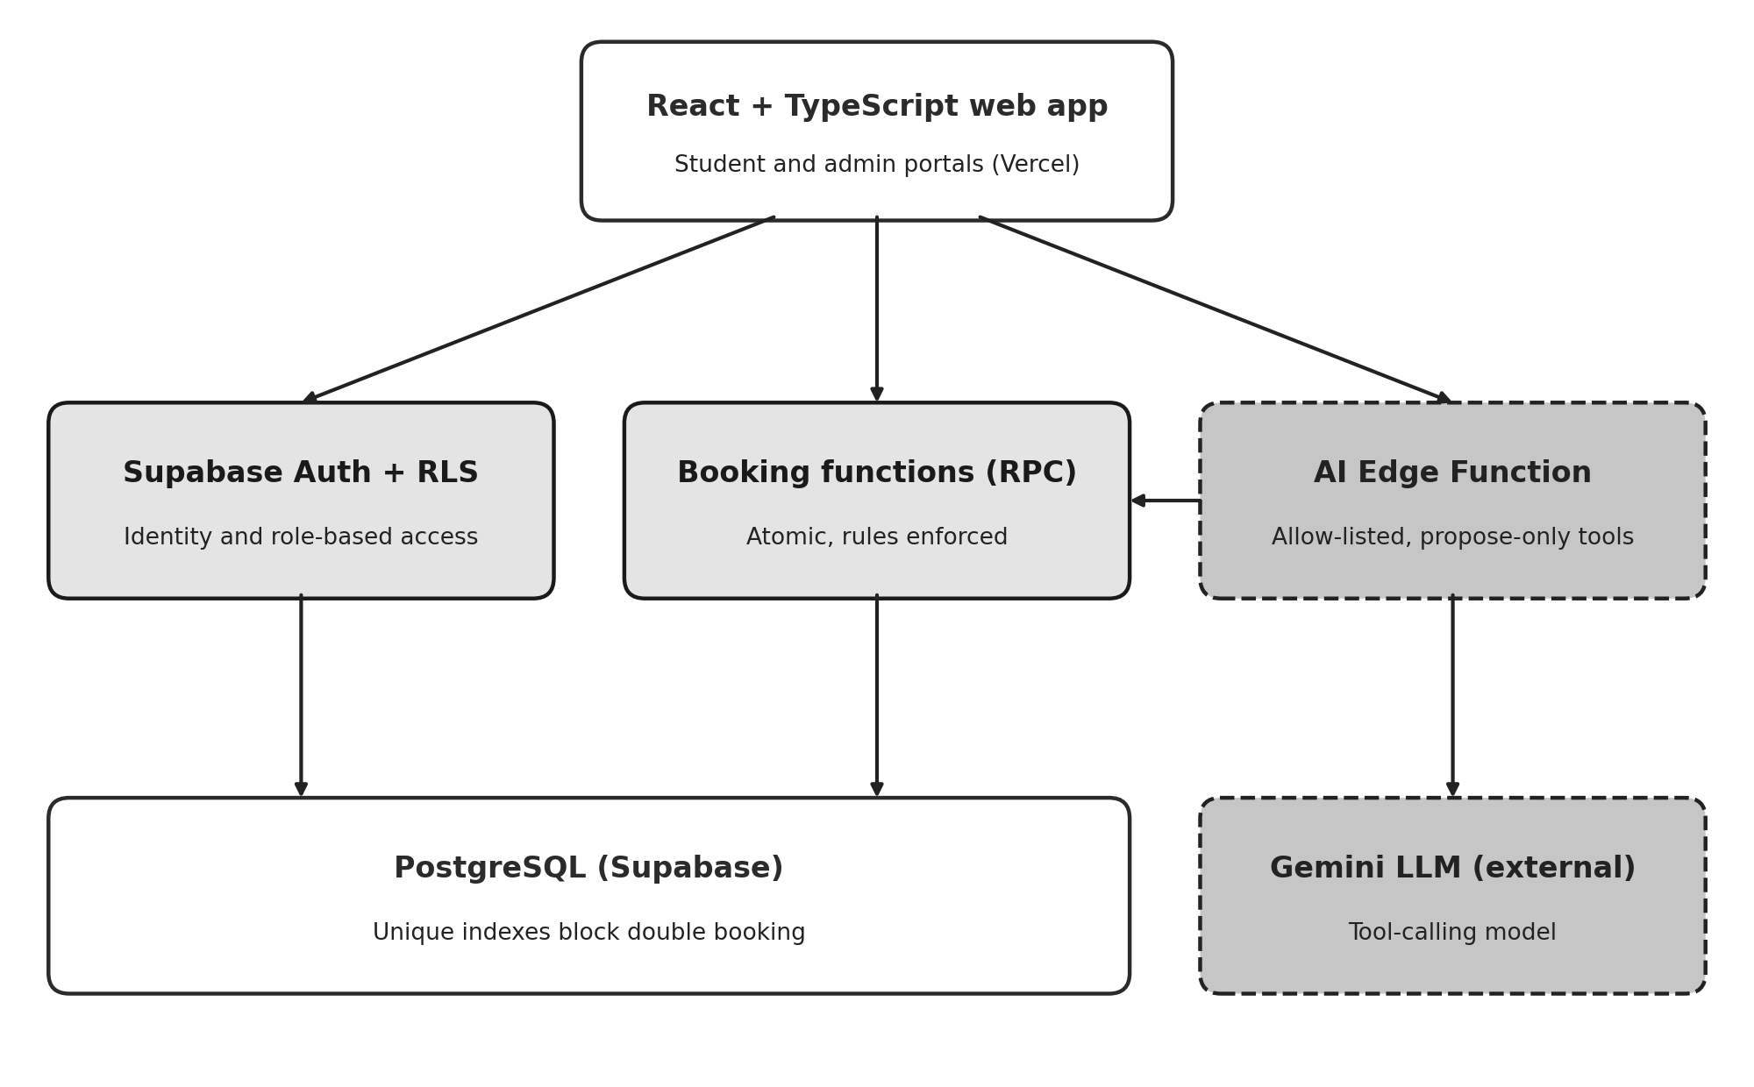
Figure 1: System architecture. Shaded boxes mark server-enforced rules; dashed boxes mark the AI layer.

4.4 Database design
The PostgreSQL schema comprises nine relational tables: profiles, buildings, rooms, beds, bookings, app_settings, audit_events, ai_proposals, and ai_evaluations (reserved for future multi-model evaluation). A room initialized with capacity N atomically instantiates N bed rows in the same transaction. Room vacancy is never stored as a mutable integer; it is derived dynamically from active beds devoid of active bookings, preventing cache stale states.
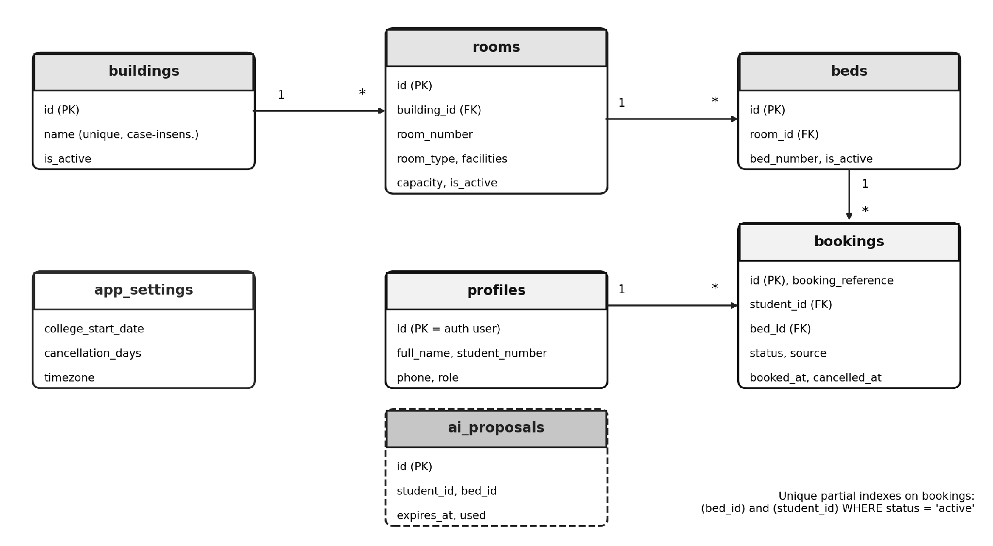
Figure 2: Entity relationships and the unique partial indexes that guarantee booking integrity.
The trusted PostgreSQL functions are outlined below. Each executes under security-definer privileges while binding caller identity to the authenticated session context.
Database Function | Functional Responsibility
create_booking(bed, source) | Validates active status of bed, room, and building; commits reservation; intercepts unique index violations and maps them to descriptive errors.
cancel_booking(id, reason) | Acquires row-level lock, verifies ownership and active state, evaluates cancellation deadline, updates status to cancelled with timestamp.
get_availability() | Queries room units containing at least one unoccupied bed, returning counts for consumption by student UI and AI tools.
get_taken_bed_ids(room) | Retrieves collection of reserved bed identifiers within a given room without revealing student identities.
create_proposal(bed) / confirm_proposal(id) | Generates and validates a five-minute temporary reservation proposal; confirmation internally calls create_booking.
admin_upsert_room, admin_create_building | Restricts inventory creation and updates to administrators; automatically synchronizes bed rows with declared room capacity.
admin_list_bookings, admin_update_settings | Delivers administrative paginated reservation rosters with student contact details; executes validated system parameter updates.
is_admin(), handle_new_user() | Verifies administrative role privileges for RLS policies; triggers automated student profile generation upon user registration.

4.5 Booking transaction and concurrency control
Bed allocation executes as an atomic stored function call. The procedure verifies user authentication, confirms active status for the target bed, room, and building, and commits the booking record. When concurrent requests contest the same bed, PostgreSQL serializes transaction commits; the second attempt encounters a unique partial index violation, which the function intercepts and returns as a BED_UNAVAILABLE error. The client interface then refreshes inventory and displays an informative notification. The database index acts as the ultimate concurrency arbiter.
insert into bookings (booking_reference, student_id, bed_id, source)
values ('HST-' || upper(substr(replace(gen_random_uuid()::text,'-',''),1,6)),
auth.uid(), p_bed_id, p_source);
-- unique (bed_id) where status = 'active' -> BED_UNAVAILABLE
-- unique (student_id) where status = 'active' -> ALREADY_HAS_ACTIVE_BOOKING

4.6 Cancellation policy
The cancellation deadline is defined as the term commencement date minus the configured advance notification window (defaulting to 10 days). Cancellations are authorized while the current date in the university timezone precedes this cutoff, and blocked thereafter. For instance, with an academic start date of 1 August 2027 and a 10-day buffer, the cutoff resolves to 22 July 2027 at 00:00 Asia/Kolkata; requests on 21 July succeed, while submissions on 22 July fail. Successful cancellation updates the booking state to cancelled and timestamps the record without deletion. Because vacancy calculations aggregate active bookings only, the bed is released immediately. The server remains the sole authority for cutoff enforcement.
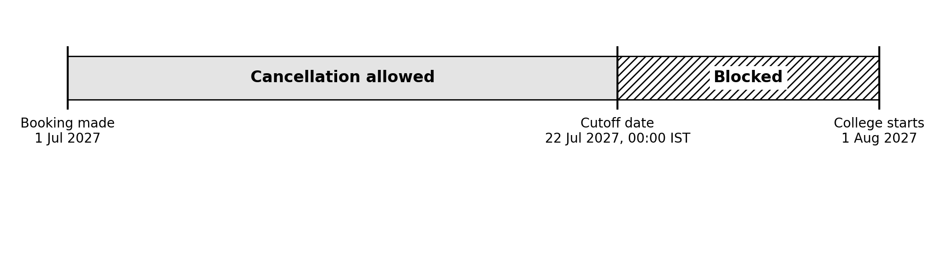
Figure 3: Worked example of the cancellation window (start date 1 August 2027, 10-day lead time).

4.7 Security model
- Identity: Managed via Supabase Auth; a database trigger initializes student profiles upon sign-up. Administrative rights are granted strictly via SQL, with RLS preventing self-escalation.
- Row-level security is active on all database tables. Students query active inventory, personal bookings, and profiles, with no direct insert, update, or delete privileges on inventory or booking tables.
- Keys: The frontend bundle contains only the public anonymous key. The Gemini API key is maintained securely as an encrypted Supabase secret. Elevated service-role keys are confined to integration test scripts and never shipped to client code.
- Privacy toward the LLM: Prompts and tool outputs convey room catalogs and bed IDs only, completely excluding student identities, phone numbers, and matriculation data.
- Input validation: Parameters such as message length, history turn count, tool names, and UUID formats are enforced programmatically in application logic rather than relying on LLM instructions.

4.8 AI assistant design
The conversational agent operates as an event-driven tool-calling loop hosted inside a Deno Edge Function. The resident's prompt and up to eight conversational context turns are dispatched to Gemini alongside three function declarations. When the model triggers a tool call, the server validates the parameters, executes the query under the student's authenticated session, and returns the result to the model. Concurrently, retrieved inventory is forwarded to the client to render interactive room cards directly from structured data.
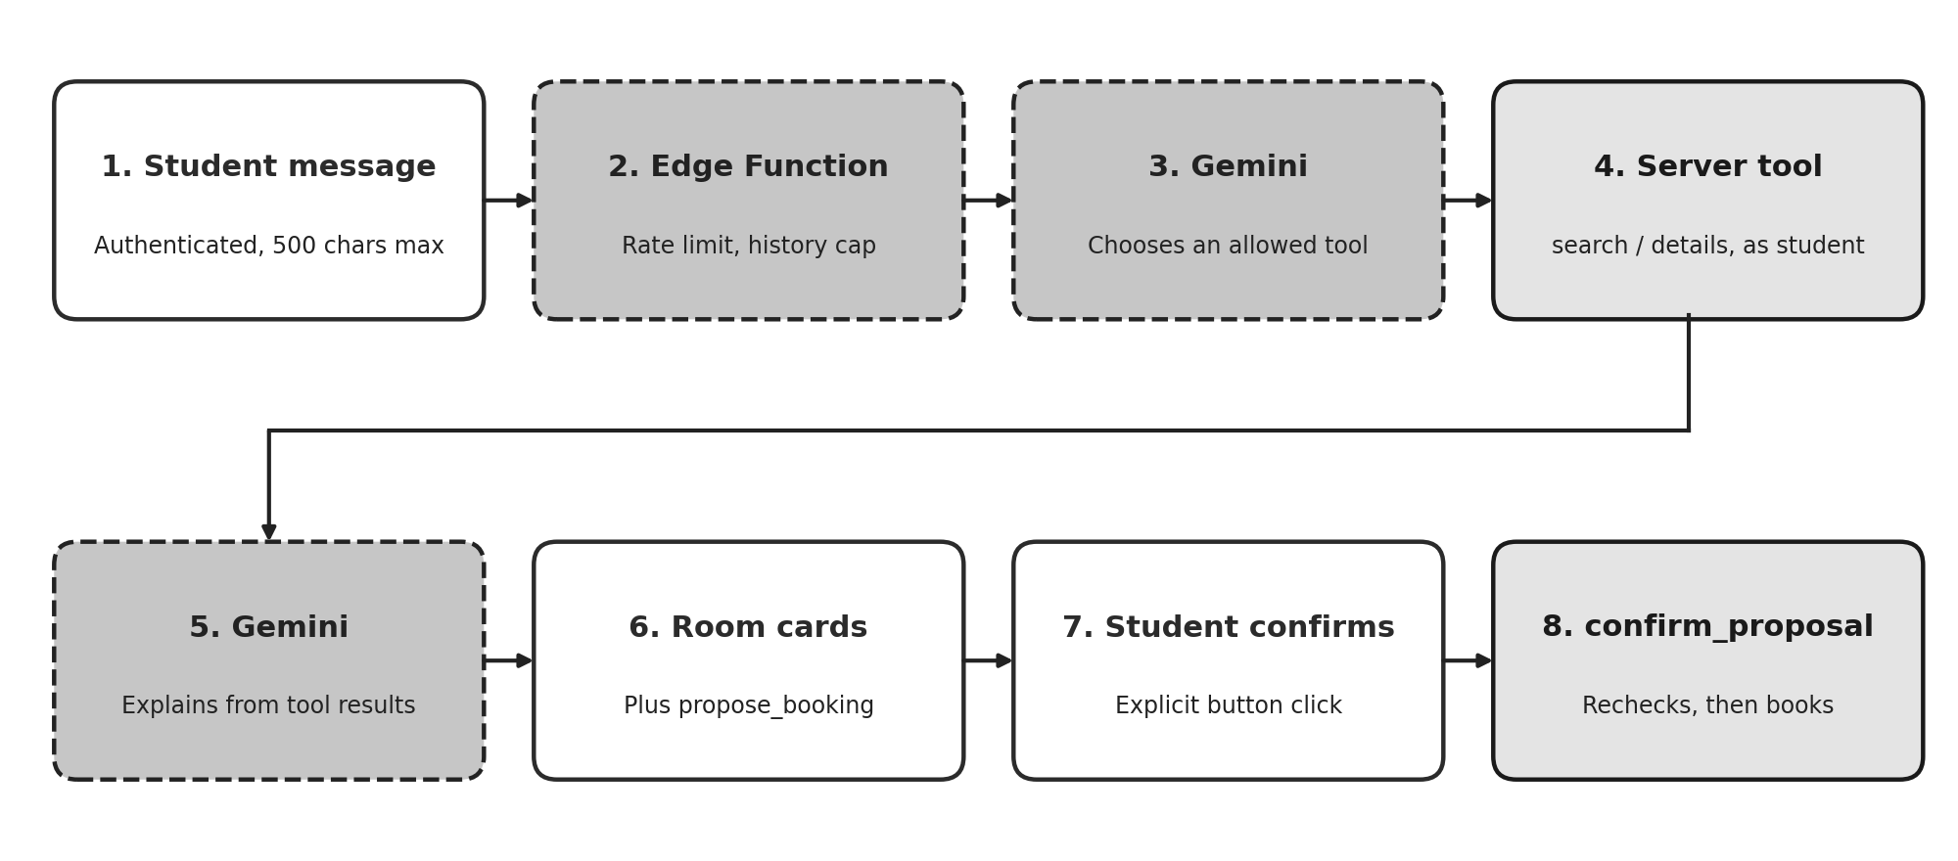
Figure 4: The AI request flow, from message to confirmed booking.

Tool Identifier | Access Scope | Operational Behavior
search_rooms | Read-Only | Invokes get_availability and applies filters for building, room category, and amenities in code; returns up to ten available rooms with free bed counts, tags, timestamps, and reasoning evidence.
get_room_details | Read-Only | Retrieves vacant bed records (IDs and bed numbers) for a specified room, validating room ID as a valid UUID.
propose_booking | Proposal Only | Registers a five-minute temporary reservation proposal for a vacant bed; commits no booking, prompting student confirmation in UI.

The system prompt instructs the language model to rely exclusively on tool execution for real-time inventory, strictly prohibits inventing facilities or housing rules, mandates seeking clarification when queries are ambiguous, requires stating lack of verification when data is missing, and forbids claiming that a reservation has been finalized. This prompt acts as behavioral guidance; parameter validity and access control are enforced in code, with unauthorized tool calls rejected automatically.

Operational controls
- Tool execution depth is restricted to three cycles; individual user prompts are capped at 500 characters.
- Student request rate is limited to six calls per minute; an internal budget (12 requests/min) ensures traffic stays well below upstream provider limits.
- Automatic exponential backoff retries handle transient 429 and 503 provider errors within a 20-second timeout envelope.
- The target model version is managed via environment secrets to allow seamless updates as model versions evolve.
- Upon external AI failure, students receive an informative notice while retaining uninterrupted access to manual reservation flows; server logs record HTTP status codes while redacting sensitive tokens.

4.9 Allocation engine
The allocation engine is implemented as a standalone, deterministic Python module taking student entities (with preference weights for buildings, room formats, and amenities) and room entities (with vacancy counts), generating optimal assignments, satisfaction scores, unallocated students, and constraint satisfaction traces. The engine never writes directly to the database; generated assignments must pass through the transactional reservation function. The algorithm uses a depth-first backtracking search over a fixed student sequence, testing eligible rooms in order of descending score, decrementing vacancies, recursing, and backtracking state upon return. Unassigned branches are evaluated to discover global maxima prioritizing student placement count followed by cumulative satisfaction scores. Outcomes are classified as feasible, partial, or infeasible. While backtracking exhibits exponential worst-case complexity, it provides transparent explainability for academic cohorts; enterprise scaling can transition to Google OR-Tools CP-SAT.

4.10 Front end
The web application provides all routes defined in the specifications: authentication screens, student room directories, personal booking views, an AI chat portal, and administrative metrics, booking logs, and system settings. Data views incorporate explicit states for loading, empty inventory, network errors, successful actions, and concurrency conflicts. System statuses are communicated via dual textual and visual indicators (e.g., 'Active' with checkmark and 'Cancelled' with cross icons), dialogs provide full keyboard navigation, and focus rings remain visible. Room cards incorporate visual bed occupancy meters and facility chips, with interface styling automatically conforming to light or dark system themes.

4.11 Testing methodology
Automated test suites were developed covering the 14 scenarios specified in the API documentation. Ten scenarios run as Vitest integration tests against an authentic cloud Supabase instance. Each test routine creates temporary user accounts, residence blocks, and room inventory via admin APIs, authenticates using public client credentials, exercises database functions and RLS policies, and tears down test data upon completion. Testing against a live cloud database provides conclusive validation of concurrency locks and security boundary enforcement.
# | Evaluated Scenario | Verification Framework
1 | Student successfully claims an available bed | Vitest Integration Test
2 | Concurrent reservation requests for a single bed; exactly one succeeds | Vitest Integration Test
3 | Rejection of a secondary active reservation attempt by an applicant | Vitest Integration Test
4 | Isolation verification: an applicant cannot inspect peer reservation records | Vitest Integration Test
5 | Non-administrative users are barred from creating building entities | Vitest Integration Test
6 | Downward adjustment of room capacity below currently occupied bed counts is rejected | Vitest Integration Test
7 | Cancellation submitted prior to the cutoff succeeds, restoring bed availability and archiving history | Vitest Integration Test
8 | Cancellation submitted on or following the cutoff threshold is blocked | Vitest Integration Test
9 | AI assistant refuses to invent fictitious rooms when queried about a non-existent block | Vitest (Optional; requires live AI endpoint)
10 | Confirmation fails when an AI-proposed bed is claimed by a competitor prior to confirmation | Vitest Integration Test
11 | Manual reservation remains fully operational during AI service interruptions | Covered by Scenario 1 (AI decoupled from booking path)
12 | Verification that AI avoids asserting non-existent dormitory amenities | Manual verification within assistant chat
13 | Optimization solver correctly classifies impossible constraints as infeasible | Automated pytest Test Suite
14 | Administrative dashboard aggregates match exact database records | Vitest Integration Test

4.12 Deployment
The cloud database was provisioned by executing five numbered migrations (foundational schema, frontend helper functions, booking identifier fix, AI proposal tables, and administrative procedures) followed by a synthetic seed script introducing two blocks, seven rooms, and fourteen beds. The Edge Function was deployed using the Supabase CLI, reading the Gemini API key from encrypted vault secrets. The React application is built and hosted by Vercel from the repository's web folder, configured with project URLs and public anonymous keys, utilizing SPA rewrite rules to ensure deep links survive reloads. Supabase Auth was configured with the production domain for secure OAuth/magic-link redirection.

5. Results

5.1 Integration test results
The recorded test execution evaluated 11 test suites: 10 passed and 1 was intentionally bypassed (optional live LLM verification). Total test execution took approximately 60 seconds, primarily due to dynamic remote user and entity provisioning on a hosted cloud instance.

# | System Invariant Evaluated | Execution Result | Wall Time (s)
1 | Applicant reserves an available bed; status marks active with an HST- prefix code | Passed | 4.0
2 | Simultaneous reservation conflict for a single bed: exactly one succeeds, the second receives BED_UNAVAILABLE, maintaining a single active record | Passed | 4.5
3 | Duplicate active booking submission by an identical applicant is rejected | Passed | 3.7
4 | An applicant is blocked from querying peer reservation records, while the owner retains access | Passed | 4.6
5 | Privilege enforcement: unprivileged account is rejected by admin procedures and denied direct insert rights | Passed | 1.5
6 | Attempting to decrease room capacity below current active occupancy is rejected | Passed | 5.7
7 | Pre-cutoff cancellation executes successfully, reinstating bed availability and preserving audit history | Passed | 5.0
8 | Cancellation requests submitted on or after the computed cutoff date are rejected | Passed | 6.1
9 | Conversational agent avoids hallucinating rooms for a fictitious residence block | Bypassed (Optional) | n/a
10 | Proposal confirmation aborts if the targeted bed is claimed in the interim, and occupied beds cannot be proposed | Passed | 5.5
14 | Administrative aggregate counts of active rooms, beds, and reservations match direct database queries | Passed | 4.7

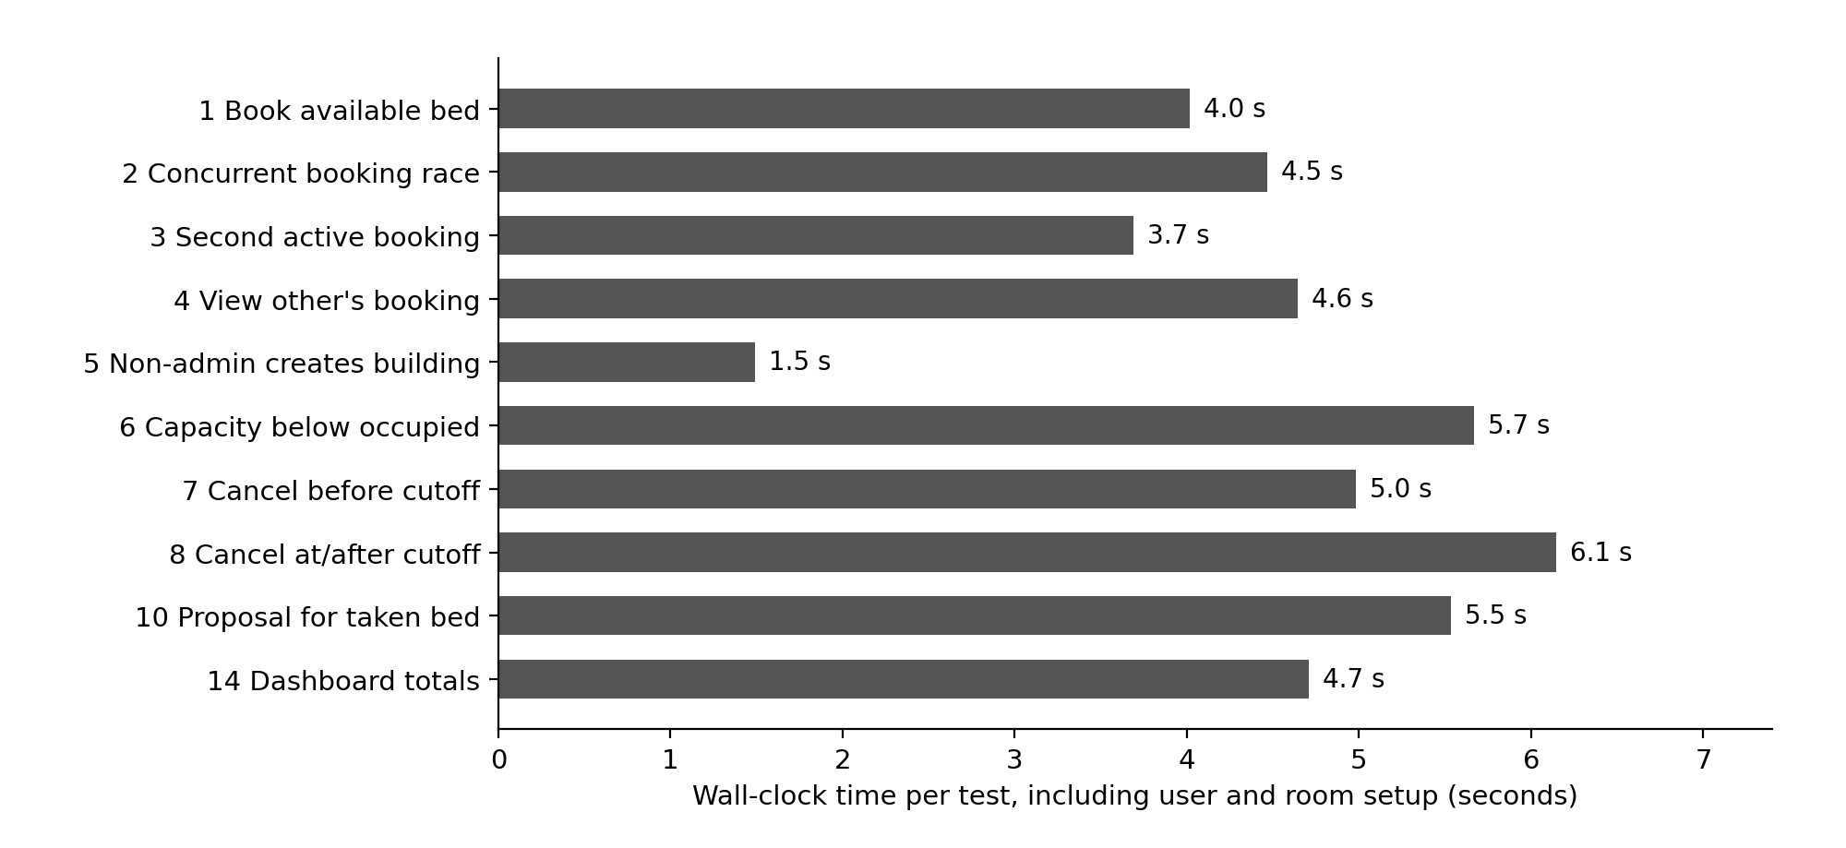
Figure 5: Wall-clock time of each passing test. Times include creating users and rooms and are not API latency.

5.2 Allocation engine results
Three automated pytest test suites passed: a fully feasible assignment placing all students, an infeasible scenario (requesting a double room when only single rooms exist) correctly flagged as infeasible with the student identified as unplaced, and a capacity contention scenario where two applicants compete for a single bed resulting in exactly one successful assignment. These results verify the engine's ability to handle unsolvable constraints predictably.

5.3 Acceptance criteria
Specification Criterion (PRD Section 8) | Fulfillment Status | Empirical Evidence
Administrators can create buildings and rooms with automated bed capacity | Satisfied | Verified via Admin Dashboard; room creation routine automatically generates bed rows
Reported inventory totals precisely match database records | Satisfied | Verified via Integration Scenario 14
Concurrent attempts to book an identical bed are strictly prevented | Satisfied | Verified via Integration Scenario 2
Unauthorized access to private student records is denied | Satisfied | Verified via Integration Scenarios 4 and 5
Manual reservation remains fully functional without AI availability | Satisfied | Verified via Integration Scenario 1; booking pipeline operates independently of AI
Conversational assistant searches real-time data and avoids hallucinating rooms | Satisfied by Architecture | Data retrieval restricted to read-only tools; automated Scenario 9 skipped in recorded run
AI-assisted booking mandates explicit applicant confirmation | Satisfied | Proposal-confirmation lifecycle verified in Integration Scenario 10
Cancellation is permitted prior to cutoff and blocked thereafter | Satisfied | Verified via Integration Scenarios 7 and 8
Cancellation preserves audit records and immediately restores bed availability | Satisfied | Verified via Integration Scenario 7
Infeasible allocation requests yield explicit, explainable diagnostic results | Satisfied | Validated via automated constraint solver test suite
Public production deployment utilizes secure environment secrets and mock data | Satisfied | Enforced via Vercel configuration, Supabase vaults, and synthetic seed scripts

5.4 Success metrics
- Core booking and cancellation tests: 10 of 10 executed automated test scenarios passed (100% pass rate).
- Duplicate active bookings for a bed: Zero duplicates observed; concurrency stress testing confirmed exactly one active booking on contested beds.
- Unauthorized access attempts: Both unauthorized access attempts (querying peer bookings and unauthorized building creation) were blocked.
- AI recommendation validity, explanation grounding and latency: Not measured systematically due to descoping multi-provider benchmarking, representing an acknowledged project boundary.
- Manual booking with AI disabled: Verified by architecture and confirmed in Test Scenario 1, which functions without invoking AI services.

5.5 Deployment outcome
The production system is deployed live at https://hostel-allocation-system-inky.vercel.app, supported by a Supabase cloud database with migration schemas and synthetic seed data. Following the resolution of model identifier settings (Section 5.6), the conversational assistant reliably handled user inquiries in manual tests across desktop and mobile browsers. Complete user journeys - including registration, bed booking, cancellation, and administrative management - were confirmed on the live site.

5.6 Engineering problems and fixes
Multiple authentic engineering defects emerged during system integration and staging. These challenges are documented below, as their resolution directly refined the final architecture.

Engineering Problem | Root Cause Analysis | Applied Remediation
Every booking attempt failed in application UI | Reference generator invoked an extension function in Supabase extensions schema that was hidden from a function with fixed search_path | Applied Migration 0003 utilizing native gen_random_uuid(); ensured automatic profile generation; exposed descriptive errors in developer console
Conversational AI assistant stopped responding | Default Gemini model version reached end-of-life; free-tier rate caps (~15 req/min) triggered transient rejections | Migrated model identifier to configurable secret; introduced sliding request budget, backoff retries, and friendly busy notifications; shortened dialogue loops
Single chat messages consumed excessive API calls | Search, detailed inspection, and response generation executed across separate round-trip LLM invocations | Refined system prompt to minimize unnecessary tool cycles; introduced per-instance budget limits to prevent quota overruns
Confirmation emails failed to deliver to applicants | Supabase default mail sender enforces tight hourly rate caps and restricts recipients to team members | Disabled mandatory email verification for demonstration deployment, recording operational trade-offs (unverified accounts, bot risk)
Integration test harness failed during startup | loadEnv utility was imported from incorrect package in test configuration | Corrected import origin to vite; test suite executed without further issues
Production build failed due to missing typings | Client environment variables lacked TypeScript type definitions | Introduced vite-env.d.ts type declaration file and confirmed production build compilation

5.7 Discussion and limitations
- The most significant outcome is that transactional integrity and concurrency rules are enforced definitively by the underlying database engine under genuine race conditions, rather than relying on brittle client-side logic.
- While the conversational AI subsystem is structurally constrained to prevent unauthorized actions, its response quality and factual grounding were evaluated through manual inspection rather than automated metric pipelines. The grounding test for non-existent amenities (Scenario 12) remains a manual verification.
- The implemented rate limiters operate on a per-instance basis within the serverless runtime, providing sufficient safeguards for a demonstration platform but falling short of an enterprise-grade global distributed rate limiter.
- Mandatory email verification was temporarily suspended for the public demonstration; an enterprise production deployment would require verified institutional emails restricted to campus domains alongside CAPTCHA challenges.
- Although the constraint allocation engine is fully operational and verified via automated tests, it is not yet integrated directly into the conversational interface or administrative bulk-assignment workflows.
- Integration test suites execute against a remote cloud database, introducing network latency compared to local SQLite testing; test harnesses must never be executed against production databases.

6. Future Work

6.1 Evaluate several language-model providers
Implement a model-agnostic abstraction layer and an administrative benchmarking dashboard capable of executing standardized synthetic evaluation scenarios across multiple leading LLM providers (e.g., Anthropic Claude, OpenAI GPT, Google Gemini). By tracking operational latency, tool-call syntax accuracy, recommendation validity, and explanation grounding within the existing ai_evaluations schema, this capability would replace subjective assessments with empirical quality metrics and eliminate dependency on a single model provider.

6.2 Use the allocation engine in the product
Publish the constraint solver via a secured backend API endpoint, enabling the conversational assistant to articulate algorithmic trade-offs directly from optimization results. Additionally, introduce an administrative bulk-allocation module that provides interactive visual previews of proposed room assignments, highlights constraint satisfaction metrics, identifies unassigned applicants, and commits allocations atomically via validated database procedures. For institutional-scale deployments handling tens of thousands of applicants, evaluate transitioning from backtracking search to Google OR-Tools CP-SAT.

6.3 Complete the admin and student experience
- Introduce comprehensive lifecycle management for residential blocks and rooms, including edit and deactivation workflows equipped with dependency warnings when active reservations exist, alongside a detailed per-room bed map visualizer displaying real-time occupancy.
- Develop an engaging public landing page, a personalized student portal highlighting active bookings, dedicated room detail pages, and multi-parameter filtering for room categories and facilities.
- Integrate automated notification systems (SMS/Email), waitlisting queues for fully occupied dormitory rooms, and a graphical audit trail viewer leveraging the existing audit_events schema.

6.4 Strengthen identity and abuse protection
Re-establish mandatory account verification using dedicated custom SMTP relays, restrict student registration strictly to authorized institutional email domains, deploy CAPTCHA verification, and cross-reference matriculation numbers against official registrar databases to prevent identity spoofing or unauthorized registration.

6.5 Richer allocation
Expand the allocation solver to incorporate soft constraints, including roommate mutual requests, special accessibility accommodations, and diversity/fairness distributions, optimized using explainable scoring weights. Advanced machine-learning compatibility matching models should remain out of scope until formal algorithmic fairness, bias, and privacy audits are conducted.

6.6 Operations and measurement
- Upgrade serverless per-instance rate limiting to a distributed Redis-backed or database-level token bucket mechanism with hard spending caps, alongside real-time monitoring of upstream provider latency and HTTP status codes.
- Implement automated health-check endpoints, a protected administrative database reset routine, and scheduled cron jobs to verify that configured LLM model identifiers remain active upstream.
- Automate amenity-grounding testing (Scenario 12) through simulated synthetic dialogues that assert conversational agents never fabricate non-existent housing amenities.
- Incorporate the automated test suite into CI/CD pipelines executed against ephemeral Supabase test environments.

6.7 Conclusion
This project demonstrates that a conversational AI assistant can be effectively integrated into a transactional booking system without compromising data integrity, provided core business rules reside within the relational database and the model is restricted to read-only queries and temporary proposals. The deployed system satisfies all core acceptance criteria: bed bookings are atomic and protected against duplicate claims, applicant confidentiality is enforced via Row-Level Security, cancellation adheres to server-computed deadlines, and the AI assistant cannot fabricate room inventory or commit unauthorized reservations. Primary areas for ongoing enhancement - including multi-provider model benchmarking, quantitative AI evaluation, and expanded administrative interfaces - are clearly defined and achievable within the existing architectural foundation.
References
- Supabase Documentation: Authentication, Row-Level Security, Database Functions, and Serverless Edge Functions. Available: https://supabase.com/docs (Accessed: November 2026).
- Google AI for Developers: Gemini API Reference, Structured Tool Calling, and Rate Limiting Quotas. Available: https://ai.google.dev/gemini-api/docs (Accessed: November 2026).
- PostgreSQL Global Development Group: PostgreSQL Documentation: Partial Indexes, Transaction Isolation, and Security-Definer Functions. Available: https://www.postgresql.org/docs/ (Accessed: November 2026).
- React Development Team: React 18 Framework Documentation. Available: https://react.dev (Accessed: November 2026).
- Vite & Vitest Engineering: Next Generation Frontend Tooling and Fast Unit/Integration Testing Framework. Available: https://vite.dev and https://vitest.dev (Accessed: November 2026).
- Google OR-Tools: Fast and Portable Software for Combinatorial Optimization (CP-SAT Solver). Available: https://developers.google.com/optimization (Accessed: November 2026).
- Vercel Documentation: Platform Deployments, Routing Rules, and Environment Configuration. Available: https://vercel.com/docs (Accessed: November 2026).
Appendix A: Project structure
hostel-allocation/
engine/allocator.py backtracking solver + pytest tests
supabase/
seed.sql synthetic demo inventory
migrations/0001_init.sql ... 0005_admin_tools.sql
functions/ai-chat/index.ts Gemini tool-calling Edge Function
web/
package.json, vite.config.ts, vitest.config.ts, vercel.json
tests/integration.test.ts scenario tests
src/ App.tsx, lib.ts, components.tsx, styles.css
src/pages/ Login, Rooms, MyBookings, AIAssistant,
Admin, AdminBookings, AdminSettings

Appendix B: Configuration names (no secrets)

Configuration Key | Deployment Scope | Operational Purpose
VITE_SUPABASE_URL, VITE_SUPABASE_ANON_KEY | Vercel / web .env | Public client credentials for Supabase connection
GEMINI_API_KEY | Supabase secret | Server-side authorization key for Gemini model access
GEMINI_MODEL | Supabase secret | Configured model name, updateable without code redeployment
GEMINI_RPM | Supabase secret | Request throughput budget aligned with provider rate limits (default 12)
TEST_SUPABASE_URL, TEST_SUPABASE_ANON_KEY, TEST_SERVICE_ROLE_KEY | web .env.test | Dedicated integration test credentials; service key isolated from client distribution

