**Mile-2 Business Objects –Set II**

**Question: 1 (Use Island Marketing Universe) :** 4*3 = (12 Marks)

1. Create a report for the following were Common cities in both the tables are listed:

As **City,Revenue,SalesRevenue**

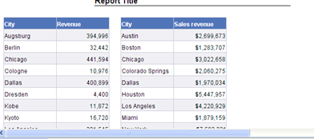

2. Create a Report to display the list of all the **Lines of Service** and their respective **Revenue**(which are having revenue more than the revenue earned in the year of 2004**)- using result of another query**

3. Create a report to display the total number of guests of country ‘US’ during the year 2004 and 2005, giving a revenue > 10000 (use predefined filters from the universe) and highlight the year where the number of guests are less than 40.

4. Create the following Report and a Bar Chart based on the Year Dimension ,

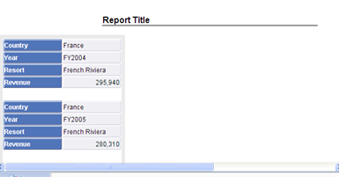

=====================================================================================

**Question : 2 : ( 20 Marks)**

Universe Creation: (Importing - 5 , universe creation - 9) = 14 Marks

Create LOV based on Dept_id,course_id,Course_name

Create Predefined filter for the total number of students in Computers Department.

Report:4*1.5= 9 Marks

1.How many students have discontinued from the University and the Semester in which they have discontinued.

2.List the details of the Students with completed status in a specific department.

3.Create Report to list the number of students based on department and course with columns year

4. Create a hierarchy for the Universe based on Student_name -> Email for the **Student_dim.**

Create a Drill report ( Year,Stud_Name,Dept_Name,Course_Name)

==============

**Univ_fact**

Pk_stud_key,pk_course_id,pk_dept_id,pk_sem_id, Pk_Dt_Key Pk_status_id avg_grade

**Student_dim**

Pk_stud_key,stud_id,stud_name,City,Email,Eff_dt,End_dt,Flag

**Course_dim:**

pk_course_id,course_name,dept_id

**Dept_dim:**

pk_dept_id,dept_name

**Semester_dim:**

Pk_sem_id,semester

**Status_dim:**

Pk_status_id,status_desc

**Date_Dim:**

Pk_Dt_Key,D_Day,D_Month,D_Year,D_Date

==========

**Student_dim**

Pk_stud_key,stud_id,stud_name,City,Email,Eff_dt,End_dt,Flag

23,S06,Anurag,Pune,anupm@sdmj.com,01/01/2007 00:00:00,12/31/9999 00:00:00,A

21,S06,Anurag,Delhi,anupm@sdmj.com,01/01/2005 00:00:00,12/31/9999 00:00:00,I

22,S01,Anu,Palakkad,anu@sdmj.com,01/01/2006 00:00:00,12/31/9999 00:00:00,A

16,S01,Anu,Kochi,anu@sdmj.com,01/01/2005 00:00:00,12/31/9999 00:00:00,I

17,S02,Anusha,Chennai,anush@sdmj.com,01/01/2005 00:00:00,12/31/9999 00:00:00,A

18,S03,Anup,Bangalore,anup@sdmj.com,01/01/2005 00:00:00,12/31/9999 00:00:00,A

19,S04,Anusree,Hyderabad,anusr@sdmj.com,01/01/2005 00:00:00,12/31/9999 00:00:00,A

20,S05,Anupama,Delhi,anupm@sdmj.com,01/01/2005 00:00:00,12/31/9999 00:00:00,A

**Course_dim:**

C101,CSC,10

C102,IT,10

M101,BBA,20

M102,BALLB,20

A101,BCOM,30

A102,BFIN,30

**Dept_dim:**

10,Computer

20,Management

30,Commerce

**Semester_dim:**

S1,Sem-1

S2,Sem-2

S3,Sem-3

S4,Sem-4

**Status_dim:**

1,Completed

2,Discontinued

3,Undergoing

**Date_Dim:**



**Univ_fact**

