Data Analysis Report Analysis Report
Comprehensive Data Analysis Report Analysis
Executive Report
Generated on December 19, 2025

Table of Contents
- Executive Summary
- Data Overview and Quality Assessment
- Key Performance Indicators
- Exit_Status Analysis
- Feature Analysis
- Statistical Insights
- Prediction Scoring
- Strategic Recommendations
- Appendices

Executive Summary
This comprehensive report analyzes 25,821 records for Data Analysis Report.
Key Highlights:
• Overall Exit_Status rate: 100.0%
• Total features analyzed: 19
• Data quality: 99.9% complete
This analysis provides actionable insights through statistical analysis, visualization,
and predictive scoring to support data-driven decision making.

Data Overview and Quality Assessment
**Dataset Size:** 25,821 records with 22 features

Data Quality Metrics
Metric | Value | Status
Total Records | 25,821 | Complete
Total Missing Values | 473 (0.1%) | Excellent
Data Completeness | 99.9% | Excellent
Numeric Features | 5 | Available
Categorical Features | 14 | Available

Key Performance Indicators
KPI | Value
Total Records | 25,821
Exit_Status - Positive Class | 25,821
Exit_Status Rate | 100.0%
Average Tenure_Months | 26.79
Average Attrition_Probability | 0.26
Average Age | 31.07
Average Years_of_Service | 2.23
Average Priority_Rank | 4.00

Exit_Status Distribution Analysis
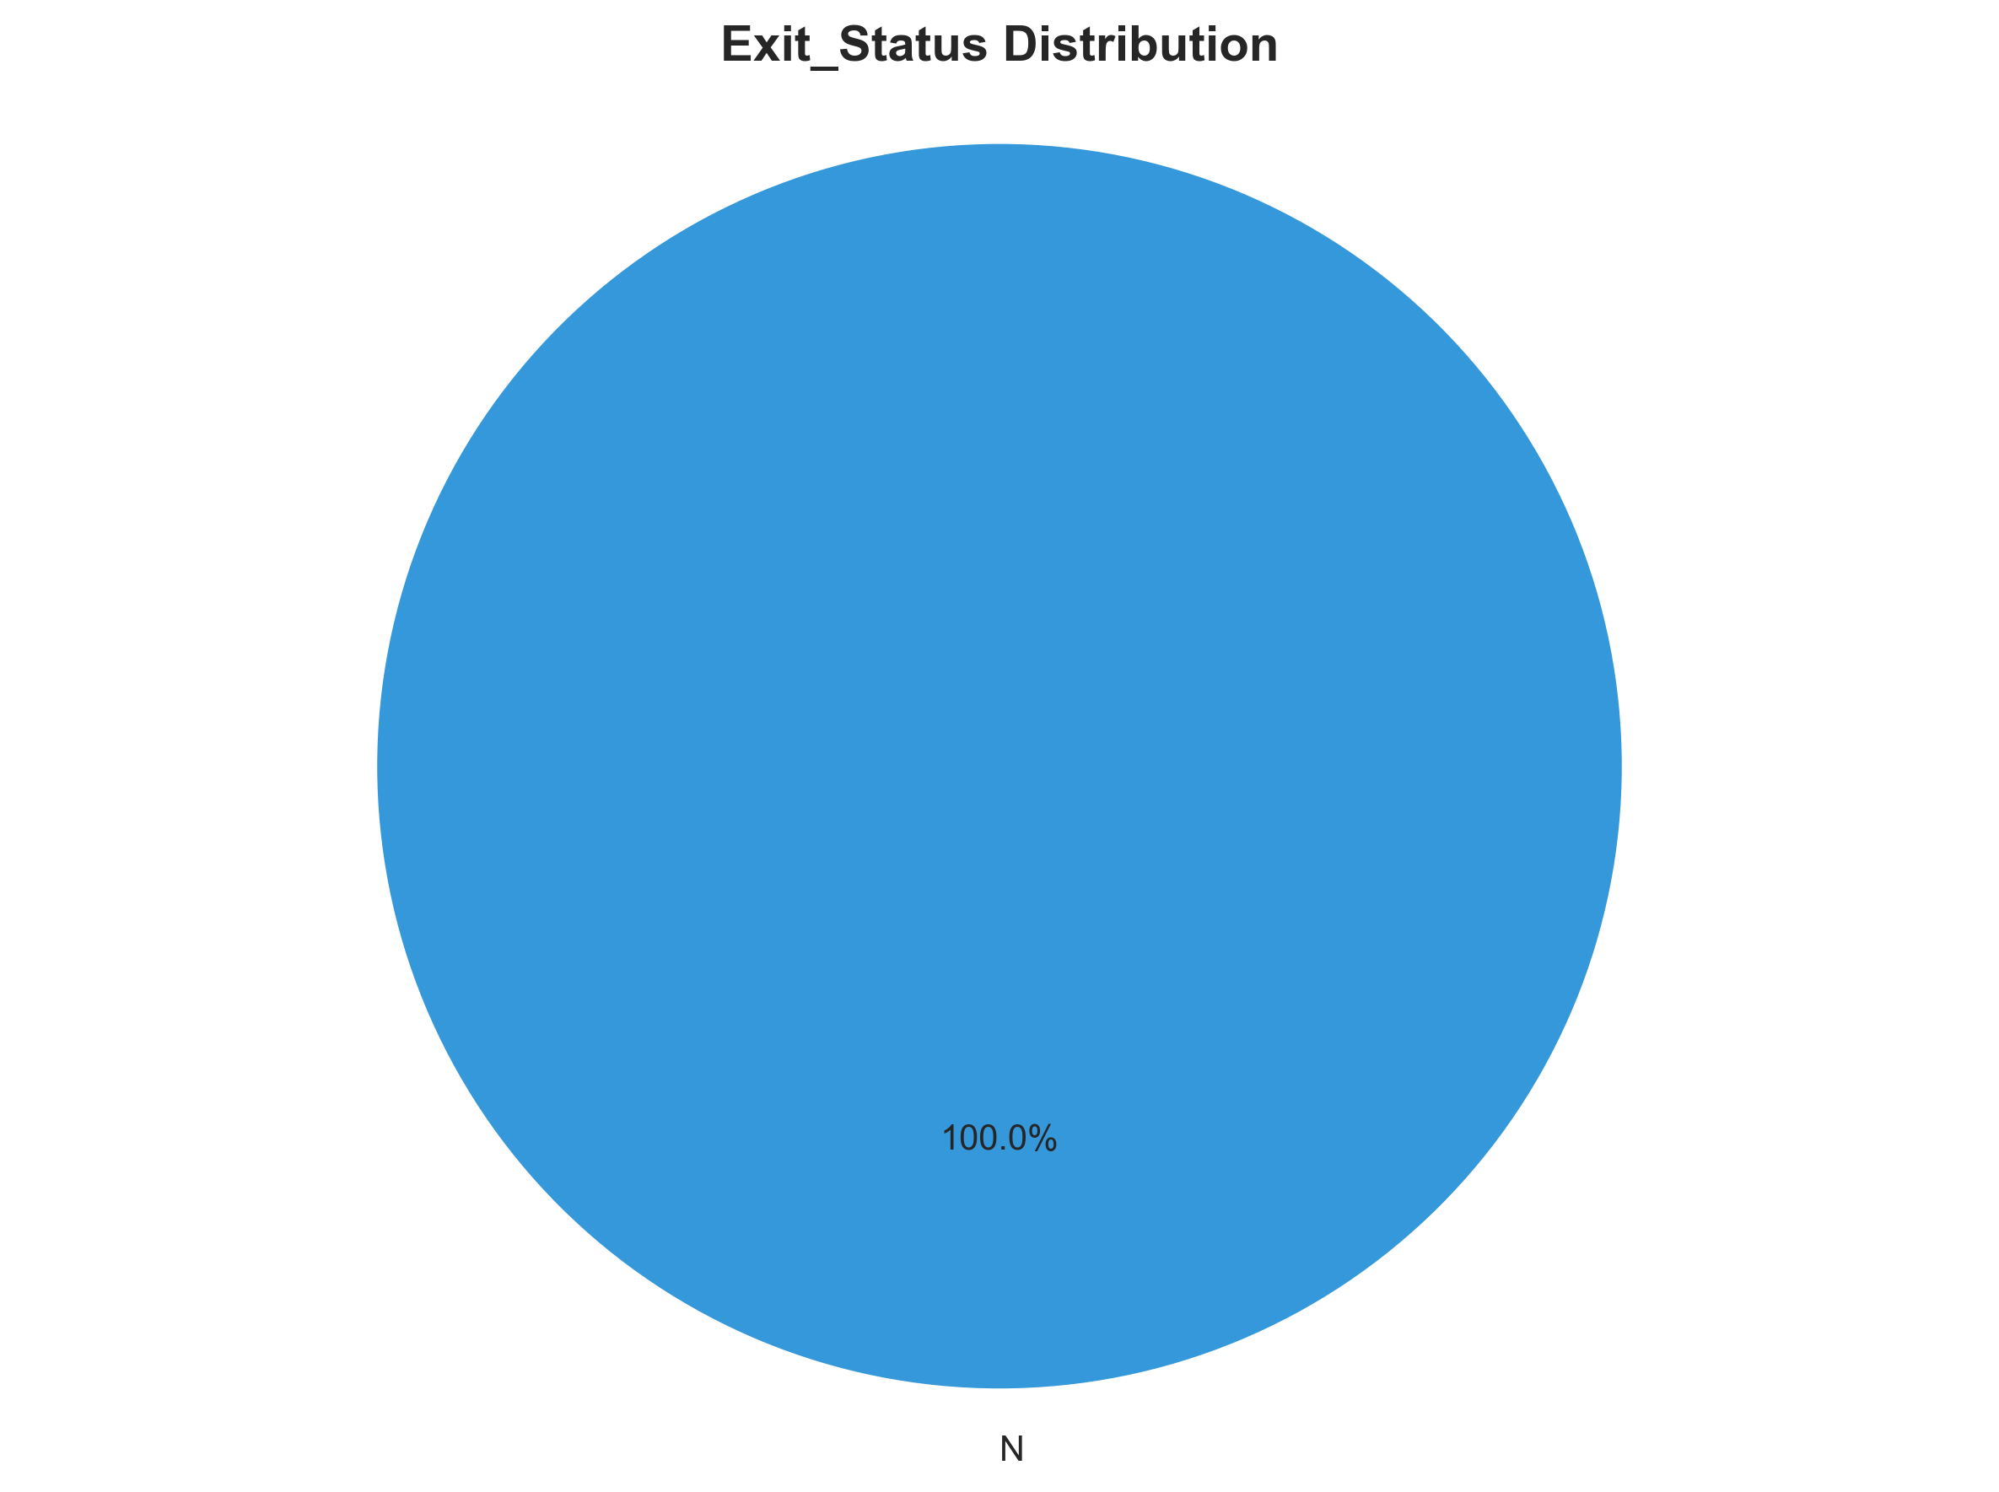

Categorical Features Analysis

Gender Analysis
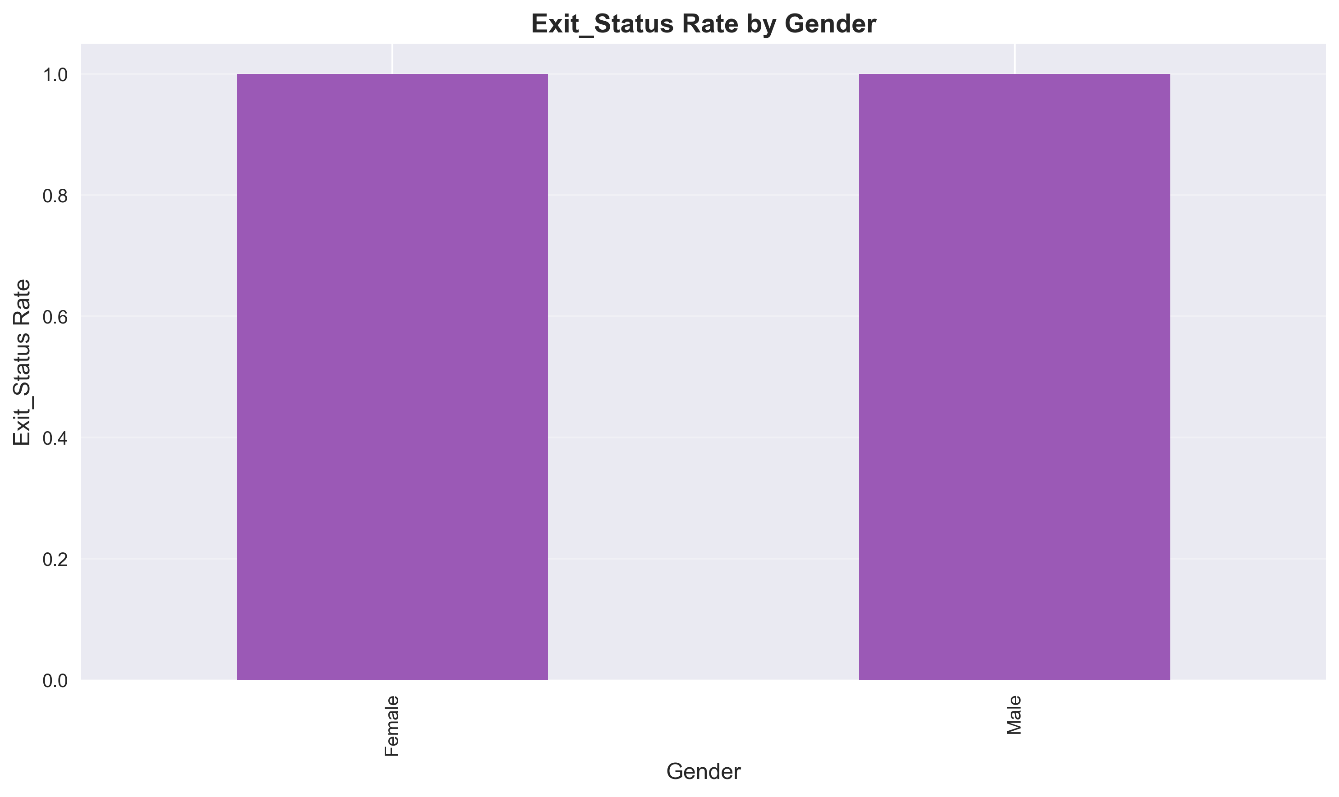

Education Analysis
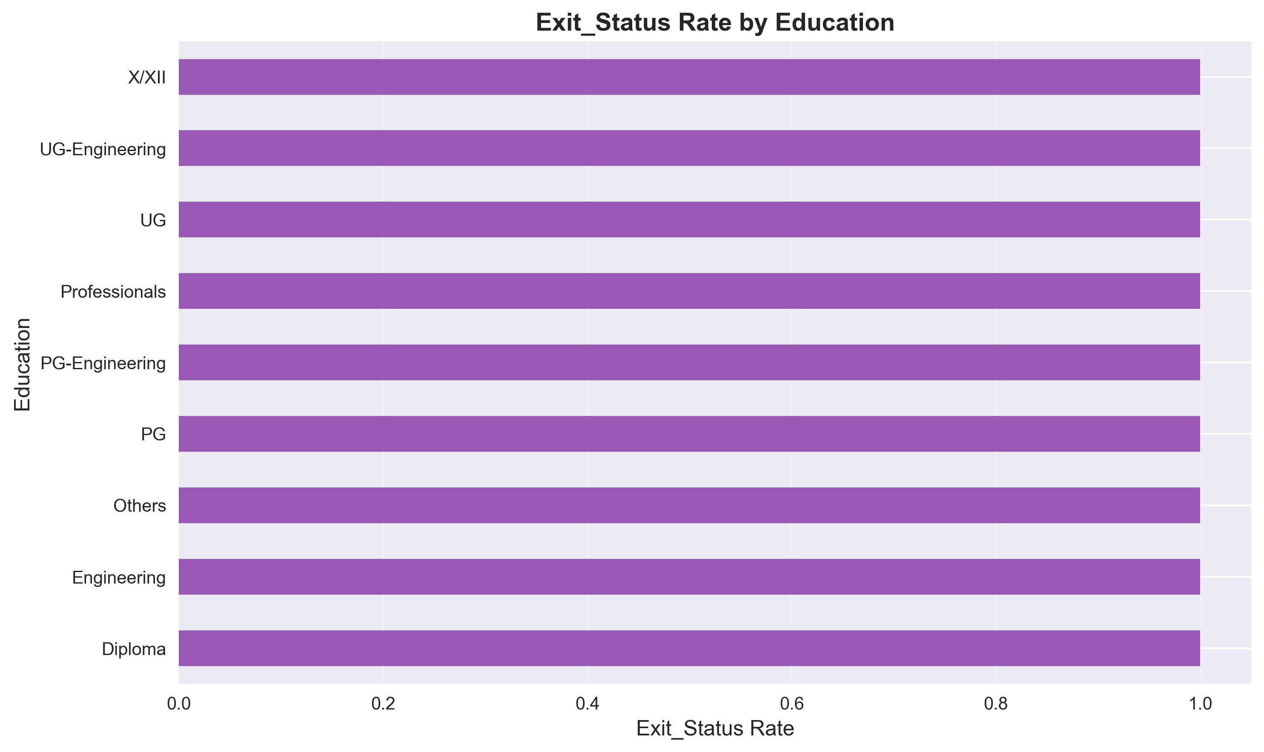

Business_Unit Analysis
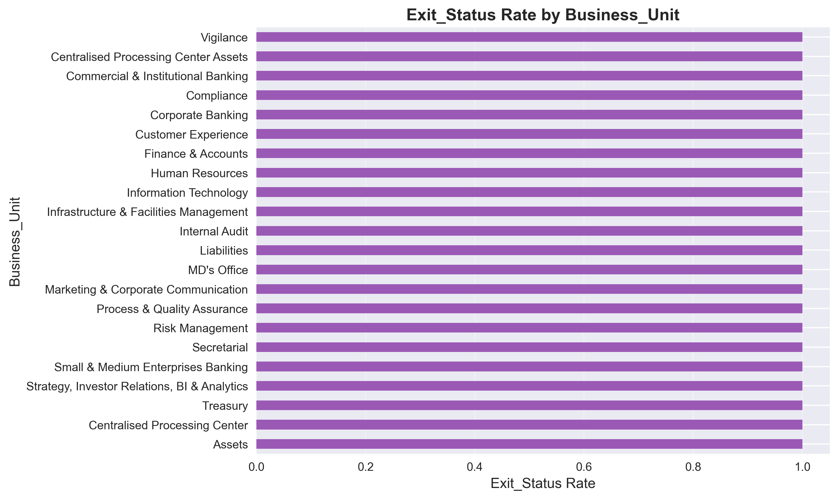

Numerical Features Analysis

Tenure_Months Distribution
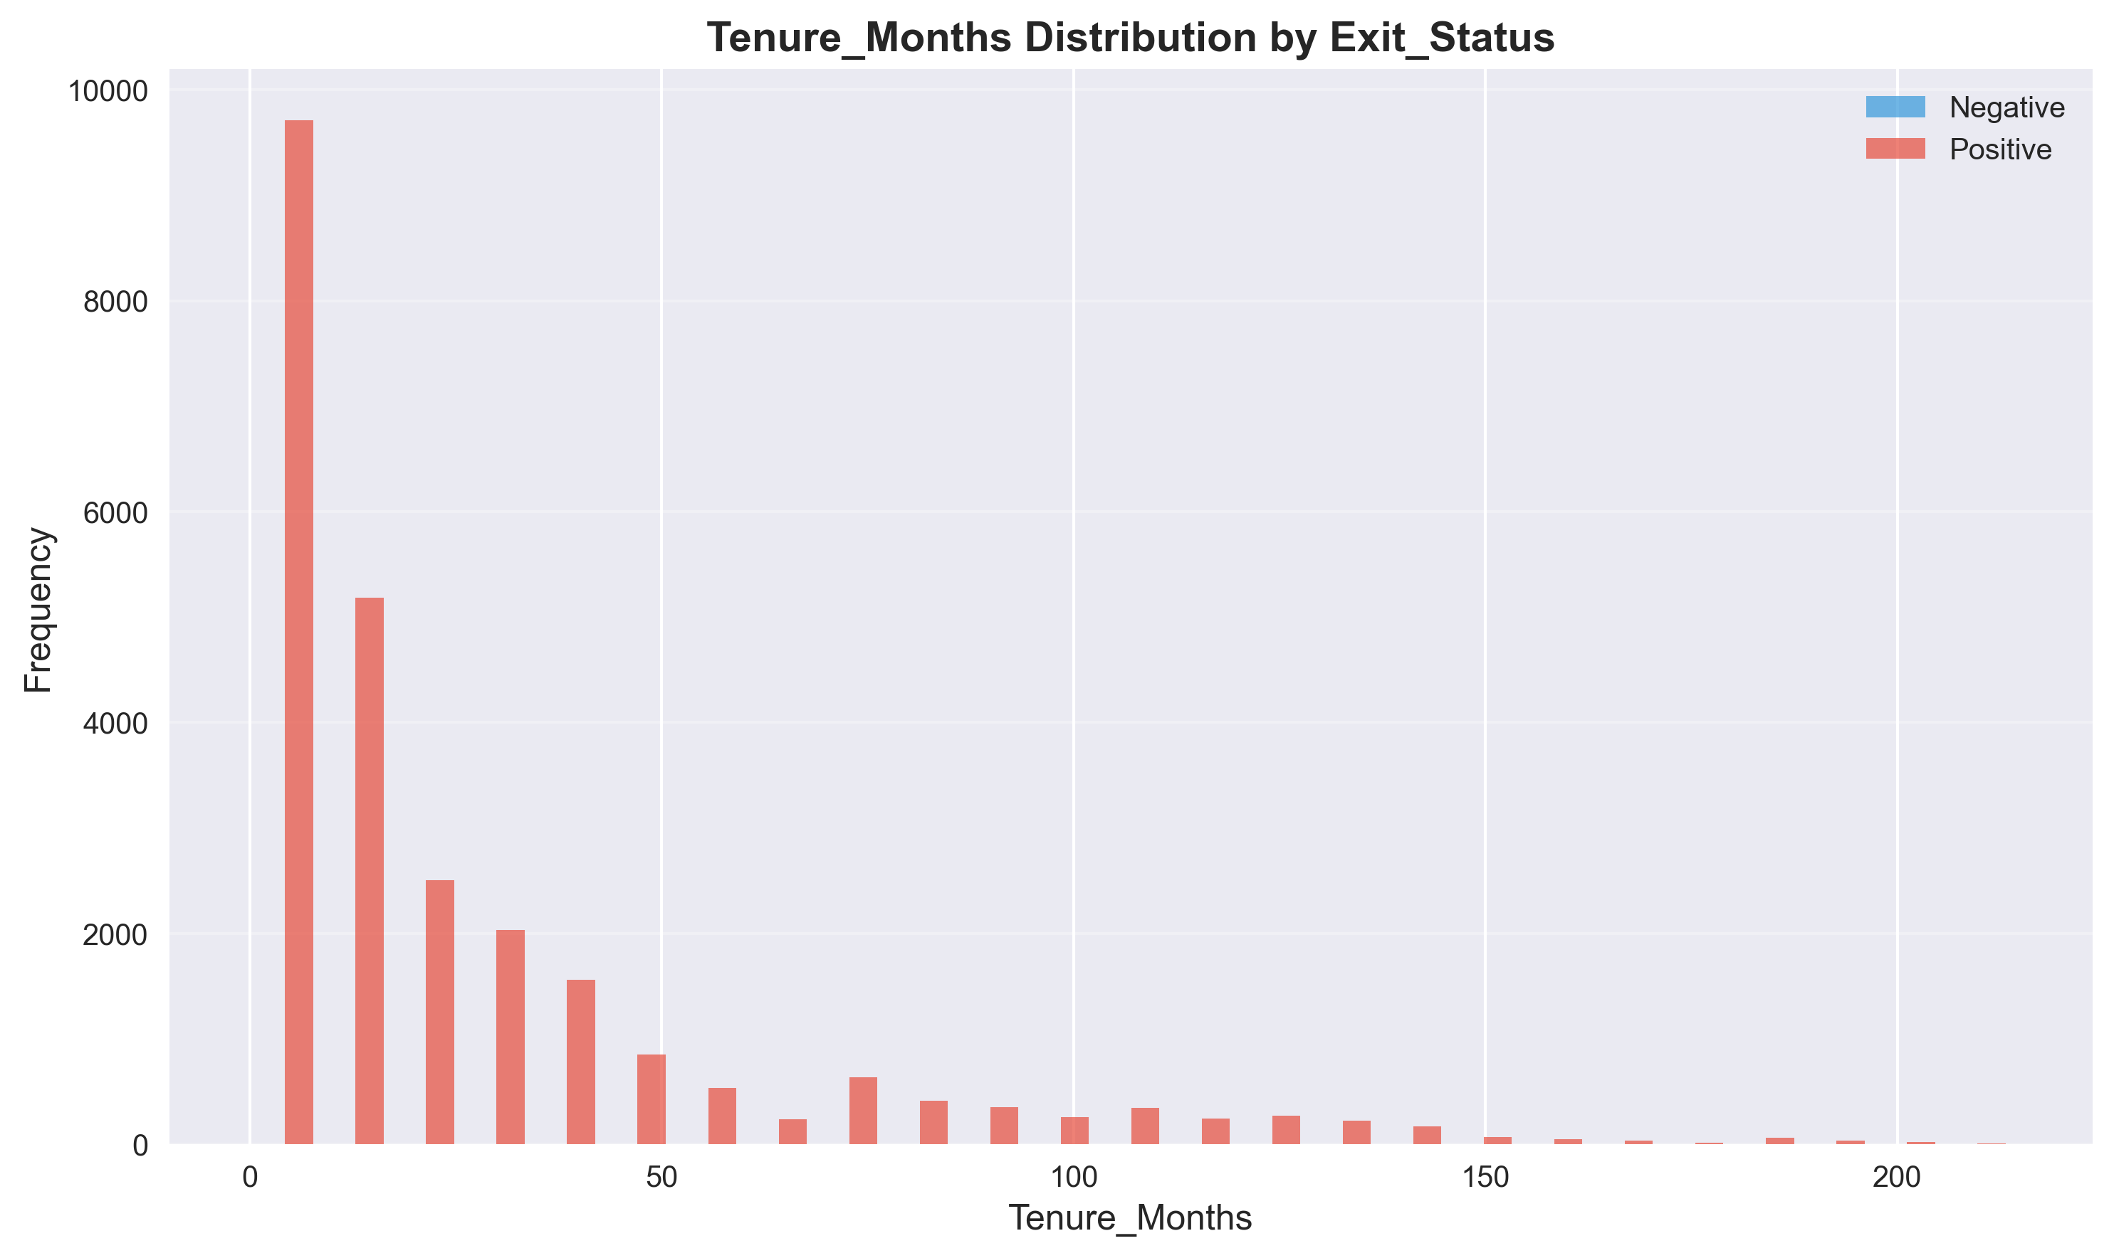
Mean: 26.79
Median: 13.00
Std Dev: 34.71
Min: 0.00
Max: 214.00

Attrition_Probability Distribution
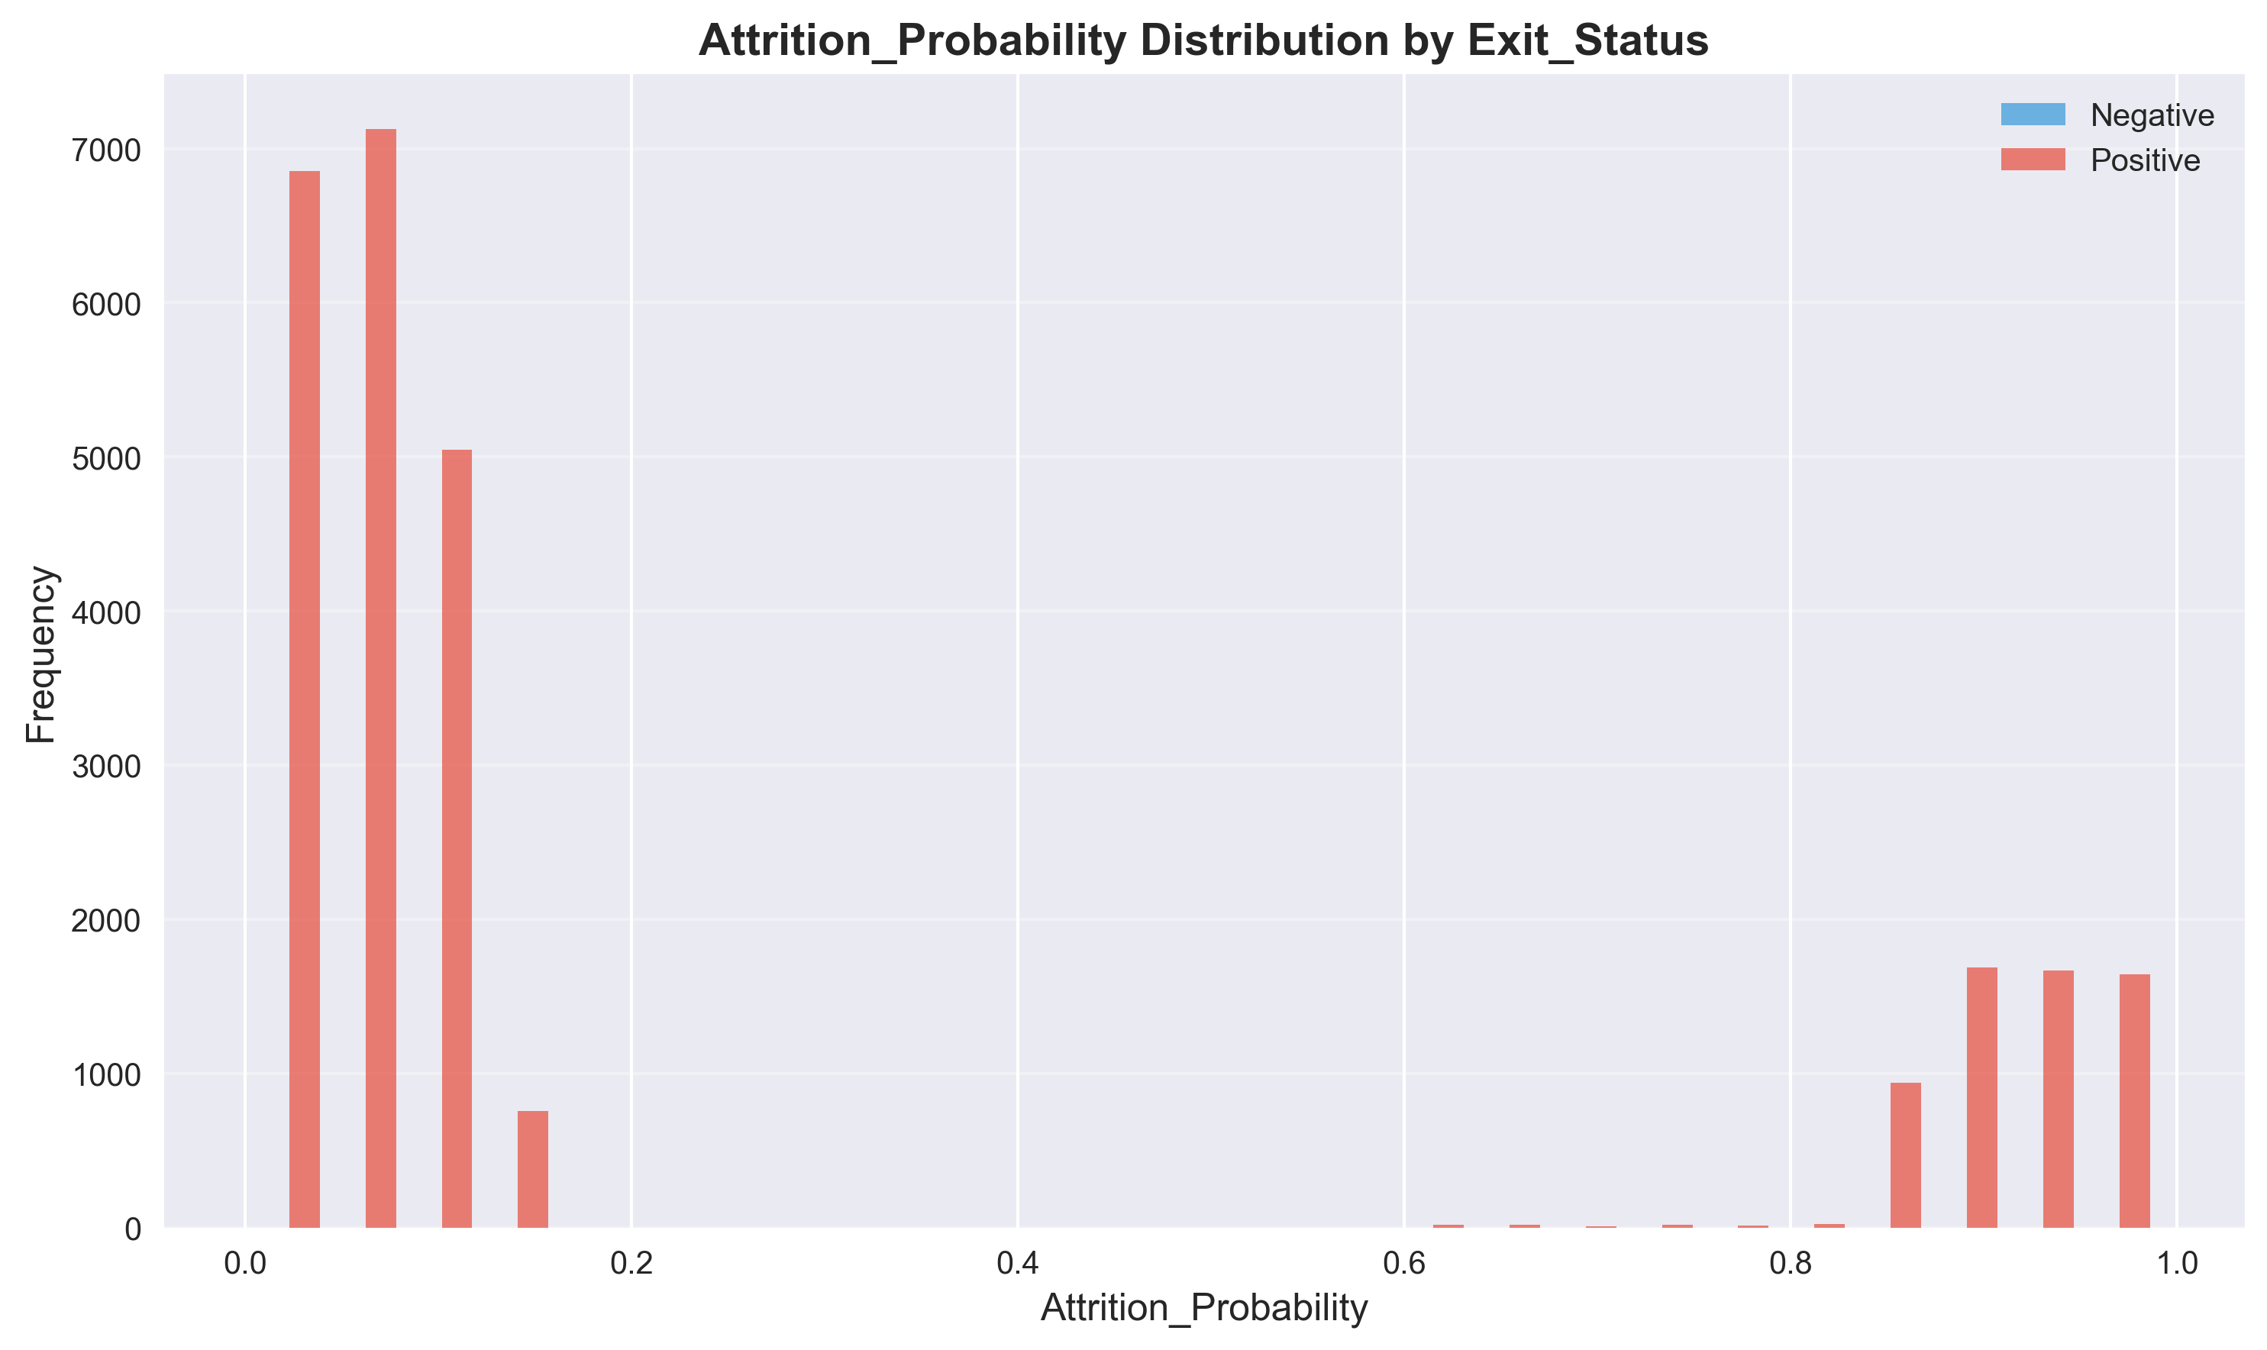
Mean: 0.26
Median: 0.08
Std Dev: 0.36
Min: 0.00
Max: 0.99

Age Distribution
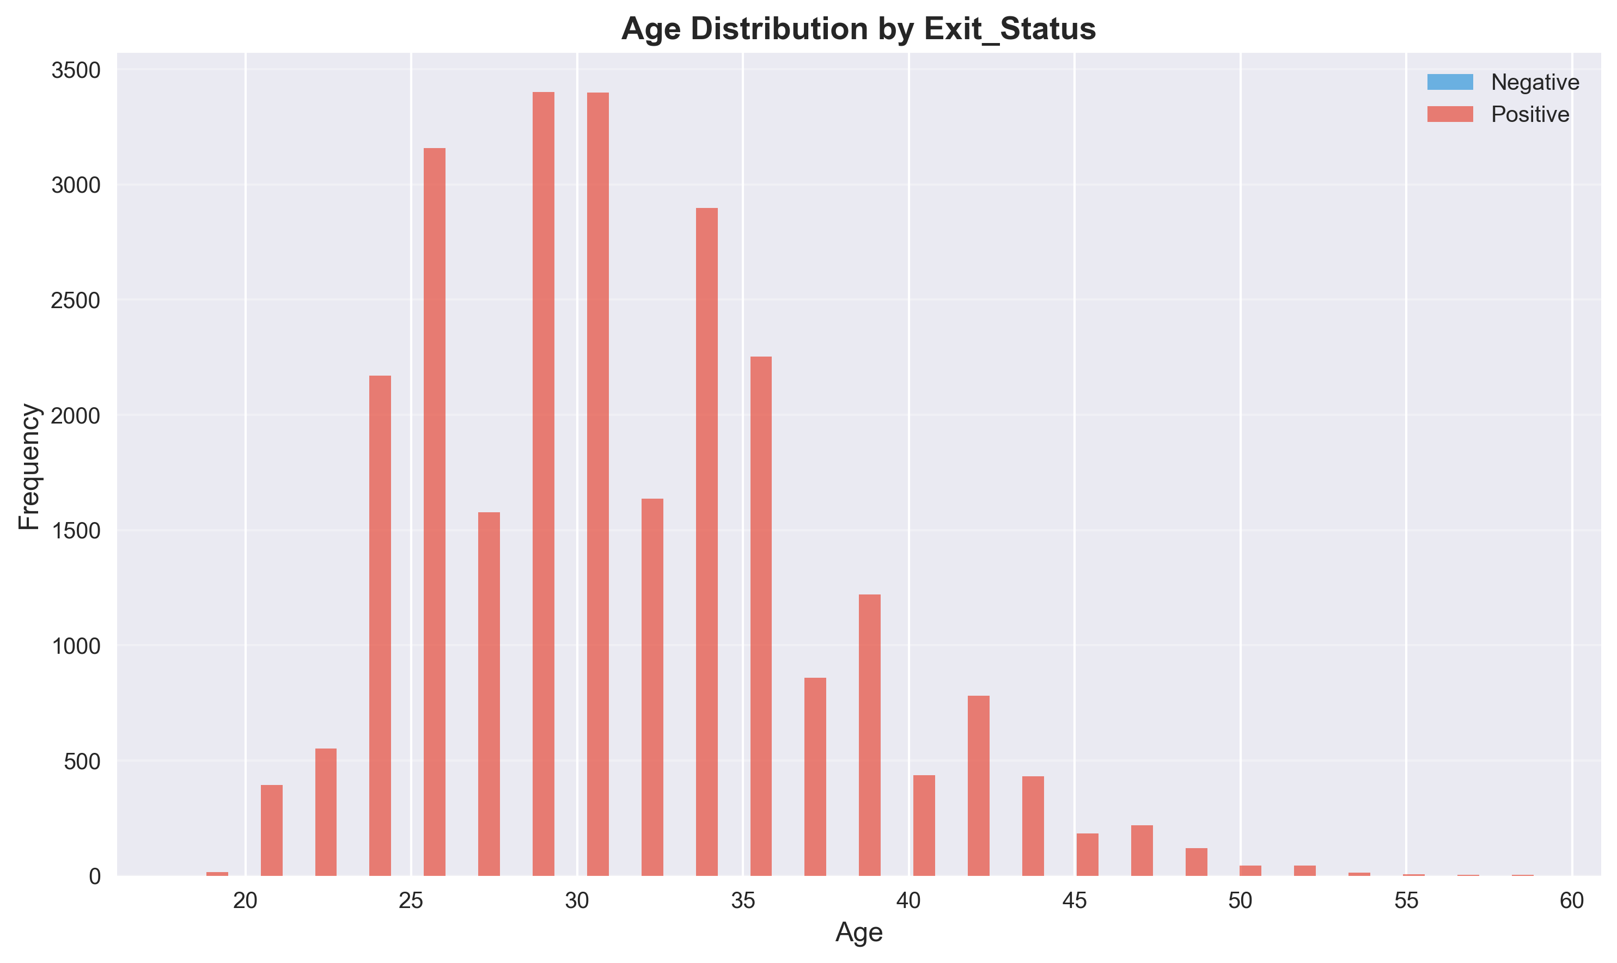
Mean: 31.07
Median: 30.00
Std Dev: 5.84
Min: 18.00
Max: 59.00

Years_of_Service Distribution
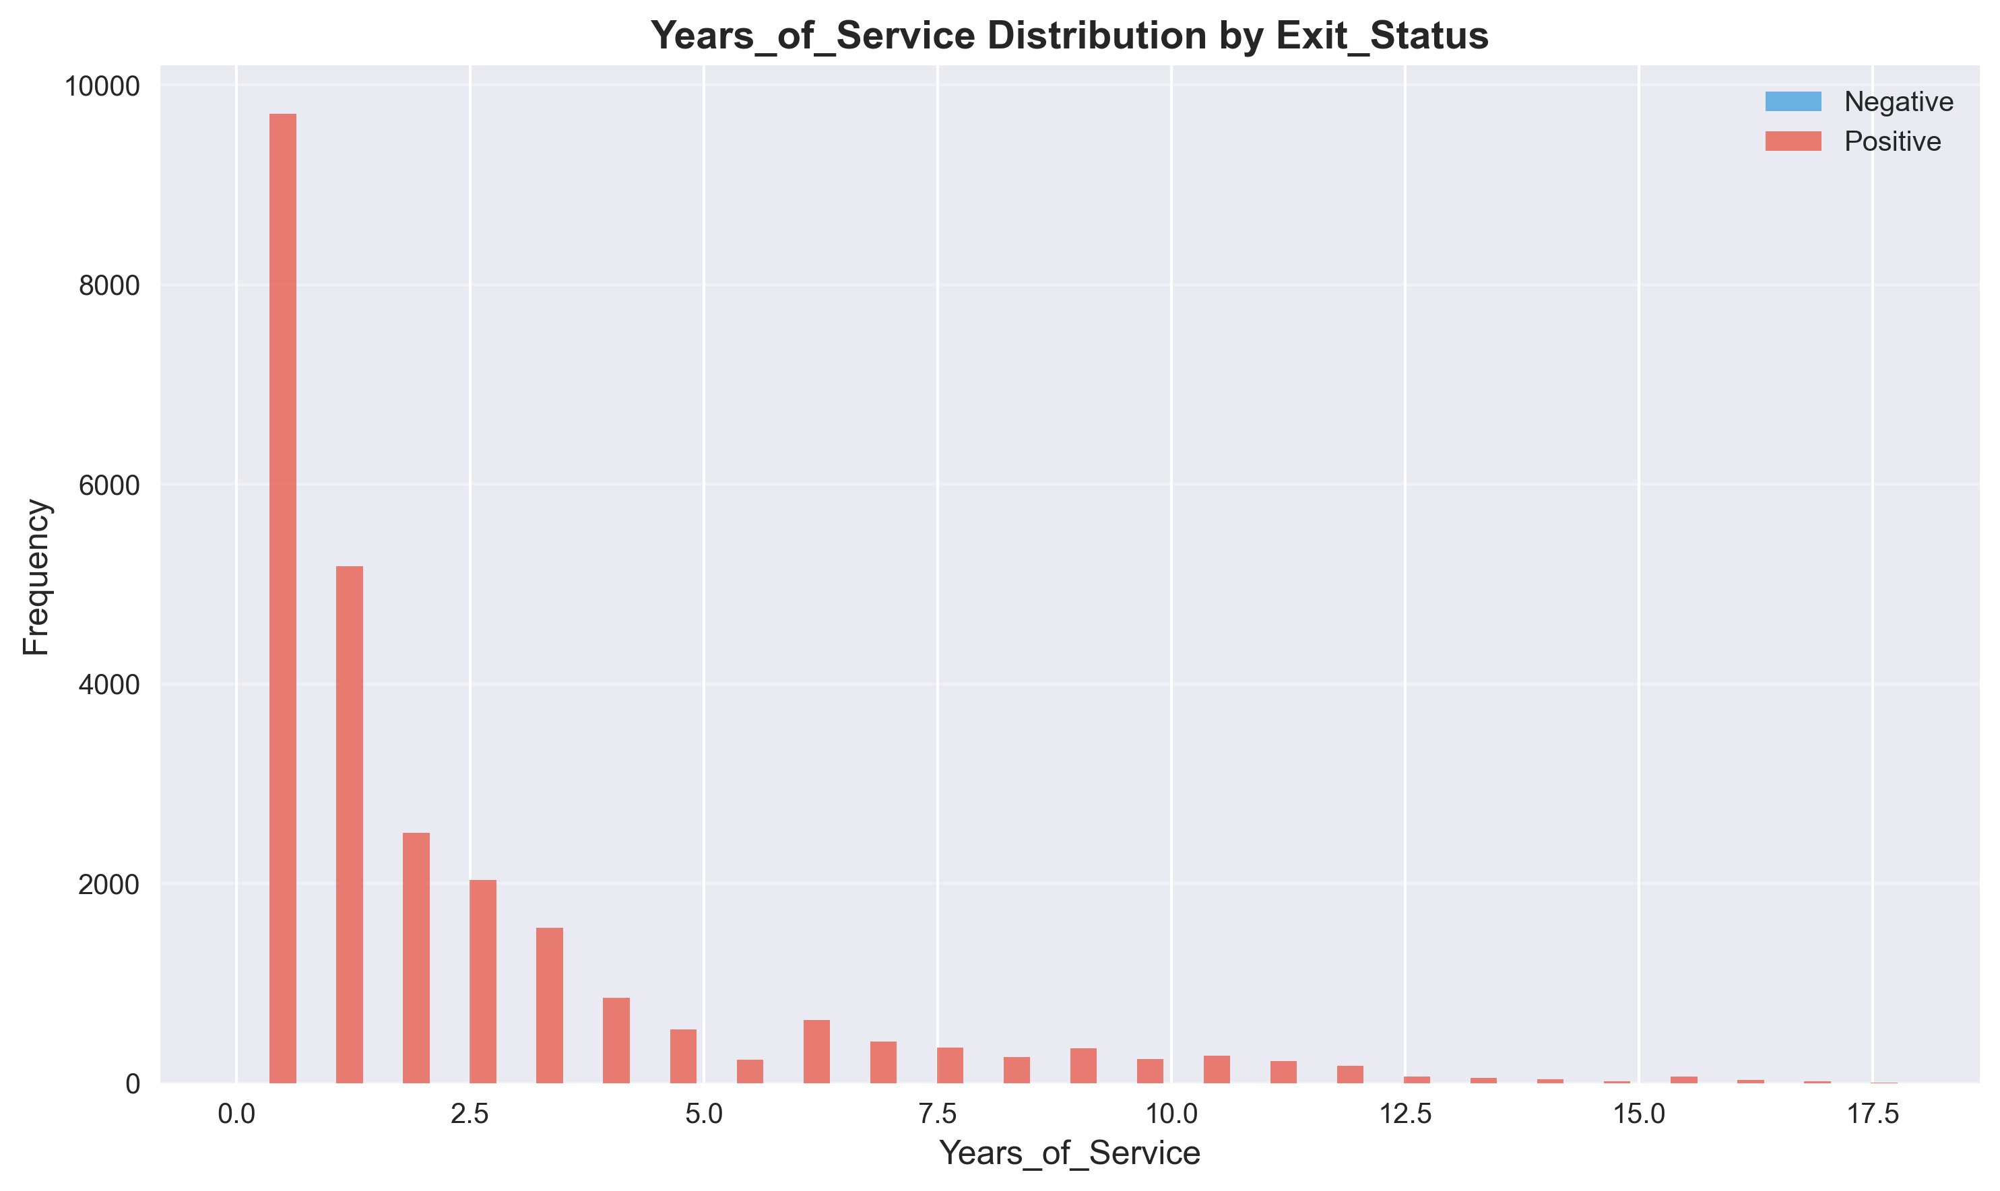
Mean: 2.23
Median: 1.08
Std Dev: 2.89
Min: 0.00
Max: 17.83

Priority_Rank Distribution
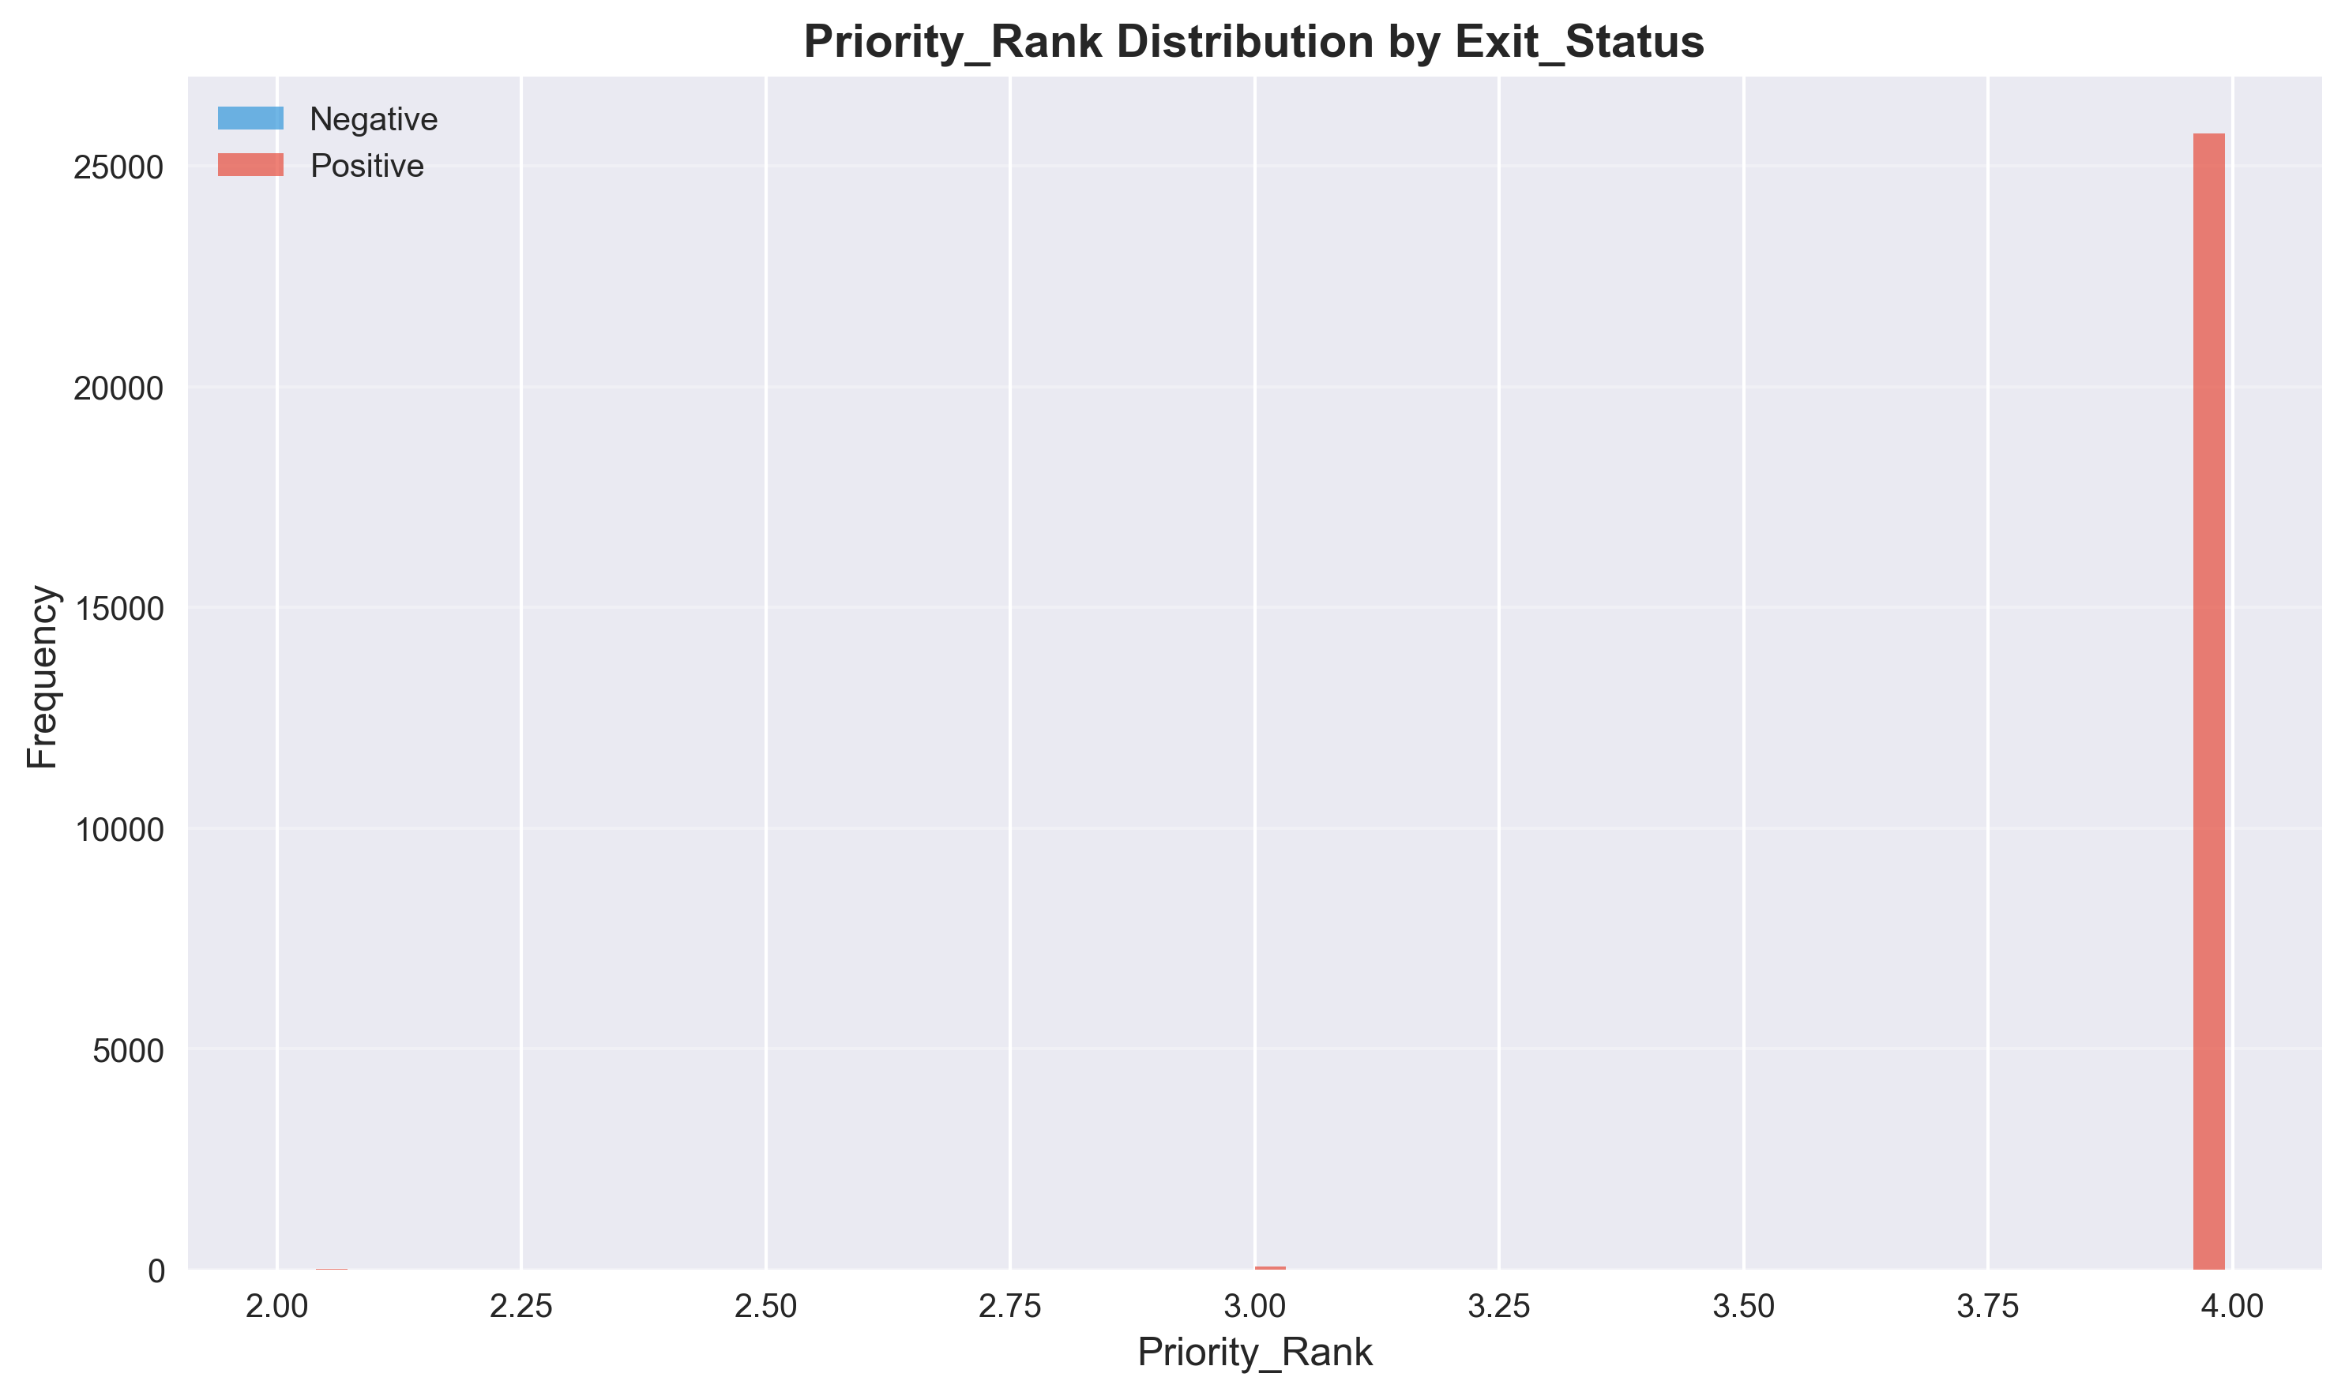
Mean: 4.00
Median: 4.00
Std Dev: 0.06
Min: 2.00
Max: 4.00

Temporal Analysis

Trends Over Time (DOJ)
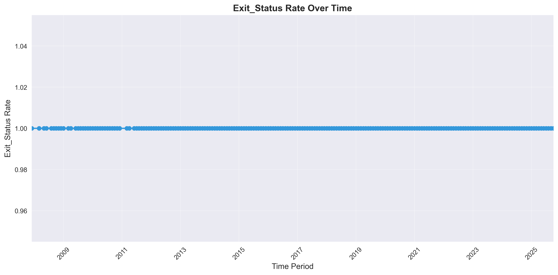

Trends Over Time (DOB)
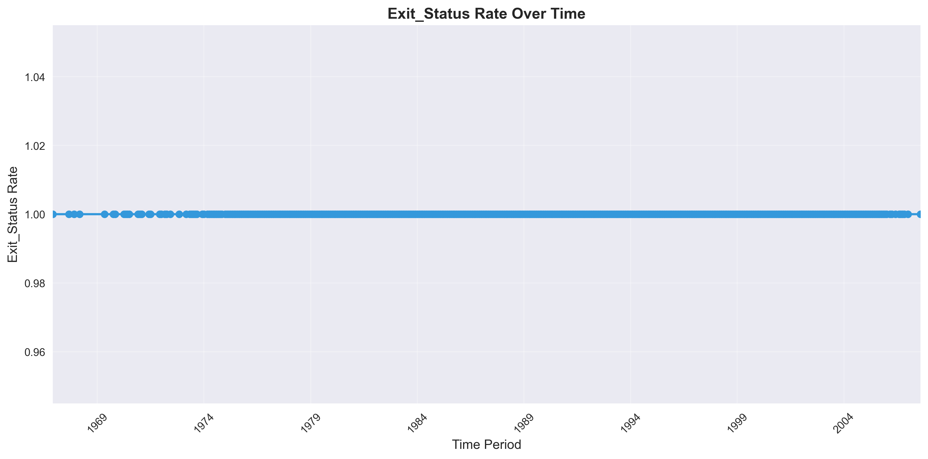

Feature Correlation Analysis
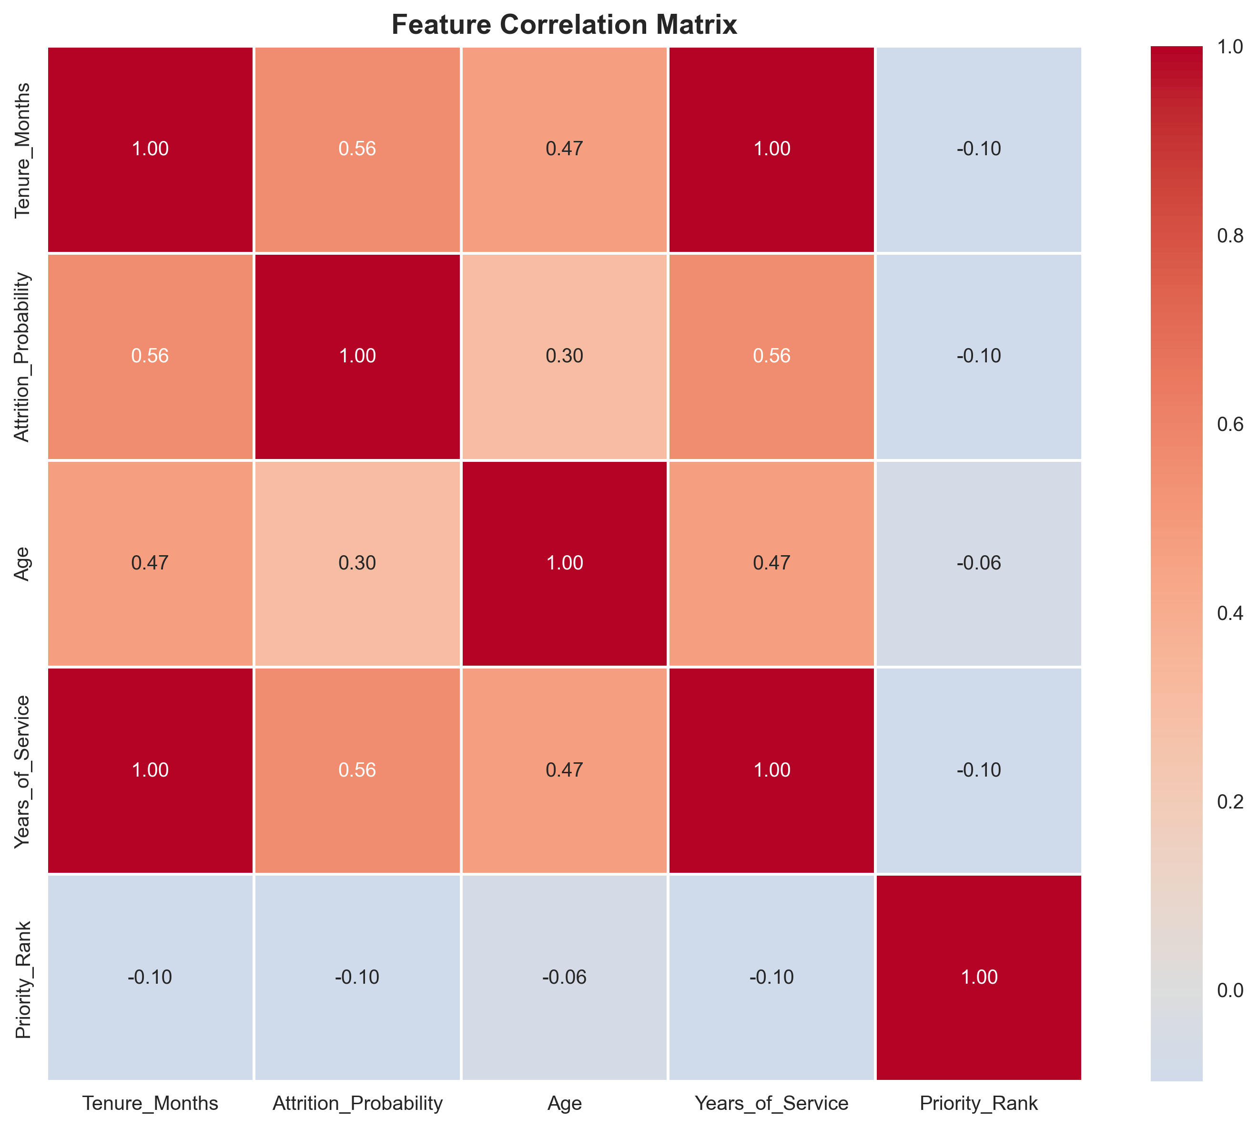

Predictive Risk Scoring
Risk scores are calculated based on feature importance and correlation with Exit_Status. Higher scores indicate higher likelihood of the positive outcome.
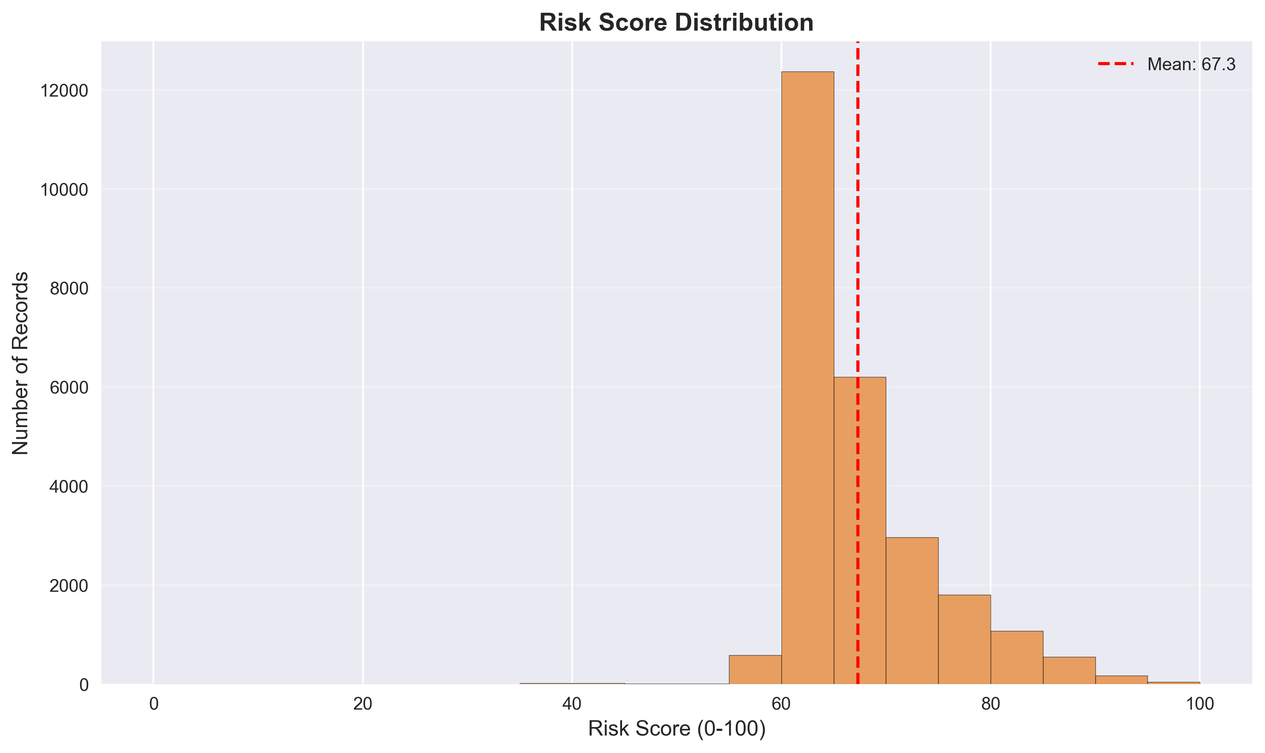

Strategic Recommendations
Priority | Area | Finding | Recommended Action | Expected Impact
HIGH | Data Monitoring | 100.0% overall rate | Implement continuous monitoring and alerting | Early detection and prevention
MEDIUM | Feature Engineering | 19 features analyzed | Develop additional predictive features | Improved prediction accuracy

Appendices

Appendix A: Feature Summary Statistics

Numerical Features
Feature | Mean | Std | Min | Max | Missing
Tenure_Months | 26.79 | 34.71 | 0.00 | 214.00 | 0
Attrition_Probability | 0.26 | 0.36 | 0.00 | 0.99 | 0
Age | 31.07 | 5.84 | 18.00 | 59.00 | 0
Years_of_Service | 2.23 | 2.89 | 0.00 | 17.83 | 0
Priority_Rank | 4.00 | 0.06 | 2.00 | 4.00 | 0

Appendix B: Methodology
Analysis Methodology:
Data Processing:
- Dataset analyzed: 25,821 records
- Target variable: Exit_Status
- Positive class: N
- Missing values handled appropriately
Statistical Methods:
- Descriptive statistics for all features
- Group-wise analysis for categorical variables
- Distribution analysis for numerical variables
- Correlation analysis for feature relationships
- Risk scoring using normalized feature values
Visualization:
- High-resolution charts (300 DPI)
- Professional color schemes
- Multiple chart types for different data types
Report Generation:
- Automated analysis and insights
- Actionable recommendations
- Executive-ready formatting

