Test Report Analysis Report
Comprehensive Test Report Analysis
Executive Report
Generated on December 19, 2025

Table of Contents
- Executive Summary
- Data Overview and Quality Assessment
- Key Performance Indicators
- status Analysis
- Feature Analysis
- Statistical Insights
- Prediction Scoring
- Strategic Recommendations
- Appendices

Executive Summary
This comprehensive report analyzes 8 records for Test Report.
Key Highlights:
• Overall status rate: 25.0%
• Total features analyzed: 4
• Data quality: 100.0% complete
This analysis provides actionable insights through statistical analysis, visualization,
and predictive scoring to support data-driven decision making.

Data Overview and Quality Assessment
**Dataset Size:** 8 records with 5 features

Data Quality Metrics
Metric | Value | Status
Total Records | 8 | Complete
Total Missing Values | 0 (0.0%) | Excellent
Data Completeness | 100.0% | Excellent
Numeric Features | 2 | Available
Categorical Features | 2 | Available

Key Performance Indicators
KPI | Value
Total Records | 8
status - Positive Class | 2
status Rate | 25.0%
Average age | 33.75
Average salary | 72250.00

status Distribution Analysis
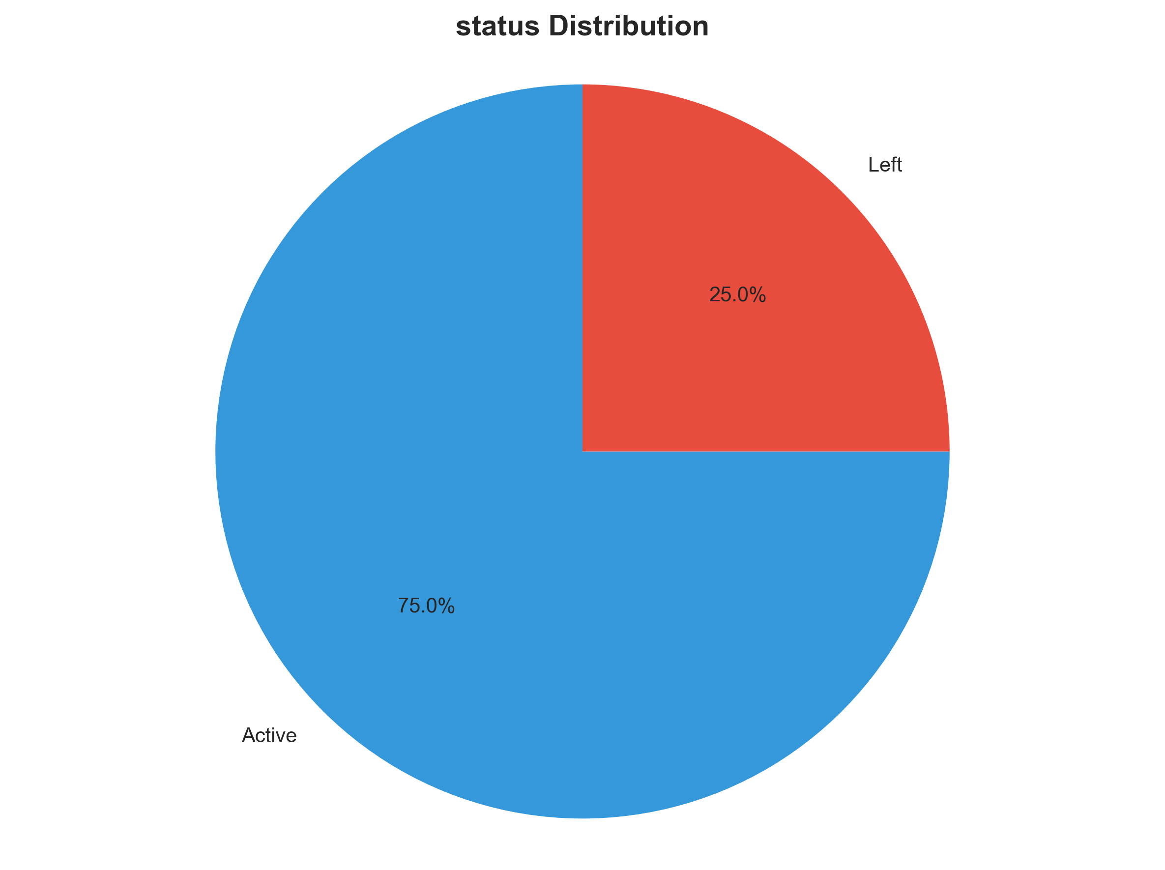

Categorical Features Analysis

name Analysis
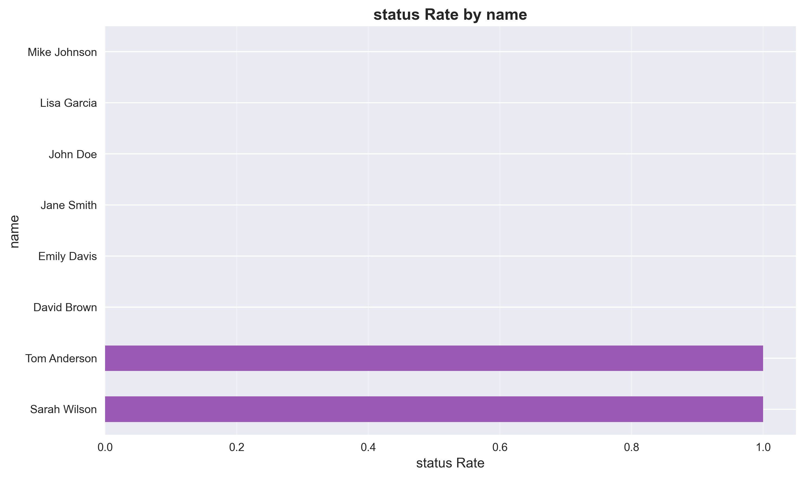

department Analysis
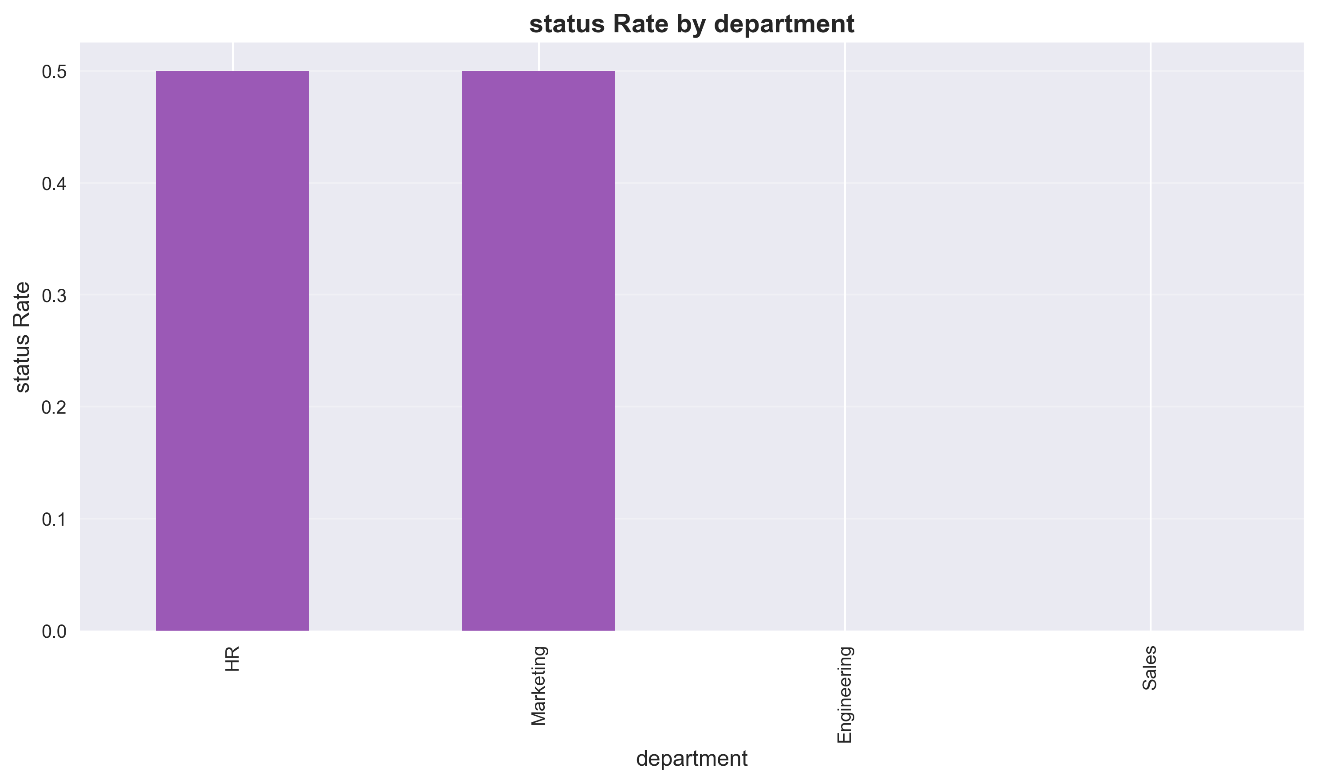

Numerical Features Analysis

age Distribution
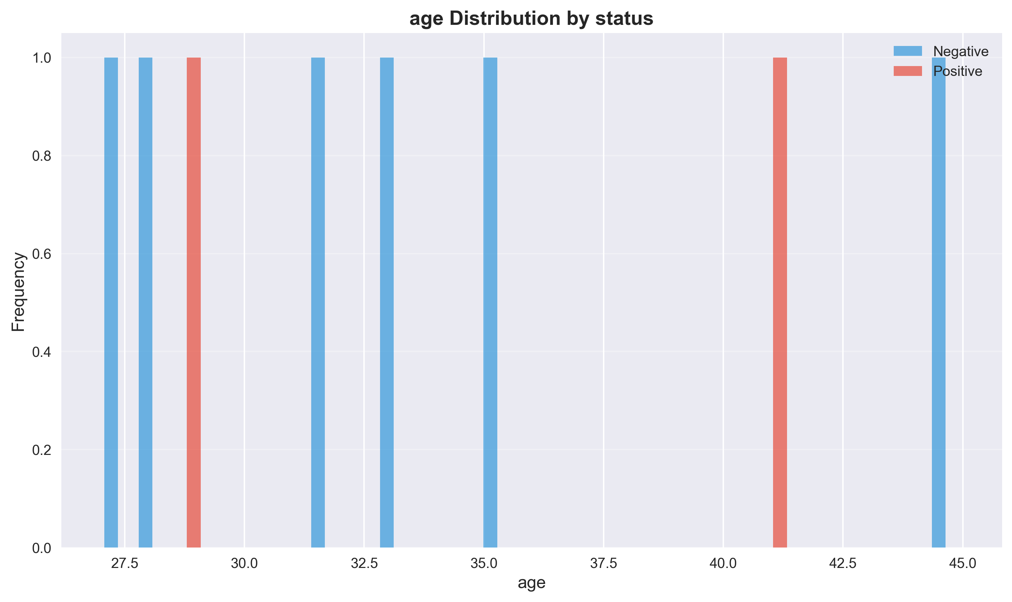
Mean: 33.75
Median: 32.50
Std Dev: 6.39
Min: 27.00
Max: 45.00

salary Distribution
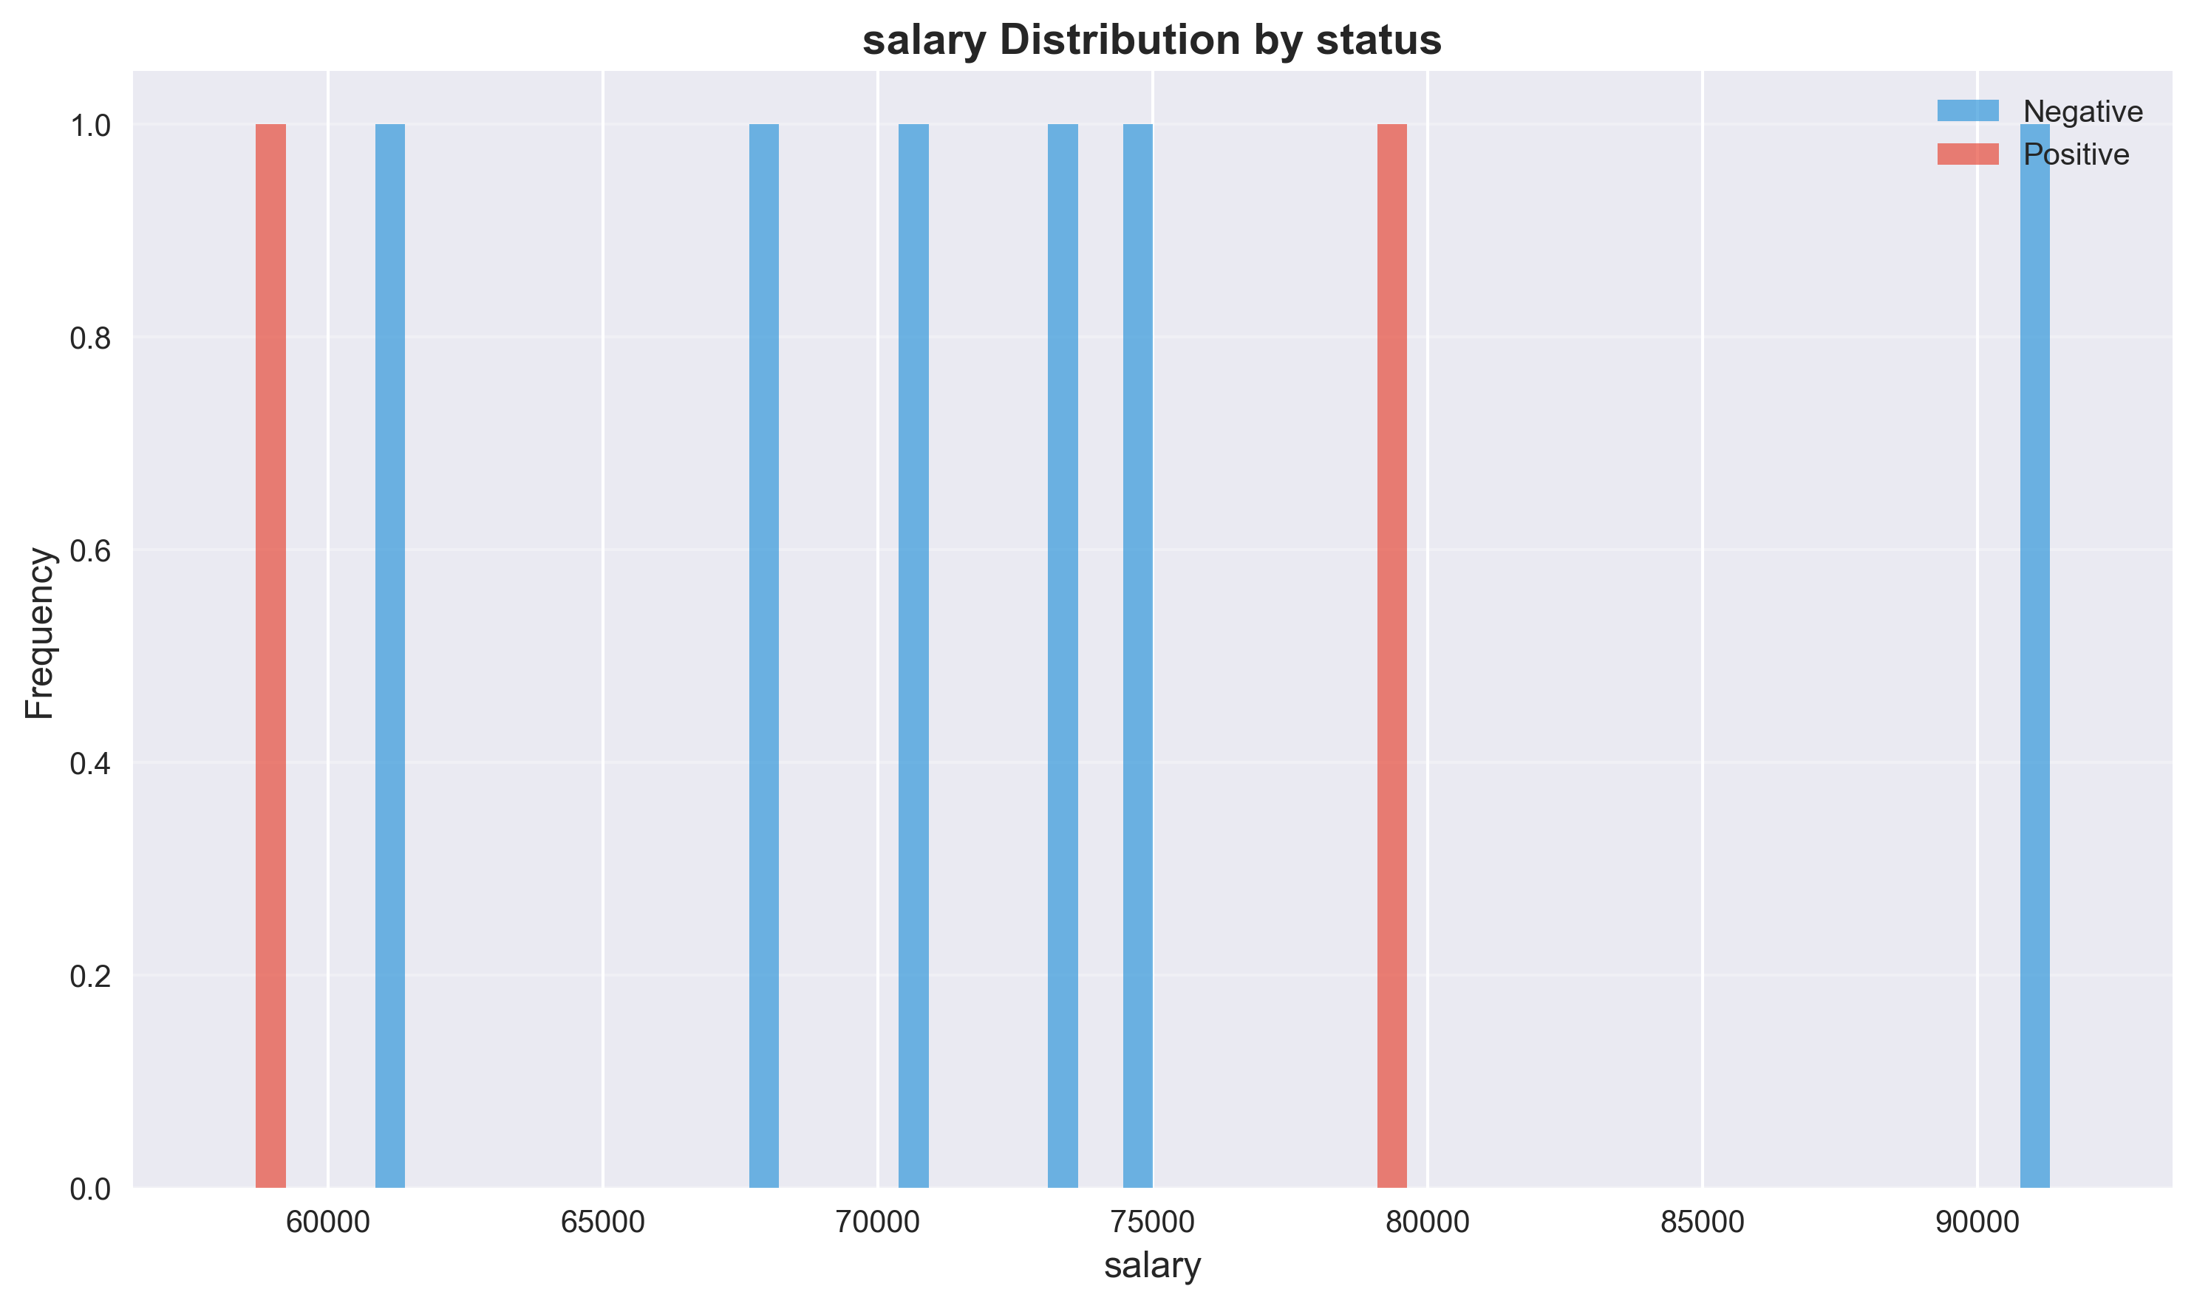
Mean: 72250.00
Median: 72000.00
Std Dev: 10498.30
Min: 58000.00
Max: 92000.00

Feature Correlation Analysis
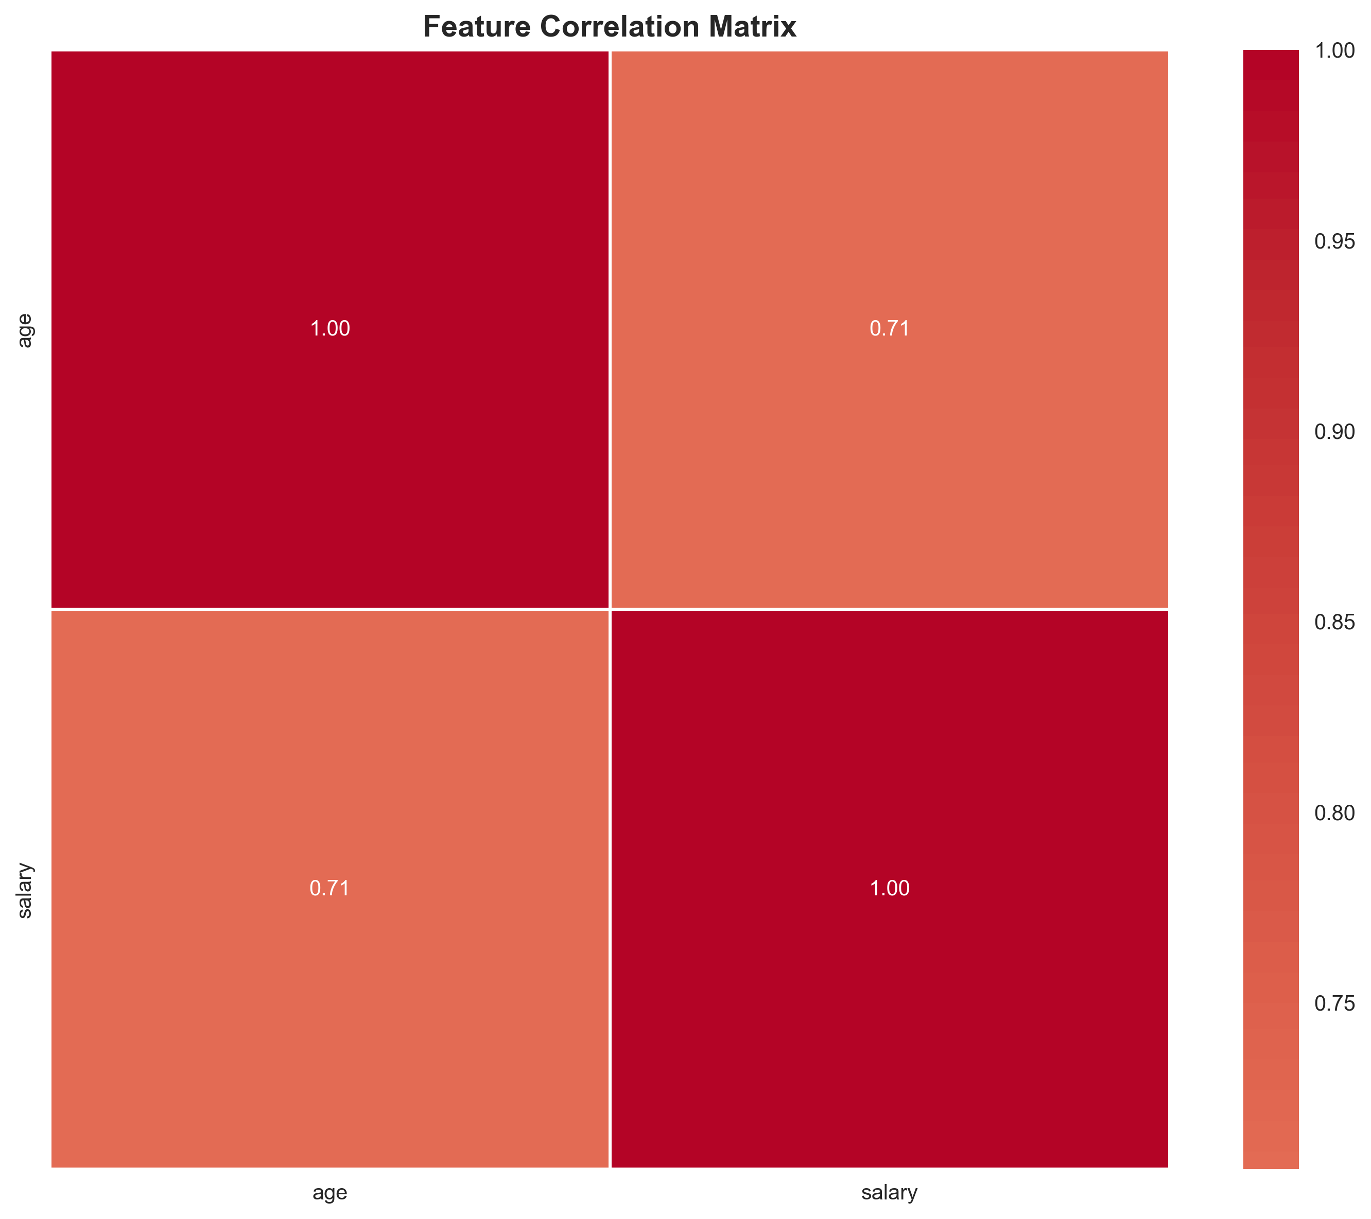

Predictive Risk Scoring
Risk scores are calculated based on feature importance and correlation with status. Higher scores indicate higher likelihood of the positive outcome.
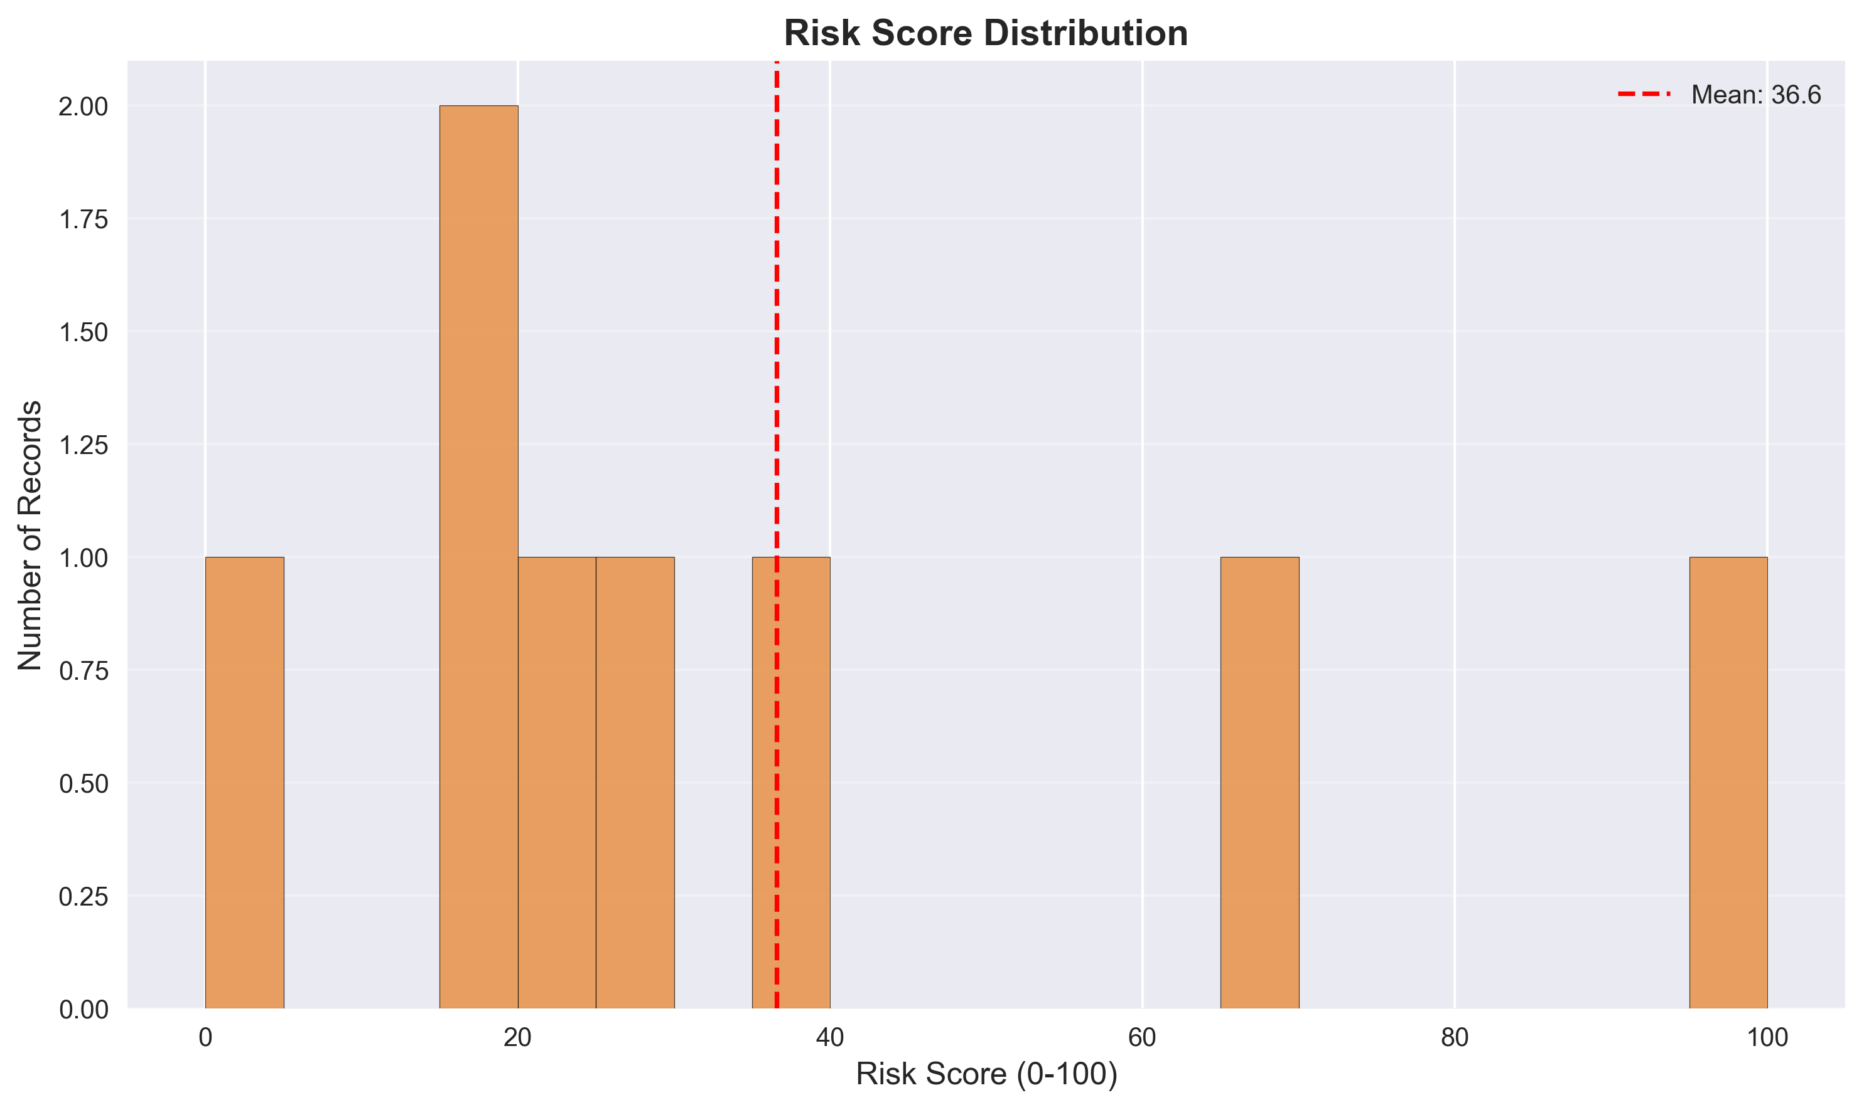

Strategic Recommendations
Priority | Area | Finding | Recommended Action | Expected Impact
HIGH | name | High variance in status rates | Focus on Sarah Wilson segment | 100.0% rate in highest segment
HIGH | department | High variance in status rates | Focus on HR segment | 50.0% rate in highest segment
HIGH | Data Monitoring | 25.0% overall rate | Implement continuous monitoring and alerting | Early detection and prevention
MEDIUM | Feature Engineering | 4 features analyzed | Develop additional predictive features | Improved prediction accuracy

Appendices

Appendix A: Feature Summary Statistics

Numerical Features
Feature | Mean | Std | Min | Max | Missing
age | 33.75 | 6.39 | 27.00 | 45.00 | 0
salary | 72250.00 | 10498.30 | 58000.00 | 92000.00 | 0

Appendix B: Methodology
Analysis Methodology:
Data Processing:
- Dataset analyzed: 8 records
- Target variable: status
- Positive class: Left
- Missing values handled appropriately
Statistical Methods:
- Descriptive statistics for all features
- Group-wise analysis for categorical variables
- Distribution analysis for numerical variables
- Correlation analysis for feature relationships
- Risk scoring using normalized feature values
Visualization:
- High-resolution charts (300 DPI)
- Professional color schemes
- Multiple chart types for different data types
Report Generation:
- Automated analysis and insights
- Actionable recommendations
- Executive-ready formatting

