# EC2 and EFS Assignment

Three EC2 Instances with different OS

Amazon

RedHat

Ubuntu

EFS

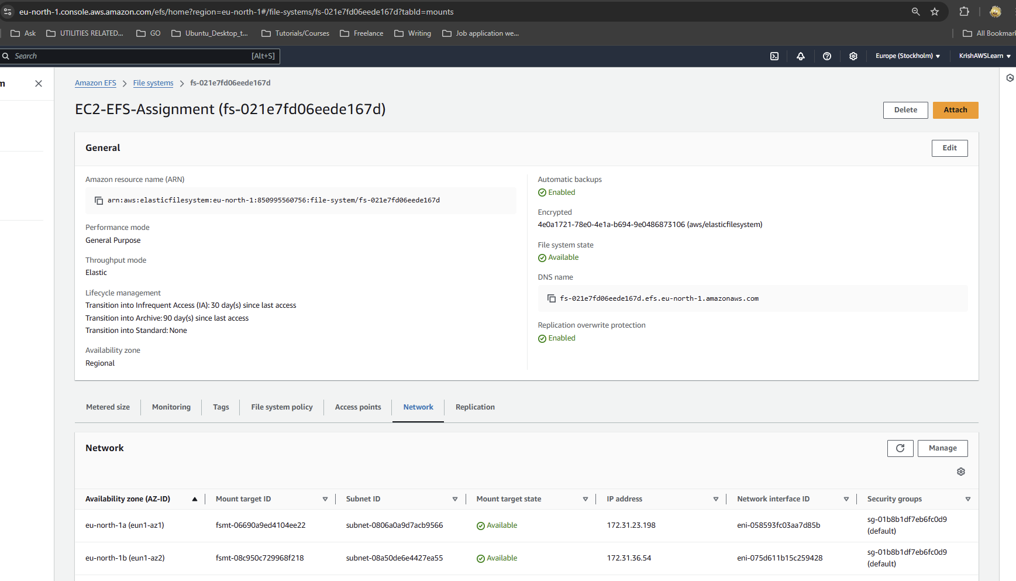

Mount to Ubuntu EC2

Mount to Amazon EC2

Mount to RedHat EC2

