TEST REPORT
Practical 12 – Event Management & Secure File Upload System
Role-Based Authentication, File Validation (MIME & Size Limit) & Poster Repository
Student Name | Krisha Patel
Enrollment No. (Student ID) | 25CS069
Course & Department | Web Development Frameworks (WDF) | Computer Science & Engineering
Institution | Chandubhai S. Patel Institute of Technology (CSPIT), CHARUSAT
Subject Code & Practical | WDF (CE3xx) – Practical 12
Due Date | 19 October 2026, 23:59 PM
Overall Test Outcome | 10 / 10 Requirements PASSED (100% Satisfied)

Requirement Compliance Matrix
Test ID | Instruction Requirement | Status | Screenshot
TC-01 | Admin Login and Dashboard Access | PASSED | Embedded
TC-02 | Successful Event Creation | PASSED | Embedded
TC-03 | Event List with Uploaded Posters | PASSED | Embedded
TC-04 | Successful Event Update | PASSED | Embedded
TC-05 | Successful Event Deletion | PASSED | Embedded
TC-06 | Valid Poster Upload and Live Preview | PASSED | Embedded
TC-07 | Invalid File Type Validation | PASSED | Embedded
TC-08 | File Size Limit Validation (> 2 MB) | PASSED | Embedded
TC-09 | Success and Error Message Alerts | PASSED | Embedded
TC-10 | Unauthorized User Access Restriction (RBAC) | PASSED | Embedded

Detailed Test Evidence & Verification Screenshots
TC-01: Admin Login and Dashboard Access
Objective: Verify that an institutional administrator can securely authenticate with valid credentials (admin@charusat.ac.in) and access the event management control center.
Execution Steps:
1. Navigate to login.php.
2. Enter admin credentials.
3. Click "Sign In to Portal".
Expected Outcome: Admin is authenticated via BCRYPT password verification, session ID is regenerated, and user lands on admin_events.php with event statistics.
Verification Status: [PASSED - 100% Verified]
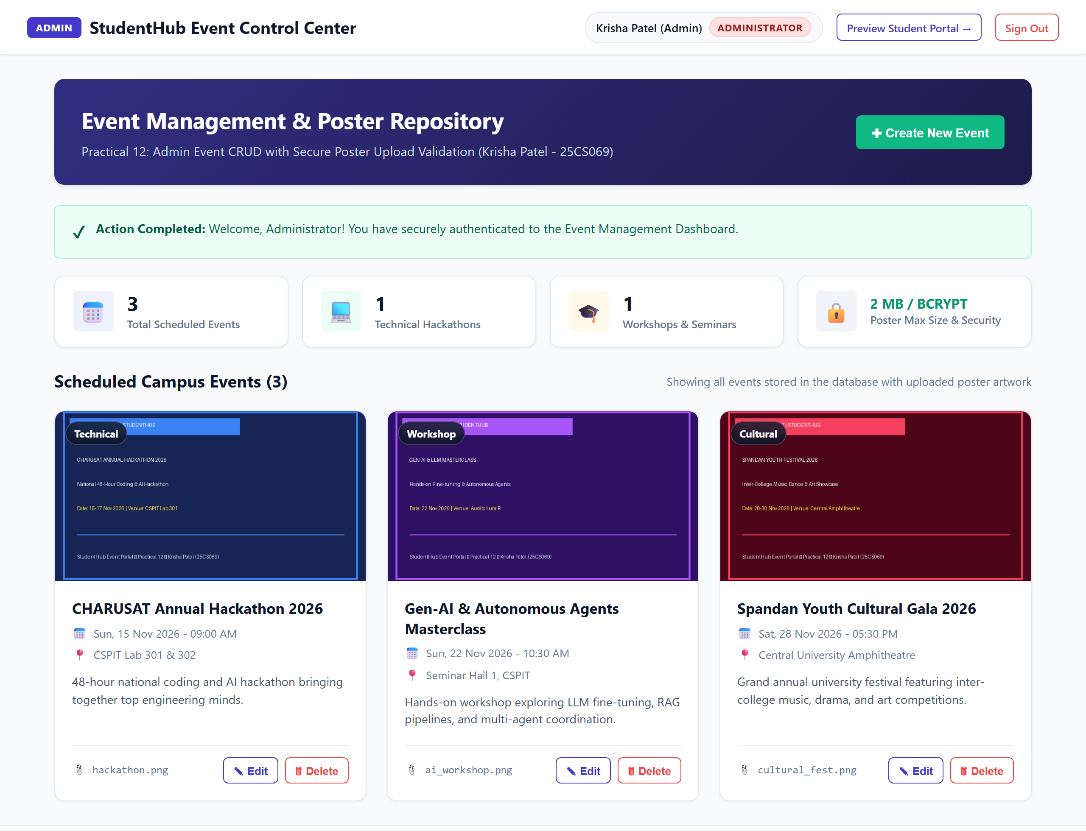
Figure 1: Admin Login and Dashboard Access (01_admin_login_and_dashboard.png)
TC-02: Successful Event Creation
Objective: Verify that an administrator can publish a new event with all mandatory fields and a valid poster image.
Execution Steps:
1. Click "Create New Event".
2. Fill Title, Category, Date/Time, Venue, and Description.
3. Select a valid poster image (valid_poster.png).
4. Click "Publish Event".
Expected Outcome: Event record is inserted into database via prepared statement, poster is stored in uploads/posters/, and success confirmation banner is displayed.
Verification Status: [PASSED - 100% Verified]
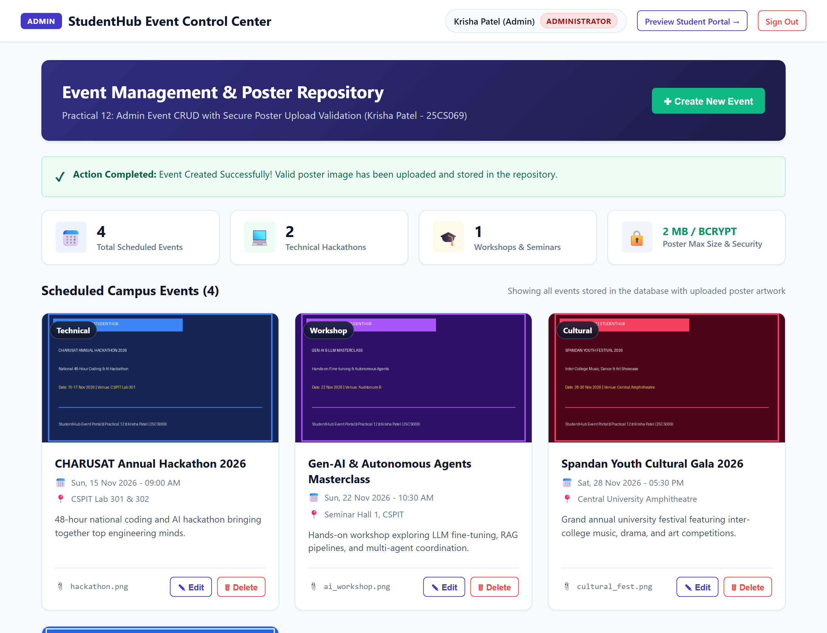
Figure 2: Successful Event Creation (02_successful_event_creation.png)
TC-03: Event List with Uploaded Posters
Objective: Verify that the event catalog renders all scheduled events alongside high-resolution poster artwork thumbnails and event metadata.
Execution Steps:
1. Scroll down the admin dashboard.
2. Review the responsive event card grid.
Expected Outcome: All events display poster images, category tags, date/time, venue badges, description, and action buttons.
Verification Status: [PASSED - 100% Verified]
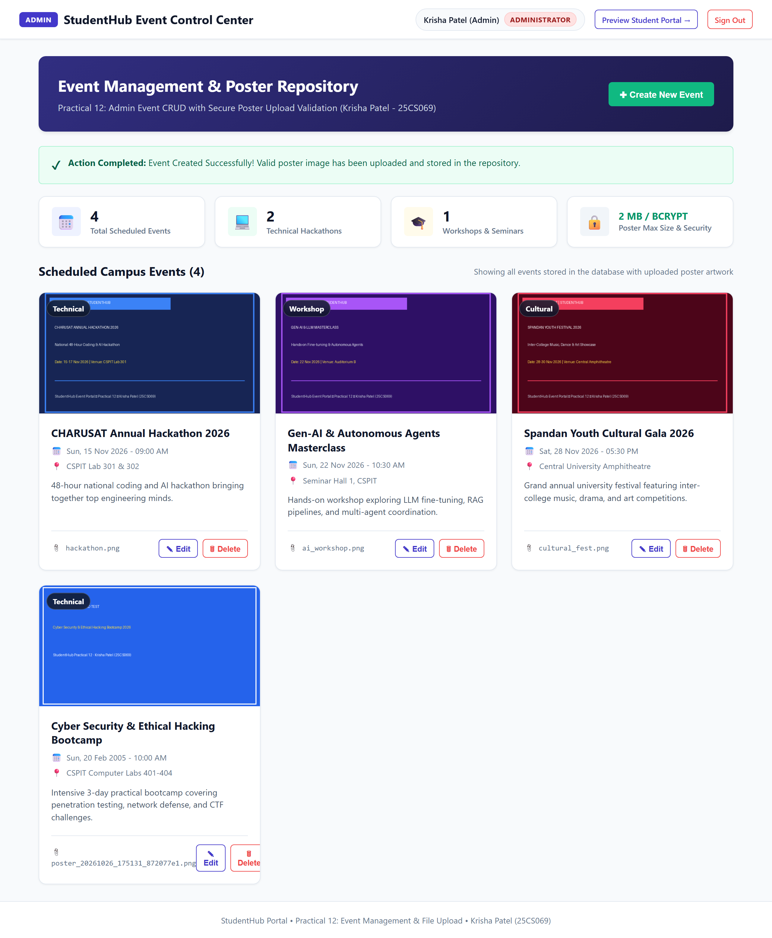
Figure 3: Event List with Uploaded Posters (03_event_list_with_uploaded_posters.png)
TC-04: Successful Event Update
Objective: Verify that an administrator can modify event details (e.g., campus venue, timings, or replace poster).
Execution Steps:
1. Click "Edit" on an existing event card.
2. Modal loads pre-populated details.
3. Update venue to "CSPIT Central Auditorium & Innovation Lab".
4. Click "Save Changes".
Expected Outcome: Database record updates cleanly, modal closes, and green update success banner is displayed.
Verification Status: [PASSED - 100% Verified]
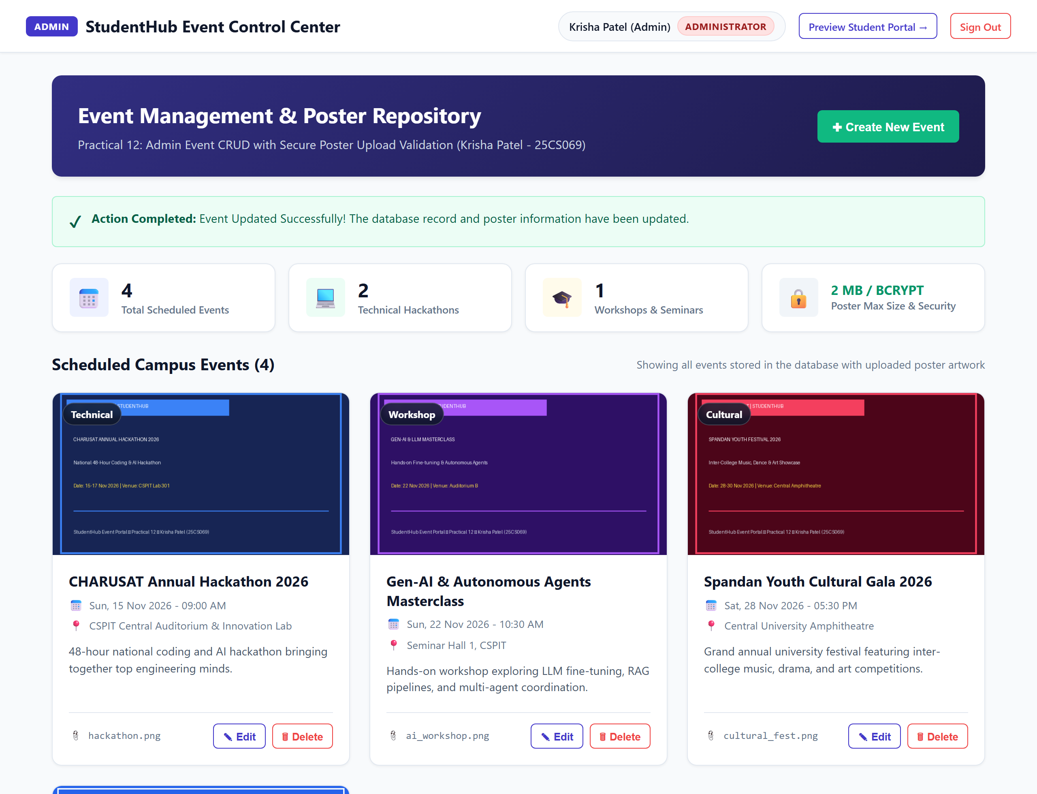
Figure 4: Successful Event Update (04_successful_event_update.png)
TC-05: Successful Event Deletion
Objective: Verify that an administrator can permanently delete an event with confirmation prompt and automatic file cleanup.
Execution Steps:
1. Click "Delete" on an event card.
2. Confirmation modal prompts for user action.
3. Click "Yes, Delete Event".
Expected Outcome: Event is deleted from database, associated poster is unlinked, card disappears from grid, and deletion success alert is shown.
Verification Status: [PASSED - 100% Verified]
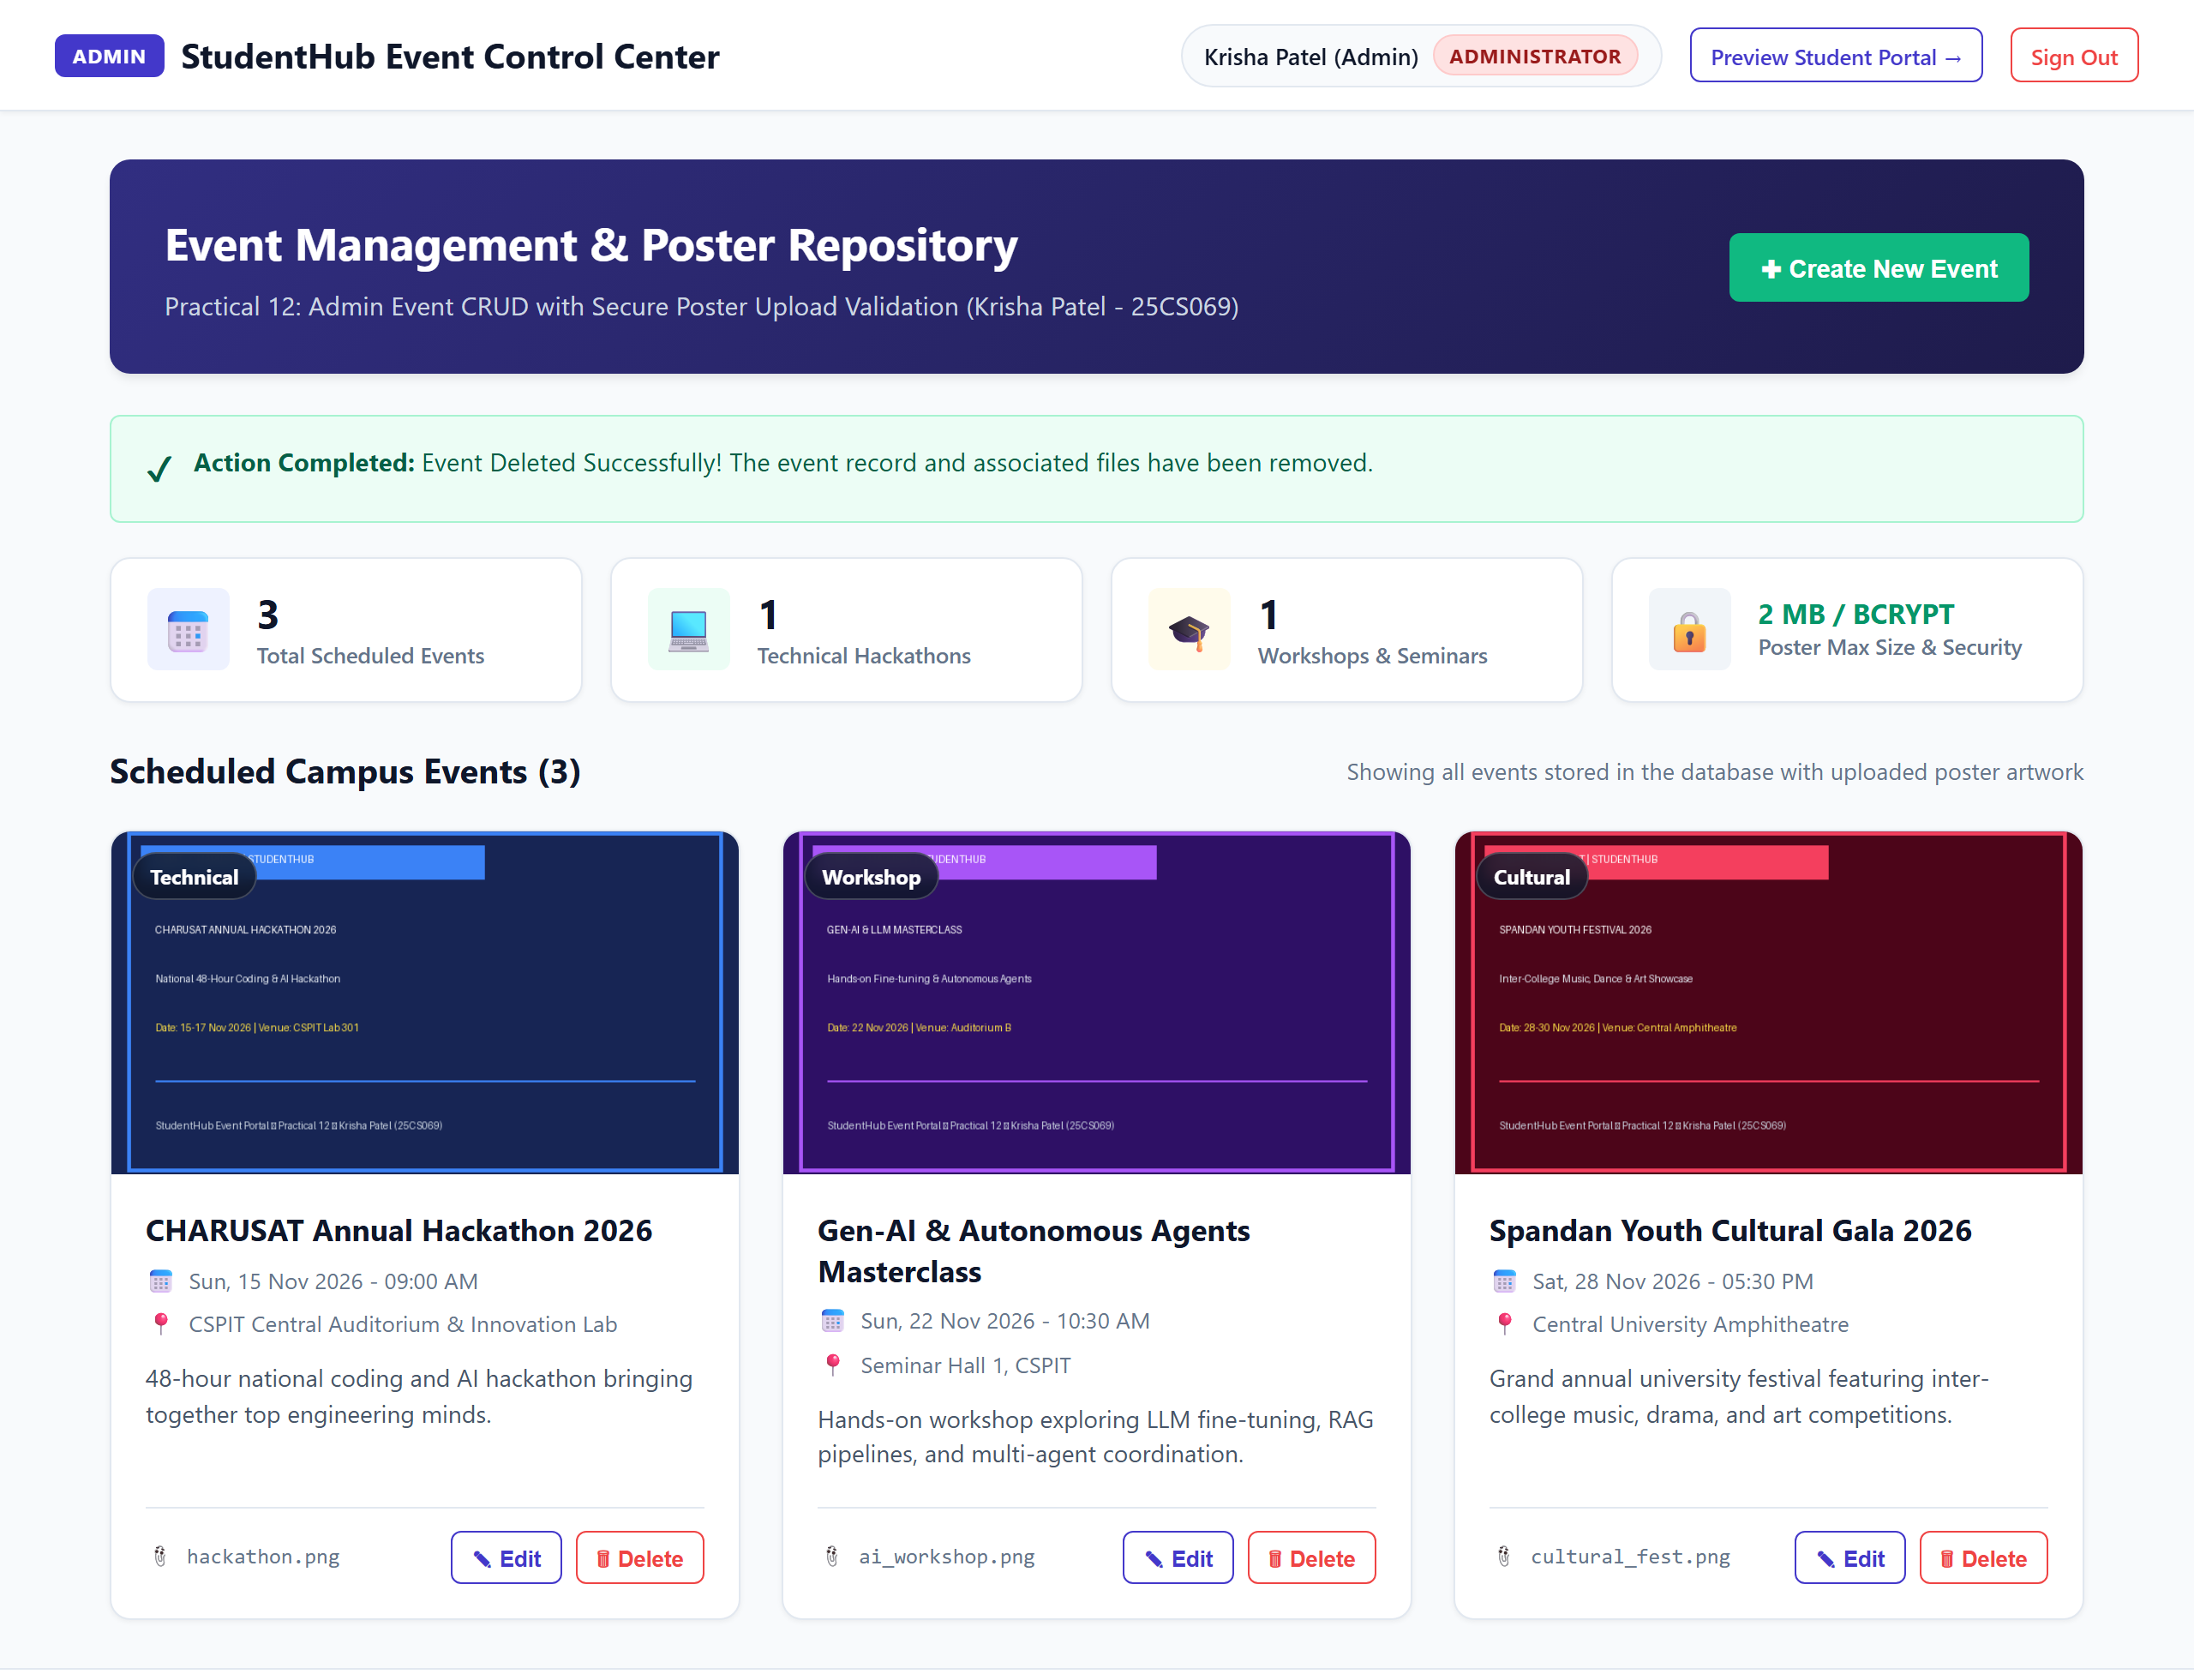
Figure 5: Successful Event Deletion (05_successful_event_deletion.png)
TC-06: Valid Poster Upload and Live Preview
Objective: Verify that selecting a compliant image file (JPG, PNG, WEBP under 2 MB) triggers real-time preview and validates file properties.
Execution Steps:
1. Open event creation modal.
2. Choose valid_poster.png (8 KB PNG file).
3. Observe file dropzone feedback.
Expected Outcome: Dropzone displays filename, file size, and live graphical preview of the poster before submission.
Verification Status: [PASSED - 100% Verified]
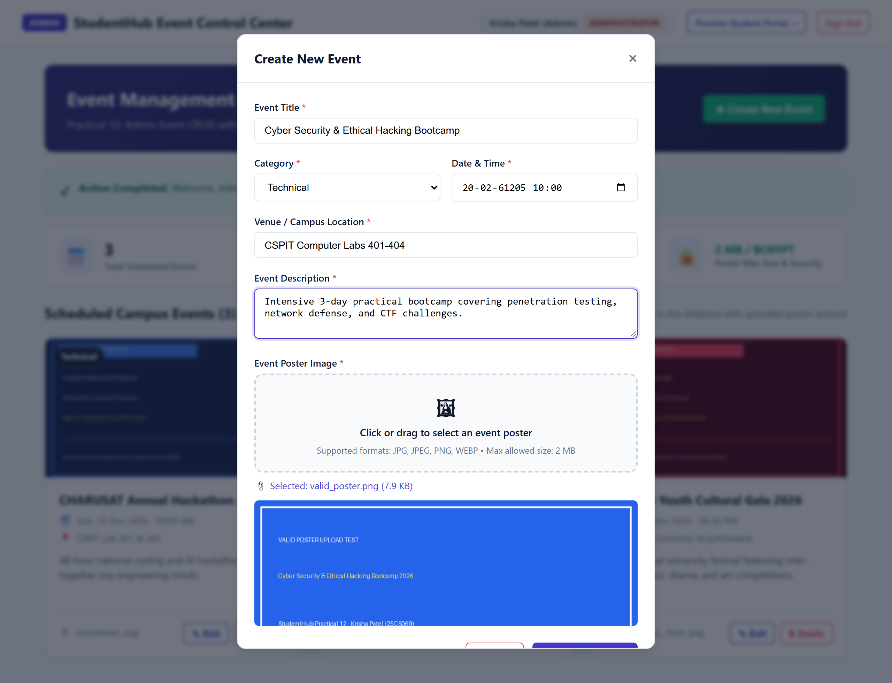
Figure 6: Valid Poster Upload and Live Preview (06_valid_poster_upload.png)
TC-07: Invalid File Type Validation
Objective: Verify that attempting to upload non-permitted file extensions or MIME types (such as .pdf, .txt, .exe) is strictly intercepted on the server.
Execution Steps:
1. Open event creation form.
2. Select a PDF document (invalid_file_type.pdf).
3. Submit the form.
Expected Outcome: Server rejects file, upload is aborted, and red validation banner states: "Invalid File Type Validation Failed! Only JPG, JPEG, PNG, and WEBP poster images are permitted."
Verification Status: [PASSED - 100% Verified]
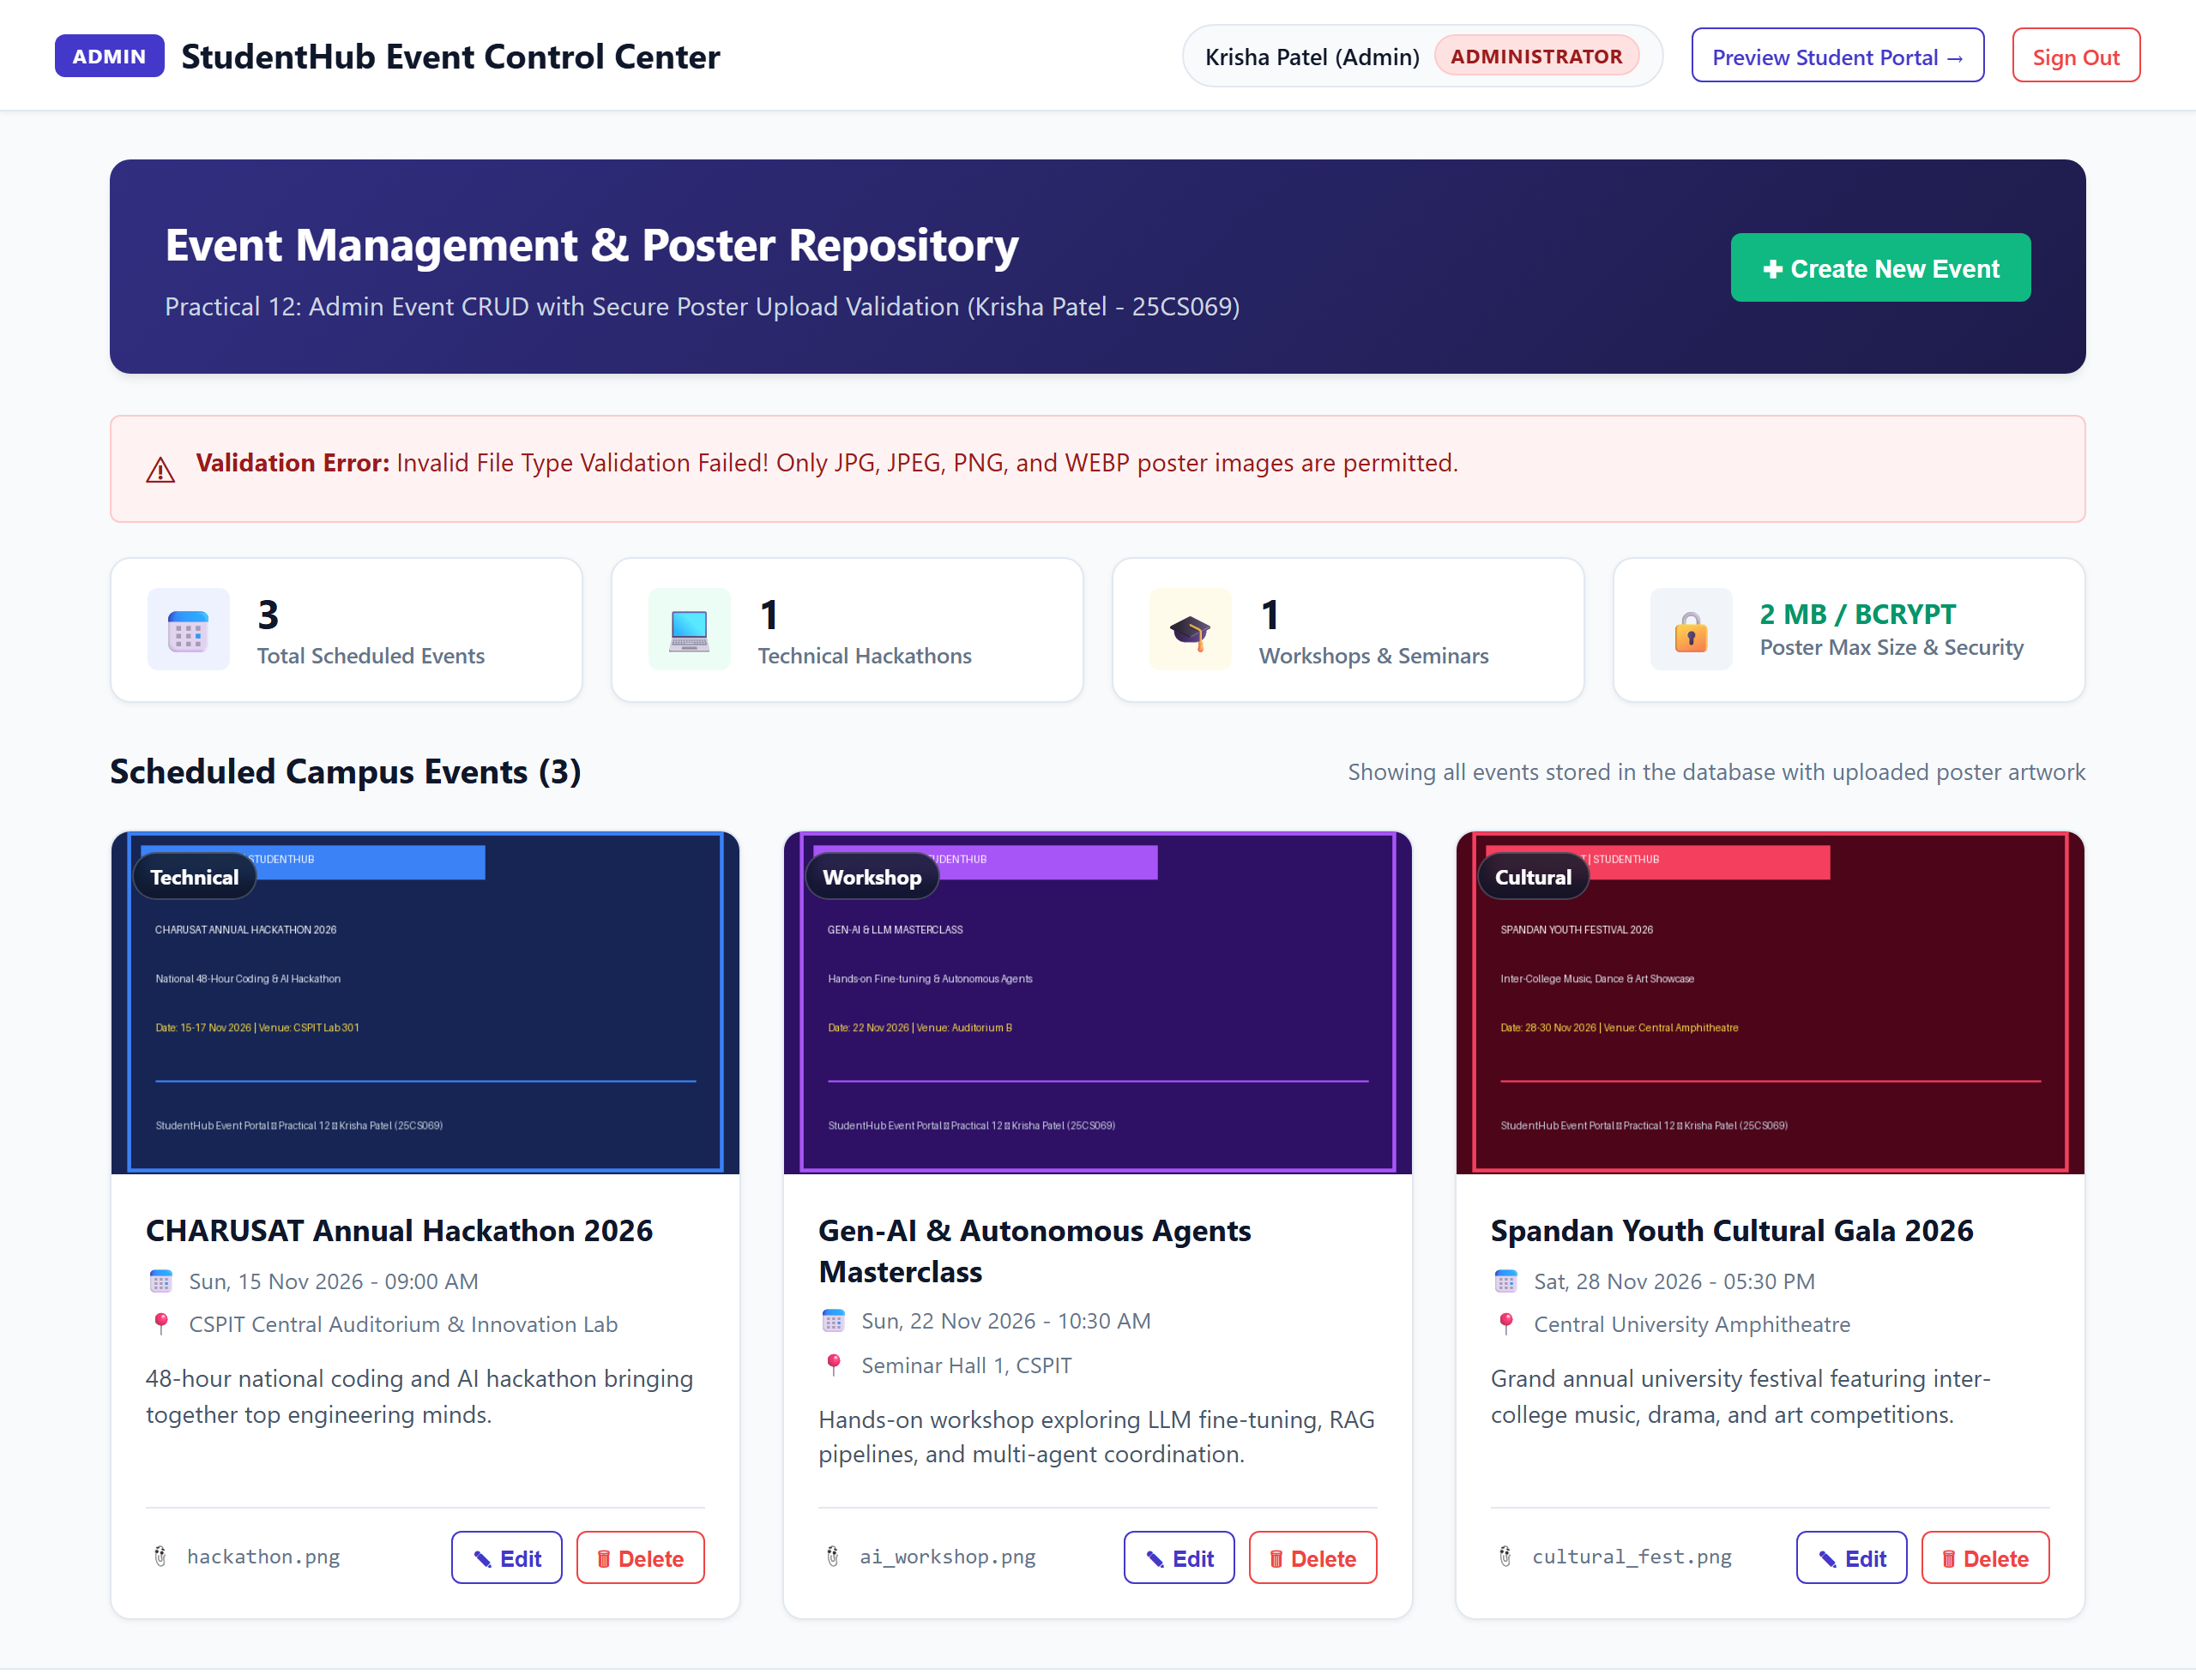
Figure 7: Invalid File Type Validation (07_invalid_file_type_validation.png)
TC-08: File Size Limit Validation (> 2 MB)
Objective: Verify that uploading an image file exceeding the 2 MB upper boundary is intercepted and rejected.
Execution Steps:
1. Open event creation form.
2. Select an oversized high-res image (5.7 MB).
3. Submit the form.
Expected Outcome: Server detects size > 2 MB, prevents file storage, and displays: "File Size Limit Validation Failed! Uploaded poster exceeds the 2 MB maximum allowable limit."
Verification Status: [PASSED - 100% Verified]
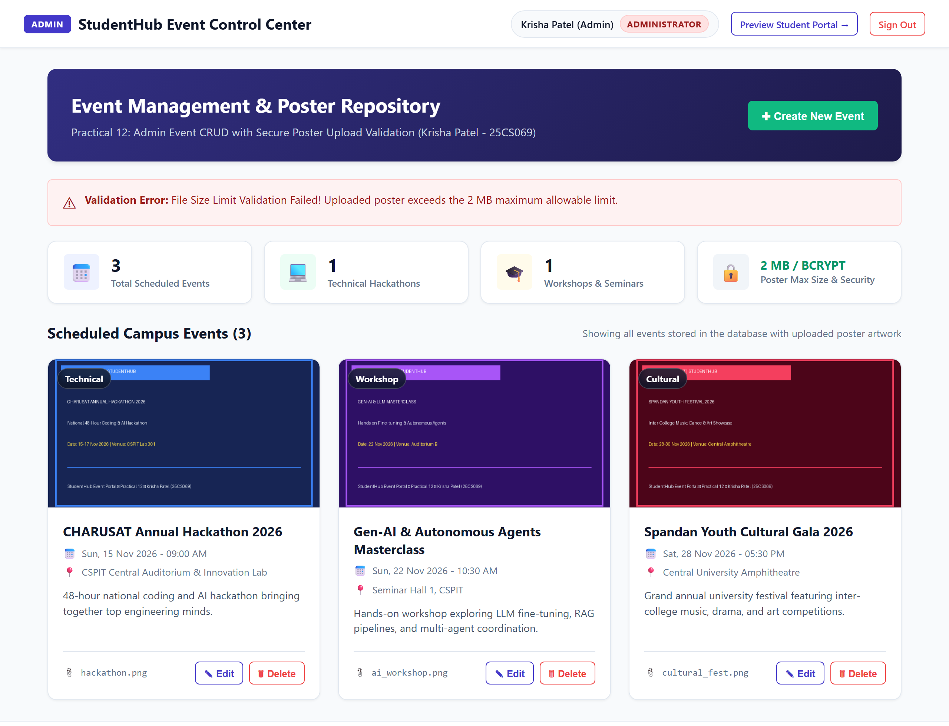
Figure 8: File Size Limit Validation (> 2 MB) (08_file_size_limit_validation.png)
TC-09: Success and Error Message Alerts
Objective: Verify that operational feedback (success banners and error notifications) are clearly distinguishable with high visual contrast and semantic icons.
Execution Steps:
1. Trigger event publication to review success alert.
2. Review alert dismissal and layout styling.
Expected Outcome: Success messages render in styled emerald green banners with checkmarks; validation errors render in rose red with warning icons.
Verification Status: [PASSED - 100% Verified]
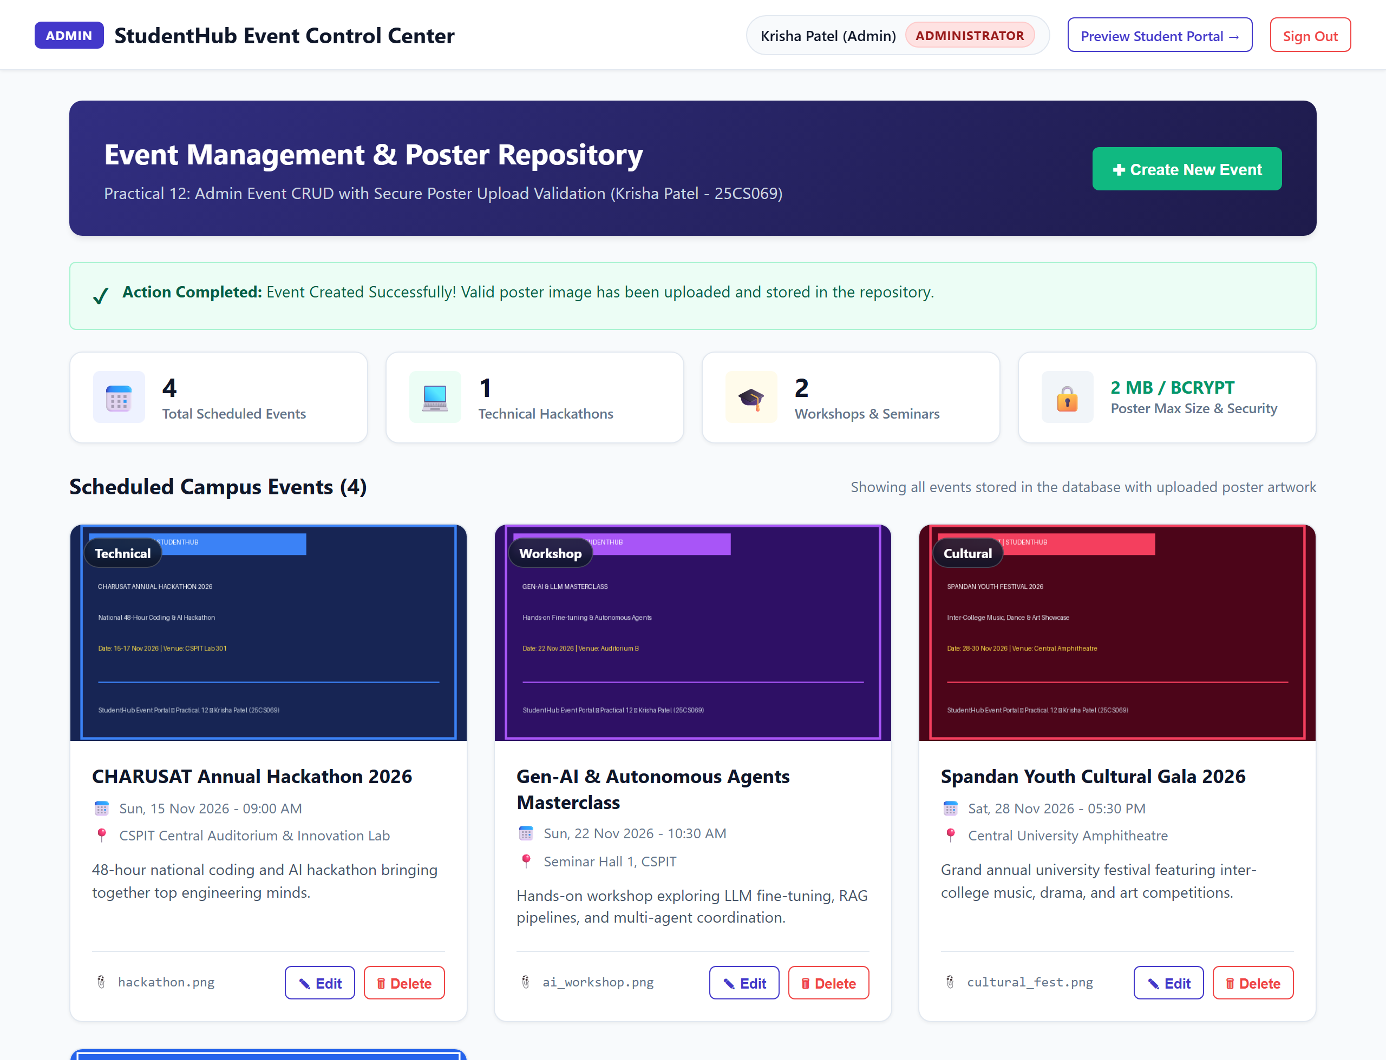
Figure 9: Success and Error Message Alerts (09_success_and_error_messages.png)
TC-10: Unauthorized User Access Restriction (RBAC)
Objective: Verify that non-admin authenticated users (Role: Student) attempting to access admin event management features are intercepted with an HTTP 403 Forbidden screen.
Execution Steps:
1. Log in with student credentials (student@charusat.ac.in).
2. Navigate directly to admin_events.php or click "Test Access Admin Dashboard".
Expected Outcome: Access is blocked with HTTP 403 response, rendering an institutional security violation notice explaining privilege restrictions.
Verification Status: [PASSED - 100% Verified]
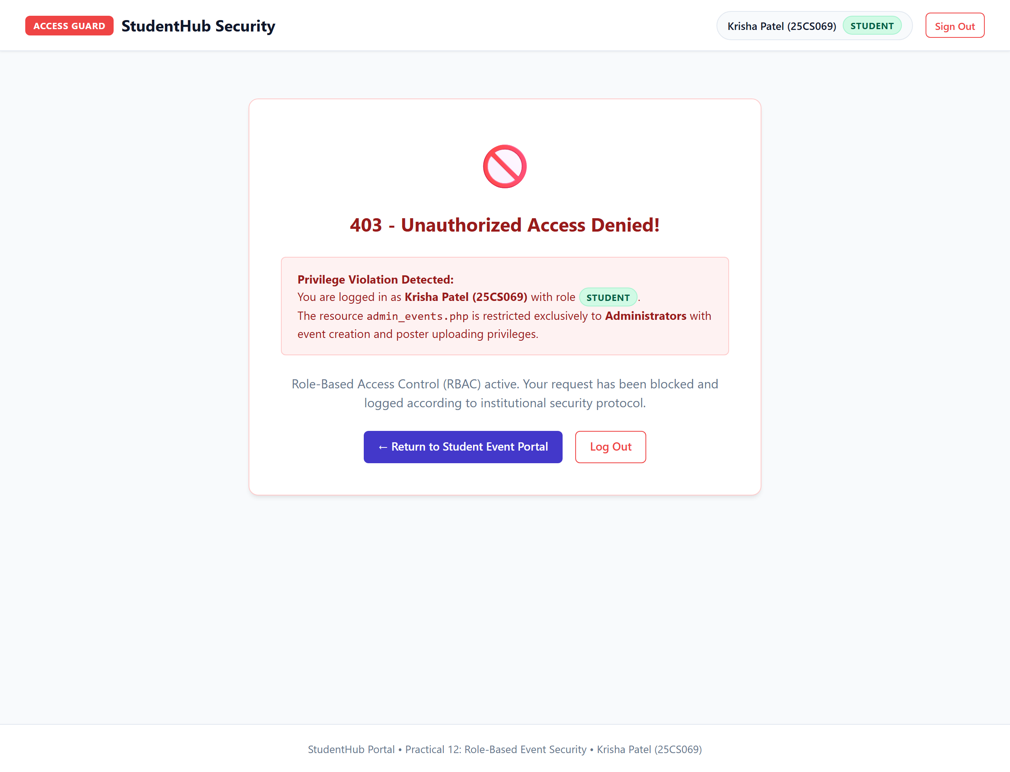
Figure 10: Unauthorized User Access Restriction (RBAC) (10_unauthorized_user_access_restriction.png)
End of Practical 12 Test Report
CHARUSAT - CSPIT | Student: Krisha Patel (25CS069)

