TEST REPORT
Practical 11 – Student Records Management System
CRUD operations, Search, Filtering, Soft Delete and CSV Export
Student Name | ______________________
Enrollment No. | ______________________
Class / Division | ______________________
Subject | ______________________
Date of Testing | October 2026
Tested On | Web application (Chrome browser), Excel / spreadsheet for CSV

1. Objective
To test the Student Records Management System and verify that students can be displayed, added, updated, searched, filtered by course, soft-deleted (status set to Inactive) and exported to CSV, with proper confirmation and success/error messages.

2. Test Summary
ID | Test Case | Screenshots | Result
TC-01 | Student records displayed in a table | 1 | PASS
TC-02 | Successful addition of a new student | 2 | PASS
TC-03 | Successful update of student details | 2 | PASS
TC-04 | Search functionality | 1 | PASS
TC-05 | Course-wise filtering | 1 | PASS
TC-06 | Delete confirmation message | 1 | PASS
TC-07 | Successful soft delete (status changed to inactive) | 1 | PASS
TC-08 | Success / error messages | 3 | PASS
TC-09 | Exported CSV file opened in Excel | 2 | PASS

Total: 9 test cases | Passed: 9 | Failed: 0

TC-01: Student records displayed in a table
Steps | Open the application.
Expected Result | All students are listed in a table with ID, Name, Email, Course, Phone, Status and Actions columns.
Actual Result | All 6 seed records displayed correctly; record count shows (6).
Status | PASS

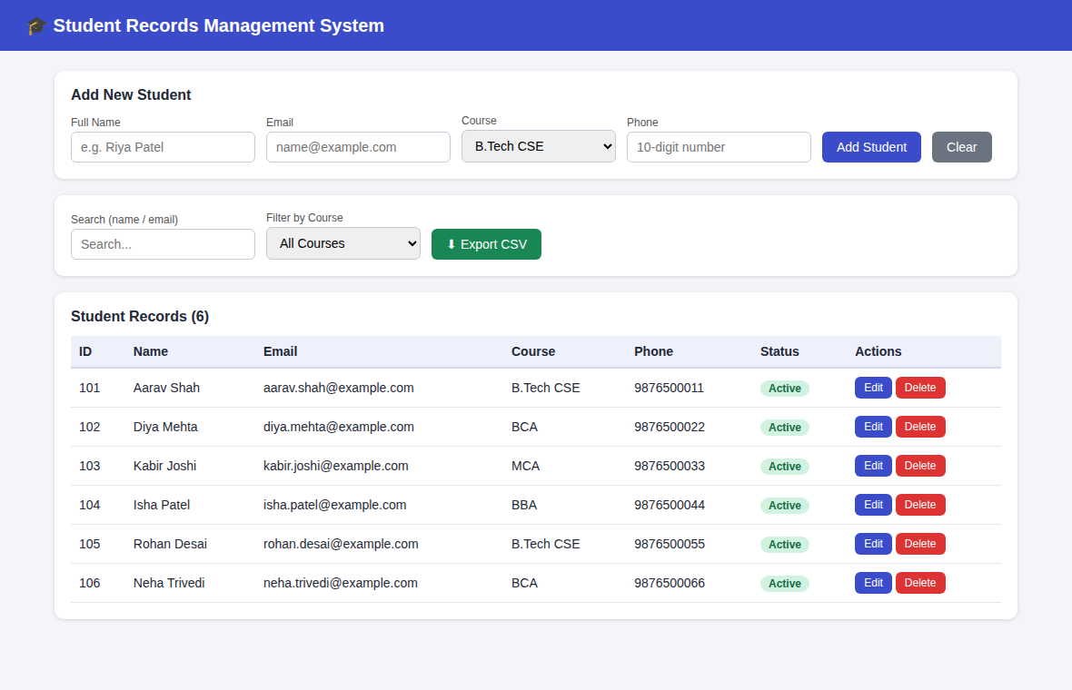
Figure: TC-01

TC-02: Successful addition of a new student
Steps | Enter Meera Kapoor / meera.kapoor@example.com / MCA / 9876500077 and click Add Student.
Expected Result | New record is saved with Active status and a success message appears.
Actual Result | Student added with ID 107, status Active. Message: "Success: New student added successfully."
Status | PASS

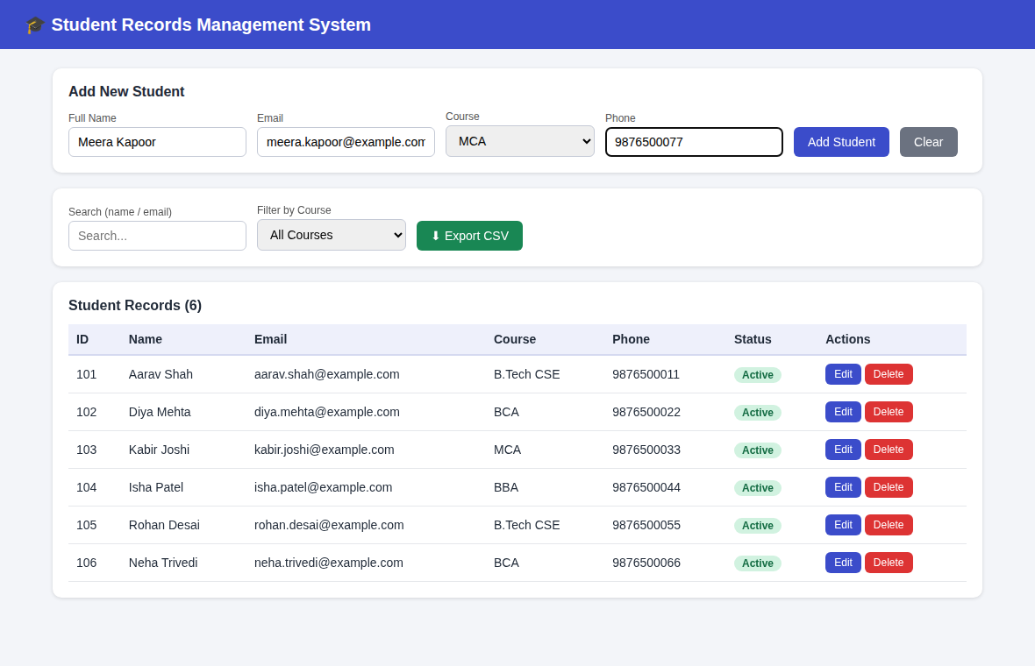
Figure: TC-02 (1 of 2)
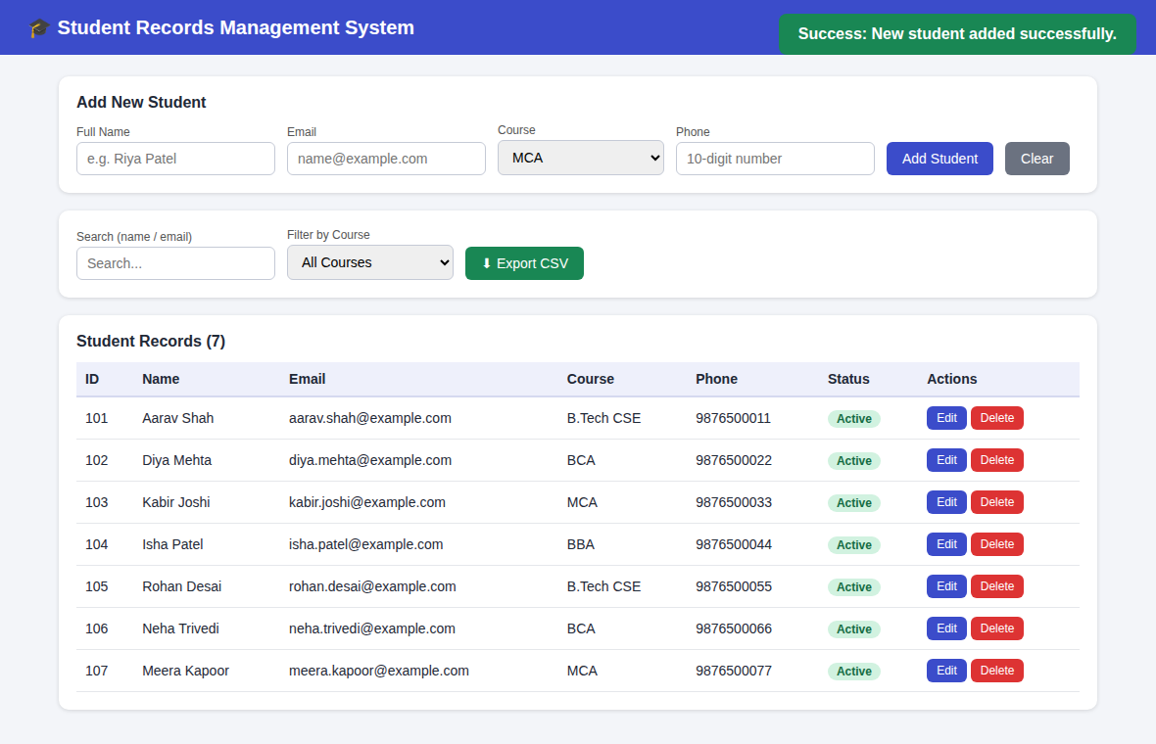
Figure: TC-02 (2 of 2)

TC-03: Successful update of student details
Steps | Click Edit on Diya Mehta, change name to "Diya Mehta Sharma" and phone to 9123456780, click Update Student.
Expected Result | Record is updated in the table and a success message appears.
Actual Result | Name and phone updated. Message: "Success: Student details updated successfully."
Status | PASS

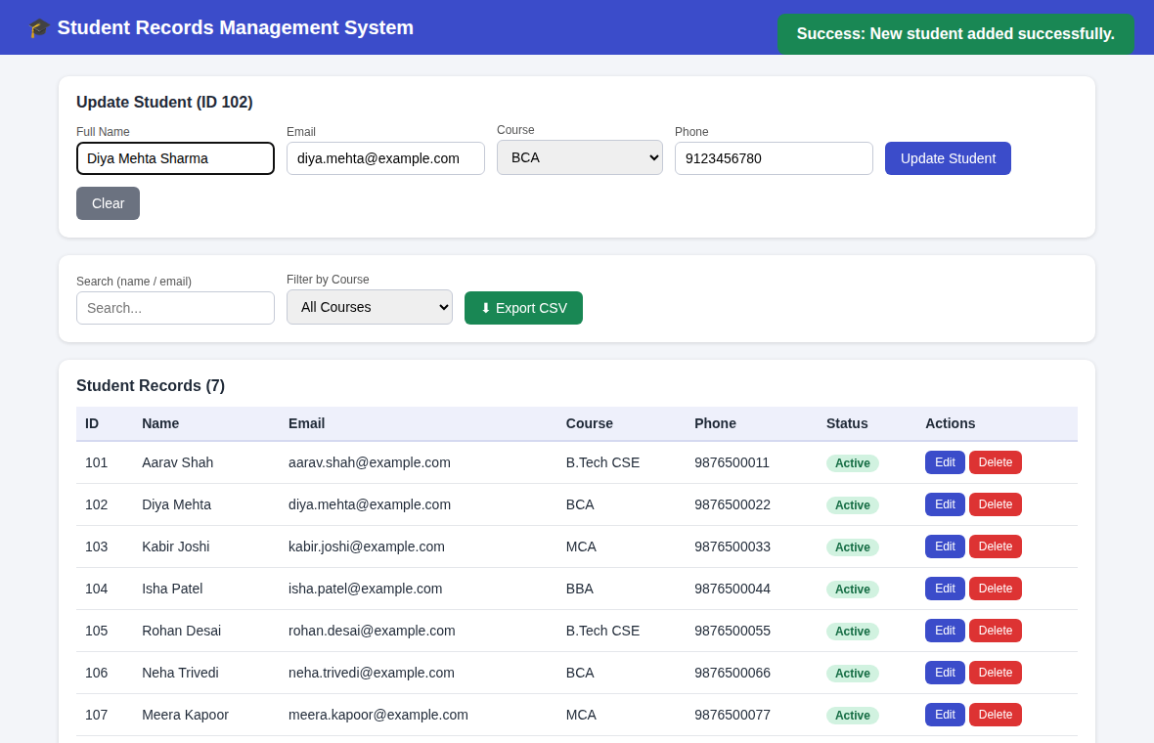
Figure: TC-03 (1 of 2)
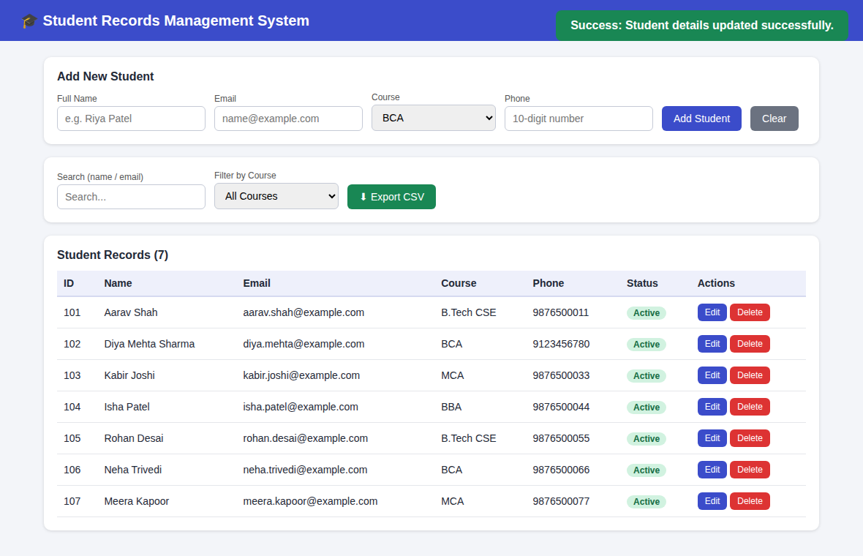
Figure: TC-03 (2 of 2)

TC-04: Search functionality
Steps | Type "patel" in the Search box.
Expected Result | Only records whose name or email contains "patel" are shown.
Actual Result | Only Isha Patel is displayed (count = 1).
Status | PASS

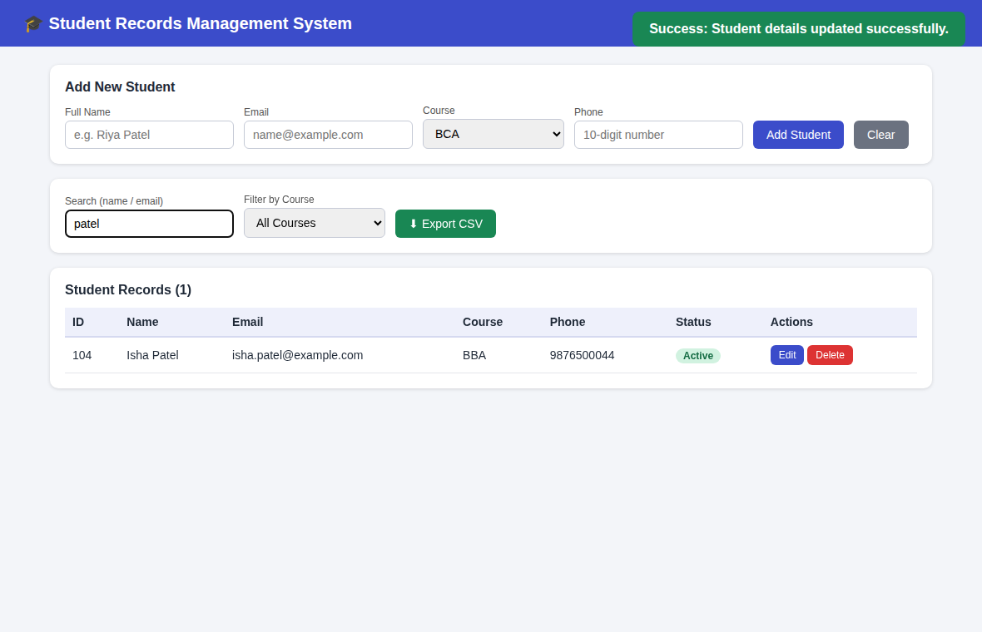
Figure: TC-04

TC-05: Course-wise filtering
Steps | Select "BCA" in the Filter by Course dropdown.
Expected Result | Only students enrolled in BCA are shown.
Actual Result | Only BCA students (Diya Mehta Sharma, Neha Trivedi) are displayed.
Status | PASS

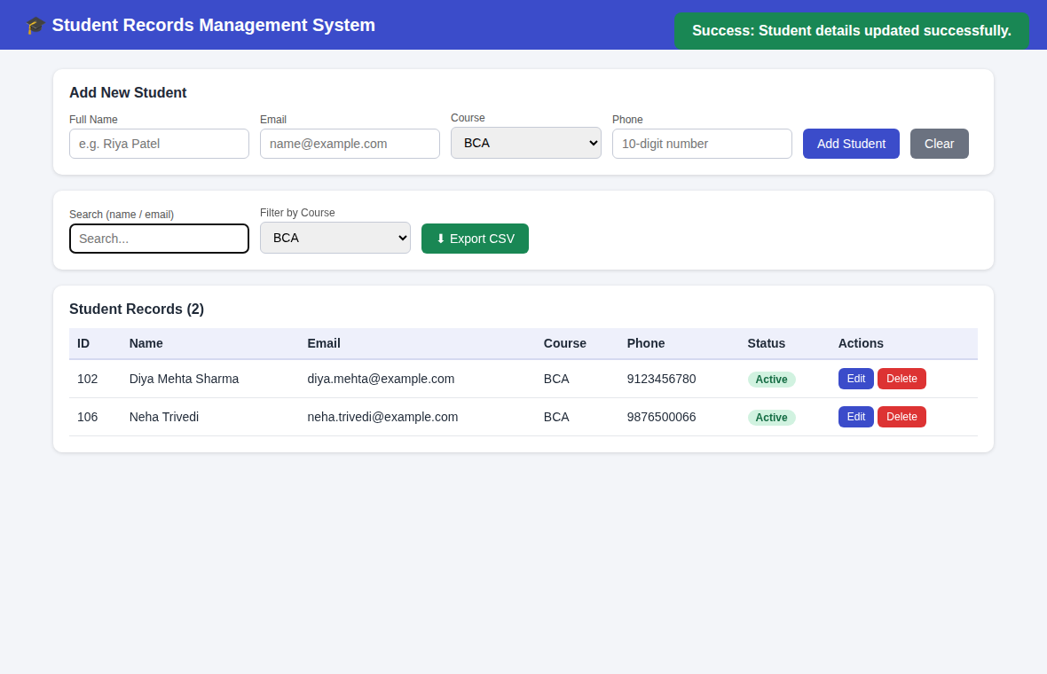
Figure: TC-05

TC-06: Delete confirmation message
Steps | Click Delete on Rohan Desai.
Expected Result | A confirmation dialog asks the user to confirm before deleting.
Actual Result | Dialog displayed: "Are you sure you want to delete "Rohan Desai"? The record will be marked Inactive (soft delete)."
Status | PASS

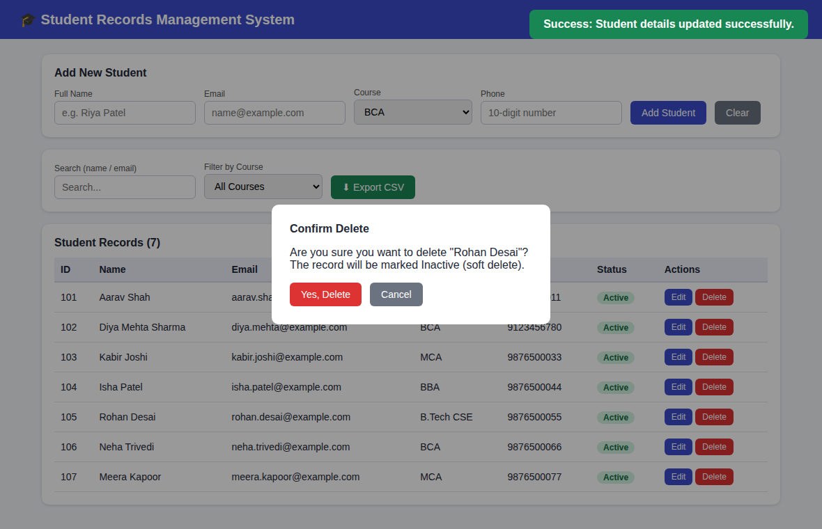
Figure: TC-06

TC-07: Successful soft delete (status changed to inactive)
Steps | Click Yes, Delete in the confirmation dialog.
Expected Result | Record is not removed; its status changes to Inactive.
Actual Result | Rohan Desai remains in the table with status Inactive (greyed out); Delete button is hidden. Message shown.
Status | PASS

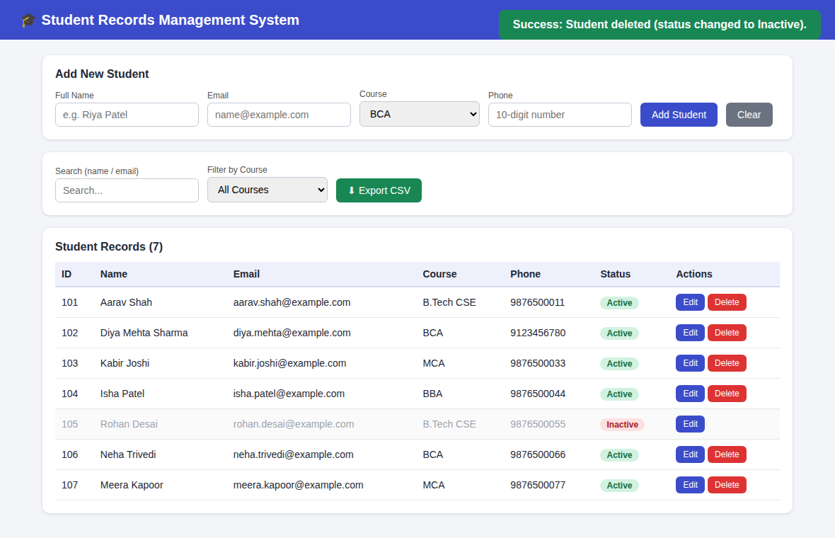
Figure: TC-07

TC-08: Success / error messages
Steps | (a) Click Add with empty fields. (b) Enter an invalid email. (c) Enter an email that already exists.
Expected Result | Appropriate error message is shown for each invalid input.
Actual Result | (a) "All fields are required." (b) "Please enter a valid email address." (c) "A student with this email already exists." Success messages shown in TC-02, 03 and 07.
Status | PASS

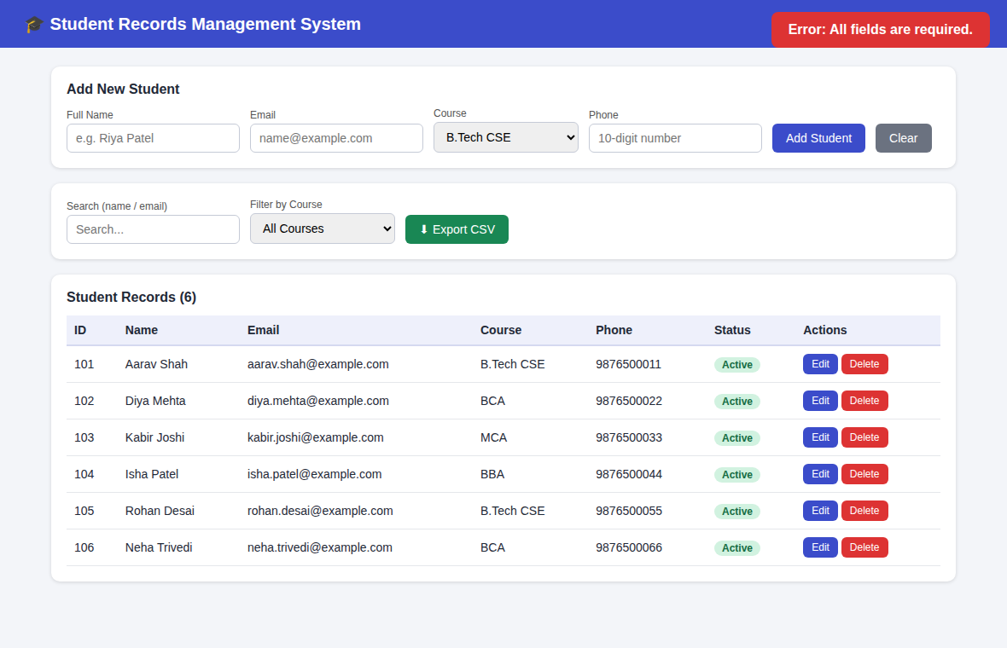
Figure: TC-08 (1 of 3)
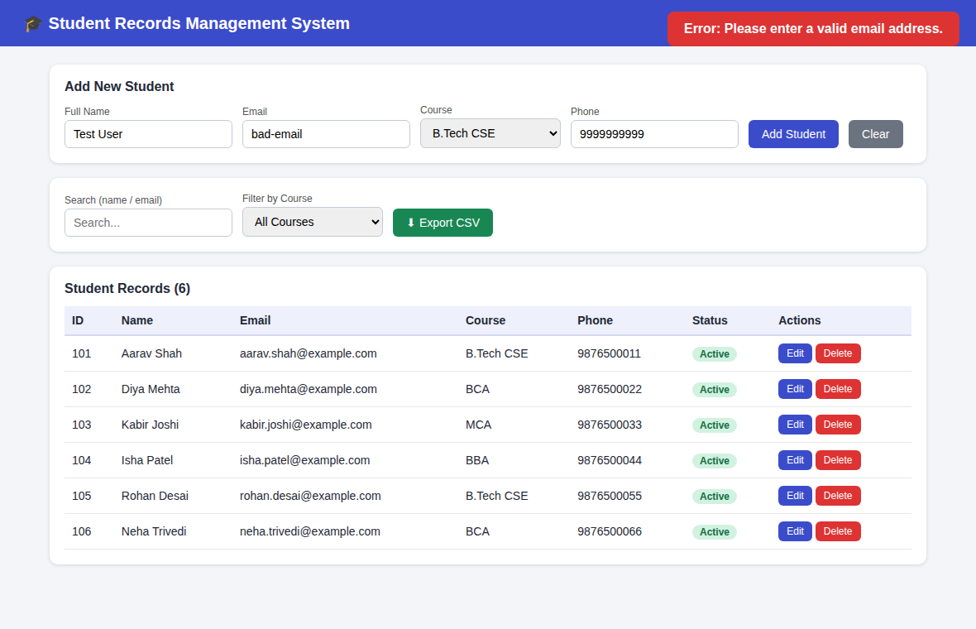
Figure: TC-08 (2 of 3)
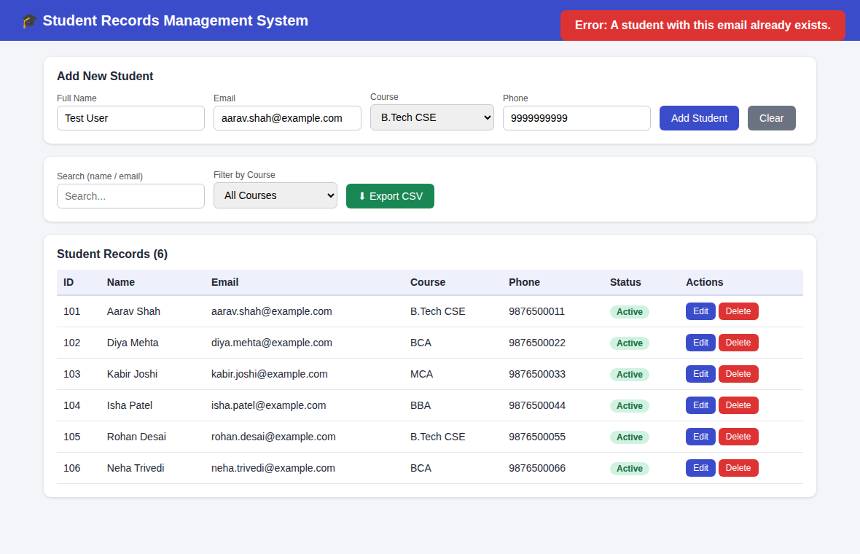
Figure: TC-08 (3 of 3)

TC-09: Exported CSV file opened in Excel
Steps | Click Export CSV, then open the downloaded students.csv in a spreadsheet application.
Expected Result | A CSV file containing all student records (including Inactive status) is downloaded and opens correctly.
Actual Result | students.csv downloaded with 7 records; Rohan Desai shown as Inactive.
Status | PASS

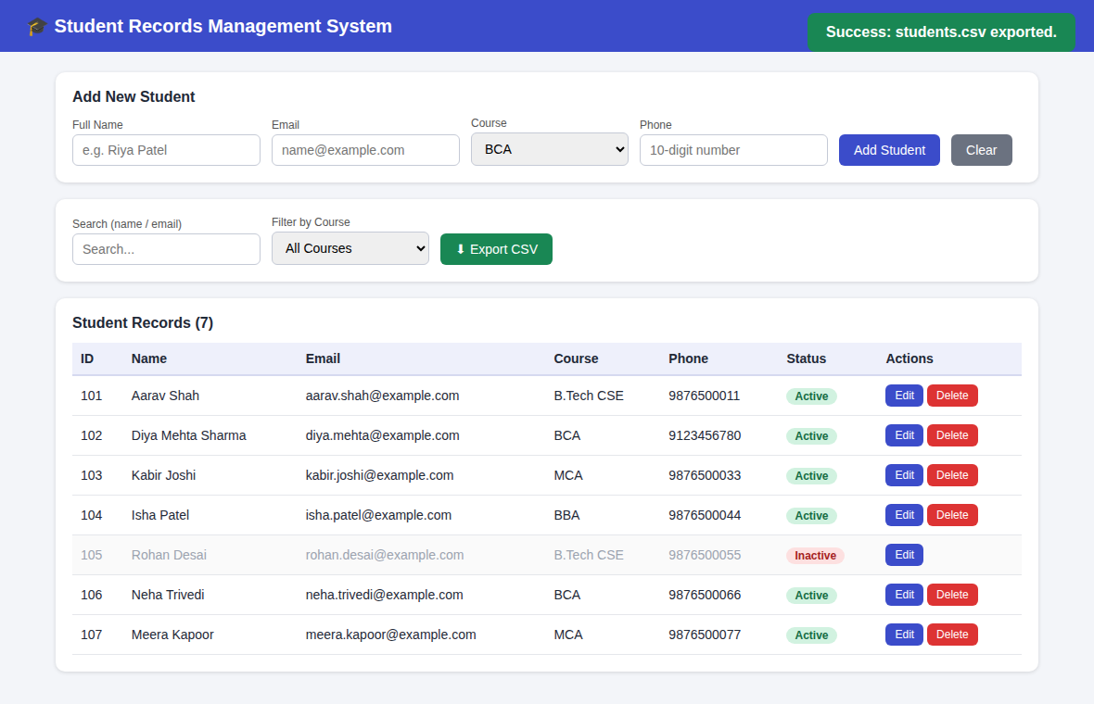
Figure: TC-09 (1 of 2)
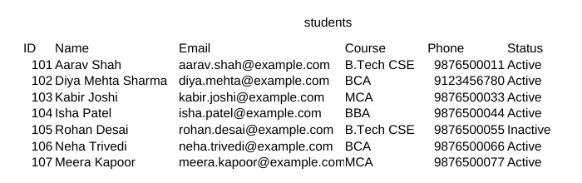
Figure: TC-09 (2 of 2)

3. Conclusion
All 9 test cases passed. The system correctly displays student records, adds and updates students with validation, supports search and course-wise filtering, asks for confirmation before deleting, performs a soft delete by setting the status to Inactive instead of removing the record, shows clear success and error messages, and exports the data to a CSV file that opens correctly in a spreadsheet.

