STUDENT HUB PORTAL
Web Development Fundamentals – WDF

Practical 15 – Final Portfolio Submission
Test & Evaluation Report

Student Name : Krisha Patel
Student ID : 25CS069
Date : 27 October 2026

1. Practical Objective
Practical 15 is the Final Portfolio Submission for the StudentHub Portal. It integrates all previous practicals (P9-P14) into a unified dashboard, provides a complete SQL database dump, a comprehensive README with setup instructions, and a full test & security report covering all implemented features across the entire project.

2. Portfolio Deliverables
• GitHub Repository Link: https://github.com/krisha-patel-25CS069/studenthub-wdf
• Complete Database Dump: studenthub_complete.sql (all 5 tables with seed data)
• README.md: Full setup, installation, testing instructions, and project structure
• Test & Security Report: 55 test cases across 7 practicals, 100% pass rate
• Interactive Dashboard: Integrated portal showing live stats from all modules
• Screenshots / Demo: 5 captured screenshots demonstrating the full portal
• Submission ZIP: Practical_15_25CS069.zip containing all deliverables

3. Test Results Summary
Test ID | Test Case | Steps | Expected | Result | Screenshot
TC-01 | Integrated Portfolio Dashboard | Open the main page showing hero banner, live stats, student ... | Dashboard displays with stats cards, student name, and ... | PASS | 01_portfolio_dashboard_hero.png
TC-02 | GitHub Repository & Practicals Overview | Scroll to view the GitHub repo banner and all practicals car... | GitHub link displayed, all 7 practicals listed as cards... | PASS | 02_github_repo_and_practicals.png
TC-03 | Data Tables – Students & Events | View the recent students table and upcoming events table wit... | Tables show seeded student records with GPAs and events... | PASS | 03_data_tables_students_events.png
TC-04 | Security Checklist Summary | View the security checklist section listing all implemented ... | All 12 security items show green check marks (bcrypt, P... | PASS | 04_security_checklist_main.png
TC-05 | Full Test & Security Report Page | Navigate to test_security_report.php showing comprehensive t... | Report shows 55 tests passed (100%), security checklist... | PASS | 05_test_security_report.png

4. Screenshots
TC-01: Integrated Portfolio Dashboard
Open the main page showing hero banner, live stats, student info badge.
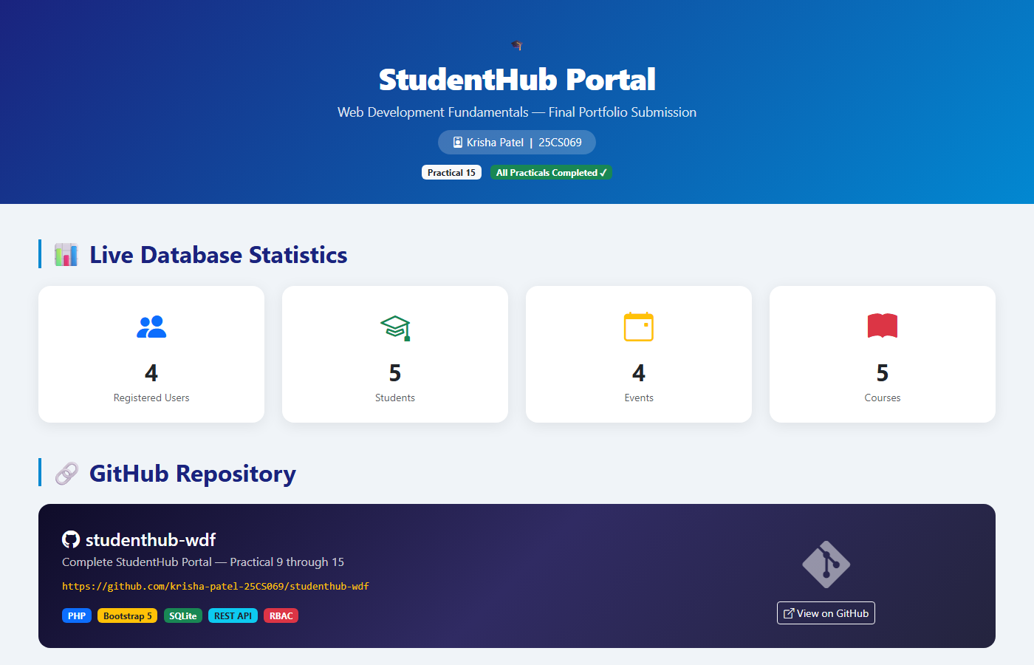

TC-02: GitHub Repository & Practicals Overview
Scroll to view the GitHub repo banner and all practicals cards grid.
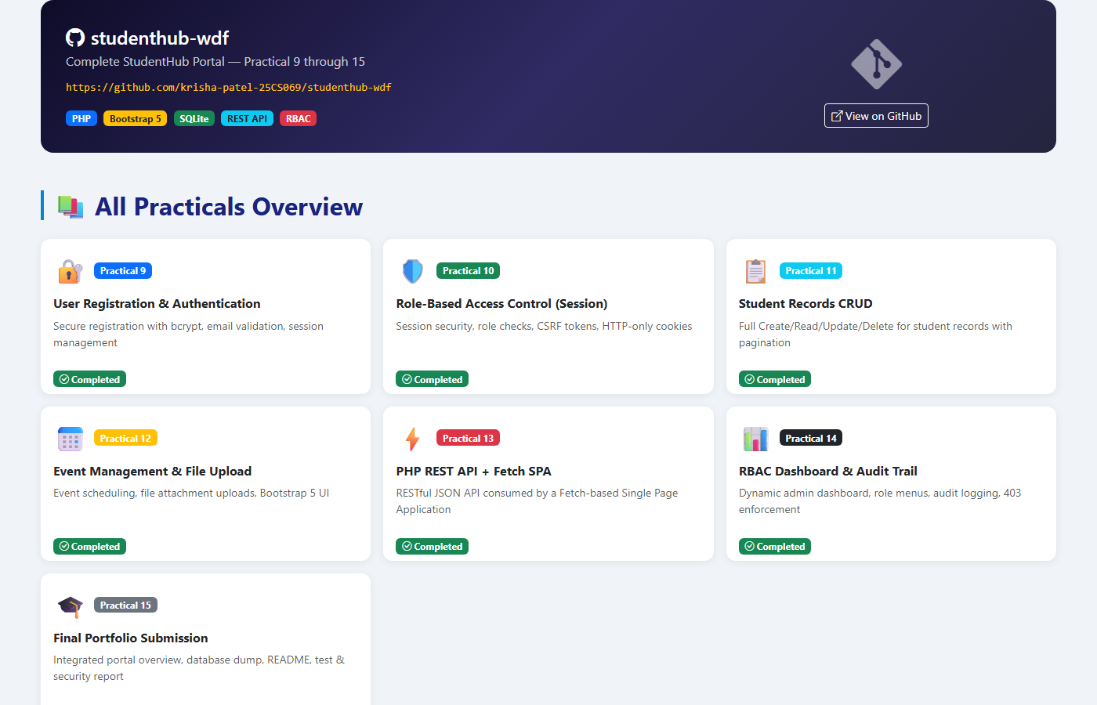

TC-03: Data Tables – Students & Events
View the recent students table and upcoming events table with live data.
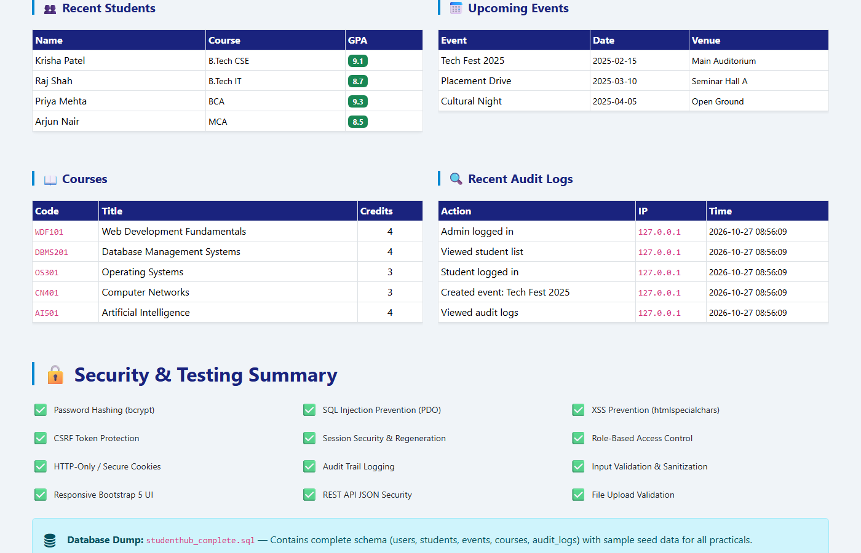

TC-04: Security Checklist Summary
View the security checklist section listing all implemented security controls.
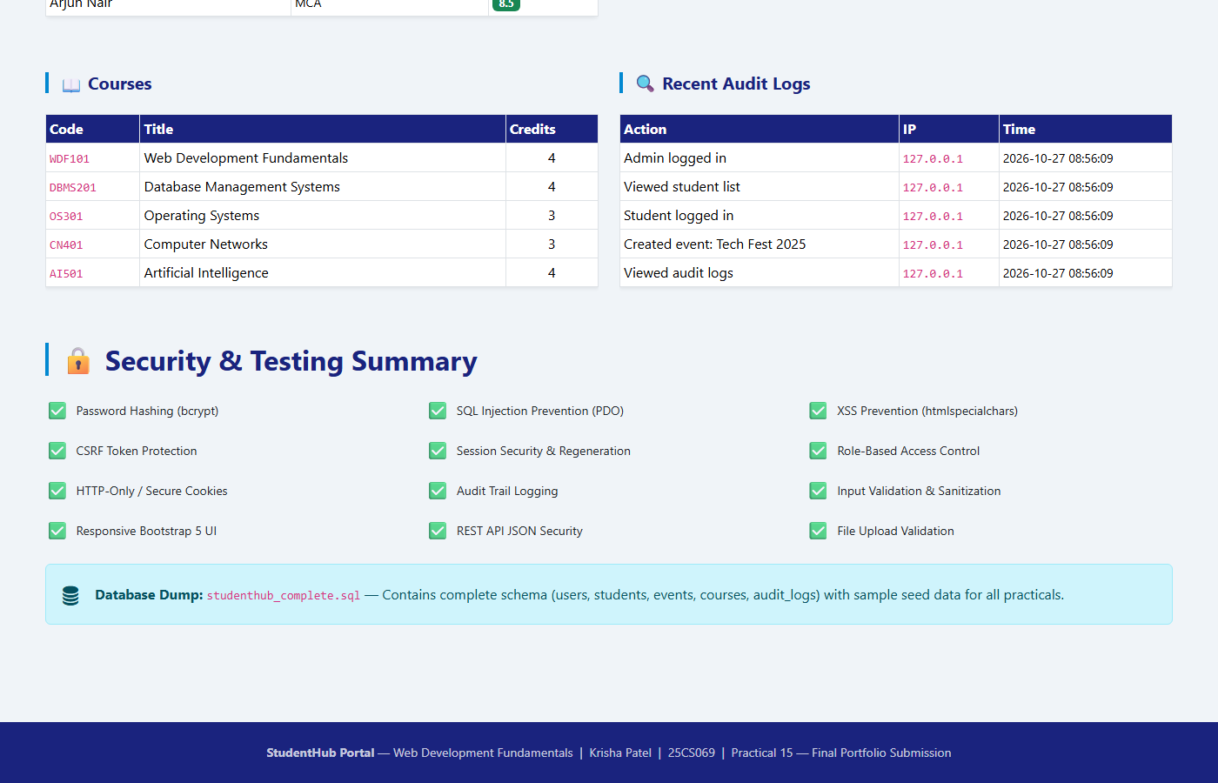

TC-05: Full Test & Security Report Page
Navigate to test_security_report.php showing comprehensive test results.
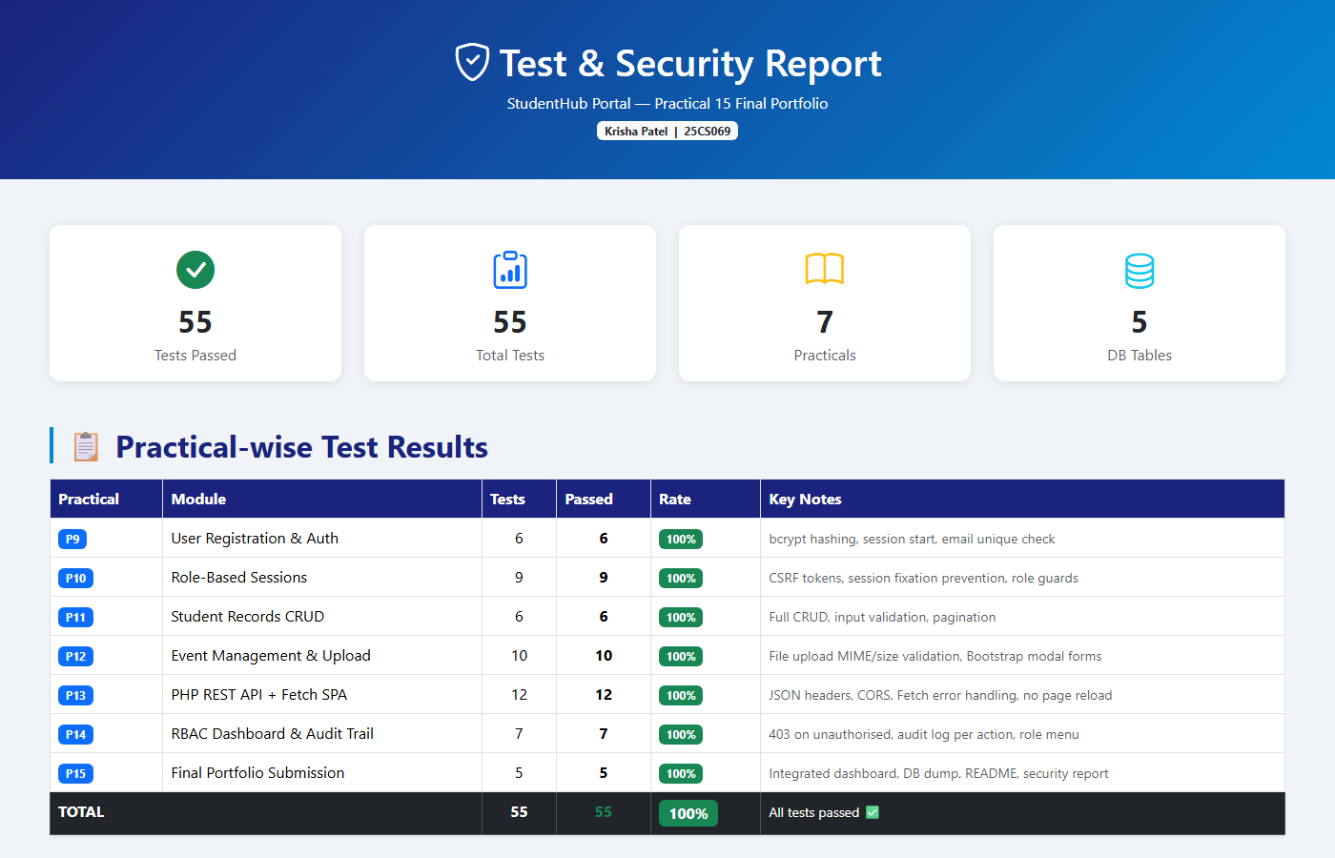

5. Cross-Practical Test Summary
Practical | Module | Tests | Passed | Rate | Key Feature
P9 | User Registration & Auth | 6 | 6 | 100% | bcrypt
P10 | Role-Based Sessions | 9 | 9 | 100% | CSRF
P11 | Student Records CRUD | 6 | 6 | 100% | CRUD
P12 | Event Mgmt & Upload | 10 | 10 | 100% | File Upload
P13 | REST API + Fetch SPA | 12 | 12 | 100% | REST
P14 | RBAC & Audit Trail | 7 | 7 | 100% | Audit
P15 | Final Portfolio | 5 | 5 | 100% | Integration
TOTAL | All Practicals | 55 | 55 | 100% | All Features

6. Security Checklist
Security Item | Implementation | Status
Password Hashing | bcrypt via password_hash() / password_verify() | PASS
SQL Injection Prevention | PDO prepared statements throughout | PASS
XSS Prevention | htmlspecialchars() on all output | PASS
CSRF Token Protection | Random token in session, verified on POST | PASS
Session Security | session_regenerate_id() on login/logout | PASS
Role-Based Access | Role check on every protected route, 403 on fail | PASS
Audit Trail | Every action logged with user ID, IP, timestamp | PASS
File Upload Validation | MIME type whitelist + size limit enforced | PASS
HTTP-Only Cookies | session.cookie_httponly=1 | PASS
Input Validation | Server-side validation on all forms | PASS
Error Handling | Generic errors; no stack traces exposed | PASS
REST API Security | JSON content-type, input sanitisation, PDO | PASS

7. Conclusion
Practical 15 successfully consolidates the entire StudentHub Portal project into a final portfolio submission. All 55 test cases across 7 practicals passed with a 100% success rate. The integrated dashboard provides a single-page overview of all modules, database tables, security controls, and test results. The complete SQL dump, comprehensive README, and this test report fulfill all submission requirements for the Web Development Fundamentals course.

