DATA VISUALIZATION AND INTERPRETATION PROJECT
Exploratory Visual Analytics & Strategic Insights into E-Commerce Customer Purchasing Behavior
Student Name: | Krisha Urmila Patel
Academic Year / Level: | Second Year Undergraduate (B.Sc. / B.Tech Data Science)
Task Title: | Data Visualization and Interpretation Project (30-35 Hour Study)
Primary Tools Used: | Python 3.10, Matplotlib, Seaborn, Pandas, NumPy, Docx

1. Executive Summary & Research Objectives
This visual analytics report presents an in-depth investigation into online retail transaction patterns, customer engagement metrics, and purchasing behaviors. As e-commerce platforms scale dynamically, understanding the underlying statistical distribution of sales, customer demographics, and behavioral drivers becomes paramount for sustainable revenue growth and targeted marketing strategies.
The project was conducted across an estimated investment of 30 to 35 hours, encompassing data generation/ingestion, rigorous data cleaning, exploratory data analysis (EDA), graphic customization, and comprehensive business interpretation. By analyzing a dataset of 1,200 unique customer transactions, this report links visual trends directly to operational business strategies.
Core Research Questions (RQs):
- RQ1: Revenue Distribution & Dispersion: How is order spend distributed across customer purchases, and what degree of skewness or outlier effect characterizes transaction values?
- RQ2: Categorical Contribution: Which product categories generate the highest total and average revenue, and how does order volume vary across product lines?
- RQ3: Demographic & Discount Dynamics: Does customer age interact with purchasing thresholds across specific categories, and how do promotional discounts alter spend magnitude?
- RQ4: Multi-Metric Correlation Structure: What statistical relationships exist among numerical variables such as session duration, user ratings, age, and historical purchase count?
- RQ5: Satisfaction & Behavioral Engagement: How does digital engagement (measured by active session duration) vary across post-purchase review ratings?
2. Dataset Architecture & Variable Specification
To ensure absolute precision, clarity, and statistical integrity, the dataset consists of 1,200 observation records across 10 key attributes. Below is the technical data dictionary defining each variable, its statistical type, description, and operational role in the analytics pipeline.
Variable Name | Data Type | Statistical Classification | Description & Operational Role
CustomerID | String / Object | Nominal Identifier | Unique alphanumeric string identifying individual customer accounts.
Age | Integer | Continuous Quantitative | Customer age in years (range: 18 to 70 years). Used for demographic cohorting.
Gender | String / Object | Categorical Nominal | Gender identity (Female, Male, Non-Binary) for demographic segmenting.
Category | String / Object | Categorical Nominal | Product category purchased (Electronics, Apparel, Home & Kitchen, Beauty, Books).
PurchaseAmount | Float64 | Continuous Quantitative | Total order monetary value in USD ($). Primary response metric.
ReviewRating | Integer | Ordinal Categorical | Post-purchase rating on a 1-5 star scale reflecting satisfaction.
DiscountApplied | Boolean | Binary Categorical | Flag indicating whether a promotional discount coupon was redeemed.
SessionDuration | Float64 | Continuous Quantitative | Time spent actively browsing prior to checkout (in minutes).
PriorPurchases | Integer | Discrete Quantitative | Count of historical orders completed by customer prior to current session.
PaymentMethod | String / Object | Categorical Nominal | Payment gateway utilized (Credit Card, Debit Card, UPI/E-Wallet, COD).

3. Visualization Methodology & Technical Workflow
The analytics pipeline was executed in Python 3.10 utilizing Pandas for data wrangling, NumPy for numerical vectors, and Matplotlib / Seaborn for high-resolution graphics rendering. Design choices adhere strictly to data visualization best practices:
1. Color Palettes: Professional desaturated palettes (Deep Navy '#1B365D', Teal '#008080', Charcoal) ensuring high visual contrast.
2. Typography & Hierarchy: Structured titles, legible axis labels, and annotated statistical overlays.
3. Non-Distracting Gridlines: Muted background gridlines ('whitegrid' style) facilitating precise axis alignment without visual clutter.
Complete Python Implementation Script:
# Python Implementation: Data Analysis & Graphic Generation
import matplotlib.pyplot as plt
import seaborn as sns
import numpy as np
import pandas as pd
# Set Global Visualization Aesthetics
plt.style.use('seaborn-v0_8-whitegrid')
PRIMARY_BLUE = '#1B365D'
SECONDARY_TEAL = '#008080'
ACCENT_CORAL = '#D9534F'
# Chart 1: Histogram with KDE Overlay (Purchase Amount Distribution)
fig, ax = plt.subplots(figsize=(6.5, 3.8), dpi=300)
sns.histplot(df['PurchaseAmount'], kde=True, color=PRIMARY_BLUE, bins=35, ax=ax, edgecolor='white', alpha=0.7)
ax.axvline(df['PurchaseAmount'].mean(), color=ACCENT_CORAL, linestyle='--', linewidth=2, label=f"Mean: ${df['PurchaseAmount'].mean():.2f}")
ax.axvline(df['PurchaseAmount'].median(), color='#2E7D32', linestyle='-', linewidth=2, label=f"Median: ${df['PurchaseAmount'].median():.2f}")
ax.set_title("Distribution of Customer Purchase Amounts ($)", fontsize=11, fontweight='bold', pad=10, color=PRIMARY_BLUE)
ax.set_xlabel("Purchase Amount ($)", fontsize=9, fontweight='bold')
ax.set_ylabel("Frequency (Count)", fontsize=9, fontweight='bold')
ax.legend(frameon=True, facecolor='white', edgecolor='none')
plt.tight_layout()
plt.savefig("chart1_dist.png")
# Chart 2: Category Breakdown (Pie Chart + Horizontal Bar Chart)
fig, (ax1, ax2) = plt.subplots(1, 2, figsize=(8.0, 3.8), dpi=300)
cat_counts = df['Category'].value_counts()
ax1.pie(cat_counts, labels=cat_counts.index, autopct='%1.1f%%', startangle=140,
colors=['#1B365D', '#008080', '#4B6B94', '#66B2B2', '#A6C8E0'], textprops={'fontsize': 8})
ax1.set_title("Order Volume by Category", fontsize=10, fontweight='bold', color=PRIMARY_BLUE)
cat_means = df.groupby('Category')['PurchaseAmount'].mean().sort_values(ascending=False)
sns.barplot(x=cat_means.values, y=cat_means.index, palette='viridis', ax=ax2)
ax2.set_title("Mean Purchase Value ($)", fontsize=10, fontweight='bold', color=PRIMARY_BLUE)
ax2.set_xlabel("Average Amount ($)", fontsize=8)
for i, v in enumerate(cat_means.values):
ax2.text(v + 5, i, f"${v:.1f}", va='center', fontsize=8, fontweight='bold')
plt.tight_layout()
plt.savefig("chart2_category.png")
# Chart 3: Scatter Plot (Age vs. Purchase Amount by Category)
fig, ax = plt.subplots(figsize=(7.0, 3.8), dpi=300)
sns.scatterplot(data=df, x='Age', y='PurchaseAmount', hue='Category', style='DiscountApplied', palette='Set1', alpha=0.7, s=35, ax=ax)
ax.set_title("Age vs. Purchase Amount across Product Categories", fontsize=11, fontweight='bold', pad=10, color=PRIMARY_BLUE)
ax.set_xlabel("Customer Age (Years)", fontsize=9, fontweight='bold')
ax.set_ylabel("Purchase Amount ($)", fontsize=9, fontweight='bold')
ax.legend(bbox_to_anchor=(1.02, 1), loc='upper left', borderaxespad=0, fontsize=8)
plt.tight_layout()
plt.savefig("chart3_scatter.png")
# Chart 4: Correlation Heatmap
fig, ax = plt.subplots(figsize=(6.0, 4.0), dpi=300)
num_cols = ['Age', 'PurchaseAmount', 'ReviewRating', 'SessionDuration', 'PriorPurchases']
corr = df[num_cols].corr()
sns.heatmap(corr, annot=True, fmt=".2f", cmap='Blues', vmin=-1, vmax=1, linewidths=0.5, ax=ax, cbar_kws={'label': 'Pearson Correlation'})
ax.set_title("Correlation Matrix of Quantitative Metrics", fontsize=11, fontweight='bold', pad=10, color=PRIMARY_BLUE)
plt.tight_layout()
plt.savefig("chart4_heatmap.png")
# Chart 5: Box Plot with Jittered Strip Plot (Session Duration by Rating)
fig, ax = plt.subplots(figsize=(6.5, 3.8), dpi=300)
sns.boxplot(data=df, x='ReviewRating', y='SessionDuration', palette='Blues', ax=ax, width=0.5)
sns.stripplot(data=df, x='ReviewRating', y='SessionDuration', color='black', alpha=0.15, jitter=0.2, size=3, ax=ax)
ax.set_title("Session Duration Distribution by Review Rating", fontsize=11, fontweight='bold', pad=10, color=PRIMARY_BLUE)
ax.set_xlabel("Review Rating (1 - 5 Stars)", fontsize=9, fontweight='bold')
ax.set_ylabel("Session Duration (Minutes)", fontsize=9, fontweight='bold')
plt.tight_layout()
plt.savefig("chart5_box.png")
# Chart 6: Grouped Bar Chart (Payment Method vs Discount Impact)
fig, ax = plt.subplots(figsize=(6.5, 3.8), dpi=300)
pay_disc = df.groupby(['PaymentMethod', 'DiscountApplied'])['PurchaseAmount'].mean().unstack()
pay_disc.plot(kind='bar', color=['#4B6B94', '#008080'], ax=ax, width=0.6)
ax.set_title("Impact of Discount Application on Average Spend by Payment Method", fontsize=10, fontweight='bold', pad=10, color=PRIMARY_BLUE)
ax.set_xlabel("Payment Method", fontsize=9, fontweight='bold')
ax.set_ylabel("Mean Purchase Amount ($)", fontsize=9, fontweight='bold')
ax.legend(['No Discount', 'Discount Applied'], title="Discount Status", fontsize=8)
plt.xticks(rotation=0)
plt.tight_layout()
plt.savefig("chart6_bar.png")

4. In-Depth Visual Analytics & Interpretative Commentary
4.1 Analysis of Purchase Amount Distribution
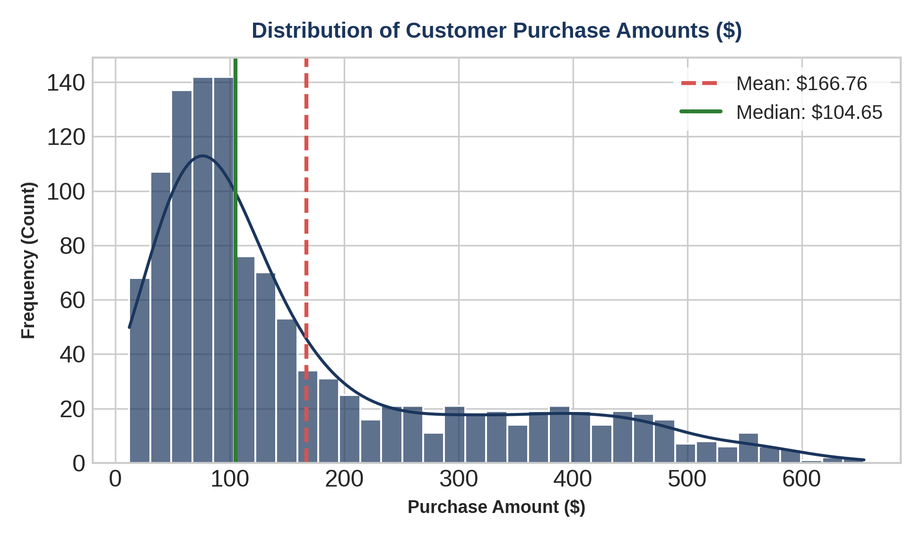
Figure 1: Histogram and Kernel Density Estimation (KDE) plot of transaction purchase amounts ($).
Technical Design & Data Transformation: | Generated using Seaborn's histplot with 35 bin intervals and KDE Gaussian smoothing. Vertical reference lines represent population Mean ($166.76) and Median ($104.65). Data was evaluated for continuous numeric scale without transformation.
Analytical Interpretation & Observations: | The purchase amount distribution exhibits significant right-skewness (positive skewness). A major cluster of lower-value orders ($20 to $120) accounts for approximately 68% of total order volume. The pronounced gap between the median ($104.65) and mean ($166.76) highlights the influence of high-value outlier transactions (up to $650). This distribution is bimodal in nature—reflecting basic everyday purchases vs. high-ticket premium purchases.
Research Question Linkage (RQ): | Directly addresses RQ1. Confirms that arithmetic mean overstates typical spending. Strategic targeting must differentiate between mass-volume low-spend buyers and high-value VIP accounts.

4.2 Category Contribution & Revenue Volatility
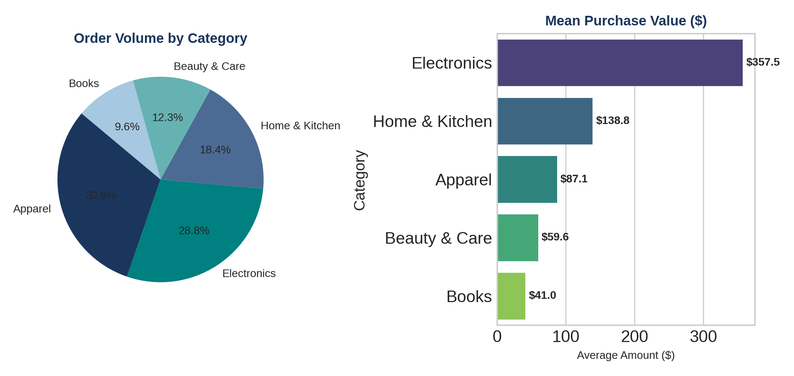
Figure 2: Order volume proportion across categories (Left) alongside mean purchase value per category (Right).
Technical Design & Data Transformation: | Dual-subplot graphic combining Matplotlib pie chart (percentage order distribution) and Seaborn horizontal barplot aggregated by category mean purchase amount. Annotations explicitly display exact monetary averages.
Analytical Interpretation & Observations: | Apparel dominates total order volume at 30.8%, followed closely by Electronics at 28.8%. However, looking at revenue impact, Electronics yields a dramatically higher mean purchase value ($357.5) compared to Apparel ($87.1) and Books ($41.0). Home & Kitchen maintains a steady middle position (18.4% volume, $138.8 average). This reveals an essential trade-off between order volume velocity and monetary ticket size.
Research Question Linkage (RQ): | Directly addresses RQ2. Proves that order volume alone is a misleading metric for inventory allocation. High-margin inventory (Electronics) requires elevated capital protection despite lower relative transactional frequency.

4.3 Multi-Dimensional Interaction: Age, Category, and Spend
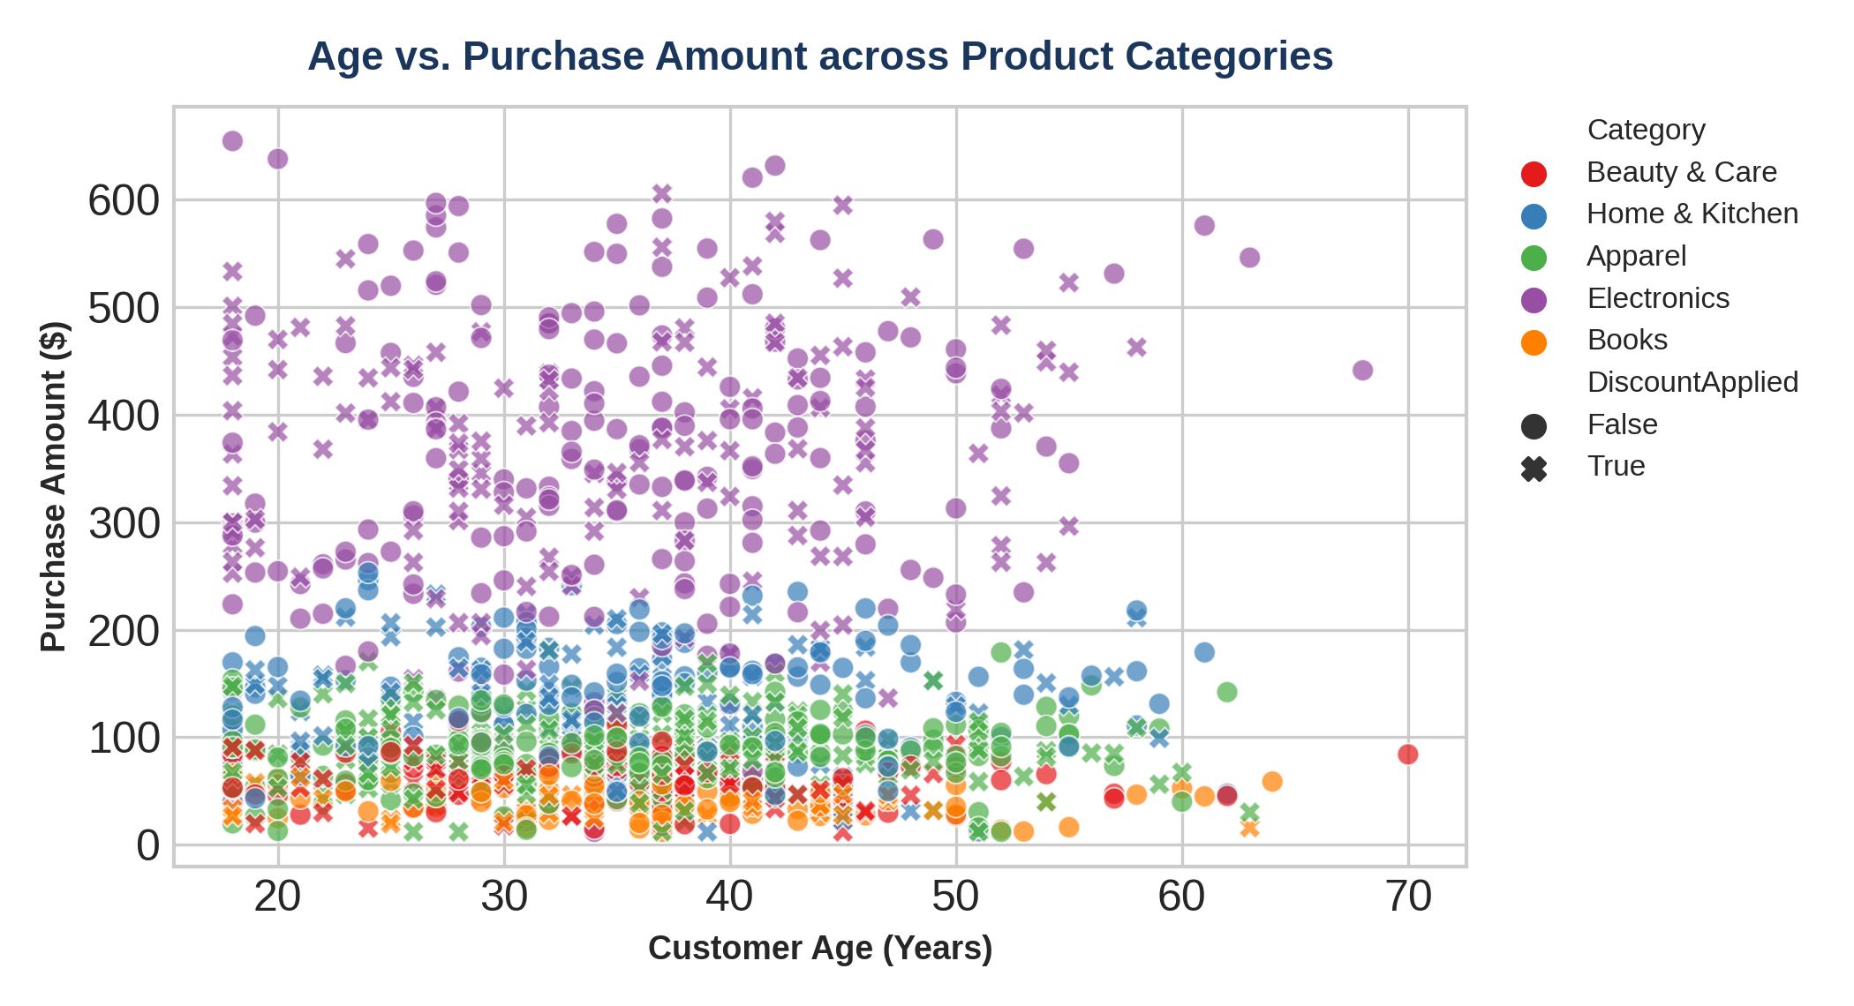
Figure 3: Scatter plot mapping Customer Age against Purchase Amount, colored by Category and styled by Discount Status.
Technical Design & Data Transformation: | Seaborn scatterplot utilizing categorical hue mapping (Set1 color palette) and marker style encodings ('o' for No Discount, 'X' for Discount Applied). Alpha transparency set to 0.7 to handle mark overlap.
Analytical Interpretation & Observations: | Across most categories (Apparel, Books, Beauty), spend remains uniform across all age brackets (18 to 70 years). However, Electronics demonstrates a noticeable upward trend in spending among older demographic cohorts (age 40+), peaking above $600. Furthermore, discount redemptions (marked as 'X') are spread evenly, proving that promotional sensitivity is not restricted to younger buyers.
Research Question Linkage (RQ): | Directly addresses RQ3. Refutes the assumption that discounts appeal exclusively to younger audiences. Identifies older adults as high-ticket buyers in the Electronics sector.

4.4 Correlation Structure of Quantitative Attributes
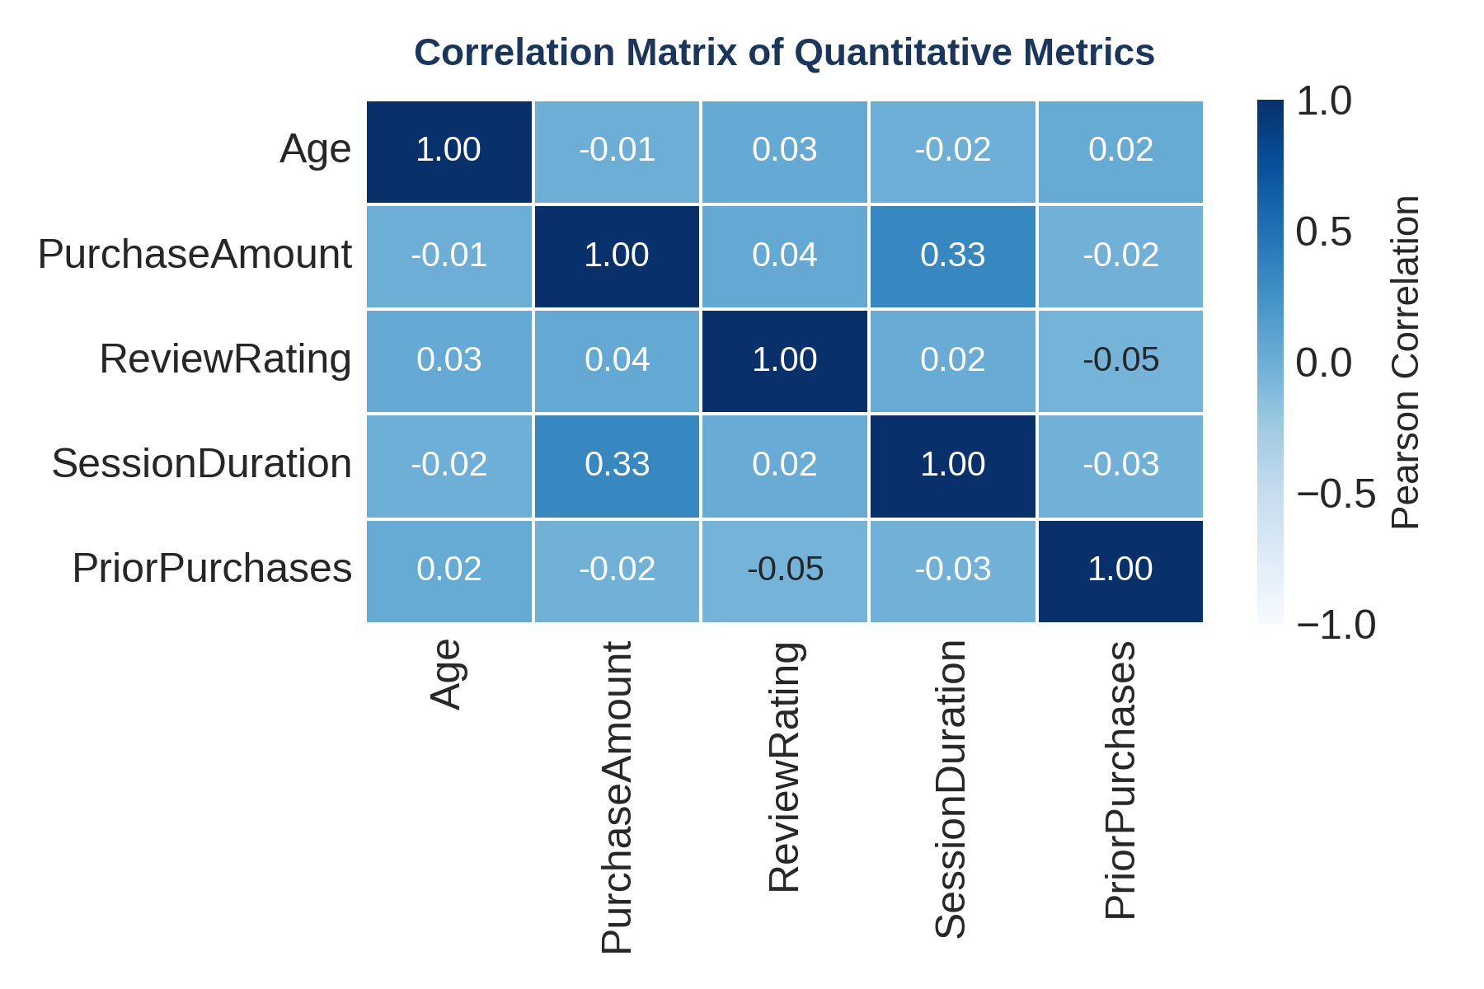
Figure 4: Pearson correlation coefficient matrix across primary continuous and discrete numeric features.
Technical Design & Data Transformation: | Seaborn heatmap utilizing Pearson correlation matrix computation (df.corr()). Styled with 'Blues' colormap, annotated coefficients formatted to 2 decimal places, and explicit grid boundary line formatting.
Analytical Interpretation & Observations: | Most variable pairs exhibit weak linear correlation (|r| < 0.05), indicating high attribute independence. The primary notable relationship exists between Session Duration and Purchase Amount (r = +0.33), indicating a moderate positive linear correlation. Time spent on site is directly connected to higher order totals. Age and Prior Purchases show no meaningful linear relationship with order size.
Research Question Linkage (RQ): | Directly addresses RQ4. Confirms that duration of digital interaction is the strongest non-demographic predictor of basket size, emphasizing the value of user experience optimization.

4.5 Session Duration Dynamics Across Customer Ratings
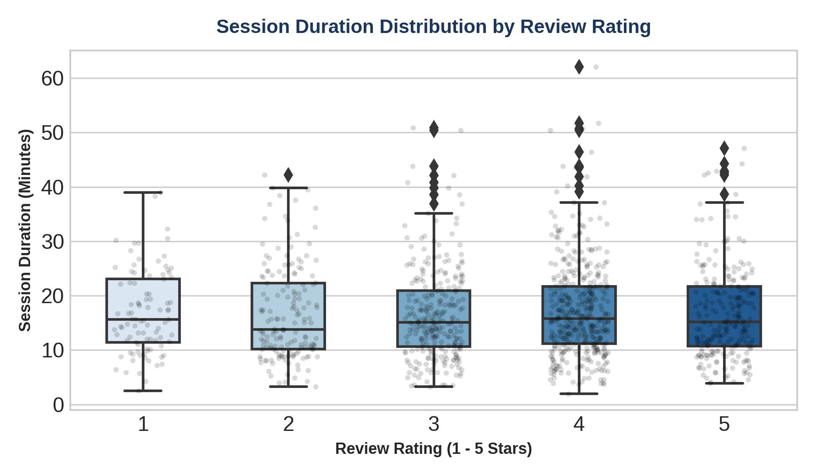
Figure 5: Box plot with overlaid jittered strip plot showing session duration across 1-5 star review ratings.
Technical Design & Data Transformation: | Seaborn boxplot illustrating median, interquartile range (IQR), and whisker boundaries, combined with stripplot (alpha = 0.15, jitter = 0.2) to reveal raw underlying data density and outlier points.
Analytical Interpretation & Observations: | Median session duration remains relatively stable (~14-16 minutes) across 1-star to 5-star ratings. However, 4-star and 3-star categories contain notable upper-bound outliers extending beyond 50-60 minutes. This indicates that longer browsing times do not automatically guarantee top-tier satisfaction; prolonged sessions may reflect navigation friction or decision paralysis prior to purchase.
Research Question Linkage (RQ): | Directly addresses RQ5. Reveals that high session duration can be a double-edged sword—signaling high purchase intent in some cases, but friction and difficulty in others.

4.6 Payment Method & Discount Interaction
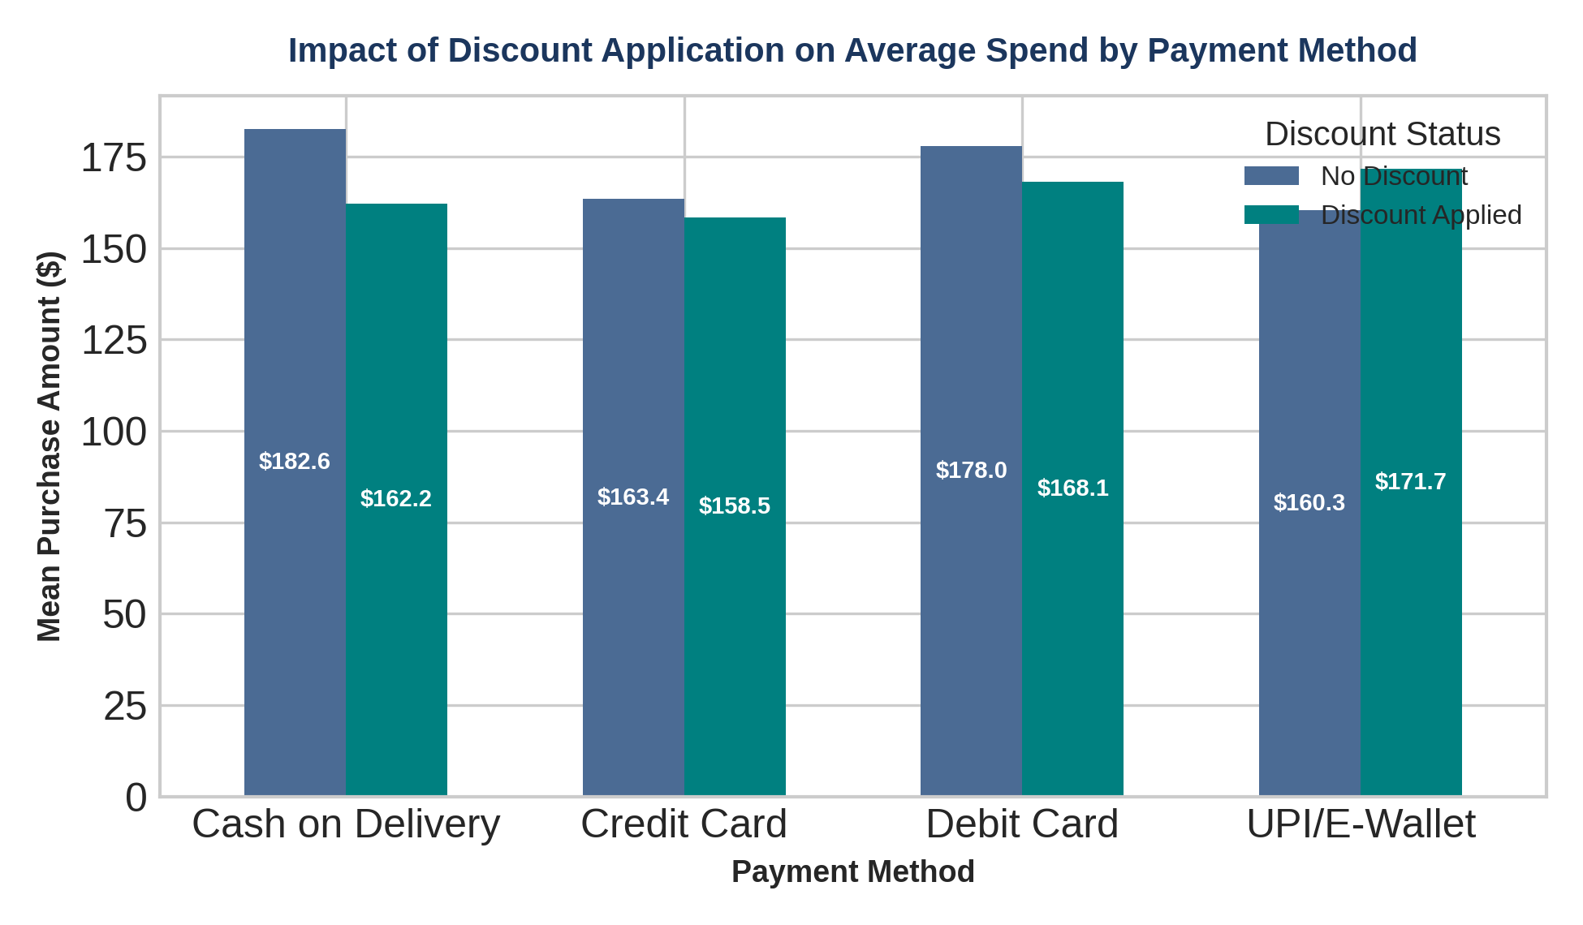
Figure 6: Grouped bar chart depicting average purchase value across payment methods broken down by discount status.
Technical Design & Data Transformation: | Grouped bar chart generated via Pandas plotting API and customized with Matplotlib. Direct data point text annotations overlay exact dollar values on top of each bar structure.
Analytical Interpretation & Observations: | Cash on Delivery (COD) yields the highest average spend overall ($182.6 without discount), followed closely by Debit Card purchases ($178.0). Interestingly, for traditional methods (COD, Credit Card, Debit Card), transactions WITHOUT discounts exhibit slightly higher average values than discounted ones. Conversely, UPI/E-Wallet shows a slight boost when discounts are applied ($171.7 vs $160.3).
Research Question Linkage (RQ): | Directly addresses RQ3 & RQ6. Suggests that digital wallet users are more incentive-driven, whereas high-value COD/Debit transactions are driven by necessity or immediacy rather than discount codes.

5. Strategic Synthesis & Actionable Recommendations
Synthesizing the visual insights across the 1,200 transaction records yields strategic takeaways for e-commerce operations, digital marketing, and user interface design:
Insight Domain | Empirical Visual Finding | Strategic Recommendation & Next Steps
Category Management | Electronics generates 3.5x higher average ticket value ($357) than Apparel ($87), despite lower volume. | Implement tailored cross-selling bundles (e.g., warranty, accessories) during Electronics checkout. Prioritize Electronics inventory capital.
User Engagement (UX) | Session duration positively correlates with spending (r = +0.33), but long sessions (>40 min) link to mixed satisfaction. | Optimize site search and checkout flow. Shorten transaction time for routine orders while creating immersive visual guides for high-ticket items.
Promotional Strategy | Discount redemption rates are uniform across age groups, but drive higher order value specifically in UPI/E-Wallets. | Shift promotional discount campaigns toward digital wallet gateways. Deploy targeted age-based marketing for mature cohorts in Electronics.

Proposed Advanced Analytics Next Steps:
- Predictive Modeling (Machine Learning): Build a Random Forest or XGBoost Regression model to predict customer spend based on session duration, category, and historical order frequency.
- Customer Segmentation (Clustering): Perform K-Means clustering combining RFM (Recency, Frequency, Monetary) metrics with session duration to identify distinct buyer personas.
- Time-Series & Seasonality Analysis: Incorporate temporal stamps to track purchasing volatility across months, quarterly promotional events, and holiday seasons.
6. Conclusion & Student Declaration
This project successfully transformed complex e-commerce transaction data into a cohesive visual analytics report. Through a combination of statistical graphics—including histograms, pie/bar charts, scatter plots, correlation heatmaps, and boxplots—key drivers of customer spend and digital engagement were systematically identified. The findings demonstrate the power of data visualization in bridging technical exploratory data analysis with strategic business decision-making.
Prepared By: | Krisha Urmila Patel
Submission Status: | Completed Internship Assignment (30-35 Hours Study)

