Strategic Data Exploration Planning
UCI Bike Sharing Dataset — Python Data Science Internship
Prepared as a structured four-week exploration roadmap

1. Introduction
This report presents a complete strategy for exploring a publicly available dataset using Python. The selected dataset is the UCI Bike Sharing Dataset, which contains hourly and daily bike rental counts from the Capital Bikeshare system for 2011 and 2012 together with seasonal and weather information. The dataset is suitable for exploratory data analysis because it combines time, weather, categorical, and numerical variables.
The purpose of this planning exercise is not only to produce charts, but to define a reproducible data science workflow: understand the problem, acquire the data, inspect data quality, clean and transform variables, explore patterns, apply appropriate statistical tests, communicate findings, and document assumptions.
Dataset source: UCI Machine Learning Repository, Bike Sharing Dataset. The repository reports 17,389 instances and 13 features for the dataset. The repository also states that the dataset has no missing values in its original form.

2. Dataset Selection and Assumptions
Item | Planning Decision
Dataset | UCI Bike Sharing Dataset — hourly data
Observation unit | One hourly observation of bike rental activity
Target variable | cnt — total bike rentals
Time period | 2011–2012
Main predictors | Hour, season, weather, temperature, humidity, windspeed, workingday
Primary objective | Understand factors associated with bike rental demand
Missing values | Expected to be absent in the original dataset; still checked programmatically
Outliers | Investigated rather than automatically deleted because extreme demand may be real
Normalized weather variables | Converted into more interpretable approximate units for exploration
Reproducibility | All transformations and figures are generated by Python code

3. Research Questions
- How does average bike rental demand change across different hours of the day?
- How does demand vary across seasons and weather conditions?
- Is temperature associated with total bike rental demand?
- Does humidity show a meaningful relationship with rental demand?
- Is average demand different between working days and non-working days?
- How did rental demand change between 2011 and 2012?
- Which combinations of time and weather conditions appear to create unusually high or low demand?
- Which variables should be prioritized for a future predictive model of hourly demand?

4. Planned Data Exploration Methodology
Problem Definition: Translate the business-style question into measurable data questions and identify the target variable.
Data Acquisition: Download the dataset from the UCI repository and preserve the raw file without modification.
Data Understanding: Inspect dimensions, column names, data types, unique values, descriptive statistics, and date range.
Data Quality Assessment: Check missing values, duplicates, invalid ranges, inconsistent categories, and potential outliers.
Cleaning: Remove exact duplicates, parse dates, validate ranges, and handle invalid observations using documented rules.
Transformation: Create readable season/weather labels, time features, weekend indicators, and interpretable weather units.
Univariate Analysis: Study distributions of rentals, temperature, humidity, windspeed, and hourly demand.
Bivariate Analysis: Compare demand with hour, season, weather, workingday, temperature, and humidity.
Time-Based Analysis: Compare patterns by month, weekday, hour, and year.
Statistical Analysis: Use Pearson correlation and an independent-samples t-test as initial inferential techniques.
Communication: Create clear charts, summarize findings, identify limitations, and document reproducible steps.

5. Data Cleaning Plan
- Check the number of rows and columns before cleaning.
- Inspect data types and convert dteday into a proper datetime variable.
- Calculate missing-value counts for every column.
- Check for exact duplicate rows and remove duplicates only when they are exact duplicates.
- Validate numerical ranges such as hour 0–23, humidity 0–100%, and rental counts greater than or equal to zero.
- Check category codes against the official dataset definitions.
- Investigate extreme values using boxplots and percentile-based summaries before deciding whether any value should be removed.
- Preserve legitimate high-demand observations because they may represent genuine peak usage.
- Create transformed variables instead of overwriting raw variables whenever possible.
- Save a cleaned CSV so that later analysis can be reproduced without repeating the raw-data preparation step.

6. Data Transformation Plan
- Convert the date column to datetime format.
- Map numerical season codes to Winter, Spring, Summer, and Fall.
- Map weather codes to readable weather-condition labels.
- Convert year codes to calendar years 2011 and 2012.
- Create day_name and month_name variables.
- Create an is_weekend indicator.
- Group hours into interpretable periods such as Night, Morning, Afternoon, and Evening.
- Convert normalized temperature and humidity variables into approximate human-readable units for interpretation.
- Keep the original variables in the cleaned dataset for traceability.

7. Exploratory Data Analysis Techniques
- Descriptive statistics: count, mean, median, standard deviation, minimum, maximum, and quartiles.
- Distribution analysis: histograms and boxplots for numeric variables.
- Time-series exploration: hourly, daily, monthly, and yearly patterns.
- Group comparisons: season, weather condition, working day, and year.
- Correlation analysis between rental demand and continuous variables.
- Scatter plots to inspect relationships between temperature/humidity and demand.
- Bar charts for categorical comparisons.
- Peak-demand analysis to identify hours and conditions associated with high rental activity.

8. Statistical Analysis Plan
The statistical stage is intended to support, not replace, visual exploration. The first analyses are deliberately simple and interpretable for an internship-level data science project.
- Pearson correlation: measure the linear association between temperature and total rentals.
- Pearson correlation: measure the linear association between humidity and total rentals.
- Independent-samples Welch t-test: compare rental counts on working days and non-working days.
- Use p-values together with effect size and practical interpretation rather than treating statistical significance as proof of causation.
- For a future extension, consider ANOVA or Kruskal–Wallis tests for multi-group comparisons and regression models for demand prediction.

9. Python Libraries and Tools
Tool | Purpose
Pandas | Data loading, cleaning, transformation, grouping, aggregation, and CSV export.
NumPy | Numerical operations, missing-value handling, and mathematical calculations.
Matplotlib | Creation of transparent, reproducible charts without relying on hidden styling.
SciPy | Correlation analysis and statistical hypothesis tests.
python-docx | Automatic generation of the final internship report in DOCX format.
urllib / zipfile | Programmatic download and extraction of the public UCI dataset.
VS Code | Development, execution, debugging, and Git/GitHub project management.
Git/GitHub | Version control, documentation, and submission of the complete project.

10. Planned Workflow / Flowchart
PUBLIC DATASET
↓
DATA ACQUISITION
↓
RAW DATA BACKUP
↓
DATA UNDERSTANDING
↓
QUALITY CHECKS
↙ ↓ ↘
Missing Duplicates Invalid Values
\ | /
CLEAN DATA
↓
TRANSFORMATION & FEATURE CREATION
↓
EXPLORATORY DATA ANALYSIS
↓
STATISTICAL ANALYSIS
↓
RESEARCH QUESTION REVIEW
↓
VISUALIZATION & INTERPRETATION
↓
FINAL REPORT + REPRODUCIBLE CODE
↓
GITHUB SUBMISSION

11. Four-Week / 32-Hour Work Roadmap
Period | Hours | Planned Work
Week 1 | 8 | Dataset research, problem definition, research questions, source verification, project setup, and data dictionary.
Week 2 | 8 | Data acquisition, inspection, quality checks, cleaning rules, transformations, and validation.
Week 3 | 9 | Exploratory analysis, visualizations, group comparisons, correlations, and statistical tests.
Week 4 | 7 | Interpretation, limitations, final report generation, code cleanup, README documentation, and GitHub submission.

12. Expected Outputs
- A reproducible cleaned dataset.
- Descriptive statistics and data-quality summaries.
- Charts showing hourly, seasonal, weather, temperature, and working-day patterns.
- Statistical evidence to support relationships identified during EDA.
- A clearly documented set of assumptions and limitations.
- A professional DOCX report generated automatically from the analysis code.
- A GitHub-ready project containing source code, requirements, README, data-generation instructions, and outputs.

13. Limitations and Risk Management
- The dataset describes one bike-sharing system and therefore may not generalize to every city.
- Observational data can reveal associations but cannot by itself prove causation.
- Weather variables are partly normalized in the original dataset, so converted values should be treated as approximate for interpretation.
- Extreme demand observations may be genuine events and should not be removed automatically.
- The project focuses on exploration and planning; predictive modeling can be added as a later phase.
- If the public source becomes temporarily unavailable, the raw downloaded file in the data folder can be used for reproducible execution.

14. Initial Programmatic Validation
After cleaning, the current run contains 17,389 observations and 28 columns. The cleaned dataset is saved as cleaned_bike_sharing.csv.
Initial temperature correlation with demand: r = 0.503, p = 0.
Initial humidity correlation with demand: r = -0.472, p = 0.
Working-day vs non-working-day Welch t-test: t = -30.025, p = 1.428e-188.
These values are included as a validation of the executable workflow. They are not presented as final causal conclusions; the final interpretation should consider confounding variables, effect sizes, visual patterns, and the research questions together.

15. Visualization Samples
01 Average Rentals By Hour
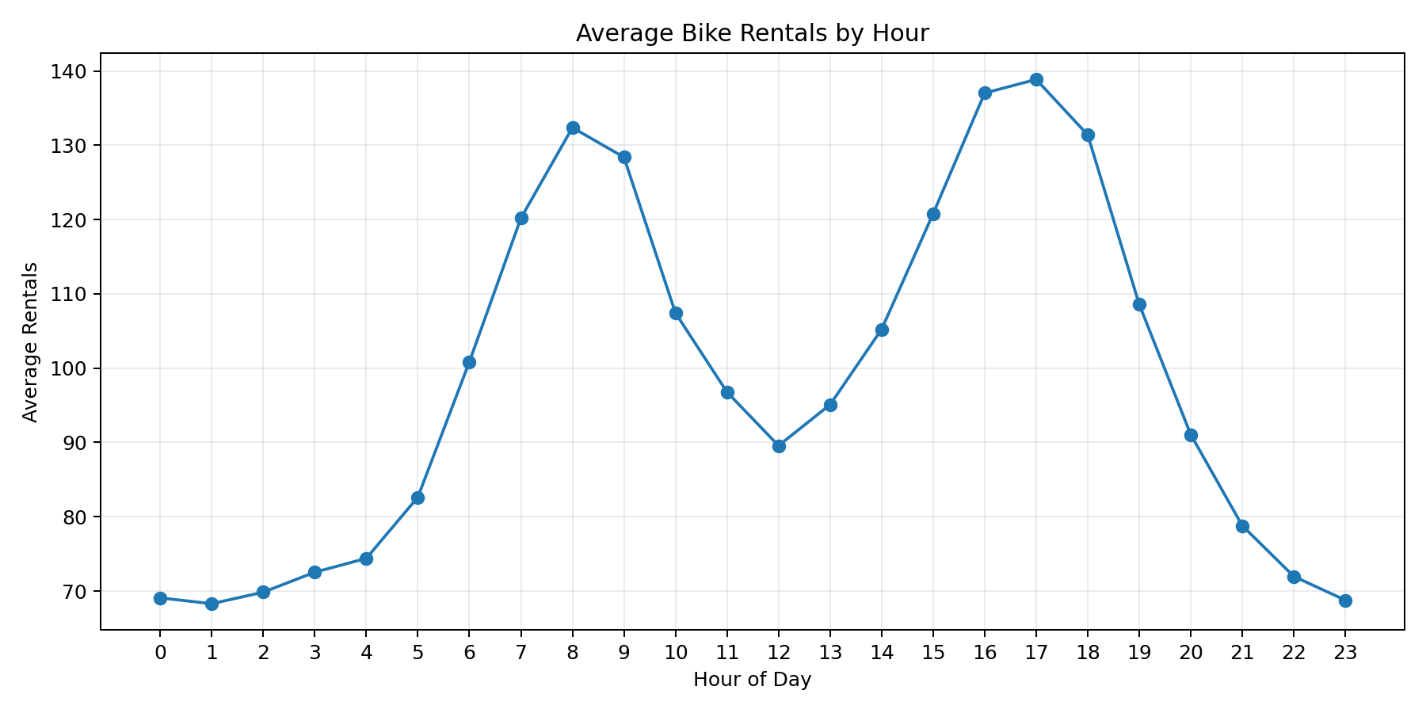
02 Average Rentals By Season
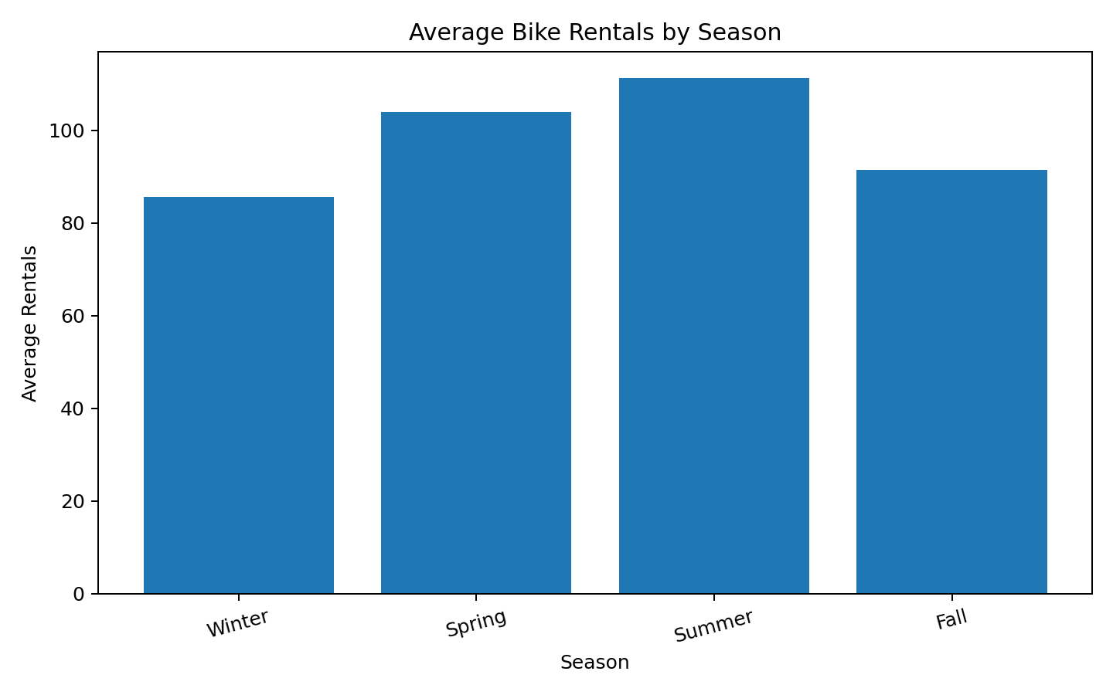
03 Average Rentals By Weather
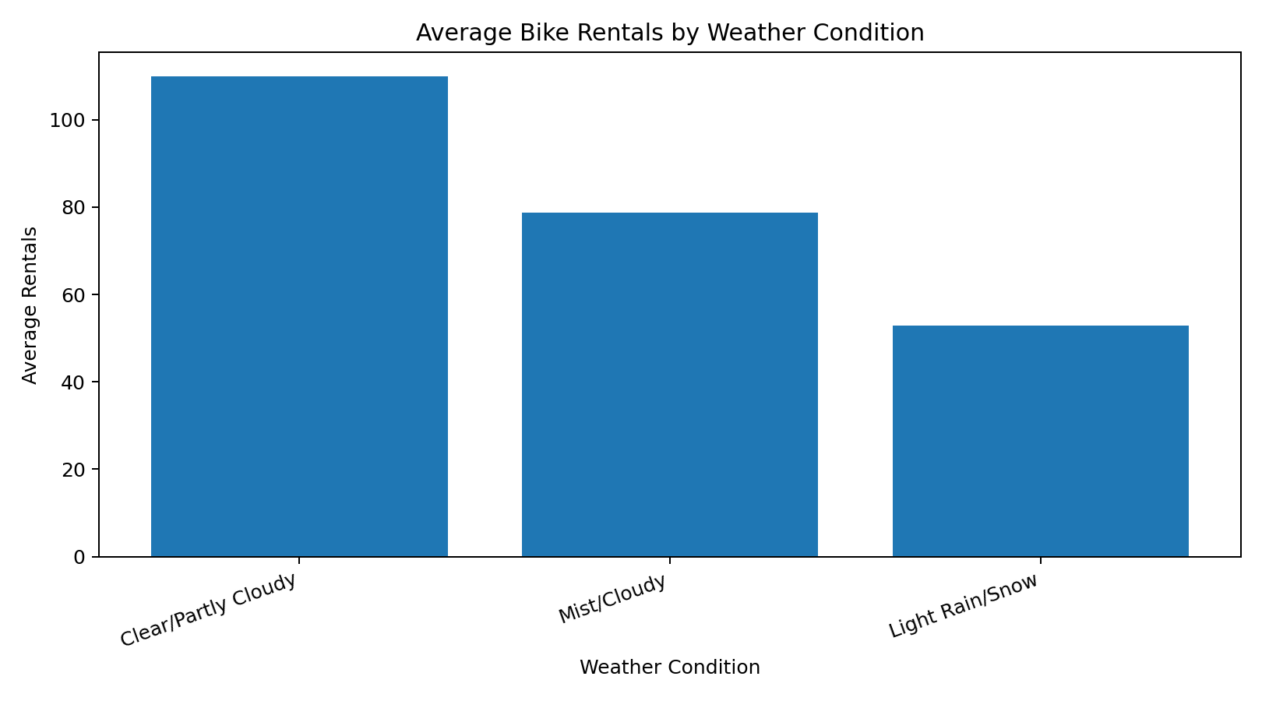
04 Temperature Vs Demand
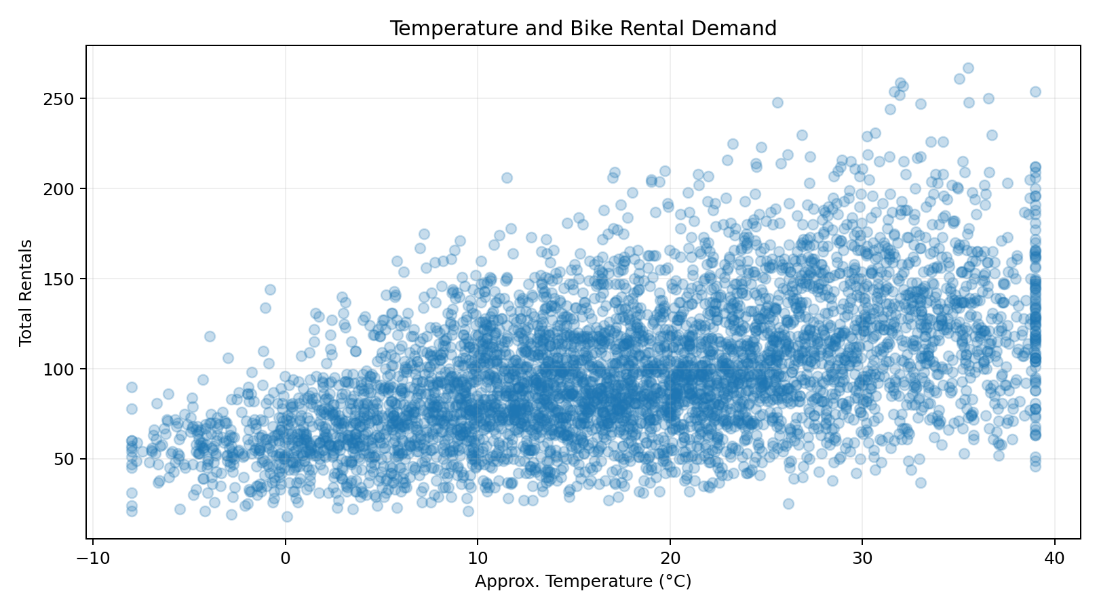
05 Workingday Comparison
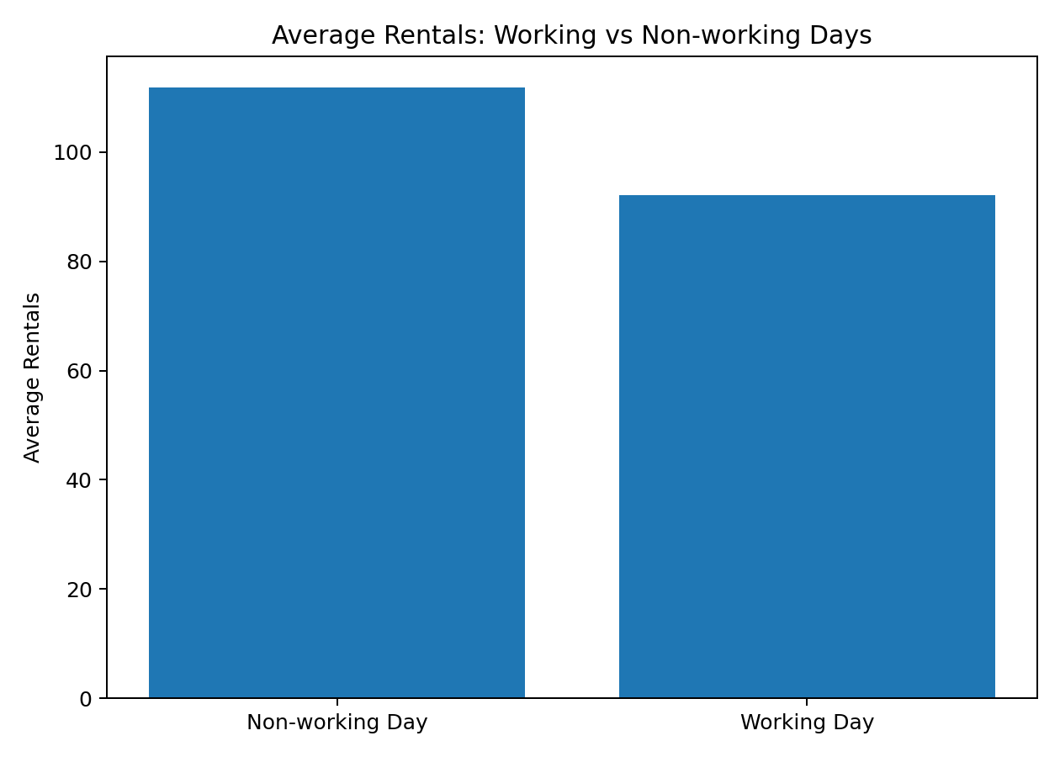

16. Conclusion
The proposed strategy provides a complete and reproducible roadmap for exploring bike-sharing demand using Python. It connects data acquisition, cleaning, transformation, exploratory visualization, statistical analysis, interpretation, and documentation. The workflow is intentionally modular so that the same approach can be reused for later internship tasks and different public datasets. The project is ready to be version-controlled and submitted through GitHub after the student reviews the generated outputs and adds any internship-specific details required by the supervisor.

17. Dataset Reference
UCI Machine Learning Repository. Bike Sharing Dataset. https://archive.ics.uci.edu/dataset/275/bike+sharing+dataset

