**Social Media Analysis**

**Project Overview**:

**Objective:**

The primary goal of this project is to analyze social media metrics using **Exploratory Data Analysis (EDA)** using **Visual Studio Code** as an editor, to identify influencers with the highest number of subscribers, views, and likes. This will help us find suitable candidates for collaboration and marketing opportunities.

Tools used for Exploratory Data Analysis (EDA):

* **Pandas**: For data manipulation and analysis.
* **NumPy**: For numerical operations and array handling.
* **Matplotlib**: For basic plotting and visualizations.
* **Seaborn**: For advanced statistical visualizations based on Matplotlib.

**Scope:**

* Collect data on influencers from various social media platforms.
* Analyze key metrics, including:

1. Subscribers: Total follower count across platforms.
2. Views: Aggregate views on their content.
3. Likes: Total likes received on posts.

* Compare and rank influencers based on these metrics to identify potential collaboration partners.

**Methodology:**

1. Data Collection: Utilize APIs or web scraping tools to gather data on influencers.

2. Data Cleaning: Process the collected data to remove duplicates and irrelevant entries.

3. Analysis: Perform quantitative analysis to determine the top influencers based on the specified metrics.

4. Visualization: Create visual representations (charts/graphs) to illustrate findings.

**Expected Outcomes**:

* A ranked list of influencers based on subscribers, views, and likes.
* Insights into the most effective influencers for potential collaborations.
* Recommendations for outreach strategies based on analysis.

This overview sets the stage for a detailed investigation into influencer engagement and collaboration opportunities.

**Output Graphs:**

1. A ranked list of Top 10 influencers based on Number of Subscribers.

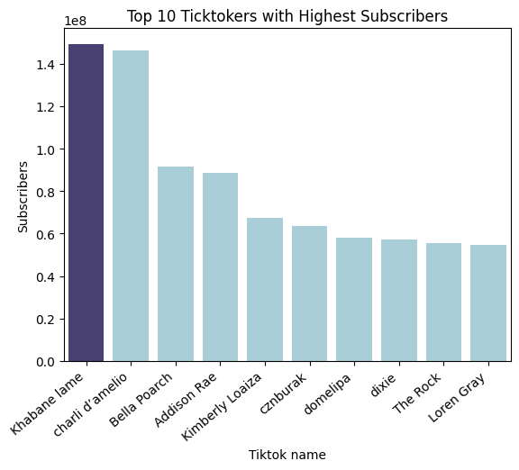

1. A ranked list of Top 10 influencers based on Average number of Views.

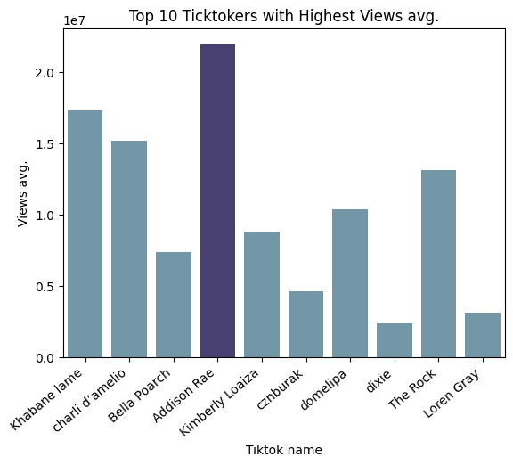

1. A ranked list of Top 10 influencers based on Average number of Likes.

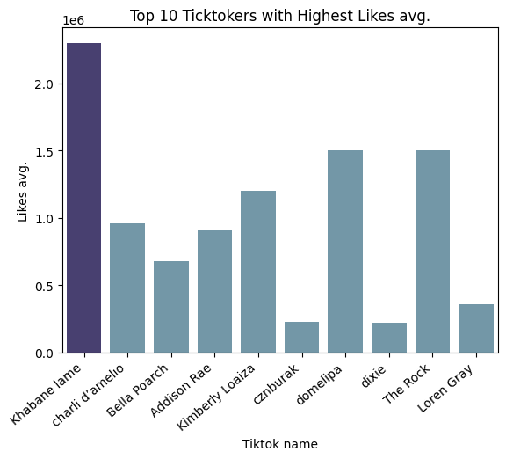

1. A ranked list of Top 10 influencers based on Average number of Shares.

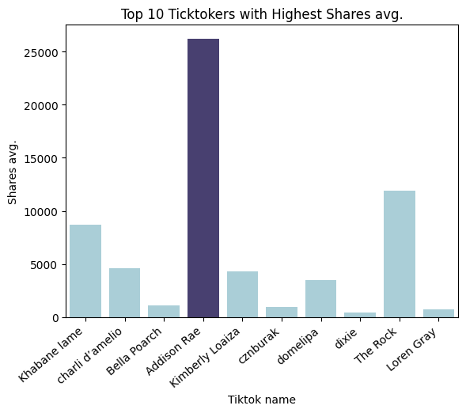

**Conclusions:**

* **Addison Rae** has highest number of views and share.
* **Khabane lame** has the highest number of subscribers and likes.

Hence we can conclude that we can reach out to either of them for collaboration or marketing purposes.

Thank you