Cloud-Based Wearable Health Analytics Platform using Edge–Cloud Intelligence
Project Documentation — Planning & Design Phase
Course: Cloud Computing
# | Name | Registration No. | Area of Responsibility
1 | Krish Agarwal | 23BIT0427 | Cloud Infrastructure, DevOps, Backend & Data
2 | Monis Raza | 23BIT228 | AI/ML & Edge Intelligence
3 | Rudra Srivastav | 23BIT174 | Frontend, Visualisation & Documentation

GitHub Repository
https://github.com/krishagarwal314/edge-cloud-wearable-health-analytics
Status: planning and design phase — code implementation not required at this stage.

Table of Contents
1. Problem Statement
2. Objectives
3. Literature Survey
4. Research Gap Analysis
5. Proposed Architecture / Framework
6. Technology Stack
7. Dataset Details
8. Repository Structure
9. Work Distribution & Individual Contribution
10. Work Completed So Far
11. Limitations, Ethics & Future Work
12. References

1. Problem Statement
Consumer wearables — smartwatches, chest straps and pulse oximeters — generate a continuous, high-frequency stream of physiological data including heart rate, ECG, blood-oxygen saturation, skin temperature and accelerometry. In practice this data remains largely under-used, for three reasons.
- Bandwidth, energy and cost. Continuously streaming raw high-rate signals such as 125 Hz ECG to the cloud for every user is expensive and drains device battery, and the overwhelming majority of those samples are clinically uninteresting.
- Latency of critical alerts. A cardiac event detected only after a round trip to a remote data centre — or after an overnight batch job — is detected too late to be clinically useful.
- Fragmentation. Vendor applications silo the data. Clinicians and researchers receive summary dashboards rather than queryable longitudinal records, and cannot substitute their own models.

Problem addressed by this project
How can we build a low-cost, scalable health-analytics pipeline that detects physiological anomalies in near-real-time, without transmitting every raw sample to the cloud, while still preserving enough data for longitudinal analysis and model retraining?
Our answer is an edge–cloud split-intelligence architecture. A lightweight quantised anomaly detector runs on the wearable gateway and forwards only (a) periodic compact summaries and (b) full-fidelity signal windows surrounding suspicious events. The cloud tier — built entirely from AWS Free Tier serverless components — performs confirmation inference, persistence, alerting and visualisation.

2. Objectives

Primary objectives
ID | Objective
O1 | Design and implement an end-to-end edge-to-cloud telemetry pipeline for wearable vital signs using AWS IoT Core, AWS Lambda and Amazon DynamoDB.
O2 | Train a lightweight anomaly-detection model (1-D convolutional autoencoder over ECG/HR windows), quantise it to TensorFlow Lite under 500 KB, and execute it on the edge gateway.
O3 | Implement a two-stage inference cascade — cheap edge screening followed by higher-capacity cloud confirmation — and quantify the bandwidth saved relative to a naive stream-everything baseline.
O4 | Deploy the entire cloud tier within AWS Free Tier limits, targeting a $0 monthly bill, with all infrastructure defined as code (CloudFormation/SAM).
O5 | Deliver a responsive web dashboard for live vitals, historical trends and an alert timeline, secured with Amazon Cognito.

Secondary objectives
ID | Objective
O6 | Provide an event-driven alerting path (SNS → email/SMS) with under 5 s end-to-end latency from anomalous sample to notification.
O7 | Benchmark the system: ingestion throughput, end-to-end latency, model accuracy (precision, recall, F1) and cost-per-1000-devices projection.
O8 | Demonstrate elasticity by replaying a synthetic multi-device load and showing automatic Lambda concurrency scaling.

3. Literature Survey

3.1 Survey method
- Databases searched: IEEE Xplore, ACM Digital Library, ScienceDirect, PubMed, arXiv.
- Inclusion criteria: English, peer-reviewed or high-citation preprint, published 2015–2025, reporting either a system architecture or a quantitative evaluation.
- Exclusion criteria: purely clinical studies with no computational contribution; papers without evaluation.

3.2 Theme A — IoT / cloud architectures for health monitoring
Ref | Work | Contribution | Limitation
[1] | Islam et al., IEEE Access, 2015 | Foundational taxonomy of IoT healthcare across sensing, network, service and application layers. | Pre-dates practical edge ML; cloud-centric; no cost analysis.
[2] | Baker, Xiang & Atkinson, IEEE Access, 2017 | Generic end-to-end IoT healthcare framework; identifies energy, security and interoperability as open issues. | Framework is conceptual; never deployed or measured.
[3] | Rahmani et al., FGCS, 2018 | Smart e-health gateway performing local processing, compression and embedded storage at the fog layer. | Dedicated on-premise hardware; no public-cloud integration or elasticity.

3.3 Theme B — Edge and fog intelligence
Ref | Work | Contribution | Limitation
[4] | Shi et al., IEEE IoT Journal, 2016 | Defines the edge-computing paradigm and its latency, bandwidth and privacy motivations. | Vision paper; no health-specific instantiation.
[5] | Satyanarayanan, IEEE Computer, 2017 | Cloudlet model; argues for tiered compute placement. | Conceptual; no split-inference design.
[6] | Kang et al., ASPLOS, 2017 (Neurosurgeon) | Automatically partitions a DNN between mobile and cloud at the optimal layer. | Partitions a single network; assumes continuous connectivity; not an anomaly-triggered cascade.
[7] | Teerapittayanon et al., ICDCS, 2017 (DDNN) | Distributed DNN with early-exit branches: easy samples exit at the edge, hard ones escalate. | Evaluated on vision, not physiological time series; no cost analysis.

3.4 Theme C — Machine learning for physiological anomaly detection
Ref | Work | Contribution | Limitation
[8] | Moody & Mark, IEEE EMB Mag., 2001 | The MIT-BIH Arrhythmia Database — the reference annotated ECG corpus. | Dataset paper; few subjects; clinical rather than wearable recording conditions.
[9] | Hannun et al., Nature Medicine, 2019 | 34-layer CNN matching cardiologist performance on 12 rhythm classes from single-lead ambulatory ECG. | Far too large for a Raspberry Pi; inference assumed server-side.
[10] | Chauhan & Vig, IEEE DSAA, 2015 | LSTM predictive model; anomalies flagged from the prediction-error distribution — semi-supervised, needing only normal data. | Recurrent model expensive on-device; no system integration.
[11] | Malhotra et al., ICML AD Workshop, 2016 | Reconstruction-error anomaly detection for multivariate sensor streams — the template for our autoencoder. | Not quantised or deployed; offline evaluation only.
[12] | Kiranyaz et al., IEEE TBME, 2016 | Compact 1-D CNN for real-time, patient-specific ECG classification. | Requires per-patient labelled data; no cloud tier.

3.5 Theme D — Serverless and cost-efficient cloud backends
Ref | Work | Contribution | Limitation
[13] | Jonas et al., Berkeley View, 2019 | Defines serverless computing, its economics and its limitations (state, cold starts, data locality). | General-purpose; no IoT or health case study.
[14] | Baldini et al., 2017 | Survey of FaaS platforms and design patterns. | Predates most managed IoT-to-FaaS integrations.
[15] | Aslanpour et al., ACSW, 2021 | Argues for FaaS abstractions spanning edge and cloud. | Vision-level; no concrete healthcare pipeline with measured cost.

3.6 Comparative summary
Aspect | Cloud-only [1–3] | Edge/fog [3–7] | Deep ECG [8–12] | This project
Where inference runs | Cloud | Edge only | Offline / server | Edge screen + cloud confirm
Uplink volume | Full raw stream | Reduced, fixed policy | Not applicable | Adaptive, anomaly-triggered
Model size constraint | None | Considered | Ignored | INT8 TFLite < 500 KB, measured
Backend model | VMs / containers | On-prem gateway | Not applicable | Fully serverless (FaaS)
Deployment cost reported | Rarely | Rarely | Never | Free Tier budget + projection
Reproducible IaC | No | No | No | Yes — one-command deploy
End-to-end latency measured | Sometimes | Sometimes | No | Yes, p95 target < 5 s

4. Research Gap Analysis

4.1 Identified gaps

Gap 1 — Cascaded inference is unvalidated for physiological streams
Early-exit and model-partitioning schemes [6][7] are demonstrated on image classification, where a sample is a discrete, independent input. Physiological data is a continuous, non-stationary, subject-specific stream in which the events of interest are rare (class imbalance frequently exceeds 100:1) and context-dependent — a heart rate of 160 bpm is normal while running and alarming at rest. No reviewed work evaluates an edge-screen to cloud-confirm cascade on wearable vital signs with an explicit false-negative budget.

Gap 2 — Bandwidth and energy savings are asserted rather than measured
Fog-computing healthcare papers [3] claim reduced transmission but rarely publish a byte-level comparison against a stream-everything baseline under identical signal conditions, and almost never relate it to a monetary or quota cost.

Gap 3 — Deep ECG models exist in isolation from deployable systems
State-of-the-art ECG models [9] are large — tens of megabytes, millions of parameters — and are evaluated offline on curated datasets. The literature does not carry them through quantisation, latency measurement on real edge hardware, and integration into a production data path.

Gap 4 — Health-IoT backends are rarely serverless, and cost is rarely reported
Reviewed systems use virtual machines, containers or on-premise gateways. The serverless literature [13][14] analyses economics generically but not for a continuous-telemetry health workload. We found no health-IoT paper publishing an actual monthly bill or a per-device cost model.

Gap 5 — Reproducibility
Architectures in this space are published as block diagrams. Almost none ship infrastructure-as-code, so a reader cannot re-create the reported results.

Gap 6 — Resilience of the edge link is under-treated
Wearable gateways operate on intermittent connectivity, yet evaluations assume a stable uplink and data loss during disconnection is seldom quantified.

4.2 Gap-to-contribution matrix
Gap | Our contribution | How it is evaluated
G1 | Anomaly-triggered edge-to-cloud escalation with activity-aware thresholds | Recall/precision versus uplink-volume operating curve
G2 | Byte and message instrumentation against a stream-everything baseline | Measured percentage reduction, reported in results/benchmarks/
G3 | INT8 TFLite pipeline plus an on-device latency harness | Accuracy delta and milliseconds per window on a Raspberry Pi 4
G4 | Fully serverless tier with a published Free Tier budget | AWS Cost Explorer bill plus a beyond-Free-Tier projection model
G5 | One-command infrastructure-as-code and a hardware-free simulator | Clean-account deployment from scratch, timed
G6 | Prioritised store-and-forward buffer | Chaos test: 30 minutes offline, measuring data loss and replay latency

4.3 Research questions
- RQ1. For 10-second wearable vital-sign windows, what edge-threshold setting minimises uplink volume subject to a false-negative rate below 5 %?
- RQ2. How much accuracy is lost by INT8 quantisation of the edge autoencoder, and is that loss recovered by the cloud confirmation stage?
- RQ3. What is the p95 end-to-end latency from an anomalous sample to a delivered notification in a purely serverless AWS pipeline, and what dominates it?
- RQ4. At what device count does the architecture exit the AWS Free Tier, and what is the marginal cost per device per month beyond that point?
- RQ5. Does incorporating accelerometer-derived activity context measurably reduce motion-artefact false positives?

4.4 Novelty statement
Existing wearable-health platforms either stream all raw physiological data to the cloud — which is expensive, energy-hungry and slow to alert — or run detection entirely on the edge, which caps model capacity. Cascaded inference resolves this tension for computer vision, but has not been validated on continuous, highly imbalanced, context-dependent physiological streams. This project implements and empirically evaluates such a cascade end to end: a sub-500 KB quantised autoencoder screens 10-second windows on the device and escalates only suspicious ones to a higher-capacity confirmation model running in a fully serverless AWS backend. The contribution is threefold: an activity-aware escalation policy with a measured recall-versus-bandwidth operating curve; an end-to-end latency and accuracy evaluation of the deployed cascade rather than the model alone; and a fully reproducible, infrastructure-as-code deployment with a published cost model demonstrating zero-cost operation within the AWS Free Tier at demonstration scale.

5. Proposed Architecture / Framework
The platform is a three-tier, event-driven, serverless architecture with split inference across the edge and cloud tiers.
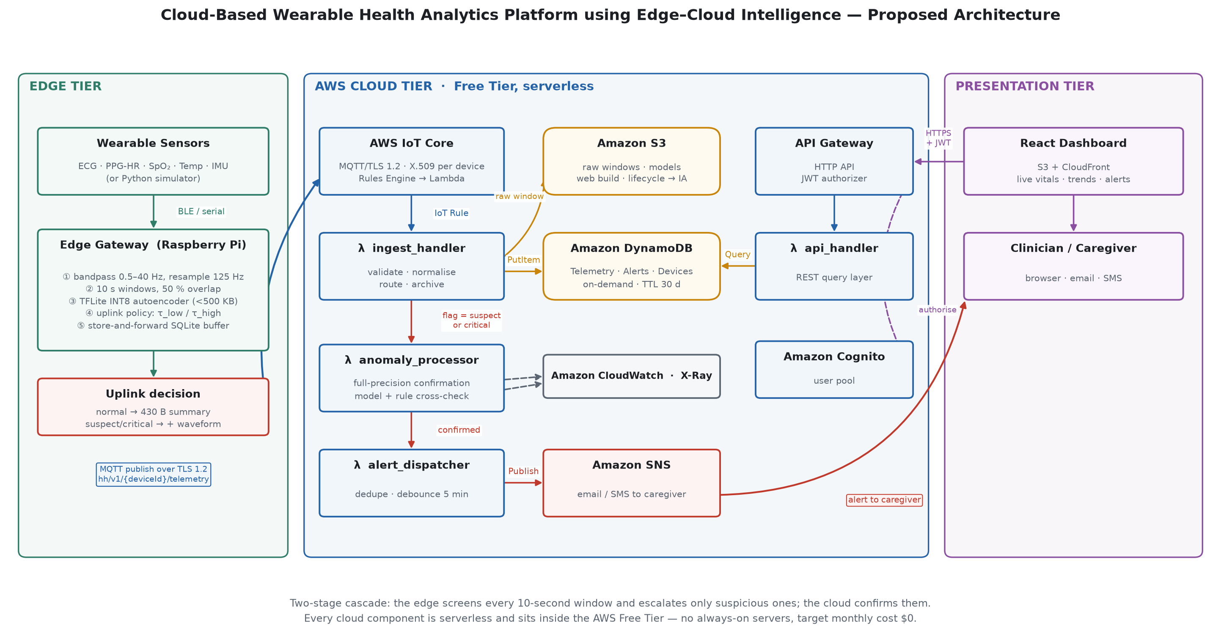
Figure 1 — Proposed system architecture. The edge tier screens every window and escalates only suspicious ones; the cloud tier confirms, persists, alerts and serves the dashboard.

5.1 Tier responsibilities
Tier | Responsibility | Deployment
Edge | Acquisition, signal conditioning, first-pass anomaly screening, adaptive uplink, offline buffering | Raspberry Pi gateway or Python simulator
Cloud | Ingestion, confirmation inference, persistence, alerting, query API | AWS managed services (Free Tier)
Presentation | Clinician and caregiver dashboard | React SPA on Amazon S3 + CloudFront

5.2 The uplink policy (core mechanism)
Every 10-second window is scored on the device; the resulting reconstruction error determines how much data is transmitted. This single decision is what keeps the deployment inside the AWS IoT Core free-tier message quota.
Reconstruction error | Flag | What is published | Approx. size
e < τ_low | normal | Compact statistical summary only | ≈ 430 bytes
τ_low ≤ e < τ_high | suspect | Summary + downsampled waveform | ≈ 2 KB
e ≥ τ_high | critical | Summary + full waveform, QoS 1, priority | ≈ 3.7 KB

Thresholds are activity-scaled: motion inflates reconstruction error, so tolerance rises while the wearer is moving. They are also overridable per device at runtime through an MQTT configuration topic, so the operating point can be tuned without reflashing devices.

5.3 Normal and anomaly data flows
- Normal path: sensor → conditioning → windowing → TFLite inference → summary published over MQTT → IoT Rule → ingest_handler Lambda → DynamoDB item with a 30-day TTL.
- Anomaly path: the full waveform is attached and published at QoS 1 → ingest_handler archives it to Amazon S3 and asynchronously invokes anomaly_processor → the full-precision model plus a rule-based cross-check either confirms the event (writing an Alert and invoking alert_dispatcher, which de-duplicates and publishes to SNS) or rejects it, recording a hard negative for the next retraining round.

5.4 Key design decisions
# | Decision | Rationale
ADR-1 | AWS Lambda for all compute, not EC2 | Lambda's 1 M requests and 400 000 GB-seconds per month are always free, whereas the EC2 allowance expires after 12 months and bills continuously. Matches a bursty, event-driven IoT workload.
ADR-2 | DynamoDB as the hot store, not RDS | 25 GB of storage is always free; the access pattern (device partition key, timestamp sort key) fits naturally. The RDS free tier expires after 12 months.
ADR-3 | AWS IoT Core as the ingestion front door | Managed MQTT with per-device X.509 identity, TLS, QoS 1 delivery on a lossy link, and a Rules Engine that invokes Lambda directly — no broker to operate.
ADR-4 | Split inference (edge screen + cloud confirm) | Cloud-only inference wastes bandwidth and the message quota; edge-only inference cannot host a high-capacity model. The cascade delivers edge latency with cloud accuracy.
ADR-5 | INT8 post-training quantisation to TFLite | Roughly 4× smaller and 3× faster on an ARM CPU; the accuracy delta is measured and reported rather than assumed.
ADR-6 | S3 + CloudFront for the web app | Cheapest and simplest; the Amplify Hosting free tier is limited to 12 months.
ADR-7 | 30-day TTL on telemetry items | Keeps DynamoDB inside the 25 GB always-free limit; older data is already archived in S3.
ADR-8 | No VPC for Lambda functions | A NAT Gateway costs approximately $32 per month and is never free.

5.5 Non-functional requirements
Requirement | Target | Verification
End-to-end alert latency | < 5 s (p95) from sample to SNS publish | AWS X-Ray traces and timestamp deltas
Edge inference latency | < 50 ms per 10 s window on a Raspberry Pi 4 | On-device timing harness
Ingestion throughput | ≥ 50 messages/second (50 simulated devices) | Load test in tests/integration/
Uplink reduction | ≥ 90 % versus stream-everything | Byte counters instrumented in the simulator
Offline resilience | Buffer ≥ 6 hours of data | Chaos test: disconnect the network and verify replay
Monthly cost | $0 within the Free Tier at demonstration scale | AWS Cost Explorer
Security | TLS in transit, encryption at rest, least-privilege IAM, no secrets in the repository | IAM policy review and automated secret scanning
Privacy | No personally identifying information in telemetry; opaque device IDs | Schema review

6. Technology Stack
Layer | Technology | Notes
Edge device | Raspberry Pi 4 / Pi Zero 2 W, or a pure-Python simulator | The simulator lets the project run with zero hardware
Edge runtime | Python 3.11, paho-mqtt, awsiotsdk, NumPy, SciPy
Edge inference | TensorFlow Lite runtime, INT8-quantised 1-D conv autoencoder | Target size below 500 KB
Ingestion | AWS IoT Core (MQTT 3.1.1 over TLS 1.2), IoT Rules Engine | 250 000 messages/month free
Compute | AWS Lambda (Python 3.11), 128–512 MB | Four functions
Hot datastore | Amazon DynamoDB (on-demand, TTL enabled) | Three tables and one GSI; 25 GB always free
Cold datastore | Amazon S3 with a Standard → Infrequent Access lifecycle | Raw windows and model artefacts
API | Amazon API Gateway HTTP API | JWT authorizer
Authentication | Amazon Cognito user pool | 10 000 MAUs always free
Notifications | Amazon SNS | Email and optional SMS
Observability | Amazon CloudWatch Logs, Metrics and Alarms; AWS X-Ray | 7-day log retention to stay within the free tier
Infrastructure as code | AWS SAM / CloudFormation (YAML) | One-command deploy
CI/CD | GitHub Actions → sam deploy | OIDC role assumption; no long-lived access keys
Model training | Python 3.11, TensorFlow/Keras, scikit-learn, Jupyter | Google Colab or SageMaker Studio Lab (free)
Frontend | React 18 + Vite, Recharts, AWS Amplify Auth
Web hosting | Amazon S3 static website + CloudFront | 1 TB egress free
Testing | pytest, moto (AWS mocks), Vitest

6.1 Free Tier budget
The entire cloud tier is designed to run at zero cost. The binding constraint is the AWS IoT Core message quota, and the edge summarisation policy is what makes the project fit within it: at one message per second per device, five devices would consume roughly 13 million messages per month — fifty times over the limit. At one summary every ten seconds, five devices consume approximately 130 000.
Service | Free Tier allowance | Type | Planned usage
AWS IoT Core | 250 000 messages/month | 12 months | ≈ 130 000 (≈ 48 % used)
AWS Lambda | 1 M requests + 400 000 GB-s/month | Always free | ≈ 200 000 invocations (< 5 %)
DynamoDB | 25 GB storage, 25 WCU + 25 RCU | Always free | ≈ 2 GB with a 30-day TTL
Amazon S3 | 5 GB, 20 000 GET, 2 000 PUT/month | 12 months | ≈ 1 GB
API Gateway | 1 M requests/month | 12 months | ≈ 50 000
Amazon Cognito | 10 000 monthly active users | Always free | < 10 users
Amazon SNS | 1 000 email notifications/month | Always free | < 500 alerts
CloudWatch | 5 GB log ingestion, 10 alarms | Always free | Constrained by 7-day retention
CloudFront | 1 TB egress/month | Always free | < 1 GB

Services deliberately avoided because they lack a usable free tier: Amazon Timestream, Kinesis Data Streams, SageMaker real-time endpoints, Amazon RDS, NAT Gateway, Amazon MSK and OpenSearch.

7. Dataset Details
All datasets are publicly released and de-identified. This project collects no new human-subject data, and raw data is not committed to the repository.
Dataset | Source | Contents | Used for
MIT-BIH Arrhythmia (primary) | PhysioNet | 48 half-hour two-channel ambulatory ECG records, 360 Hz, 47 subjects, beat-level cardiologist annotations (~110 000 beats) | Training the autoencoder on normal beats; anomaly-detection evaluation
PTB-XL | PhysioNet | 21 837 clinical 12-lead ECGs, 10 s each, 100/500 Hz, multi-label diagnoses | Generalisation check — does the model transfer?
WESAD | UCI ML Repository | 15 subjects; chest (ECG, EDA, TEMP, RESP, ACC) and wrist (BVP, EDA, TEMP, ACC) | Realistic wearable-grade noisy signals; multimodal fusion
MHEALTH | UCI ML Repository | 10 subjects, 23 channels, 12 physical activities | Activity context, to suppress motion-artefact false positives (RQ5)
Synthetic stream | Generated in-repo (edge/simulator/) | Configurable physiologically-shaped ECG across six profiles | Load testing, elasticity demonstration, live demo

7.1 Preprocessing contract
Every dataset is normalised to a common window format before training.
Property | Value
Signal | Single-lead ECG (lead II or nearest equivalent)
Filter | Butterworth bandpass, 0.5–40 Hz, zero-phase
Resampling | 125 Hz
Window | 10 seconds (1 250 samples), 50 % overlap
Normalisation | Per-record z-score, fitted on that record only
Auxiliary features | HR mean/min/max, SDNN, SpO₂, temperature, activity class
Label | 0 = normal, 1 = anomalous (any non-normal annotated beat in the window)
Split | Subject-disjoint 70/15/15 — no subject appears in two splits

Subject-disjoint splitting is treated as non-negotiable: splitting by window would leak recordings between training and test sets and inflate every reported metric.

8. Repository Structure
Every folder contains a README describing its purpose, so no directory is empty and the intent of each area is documented.
edge-cloud-wearable-health-analytics/
├── README.md Project overview (title, team, problem, objectives,
│ architecture, tech stack, dataset details)
├── CONTRIBUTING.md Team conventions, branching, hard rules
├── LICENSE MIT
├── docs/
│ ├── WORK_DISTRIBUTION.md Per-member responsibilities, timeline, ledger
│ ├── architecture/ Design document, API contract, Mermaid diagrams
│ ├── literature-survey/ Survey, research gap, BibTeX references
│ ├── aws/ Free Tier budget, IAM and security notes
│ └── setup/ Deployment runbook and troubleshooting
├── edge/ Edge tier: simulator, TFLite inference, uplink policy
├── backend/ Four AWS Lambda functions, shared layer, API spec
├── ai-models/ Notebooks, training scripts, model artefacts
├── frontend/ React dashboard (components, pages, services)
├── database/ DynamoDB schemas, access patterns, seed data
├── infrastructure/ CloudFormation/SAM templates and deploy scripts
├── dataset/ Dataset acquisition and preprocessing documentation
├── results/ Benchmarks, figures, evaluation reports
├── presentation/ Slides, demo script, report
├── tests/ Unit and integration tests
└── .github/workflows/ CI pipeline
Folder | Purpose | Owner
edge/ | Signal conditioning, on-device inference, uplink policy, offline buffer | Monis Raza
backend/ | Serverless compute: ingest, anomaly processing, alerting, REST API | Krish Agarwal
ai-models/ | Model development from raw signal to a deployable TFLite artefact | Monis Raza
frontend/ | React dashboard for live vitals, trends and alerts | Rudra Srivastav
database/ | DynamoDB single-table design, access patterns, seed data | Krish Agarwal
infrastructure/ | Infrastructure as code, deployment and teardown scripts | Krish Agarwal
dataset/ | Dataset acquisition, licensing, preprocessing contract | Monis Raza
docs/ | Architecture, literature survey, AWS notes, setup runbook | Rudra Srivastav
results/ | Benchmarks, figures and evaluation reports | Rudra Srivastav
presentation/ | Slide deck, demo script, final report | Rudra Srivastav
tests/ | Unit and integration test suites | Krish Agarwal

9. Work Distribution & Individual Contribution
Name | Registration No. | Area of Responsibility | Tasks | Share
Krish Agarwal | 23BIT0427 | Cloud Infrastructure, DevOps, Backend & Data | 16 (I-1…I-8, B-1…B-8) | ~45 %
Monis Raza | 23BIT228 | AI/ML & Edge Intelligence | 8 (M-1…M-8) | ~30 %
Rudra Srivastav | 23BIT174 | Frontend, Visualisation & Documentation | 8 (F-1…F-8) | ~25 %

Rationale for the distribution
The project comprises four distinct technical areas but the team has three members, so Krish Agarwal covers two of them — the cloud infrastructure tier and the backend/data tier. These are the most tightly coupled parts of the system: the CloudFormation template, the Lambda functions and the DynamoDB schema all change together, so dividing them between two people would create constant merge friction on the same files. This gives Krish 16 of the 32 planned tasks, with Monis and Rudra owning 8 each.

9.1 Krish Agarwal (23BIT0427) — Cloud Infrastructure, DevOps, Backend & Data
Infrastructure and DevOps
ID | Task | Deliverable
I-1 | AWS account setup, IAM users, MFA, budget and billing alarm at $1 | docs/setup/SETUP.md
I-2 | Author the SAM/CloudFormation template for the full stack | infrastructure/cloudformation/template.yaml
I-3 | IoT Core thing type, policy and X.509 certificate provisioning | infrastructure/scripts/provision_device.sh
I-4 | Least-privilege IAM roles for each Lambda function | docs/aws/IAM_NOTES.md
I-5 | CI/CD with GitHub Actions and OIDC federation to AWS | .github/workflows/deploy.yml
I-6 | CloudWatch dashboards, log-retention policies and alarms | Dashboard definition and screenshots
I-7 | Free Tier quota tracking and weekly cost reporting | docs/aws/FREE_TIER_BUDGET.md
I-8 | S3 + CloudFront static hosting and cache invalidation | Template section and deploy script

Backend and data
ID | Task | Deliverable
B-1 | Define and validate the telemetry message schema | backend/common/schema.py, API contract
B-2 | ingest_handler Lambda: validate, normalise, fan out to DynamoDB and S3 | backend/lambdas/ingest_handler/
B-3 | anomaly_processor Lambda: cloud-side confirmation inference | backend/lambdas/anomaly_processor/
B-4 | alert_dispatcher Lambda: de-duplication, debounce, SNS publish | backend/lambdas/alert_dispatcher/
B-5 | api_handler Lambda and API Gateway routes | backend/lambdas/api_handler/, OpenAPI spec
B-6 | DynamoDB single-table design, GSIs and TTL policy | database/schemas/
B-7 | Cognito user pool integration and JWT authorizer wiring | backend/api/
B-8 | Integration tests with moto; load-test harness | tests/integration/

Also responsible for end-to-end system integration and for keeping the deployed stack within the AWS Free Tier.

9.2 Monis Raza (23BIT228) — AI/ML & Edge Intelligence
ID | Task | Deliverable
M-1 | Acquire and document MIT-BIH, PTB-XL and WESAD; write download scripts | dataset/, ai-models/preprocessing/
M-2 | Preprocessing pipeline: filtering, resampling, windowing, normalisation | ai-models/preprocessing/
M-3 | Baseline models (threshold rules, Isolation Forest) for comparison | ai-models/notebooks/01_baselines.ipynb
M-4 | 1-D convolutional autoencoder; training and threshold selection | ai-models/training/train_autoencoder.py
M-5 | INT8 post-training quantisation to TFLite; verify accuracy delta < 2 % | ai-models/models/
M-6 | Edge inference runtime and store-and-forward MQTT publisher | edge/edge_inference/, edge/simulator/
M-7 | Cloud-side confirmation model packaged for AWS Lambda | ai-models/models/cloud/
M-8 | Model evaluation: precision, recall, F1, ROC-AUC, confusion matrices | results/benchmarks/model_eval.md

9.3 Rudra Srivastav (23BIT174) — Frontend, Visualisation & Documentation
ID | Task | Deliverable
F-1 | React + Vite application scaffold, routing and theming | frontend/
F-2 | Cognito-backed login and logout flow | frontend/src/services/auth.js
F-3 | Live vitals view with polling updates | frontend/src/pages/LiveVitals.jsx
F-4 | Historical trends with a time-range picker | frontend/src/pages/Trends.jsx
F-5 | Alert timeline and acknowledgement action | frontend/src/pages/Alerts.jsx
F-6 | Device management view | frontend/src/pages/Devices.jsx
F-7 | Literature survey and research-gap documents | docs/literature-survey/
F-8 | Architecture diagrams, final report, slide deck and demo script | docs/architecture/, presentation/

9.4 Twelve-week timeline
Week | Milestone | Owner
1 | Problem finalisation and literature survey | Rudra (all contribute)
2 | Architecture design, repository scaffold, work split | Krish (all contribute)
3 | AWS account, IAM, billing alarms, IoT Core skeleton | Krish
4 | Telemetry schema, ingest_handler and DynamoDB tables | Krish
5 | Dataset acquisition and preprocessing pipeline | Monis
6 | Edge simulator publishing to IoT Core end to end | Monis + Krish
7 | Autoencoder training and quantisation | Monis
8 | Anomaly processor and SNS alerting path | Krish
9 | REST API and Cognito authentication | Krish + Rudra
10 | Dashboard: live view, trends, alerts | Rudra
11 | Benchmarking, elasticity demonstration, cost analysis | Krish + Monis
12 | Report, slides, demo rehearsal, submission | All

10. Work Completed So Far
Code implementation is not required at this stage. Beyond the planning deliverables, we have built a working edge simulator so that the design can be validated end to end before any AWS resources are provisioned. The figures below are genuine output of that code, not illustrations.
Deliverable | Status
Problem definition, objectives, literature survey, research gap | Complete
Proposed architecture, ADRs, non-functional requirements | Complete
MQTT telemetry contract and REST API contract | Complete
Repository scaffold with a README in every folder | Complete
Work distribution and 12-week timeline | Complete
AWS Free Tier budget and IAM security plan | Complete
Edge simulator: ECG generation, uplink policy, bandwidth instrumentation | Working prototype
Telemetry JSON Schema | Complete
CI pipeline (lint, smoke test, template validation, secret scan) | Complete
Cloud tier deployment (CloudFormation) | Planned — weeks 3–4
Model training and quantisation | Planned — weeks 5–7
Dashboard implementation | Planned — week 10

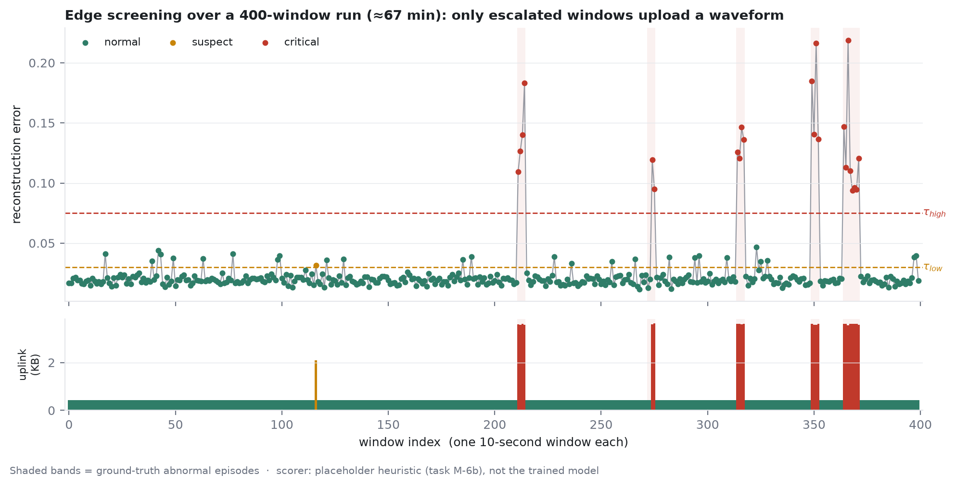
Figure 2 — Edge screening across a simulated 400-window run (≈ 67 minutes). Windows below τ_low upload only a compact summary; escalated windows upload a waveform. Shaded bands mark ground-truth abnormal episodes.
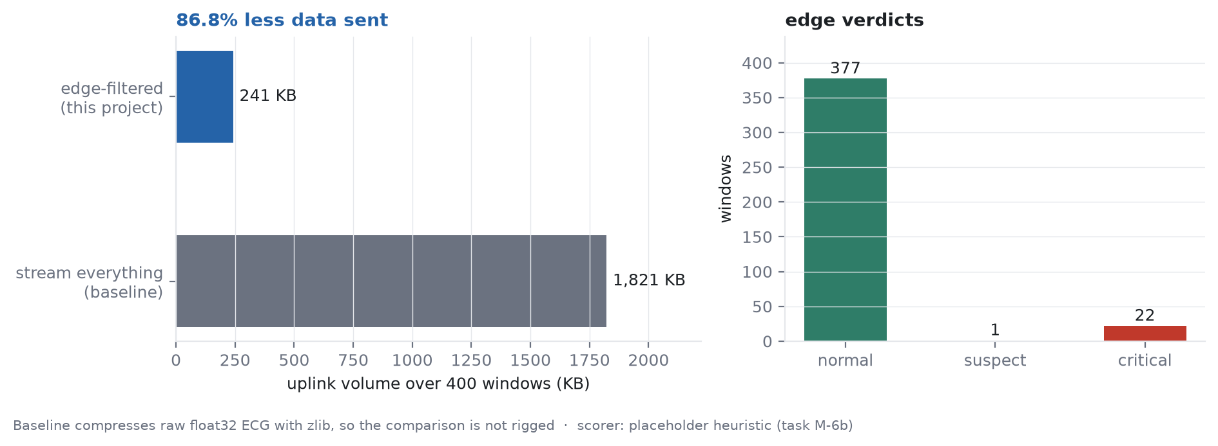
Figure 3 — Measured uplink volume against a stream-everything baseline: an 86.8 % reduction. The baseline is itself compressed, so the comparison is not favourable by construction.
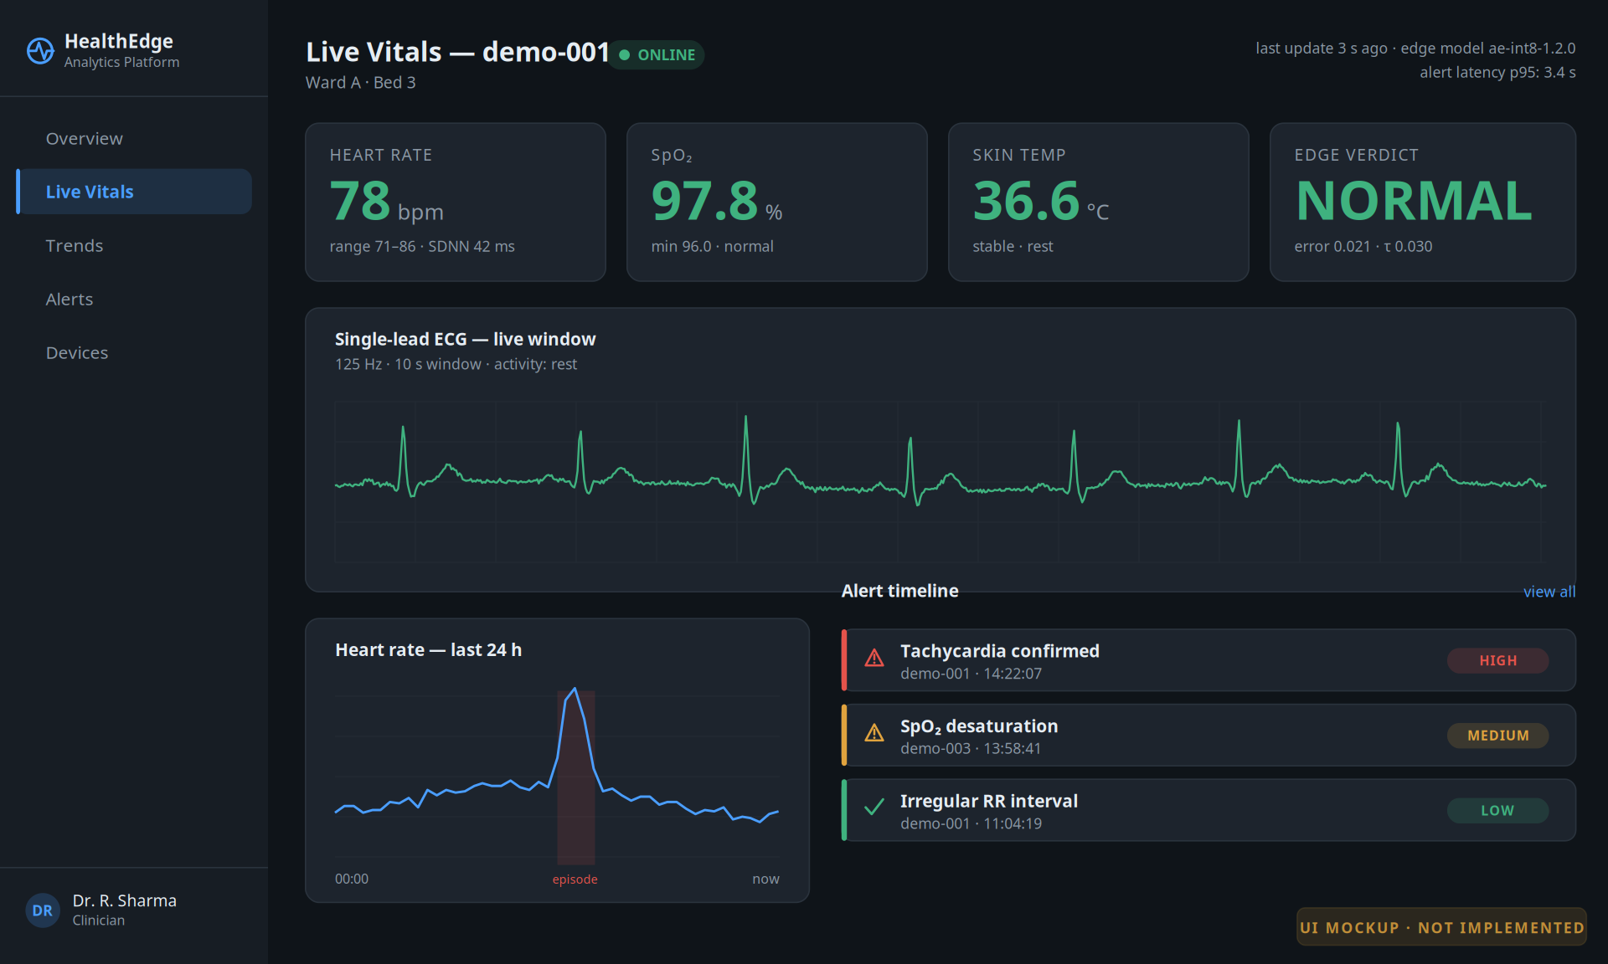
Figure 4 — Design mockup of the clinician dashboard. This is a proposed interface, not a screenshot; the frontend is scheduled for week 10.
Note on interpretation: the anomaly scorer behind Figures 2 and 3 is a documented placeholder heuristic, not the trained TFLite autoencoder, which is scheduled for weeks 5–7. These figures demonstrate that the pipeline and the uplink policy function end to end; they are not the final model-accuracy results, and the bandwidth figure will be re-measured once the trained model is in place.

11. Limitations, Ethics & Future Work

11.1 Scope and limitations
- Not a medical device. This is an academic prototype with no clinical validation and no regulatory claim. It must not be used for diagnosis or treatment.
- Datasets are clinical, not wearable-grade. MIT-BIH was recorded with clinical electrodes, whereas wrist-worn photoplethysmography is considerably noisier. We mitigate this with noise and motion-artefact augmentation, but it remains a threat to external validity.
- Limited demographic coverage. MIT-BIH contains only 47 subjects.
- Optimistic prevalence. Anomaly prevalence in curated datasets is far higher than in a free-living population, so reported precision is optimistic.
- Single region, no failover. Cross-region traffic is billable and out of scope; a disaster-recovery strategy is documented instead.
- Free Tier constrains scale. Sustained load tests are short and bounded so the account remains within quota.

11.2 Ethics and privacy
- All datasets used are publicly released and de-identified; no new human-subject data is collected, so no institutional ethics approval is required.
- The deployed system stores no personally identifying information — device identifiers are opaque, and any mapping to a person lives outside the system.
- Privacy improves as a direct consequence of the architecture: raw waveforms are transmitted only around suspected events, not continuously.
- Data is encrypted in transit (TLS 1.2 with mutual X.509 authentication) and at rest, with least-privilege IAM roles for every component.

11.3 Future work
- Federated learning, so per-device models improve without centralising raw signals.
- On-device incremental personalisation using the wearer's own baseline.
- Multimodal fusion of ECG with electrodermal activity and respiration.
- Multi-region deployment with automated failover.
- A clinical validation study, which would be a prerequisite for any real use.

12. References
[1] Islam, S. M. R., Kwak, D., Kabir, M. H., Hossain, M., & Kwak, K.-S. (2015). The Internet of Things for Health Care: A Comprehensive Survey. IEEE Access, 3, 678–708.
[2] Baker, S. B., Xiang, W., & Atkinson, I. (2017). Internet of Things for Smart Healthcare: Technologies, Challenges and Opportunities. IEEE Access, 5, 26521–26544.
[3] Rahmani, A. M., et al. (2018). Exploiting Smart e-Health Gateways at the Edge of Healthcare Internet-of-Things: A Fog Computing Approach. Future Generation Computer Systems, 78, 641–658.
[4] Shi, W., Cao, J., Zhang, Q., Li, Y., & Xu, L. (2016). Edge Computing: Vision and Challenges. IEEE Internet of Things Journal, 3(5), 637–646.
[5] Satyanarayanan, M. (2017). The Emergence of Edge Computing. Computer, 50(1), 30–39.
[6] Kang, Y., et al. (2017). Neurosurgeon: Collaborative Intelligence Between the Cloud and Mobile Edge. ASPLOS.
[7] Teerapittayanon, S., McDanel, B., & Kung, H. T. (2017). Distributed Deep Neural Networks over the Cloud, the Edge and End Devices. IEEE ICDCS.
[8] Moody, G. B., & Mark, R. G. (2001). The Impact of the MIT-BIH Arrhythmia Database. IEEE Engineering in Medicine and Biology Magazine, 20(3), 45–50.
[9] Hannun, A. Y., et al. (2019). Cardiologist-Level Arrhythmia Detection and Classification in Ambulatory Electrocardiograms Using a Deep Neural Network. Nature Medicine, 25, 65–69.
[10] Chauhan, S., & Vig, L. (2015). Anomaly Detection in ECG Time Signals via Deep Long Short-Term Memory Networks. IEEE DSAA.
[11] Malhotra, P., et al. (2016). LSTM-Based Encoder-Decoder for Multi-Sensor Anomaly Detection. ICML Anomaly Detection Workshop.
[12] Kiranyaz, S., Ince, T., & Gabbouj, M. (2016). Real-Time Patient-Specific ECG Classification by 1-D Convolutional Neural Networks. IEEE Transactions on Biomedical Engineering, 63(3), 664–675.
[13] Jonas, E., et al. (2019). Cloud Programming Simplified: A Berkeley View on Serverless Computing. UC Berkeley EECS Technical Report UCB/EECS-2019-3.
[14] Baldini, I., et al. (2017). Serverless Computing: Current Trends and Open Problems. Research Advances in Cloud Computing, Springer.
[15] Aslanpour, M. S., et al. (2021). Serverless Edge Computing: Vision and Challenges. Australasian Computer Science Week.
[16] Goldberger, A. L., et al. (2000). PhysioBank, PhysioToolkit, and PhysioNet. Circulation, 101(23), e215–e220.
[17] Wagner, P., et al. (2020). PTB-XL, a Large Publicly Available Electrocardiography Dataset. Scientific Data, 7(154).
[18] Schmidt, P., et al. (2018). Introducing WESAD, a Multimodal Dataset for Wearable Stress and Affect Detection. ICMI.

Repository: https://github.com/krishagarwal314/edge-cloud-wearable-health-analytics

