Database Assignment

Q1. Problem Statement: There can be multiple customers, who can place multiple orders on the site. Now a sales person can handle these orders will distribute into multiple sales persons (One order will be assign to one salesperson only). So a sales person can have multiple orders of multiple customers

Create Database

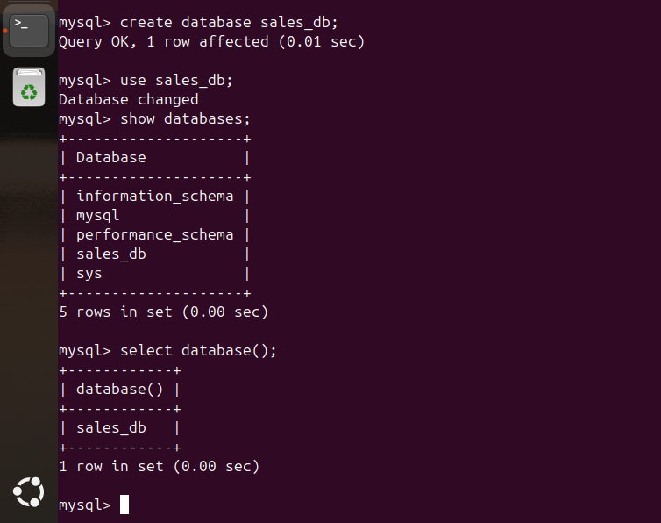

Q2. Design Schema

Ans. For designing the schema, we need to identify two things:

a. Relationship between entities
b. tables the database schema consists of

Based on the problem statement, I have identified the following relationships and tables:

→ Relationships:

one customer can place many orders (one to many)
one salesperson can handle many orders (one to many)
no direct relationship between customer and salesperson, they are connected through orders.

→ Tables:

Customers
Salespersons
Orders

→ Schema Design

Customers table
- customer_id (primary key)
- customer_name

Salesperson table
- salesperson_id (primary key)
- salesperson_name

Orders table
- order_id (primary key)
- order_amount
- customer_id (foreign key)
- salesperson_id (foreign key)

Q3. Create tables

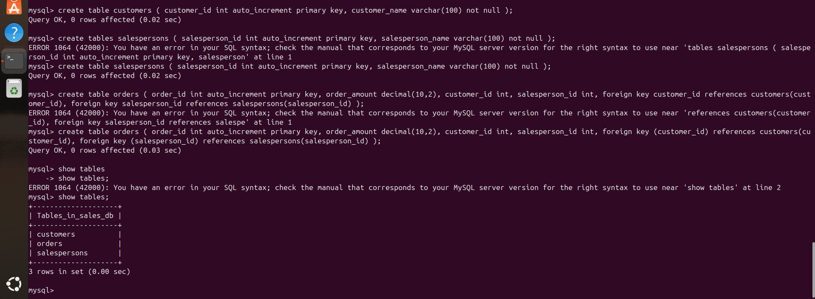

Q4. Insert sample data
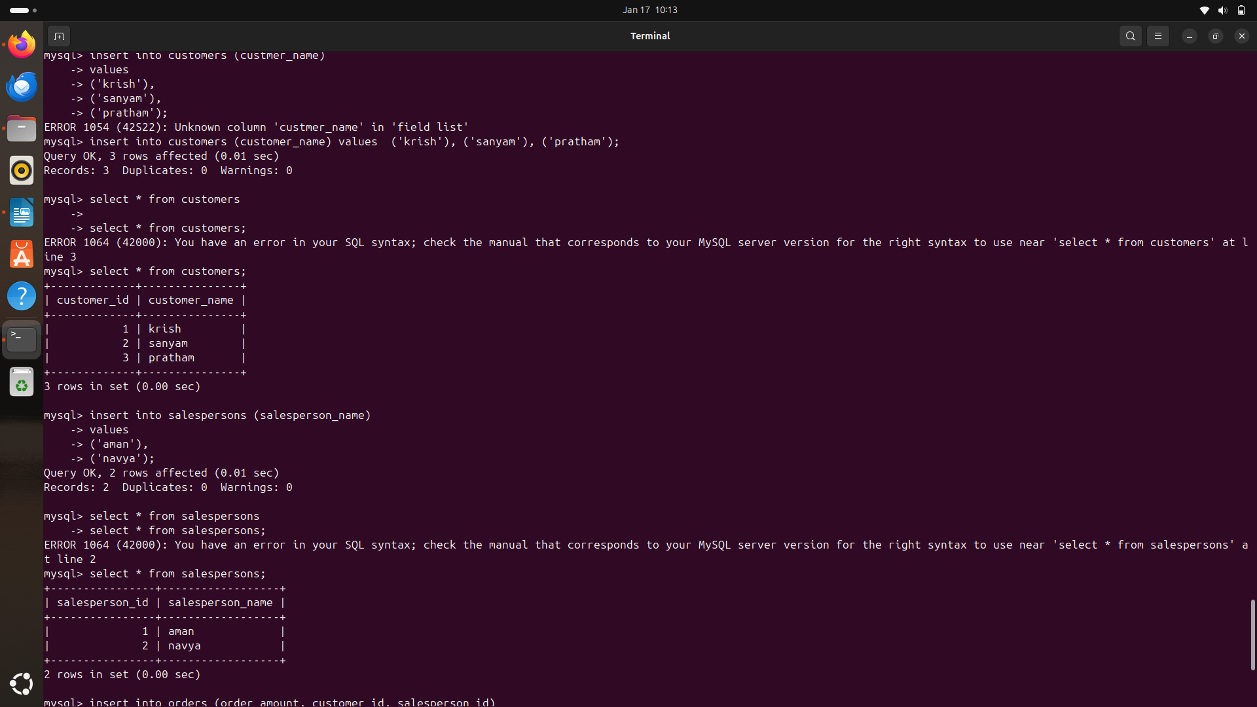
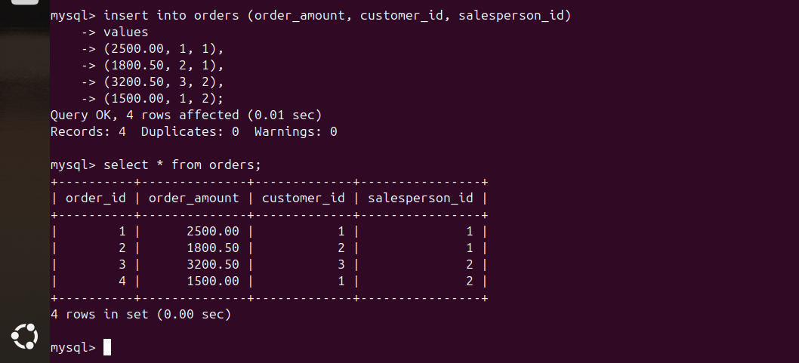

Q5. Find the sales person have multiple orders

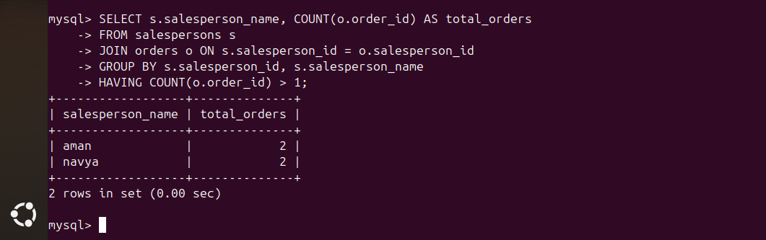

Q6. Find the all sales person details along with order details

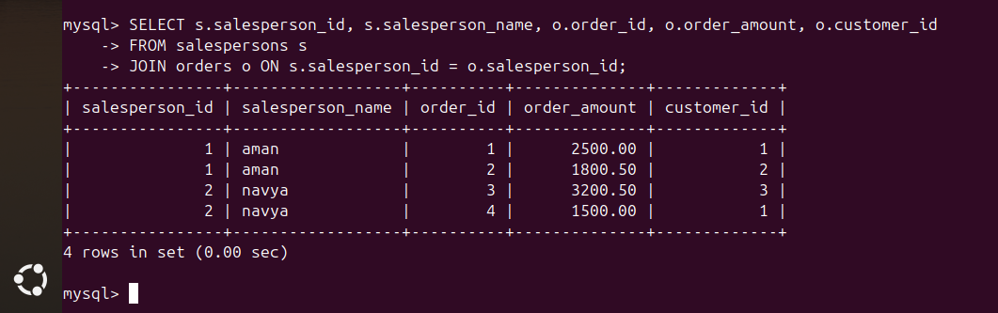

Q7. Create index



Q8. How to show index on a table

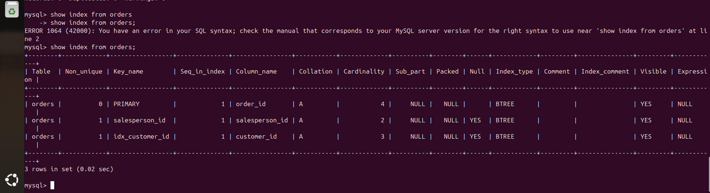

Q9. Find the order number, sale person name, along with the customer to whom that order belongs to

