AWS Assignment

Q1. List out the types of instance base on the pricing model and write a brief about your understanding about it.

Ans. AWS provides different EC2 pricing models so that users can choose how they want to pay based on their workload and budget. These pricing models help in reducing cost and improving flexibility.

On-Demand Instances
are the most commonly used pricing model. In this model, we pay only for the time the instance is running, without any long-term commitment. It is very useful for beginners, testing applications, or workloads that run for a short period of time because we can start or stop the instance whenever we want.
Reserved Instances
are suitable when we know that an application will run continuously for a long time. In this model, we reserve an instance for one or three years, and AWS provides a discounted price compared to On-Demand. This option is cost-effective for stable and predictable workloads.
Spot Instances
are the cheapest option provided by AWS. These instances use unused AWS capacity and are available at a much lower price. However, AWS can stop these instances at any time if the capacity is needed. Because of this, Spot Instances are mainly used for non-critical tasks like batch processing or background jobs.
Savings Plans
are another cost-saving option where we commit to spending a fixed amount per hour for a long duration. Savings Plans provide flexibility because they are not limited to a specific instance type and can be used across different services.

In conclusion, AWS EC2 pricing models allow users to choose between flexibility, stability, and cost savings depending on their use case.

Q2. Host a static website in S3


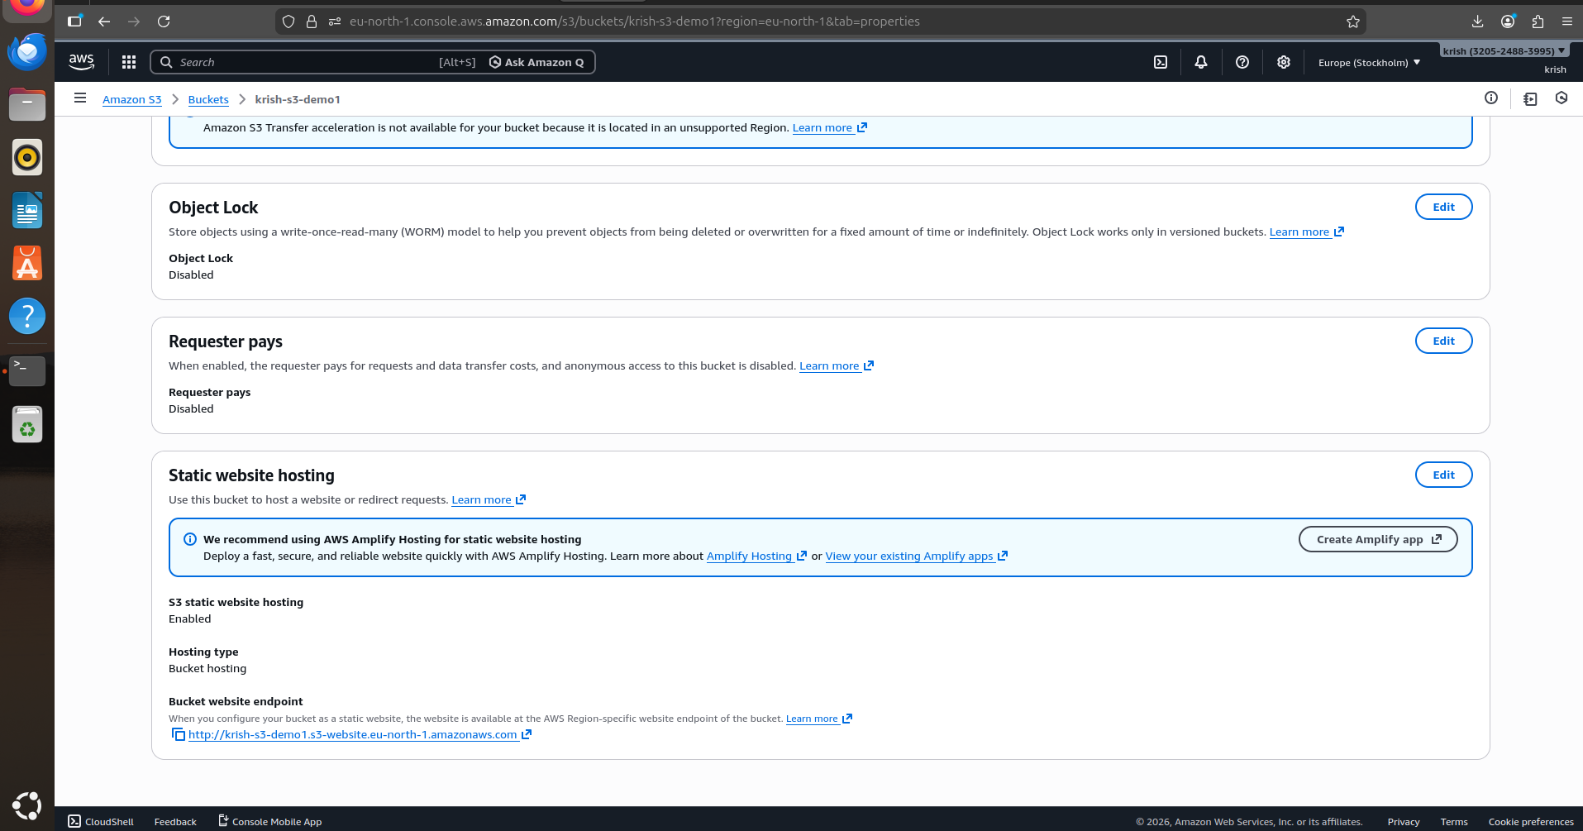

Q3. Launch an Ubuntu EC2 instance on AWS, with 10GB root volume, and SSH from your local machine using the private key

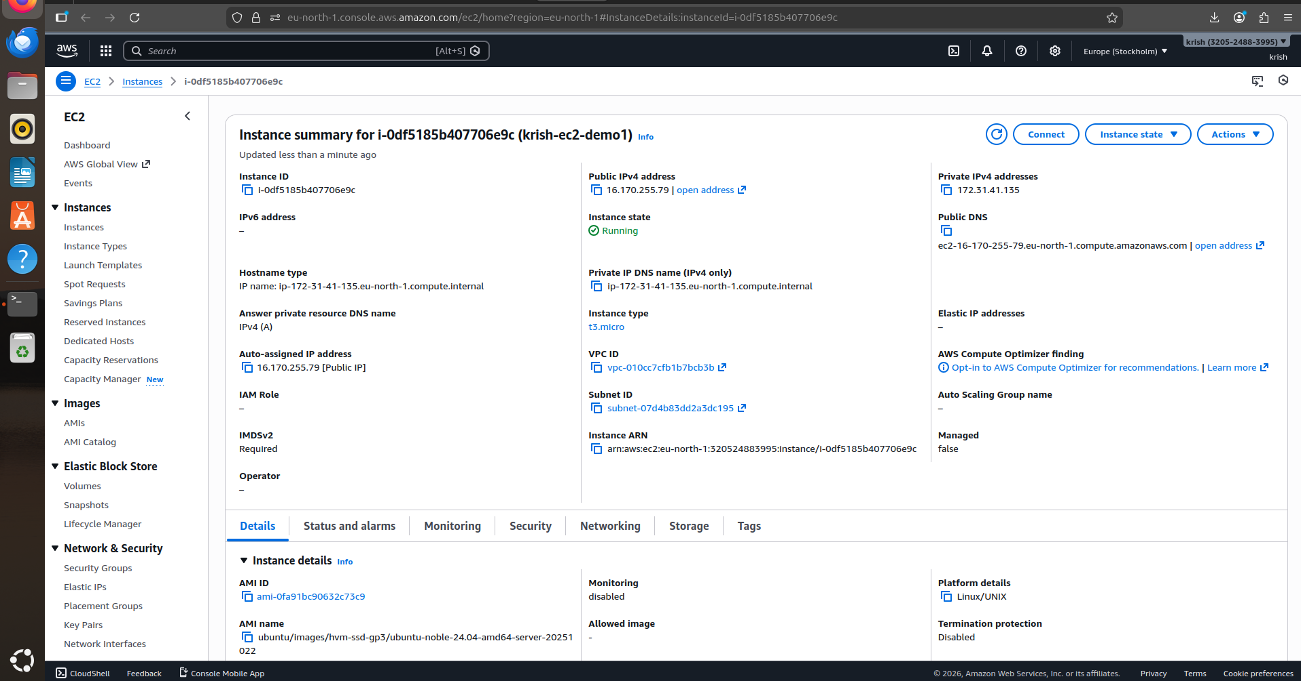
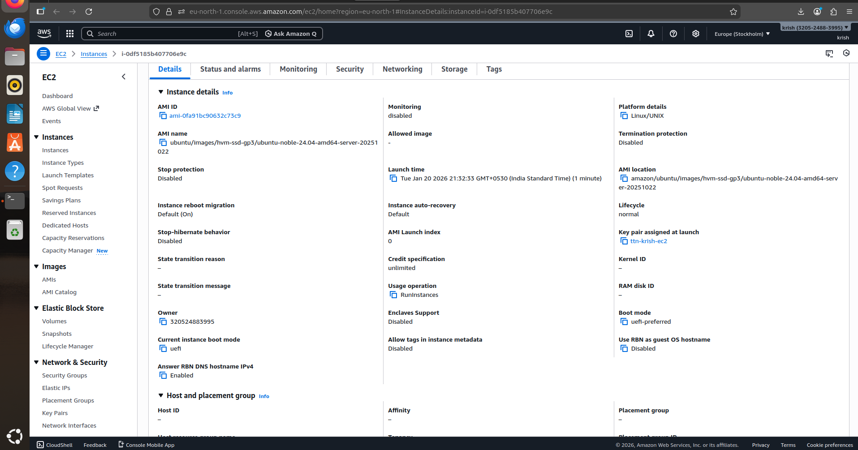
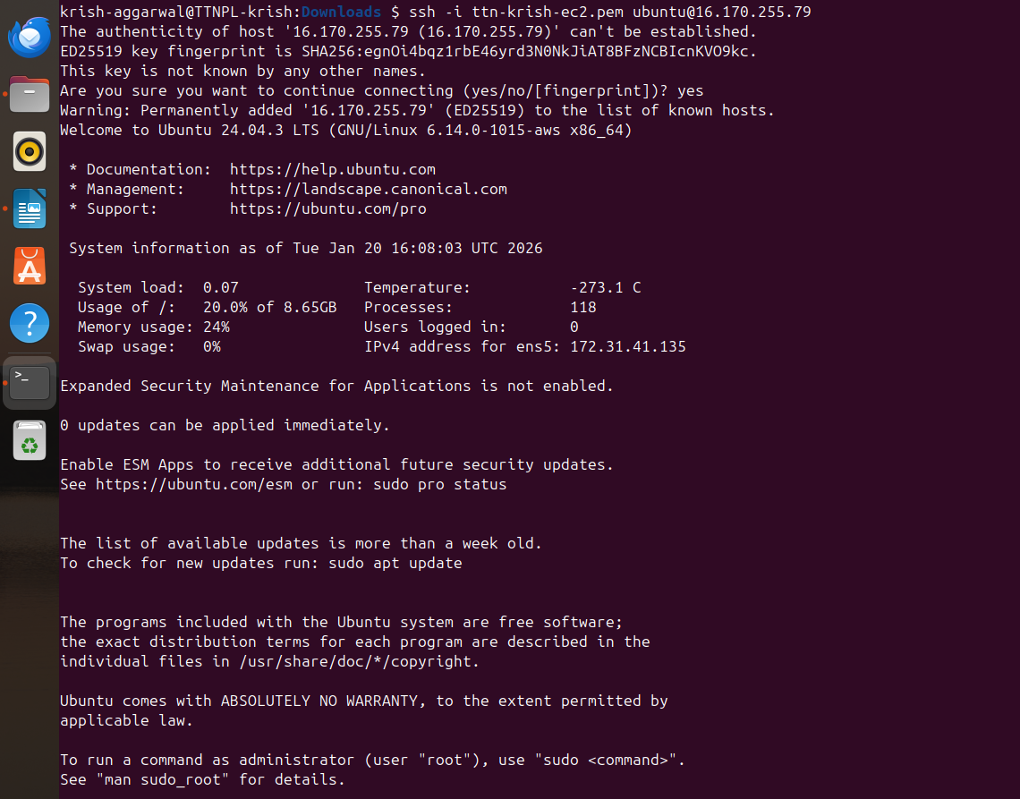
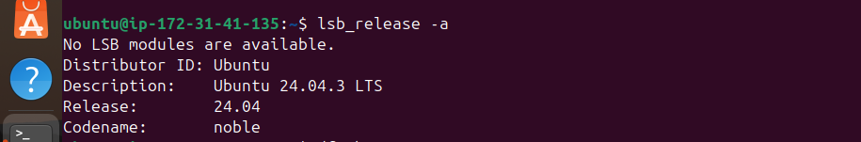

Q4. Install nginx package in the above server and access this page from your local browser using a domain name instead of IP address of the server

