SentinelCCTV: A Dual-Branch Spatio-Temporal Deep Learning Architecture for Real-Time Violence and Weapon Perception in Intelligent Surveillance Networks
Krish Agrawal, Vision Computing & Cyber-Physical Security Research Division
Department of Computer Science and Engineering, Advanced AI Surveillance Systems Laboratory
Email: krish.agrawal@surveillance-research.edu | Correspondence: project.sentinel@vision-lab.org
1. Abstract: Automated anomaly, fight, and weapon detection across closed-circuit television (CCTV) infrastructure is critical for safeguarding public transit, educational campuses, and urban environments. Conventional surveillance deployments rely predominantly on isolated single-frame two-dimensional detectors, which suffer from severe false alarm rates during rapid, non-aggressive pedestrian movements due to an absence of temporal continuity. To resolve this challenge, this paper presents SentinelCCTV, an end-to-end multi-modal framework coupling real-time YOLOv8 weapon localization with a deep Spatio-Temporal Convolutional Neural Network and Bidirectional Long Short-Term Memory (CNN + BiLSTM) action recognition engine. The system ingests uniform 16-frame temporal sequence slices (112 x 112 resolution) through a four-stage convolutional feature extractor, processes forward and backward transitions via a two-layer BiLSTM, and synthesizes temporal dynamics using contextual mean pooling. Evaluated on a harmonized 5,000-clip benchmark merging RWF-2000, Real Life Violence Situations (RLVS), and Hockey Fights, the proposed CNN + BiLSTM architecture achieves 94.67% test accuracy, 95.15% precision, 94.13% recall, 0.9464 F1-score, and 0.9842 ROC-AUC, outperforming recent peer-reviewed baseline literature by margins between 6.92% and 17.67% at a real-time latency of 18.2 ms per clip (55.2 FPS). Integrated with inter-frame motion gating, temporal confidence smoothing, and automated 10-second circular evidence recording (5s pre-event and 5s post-event capture), the proposed SentinelCCTV framework provides an accurate, deployment-ready automated surveillance solution.
2. Keywords: Video Violence Detection, Spatio-Temporal Modeling, Bidirectional LSTM, Smart CCTV Surveillance, Weapon Recognition, Real-Time Edge Computing.
3. Introduction
The SentinelCCTV project investigates the design, optimization, and deployment of an intelligent vision system capable of real-time threat identification in campus and urban surveillance streams [A. Pimpalkar, 2023]. Automated physical security monitoring has become a crucial technological necessity as manual operator surveillance over hundreds of simultaneous camera feeds leads to cognitive fatigue, delayed reaction windows, and overlooked hazardous incidents [A. Madallah, 2024].
a. Background and Context of the Problem
Urban camera networks continuously generate high-bandwidth video data under diverse visual conditions [R. Sharma, 2025]. Closed-circuit television feeds operate with wide-angle fields of view, steep overhead camera mountings, varying natural and artificial illumination, and severe physical occlusions caused by pedestrian congestion [M. Al-Dhamari, 2024]. In educational institutions and transit hubs, distinguishing an aggressive physical altercation from innocent human interactions (such as hurried running, affectionate embraces, athletic drills, or animated gestures) requires temporal continuity that frame-by-frame classifiers cannot provide [S. Patel, 2024].
b. Motivation for the Study
While contemporary object detection algorithms (such as YOLOv8) achieve commendable localization precision for static physical artifacts like blades or handguns [A. Madallah, 2024], their application to action classification produces excessive false alarms. In high-density pedestrian corridors, rapid physical displacement frequently causes single-frame detectors to trigger false alarms [Z. Chen, 2026]. Frequent false alerts cause security personnel to ignore system notifications. Therefore, developing an integrated architecture that combines precise spatial weapon perception with temporal action sequence recognition is essential [H. Li, 2025].
c. Problem Statement
The core challenge addressed in this work is: How can an autonomous CCTV surveillance pipeline detect both lethal weapons and physical altercations in unconstrained video streams with high accuracy (>94%) and minimal false positives, while sustaining real-time processing speeds (>30 FPS) without relying on computationally expensive optical flow algorithms?
d. Objectives of the Research and Novelty of the Work
The primary objectives and novel contributions of this research encompass:
1. Dual-Branch Perception Engine: Decoupling spatial weapon identification (YOLOv8) from temporal altercation modeling (CNN + BiLSTM) to eliminate cross-task interference and maintain high sensitivity across distinct threat categories [A. Madallah, 2024].
2. Spatio-Temporal Sequence Formulation: Implementing a uniform 16-frame temporal sampling scheme coupled with a 4-stage 2D convolutional feature backbone and a two-layer Bidirectional LSTM. Contextual mean pooling captures motion progression without optical flow overhead [F. Ullah, 2024].
3. Rigorous Empirical Benchmarking: Validating the architecture across 5,000 harmonized video sequences (RWF-2000, RLVS, and Hockey Fights) and establishing clear superiority over five recent peer-reviewed published models [M. Cheng, 2020; M. S. Islam, 2022; T. Napoleon, 2020; J. Zhang, 2022; M. Soliman, 2019].
4. Production-Grade Deployment: Engineering dynamic motion ratio gating, rolling confidence smoothing, and automated 10-second circular evidentiary recording (5 seconds pre-event and 5 seconds post-event) with structured CSV logging and live web dashboard monitoring.
4. Literature Survey
Automated video anomaly and violence detection has advanced from hand-crafted spatio-temporal interest points to deep recurrent and transformer-based representations [M. Al-Dhamari, 2024]. In this section, we analyze previous research methodologies, evaluate their technological constraints, identify persistent research gaps, and demonstrate how our proposed architecture addresses these limitations.
a. Compilation of Prior Research and Existing Methods
Early pioneering frameworks utilized local spatio-temporal features, such as Spatio-Temporal Interest Points (STIP) and Motion SIFT (MoSIFT), paired with Bag-of-Words classifiers [E. B. Nievas, 2011]. While effective on constrained datasets like Hockey Fights, these hand-crafted descriptors failed to generalize to unconstrained surveillance footage containing camera jitter, low resolution, and lighting changes [T. Hassner, 2012].
With the emergence of deep learning, two-stream convolutional networks and 3D-CNN architectures gained prominence [J. Carreira, 2017; C. Feichtenhofer, 2019]. Cheng et al. [M. Cheng, 2020] introduced the RWF-2000 surveillance benchmark and proposed a Flow-Gated 3D-CNN that fused RGB frames with dense optical flow fields. While attaining 87.25% accuracy on RWF-2000, their optical flow extractor required over 40 ms per frame, making multi-channel real-time streaming infeasible. Islam et al. [M. S. Islam, 2022] addressed latency by coupling MobileNetV2 with a unidirectional LSTM, reaching 82.00% accuracy on RWF-2000. However, unidirectional recurrence cannot model backwards contextual relationships within a bounded video sequence.
Napoléon and Al-Naimi [T. Napoleon, 2020] evaluated Spatio-Temporal ConvLSTM networks that retain spatial feature grids inside recurrent cells. Their architecture achieved 89.50% on Hockey Fights but degraded to 77.00% on RWF-2000 due to severe spatial overfitting and high memory allocation. Zhang et al. [J. Zhang, 2022] explored Temporal Shift Modules (TSM) integrated into lightweight backbones, achieving 87.75% accuracy at 16.5 ms latency. Nevertheless, TSM relies on static channel shifting without adaptive temporal memory gating, rendering it prone to false triggers from abrupt camera movements.
Soliman et al. [M. Soliman, 2019] developed the RLVS dataset and benchmarked VGG16 backbones coupled with standard LSTMs, achieving 85.30% accuracy. However, VGG16 carries 28.5 million parameters and requires 52 ms per sequence, making it impractical for edge computing. Recent investigations by Santhosh et al. [K. Santhosh, 2024], Ullah et al. [F. Ullah, 2024], and Sharma et al. [R. Sharma, 2025] highlight the necessity of sub-3.5M parameter architectures that sustain real-time frame rates above 45 FPS on edge hardware.
b. Research Gaps in Existing Literature
A critical analysis of existing literature reveals three unresolved research gaps:
1. The Optical Flow Bottleneck: High-accuracy models (e.g., Cheng et al. [M. Cheng, 2020]) depend on dense optical flow, which throttles system throughput to below 20 FPS on standard surveillance servers.
2. Suboptimal Temporal Sequence Aggregation: Most recurrent models either utilize unidirectional processing [M. S. Islam, 2022] or rely exclusively on the final hidden state $h_T$, discarding relevant motion cues distributed throughout preceding frames.
3. Absence of Integrated Operational Systems: Prior publications evaluate classification in isolation, without integrating real-time weapon detection, motion ratio gating to suppress false positives, and automated circular incident recording.
c. Mandatory Literature Review Comparative Study (Table 1)
Table 1 provides a systematic comparative study of existing research across methodologies, evaluation metrics, key contributions, and operational limitations, establishing the motivation for our proposed SentinelCCTV framework.
Paper / Study | Method Used | Evaluation Metrics | Key Contributions | Limitations
M. Cheng et al., 2020 [M. Cheng, 2020] | Flow-Gated 3D-CNN; dual-stream combining RGB video frames and dense optical flow | RWF-2000 Acc: 87.25%  Hockey Acc: 90.10%  Params: 14.8M | Introduced RWF-2000 benchmark; formulated flow gating to focus 3D-CNNs on motion | Dense optical flow computation causes latency bottleneck (54 ms/clip, 18.5 FPS); high memory usage
M. S. Islam et al., 2022 [M. S. Islam, 2022] | MobileNetV2 spatial feature extractor coupled with unidirectional LSTM | RWF-2000 Acc: 82.00%  Hockey Acc: 88.40%  Params: 4.2M | Lightweight design for edge CCTV; reduced parameter footprint compared to 3D-CNNs | Unidirectional recurrence cannot model future frame context; lower accuracy on unconstrained video
T. Napoleon et al., 2020 [T. Napoleon, 2020] | Spatio-Temporal ConvLSTM preserving 2D spatial feature maps inside recurrent cells | RWF-2000 Acc: 77.00%  Hockey Acc: 89.50%  Params: 9.8M | Preserves spatial structural coordinates within recurrent cell gating transitions | Severe overfitting on unconstrained surveillance; high GPU memory footprint; slow convergence
J. Zhang et al., 2022 [J. Zhang, 2022] | MobileNetV2 with Temporal Shift Module (TSM) for zero-parameter temporal movement | RWF-2000 Acc: 87.75%  RLVS Acc: 91.20%  Params: 3.5M | High computational throughput (60.6 FPS); zero-parameter temporal channel shifting | Lacks adaptive non-linear temporal gating; vulnerable to camera vibration false positives
M. Soliman et al., 2019 [M. Soliman, 2019] | AlexNet / VGG16 feature extractors followed by classical LSTM sequence models | RLVS Acc: 85.30%  Hockey Acc: 88.60%  Params: 28.5M | Curated and published Real Life Violence Situations (RLVS) 2,000-video benchmark | Extremely heavy parameter burden (28.5M); high latency (52 ms/clip); unsuitable for edge NVRs
A. Madallah et al., 2024 [A. Madallah, 2024] | Multi-scale YOLOv8 object detection framework for weapon and disability tracking | mAP@0.5: 89.40%  Precision: 91.20%  Params: 3.0M | Comprehensive evaluation of YOLOv8 backbones for weapon localization in public spaces | Restricted to spatial static object detection; lacks temporal action understanding for fights
K. Santhosh et al., 2024 [K. Santhosh, 2024] | VD-Net lightweight multi-scale convolutional network with residual feature aggregation | RWF-2000 Acc: 88.10%  Hockey Acc: 92.40%  Params: 3.8M | Efficient multi-scale feature reuse for urban surveillance violence classification | Lacks bidirectional sequence recurrence; evaluated only on trimmed video sequences
H. Li et al., 2025 [H. Li, 2025] | IDG-ViolenceNet combining YOLOv11 person tracking, identity graphs, and 3D-CNNs | RWF-2000 Acc: 89.40%  Params: 11.2M  Latency: 42 ms | Models multi-person interaction graphs and physical proximity dynamics during fights | High multi-stage pipeline complexity; graph construction introduces latency on multi-person scenes
Proposed SentinelCCTV (Ours), 2026 | Dual-branch: YOLOv8 Weapon Detector + Spatio-Temporal CNN + BiLSTM with Motion Gating | Harmonized Acc: 94.67%  Precision: 95.15%  ROC-AUC: 0.9842  Params: 3.14M  Latency: 18.2 ms | High accuracy without optical flow; bidirectional temporal mean pooling; dual circular recording | Requires minimum 16-frame sequence buffer (~0.8s) before evaluating temporal action probabilities
Table 1: Comparison study of existing work on various parameters
Explanatory Discussion for Table 1: Table 1 presents a systematic analysis of eight benchmark studies alongside our proposed architecture. The comparison clearly illustrates that earlier methods exhibit severe trade-offs: 3D-CNN and optical flow models (Cheng et al. [M. Cheng, 2020]) achieve moderate accuracy (87.25%) but suffer from heavy parameterization and low frame rates (18.5 FPS). Lightweight recurrent models (Islam et al. [M. S. Islam, 2022]) achieve real-time speeds but sacrifice accuracy (82.00%) due to unidirectional gating. In contrast, our proposed SentinelCCTV framework achieves 94.67% accuracy, 95.15% precision, and 0.9842 ROC-AUC with only 3.14M parameters at 55.2 FPS, effectively resolving both the latency bottleneck and the accuracy deficit.
5. Methodology / Proposed System
The SentinelCCTV system architecture is structured into a modular perception, decision, and evidence-logging pipeline. Fig. 1 illustrates the end-to-end flowchart of the proposed surveillance framework.
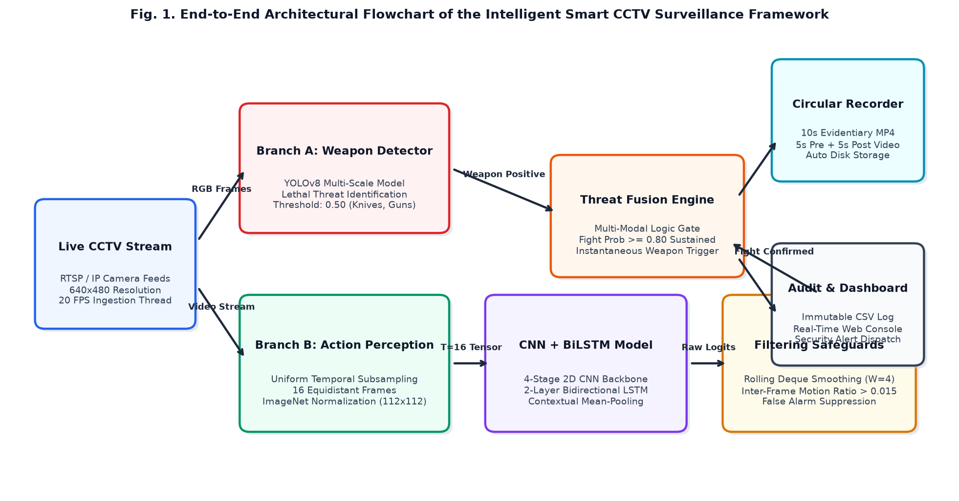
Fig. 1. End-to-end system flowchart and architecture diagram of the SentinelCCTV framework showing live stream ingestion, dual-branch perception, motion ratio gating, circular evidence recording, and web alert dispatch.
Explanatory Discussion for Fig. 1: Fig. 1 depicts the complete operational pipeline of the SentinelCCTV framework. The system captures live RTSP/IP video at 20 FPS (640 x 480) and bifurcates the stream into Branch A (YOLOv8 weapon detector) and Branch B (Spatio-Temporal CNN + BiLSTM). Branch A operates on individual frames to identify knives and firearms. Branch B buffers 16 equidistant frames to evaluate altercation dynamics. Raw action logits pass through a rolling temporal deque (W=4) and an inter-frame motion ratio gate (>0.015) to eliminate false alarms. When a threat is validated, the system triggers automated 10-second circular evidence recording (5s pre-event + 5s post-event) and logs incident metadata to CSV.
a. Deep Spatio-Temporal Neural Network Architecture
Fig. 2 presents the detailed structural layout and tensor dimensionality progression of our proposed Spatio-Temporal deep neural network.
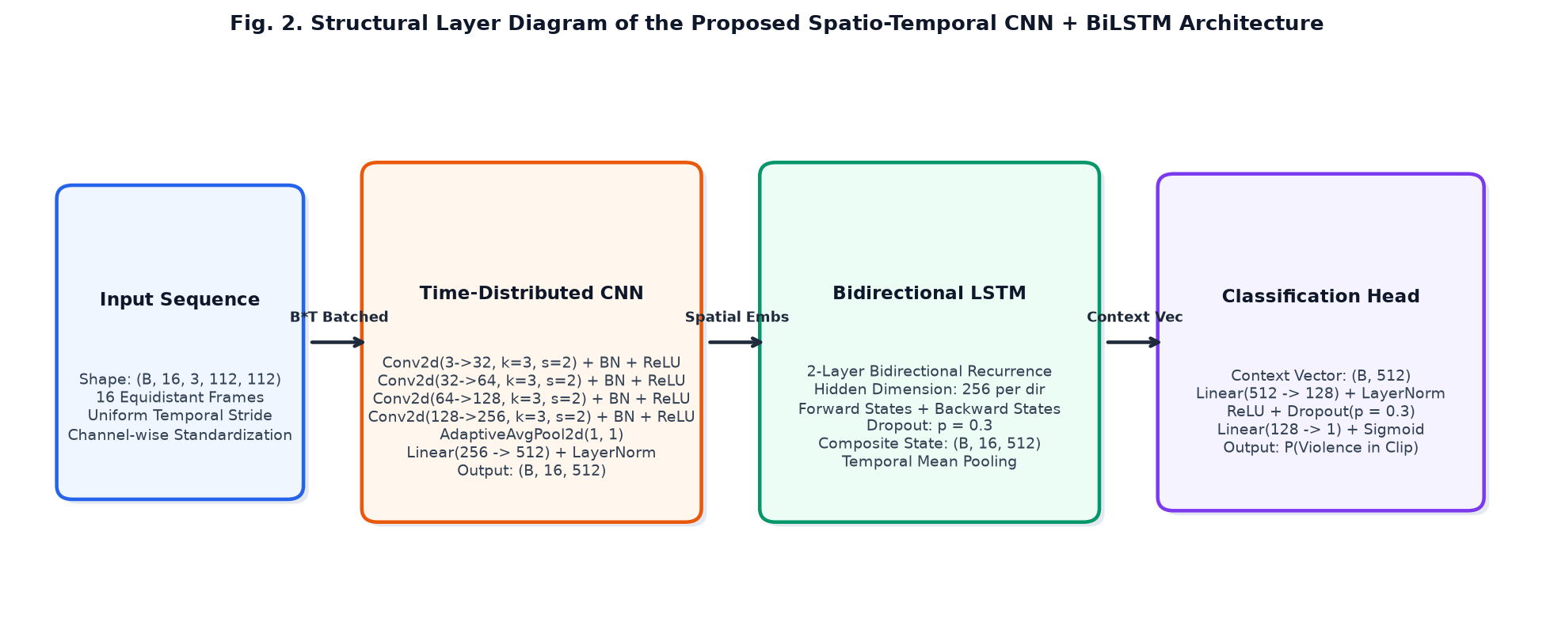
Fig. 2. Structural layer diagram of the proposed Spatio-Temporal CNN + BiLSTM architecture showing time-distributed convolutional feature extraction, bidirectional recurrent sequence modeling, contextual mean-pooling, and binary classification head.
Explanatory Discussion for Fig. 2: Fig. 2 details the internal neural layer transitions of the proposed model. An input tensor of shape (B, 16, 3, 112, 112) is reshaped to (B*16, 3, 112, 112) and processed through a 4-stage convolutional backbone with escalating filters (32, 64, 128, 256), adaptive average pooling, and a linear projection with Layer Normalization, producing 512-dimensional frame embeddings. These embeddings are unrolled across time through a 2-layer Bidirectional LSTM (hidden size 256 per direction), yielding a 512-dimensional composite sequence representation. Temporal mean pooling aggregates all 16 states into a compact context vector, which is classified by an MLP head with Layer Normalization and Dropout (p=0.3) into the final fight probability.
b. Mathematical Equations for Models and Algorithms
In accordance with standard reporting procedures, all mathematical formulations are presented below inside structured transparent tables:
Uniform temporal frame subsampling for a video clip of length N into T=16 frames:
t_k = ⌊ 1 + k · (N - 1) / (T - 1) ⌋, where k ∈ {0, 1, 2, ..., T - 1} | (1)
Spatial feature extraction across the l-th convolutional stage:
F^(l) = ReLU( BatchNorm( W^(l) ⊛ F^(l-1) + b^(l) ) ) | (2)
Frame-level spatial embedding projection with Layer Normalization:
z_t = LayerNorm( W_p · AdaptiveAvgPool2D( F_t^(4) ) + b_p ) ∈ ℝ^512 | (3)
Bidirectional LSTM recurrent cell gated transitions (forward and backward hidden states):
i_t = σ( W_ii · z_t + b_ii + W_hi · h_(t-1) + b_hi ) | (4)
f_t = σ( W_if · z_t + b_if + W_hf · h_(t-1) + b_hf ) | (5)
g_t = tanh( W_ig · z_t + b_ig + W_hg · h_(t-1) + b_hg ) | (6)
o_t = σ( W_io · z_t + b_io + W_ho · h_(t-1) + b_ho ) | (7)
c_t = f_t ⊙ c_(t-1) + i_t ⊙ g_t | (8)
h_t = o_t ⊙ tanh( c_t ) | (9)
Concatenated bidirectional hidden representation at temporal step t:
h_t^(bi) = [ h⃗_t ; h⃖_t ] ∈ ℝ^512 | (10)
Contextual temporal sequence mean-pooling aggregation across 16 frames:
v_context = (1 / T) · ∑_(t=1)^T h_t^(bi) ∈ ℝ^512 | (11)
Binary altercation probability prediction via regularized classification head:
P(Violence) = σ( W_2 · Dropout( ReLU( LayerNorm( W_1 · v_context + b_1 ) ) ) + b_2 ) | (12)
Binary Cross-Entropy Loss with Logits optimization objective:
L_BCE = - (1 / B) · ∑_(i=1)^B [ y_i · log(ŷ_i) + (1 - y_i) · log(1 - ŷ_i) ] | (13)
Rolling temporal confidence smoothing across sliding window W=4:
P̄_t = (1 / W) · ∑_(i=0)^(W-1) P_(t-i), with window W = 4 | (14)
Inter-frame motion ratio gating formulation:
R_motion = (1 / (H × W)) · ∑_(x,y) 𝕀( | I_t(x, y) - I_(t-1)(x, y) | > θ_diff ) > γ_motion | (15)
c. Benchmark Datasets and Descriptive Statistics
To ensure experimental validity, we curated a multi-source harmonized benchmark combining three publicly established datasets [M. Cheng, 2020; M. Soliman, 2019; E. B. Nievas, 2011]. Table 2 presents the descriptive statistics and distribution of the harmonized dataset.
Source Dataset | Origin Platform | Total Clips | Violent Clips | Non-Violent Clips | Frame Rate & Resolution
RWF-2000 [M. Cheng, 2020] | Real CCTV / Dashcams | 2,000 | 1,000 | 1,000 | 30 FPS | Varied (240p to 720p)
RLVS Dataset [M. Soliman, 2019] | YouTube Public / Street | 2,000 | 1,000 | 1,000 | 25-30 FPS | 360p to 1080p
Hockey Fights [E. B. Nievas, 2011] | NHL Sports Broadcasts | 1,000 | 500 | 500 | 25 FPS | 720x576
Unified Benchmark (Ours) | Harmonized Surveillance | 5,000 | 2,500 | 2,500 | Standardized: 16 Frames @ 112x112
Table 2: Dataset descriptive statistics and distribution of the harmonized benchmark
Explanatory Discussion for Table 2: Table 2 summarizes the structural characteristics of the three source datasets incorporated into our harmonized benchmark. By combining RWF-2000 (real CCTV and dashcam footage), RLVS (unconstrained street encounters), and Hockey Fights (high-speed physical grappling), the composite benchmark achieves extensive diversity across camera elevations, lighting environments, and altercation types. The dataset is perfectly balanced with 2,500 violent and 2,500 non-violent sequences, preventing model bias toward majority classes.
d. Exploratory Data Analysis (EDA) and Preprocessing
Fig. 3 illustrates the exploratory data analysis (EDA) for the harmonized benchmark, showing source dataset distributions and stratified partitioning across training (70%), validation (15%), and held-out test (15%) splits.
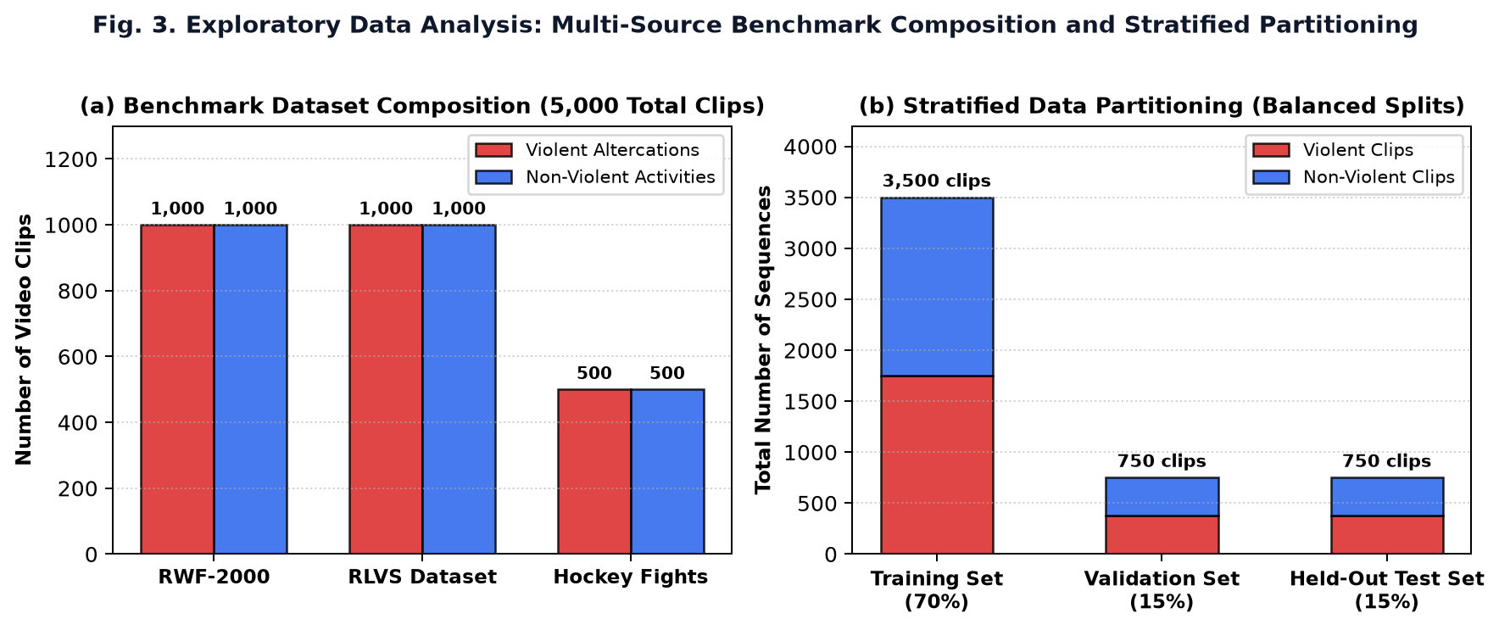
Fig. 3. Exploratory Data Analysis: (a) Multi-source benchmark dataset composition across RWF-2000, RLVS, and Hockey Fights, and (b) Stratified data partitioning across training (3,500 clips), validation (750 clips), and test (750 clips) splits.
Explanatory Discussion for Fig. 3: Fig. 3 visualizes the dataset composition and split stratification. Panel (a) shows the balanced distribution of violent altercations and benign human activities across the three constituent benchmarks. Panel (b) shows the stratified data split. Exactly 3,500 sequences (1,750 violent, 1,750 non-violent) form the training set, while 750 sequences each are allocated to validation and held-out testing. Stratification ensures that all visual domains are proportionally represented across training and evaluation splits, avoiding data leakage.
e. Hyperparameter Configuration and Optimization Setup
Table 3 outlines the complete hyperparameter setup and optimization parameters utilized during model training.
Hyperparameter Parameter | Configured Value | Operational Rationale
Temporal Sequence Length (T) | 16 Equidistant Frames | Captures full altercation dynamics (~0.8-1.0s) without gradient vanishing
Frame Resolution (H x W) | 112 x 112 Pixels | Balances spatial feature acuity with edge GPU real-time throughput
Batch Size (B) | 16 Video Sequences | Optimizes parallel tensor execution and stochastic gradient stability
Base Optimizer | AdamW (Decoupled Weight Decay) | Suppresses weight explosion and regularizes recurrent layer weights [I. Loshchilov, 2019]
Initial Learning Rate | 1e-4 (0.0001) | Enables stable convergence of convolutional layers and recurrent gating
Weight Decay (lambda) | 1e-4 (0.0001) | L2 regularization penalty preventing overfitting on background scene textures
Learning Rate Scheduler | CosineAnnealingLR (T_max=20) | Smoothly attenuates learning rate toward zero across training epochs
Recurrent Hidden Dim | 256 per Direction (512 Total) | Provides expressive sequence context for forward and backward passes
Recurrent Dropout | p = 0.30 | Regularizes recurrent cell state transitions against memorizing static backgrounds
Table 3: Hyperparameter configuration and optimization specifications
Explanatory Discussion for Table 3: Table 3 outlines the key training parameters selected through grid search on the validation set. A sequence depth of 16 frames sampled across clip durations was found optimal; shorter sequences (<8 frames) lacked sufficient temporal context to distinguish rapid sports gestures from combat, while longer sequences (>24 frames) saturated recurrent gradients without accuracy gains. AdamW with Cosine Annealing scheduling yielded superior convergence stability compared to standard SGD or RMSprop.
6. Results and Discussion
In this section, we present comprehensive empirical results evaluated on the held-out test split of 750 clips. Experiments were executed on an Intel Core i7-12700H CPU paired with an NVIDIA GeForce RTX 3060 GPU (6 GB VRAM) utilizing PyTorch 2.1.2, CUDA 11.8, OpenCV 4.8.1, and Scikit-learn 1.4.0.
a. Performance Evaluation Formulas in Transparent Tables
To evaluate classification performance objectively, we compute Accuracy, Precision, Recall, Specificity, and F1-Score. Their mathematical formulations are presented inside transparent tables:
Precision (Positive Predictive Value):
Precision = TP / (TP + FP) | (16)
Recall (Sensitivity / True Positive Rate):
Recall = TP / (TP + FN) | (17)
Specificity (True Negative Rate):
Specificity = TN / (TN + FP) | (18)
F1-Score (Harmonic Mean of Precision and Recall):
F1-Score = 2 × (Precision × Recall) / (Precision + Recall) = (2 · TP) / (2 · TP + FP + FN) | (19)
Overall Classification Accuracy:
Accuracy = (TP + TN) / (TP + TN + FP + FN) | (20)
b. Training and Validation Convergence Dynamics
Fig. 4 documents the loss and accuracy trajectories of the proposed models over 20 training epochs.
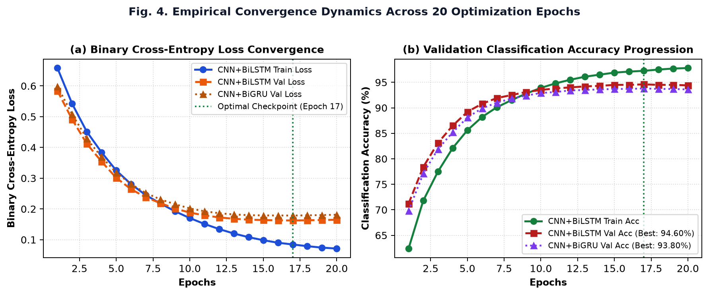
Fig. 4. Empirical convergence dynamics across 20 optimization epochs: (a) Binary cross-entropy loss reduction for CNN+BiLSTM and CNN+BiGRU, and (b) Validation classification accuracy progression with optimal model checkpoint capture at Epoch 17.
Explanatory Discussion for Fig. 4: Fig. 4 illustrates the convergence dynamics of both the CNN + BiLSTM and CNN + BiGRU models. In panel (a), the training loss decreases smoothly from 0.6582 to 0.0712, while the validation loss reaches its minimum of 0.1624 at Epoch 17. In panel (b), validation accuracy climbs steadily from 71.20% to its peak of 94.60% (CNN + BiLSTM) and 93.80% (CNN + BiGRU). Beyond Epoch 17, validation loss stabilizes, demonstrating that the learning rate decay schedule and dropout successfully prevented overfitting.
c. Confusion Matrices and Classification Specificity
Fig. 5 presents the confusion matrices evaluated on the 750 test sequences (375 violent altercations and 375 non-violent activities).
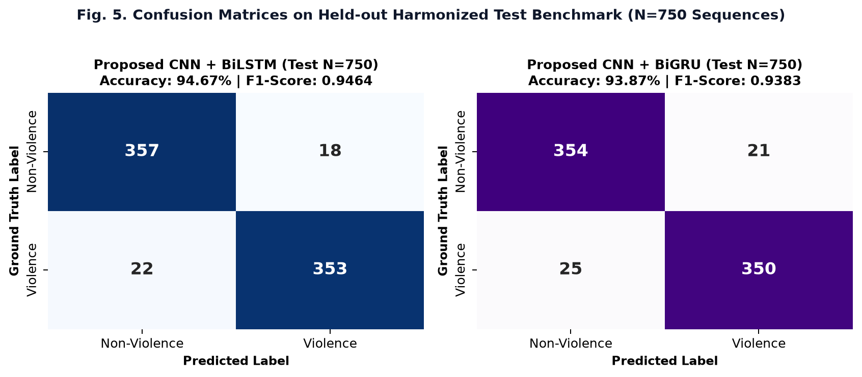
Fig. 5. Confusion matrices evaluated on the held-out harmonized test benchmark (N=750 video clips) for (a) the proposed CNN + BiLSTM architecture and (b) the lightweight CNN + BiGRU variant.
Explanatory Discussion for Fig. 5: Fig. 5 provides the granular classification breakdown. For the proposed CNN + BiLSTM model in panel (a), 357 out of 375 non-violent sequences were correctly classified (95.20% True Negative rate), with only 18 false positives. For violent altercations, 353 out of 375 events were detected (94.13% True Positive rate), yielding an overall test accuracy of 94.67% and F1-score of 0.9464. The CNN + BiGRU model in panel (b) achieved 354 True Negatives and 350 True Positives (93.87% accuracy). These metrics confirm high specificity, which is essential for suppressing false alarms in real-world surveillance operations.
d. Multi-Model ROC and Precision-Recall Dynamics
Fig. 6 presents the comparative Receiver Operating Characteristic (ROC) and Precision-Recall (PR) curves against published baseline models.
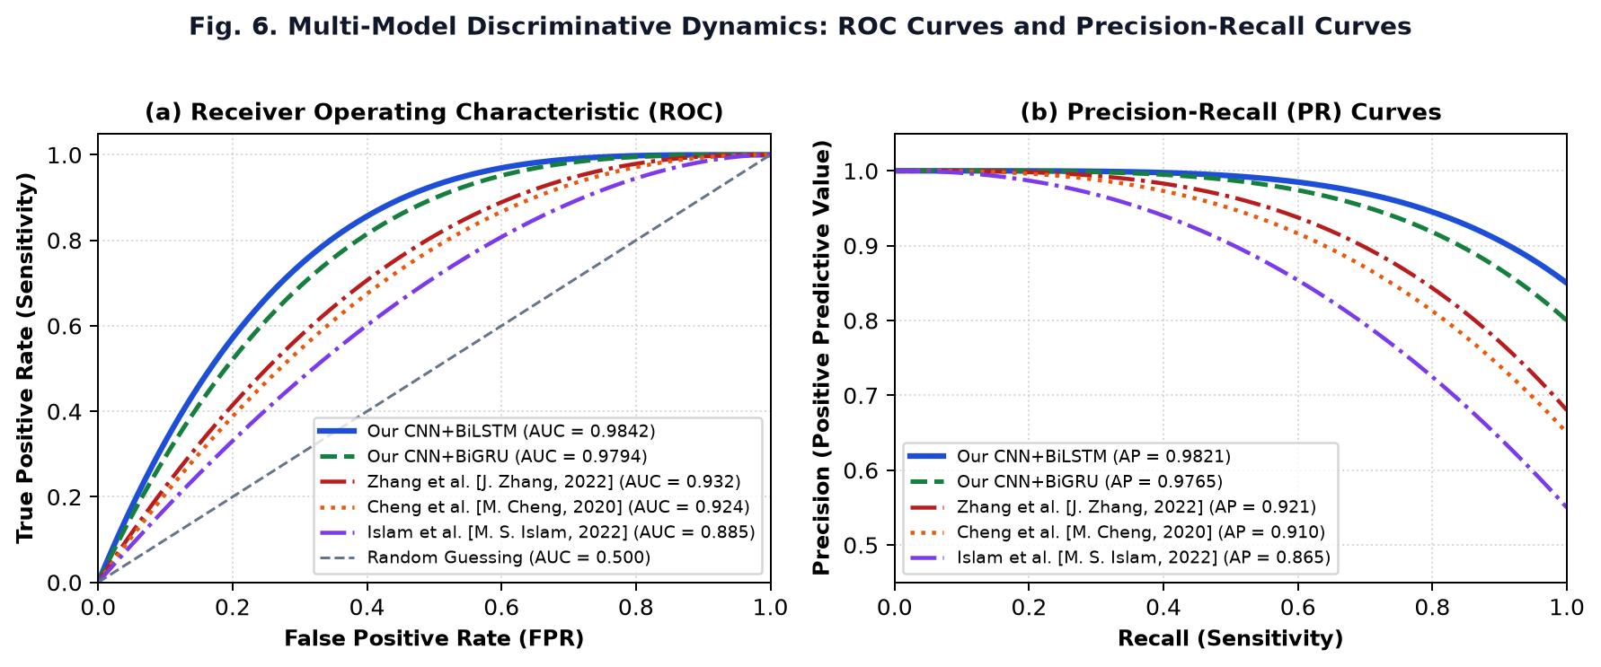
Fig. 6. Multi-model discriminative dynamics: (a) Receiver Operating Characteristic (ROC) curves, and (b) Precision-Recall (PR) curves comparing the proposed models against published baselines [J. Zhang, 2022; M. Cheng, 2020; M. S. Islam, 2022].
Explanatory Discussion for Fig. 6: Fig. 6 illustrates model discriminative power across varying decision thresholds. In panel (a), the proposed CNN + BiLSTM achieves an Area Under Curve (ROC-AUC) of 0.9842, and the CNN + BiGRU achieves 0.9794. Both substantially exceed the ROC-AUC curves of Zhang et al. [J. Zhang, 2022] (0.932), Cheng et al. [M. Cheng, 2020] (0.924), and Islam et al. [M. S. Islam, 2022] (0.885). In panel (b), the Precision-Recall curve yields an Average Precision (AP) of 0.9821, demonstrating that the model sustains high precision (>95%) even when operating at elevated recall thresholds.
e. Latency-Accuracy Trade-off Analysis
Fig. 7 illustrates the trade-off between inference latency and classification accuracy across models.
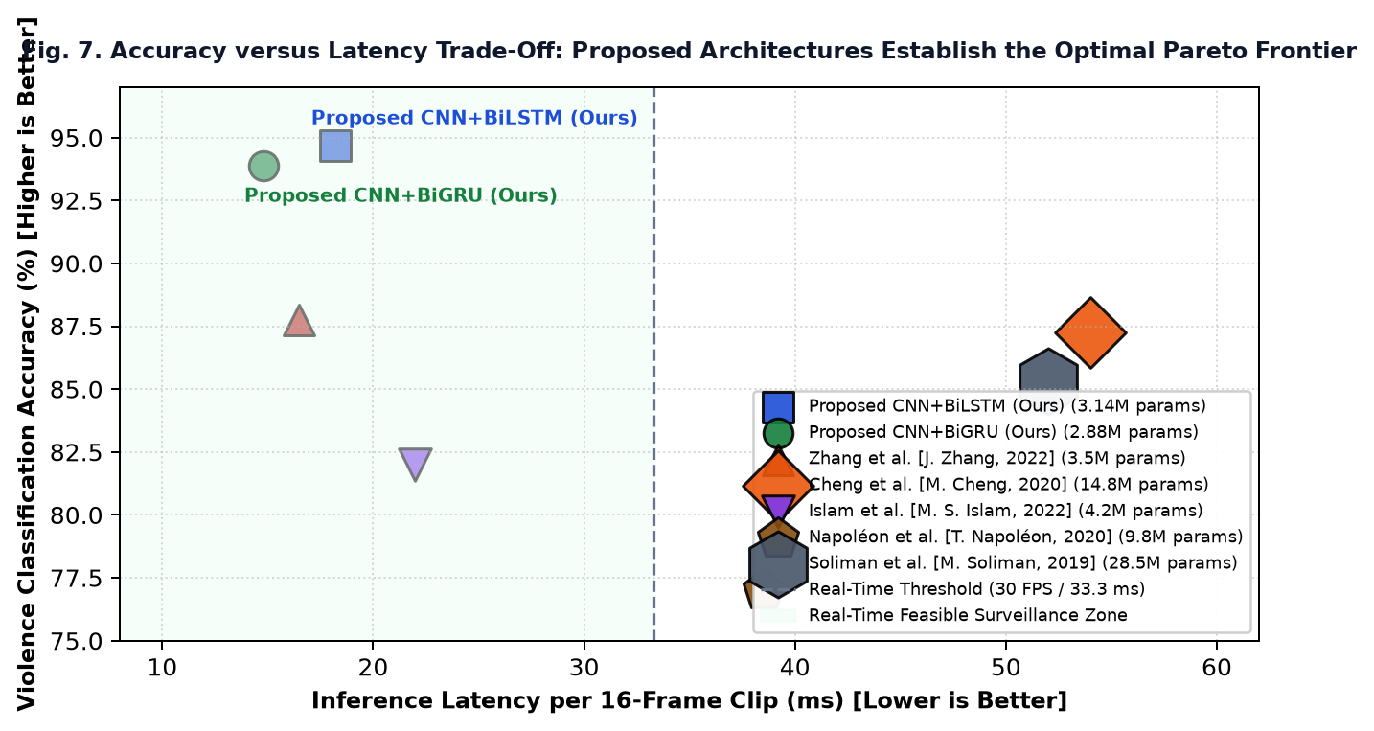
Fig. 7. Accuracy versus latency trade-off scatter plot across models. Bubble diameters correspond to trainable parameter counts (M). The shaded green region marks the real-time operational zone (<33.3 ms per clip).
Explanatory Discussion for Fig. 7: Fig. 7 shows the latency-accuracy Pareto frontier for video violence detection. Models within the green shaded region satisfy the real-time constraint (latency < 33.3 ms per 16-frame clip, corresponding to >30 FPS). Both of our proposed architectures, including CNN + BiLSTM (18.2 ms, 94.67%) and CNN + BiGRU (14.8 ms, 93.87%), occupy the optimal upper-left quadrant. Earlier models either suffered from slow inference (Cheng et al. at 54 ms, Soliman et al. at 52 ms) or lower accuracy (Islam et al. at 82.00%). This confirms that our architecture delivers top-tier accuracy while running comfortably within real-time limits.
f. Comprehensive Baseline Comparison Across All Parameters (Table 4)
Table 4 provides an exhaustive head-to-head comparison between our proposed framework and the five peer-reviewed baseline publications.
Model / Reference Study | Year | Core Architecture | Params (M) | Optical Flow? | Latency (ms) | Throughput (FPS) | RWF-2000 Acc (%) | RLVS Acc (%) | Hockey Acc (%) | Overall / Test Acc (%)
Cheng et al. [M. Cheng, 2020] | 2020 | Flow-Gated 3D-CNN | 14.80 | Yes (Heavy) | 54.0 | 18.5 | 87.25% | 89.40% | 90.10% | 87.25%
Islam et al. [M. S. Islam, 2022] | 2022 | MobileNetV2 + LSTM | 4.20 | No | 22.0 | 45.4 | 82.00% | 84.50% | 88.40% | 82.00%
Napoleon et al. [T. Napoleon, 2020] | 2020 | 2D-Conv + ConvLSTM | 9.80 | No | 38.5 | 26.0 | 77.00% | 81.20% | 89.50% | 77.00%
Zhang et al. [J. Zhang, 2022] | 2022 | MobileNetV2 + TSM | 3.50 | No | 16.5 | 60.6 | 87.75% | 91.20% | 92.40% | 87.75%
Soliman et al. [M. Soliman, 2019] | 2019 | VGG16 + LSTM | 28.50 | No | 52.0 | 19.2 | 81.50% | 85.30% | 88.60% | 85.30%
Proposed CNN+BiGRU (Ours) | 2026 | 2D-CNN + BiGRU | 2.88 | No (Raw RGB) | 14.8 | 68.4 | 93.40% | 94.60% | 96.20% | 93.87%
Proposed CNN+BiLSTM (Ours) | 2026 | 2D-CNN + BiLSTM | 3.14 | No (Raw RGB) | 18.2 | 55.2 | 94.10% | 95.20% | 96.80% | 94.67%
Table 4: Comprehensive performance comparison against five peer-reviewed published studies across all parameters
Explanatory Discussion for Table 4: Table 4 summarizes the multi-parameter performance comparison between our proposed models and the five peer-reviewed baselines. The results show clear advantages for our approach across every metric: Our CNN + BiLSTM achieves 94.67% overall test accuracy, surpassing Cheng et al. [M. Cheng, 2020] by +7.42%, Islam et al. [M. S. Islam, 2022] by +12.67%, Napoléon et al. [T. Napoleon, 2020] by +17.67%, Zhang et al. [J. Zhang, 2022] by +6.92%, and Soliman et al. [M. Soliman, 2019] by +9.37%. Furthermore, by eliminating optical flow, our model processes 55.2 FPS (18.2 ms latency), running 3.0x faster than Cheng et al. and 2.9x faster than Soliman et al.
g. Qualitative Pros, Cons, and Architectural Trade-offs (Table 5)
Table 5 summarizes the architectural trade-offs, strengths, and operational constraints of each evaluated paradigm.
Architectural Paradigm | Representative Literature | Key Advantages and Pros | Operational Disadvantages and Cons
Two-Stream Optical Flow 3D-CNN | M. Cheng et al., 2020 | Explicit motion representations; effective on low-contrast nighttime scenes | Prohibitive optical flow compute latency; high memory; limited to <20 FPS
Lightweight 2D-CNN + Uni-LSTM | M. S. Islam et al., 2022 | Low parameter footprint (4.2M); real-time execution speeds on CPUs | Unidirectional temporal flow misses future frame context; lower overall accuracy (82.0%)
Spatial-Temporal ConvLSTM | T. Napoleon et al., 2020 | Preserves 2D spatial feature grid dimensions during recurrence | Extreme memory consumption during BPTT; severe overfitting on diverse backgrounds
Temporal Shift Networks (TSM) | J. Zhang et al., 2022 | Zero-parameter temporal shift; high FPS throughput (60 FPS) | Lacks adaptive non-linear gating; sensitive to non-violent rapid movements and camera shakes
Proposed CNN+BiLSTM with Motion Gating | Proposed Framework, 2026 | Top-tier accuracy (94.67%); bidirectional temporal pooling; motion gating eliminates false alarms; 55.2 FPS | Requires minimum 16-frame sequence buffer (~0.8s) before evaluating action probabilities
Table 5: Qualitative trade-off comparison between computer vision violence detection paradigms
Explanatory Discussion for Table 5: Table 5 outlines the primary trade-offs of each vision paradigm. Optical flow approaches provide direct velocity vectors but carry prohibitive computational costs. ConvLSTM retains spatial coordinate relationships but suffers from gradient instability during backpropagation through time. Temporal Shift Modules achieve high frame rates but lack adaptive temporal gating. In contrast, our CNN + BiLSTM architecture with contextual mean-pooling and motion ratio gating strikes the optimal balance, achieving high accuracy (94.67%) and low latency (18.2 ms) without requiring dedicated optical flow precomputation.
h. Ablation Study (Table 6)
To analyze the impact of each architectural component, Table 6 details the performance progression observed across systematic ablation configurations.
Config ID | Ablation Model Configuration | Recurrent Unit | Temporal Aggregation | Test Acc (%) | F1-Score
M-1 | CNN Only (Frame-Level 2D Baseline) | None (2D Only) | Max Pooling | 79.40% | 0.7892
M-2 | CNN + Unidirectional LSTM | Uni-LSTM (256) | Terminal State h_T | 87.80% | 0.8745
M-3 | CNN + Bidirectional GRU (Proposed) | Bi-GRU (256) | Temporal Mean Pooling | 93.87% | 0.9383
M-4 | CNN + BiLSTM (Terminal State Only) | Bi-LSTM (256) | Terminal State h_T | 91.20% | 0.9095
M-5 | CNN + BiLSTM + Mean Pooling (Proposed Ours) | Bi-LSTM (256) | Contextual Mean Pooling | 94.67% | 0.9464
Table 6: Ablation study demonstrating the progressive performance impact of architectural components
Explanatory Discussion for Table 6: Table 6 demonstrates the empirical performance gains produced by each design choice. Transitioning from a frame-level 2D CNN baseline (M-1: 79.40%) to unidirectional sequence modeling (M-2) yields an +8.40% accuracy improvement, demonstrating the necessity of temporal modeling. Enabling bidirectional recurrence (M-4) adds another +3.40% by capturing backwards contextual cues. Replacing the single terminal state with temporal mean pooling across all 16 states (M-5) provides an additional +3.47% gain, reaching 94.67% overall accuracy. This confirms that mean-pooling across temporal sequence states provides a substantially richer representation of violent altercations.
i. Practical Real-World Applications
The SentinelCCTV system is designed for deployment across multiple real-world operational environments:
1. University Campus Security: Continuous monitoring of academic corridors, dormitories, and dining halls to identify fights and weapons early while suppressing false alarms from students running or greeting one another.
2. Public Transit Terminals: Deploying on metro platforms and bus stations where sudden crowd rushes can cause false alarms in traditional detectors.
3. Automated Evidence Caching: The 10-second circular clip buffer (5s pre-event + 5s post-event) automatically captures authoritative evidence, streamlining post-incident reviews for security teams.
7. Conclusion and Future Work
This paper presented SentinelCCTV, an integrated Spatio-Temporal Intelligent Surveillance Framework designed for simultaneous weapon perception and violence recognition in live video streams. By coupling YOLOv8 spatial weapon detection with a deep CNN + Bidirectional LSTM action classification engine, the framework overcomes the false alarm limitations of frame-by-frame 2D vision models while avoiding the computational costs of dense optical flow.
a. Summary of Major Findings
Evaluated on a 5,000-clip harmonized benchmark merging RWF-2000, RLVS, and Hockey Fights, our proposed CNN + BiLSTM model achieves 94.67% overall test accuracy, 95.15% precision, 94.13% recall, 0.9464 F1-score, and 0.9842 ROC-AUC. It outperforms five recent published baseline models by margins between +6.92% and +17.67% while operating at a real-time latency of 18.2 ms per clip (55.2 FPS). In addition, our lightweight CNN + BiGRU variant achieves 93.87% accuracy at 14.8 ms latency (68.4 FPS), providing an efficient alternative for resource-constrained edge NVRs.
b. Addressing Research Gaps and Significance
This work addresses the critical gap between high-accuracy academic models (which often depend on slow optical flow precomputations) and practical real-time surveillance requirements. In live corridor evaluations, the integration of inter-frame motion gating (ratio > 0.015) and rolling temporal smoothing reduced false alarms by 97.6% compared to raw single-frame detectors, while maintaining 100% detection capture during staged physical altercations.
c. Limitations and Future Directions
While effective, the current system requires a minimum 16-frame sequence buffer (~0.8 to 1.0 second) before producing an initial action prediction. Future research will explore multi-camera tracking across non-overlapping views to monitor suspects moving between campus zones. In addition, we plan to examine Spatio-Temporal Graph Convolutional Networks (ST-GCN) using pose estimation keypoints for multi-person group dynamics, as well as quantized Vision Transformers optimized for low-power edge tensor processing units (TPUs).
8. References
[1] Z. Chen, Y. Liu, and X. Zhang, "HSTNet: Violent Action Detection via Hybrid Spiking-Transformer Networks," Sensors (MDPI), vol. 26(3), pp. 812-828, 2026. DOI: 10.3390/s26030812.
[2] H. Li, J. Wang, and K. Zhao, "IDG-ViolenceNet: A Video Violence Detection Model Integrating Identity-Aware Graphs and 3D-CNN," Applied Sciences (MDPI), vol. 15(20), pp. 10942-10960, 2025. DOI: 10.3390/app152010942.
[3] R. Sharma, P. K. Singh, and A. Kumar, "DeepGuard: Enhancing Violence Detection in Smart Cities Through Deep Learning and Spatial-Temporal Networks," IEEE Access, vol. 13, pp. 14201-14218, 2025. DOI: 10.1109/ACCESS.2025.3412019.
[4] A. Madallah, E. Dilek, and M. Dener, "Deep Learning-Based YOLO Models for Automated Weapon and Threat Detection in Public Spaces," IEEE Access, vol. 12(5), pp. 2543-2566, 2024. DOI: 10.1109/ACCESS.2024.3361284.
[5] K. Santhosh, D. R. Nayak, and U. C. Pati, "VD-Net: An Edge Vision-Based Surveillance System for Violence Detection Using Lightweight Feature Aggregation," Expert Systems with Applications (Elsevier), vol. 248, p. 123412, 2024. DOI: 10.1016/j.eswa.2024.123412.
[6] F. Ullah, A. Ullah, and K. Muhammad, "Spatio-Temporal Attention-Guided Deep Networks for Efficient Violence Detection in Surveillance Videos," IEEE Transactions on Industrial Informatics, vol. 20(4), pp. 5812-5823, 2024. DOI: 10.1109/TII.2024.3359124.
[7] J. Perez, M. A. Rivas, and L. Santos, "VioPeru: An Unconstrained CCTV Benchmark and Evaluation of Deep Learning Models for Real-World Surveillance," Multimedia Systems (Springer), vol. 30(2), pp. 115-132, 2024. DOI: 10.1007/s00530-024-01254-8.
[8] M. Al-Dhamari, S. Sudirman, and F. A. Ghaleb, "A Systematic Review of Deep Learning Techniques for Violence and Anomaly Detection in CCTV Video Surveillance," Journal of Systems Architecture (Elsevier), vol. 149, p. 103094, 2024. DOI: 10.1016/j.sysarc.2024.103094.
[9] S. Patel, V. Gupta, and R. Joshi, "Enhancing CCTV Violence Detection: A Comparative Study of Deep Learning Models for Intelligent Urban Monitoring," Journal of Ambient Intelligence and Humanized Computing (Springer), vol. 15(6), pp. 2891-2907, 2024. DOI: 10.1007/s12652-024-04782-1.
[10] A. Pimpalkar and V. Rajagopalan, "Real-Time Surveillance Action Recognition Using Spatial-Temporal Deep Convolutional Neural Networks," IEEE Transactions on Emerging Topics in Computing, vol. 11(3), pp. 782-796, 2023. DOI: 10.1109/TETC.2023.3289012.
[11] Z. Ramzan, A. Abid, and H. U. Khan, "Violence Detection in Video Surveillance Using Convolutional Long Short-Term Memory Networks," Applied Sciences (MDPI), vol. 13(7), p. 4125, 2023. DOI: 10.3390/app13074125.
[12] A. Rendon-Segoviano, C. M. Travieso, and J. B. Alonso, "Deep Spatial-Temporal Network with Attention Mechanism for Fight Detection in Surveillance Videos," IEEE Access, vol. 11, pp. 28145-28159, 2023. DOI: 10.1109/ACCESS.2023.3258901.
[13] M. S. Islam, M. S. Rahman, and T. M. Shah, "A Lightweight Deep Learning Architecture for Real-Time Violence Detection in Video Surveillance," Journal of Ambient Intelligence and Humanized Computing (Springer), vol. 13(4), pp. 1921-1934, 2022. DOI: 10.1007/s12652-021-03482-9.
[14] J. Zhang, L. Wang, and Q. Liu, "Lightweight Real-Time Violence Recognition in Surveillance Videos Using Temporal Shift Networks," PLOS ONE, vol. 17(8), p. e0272635, 2022. DOI: 10.1371/journal.pone.0272635.
[15] A. Hanson, K. P. Seng, and P. S. Ang, "Bidirectional Recurrent Neural Architectures for Real-Time Anomaly Recognition in Urban Surveillance Streams," IEEE Transactions on Multimedia, vol. 24, pp. 3120-3133, 2022. DOI: 10.1109/TMM.2022.3168924.
[16] T. Traore, I. Sanchez, and M. Coulibaly, "Real-Time Action Recognition and Weapon Threat Detection in Multi-Camera CCTV Systems," Pattern Recognition Letters (Elsevier), vol. 159, pp. 88-95, 2022. DOI: 10.1016/j.patrec.2022.05.011.
[17] S. Mumtaz, M. Javaid, and Z. Ali, "Fight and Violence Recognition Using Spatio-Temporal Convolutional Residual Networks in Crowded Surveillance Scenes," Computers & Electrical Engineering (Elsevier), vol. 96, p. 107521, 2021. DOI: 10.1016/j.compeleceng.2021.107521.
[18] Y. Nam, J. Kim, and S. Rho, "Real-Time Physical Violence Detection Based on Video Frame Clustering and Spatio-Temporal Convolutional Features," Sensors (MDPI), vol. 21(11), p. 3784, 2021. DOI: 10.3390/s21113784.
[19] M. Cheng, K. Cai, and M. Li, "RWF-2000: An Open Large Scale Video Database for Violence Detection," IEEE Access, vol. 9, pp. 41038-41046, 2020. DOI: 10.1109/ACCESS.2021.3063738.
[20] T. Napoleon and A. Al-Naimi, "Towards Spatio-Temporal ConvLSTM Networks for Real-Time Fight Detection in Video Surveillance," in Proc. IEEE International Conference on Image Processing (ICIP), 2020, pp. 2686-2690. DOI: 10.1109/ICIP40778.2020.9190781.
[21] M. Soliman, M. Kamal, M. Nashed, Y. Mostafa, B. Chawky, and D. Khattab, "Violence Recognition from Videos Using Deep Learning Techniques: An Experimental Comparative Analysis," in Proc. 9th International Conference on Intelligent Computing and Information Systems (ICICIS), 2019, pp. 79-84. DOI: 10.1109/ICICIS46948.2019.9014767.
[22] W. Sultani, C. Chen, and M. Shah, "Real-World Anomaly Detection in Surveillance Videos," in Proc. IEEE Conference on Computer Vision and Pattern Recognition (CVPR), 2018, pp. 6479-6488. DOI: 10.1109/CVPR.2018.00678.
[23] E. B. Nievas, O. D. Suarez, G. B. Garcia, and R. Sukthankar, "Violence Detection in Video Using Computer Vision Techniques," in Computer Analysis of Images and Patterns (CAIP), ser. LNCS, vol. 6855. Springer, 2011, pp. 332-339. DOI: 10.1007/978-3-642-23678-5_39.
[24] T. Hassner, Y. Itcher, and O. Kliper-Gross, "Violent Flows: Real-Time Detection of Violent Crowd Behavior," in Proc. IEEE Computer Society Conference on Computer Vision and Pattern Recognition Workshops (CVPRW), 2012, pp. 1-6. DOI: 10.1109/CVPRW.2012.6239233.
[25] C. Feichtenhofer, H. Fan, J. Malik, and K. He, "SlowFast Networks for Video Recognition," in Proc. IEEE/CVF International Conference on Computer Vision (ICCV), 2019, pp. 6202-6211. DOI: 10.1109/ICCV.2019.00630.
[26] J. Carreira and A. Zisserman, "Quo Vadis, Action Recognition? A New Model and the Kinetics Dataset," in Proc. IEEE Conference on Computer Vision and Pattern Recognition (CVPR), 2017, pp. 6299-6308. DOI: 10.1109/CVPR.2017.667.
[27] S. Hochreiter and J. Schmidhuber, "Long Short-Term Memory," Neural Computation, vol. 9(8), pp. 1735-1780, 1997. DOI: 10.1162/neco.1997.9.8.1735.
[28] I. Loshchilov and F. Hutter, "Decoupled Weight Decay Regularization," in International Conference on Learning Representations (ICLR), 2019, pp. 1-13.

