PROGRAM 4: WATER JUG PROBLEM
Aim
The aim of this experiment is to solve the Water Jug Problem using the Breadth First Search (BFS) algorithm
Objective
To obtain exactly 2 litres of water using a 4-litre jug and a 3-litre jug.
Algorithm
Algorithm: WaterJugBFS()
Step 1: Start.
Step 2: Initialize the capacities of Jug1 and Jug2.
Step 3: Define the target state.
Step 4: Create an empty queue and insert the initial state (0,0).
Step 5: Create an empty visited set.
Step 6: Repeat until the queue becomes empty.
Remove the front state from the queue.
If the current state is already visited,
Continue to the next state.
Mark the current state as visited.
If the current state is equal to the target state,
Display the solution path.
Stop.
Generate all possible next states by:
Fill Jug1.
Fill Jug2.
Empty Jug1.
Empty Jug2.
Pour water from Jug1 to Jug2.
Pour water from Jug2 to Jug1.
Add all unvisited states to the queue.
Step 7: If no solution is found,
Display "No Solution Exists."
Step 8: End.
Source Code
from collections import deque
# Capacities
CAP1 = 4
CAP2 = 3
TARGET = (2, 0)
def get_next_states(x, y):
states = []
# Fill either jug
states.append((CAP1, y))
states.append((x, CAP2))
# Empty either jug
states.append((0, y))
states.append((x, 0))
# Pour Jug1 -> Jug2
transfer = min(x, CAP2 - y)
states.append((x - transfer, y + transfer))
# Pour Jug2 -> Jug1
transfer = min(y, CAP1 - x)
states.append((x + transfer, y - transfer))
return states
def bfs():
queue = deque()
queue.append(((0, 0), []))
visited = set()
while queue:
(x, y), path = queue.popleft()
if (x, y) in visited:
continue
visited.add((x, y))
path = path + [(x, y)]
if (x, y) == TARGET:
return path
for state in get_next_states(x, y):
if state not in visited:
queue.append((state, path))
return None
solution = bfs()
print("Steps:")
for step in solution:
print(step)
Flowchart
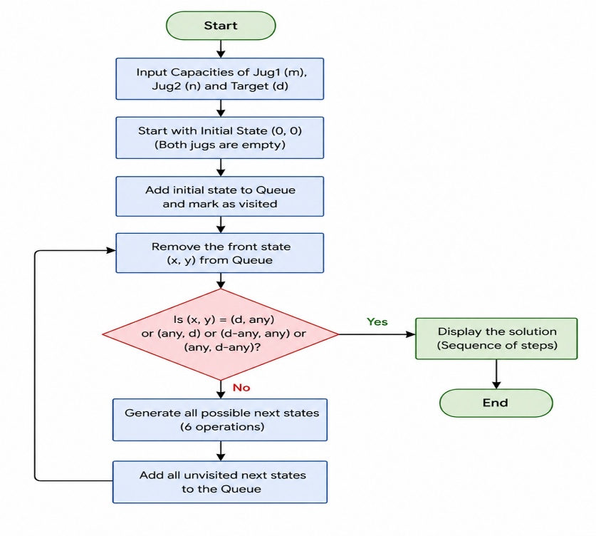
OUTPUT:
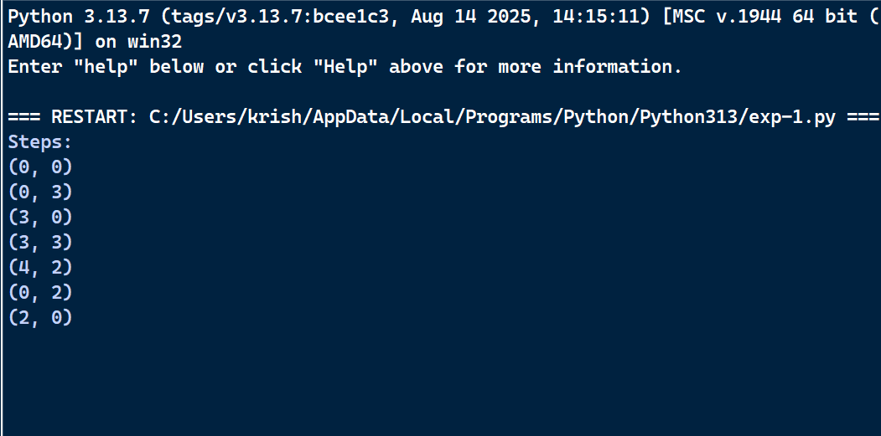
Result
Thus, the Python program to solve the Water Jug Problem was executed successfully.

