***Tutorial for Simple Bar Chart with D3.js using American Time Usage Survey (ATUS) data set***

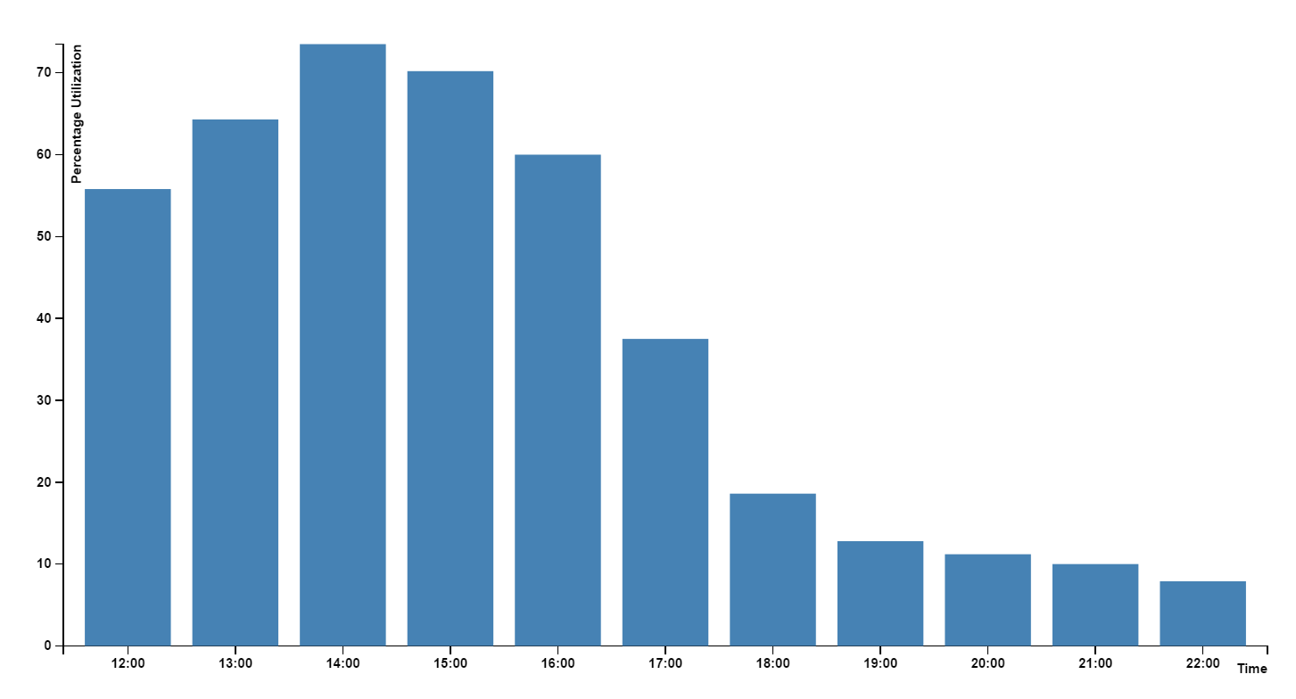

Load D3.js library from cdn repository as shown below. Create a placeholder div tag to append the chart,

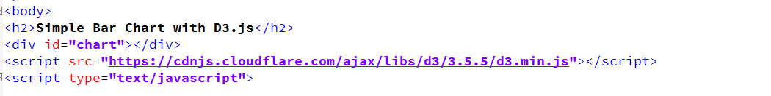

Define the height, width and margins for the chart. Initialize the x and y axes and set their orientations. Create ‘svg’ variable that appends the chart to the placeholder with the appropriate dimensions. The transform function translates coordinates to corresponding screen pixels.

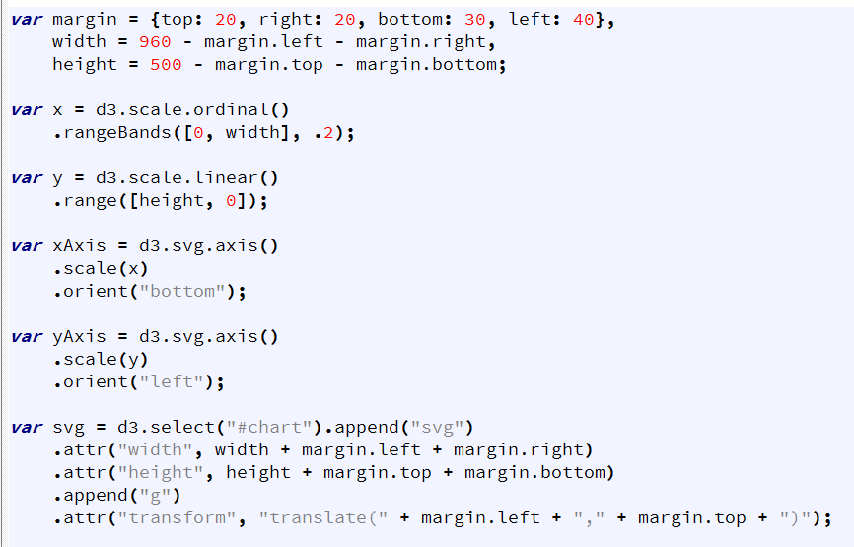

Initialize the ‘tooltip’ variable and append the tooltip to the placeholder element on html page.

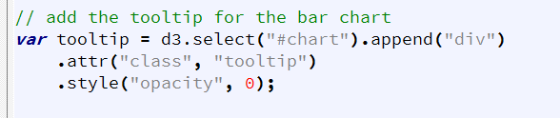

Initialize the variable ‘columnName’ that takes column name from the csv file for which we need to plot bar chart. You can change this variable to different column names from ‘data.csv’ file to plot bar graphs for different professions.



Read the data.csv file using d3.csv function. Set the domains for x and y axes. Domain is the value that defines the source of data for each axis.

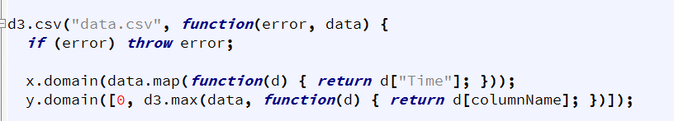

Append the x and y axes to the svg and add the description text to them.

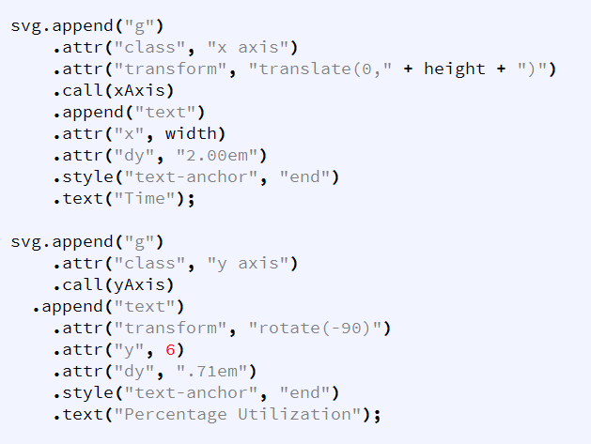

Plot each bar graph and add the tooltip that we initialized before with basic transition effects to the bar’s mouse on and mouse out events.

