***Tutorial for Simple Line Chart with D3.js using American Time Usage Survey (ATUS) data set***

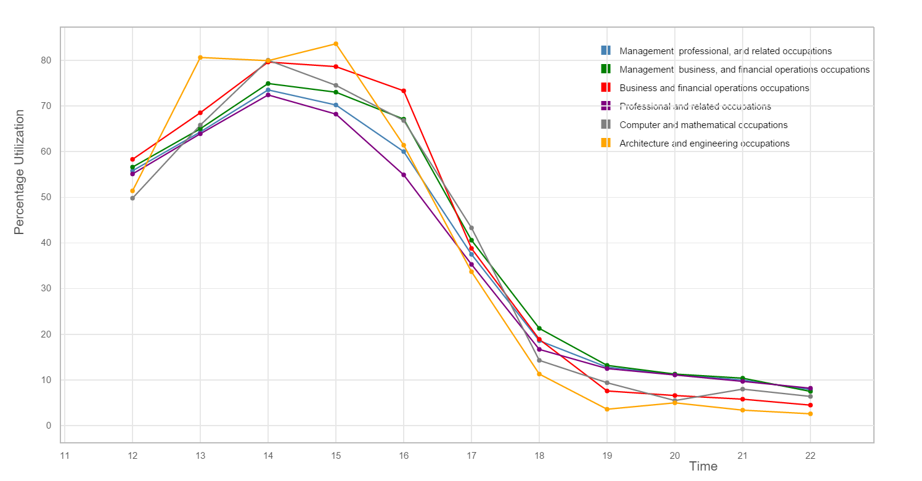

Step 1: Load D3.js library from cdn repository as shown below. Create a placeholder div tag to append the chart,

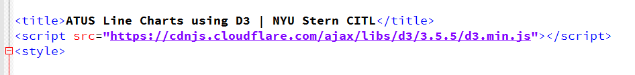

Step 2: Initialize the data from the csv files as per the professions and create an array of colors to denote each profession a different color. This color array will be used for creating legends for the chart.

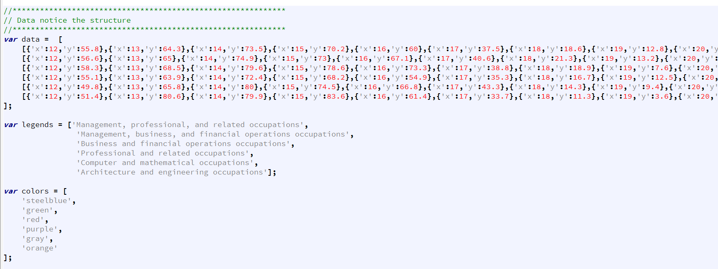

Step 3: Define the x and y axes, their scales and orientations for the plot,

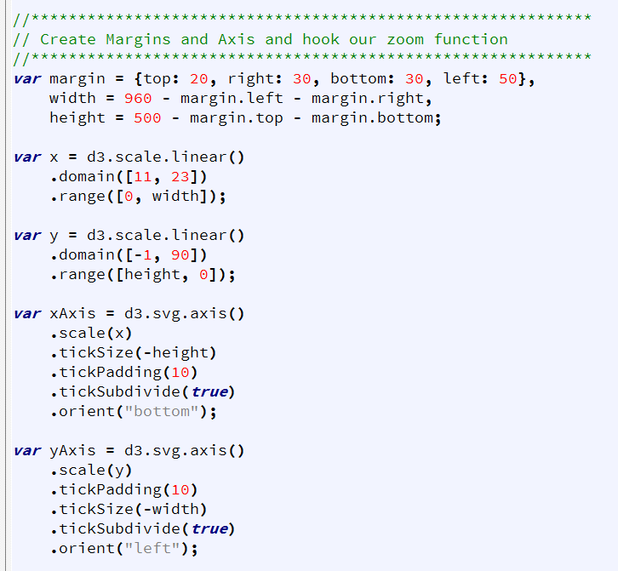

Step 4: Define and initialize a variable ‘zoom’ that handles the zoom event on the plot.

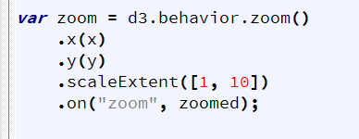

Step 5: Create a ‘svg’ variable and append the svg to the body of the html page. Also create ‘legend’ variable and it to svg. You can now append legend rectangles and text to the plot using ‘legend’ variable and assign them different colors from color array defined earlier.

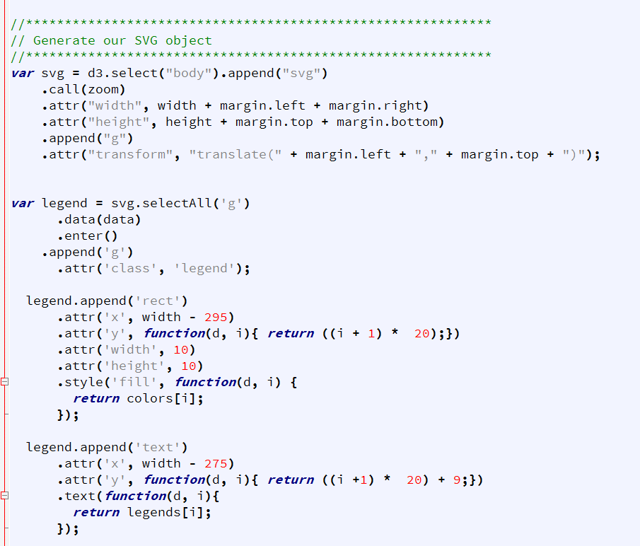

Step 6: Plot the lines on the svg object and assign each line a different color from the colors array. ‘clip-path’ is used for zoom in and zoom out functionality.

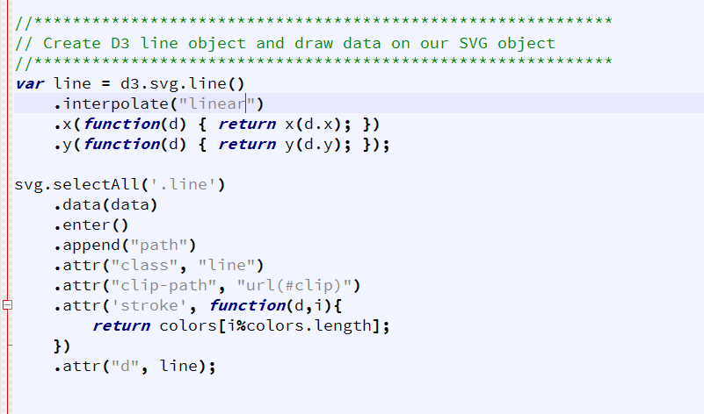

Step 7: Draw the points svg based on the data given.

