***Tutorial for Parallel Coordinate Chart with D3.js using crime data set***

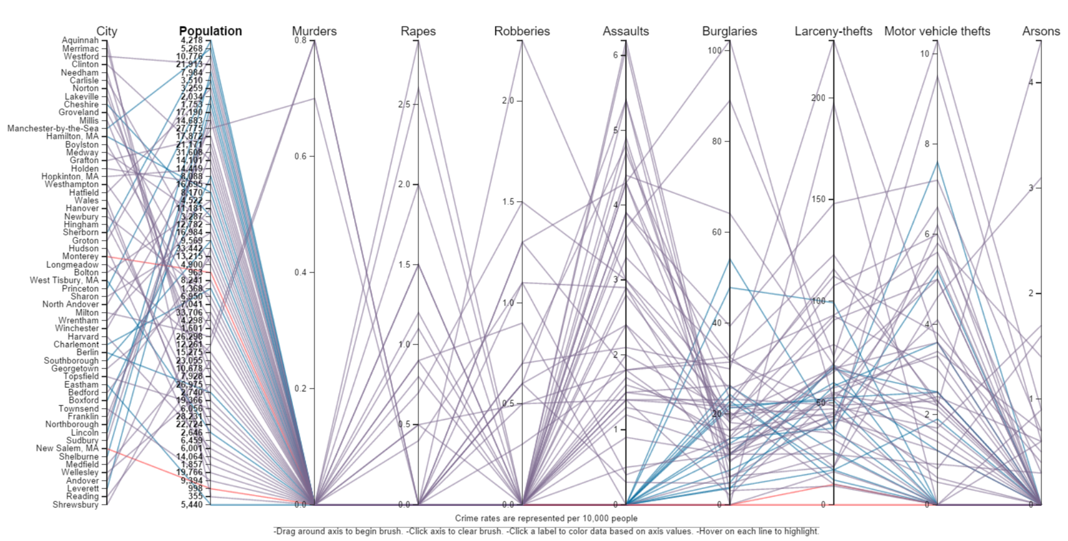

Create a HTML page and import D3 js library.

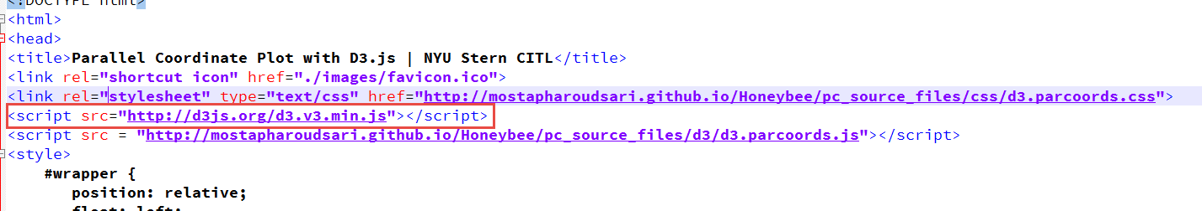

Next,

Set the range of colors for the lines on Parallel Coordinate Graph

Load the CSV file

Calculate the maximum length of the first column. This used to give the appropriate left margin to the graph.

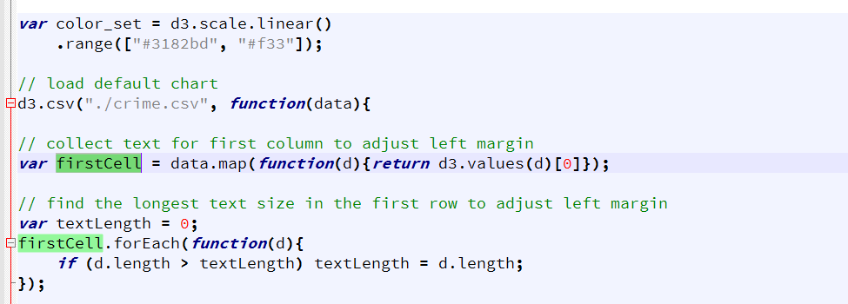

Initialize the parallel coordinate graph and specify the parameters

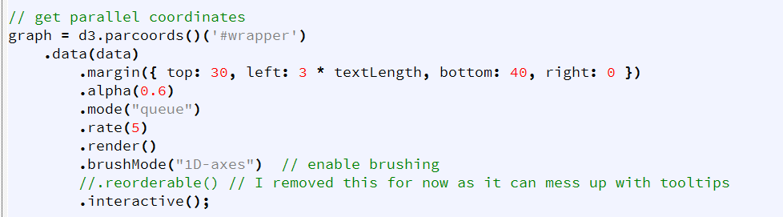

Initialize the instructions text to be displayed at the bottom of the plot.

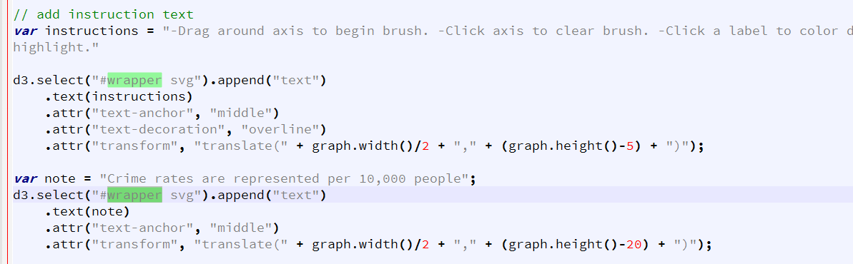

Handle the on click event of the dimension so that when the dimension is clicked the coloring of the plot is updated as per the dimension

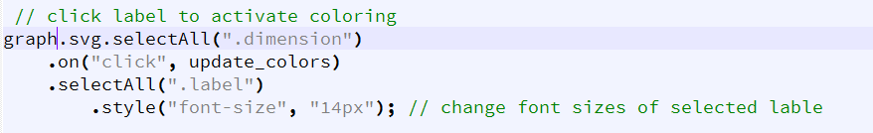

Add a hover event to handle so that the plot is highlighted when the mouse is hovered.

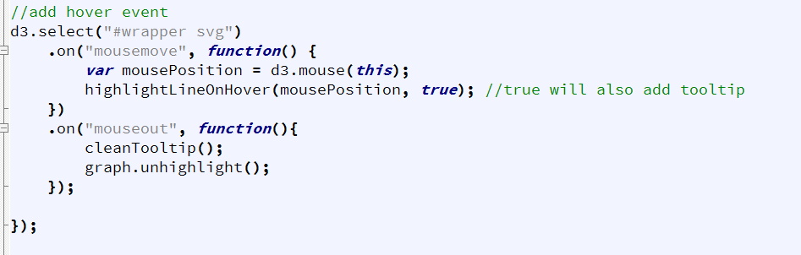

Define the tooltip parameters and append it to the graph svg

