***Tutorial for Scatter plot with D3.js using crime data set***

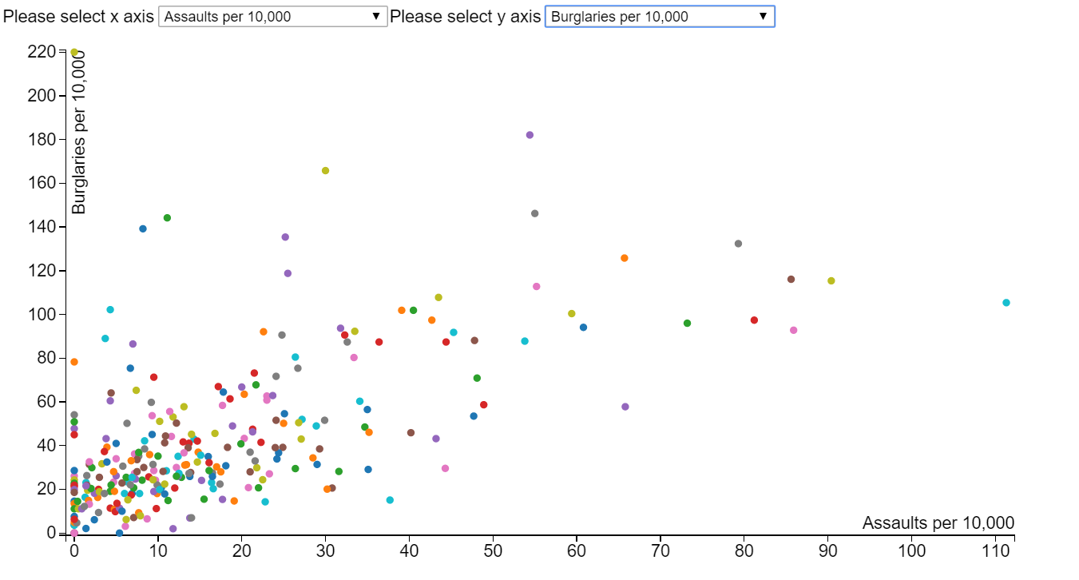

Create a HTML page and import D3 js library.

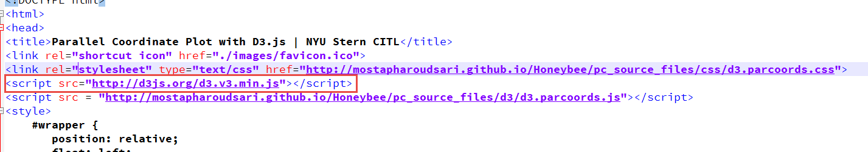

Load the csv file

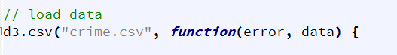

Retrieve all the name of columns from the csv file to populate the dropdowns for x and y axes

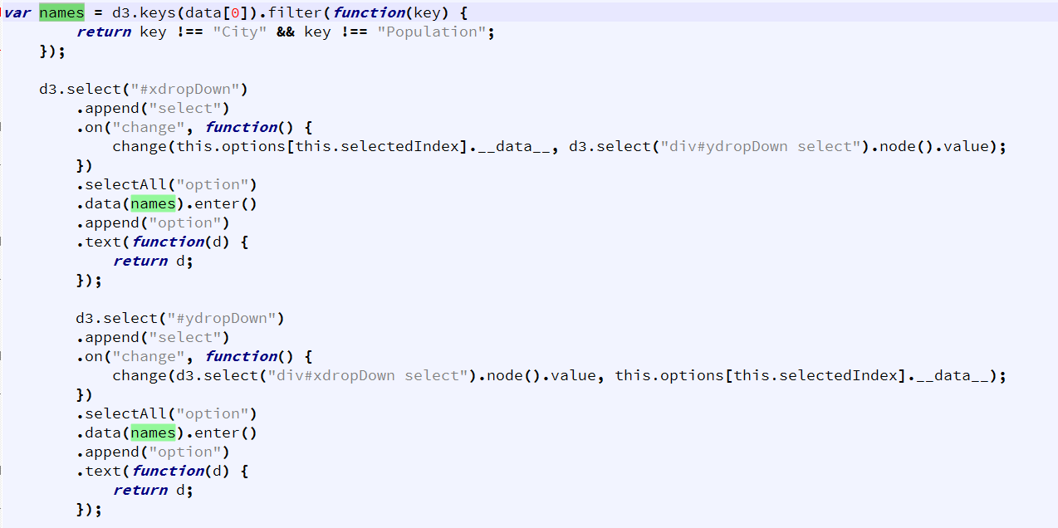

Define the change(x, y) method that is called everytime the drop down selection is changed. This redraws the scatter plot updating the x and y axes.

Inside the change method write the code to initialize the x and y axis to proper dimensions selected as per the drop down

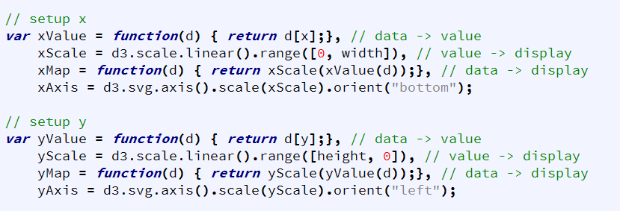

Initialize the d3 color so that each bubble is colored based on the value of City in the data set.

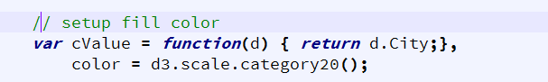

Finally, add the graph to the body of the webpage and define the tooltips

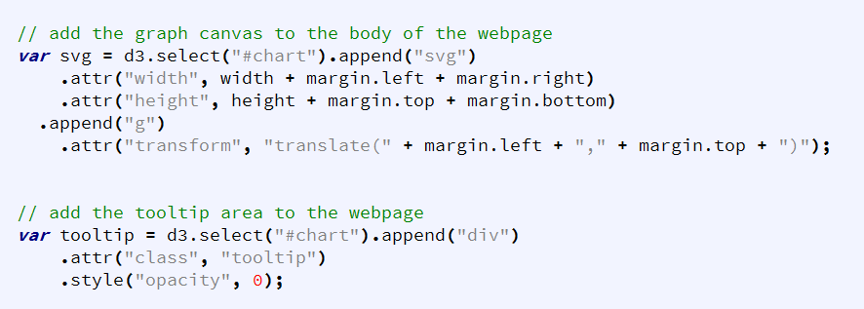

Draw x and y axes and label them with the values passed to the change(x, y) method.

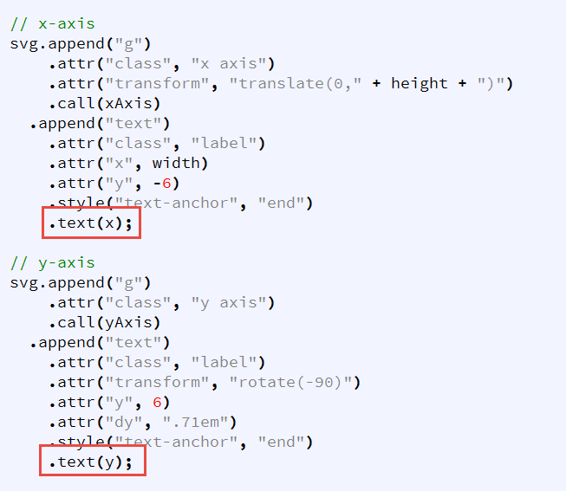

Finally draw the bubbles and add the tooltip text on mouse over event.

