***Tutorial for Scatter Plot Matrix with D3.js using crime data set***

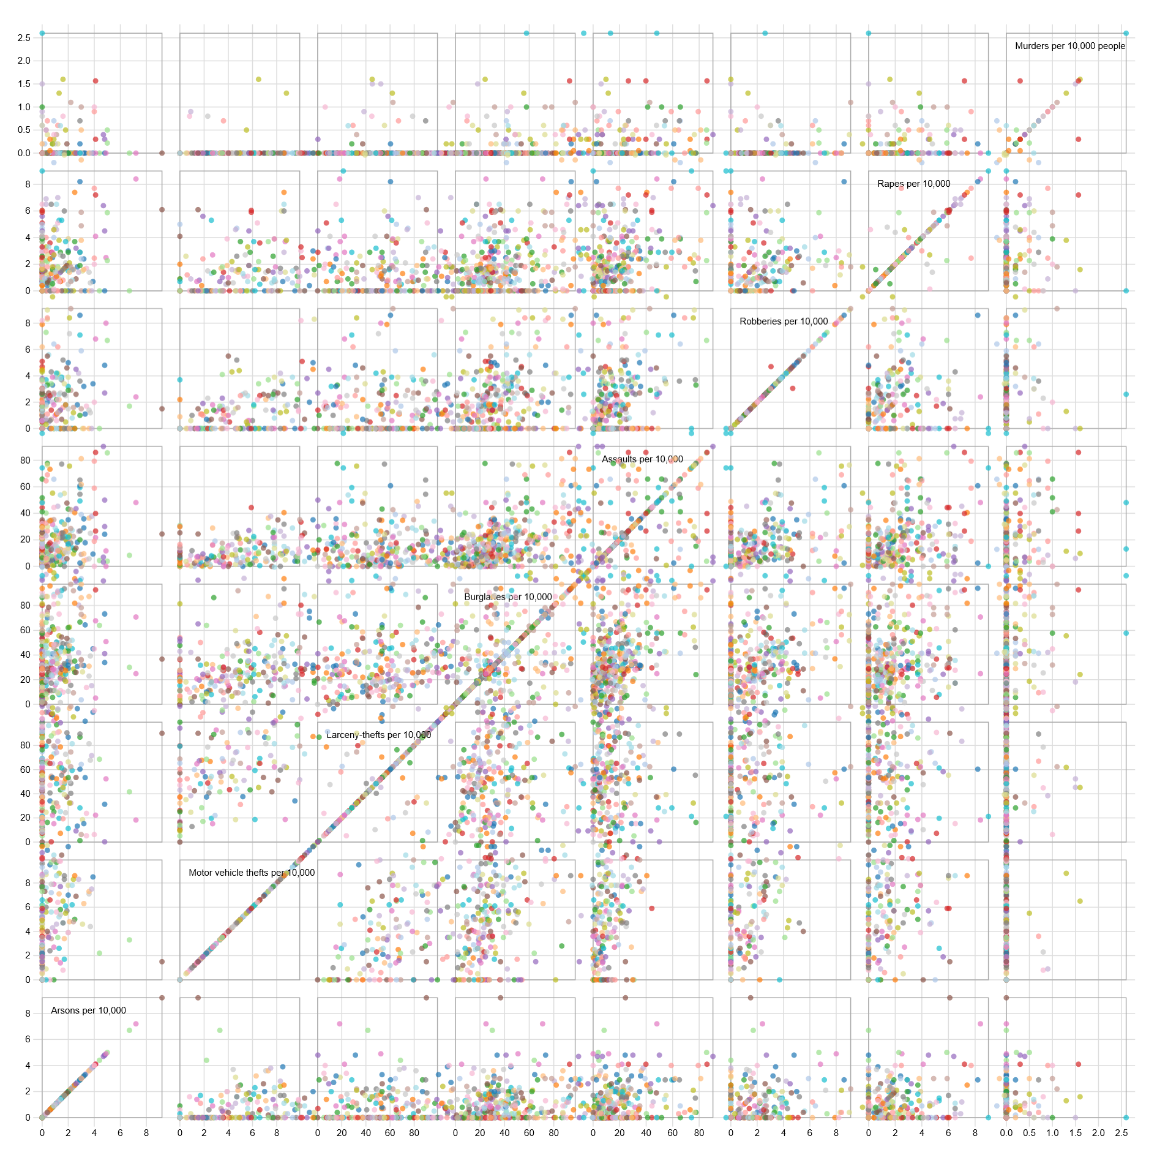

Create a HTML page and import D3 js library.

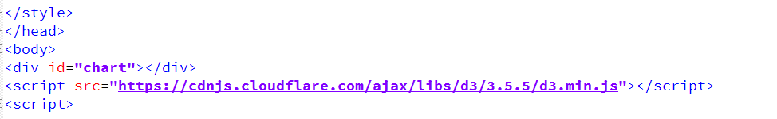

Initialize the linear x and y axes, add the axes to svg and initialize the color for coloring the bubbles based on the city.

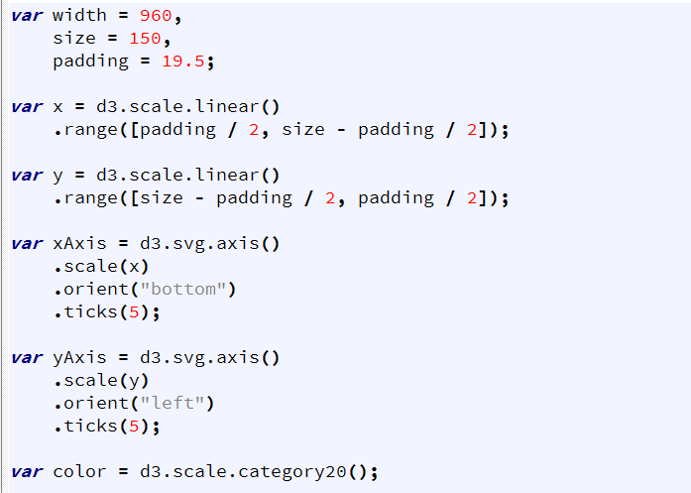

Load the csv file

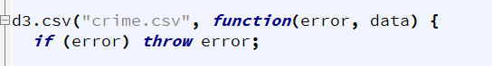

Load headers from the csv file and store them to domainByCrime map to be used later to draw each scatter plot

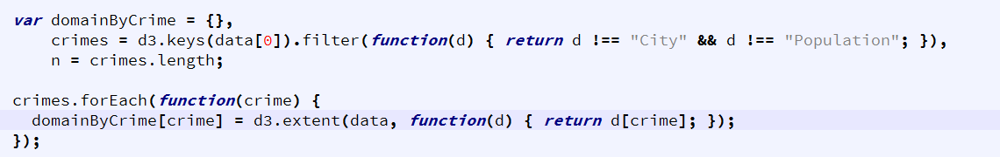

Define svg, tooltips and the x and y axes. Append the svg to the div container with id “chart”. Each cell is defined to plot different scatter plots.

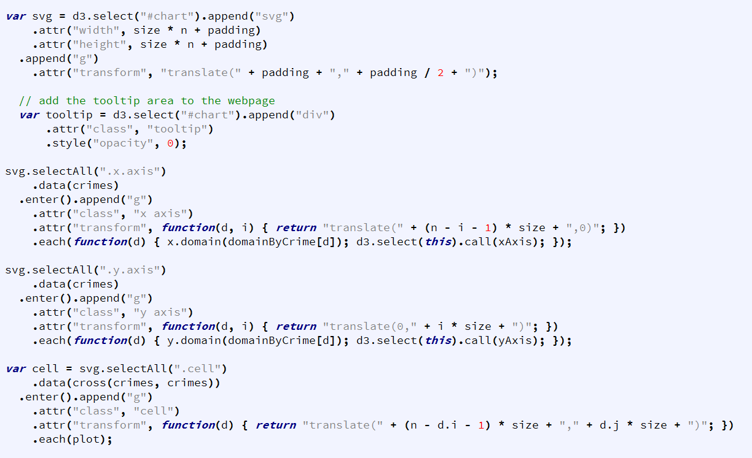

Create a filter for the diagonal cells to display text on them

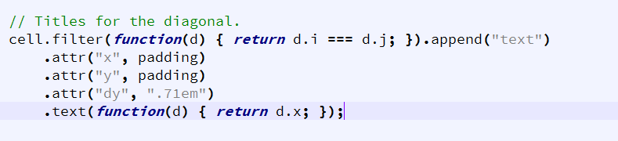

Finally, define a plot(x) method to draw each scatter plot on the svg. Define the tooltip body. In this example the tooltip shows up when mouse is hovered on the bubbles. City, population and the axes are shown on the tooltip.

