**Scope of Work**

To provide services for implementation of an Integrated Solution of Learning Management System and Student Relationship Management System.

The integrated LMS includes all planning, execution, implementation either on intranet or on internet with blended learning.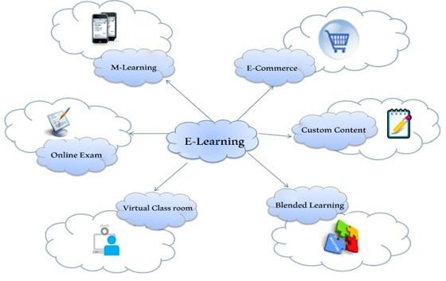

Benefits with LMS

* Create unlimited course libraries
* Create unlimited users
* Setup unlimited sub domains with multiple user groups
* Create various store fronts unique to each sub domain
* Perform assessments and surveys
* Create Learning paths
* Customize automatic reminders and notifications
* Monitor credentials
* Create global and user-group calendars
* Implement customized reporting and tracking
* Apply time constraints to specified activities
* Provide users with browser-based access for 24/7 service with no additional software
* Perform scheduled and manual data back-up
* Protect against viruses, unauthorized access and loss of data
* Integrate smoothly with your other software applications
* Comply with AICC and SCORM standards

|  |  |
| --- | --- |
| Sr. No. | Scope and Features of our LMS |
| 1 | Supports various content formats such as Videos, E-book, SCORM/AICC/Tin CAN  Content, Knowledge links, Assignments. |
| 2 | Supports various Assessment formats such as Video based questions, Image based  questions, Passage based questions, MCQ's, MMQ's, True or False, Text Questions.etc. |
| 3 | Integration with any VCR such as Zoom or CISCO WebEx. |
| 4 | Payment Gateway Integration |
| 5 | Integrated Bulk mail system and Bulk SMS. |
| 6 | Feedback Management |
| 7 | Query Management |
| 8 | E-Certificate as per your design with QR Code |
| 9 | E-Commerce functionality to buy Course |
| 10 | Android Mobile app |
| 11 | Batch Management |
| 12 | Student Relationship Management (SRM) |
| 13 | Contact Programs |
| 14 | Student Course Tracking |
| 15 | Student Lifecycle Tracking and Management |
| 16 | Discussion Forum |
| 17 | User Groups |
| 18 | Survey Management |
| 19 | Leaderboard |
| 20 | Announcements and Notifications |
| 21 | Fee Management |
| 22 | Course Planner |
| 23 | Attendance Management |
| 24 | Internal Mailing System |

|  |  |
| --- | --- |
| 25 | Reports and Analysis |
| 26 | Events Calendar |
| 27 | Tracking Student IP address details |
| 28 | Custom mail templates and signatures. |
| 29 | Course content upload |
| 30 | Define Course durations |
| 31 | Student Roll Number generation and ID Card |
| 32 | Send SMS & email notification to student |
| 33 | Question paper generation |
| 34 | Dynamic grading scheme templates for all questions |
| 35 | Mock test /Question bank |
| 36 | Final Exam |
| 37 | Upload Manual certificate instead of dynamic e-Certificate |
| 38 | Feedback from student |
| 39 | Internship courses – different from actual courses |
| 40 | Integrating with other university courses and programs |
| 41 | Competitive exams pattern like NEET |
| 42 | Payments – ecommerce payments |
| 43 | Payments – Offline / Installment wise payment collections |
| 44 | Geo tagging attendance – Mobile based |
| 45 | Live Tracking / Live Proctoring – Can be updated if you required |
| 46 | Student course enquiries conversion into leads. |
| 47 | Leads : Integration with digital marketing lead generation landing pages |
| 48 | Dynamic homepage with banners, testimonials, gallery, partner details and other  homepage content. |
| 49 | Blog |
| 50 | Discount Coupons |
| 51 | Master Settings |

**TECHNICAL CAPABILITIES**

Technology and Architecture of the product

* + Microsoft .Net, Ajax, HTML 5, CSS, JS, XML, Web Services, SQL Server
  + Three Tier MVC Architecture
  + Secure Application Development Procedure
  + Plug and Play Modules

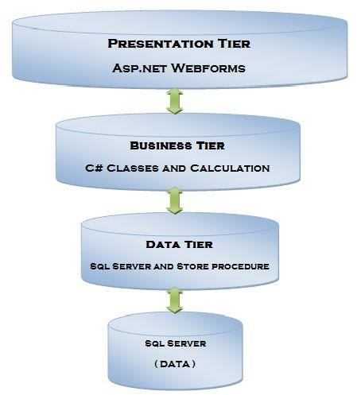

**Methodology**

The proposed solution would be built using agile methodology. This allows to clearly track the progress of the project with an opportunity to frequently review solution and share feedback.

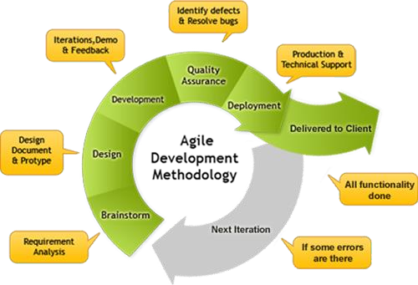

User interface

HTML5, CSS3, JavaScript, Jquery , Ajax, Bootstrap System reports

Web Reports, Report Viewer, High Charts, MS Charts, Fusion Charts

Helpdesk

A phone number and email ID along with ChatID will be provided to log in helpdesk related queries or support by UPGUAGE to ACCESS HEALTH INTERNATIONAL.

* + - Email
    - Chat
    - Phone

Methods of Incident Reporting

Incidents identified by Customer can be reported via:

Email to the UPGUAGE Support Desk - at any time

Phone call to the UPGUAGE Support Desk - during UPGUAGE Support working hours.

As indicated above, problems and issues should be reported to the UPGUAGE Support Desk.

The hours of operation and approach to out-of-hours service vary amongst locations. They are identified in the following table.

|  |  |  |
| --- | --- | --- |
| S.No | Support Type | Working Hours |
| 1 | Weekday Service | Staffed Service from 9.30am to 6:30pm |
| 2 | Holidays List | Provided by UPGUAGE |
| 3 | Out-of Hours – week days | e-mail service on a best effort basis |
| 4 | Out-of Hours – weekends | e-mail service on a best effort basis |
| 5 | Public Holidays | e-mail service on a best effort basis |
| 6 | Case of support staff not available | Replacement to be provided within1 hour |
| 7 | Ticketing Mode | UPGUAGE’s Support ticketing system  Support using GoToMeeting -on request Support using Conf. call -on request |
| 8 | Support Contact Details | Contact details of support team and additional contact details to be provided. |

Training plan

ACCESS HEALTH INTERNATIONAL enters the required master data for the modules to be functional. UPGUAGE guides the data entry process and clarify any doubts. UPGUAGE provides training based on a ‘Train the Trainer’ approach to the designated coordinators from ACCESS HEALTH INTERNATIONAL by holding training workshops for functional representatives of ACCESS HEALTH INTERNATIONAL for a total of 2 week(s).

**Pricing/Service Fee**

|  |  |
| --- | --- |
| Model | SaaS |
| Cost per month | Up to 1000 users : INR 35,000 exclusive of taxes  1001 to 2000 users : INR 40,000 exclusive of taxes 2001 to 3000 users : INR 50,000 exclusive of taxes 3001 to 5000 users : INR 60,000 exclusive of taxes  Beyond 5000 users : INR 50 plus exclusive of taxes additional user |
| No of courses | Unlimited |
| Hosting Server | UPGUAGE Server |
| Setup Charges (one time) | INR 50,000 plus GST |
| Customization | Additional Cost |
| Billing | Monthly |

**Note:**

* Additional customization requirements (CR) will be done at INR 5000/ man day.
* Post submission of requirement document from AHI, Upguage team will share time and cost for the CR. Upon approval from AHI for the cost and time the CR work will be started.
* After UAT the CR will be deployed into the production.

**Schdeule B**

Service Level Agreement for Support

By

UPGUAGE Solutions Private Limited

Purpose

This document outlines the Service Level Agreement (SLA) to manage the Customer’s ongoing support requirements for the ACCESS HEALTH INTERNATIONAL.

This document defines the service levels to be provided by UPGUAGE Solutions for the Learning Management System.

The services covered by this document include:

* Management of Incidents (issues and problems)
* Management of Requests.
* Contact information.

1. Services Provided Under this Agreement

The primary services provided under this agreement are:

* Management of Incidents
* Management of Requests

In the context of this document, an incident is any issue or problem which arises with the operation of the Learning Management System which affects its day-to-day operation by Customer staff and which causes, or may cause, an interruption to, or a reduction in, the quality of the Learning Management System.

1. Methods of Incident Reporting

Incidents identified by Customer can be reported via:

* Email to the UPGUAGE Support Desk - at any time
* Phone call to the UPGUAGE Support Desk - during UPGUAGE Support working hours (for Severity 1 and 2 incidents).

1. Support Hours

As indicated above, problems and issues should be reported to the UPGUAGE Support Desk.

The hours of operation and approach to out-of-hours service vary amongst locations. They are identified in the following table.

*UPGUAGE Support Centre*

|  |  |
| --- | --- |
| Service Period | Hours of Operation |
| Weekday Service | Staffed Service from 10am to 6:00pm |
| Out-of Hours – week days | e-mail service on a best effort basis |
| Out-of Hours – weekends | e-mail service on a best effort basis |
| Public Holidays | No support service |

1. Incident and Request Categorisation

Type Categorisation (whether incident or request) and Severity Level Classification are critical steps in determining the manner in which an issue is addressed.

With respect to Type Categorisation, a logged call may be categorised as either:

* Incident; or
* Request.

If categorised as a Request, the logged call will be considered non-critical and will be assessed on its merits for attention by the appropriate area.

1. Severity Level Classification

With respect to Severity Classification, an incident may be classified as:

* Severity 1 – Critical
* Severity 2 – High
* Severity 3 – Medium
* Severity 4 – Low

The following provisions apply for Severity Levels:

* The UPGUAGE Support will require input from users regarding urgency and impact of the issue
* Assessment of severity level is to be made by UPGUAGE Support based on information collected
* Users logging the issue cannot dictate the severity level
* Incident severity level will be assigned, based upon assessment of a number of criteria (see section 7) and
* After investigation of the issue, the UPGUAGE Support may upgrade or downgrade the severity level of the issue based upon the criteria defined in section 7

1. Incident Severity Level Definition

|  |  |  |  |
| --- | --- | --- | --- |
| Severity | Technical Services | User Services | LMS Services |
| Severity 1 Critical | Application down  Users cannot access even basic functionality of the application | Users private information mishandled | System unavailable  A large number of users (50 %+) cannot access the system. |
|  |  |  | System performance degrades making the system unstable – see performance metrics defined in section 5.2 System Performance for details |
| Severity 2  High | Major part of application is inaccessible |  | A number of users (<50%) cannot access the system. |
|  |  | Users cannot access the  majority of the content |
| Severity 3 Medium | Only certain sections of application are inaccessible | Issues with account access | Cannot access parts of content items |
|  | Password resets |  |  |
|  | Unable to access LMS content |  |  |
| Severity 4 Low | Incident relates to some superficial or cosmetic part of the application  Minor errors in user interface  Access available but at reduced performance level | Help required regarding interface  Help required to clarify access methods | The issue is cosmetic in nature and does not result in a compromise of service.  Help required for understanding the subject matter laid out in the online course. |

Very few incidents will be deemed as Severity 1 – ‘Critical’. All relevant managers will be notified as soon as a Severity 1 problem is logged.

1. Incident Response, and Escalation Times

|  |  |  |  |
| --- | --- | --- | --- |
| Severity | Initial Response | Initial Escalation | Resolution Time |
| Severity 1 Critical  During Standard Hours of Operation | 1 hour | 1 hour if no response | 4 hours during normal working hours unless the issue cannot be resolved within the specified timeframe due to issues outside UPGUAGE control such as server hardware or networking problem |
| Severity 2 High | 2 hours | 2 hours if no response | 8 hours during normal working hours |
| Severity 3 Medium | 8 hours | 48 hours if no response | On agreement with Customer |
| Severity 4 Low | 48 hours | 72 hours if no response | On agreement with Customer |

*Notes*

* + All severity incidents: Escalation times apply during normal business hours.
  + Escalation occurs during normal hours of operation for the LMS Support Desk.
  + If the LMS Support Desk is awaiting information from the Customer the SLA clock is stopped.
  + All times quoted are in business hours and working days.
  + Times quoted are where the resolution is completely under the control of UPGUAGE. Where UPGUAGE is reliant on an external supplier, additional time may be required.
  + When work is delayed due to a lack of response from the Customer, the time taken to solicit a response is not counted for SLA purposes. Where no response has been received from the Customer after three contacts within a two-week period the call will be considered closed.
  + The resolution time for incidents is the maximum time it will take for the incident to be solved or for a workaround to be put in place. The workaround will reduce the severity of the call by restoring basic functions to allow staff to perform their duties. A full resolution will then be found as a matter of priority.
  + In extreme cases where an incident, or group of incidents, signifies an underlying problem and a workaround cannot be implemented within the timeframes outlined in the SLA, the Customer will be informed and a workaround or resolution will be implemented as a matter or priority. A working group involving representatives from UPGUAGE and the Customer group may also be formed to solve groups of problems if this is deemed the most effective approach. These parties will collaboratively agree on resolution times.

1. Requests, as per new functionality, would be completed on a fee-for-service basis. An effort estimate will be provided based on the tasks given.
2. Contact Information

|  |  |  |  |
| --- | --- | --- | --- |
| Contact | Name | Number | Email |
| UPGUAGE Support Desk | N/A | +91- 9392035237 | [support@UPGUAGE.com](mailto:support@UPGUAGE.com) |