**Annexure I**

**Scope of Work**

Digital Payment Workstream will design and develop interoperable workflows and data standards to deliver direct payment from government and agencies to beneficiary organizations /individual. Thus, demonstrating through integrating digital public goods like OpenIMIS, Mojaloop and MIFOS / Core Banking Systems. The Digital Payments Workstream will continue from its existing work on integrating openIMIS, Mojaloop and MIFOS in different workflows. The workstream will provide the foundation and process to execute the desired use cases on an integrated payment system**.**

The following items listed below are options provided by ACCESS Health International in the GIZ contract that will be confirmed as the Phase develops.

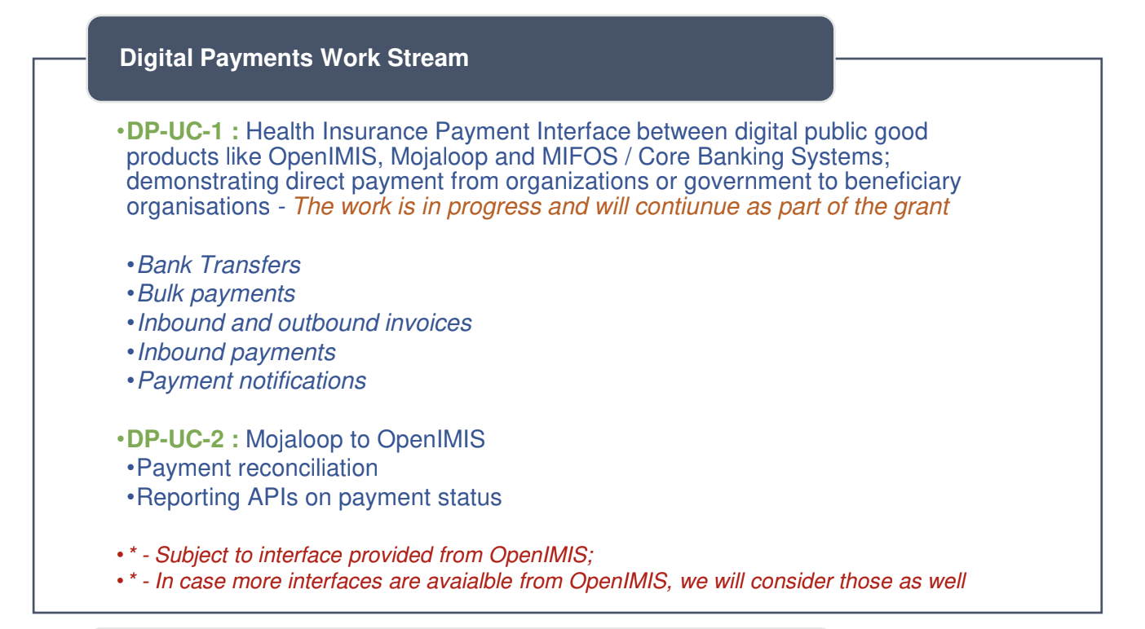

Based on the above suggestions ModusBox will:

1. Define a set of standards they become the Global Gold Standard for Payments systems
2. Produce a number of Demo’s showing the implementation of these standards for agreed use cases
3. Deliver a work plan to achieve the implementation of these (over a year or two)