**Title:** Strengthening Capacity of National Medical College Network (NMCN) to Design, Develop and Deliver Online Education to Medical Students across India (and globally)

**Scope of Work**

**Overall Goal and Objectives**

Goal: To launch high-quality, standardized, and competency-based online courses of the National Medical College Network (NMCN) for medical students of India over a period of 18 months.

The two objectives include:

1. Aggregate and strengthen the medical content of NMCN, and guide and review the development of NIHFW’s LMS development for its robustness, flexibility, and adaptability (Over 18 months, 1200-1800 lessons, equivalent to 400-600 modules, will be upgraded)
2. Strengthen the ability of the 50 NMCN to design and deliver high-quality, standardized content

The above objective is divided into the following phases: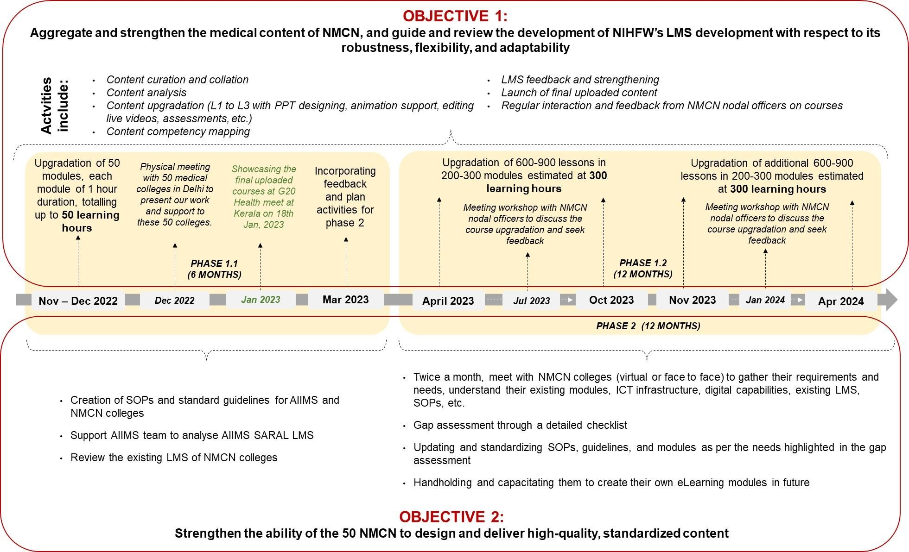

**Objective 1**: Aggregate and strengthen the medical content of NMCN and guide and review the development of NIHFW’s LMS development for its robustness, flexibility, and adaptability

**Phase 1.1 – 6 months (October 2022 – April 2023)**

**Target: Create 50 new lessons before Jan 10, 2023, encompassing new processes and standardized templates with high-quality visualization/animation and showcase at G20 Presidency Summit on Jan 19, 2023**

**Key Interventions:**

The overall approach is to facilitate MOH and NMCN in collating, curating, and upgrading the content available with the 50 National Medical Colleges Network (NMCN) in India.

1. **Content Curation and Collation**

* Content curation and collation by AIIMS from 50 NMCN colleges in the form of pdfs, manuals, videos, and presentations.
* Create a knowledge repository location for AIIMS to upload the source content in the form of PowerPoint presentations and live video recordings of ready modules.
* The content shared by AIIMS will be in three parts:
* Starting with lessons (~10-15 min duration including 5-7 min of animation), which will be converted into modules (~1-hour duration), and multiple modules will be integrated into a course (~3-4 hour duration).
* Empower will support AIIMS/ NMCN in updating/ upgrading 50 new lessons.

## Content Analysis

* Empower team to analyze the uploaded content (assuming 50 lessons in total) for content technicality and standardization (content format, content flow, etc.) and connect with the subject faculty of AIIMS for understanding and finalization.
* Empower team supporting AIIMS in finalizing the SOPs document and standard guidelines to be followed by all the 50 NMCN colleges while developing the module content.

## Content Upgradation

* Empower team to suggest and work on the design approaches for finalizing standard PPTs, animate PPTs, edit live video recordings, inclusion of MCQs/ assessments, etc., in the existing format.
* The content complexity would be a mix from simple and advanced to expert. Likewise, the module interactivity level would vary from Level 1 to 3. The details about interactivity levels are at the appendix.

1. **Competency framework, competency tagging/assessments, and competency dictionaries**

* The 50 new lessons will be aligned with medical education competencies (domain or behavioral or functional competency) based on available metrics of medical colleges, in coordination with C-LOP and the existing competency framework of AIIMS.
* Each new lesson encompasses a pre and post-question bank in the form of MCQs, true and false, helping learners understand how much they have learned.

1. **LMS feedback and strengthening**

* Empower will review the NIHFW platform and suggest fixes regarding learner and faculty journey/ user experience, software upgradation, server compatibility, admin capability (measuring metrics and analytics), and front-end issues by Dec, 2022.
* Review the LMIS from a user and faculty perspective (we will get our doctors, public health and IT, QA experts to go over it, and test it on a computer, mobile (android and iOS), and a tablet PC).
* Provide feedback on the types of reports that should be collected
* Support the AIIMS team to analyze AIIMS SARAL LMS in terms of its current functionalities and potential upgradation.
* Support NMCN colleges to analyze NMCN’s existing LMS in terms of its current functionalities and potential upgradation

## Launch of final uploaded content

* Empower will support the NIHFW team in uploading the final modules on the LMS by Jan 10, 2023.
* Support MoHFW, AIIMS, and NIHFW in showcasing the final uploaded courses and LMS at G20 Presidency Meet on Jan 19, 2023

**Budget**

The total budget for proposed engagement will be USD 254,000 exclusive of taxes.

|  |  |
| --- | --- |
| **Particulars** | **Total Amount (USD)** |
| Manpower cost (average of 12 FTE deployed for 6 months)   * Junior and mid-level staff (including public health associates, researchers, instructional designers, graphic designers, IT/ tech team.) * Senior staff (project manager, sr. instructional designers, sr. graphic designers, tech experts, QC experts, IT/tech experts, learning designers etc.) * Director | $221,400 |
| **Travel expenses** assuming 2 trips x 3 people x 4 days x  $200 per day; flights $400 x 2 trips x 3 people (including flight tickets, accommodation, meals, per diem, other incidentals) | $7,200 |
| Overheads (10% of the total cost) | $25,400 |
| **Total Cost (excluding 18% GST)** | $254,000 |

**Bank Account Details**

|  |  |  |
| --- | --- | --- |
|  | **Name of the Beneficiary** | Empower School of Health LLP |
|  | **Bank Name** | Kotak Mahindra Bank |
|  | **Account Number** | 4711580424 |
|  | **Bank Address** | JMD Regent Square Mehrauli, Gurgaon Road, Gurgaon 122002 |
|  | **IFSC Code** | KKBK0000261 |
|  | **Swift Code** | KKBKINBB |

**Remuneration**

The entire fee/compensation, not exceeding INR 254,000 exclusive of taxes would be paid to the account mentioned above held by Empower School of Health LLP.

**Deliverables & Payment Schedule**

|  |  |  |  |
| --- | --- | --- | --- |
| **S. No** | **Deliverables** | **Payment Timeline** | **Payment %** |
| 1 | On signing of the contract | November 2022 | 50% |
| 2 | **Deliverable I**   * Content upgradation of 50 lessons/ modules (WIP) by January 15, 2023 including videos, ppt * LMIS feedback implementation and strengthening for NIHFW and SARAL AIIMS – January 15, 2023 * Showcasing the final uploaded e-lessons to the Ministry of Health/ G20 health meet by January 18, 2023 * 2 physical meetings   + Physical meetings with 50 NMCN colleges in Delhi on December 13, 2022   + G20 health meet at Kerala, scheduled on January 18, 2023 | January 2023 | 25% |
| 3 | **Deliverable II**   * Feedback implementation post G20 health meet * Initiate the process the competency analysis, tagging and assessment * Planning activities for phase 2 of the program * Strengthening and review other NMCN colleges includes SOPs, LMS and competency mapping * More courses, more complex styles of content | March 2023 | 25% |

**Term of Contract**

This contract period is from **November 01, 2022** to **March 31, 2023.** Empower School of Health LLP will be engaged under the agreement from the date of signing the contract till the date of closure as mentioned above**. The contract will be considered closed when the deliverable is received, and final report is submitted.**