Schedule A
Scope of Work
ToprovideaplatformtohosttheonlinelearningcontentofACCESS Health International
Based on the requirements from ACCESS Health International, Hurix LMS offering which is built on the open-source Model platform with additional essential features/functionalities built-in/ customized/ conﬁgured for our customers whoneedacustomsolution.
Hurix will provide following features:
- Setup the Hurix LMS instance
- ApplydefaultfreethemeontheLMS.Ifapaidthemeisrequireditshallneedtobeprocuredbytheclient.
- AddbrandingofAccessHealthontheLMSinstance(AsperMoodleGuidelines)
- Integrate Big Blue Button
- HosttheLMSinstanceonAWS
- Providesubscriptionforupto1000users
TheLMSwillbeaccessiblethroughaWebapplication.ThesupportedWebBrowserswillbeMozillaFirefox,GoogleChromeandAppleSafari.
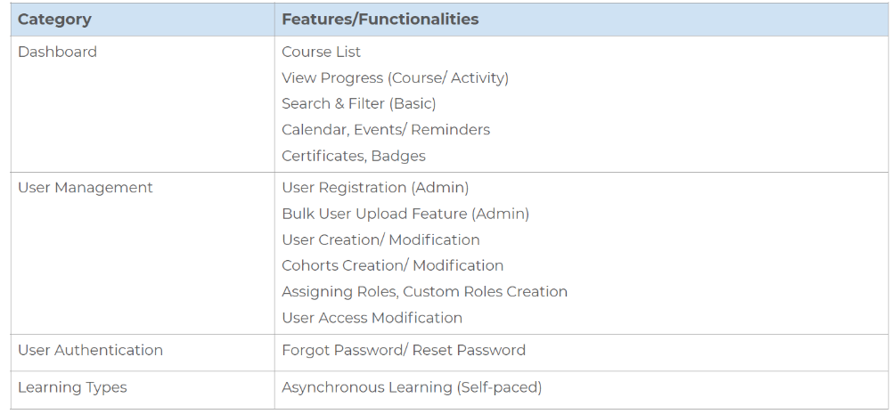

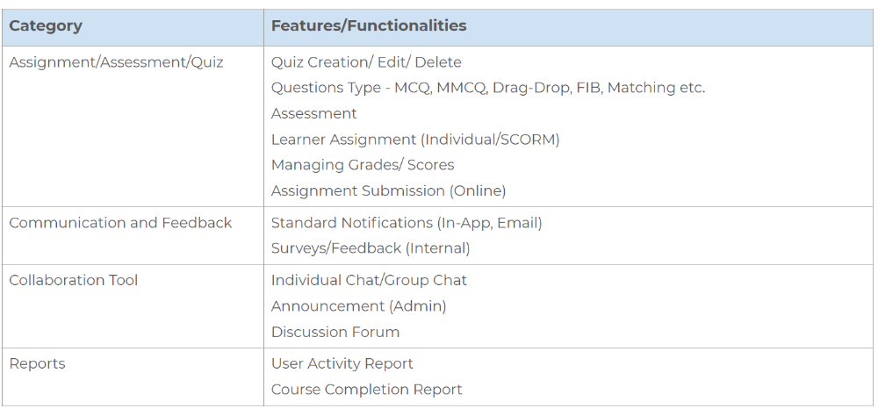
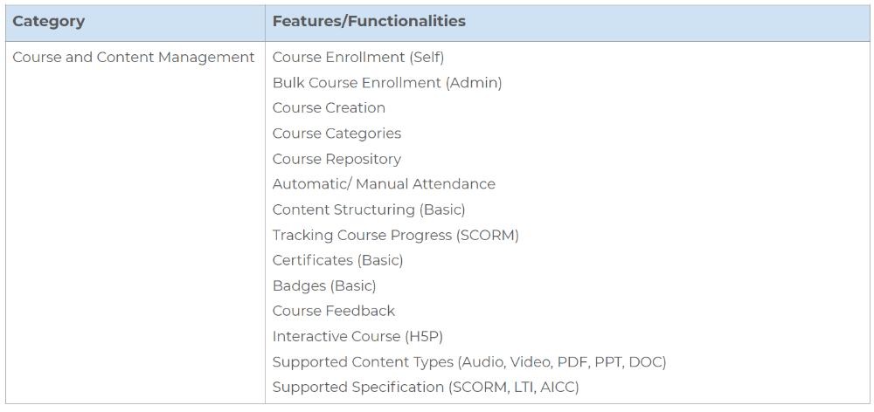
Compensation:
A total service fee of INR 8,50,000 exclusive (including 12 month subscription) of taxes will be paid to the service provider. The payment will be released only on the completion of deliverable and invoicing by the service provider.

Initial Cost:
Hurix LMS Instance Setup (Includes Branding & White Labelling) INR 1,50,000
Big Blue Button (Virtual Conference) – One-time Setup/Integration INR 1,00,000 + one month subscription 50,000.(Once the project is ready for kick start, after branding and white labelling work)
Monthly subscription:
*Monthly license for LMS Usage (Includes Hosting and Maintenance)-101 – 1000 active users (up to 100 concurrent users) INR 50,000 (This need to be paid every month periodically) for eleven months *Per month.
Term
This engagement shall commence upon execution of this Agreement. The Agreement shall continue in full force and is effect from November 01, 2021 to October 31, 2022.

