**Chapter-1**

**Enter your Course**

**Submitted To:** **Submitted By:**

Krishan Chawla

**Description of Organization**

**Introduction -Existing System**

An E-tutor (or an automated tutor) as a software tool that offers “students guidance in undertaking specific tasks”Some tutorials will simply guide the user through a set a resources to help complete a specific assignment .Resources such as videos are becoming a popular resource in these tutorial programs. Other e-tutors can be much more complex and interactive. Many e-tutors are interactive, can adjust for skill level, and will offer random content to challenge the learner.

**Objective of Organization**

The aim of this E Tutorial application is to effectively promote student learning and increase student knowledge in specific subjects and topics through targeted components detailed in each lesson module. It aids in increasing advanced computing skills such as HTML, CSS, PHP, MYSQL.

**Functions**

* **User :**
* Login
* Register
* Password reset
* Dashboard management

**Services**

Tutorials on various subjects

Visual aided examples to provide better understandings

Well-built Admin Panel support

Easy addition / Modifications of Tutorials from Admin Panel

**Methodology for Data Collection**

**Secondary Data Collection**

**Internet**

The internet is a global system of interconnected computer networks that use the standard Internet protocol suite (TCP/IP) to link several billion devices worldwide. It is an international network of networks that consists of millions of private, public, academics, business, and government packet switched networks, linked by a broad array of electronic, wireless, and optical networking technologies.

**Tools/Platforms**

1. **Hardware specifications**

* Processor : Core 2 Duo or above
* RAM : 2GB RAM
* Monitor : 15” Color Monitor
* Hard Disk : 120 GB or above
* Internet Access

1. **Software specifications**

**Front End:**

Web designing : PHP

**Back end:**

SQL

**Other tools:**

Style Sheet : Cascading Style sheet

**Project Planning**

|  |  |  |  |
| --- | --- | --- | --- |
| **Task Name** | **Duration** | **Start** | **Finish** |
| Requirements Gathering | 3d | 06/19/15 | 06/23/15 |
| Requirements Analysis | 2d | 06/23/15 | 06/24/15 |
| Designing | 7d | 06/24/15 | 07/02/15 |
| Implementation | 10d | 07/02/15 | 07/15/15 |
| Testing | 5d | 07/15/15 | 07/21/15 |

1. Task Scheduling

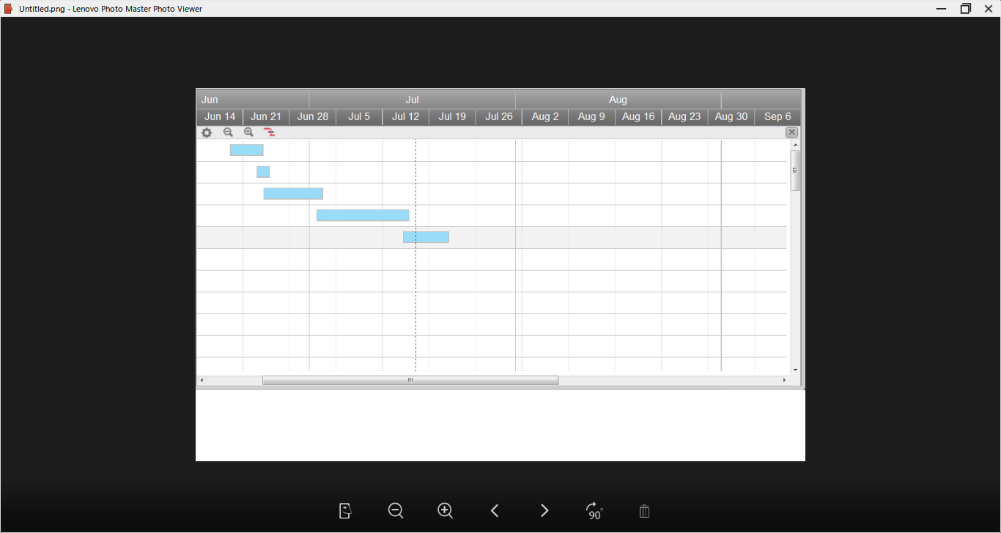

(b)Gantt chart