* 1. Use Case Diagram

A use case diagram (UCD) at its simplest is a representation of a user's interaction with the system and depicting the specifications of a use case.

User

**Figure 3: Use Case Diagram**

* 1. DATA FLOW DIAGRAM (DFD)

A data flow diagram (DFD) is a graphical representation of the "flow" of data through an information system, modeling its process aspects. They show the flow of data through the system.

Following observations have to be kept in mind for DFD’s:

a) All names should be unique

b) Arrows show the flow of data

**Context Level DFD for Tutorial Plus**

User Area

Insert

Member

Update

Manages his own account, his skills,

Takes tutorials to increase his skills

**Figure No.4: Level 0 DFD**

Level 1 DFD for Tutorial Plus

Database

USER

**Figure no.-5: Level-1 DFD**

* 1. Database Specifications

|  |  |  |  |
| --- | --- | --- | --- |
| **Field Name** | **Field Type** | **Size (No of Characters)** | **Description** |
| memberID | Int | 11 | Auto Increment by 1 on every registration |
| username | Varchar | 255 | Unique Name for every user, Name cannot be same. |
| Password | Varchar | 255 | Password of User/Admin |
| email | Varchar | 255 | Email address |
| active | Varchar | 255 | Account Status |
| Html_pageStep | Int | 10 | Stores the progress of user’s HTML tutorial |

* 1. VALIDATION SPECIFICATIONS

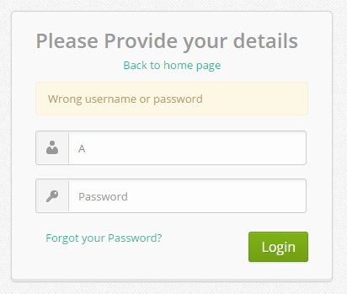

**Figure-7: Login Validation**

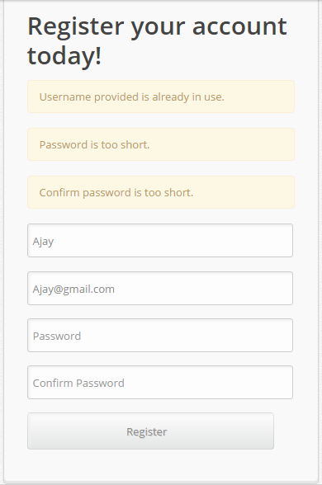

**Figure-8:Registration Validation**