CAPSTONE PROJECT REPORT
Simple Password Vault with Secure GUI

Student Names | Krishang Gulati, Madhur Mehta, Arpit Parashar
Roll Numbers | 590016563, 590016752, 590013122
Batch / Section | B.Tech CSE (Cybersecurity & Forensics)
Submission Date | May 08, 2026

2. Project Overview

2.1 Problem Statement / Scope / Objectives
Managing multiple unique passwords manually is time-consuming and prone to human error or reuse, which creates security vulnerabilities. This project automates the storage and management of credentials in a localized, user-friendly environment.
Objectives:
- To develop a Java-based application for secure credential management.
- To store records efficiently using a local file-based database system.
- To provide easy search, masking, and update options for the user.

3. Requirement Analysis

3.1 Functional Requirements
- Add New Records: Allow users to input Website, Username, and Password.
- Delete Records: Remove existing credential entries from the vault.
- Search Records: Filter and find specific credentials quickly.
- Masking / Toggling: Securely hide passwords behind dots or reveal them via toggle.

3.2 Software Requirements
- Java JDK: Version 17 or higher.
- IDE: Visual Studio Code / IntelliJ IDEA.
- JDBC Driver: MySQL Connector (if extended to SQL).
- Version Control: GitHub.

4. System Design

4.1 Module Description
- GUI Module: Handles the Java Swing interface and user interactions.
- Data Processing Module: Validates inputs and handles the logic for adding/deleting entries.
- File I/O Module: Manages saving and loading data to the local text-based database.

4.2 Simple Flow Diagram
Start → Launch App → View Dashboard → Add / Search / Delete Entry → Save to Vault → Exit

4.3 Database Design
Table Name: Vault Table
Field Name | Data Type | Description
entry_id | INT | Unique Identifier (Primary Key)
website | VARCHAR | Name of the service / site
username | VARCHAR | User login name
password | VARCHAR | Credential string

5. Implementation

5.1 Technologies Used
- Java: Core programming language.
- Swing GUI: For building the interactive dashboard.
- GitHub: For collaboration and version control.

5.2 Screenshots of GUI
Main Dashboard — showing the JTable and credential input fields:
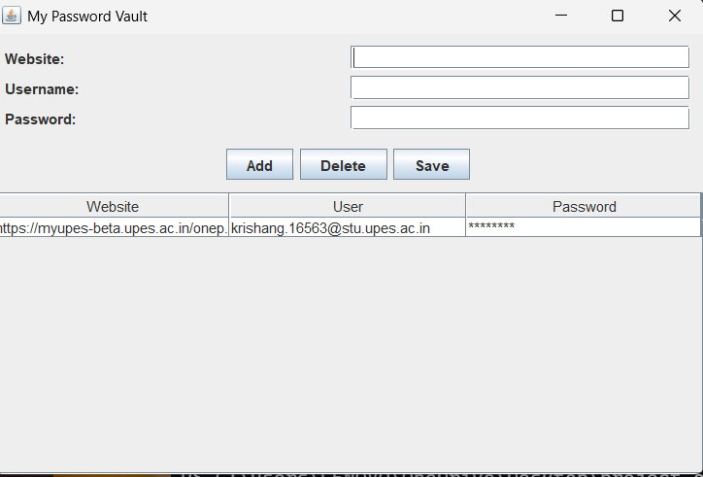
The screenshot above shows the main vault interface with Website, Username, and Password input fields, along with Add, Delete, and Save buttons, and the credential table listing stored entries with masked passwords.

5.3 Important Code Snippets
GUI Event Handling — Adding an Entry:
addButton.addActionListener(e -> {
String service = serviceField.getText();
String user = userField.getText();
String pass = new String(passwordField.getPassword());
if (!service.isEmpty()) {
tableModel.addRow(new Object[]{service, user, "●●●●●"});
}
});

6. GitHub and Version Control

6.1 Repository Link
[Paste your GitHub repository link here]

