**INTERNSHIP PROJECT REPORT**

(Project Term January-April, 2019)

## (Employee Management System)

Submitted by

**Krishan Gulati Registration Number : 11505658**

**Course Code ……………………**

Under the Guidance of

Devendra Soni  
Sr. Associate  
( Cognizant Technology Solution )

# School of Computer Science and Engineering



|  |
| --- |
| **Candidate Declaration**  We hereby declare that the work which is being presented in this project entitled **Employee Management System** in partial fulfilment of degree of Bachelor of Engineering in Electronics & Telecommunication Engineering is an authentic record of our own work carried out under the supervision and guidance of **Devendra Soni (Cognizant).**  We are fully responsible for the matter embodied in this project in case of any discrepancy found in the project and the project has not been submitted for the award of any other degree.  **Date:**  **Place:**    **Krishan Gulati** |
|  |
|  |
|  |
|  |
|  |
|  | |
|  | |
| **CERTIFICATE**  This is to certify that the declaration statement made by the student is correct to the best of my knowledge and belief. He has completed his internship under my guidance and supervision. The present work is the result of his original investigation, effort and study. No part of the work has ever been submitted for any other degree at any University. The internship is fit for the submission and partial fulfillment of the conditions for the award of B.Tech degree in _____________ (Programme Name) from Lovely Professional University, Phagwara.  **Signature and Name of the Mentor**  **Designation**  **School of Computer Science and Engineering,**  Lovely Professional University,  Phagwara, Punjab.  Date : | |

**ACKNOWLEDGEMENT**

We take this opportunity to present our votes of thanks to all those guideposts who really acted as lightening pillars to enlighten our way throughout this project that has led to successful and satisfactory completion of this study.

We are grateful to Cognizant Technology Solution for providing us with an opportunity to undertake this Internship project and providing us with all the facilities. We are highly thankful to organization for their active support, valuable time and advice, whole-hearted guidance, sincere cooperation, and pains-taking involvement during the study and in completing the assignment of preparing the said project requirement within the time stipulated.

Lastly, we are thankful to all those, particularly the various teammates, who have been instrumental in creating proper, healthy, and conductive environment and including new and fresh innovative ideas for us during the Internship project, without their help, it would have been extremely difficult for us to prepare it in a time bound framework.

**ABSTRACT**

This report is aimed at documenting the “**Employee Management System** ” that has been developed as a solution of a common interface between the allocators and the nominees. While starting with the project we went through some similar existing platforms that inspired the project to be developed in the first place, however it provided the motivation to do it even better. The system we have created provides a common platform for logging in as the predefined user type , the allocators and the nominees and thereafter surfing their corresponding dashboards in order to complete their tasks. Their dashboards comprise of windows for their respective functions that is easy to navigate and control since the main objective of the management system has been kept as the same. Dash board is used to store the data regarding the projects running in a particular account. Using this application user can get the report at Account, Project and PM levels. In this project, the function of allocator is performed by the ‘Admin’. The admin performs the task of managing which includes details of the employee and the project allocated for the respective candidate. Admins another function includes managing the database which consists of employee id, name, email address. Admin can edit , delete or upload users accessibility (Read-only, Write-only, Manager).

|  |  |  |
| --- | --- | --- |
| 1. **INTRODUCTION** | | |
| **1.1 Purpose of this document** | | |
|  | | |
| This document is aimed at:  • Providing the necessary inputs to the detailed requirements gathering phase and further on for the SDLC processes.  The purpose of this document is to systematically capture requirements for the project and the system to be developed. Functional requirements are captured in this document. | |  |
|  |  | |

**1.2 Project Overview**

1.2.1 Objectives

**Administrator-**

Below are the objectives of Administrator Module:

• User credential authentication

• Allocate nominee with particular program

• Edit credential /or update nominee allocated program

• Generation of emails for a specific set of users

**Employee -**

Below are the objectives of Employee Module:

• User credential authentication

• Procurement of trainer information with skill group and availability

• Allocated list for particular Employee’s

**2. Problem Description**

The purpose of this application is to fulfil the requirements of organizations and job applicants today on a single application based platform, where organizations This dashboard is used to store the data regarding the employees allocated to respective projects running in a particular account. Using this application user can get the report at Account, Project and PM levels. This application has three roles i.e. Read only, Managers and Admin. By default associate joining the team will be given Read only role where they can see the onboarding procedure for specific customer. Associates with Manager role will be able to access all account level report like utilization reports etc; and Admin role will be able to access all functionalities of dashboard.

Every module of the application has an important part and totally differ from each other that provides a variety of things to be experienced in the application. Combining different features like On-boarding, Account level Reports, Administrator together make it different from other applications.

Application can work on any Web Browser with suitable configuration.

ABSTRACT

**Cognizant** is an American multinational corporation that provides IT services, including digital, technology, consulting, and operations services. It is headquartered in Teaneck, New Jersey,United States of America. Cognizant is included in the NASDAQ-100 and the S&P 500 indices. It is also one of the fastest growing Fortune 500 companies. It was founded as an in-house technology unit of DUN & BRADSTREEIN in 1994, and started serving external clients in 1996.

Cognizant had a period of fast growth during the 2000s, becoming a Fortune 500 company in 2011. In 2015, the FORTUNE Magazine named it as the world's fourth most admired IT Services company. In 2017, Cognizant was named in Fortune’s Future 50 list.

Cognizant provides information technology, information security, consulting, ITO and BPO services. These include business & technology consulting, system integration, application development & maintenance, IT infrastructure services, analytics, business intelligence data , warehousing, customer relationship management, supply chain management, engineering & manufacturing solutions, enterprise resource planning, research and development, outsourcing, and testing solutions.

Cognizant has three key practice areas that span its business — Digital Business, Digital Operations, and Digital Systems & Technology.

**Chapter 1**

Introduction

1. **Purpose of this Project**

This Project is aimed at:

• This Project is about the mechanic and customer login in which there would be two user using the web.

• This project is about On_Road_assistance where the customer end would login to share the problems related to him/her like tyre puncture,need of petrol,accident or some basic needs related to the vehicle.

•And the customer would send request to the local mechanics present over those arena.

•Similarly there would be mechanic end login where the mechanic would either accept or reject the request send by the customer.

This acception or rejection by the mechanic would be further notified to the customer end.

The purpose of this document is to systematically capture requirements for the project and the system to be developed. The document also captures the Functional requirements and serves as an input for the scope of project.

1.1 Objectives

Below are the objectives that shall be fulfilled post the execution of this project:

• Customer and Mechanic registration and credential authentication.

• Requests for service by customer.

• Location based searching of mechanics.

• Accepting requests made by customer and providing service.

• Customer will also provide rating to the mechanic on the basis of the service.

• Real time navigation.

1.2 Intended Audience

• Interns/Project Team

• Mentors and SME’s

**1.1.0 Business Case**

With new vehicular addition to the roads each day, the traffic density has been creeping significantly. With increasing traffic, there has also been a strong pattern of tourist spot exploration by using their personnel vehicle. This causes more dependence on roadside assistance should there be a situation of vehicular breakdown, fuel insufficiency or accident. A mobile app, which shall let the users to request for an on-road assistance will be a game changer to the automobile industry.

The solution developed will address the objective in a holistic manner and will have all the features and functionalities which shall let the portal allow a customer to perform a location based search, browse by the nature of service offered and contact info. This shall allow the mechanic to accept the request from the customer and a real time navigation can be performed. Customer rating for the service will be an added feature.

**1.1.1 Technologies Recommended**

|  |  |
| --- | --- |
| Front End | Java (HTML5, JavaScript) |
| Middleware | Servlet Jsp MVC |
| Backend | Oracle/SQL Server |

**1.1.2 Hardware and Software Requirements**

|  |  |  |
| --- | --- | --- |
| Technology | Hardware | Software |
| Java | Desktop PC with 8GB RAM | 1. Node.js 10.15.1  2. Angular 5.0  3. Visual Studio Code 1.30  4. Eclipse IDE for Java EE Developers (Oxygen)  5. Maven 3.6.0  6. Tomcat 9  7. MySQL Community Server 8.0  8. MySQL Workbench  9. Putty  10. WinSCP  11. Oracle 11g express version |

**1.1.3 Product Scope**

This product is a powerful web aggregation engine is a core enabling technology of Cognizant solutions and is a fundamental tool for improving the management of collections and deductions. This product is a great start to an efficiency initiative

**1.1.4 Definition**

• Client: Cognizant Client who is using our software.

• Customer: Cognizant Client’s end-customers. The companies that actually make Payments to Clients.

• Mechanic: They are project used words who will provide service to the customer.

• Invoice: A receipt of acknowledgement for the goods or services provided and their respective cost. Customer receives an invoice from the mechanic specifying the goods dispatched or soled and the cost associated with the purchase.

• Location_Based: The customer will search for the mechanic on the closest vicinity.

• Rating:The customer will give the rating to the mechanic on the basis of the service provided by the mechanic.

• Notification: The customer will receive a notification on the basis of the mechanic acception or rejection.

• Payment: Money paid by Customer to Mechanic for some product or service they bought and got billed for. Payment can be in the form of: Checks, Cash or Credit or Debit Card transactions.

**Chapter 2**

2.0 Process Architecture



**Chapter 3**

3.1 Detailed Business Requirements

3.1 Functional Requirements

The functional requirements are charted for each of the high level requirements called out in the earlier section:

Additionally, the following elements are captured for each business requirement in the table provided below: -

* Req. Type = (F Core Functionality, E Exception, UI User Interface, R Reporting)

** Priority of Requirement = (1=Base Functionality, 2=Advanced Functionality,

3=Additional Opportunities)

** Originator = (Name of the business process of the system/ department or function

name in the customer organization)

The Requirements in this document are prioritized as follows:

3=Additional Opportunities)

** Originator = (Name of the business process of the system/ department or function

name in the customer organization)

The Requirements in this document are prioritized as follows

|  |  |  |
| --- | --- | --- |
| **Value** | **Rating** | **Description** |
| 1 | Critical | This requirement is critical to the success of the project. The project will not be possible without this requirement. |
| 2 | High | This requirement is high priority, but the project can be implemented at a bare minimum without this requirement. |
| 3 | Medium | This requirement is somewhat important, as it provides some value but the project can proceed without it. |
| 4 | Low | This is a low priority requirement, or a “nice to have” feature, if time and cost allow it. |
| 5 | Future | This requirement is out of scope for this project, and has been included here for a possible future release. |

|  |  |  |  |  |  |  |  |  |  |  |  |  |
| --- | --- | --- | --- | --- | --- | --- | --- | --- | --- | --- | --- | --- |
| **Req. #** | **Rationale Categorization** | | | **Business Requirement** | | **Req. Type \*** | | **Priority \*\*** | **Originator \*\*\*** | | **BR Traced to Business Requirement / Use case ID** | |
| Req_1.1 | | Customer and Mechanic Registration | When the user clicks on the registration link, it should re-direct to registration form. | | UI | | Critical | | | NA | |
| Req_1.2 | Customer and Mechanic Registration | | | User needs to fill some of the basic attributes/fields as mentioned below in requirement: First Name, Last Name, Age, Gender, Contact Number, Password, Email | | UI | | Critical | NA | | Req_1 | |
| Req_1.3 | | Customer and Mechanic Registration | Clicking ‘Submit’ should validate the datatype constraints for each field | | F | | Critical | | | NA | |
| Req_1.4 | | Customer and Mechanic Registration | User failing to provide information on the mandatory fields be provided with an alert message – ‘Please update the highlighted mandatory field(s).’ Also, highlight the missed out field in red | | E | | Medium | | | NA | |
| Req_1.5 | | Customer and Mechanic Registration | Post-successful field level validation, save the information in the database | | F | | Critical | | | NA | |
| Req_1.6 | | Customer and Mechanic Registration | Upon saving the information in the database, display the message ‘Your details are submitted successfully’. | | E | | Medium | | | NA | |
| Req_2.1 | Credential Authentication | | | A registered user – is able click ‘Login’ link, after keying in ‘User ID’ & ‘Password’ field and get his credentials authenticated with the existing database entry. | | F | | Critical | NA | | Req_2 | |
| Req_3.1 | | Customer Requests | Customer is able to click request button. | | F | | Critical | | | NA | |
| Req_3.2 | Customer Requests | | | Customer should enter their current location and their basic information is fetched from database. | | F | | Critical | NA | | Req_3 | |
| Req_3.3 | | Customer Requests | Clicking ‘SEARCH’ will navigate to next page along with the entered details. | | F | | Critical | | | NA | |
| Req_3.4 | | Customer Requests | User failing to provide information on the mandatory fields be provided with an alert message – ‘Please update the highlighted mandatory field(s).’ Also, highlight the missed out field in red | | E | | Medium | | | NA | |

|  |  |  |  |  |  |  |  |  |  |  |  |  |
| --- | --- | --- | --- | --- | --- | --- | --- | --- | --- | --- | --- | --- |
| **Req. #** | **Rationale Categorization** | | **Business Requirement** | | | **Req. Type \*** | **Priority \*\*** | | **Originator \*\*\*** | | **BR Traced to Business Requirement / Use case ID** | |
| Req_3.5 | | Customer Requests | | Customer can choose mechanics from a list which is ordered based on mechanics previous ratings | F | | | Medium | | NA | |
| Req_3.6 | | Customer Requests | | Mechanics receives requests has option to accept or reject the requests, in which case, customer can choose other mechanic from the list. | F | | | High | | NA | |
| Req_4.1 | | Accepting Requests  ( Mechanic Module ) | | Mechanic has an option to accept or reject the request sent by customer, by clicking on the accept or reject button. | F | | | High | | NA | |
| Req_4.2 | | Accepting Requests  ( Mechanic Module ) | | If mechanic click ‘ACCEPT’ button, then it enters real time navigation. | F | | | High | | NA | |
| Req_4.3 | | Accepting Requests  ( Mechanic Module ) | | If mechanic click ‘REJECT button, then it sends notification to customer suggesting them to choose any other mechanic. | F | | | Critical | | NA | |
| Req_5 | Real time navigation | | Customer and mechanic can locate each other, determine the estimated arrival time. | | | F | Critical | | NA | | Req_5 | |
| Req_6 | Mechanic Rating | | After customer requests are fulfilled they can rate mechanic out of 5 which will be stored in database. | | | F | High | | NA | | Req_6 | |

References

Table1

|  |  |  |  |  |  |  |  |
| --- | --- | --- | --- | --- | --- | --- | --- |
| **Field Name** | | **Field Type** | **Data Type** | | **Mandatory** | | **Possible Values** |
| Customer Name | Text(50) | | | Alphabetic | | Yes | |
| Password | Text(50) | | | Alphabetic | | Yes | |
| Gender | | Numeric(1) | Numeric | | Yes | | Male, Female |
| Date of Birth | | Date | NA | | Yes | | yyyy-MM-dd |
| Contact Number | | Text(10) | Numeric | | Yes | | 10 digits |
| Email ID | Text(30) | | | Alphanumeric | | No | |
| Cust ID | Numeric(10) | | | Numeric | | YES | |

**Table 2**

|  |  |  |  |  |  |  |  |
| --- | --- | --- | --- | --- | --- | --- | --- |
| **Field Name** | | **Field Type** | **Data Type** | | **Mandatory** | | **Possible Values** |
| Mechanic Name | Text(50) | | | Alphabetic | | Yes | |
| Password | Text(50) | | | Alphabetic | | Yes | |
| Gender | | Numeric(1) | Numeric | | Yes | | Male, Female |
| Date of Birth | | Date | NA | | Yes | | yyyy-MM-dd |
| Contact Number | | Text(10) | Numeric | | Yes | | 10 digits |
| Email ID | Text(30) | | | Alphanumeric | | No | |
| Latitude | | Double | Numeric | | Yes | | For navigation |
| Longitude | | Double | Numeric | | Yes | | For navigation |

**Table 3**

|  |  |  |  |  |  |  |  |
| --- | --- | --- | --- | --- | --- | --- | --- |
| **Field Name** | **Field Type** | | **Data Type** | | **Mandatory** | | **Possible Values** |
| User ID | | Numeric(10) | | Numeric | | Yes | |
| Password | | Text(50) | | Alphabetic | | Yes | |
| Type (Customer/Mechanic) | Text(1) | | Alphabetic | | Yes | | C or M |

**Table 4**

|  |  |  |  |  |  |  |  |  |
| --- | --- | --- | --- | --- | --- | --- | --- | --- |
| **Field Name** | | **Field Type** | **Data Type** | | **Mandatory** | | | **Possible Values** |
| Customer ID | Text(50) | | | Alphabetic | | Yes | | |
| Contact Number | | Text(10) | Numeric | | Yes | | 10 digits | |
| Email ID | Text(30) | | | Alphanumeric | | No | | |
| Location | Text(30) | | | Alphabet | | Yes | | |
| Latitude | | Double | Numeric | | No | | For navigation | |
| Longitude | | Double | Numeric | | No | | For navigation | |

**Table 5**

|  |  |  |  |  |
| --- | --- | --- | --- | --- |
| **Field Name** | **Field Type** | **Data Type** | **Mandatory** | **Possible** |
| Mechanic Id | Numeric(10) | Numeric | Yes | User Id of Mechanic |
| Customer ID | Numeric(10) | Numeric | Yes | User ID of Customer |
| Rating | Numeric | Numeric | Yes | 0-5 (out of 5 ) |

CODES REQUIRED FOR FRONTEND(HTML)

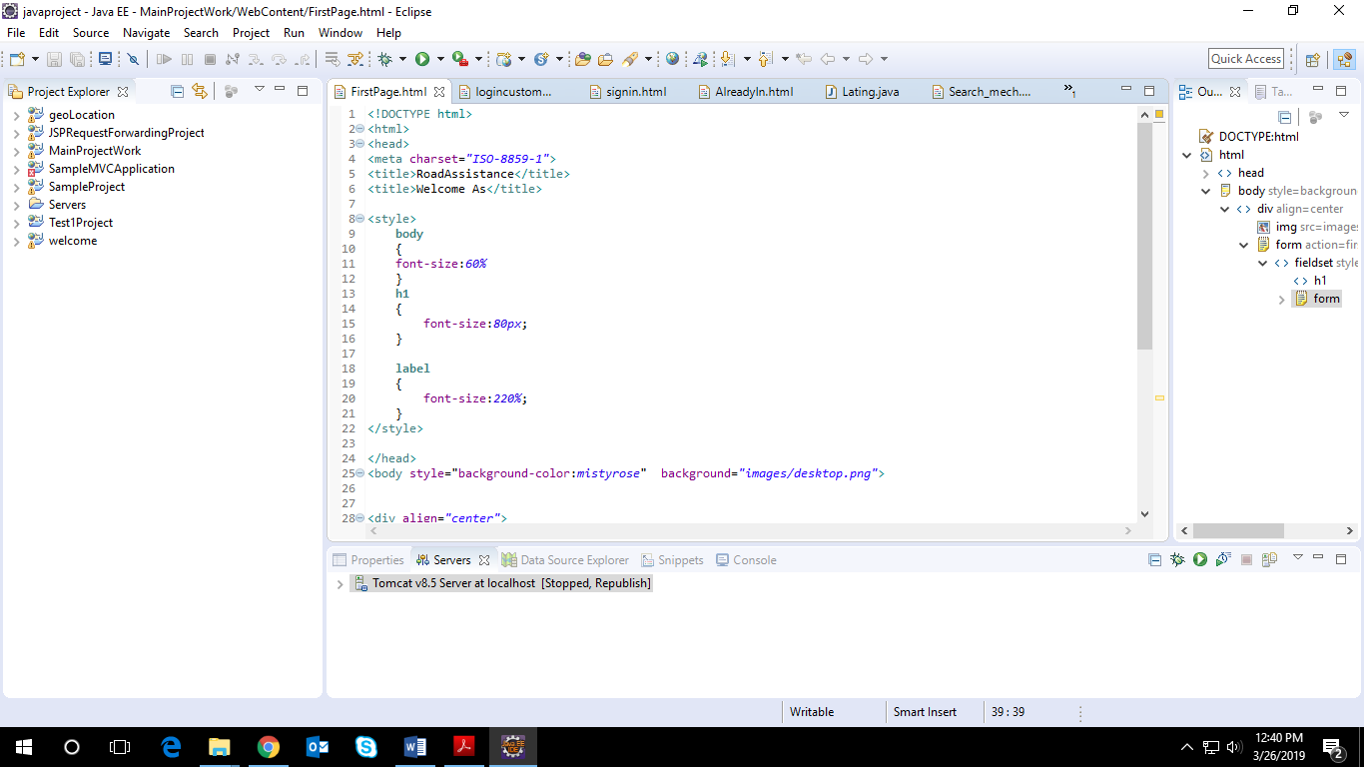

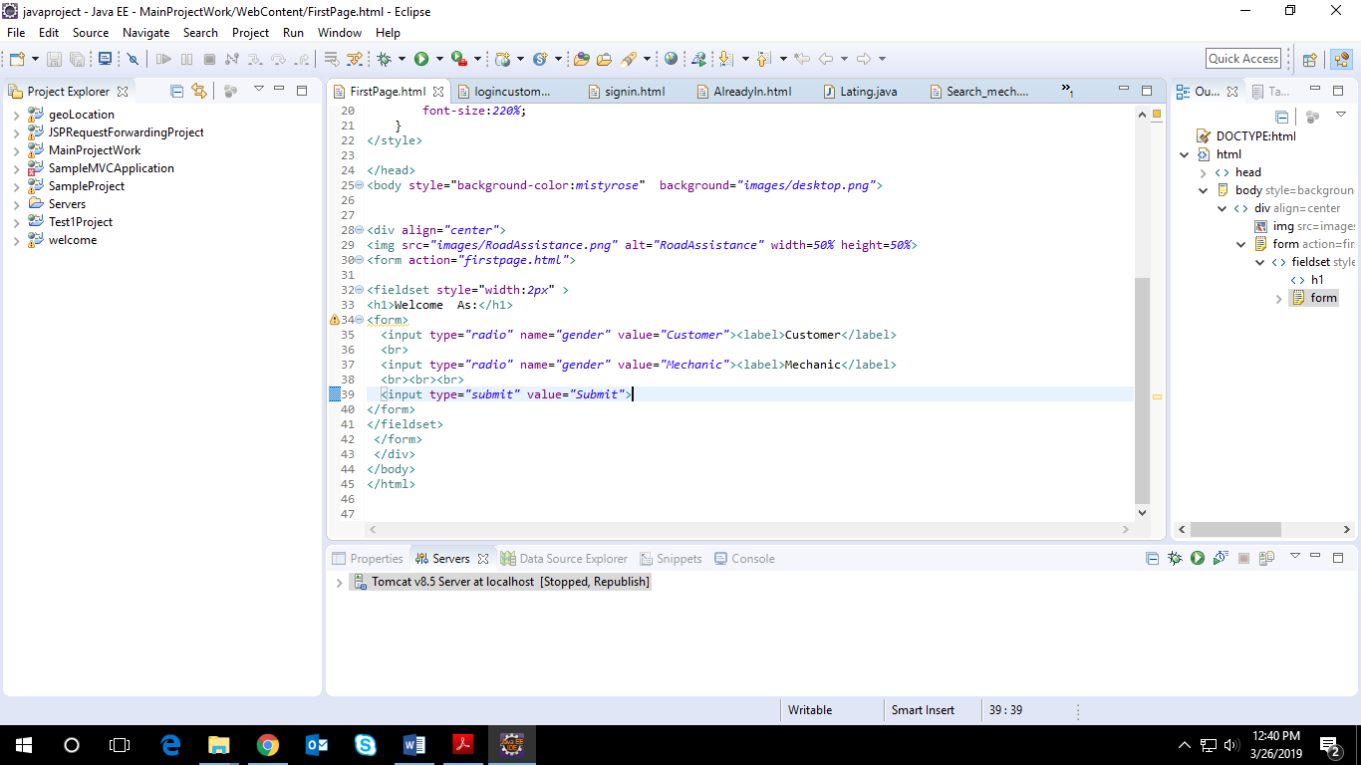

CODES REQUIRED FOR MIDDLEWARE

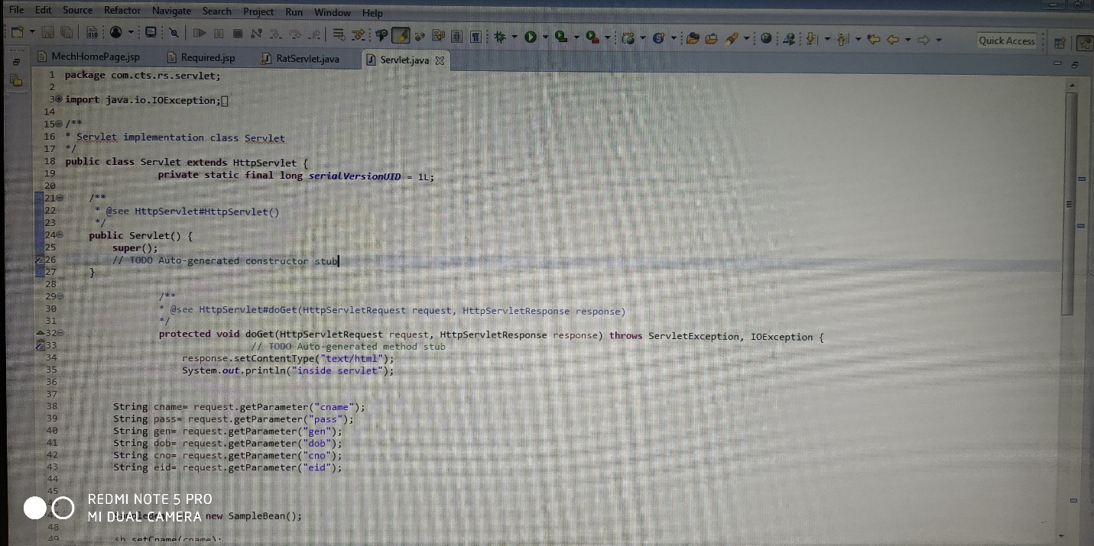

CODES FOR BACKEND

