Experiment No. 10 - Disk Scheduling Algorithms
Roll No | B106
Name | Krishang Vikram Singh
Class | B.Tech CE
Batch | C1
Date of Experiment | 20/10/24
Date of Submission | 20/10/24
Grade

Aim
Study various Disk Scheduling Algorithms and implement FCFS, SSTF, SCAN, C-SCAN, LOOK and C-LOOK.

B.1 Work done by student
Request queue: 95, 180, 34, 119, 11, 123, 62, 64. Head starts at track 50 and the last track is 199. The program is written in Python.

Code
def fcfs(req, head, end):
order = list(req)
total, cur = 0, head
for r in order:
total += abs(r - cur)
cur = r
return order, total
def sstf(req, head, end):
pending = list(req)
order = []
total, cur = 0, head
while pending:
nxt = min(pending, key=lambda r: abs(r - cur))
total += abs(nxt - cur)
cur = nxt
order.append(nxt)
pending.remove(nxt)
return order, total
def go_down(head, end):
return head <= end - head
def scan(req, head, end):
lo = sorted(r for r in req if r < head)
hi = sorted(r for r in req if r >= head)
if go_down(head, end):
order = lo[::-1] + hi
total = head + (hi[-1] if hi else 0)
else:
order = hi + lo[::-1]
total = (end - head) + (end - lo[0] if lo else 0)
return order, total
def cscan(req, head, end):
lo = sorted(r for r in req if r < head)
hi = sorted(r for r in req if r >= head)
if go_down(head, end):
order = lo[::-1] + hi[::-1]
total = head + (end - hi[0] if hi else 0)
else:
order = hi + lo
total = (end - head) + (lo[-1] if lo else 0)
return order, total
def look(req, head, end):
lo = sorted(r for r in req if r < head)
hi = sorted(r for r in req if r >= head)
order = lo[::-1] + hi if go_down(head, end) else hi + lo[::-1]
total, cur = 0, head
for r in order:
total += abs(r - cur)
cur = r
return order, total
def clook(req, head, end):
lo = sorted(r for r in req if r < head)
hi = sorted(r for r in req if r >= head)
if go_down(head, end):
first, second = lo[::-1], hi[::-1]
else:
first, second = hi, lo
total, cur = 0, head
for r in first:
total += abs(r - cur)
cur = r
for i, r in enumerate(second):
if i > 0 or not first:
total += abs(r - cur)
cur = r
return first + second, total
print("Name: Krishang Vikram Singh | Roll No: B106 | Batch: C1 | Class: B.Tech CE")
print("DOS & DOE: 20/10/24\n")
s = input("Enter request queue: ").split()
queue = [int(x) for x in s] if s else [95, 180, 34, 119, 11, 123, 62, 64]
head = int(input("Enter head position: ") or 50)
end = int(input("Enter last track: ") or 199)
algos = [("FCFS", fcfs), ("SSTF", sstf), ("SCAN", scan),
("C-SCAN", cscan), ("LOOK", look), ("C-LOOK", clook)]
results = {}
print("\nQueue:", queue, " Head:", head, " Last track:", end, "\n")
for name, fn in algos:
order, total = fn(queue, head, end)
results[name] = total
print(name, "order:", head, "->", " -> ".join(map(str, order)))
print(name, "total seek time =", total, "\n")
best = min(results, key=results.get)
print("Least head movement:", best, "=", results[best])
Screenshot of the code (IDLE):
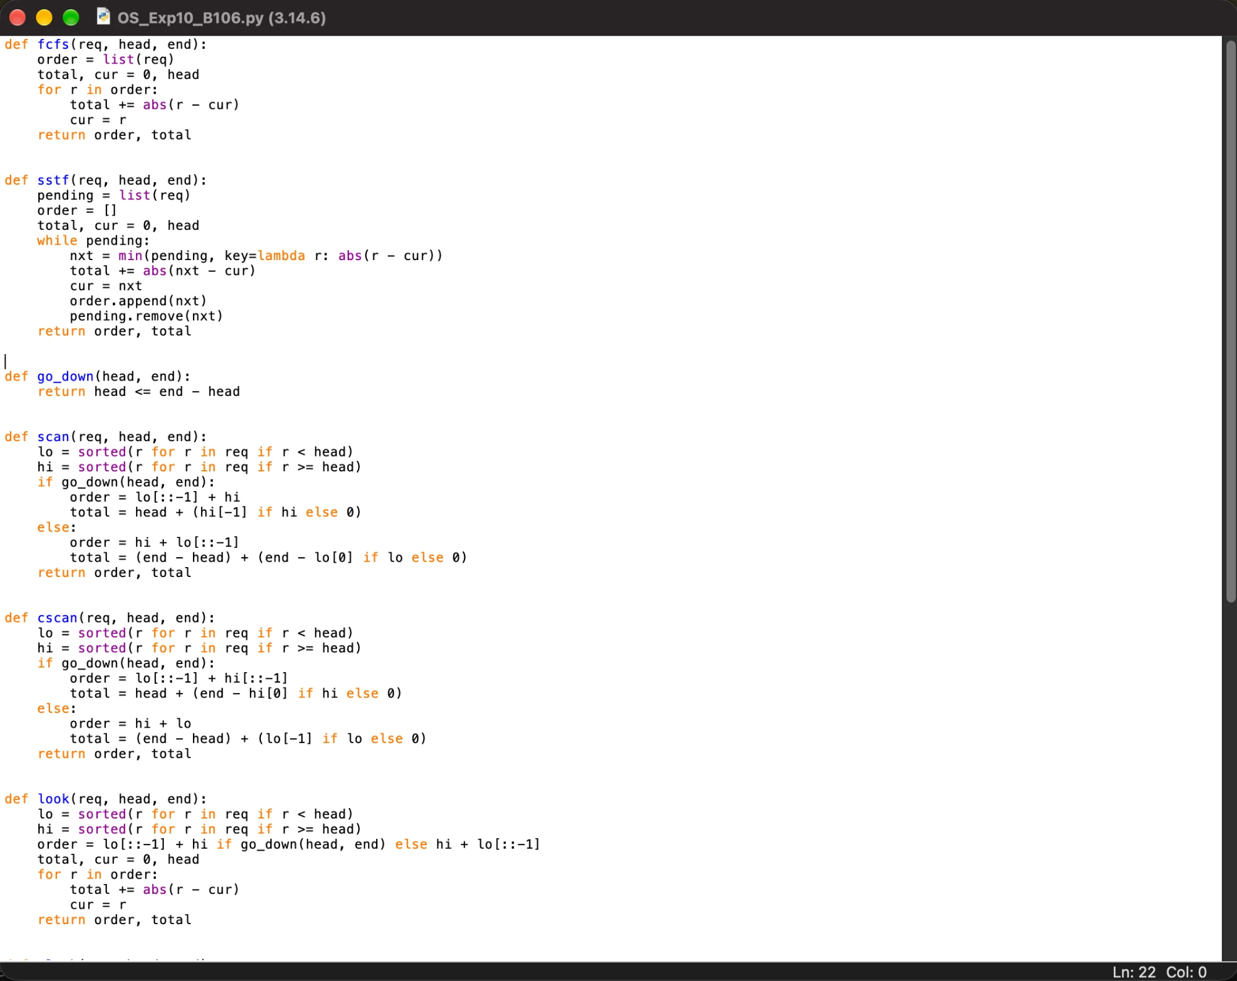

Output
Name: Krishang Vikram Singh | Roll No: B106 | Batch: C1 | Class: B.Tech CE
DOS & DOE: 20/10/24
Enter request queue: Enter head position: Enter last track:
Queue: [95, 180, 34, 119, 11, 123, 62, 64] Head: 50 Last track: 199
FCFS order: 50 -> 95 -> 180 -> 34 -> 119 -> 11 -> 123 -> 62 -> 64
FCFS total seek time = 644
SSTF order: 50 -> 62 -> 64 -> 34 -> 11 -> 95 -> 119 -> 123 -> 180
SSTF total seek time = 236
SCAN order: 50 -> 34 -> 11 -> 62 -> 64 -> 95 -> 119 -> 123 -> 180
SCAN total seek time = 230
C-SCAN order: 50 -> 34 -> 11 -> 180 -> 123 -> 119 -> 95 -> 64 -> 62
C-SCAN total seek time = 187
LOOK order: 50 -> 34 -> 11 -> 62 -> 64 -> 95 -> 119 -> 123 -> 180
LOOK total seek time = 208
C-LOOK order: 50 -> 34 -> 11 -> 180 -> 123 -> 119 -> 95 -> 64 -> 62
C-LOOK total seek time = 157
Least head movement: C-LOOK = 157
Screenshot of the output (IDLE Shell):
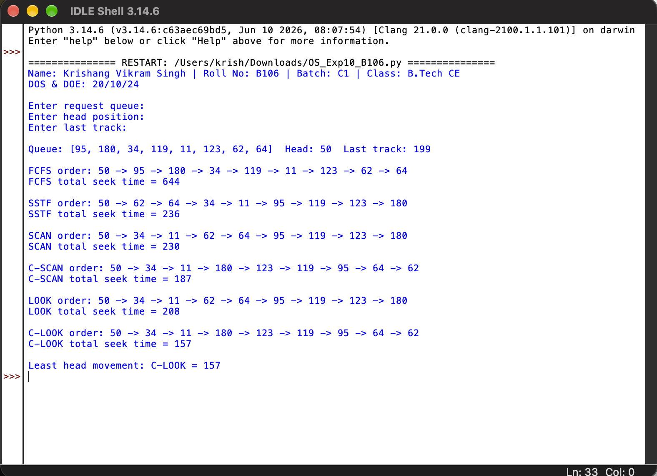

Result table
Algorithm | Total head movement (tracks)
FCFS | 644
SSTF | 236
SCAN | 230
C-SCAN | 187
LOOK | 208
C-LOOK | 157

B.2 Conclusion
I studied the disk scheduling algorithms and implemented FCFS, SSTF, SCAN, C-SCAN, LOOK and C-LOOK in Python. For the given queue, C-LOOK gave the least head movement (157 tracks) and FCFS the most (644 tracks). Seek time reduces when the head avoids unnecessary movement.

B.3 Questions of Curiosity
Q1. What is the total seek time for the algorithm implemented?
FCFS = 644, SSTF = 236, SCAN = 230, C-SCAN = 187, LOOK = 208 and C-LOOK = 157 tracks.
Q2. Which algorithm gives optimal results? Justify.
C-LOOK gives the best result here (157 tracks). It does not go to the ends of the disk; the head only travels as far as the last request in its direction and then jumps to the farthest pending request, so no movement is wasted. Its one-directional sweep also gives uniform waiting time and avoids the starvation seen in SSTF.

