Experiment: 4
PART A
Roll No.: B106 | Name: Krishang Vikram Singh
Prog/Yr/Sem: B.Tech CE / Third Year / Fifth Sem | Batch: C1
Date of Experiment: 15/10/24 | Date of Submission: 15/10/24
(PART A: TO BE REFERRED BY STUDENTS)

Aim: To understand and demonstrate end to end command-based control and modes in ArduPilot

Learning Outcomes: After completing this experiment, students should be –
- Identify and describe different flight modes available in ArduPilot (e.g., Stabilize, Loiter, Auto, Guided, Follow Me, etc.).
- Demonstrate how to configure and switch between flight modes in ArduPilot.
- Implement end-to-end command sequences to control drone navigation (takeoff, waypoint navigation, landing).
- Analyze the behavior of the drone under different modes and commands to ensure safe and efficient operation.
Theory:
ArduPilot is an open-source system widely used in drones, rovers, and other autonomous vehicles. It supports multiple flight modes that allow users to control the vehicle either manually, semi-autonomously, or fully autonomously. The system provides flexibility through command-based control, where users can send specific instructions (such as takeoff, go to waypoint, loiter, or land) to the drone.

Flight modes in ArduPilot (ArduCopter)
Mode | Type | Description
STABILIZE | Manual | Pilot controls roll/pitch/yaw angle and throttle; self-levels when sticks centred. Used for take-off and manual flight.
ALT_HOLD | Manual + assisted | Holds altitude with barometer; pilot controls roll, pitch, yaw.
LOITER | Semi-autonomous | Holds position, heading and altitude using GPS; pilot can reposition with sticks.
AUTO | Autonomous | Executes the uploaded mission (takeoff, waypoints, RTL, land).
GUIDED | Autonomous / command | Flies to points/altitudes commanded live from the ground station or companion computer.
RTL | Failsafe / auto | Returns to launch point at safe altitude and lands.
LAND | Auto | Descends and lands at the current position.
FOLLOW | Autonomous | Follows another vehicle or ground-station device (“Follow Me”).

In ArduPilot the flight mode is selected by the RC mode switch (channel 5, parameters FLTMODE1–6) or by the ground station / MAVLink command. Commands such as arm, takeoff, go to location and land are sent as MAVLink messages (e.g. via MAVProxy or Mission Planner).
Simulation Screenshots:
Experiment performed in ArduPilot SITL (Software-In-The-Loop) with MAVProxy / Mission Planner:
sim_vehicle.py -v ArduCopter --console --map # start SITL
mode GUIDED # switch to GUIDED mode
arm throttle # arm motors
takeoff 20 # take off to 20 m
guided <lat> <lon> 20 # go to a waypoint
mode LOITER # hold position
wp load mission.txt ; mode AUTO # run uploaded mission
mode RTL # return to launch
mode LAND # land and disarm

Step | Command / Mode | Expected behaviour
1 | STABILIZE → arm | Motors spin at idle; manual control
2 | GUIDED + takeoff 20 | Drone climbs vertically to 20 m
3 | guided lat lon alt | Flies to the commanded point
4 | LOITER | Holds position despite wind
5 | AUTO | Executes mission waypoints
6 | RTL / LAND | Returns home and lands; disarms

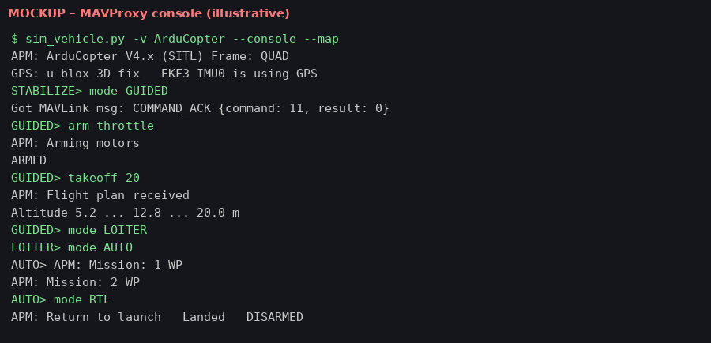
Fig. 1 (mockup): MAVProxy console – mode changes, arm, takeoff, AUTO, RTL
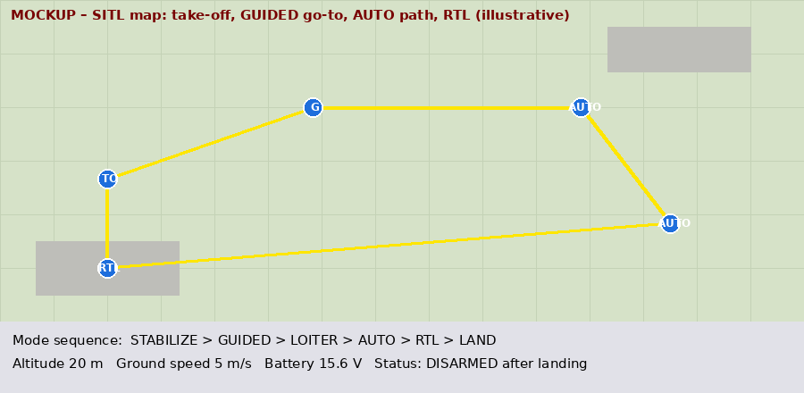
Fig. 2 (mockup): SITL map showing the flown path

PART B

Observations and Learning:
• STABILIZE gave full manual control and needed constant pilot input; LOITER and ALT_HOLD reduced workload by holding position/altitude automatically.
• In GUIDED mode the drone responded to each command in order (arm → takeoff → go to → land); the vehicle must be armed and in GUIDED before takeoff command is accepted.
• In AUTO mode the drone followed the pre-loaded mission without pilot input; RTL brought it back to the home point.
• The flight mode can be changed in flight with the mode switch or ground station; GPS lock is required for LOITER, AUTO, GUIDED and RTL.
• Pre-arm checks (GPS, compass, battery, RC) must pass before the vehicle can be armed.
Conclusion:
Different ArduPilot flight modes (Stabilize, Alt Hold, Loiter, Auto, Guided, RTL, Land, Follow) were studied and configured, and end-to-end command sequences for take-off, waypoint navigation and landing were demonstrated in simulation. The behaviour of the drone in each mode was analysed, showing how the degree of autonomy increases from manual to fully autonomous and how safe, efficient operation is ensured. All learning outcomes were attained.

