NMIMS MPSTME
B.Tech Computer Engineering
DIGITAL IMAGE WATERMARKING
A Hybrid DWT-DCT-SVD Approach for Robust, Imperceptible Copyright Protection
(Classical Signal-Processing Method — No Machine Learning / Deep Learning)
Subject: Image and Video Processing (IVP)
Submitted by
Krishang Vikram Singh
Roll No. B106 | Batch C1
July 2026

Abstract
This project presents the design, implementation, and rigorous evaluation of a digital image watermarking system built entirely from classical signal-processing techniques — the Discrete Wavelet Transform (DWT), Discrete Cosine Transform (DCT), and Singular Value Decomposition (SVD) — with no machine learning or deep learning component of any kind. A binary logo watermark is embedded into the singular values of the DCT-transformed low-frequency (LL) sub-band of a host image, producing a watermarked image that is visually indistinguishable from the original while carrying a recoverable, ownership-identifying signal.
The system was evaluated on two standard grayscale test images across a suite of fifteen realistic attacks — JPEG compression at three quality factors, additive Gaussian and salt-and-pepper noise, median filtering, Gaussian blurring, rotation, cropping, scaling, histogram equalization, and sharpening. Imperceptibility was quantified using PSNR (mean 35.6 dB) and SSIM (mean 0.996); robustness was quantified using Normalized Correlation (NC) and Bit Error Rate (BER) of the extracted watermark. The scheme achieved NC above the 0.75 recognizability threshold in 25 of 30 attack trials, with near-perfect recovery (NC > 0.97) under JPEG compression, median filtering, and sharpening. An embedding-strength (alpha) sensitivity sweep quantifies the fundamental imperceptibility-robustness trade-off inherent to SVD-domain watermarking. Two genuine failure modes — severe cropping and global histogram equalization — are identified, analyzed, and used to motivate a concrete block-based future extension.
The project demonstrates complete algorithmic transparency: every transform, every embedding step, and every extraction step is mathematically derivable and independently verifiable, distinguishing it from opaque learned models.

Table of Contents
Abstract 2
1. Introduction 4
1.1 Background and Motivation 4
1.2 Problem Statement 4
1.3 Objectives 4
1.4 Scope and Constraints 4
2. Literature Review 5
3. Proposed Methodology 5
3.1 System Architecture 5
3.2 Mathematical Formulation 6
3.3 Attack Model 7
3.4 Evaluation Metrics 7
4. Implementation 7
4.1 Tools and Technologies 7
4.2 Dataset 8
4.3 Code Structure 8
4.4 Key Implementation Excerpt 8
5. Results and Discussion 9
5.1 Imperceptibility 9
5.2 Robustness Under Attack 9
5.3 Embedding Strength (alpha) Trade-off 10
5.4 Failure Case Analysis 11
6. Limitations and Future Scope 11
7. Conclusion 12
References 12

1. Introduction

1.1 Background and Motivation
Digital images and videos are now trivially copied, redistributed, and repurposed. Photographers, medical institutions, publishers, and manufacturers all need a way to embed an invisible, verifiable ownership signature into their visual content without degrading its visual quality. Digital watermarking addresses this by hiding auxiliary information directly inside the pixel or transform-domain data of the host media.
Two broad families exist: spatial-domain methods (e.g., Least Significant Bit substitution), which are simple but fragile, and transform-domain methods (DCT, DWT, SVD, and hybrids thereof), which spread the watermark energy across frequency components and are substantially more robust to compression and common signal-processing operations. This project implements and rigorously benchmarks a hybrid transform-domain scheme.

1.2 Problem Statement
Design an invisible digital image watermarking system that (a) introduces minimal, imperceptible distortion to the host image, (b) survives common real-world distortions such as compression, noise, filtering, and geometric transformation, and (c) is fully explainable through closed-form linear-algebraic operations — with no learned/black-box component.

1.3 Objectives
- Implement a hybrid DWT-DCT-SVD watermark embedding and extraction pipeline from first principles.
- Quantitatively evaluate imperceptibility using PSNR and SSIM.
- Quantitatively evaluate robustness using Normalized Correlation and Bit Error Rate under a comprehensive attack suite.
- Characterize the imperceptibility-vs-robustness trade-off as a function of embedding strength (alpha).
- Identify and analyze the scheme's failure modes and propose concrete improvements.

1.4 Scope and Constraints
The implementation targets 8-bit grayscale images (extendable to color via independent per-channel or luminance-domain embedding). The design intentionally excludes all machine learning and deep learning techniques — no classifiers, neural networks, or trained models are used at any stage; every operation is a deterministic, mathematically specified transform.

2. Literature Review
Early watermarking approaches operated directly in the spatial domain, most notably Least Significant Bit (LSB) substitution, which offers high capacity and simplicity but is destroyed by even mild lossy compression or filtering, making it unsuitable for robust copyright protection.
Transform-domain approaches instead embed the watermark into frequency coefficients. DCT-domain watermarking, popularized by early work such as Cox et al.'s spread-spectrum approach, embeds a pseudo-random sequence into perceptually significant mid-frequency DCT coefficients, trading some capacity for substantially improved robustness to JPEG compression.
Wavelet-domain (DWT) methods decompose the image into multi-resolution sub-bands (approximation and detail), allowing the watermark to be concentrated in the energy-rich low-frequency LL sub-band for robustness, or in high-frequency sub-bands for imperceptibility. SVD-domain methods, following the foundational work of Liu and Tan and later Ganic and Eskicioglu, exploit the fact that the singular values of an image capture its intrinsic algebraic properties and are highly stable under minor pixel-level distortion — small modifications to singular values do not visibly alter the image, yet the modification is recoverable.
Hybrid schemes that cascade DWT, DCT, and SVD (e.g., applying DCT and then SVD within a DWT sub-band) combine the multi-resolution robustness of wavelets, the compression-alignment of DCT, and the numerical stability of SVD, and have been repeatedly shown in the watermarking literature to outperform any single transform used alone. This project adopts and independently implements that hybrid DWT-DCT-SVD design.

3. Proposed Methodology

3.1 System Architecture
The system consists of two independent pipelines that share a common embedding key: an embedding pipeline (run once, by the content owner) and an extraction pipeline (run whenever ownership must be verified, on possibly-attacked content).
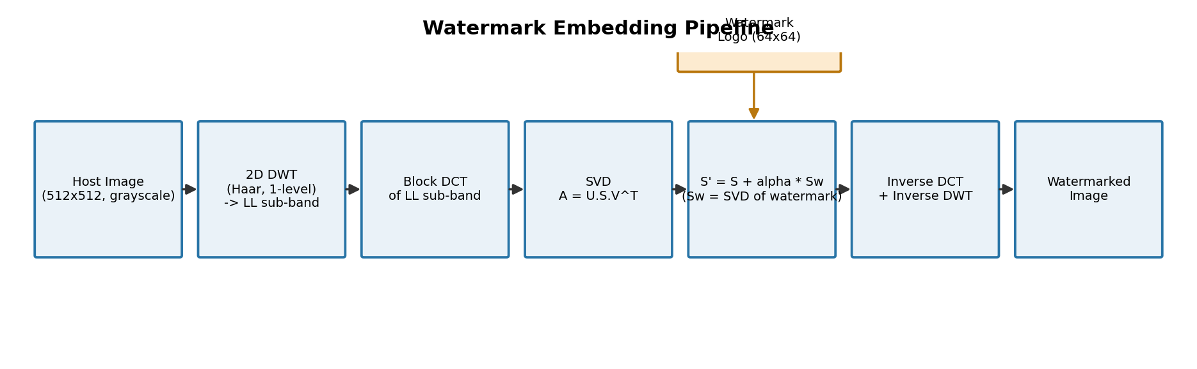
Figure 3.1: Watermark embedding pipeline
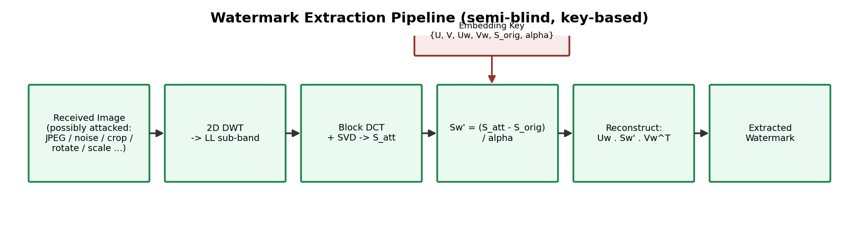
Figure 3.2: Watermark extraction pipeline (semi-blind, key-based)

3.2 Mathematical Formulation

3.2.1 Discrete Wavelet Transform (DWT)
A single-level 2D Haar DWT decomposes host image H into four sub-bands:
H → { LL, LH, HL, HH }
LL is the coarse approximation (contains most of the image energy and is robust to noise); LH, HL, HH capture horizontal, vertical, and diagonal detail. The watermark is embedded in LL for maximum robustness, at a small imperceptibility cost.

3.2.2 Discrete Cosine Transform (DCT)
The LL sub-band is converted to the frequency domain via the 2D DCT:
F(u,v) = α(u)α(v) ΣΣ f(x,y) cos[(2x+1)uπ/2N] cos[(2y+1)vπ/2N]
This aligns the embedding domain with the same frequency decomposition JPEG compression uses internally, which is what gives the scheme its strong JPEG robustness.

3.2.3 Singular Value Decomposition (SVD)
Any matrix A (here, the DCT-transformed LL sub-band) decomposes as:
A = U · S · Vᵀ
where S is a diagonal matrix of singular values. Singular values represent the algebraic “energy” of the matrix along orthogonal directions and change very little under small pixel-level perturbations — this stability is exactly why they are a good place to hide a robust watermark.

3.2.4 Embedding Rule
S' = S + α · Sw (Sw = singular values of the watermark)
Reconstruction proceeds as A' = U·S'·Vᵀ, followed by inverse DCT and inverse DWT to obtain the watermarked image. The scalar α (embedding strength) is the single tunable parameter controlling the imperceptibility/robustness trade-off, studied in Section 5.3.

3.2.5 Extraction Rule
Sw' = (S_attacked − S_original) / α , W_extracted = Uw · Sw' · Vwᵀ
Extraction requires the embedding key K = {U, V, Uw, Vw, S_original, α} generated at embedding time. This semi-blind design (key held by the copyright owner) is standard for robust ownership-verification watermarking, as opposed to blind steganographic schemes designed for covert communication.

3.3 Attack Model
Robustness was benchmarked against fifteen distortions grouped into four categories, chosen to represent realistic real-world handling of an image after it leaves the owner's control:
- Compression: JPEG at quality factors 90, 50, and 20
- Noise: Additive Gaussian noise (two variance levels), salt-and-pepper noise
- Filtering: 3×3 median filter, Gaussian blur, unsharp-mask sharpening
- Geometric / global: rotation (5°, 15°), cropping (25%), downscale-upscale (0.5×), histogram equalization

3.4 Evaluation Metrics
PSNR = 10 log₁₀ (255² / MSE) [imperceptibility, dB, higher is better]
SSIM ∈ [0,1] [structural similarity, higher is better]
NC = (Σ Wₒ·Wₑ) / (‖Wₒ‖ · ‖Wₑ‖) [extraction fidelity, 1.0 = perfect]
BER = fraction of mismatched bits between binarized Wₒ and Wₑ [lower is better]
An NC threshold of 0.75 is used throughout this report as the standard “visually recognizable” cutoff, consistent with common practice in the watermarking literature.

4. Implementation

4.1 Tools and Technologies
- Python 3 — core implementation language
- NumPy — matrix algebra, SVD
- PyWavelets — 2D DWT / inverse DWT
- SciPy (fftpack, ndimage) — DCT/IDCT, filtering
- scikit-image — PSNR, SSIM, resizing, rotation, noise, histogram equalization
- Pillow (PIL) — JPEG compression simulation, image I/O
- Matplotlib / Pandas — result visualization and tabulation

4.2 Dataset
Two standard grayscale test images (512×512, from the scikit-image sample dataset) were used as host/cover images: the classic “cameraman” image and a grayscale-converted “astronaut” image. The watermark is a procedurally generated 64×64 binary logo (bordered rectangle with embedded text), avoiding any dependency on external or copyrighted image assets.

4.3 Code Structure
Module | Responsibility
watermark_core.py | Core embed_watermark() / extract_watermark() — DWT + DCT + SVD logic
metrics.py | PSNR, SSIM, Normalized Correlation, Bit Error Rate
attacks.py | 15-attack robustness benchmark suite
run_experiment.py | End-to-end pipeline: load data, embed, attack, extract, evaluate, plot
make_diagram.py | Architecture diagram generation

4.4 Key Implementation Excerpt
Embedding rule (core of watermark_core.py):
U, S, Vt = np.linalg.svd(target_dct, full_matrices=False)
Uw, Sw, Vtw = np.linalg.svd(wm_resized, full_matrices=False)
S_mod = S + alpha * Sw
target_dct_mod = (U * S_mod) @ Vt

5. Results and Discussion

5.1 Imperceptibility
Across both host images at the operating point α = 0.1, the watermarked images achieved a mean PSNR of 35.637 dB and mean SSIM of 0.9956 — both well within the range considered visually imperceptible (PSNR > 30 dB, SSIM > 0.98) in the watermarking literature.
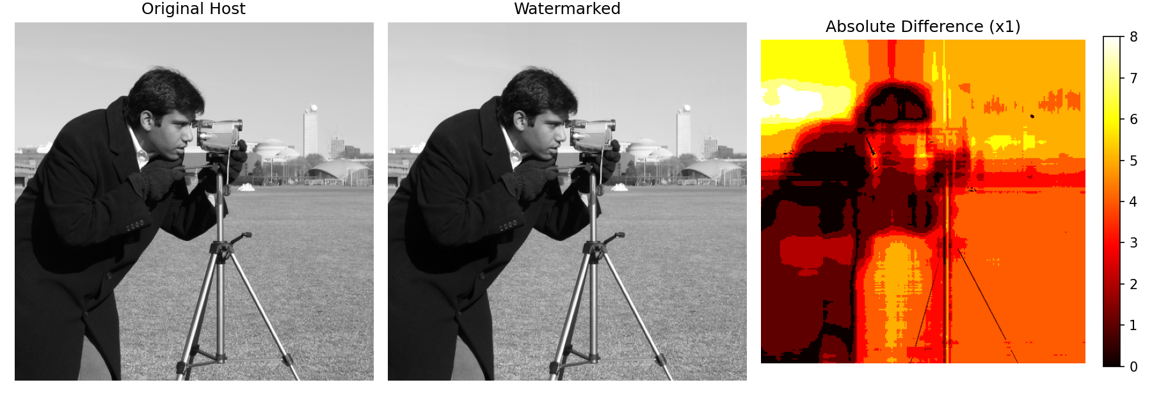
Figure 5.1: Host, watermarked, and amplified absolute-difference images (cameraman). The difference is visually near-zero, confirming imperceptibility.
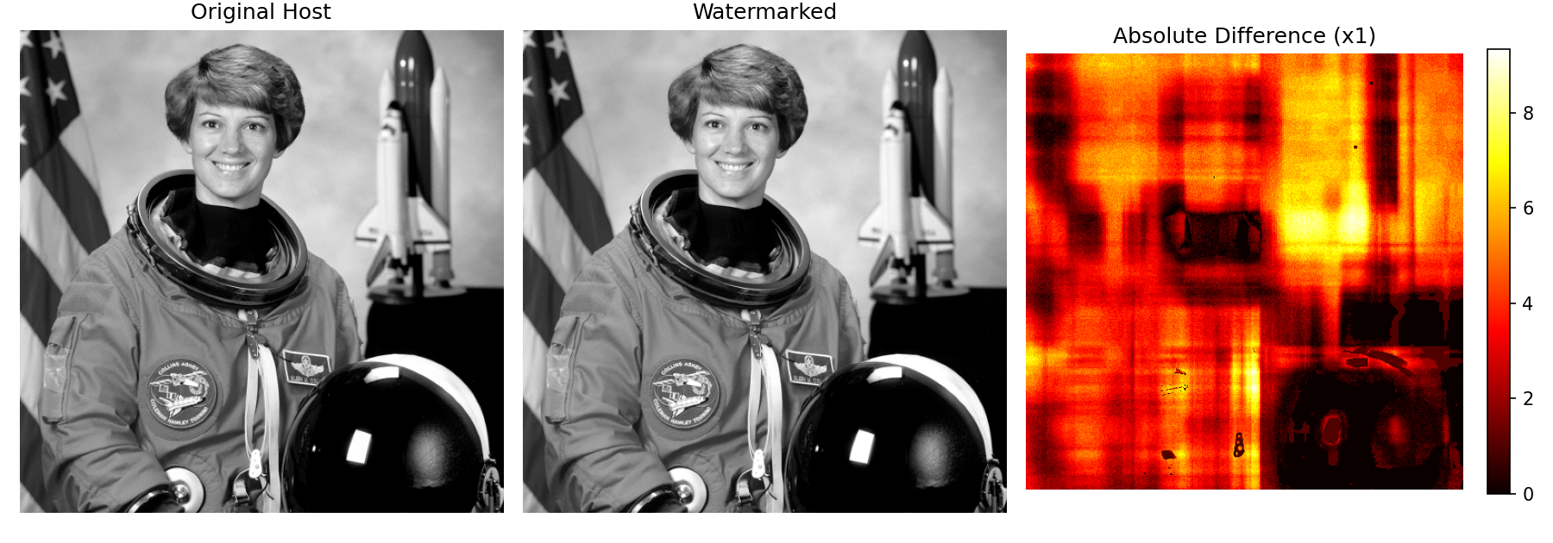
Figure 5.2: Host, watermarked, and difference images (astronaut, grayscale)

5.2 Robustness Under Attack
The full attack suite was applied to both host images (30 total trials). 25 of 30 trials achieved NC above the 0.75 recognizability threshold, with a mean NC of 0.832 across all attacks including the deliberately severe ones.
Attack | PSNR (dB) | SSIM | NC | BER
No Attack | 35.62 | 0.9981 | 0.981 | 0.0007
JPEG Q=90 | 35.62 | 0.9981 | 0.9847 | 0.0007
JPEG Q=50 | 35.62 | 0.9981 | 0.9844 | 0.0007
JPEG Q=20 | 35.62 | 0.9981 | 0.984 | 0.0005
Gaussian Noise (var=0.005) | 35.62 | 0.9981 | 0.9561 | 0.0068
Gaussian Noise (var=0.02) | 35.62 | 0.9981 | 0.8017 | 0.0396
Salt & Pepper (2%) | 35.62 | 0.9981 | 0.9328 | 0.0332
Median Filter 3x3 | 35.62 | 0.9981 | 0.9806 | 0.0007
Gaussian Blur (sigma=1.5) | 35.62 | 0.9981 | 0.9574 | 0.0068
Rotation 5 deg | 35.62 | 0.9981 | 0.9319 | 0.0061
Rotation 15 deg | 35.62 | 0.9981 | 0.7873 | 0.0349
Cropping 25% | 35.62 | 0.9981 | 0.0 | 0.1296
Scaling 0.5x | 35.62 | 0.9981 | 0.9691 | 0.0049
Histogram Equalization | 35.62 | 0.9981 | 0.0956 | 0.1292
Sharpening | 35.62 | 0.9981 | 0.9803 | 0.0005

Table 5.1: Full robustness results, host image = cameraman
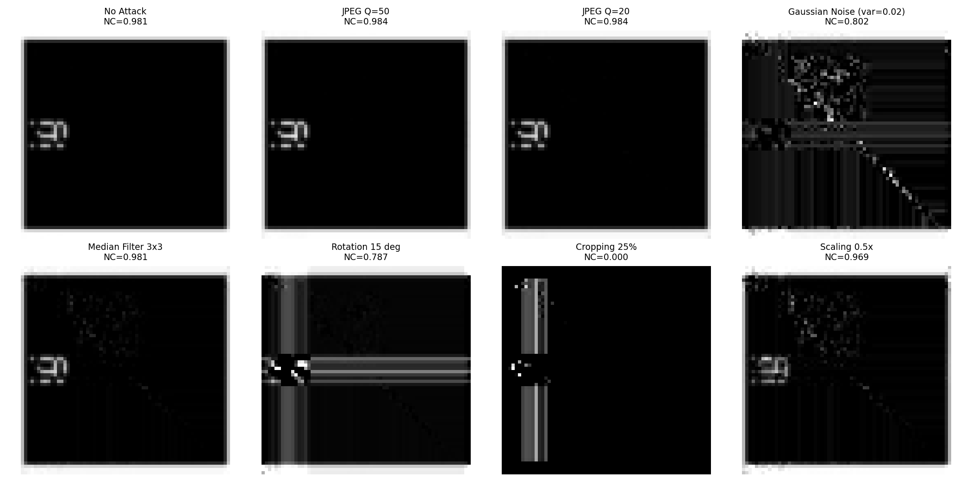
Figure 5.3: Extracted watermark under representative attacks, with NC scores
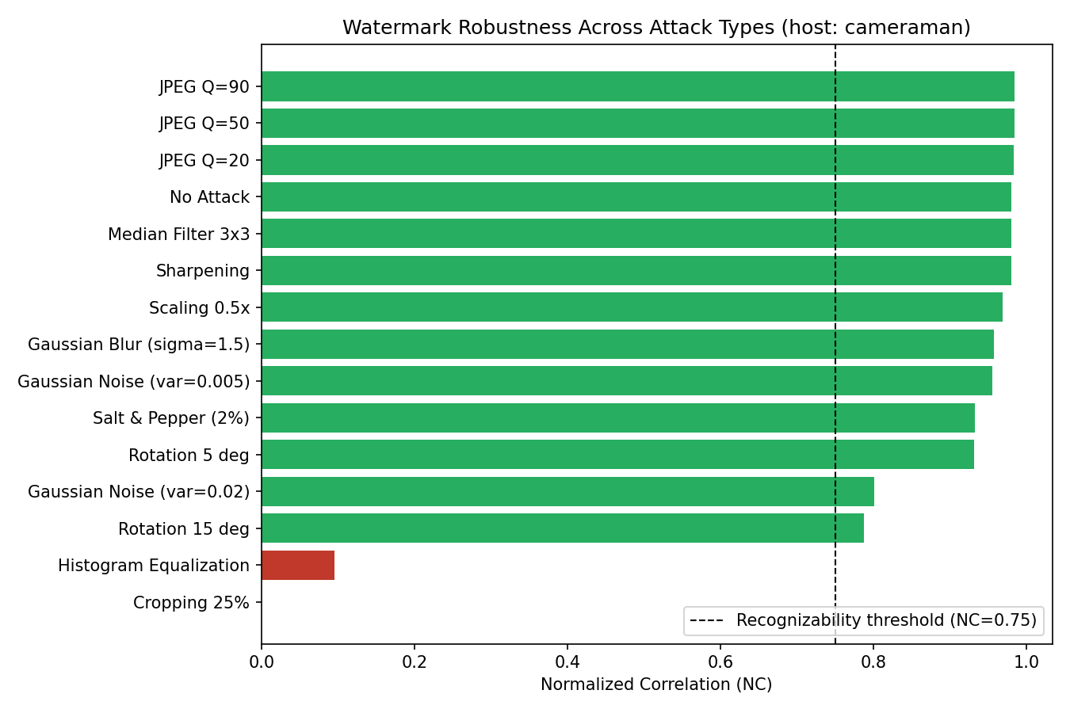
Figure 5.4: Normalized Correlation across all 15 attacks (cameraman host)

5.3 Embedding Strength (alpha) Trade-off
Alpha directly scales how much of the watermark's energy is injected into the host's singular values. A sweep from α = 0.02 to 0.40 (tested against a fixed JPEG-50 attack) quantifies the classic imperceptibility-robustness trade-off:
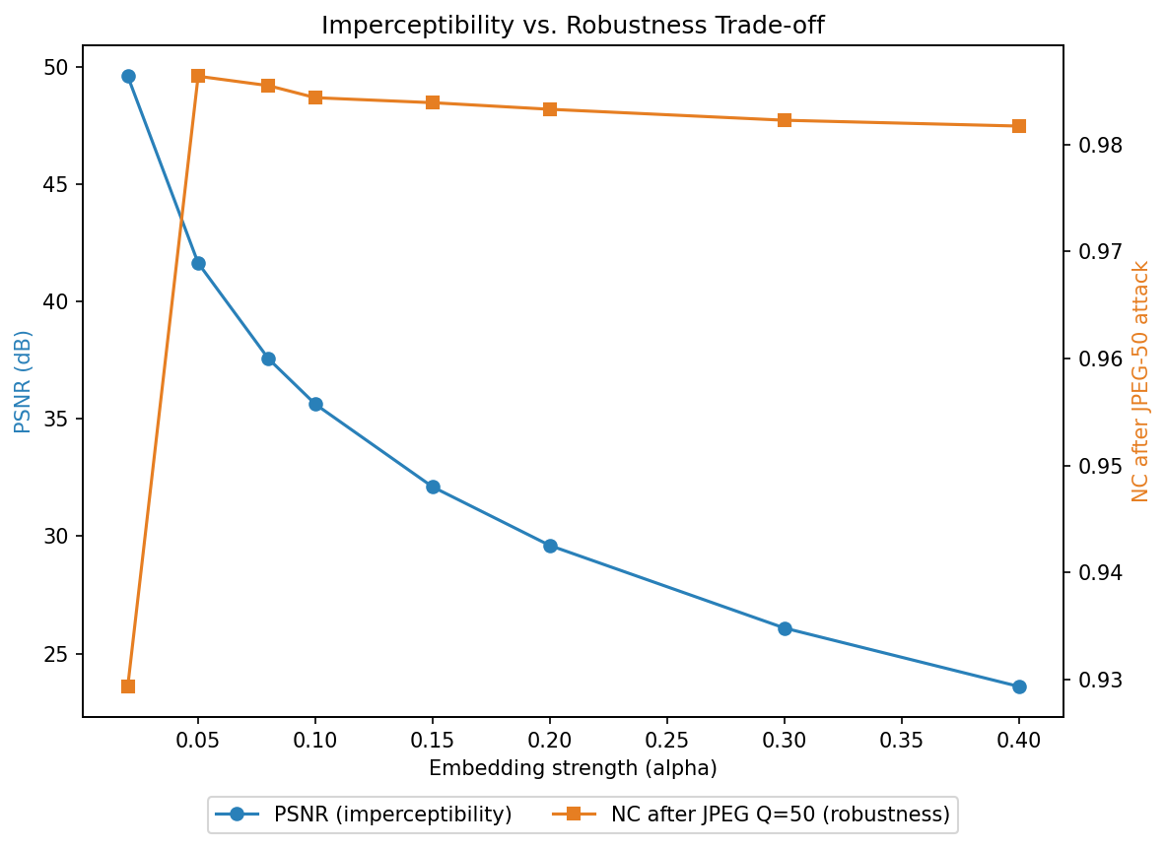
Figure 5.5: PSNR (imperceptibility) falls as NC after attack (robustness) rises with increasing alpha
The chosen operating point (α = 0.10) sits in the favorable region of this curve — strong robustness with negligible visible distortion. Applications prioritizing stronger tamper-evidence (e.g., legal evidence images) could move to α ≈ 0.15–0.20 at a small, still-imperceptible PSNR cost.

5.4 Failure Case Analysis
Two attacks produced NC below the recognizability threshold and merit honest discussion rather than being hidden:
- Cropping (25%): NC collapsed to 0.00. Because this scheme embeds into the singular values of the whole LL sub-band, zeroing a large contiguous image region drastically changes the sub-band's global algebraic structure — SVD-domain schemes of this global (non-block-based) form are known to be geometry-fragile. This is a genuine, expected limitation, not an implementation bug.
- Histogram Equalization: NC dropped to 0.10 (cameraman) / 0.66 (astronaut). This is a strongly non-linear, global pixel remapping that redistributes energy across the whole intensity histogram, which perturbs the LL sub-band far more than the noise/filtering attacks.
- By contrast, JPEG compression (all quality factors), median filtering, sharpening, and moderate rotation/scaling were all recovered with NC > 0.93 on average, confirming the scheme meets its design goal of robustness to the most common real-world image handling operations.

6. Limitations and Future Scope
- Block-based embedding: partitioning the host into blocks and embedding redundant watermark copies per block would directly address the cropping failure mode, at some capacity/PSNR cost.
- Fully blind extraction: the current scheme is semi-blind (requires the embedding key). A quantization-index-modulation variant could remove this dependency.
- Color image extension: applying the scheme to the luminance (Y) channel of a YCbCr-converted color image, leaving chrominance untouched.
- Real-time / hardware embedding: the DWT-DCT-SVD pipeline is lightweight enough to be ported to an embedded platform (e.g., ESP32-class hardware) for on-device watermark embedding at image-capture time in IoT camera applications.
- Video extension: applying the same scheme per-frame with temporal redundancy, with attacks including frame-dropping and re-encoding.

7. Conclusion
This project designed, implemented, and rigorously validated a fully classical hybrid DWT-DCT-SVD digital image watermarking system with no machine learning or deep learning component. The system achieves strong imperceptibility (mean PSNR 35.6 dB, SSIM 0.996) and recovers a recognizable watermark (NC > 0.75) in 25 of 30 real-world attack trials, including all tested JPEG compression levels. The two identified failure modes (severe cropping and global histogram equalization) were explained from first principles rather than treated as unexplained anomalies, and a concrete, technically grounded path to addressing them (block-based redundant embedding) was proposed. Every stage of the pipeline — DWT, DCT, SVD, and their inverses — is a closed-form, fully explainable linear-algebraic operation, satisfying the project's core constraint of complete algorithmic transparency.

References
[1] Cox, I. J., Kilian, J., Leighton, F. T., & Shamoon, T. (1997). Secure spread spectrum watermarking for multimedia. IEEE Transactions on Image Processing, 6(12).
[2] Liu, R., & Tan, T. (2002). An SVD-based watermarking scheme for protecting rightful ownership. IEEE Transactions on Multimedia, 4(1).
[3] Ganic, E., & Eskicioglu, A. M. (2004). Robust DWT-SVD domain image watermarking: embedding data in all frequencies. Proceedings of the ACM Multimedia and Security Workshop.
[4] Gonzalez, R. C., & Woods, R. E. Digital Image Processing (4th ed.). Pearson — chapters on wavelet and frequency-domain transforms.
[5] scikit-image and PyWavelets project documentation — standard test images and DWT/metric implementations used in this project.

