PART A
(PART A : TO BE REFFERED BY STUDENTS)

Experiment No. 09

A.1—Aim:
Study various Page replacement Algorithms and implementation of any (LRU or Optimal) Page Replacement Algorithm.

A.2--- Prerequisite:
Memory Management & Page Replacement Algorithms.

A.3--- Outcome:
After successful completion of this experiment students will be able to:
- Understand the concept of Memory Management & Page Replacement.
- Implement Page Replacement Algorithms

A.4--- Theory:

Page replacement algorithms are the techniques using which an Operating System decides which memory pages to swap out, write to disk when a page of memory needs to be allocated. Paging happens whenever a page fault occurs and a free page cannot be used for allocation purpose accounting to reason that pages are not available or the number of free pages is lower than required pages.

When the page that was selected for replacement and was paged out, is referenced again, it has to read in from disk, and this requires for I/O completion. This process determines the quality of the page replacement algorithm: the lesser the time waiting for page-ins, the better is the algorithm.

A page replacement algorithm looks at the limited information about accessing the pages provided by hardware, and tries to select which pages should be replaced to minimize the total number of page misses, while balancing it with the costs of primary storage and processor time of the algorithm itself. There are many different page replacement algorithms. We evaluate an algorithm by running it on a particular string of memory reference and computing the number of page faults

Various Page Replacement Algorithms are :
1. FIFO
2. LRU
3. Optimal

Optimal Page algorithm
- An optimal page-replacement algorithm has the lowest page-fault rate of all algorithms. An optimal page-replacement algorithm exists, and has been called OPT or MIN.
- Replace the page that will not be used for the longest period of time. Use the time when a page is to be used.
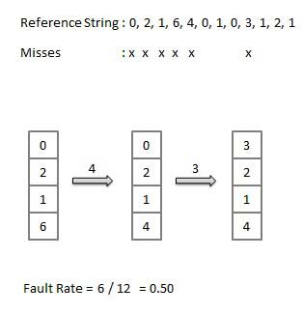

Least Recently Used (LRU) algorithm
- Page which has not been used for the longest time in main memory is the one which will be selected for replacement.
- Easy to implement, keep a list, replace pages by looking back into time.
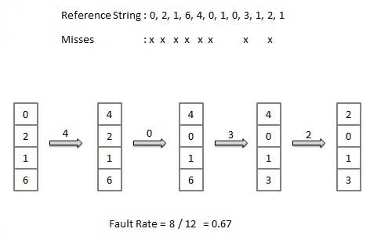

A.5--- Procedure:
Task:
1. Page Replacement Algorithms.
2. Implement LRU or Optimal.
3. Save and close the file and name it as EXP9_ your Roll no.
PART B
(PART B: TO BE COMPLETED BY STUDENTS)
Roll No: B106 | Name: Krishang Vikram Singh
Class: B.Tech CE | Batch: C1
Date of Experiment 13/10/24 | Date of Submission 13/10/24
Grade:

B.1 Work done by student

Aim: To study page replacement algorithms and implement FIFO, LRU and Optimal page replacement in Python.

Reference string: 7 0 1 2 0 3 0 4 2 3 0 3 2 1 2 0 1 7 0 1 Number of frames: 3

Python Code:

def fifo(pages, frames):

mem, faults, steps = [], 0, []

for p in pages:

if p not in mem:

faults += 1

if len(mem) == frames:

mem.pop(0)

mem.append(p)

steps.append((p, list(mem), "Fault"))

else:

steps.append((p, list(mem), "Hit"))

return faults, steps

def lru(pages, frames):

mem, faults, steps = [], 0, []

for p in pages:

if p in mem:

mem.remove(p)

mem.append(p)

steps.append((p, list(mem), "Hit"))

else:

faults += 1

if len(mem) == frames:

mem.pop(0)

mem.append(p)

steps.append((p, list(mem), "Fault"))

return faults, steps

def optimal(pages, frames):

mem, faults, steps = [], 0, []

for i, p in enumerate(pages):

if p in mem:

steps.append((p, list(mem), "Hit"))

continue

faults += 1

if len(mem) < frames:

mem.append(p)

else:

future = pages[i + 1:]

victim = max(mem, key=lambda q: future.index(q) if q in future else len(future) + 1)

mem[mem.index(victim)] = p

steps.append((p, list(mem), "Fault"))

return faults, steps

def show(name, pages, frames, algo):

faults, steps = algo(pages, frames)

print(f"\n=== {name} ({frames} frames) ===")

print(f"{'Page':<6}{'Frames':<20}Result")

for p, mem, res in steps:

print(f"{p:<6}{str(mem):<20}{res}")

print(f"Total Page Faults = {faults}")

print(f"Page Hits = {len(pages) - faults}")

print(f"Fault Rate = {faults / len(pages):.2f}")

return faults

if __name__ == "__main__":

print("Name: Krishang Vikram Singh | Roll No: B106 | Batch: C1 | Class: B.Tech CE | DOS & DOE: 13/10/24")

ref = [7, 0, 1, 2, 0, 3, 0, 4, 2, 3, 0, 3, 2, 1, 2, 0, 1, 7, 0, 1]

n = 3

print("Reference string:", ref)

r = {nm: show(nm, ref, n, f) for nm, f in

[("FIFO", fifo), ("LRU", lru), ("Optimal", optimal)]}

print("\nSummary:", r)

Code Screenshot:

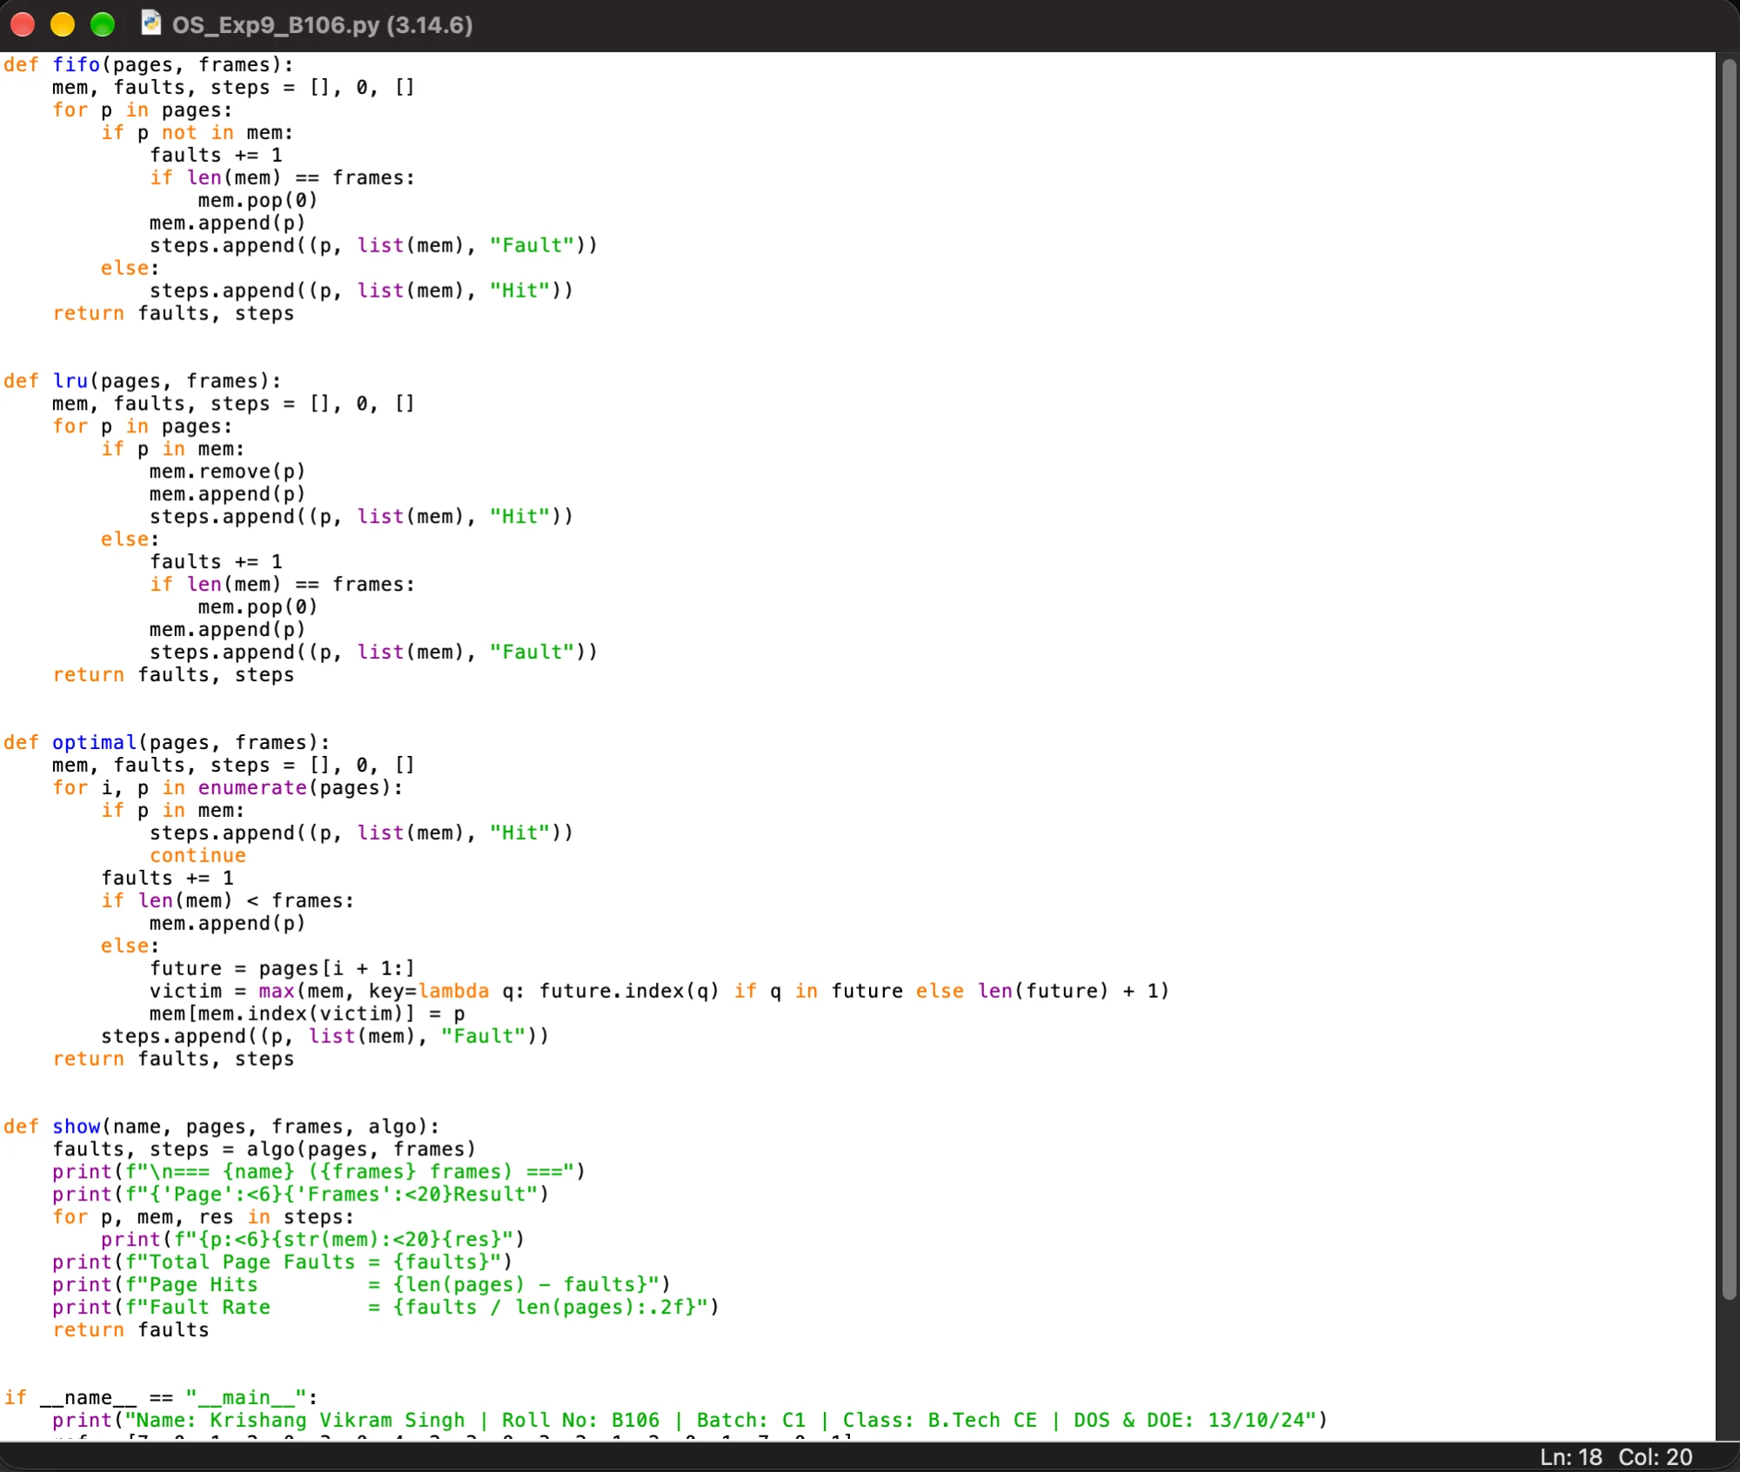

Output:

Name: Krishang Vikram Singh | Roll No: B106 | Batch: C1 | Class: B.Tech CE | DOS & DOE: 13/10/24

Reference string: [7, 0, 1, 2, 0, 3, 0, 4, 2, 3, 0, 3, 2, 1, 2, 0, 1, 7, 0, 1]

=== FIFO (3 frames) ===

Page Frames Result

7 [7] Fault

0 [7, 0] Fault

1 [7, 0, 1] Fault

2 [0, 1, 2] Fault

0 [0, 1, 2] Hit

3 [1, 2, 3] Fault

0 [2, 3, 0] Fault

4 [3, 0, 4] Fault

2 [0, 4, 2] Fault

3 [4, 2, 3] Fault

0 [2, 3, 0] Fault

3 [2, 3, 0] Hit

2 [2, 3, 0] Hit

1 [3, 0, 1] Fault

2 [0, 1, 2] Fault

0 [0, 1, 2] Hit

1 [0, 1, 2] Hit

7 [1, 2, 7] Fault

0 [2, 7, 0] Fault

1 [7, 0, 1] Fault

Total Page Faults = 15

Page Hits = 5

Fault Rate = 0.75

=== LRU (3 frames) ===

Page Frames Result

7 [7] Fault

0 [7, 0] Fault

1 [7, 0, 1] Fault

2 [0, 1, 2] Fault

0 [1, 2, 0] Hit

3 [2, 0, 3] Fault

0 [2, 3, 0] Hit

4 [3, 0, 4] Fault

2 [0, 4, 2] Fault

3 [4, 2, 3] Fault

0 [2, 3, 0] Fault

3 [2, 0, 3] Hit

2 [0, 3, 2] Hit

1 [3, 2, 1] Fault

2 [3, 1, 2] Hit

0 [1, 2, 0] Fault

1 [2, 0, 1] Hit

7 [0, 1, 7] Fault

0 [1, 7, 0] Hit

1 [7, 0, 1] Hit

Total Page Faults = 12

Page Hits = 8

Fault Rate = 0.60

=== Optimal (3 frames) ===

Page Frames Result

7 [7] Fault

0 [7, 0] Fault

1 [7, 0, 1] Fault

2 [2, 0, 1] Fault

0 [2, 0, 1] Hit

3 [2, 0, 3] Fault

0 [2, 0, 3] Hit

4 [2, 4, 3] Fault

2 [2, 4, 3] Hit

3 [2, 4, 3] Hit

0 [2, 0, 3] Fault

3 [2, 0, 3] Hit

2 [2, 0, 3] Hit

1 [2, 0, 1] Fault

2 [2, 0, 1] Hit

0 [2, 0, 1] Hit

1 [2, 0, 1] Hit

7 [7, 0, 1] Fault

0 [7, 0, 1] Hit

1 [7, 0, 1] Hit

Total Page Faults = 9

Page Hits = 11

Fault Rate = 0.45

Summary: {'FIFO': 15, 'LRU': 12, 'Optimal': 9}

Output Screenshot:

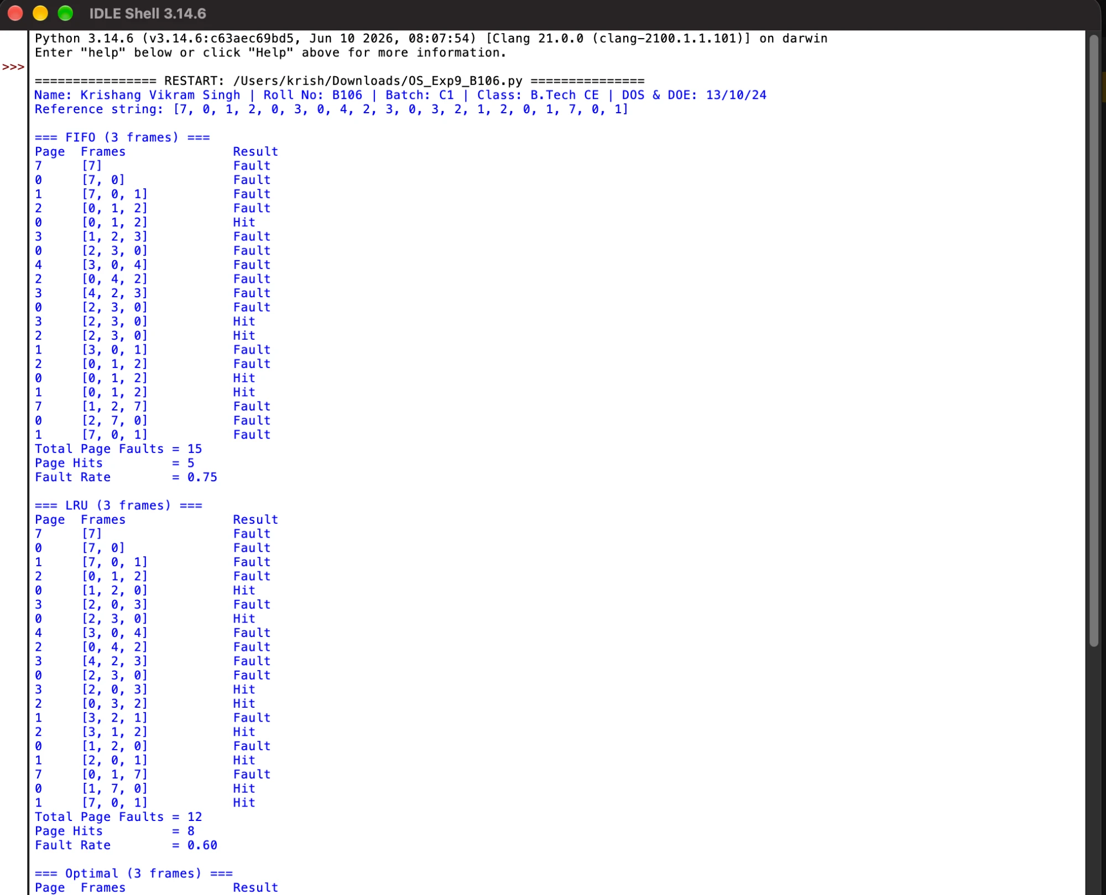

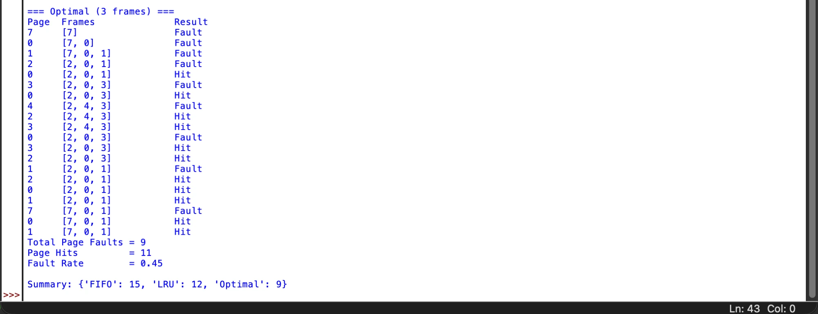

Result Summary:

FIFO: 15 page faults (5 hits) | LRU: 12 page faults (8 hits) | Optimal: 9 page faults (11 hits)

B.2 Conclusion:
In this experiment, I studied the FIFO, LRU and Optimal page replacement algorithms and implemented them in Python. For the given reference string with 3 frames, FIFO produced 15 page faults, LRU produced 12 and Optimal produced 9. LRU performs better than FIFO because it replaces the page that has not been used for the longest time, using past usage as a guide. Optimal gives the fewest page faults, but it requires knowledge of future references, so it cannot be implemented in a real operating system and is used only as a benchmark. LRU is a practical approximation of Optimal.

B.3 Questions of Curiosity:
Q1. Differentiate between FIFO, LRU & Optimal? Which is better?
Ans: FIFO replaces the page that has been in memory the longest. LRU replaces the page that has not been used for the longest time in the past. Optimal replaces the page that will not be used for the longest time in the future.

Basis | FIFO | LRU | Optimal
Victim page | Oldest page in memory | Least recently used page | Page not needed for the longest time in future
Information used | Arrival order only | Past references | Future references
Implementation | Very simple (queue) | Moderate (counters or stack) | Not implementable in practice
Belady's anomaly | Can occur | Does not occur | Does not occur
Page faults here | 15 | 12 | 9
Optimal is the best in theory as it has the lowest page-fault rate, but it is only a benchmark. Among the algorithms that can actually be implemented, LRU is better than FIFO.
Q2. What is the page fault in the example implemented?
Ans: For the reference string 7 0 1 2 0 3 0 4 2 3 0 3 2 1 2 0 1 7 0 1 with 3 frames, the number of page faults is 15 for FIFO, 12 for LRU and 9 for Optimal.

