EXPERIMENT- 7

Aim: To draw the behavioral view (Collaboration) diagram for Student Recommendation Platform for New City Students
Student Details
Name: Krishang Vikram Singh | Roll No.: B106 | Batch: C1
Class: B.Tech Computer Engineering | Date of Experiment: __/__/2026 | Date of Submission: __/__/2026

Prerequisite:
- Basic understanding of functionality for the system to be designed
Outcome: After successful completion of this experiment students will be able to
- Understand the various model used for identifying behavior of a system to be designed.
- Compare and contrast the various behavioral models.

Theory:
What is Behavioral modeling?
All behavioral models really do is describe the control structure of a system. This can be things like:
- Sequence of operations
- Object states
- and Object interactions
Furthermore, this modelling layer can also be called Dynamic Modelling. The activity of creating a behavioural model is commonly known as behavioural modelling. As well as this, a system should also only have one behavioural model – much like functional modelling.
Two types of behavioral model are:
  - Data processing models that show how data is processed as it moves through the system;
  - State machine models that show the systems response to events.
  - These models show different perspectives so both of them are required to describe the system’s behavior.

How to draw Collaboration diagram?
Collaboration diagram is used to model how objects involved in a scenario interact, with each object instantiating a particular class in the system. Objects are connected by links, each link

representing an instance of an association between the respective classes involved. The link shows messages sent between the objects, and the type of message passed (synchronous, asynchronous, simple, balking, and timeout).
Collaboration diagrams offer a better view of a scenario than a Sequence diagram when the modeler is trying to understand all of the effects on a given object and are therefore good for procedural design.

Objects
Objects are depicted on a Collaboration diagram as rectangles. The object name is provided first, with the class name to the right; the two names are separated by a colon. You may specify the multiple occurrence of an object by opening its definition dialog, selecting its Symbol tab, and toggling on the Multiple choice. You may also select the Multiple Object tool from the toolbar.

Links
Messages passed between objects are specified within the Link drawn between objects.

Procedure:
- Identify various elements needed for a collaboration diagram
- Identify the behavior of the systems element with the external interfaces.
- Draw the collaboration diagram as per the guidelines.

Output: A Collaboration diagram for the system.
Part B: Deliverable
Selected Application: Student Recommendation Platform for New City Students
A collaboration diagram (called a communication diagram in UML 2) shows the same interactions as a sequence diagram but organises them around the objects and the links between them instead of around time. In this experiment the two scenarios modelled as sequence diagrams in Experiment 6 are redrawn as collaboration diagrams so that the two behavioural models can be compared directly. The objects are instances of the classes of the class diagram (Experiment 5) and of the actors of the use case diagram (Experiment 3); the messages carry the same operation names, and their order is shown by sequence numbers instead of vertical position.
Elements Identified
Following step 1 of the procedure, the following objects were identified (written as object : Class):
- s : Student «actor» – the Student class of Experiment 5; starts registration, login, search, viewing and review submission.
- admin : Administrator «actor» – the Administrator class of Experiment 5; receives pending reviews and validates them.
- ui : WebInterface «boundary» – the external interface of the platform; every message between a user and the system passes through it.
- ctrl : PlatformController «control» – coordinates the use cases and decides the outcome of verification, authentication and validation.
- db : Database «entity» – stores User/Student, College, Recommendation and Review objects.
Behaviour of Elements with the External Interfaces
Following step 2 of the procedure, the behaviour of each element towards its neighbours was identified from the links of the diagrams:
Link | Objects joined | Behaviour across the link
Link 1 | s : Student – ui : WebInterface | The Student's only contact with the system: requests (register, login, search, view, submit review) go in; results, confirmations and error messages come out.
Link 2 | ui : WebInterface – ctrl : PlatformController | The interface forwards each request and receives the outcome; the controller also pushes the review outcome to the interface (asynchronous message).
Link 3 | ctrl : PlatformController – db : Database | The controller reads and writes entities: accounts, colleges, recommendations and reviews.
Link 4 | ctrl : PlatformController – admin : Administrator | The controller notifies the Administrator of a pending review (asynchronous), and the Administrator calls validateReview() on the controller.

Scenarios Modelled
- Scenario 1 – Registration, College Verification and Login (Figure 7.1): Register Account, Verify Student and Login use cases.
- Scenario 2 – Search, View Recommendation and Submit / Validate Review (Figure 7.2): Search Recommendations, View Recommendations, Submit Review and Validate Review use cases.
Notation Used
Each object is a rectangle labelled name : Class. A solid line between two objects is a link, an instance of an association between their classes. A message is written next to the link it travels along, with a small arrow showing its direction. The number in front of each message gives its order, and decimal numbering shows nesting: message 1.1 is sent while message 1 is being handled, and 1.1.1 while 1.1 is being handled. A condition in square brackets, such as [email valid], is a guard that must hold for the message to be sent. A message from an object to itself is drawn as a loop on that object. Filled arrowheads show synchronous messages and open arrowheads show asynchronous messages.
Collaboration Diagram 1: Registration, College Verification and Login
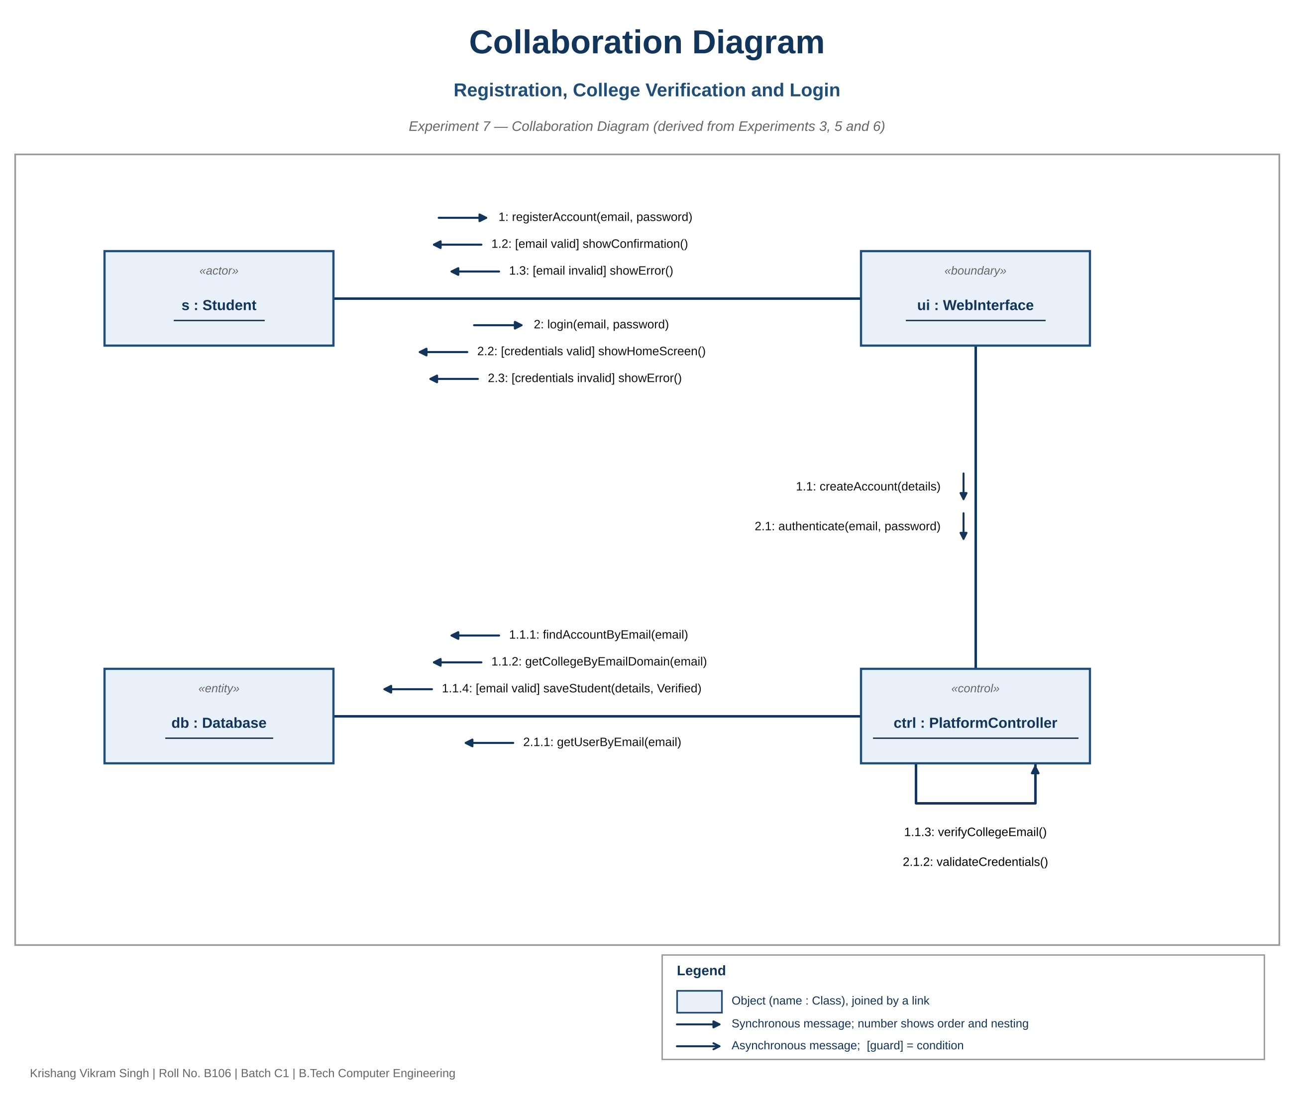
Figure 7.1 – Registration, College Verification and Login
Message Description – Scenario 1
No. | From to To | Message | Sequence diagram (Exp. 6)
1 | s to ui | registerAccount(email, password) | Message 1
1.1 | ui to ctrl | createAccount(details) | Message 2
1.1.1 | ctrl to db | findAccountByEmail(email) | Message 3
1.1.2 | ctrl to db | getCollegeByEmailDomain(email) | Message 4
1.1.3 | ctrl to ctrl | verifyCollegeEmail() | Message 5
1.1.4 | ctrl to db | [email valid] saveStudent(details, Verified) | Message 6
1.2 / 1.3 | ui to s | [valid] showConfirmation() / [invalid] showError() | Return messages of the alt fragment
2 | s to ui | login(email, password) | Message 7
2.1 | ui to ctrl | authenticate(email, password) | Message 8
2.1.1 | ctrl to db | getUserByEmail(email) | Message 9
2.1.2 | ctrl to ctrl | validateCredentials() | Message 10
2.2 / 2.3 | ui to s | [valid] showHomeScreen() / [invalid] showError() | Return messages of the alt fragment

Collaboration Diagram 2: Search, View Recommendation and Submit / Validate Review
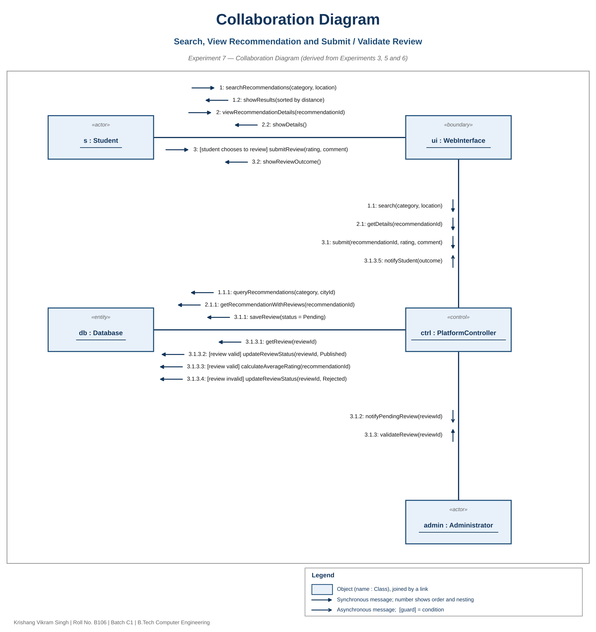
Figure 7.2 – Search, View Recommendation and Submit / Validate Review
Message Description – Scenario 2
No. | From to To | Message | Sequence diagram (Exp. 6)
1 | s to ui | searchRecommendations(category, location) | Message 1
1.1 | ui to ctrl | search(category, location) | Message 2
1.1.1 | ctrl to db | queryRecommendations(category, cityId) | Message 3
1.2 | ui to s | showResults(sorted by distance) | Return messages
2 | s to ui | viewRecommendationDetails(recommendationId) | Message 4
2.1 | ui to ctrl | getDetails(recommendationId) | Message 5
2.1.1 | ctrl to db | getRecommendationWithReviews(recommendationId) | Message 6
2.2 | ui to s | showDetails() | Return messages
3 | s to ui | [student chooses to review] submitReview(rating, comment) | Message 7 (opt fragment)
3.1 | ui to ctrl | submit(recommendationId, rating, comment) | Message 8
3.1.1 | ctrl to db | saveReview(status = Pending) | Message 9
3.1.2 | ctrl to admin | notifyPendingReview(reviewId) – asynchronous | Message 10
3.1.3 | admin to ctrl | validateReview(reviewId) | Message 11
3.1.3.1 | ctrl to db | getReview(reviewId) | Message 12
3.1.3.2 | ctrl to db | [review valid] updateReviewStatus(reviewId, Published) | Message 13
3.1.3.3 | ctrl to db | [review valid] calculateAverageRating(recommendationId) | Message 14
3.1.3.4 | ctrl to db | [review invalid] updateReviewStatus(reviewId, Rejected) | Message 16
3.1.3.5 | ctrl to ui | notifyStudent(outcome) – asynchronous | Messages 15 and 17
3.2 | ui to s | showReviewOutcome() | Return message

Comparison of Behavioural Models
To meet the second outcome of the experiment, the models used so far for the platform are compared below:
Aspect | Activity diagram (Exp. 4) | Sequence diagram (Exp. 6) | Collaboration diagram (Exp. 7)
Main focus | Flow of activities and decisions | Messages between objects in time order | Objects, their links and the messages on each link
Organised by | Swimlanes of actors | Time, running top to bottom | Structure of objects, with numbers for order
Order of events | Shown by the control-flow arrows | Obvious from vertical position | Read from sequence numbers; harder to follow
Shows links between objects | No | No (only lifelines) | Yes
Branches | Decision nodes | alt / opt fragments | Guards in square brackets
Best suited to | Business workflow for non-technical readers | Following one scenario step by step | Seeing everything one object is involved in
In this project | One end-to-end flow with the Administrator swimlane | Two scenarios, 10 and 17 messages | The same two scenarios, same operations

The two interaction diagrams hold the same information. The sequence diagram makes the order of the review submission and validation easiest to read, while the collaboration diagram shows that the Platform Controller is the object linked to every other object, so any change to the controller affects all four links. Neither diagram replaces the activity diagram, which shows the business flow and the decisions without naming objects.
Consistency with Previous Experiments
- Experiment 3 (Use Case Diagram): both scenarios realise its use cases, and the Administrator is linked to the controller for validation as in the Validate Review «include».
- Experiment 5 (Class Diagram): the objects are instances of Student, Administrator and the entities stored in the database, and the messages use the operations defined there.
- Experiment 6 (Sequence Diagram): every message of Figure 6.1 and Figure 6.2 appears in Figure 7.1 and Figure 7.2 with the same name, as the tables above show.
Conclusion
Collaboration diagrams were drawn for the Student Recommendation Platform for New City Students for the same two scenarios modelled in Experiment 6: registration, college verification and login, and search, viewing a recommendation and submitting a review that the Administrator validates. Five objects (s : Student, ui : WebInterface, ctrl : PlatformController, db : Database and admin : Administrator) are joined by four links, and the messages are ordered with nested sequence numbers and guards. Comparing the models showed that the sequence diagram shows the order of messages more clearly and the collaboration diagram shows the structure of links more clearly, while the activity diagram remains the better view of the business flow. The diagrams cover only the scenarios chosen, so alternative flows such as duplicate-account rejection and the login lockout from Experiment 1 are not shown.

