Experiment: 10
PART A
(PART A: TO BE REFERRED BY STUDENTS)
Aim:
- To connect Electronic Speed Controllers (ESCs), motors, and the receiver to the PX4 flight controller.
- To ensure proper wiring and configuration for the successful operation of the quadcopter.

Pre-requisite: Basic Understanding of Quadcopter Components, Familiarity with PX4 Flight
Controller Hardware, Experience with PX4 Software Configuration

Learning Outcomes:
After completing this lab, students will be able to:
- Identify and connect Electronic Speed Controllers (ESCs), motors, and the receiver to the PX4 flight controller correctly.
- Understand the wiring and power distribution required for proper quadcopter operation.
- Calibrate and configure ESCs to ensure synchronized motor operation.
- Verify correct motor rotation and propeller orientation for stable flight.
- Set up and bind the radio receiver with the transmitter for proper signal communication.
- Troubleshoot wiring and configuration issues to ensure a fully functional flight control system.
Materials Required:
• PX4 Flight Controller
• Electronic Speed Controllers (ESCs)
• Motors (4 for a quadcopter)
• Flysky FS-iA6B Receiver (compatible with your transmitter, e.g., PPM, SBUS, DSMX)
• Battery (LiPo)
• Power Distribution Board (PDB) or Power Module
• Propellers
• USB Cable
• Ground Station Software (e.g., QGroundControl)
• Jumper wires and connectors
• Soldering kit (if needed)
Theory:

Step 1: Understanding the PX4 Pin Layout
- ESC Connections (PWM Outputs): The PX4 flight controller has PWM output pins that connect to the ESCs.
- Receiver Inputs: The receiver can be connected using PPM, SBUS, or DSMX input depending on the type of receiver.
- Power Supply: Power to the PX4 can be provided through the USB or battery using a power distribution board (PDB) or power module.

Step 2: Connecting the ESCs to the PX4
- Identify PWM Output Ports:
  - The PX4 typically has 8 PWM outputs for ESCs.
  - In the case of a quadcopter, you will connect ESCs to the first 4 PWM outputs (usually labeled as MAIN 1, MAIN 2, MAIN 3, and MAIN 4).
  - Ensure to check the documentation of the PX4 for exact pinout details.
- Connecting ESC Signal Wires:
  - Each ESC has three wires: Signal (usually white or yellow), Power (red), and Ground (black).
  - Signal wire (White/Yellow): Connect this to the corresponding PWM output (MAIN 1-4).
  - Ground wire (Black): Connect this to the ground pin adjacent to the PWM output.
  - Power wire (Red): In most cases, this is not connected directly to the PX4 but instead powered through a Power Distribution Board (PDB).
- Powering the ESCs:
  - The positive and negative leads of each ESC are connected to the PDB or Power Module, which is connected to the main battery. This ensures that the ESCs receive power from the battery.

- Double Check the Wiring:
  - Verify that the correct signal wires are connected to the appropriate PWM output channels, and ensure that the ground connections are secure.

Step 3: Connecting Motors to ESCs
- Connect Motor Wires:
  - Each motor has three wires that must be connected to the three corresponding wires from the ESC (often labeled as A, B, and C).
  - Test Motor Rotation: After wiring, test the motor rotation direction by lightly powering up the system. If a motor spins in the wrong direction, swap any two wires between the ESC and motor to reverse the direction.
- Assigning Motors to the Correct ESC:
  - PX4 follows a specific motor numbering for quadcopters:
    - Motor 1: Front-right
    - Motor 2: Rear-left
    - Motor 3: Front-left
    - Motor 4: Rear-right
  - Make sure the motors are connected to the correct PWM output pins on PX4 as per this numbering.

Step 4: Connecting the Receiver (FS-iA6B) to PX4
- Choose the Receiver Protocol:
  - PX4 supports various receiver protocols like PPM, SBUS, and DSMX.
  - Choose the correct receiver type that matches your transmitter. For example:
    - PPM/SBUS Receiver: Most modern receivers use SBUS or PPM protocols. Check your receiver’s manual for details.
- Connecting a PPM Receiver:
  - If using a PPM receiver, connect the PPM signal pin to the designated RC_IN or PPM input on the PX4.
  - Connect the ground and power lines of the receiver to the corresponding GND and VCC pins on the PX4.
- Connecting an SBUS Receiver:
  - If using an SBUS receiver, connect the SBUS signal wire to the SBUS input on PX4.
  - Similarly, connect the ground and power lines to the GND and VCC pins on PX4.
- Powering the Receiver:
  - The receiver will draw power from the PX4’s 5V output. Ensure that the power and ground lines are properly connected.

Step 5: Powering the PX4 and Quadcopter
- Power Supply:
  - Connect a power module or power distribution board (PDB) between the battery and the ESCs. This will manage the distribution of power to all components, including the flight controller.
- Connecting the Battery:
  - Ensure all connections are secure and plug in the battery to power the system.

Step 6: Configuring the PX4 in Ground Station Software
- Connect PX4 to Ground Station:
  - Use a USB cable to connect the PX4 to your computer.
  - Open the ground station software (e.g., QGroundControl or Mission Planner).
- Calibrate ESCs and Sensors:
  - Perform ESC calibration as per the earlier lab manual.
  - Calibrate the accelerometer by following the on-screen instructions in the ground station software.
  - Ensure that the motor numbering and orientation match the quadcopter frame in the software.
- Configure the Receiver in Software:
  - Verify the RC Input configuration in the ground control software to ensure the receiver is functioning correctly.
  - Perform a radio calibration to check that the transmitter sticks control the corresponding functions on the quadcopter.
PART B

Roll No.: B106 | Name: Krishang Vikram Singh
Prog/Yr/Sem: B.Tech CE / Third Year / Fifth Sem | Batch: C1
Date of Experiment: 15/10/24 | Date of Submission: 15/10/24
Task to be performed
- Hardware Connection Setup
- Placed the frame on the bench with propellers removed and identified the PX4 ports: MAIN OUT 1–8 (ESC signals), RC IN (receiver), POWER (power module), USB.
- Connected the LiPo battery to the power module (XT60), and the power module output to the PDB that feeds the four ESCs; the 6-pin power-module cable was plugged into the POWER port of the PX4.
- Fixed the PX4 on the frame centre with the arrow pointing to the front.
Power path | Connection
Battery → Power module | XT60 connector
Power module → PDB → ESCs | Red (+) and black (–) leads of each ESC
Power module → PX4 | 6-pin cable to POWER port, supplies 5 V and battery voltage/current sensing
PX4 → Receiver | 5 V and GND from the RC port

- Connecting ESCs and Motors
- Connected the signal (white/yellow) and ground (black) wire of each ESC to MAIN 1–4; the red ESC power wire is left unconnected on the PX4 (power comes from the PDB).
- Connected the three motor wires of each ESC to the motor’s three wires (A, B, C); powered up lightly and checked rotation direction; swapped any two wires where a motor turned the wrong way.
Motor | Position | PX4 output | Rotation
1 | Front-right | MAIN 1 | CCW
2 | Rear-left | MAIN 2 | CCW
3 | Front-left | MAIN 3 | CW
4 | Rear-right | MAIN 4 | CW

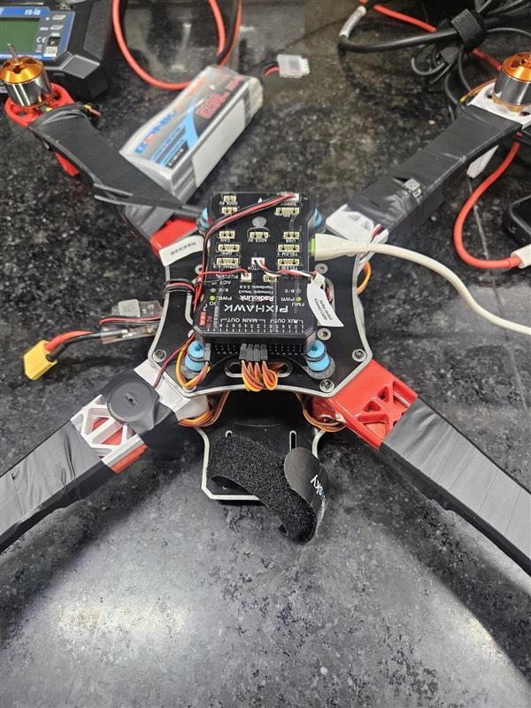
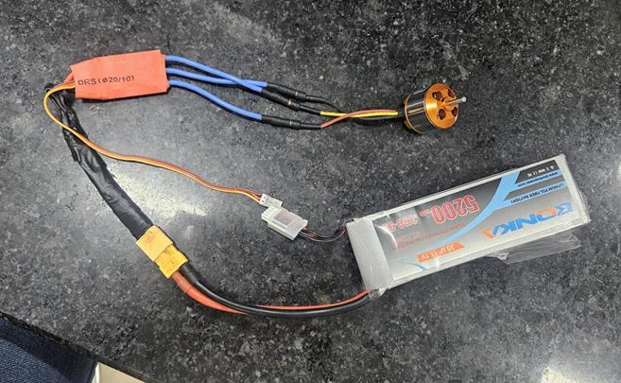

- Connecting the Receiver to the PX4 Flight Controller
- Used the FS-iA6B receiver’s PPM output: PPM signal pin → RC IN signal pin of PX4; receiver VCC → 5 V (+) and GND → GND of the RC port (the receiver is powered from the PX4).
- Bound the receiver with the FS-i6 transmitter: receiver bind button pressed while powering, transmitter put in bind mode (System → RX Bind); the receiver LED changed from flashing to steady, showing a successful bind.
Receiver pin | PX4 RC port
PPM output | RC IN signal
VCC | 5 V (+)
GND | GND (–)

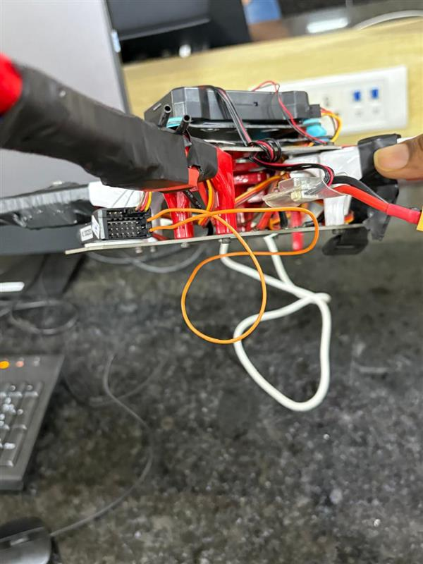

- Configuring PX4 in QGroundControl
- Connected the PX4 to the computer with a USB cable and opened QGroundControl.
- Vehicle Setup → Airframe: selected Generic Quadcopter / Quad X and applied (vehicle restarts).
- Vehicle Setup → Sensors: calibrated the compass, gyroscope, accelerometer and level horizon.
- Vehicle Setup → Power: set the number of battery cells and voltage divider/amps-per-volt for the power module.
- Calibrated ESCs as per the earlier lab (Vehicle Setup → Power → ESC calibration).

- Performing Receiver Calibration
- Turned on the FS-i6 transmitter and opened Vehicle Setup → Radio in QGroundControl; the receiver signal was detected.
- Clicked Calibrate and moved the sticks as instructed: throttle down/yaw left → throttle up/yaw right → roll and pitch to all extremes → centre; confirmed with Next.
- Checked the channel monitor: Roll (CH1), Pitch (CH2), Throttle (CH3), Yaw (CH4) bars moved correctly with the sticks; set the flight-mode channel under Flight Modes.
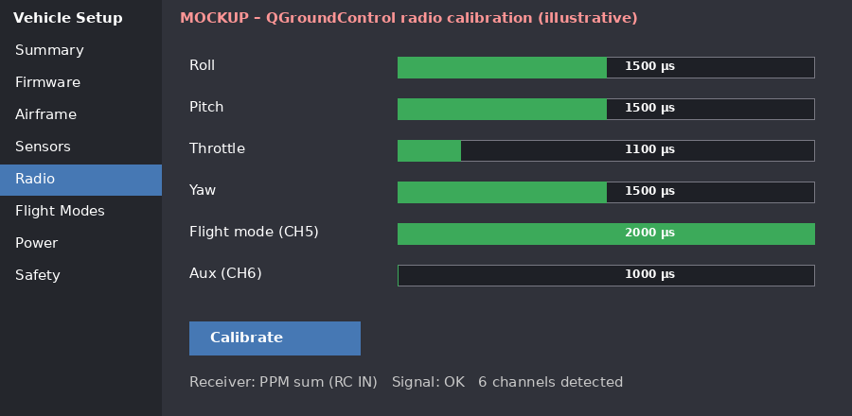
Fig. 1 (mockup): Radio calibration screen – channel bars for all sticks and switches

- Verifying and Testing the Setup
- Wiring check: signal to MAIN 1–4, grounds secure, polarity of the battery and power module correct.
- Motor test with propellers removed (Vehicle Setup → Motors): each motor spun at low throttle in the right order and direction.
- Armed in a safe mode and raised the throttle slowly – all motors responded together; RC input and attitude indications were correct.
- Fitted the propellers (CW on CW, CCW on CCW) only after all tests passed.
Problem | Likely cause / fix
Motor doesn’t spin | Signal wire on wrong MAIN pin or ESC not calibrated / power not connected
Motor turns wrong way | Swap any two of the three motor–ESC wires
No RC signal | Receiver not bound / wrong RC IN pin or protocol
Won’t arm | Pre-arm checks (sensors, radio, safety switch) not satisfied

Observations and Learning:
- Each ESC signal wire must be on the right MAIN output; the order of the motors decides stability and direction of rotation.
- The ESCs get power from the PDB/power module while the PX4 only supplies the signal and ground; the 5 V rail powers the receiver.
- The FS-iA6B receiver works with the PX4 through its PPM output on RC IN after binding.
- Radio calibration confirms each stick moves its channel correctly; ESC calibration makes motors respond uniformly.
- Propellers are fitted only after the tests are completed.

Conclusion:
The ESCs, motors and FS-iA6B receiver were connected correctly to the PX4 flight controller with proper wiring and power distribution. The ESCs and sensors were calibrated, motor rotation direction and propeller orientation were verified, the receiver was bound and calibrated, and wiring and configuration issues were checked and troubleshot. All learning outcomes were attained and the quadcopter is ready for flight.

