Experiment: 9
PART A
(PART A: TO BE REFERRED BY STUDENTS)
Aim:
- To understand the process of calibrating Electronic Speed Controllers (ESCs) and the accelerometer sensor to ensure the proper functionality of a quadcopter.

Pre-requisite: Basic Knowledge of Quadcopter Components, Familiarity with ESC Operation,
Understanding of Accelerometer Functionality
Learning Outcomes: The learner would be able to
- Calibrate ESCs to ensure a uniform response from all motors.
- Accurately perform accelerometer calibration using flight control software.

Materials Required:
- Quadcopter frame with motors
- Electronic Speed Controllers (ESCs)
- Flight Controller (PX4)
- Transmitter and Receiver
- Battery
- USB Cable
- Ground Station Software (QGroundControl/Mission Planner)
- Propeller (should be removed during ESC calibration for safety)
Theory:

Part 1: ESC Calibration

Step 1: Remove Propellers
- For safety reasons, remove the propellers from all motors before proceeding with the ESC calibration.

Step 2: Connect the Flight Controller to Ground Station
- Power the flight controller by connecting it to the computer using a USB cable.
- Launch the ground station software (e.g., QGroundControl or Mission Planner).

Step 3: Enter ESC Calibration Mode
- Connect the battery to the quadcopter.
- Open the Power Setup menu in the ground station software.
- Choose the option to Calibrate ESCs. The system will guide you to enter calibration mode.
  - In QGroundControl: Navigate to Vehicle Setup > Power > ESC Calibration.
  - In Mission Planner: Go to Initial Setup > Mandatory Hardware > ESC Calibration.

Step 4: Throttle Maximum Command
- Move the throttle stick of your transmitter to the maximum position.
- Plug in the battery. The ESCs will enter calibration mode, and you may hear beeps indicating readiness.

Step 5: Throttle Minimum Command
- After hearing the initial confirmation beeps, lower the throttle to the minimum position.
- The ESCs will then store the throttle range, and additional beeps will confirm successful calibration.

Step 6: Test the Calibration
- Disconnect the battery.
- Reconnect the battery and arm the quadcopter. Slowly increase the throttle to verify that all motors start spinning simultaneously.

Part 2: Accelerometer Calibration

Step 1: Connect to Ground Station
- With the propellers still removed, connect the flight controller to the ground station software using a USB cable.
- Ensure the battery is connected for proper calibration.

Step 2: Open the Sensor Calibration Page
In the ground station software, navigate to the Sensors or Calibration tab.
  - In QGroundControl: Go to Vehicle Setup > Sensors > Accelerometer.
  - In Mission Planner: Go to Initial Setup > Mandatory Hardware > Accelerometer Calibration.

Step 3: Follow Calibration Prompts
- The software will prompt you to place the quadcopter in various orientations (e.g., on its side, nose up, nose down, upside down, and level).
- Follow the instructions and press the Calibrate button for each orientation.

Step 4: Complete the Calibration
- Once all orientations are successfully calibrated, the software will display a confirmation message indicating the accelerometer calibration is complete.

Step 5: Verify Sensor Data
- Verify that the accelerometer is reading correct orientation data by moving the quadcopter and observing changes in the attitude displayed in the ground station software.
Safety Precautions:
- Always remove the propellers during calibration to avoid accidents.
- Ensure that the battery is properly charged before starting the calibration.
PART B
Roll No.: B106 | Name: Krishang Vikram Singh
Prog/Yr/Sem: B.Tech CE / Third Year / Fifth Sem | Batch: C1
Date of Experiment: 15/10/24 | Date of Submission: 15/10/24
Task to be performed
- Preparation & Setup
- Collected the materials: quadcopter frame with 4 motors, 4 ESCs, PX4 flight controller, FlySky transmitter and receiver, LiPo battery, USB cable and a computer with QGroundControl.
- Removed all four propellers (safety) and placed the quadcopter on a flat, stable surface.
- Checked that the ESC–motor–PDB–flight controller wiring is secure and the battery is fully charged.
- Connected the PX4 to the computer by USB and launched QGroundControl; the vehicle was detected and shown as connected.

- Electronic Speed Controller (ESC) Calibration
- In QGroundControl opened Vehicle Setup → Power → ESC Calibration and clicked Calibrate.
- As instructed, disconnected the USB cable and the battery, then connected the LiPo battery.
- The ESCs powered up and gave start-up tones; the flight controller sent the maximum throttle signal followed by minimum throttle, so each ESC stored the full throttle range.
- Confirmation beeps from all four ESCs showed that calibration was complete; QGroundControl showed “Calibration complete”.
- Disconnected the battery, reconnected and slowly raised the throttle (propellers off) – all four motors started together at the same speed.
Stage | ESC response
Battery connected | Start-up tone sequence (power-on)
Max throttle detected | Beeps indicating maximum throttle point stored
Min throttle detected | Confirmation beeps – minimum stored; calibration finished

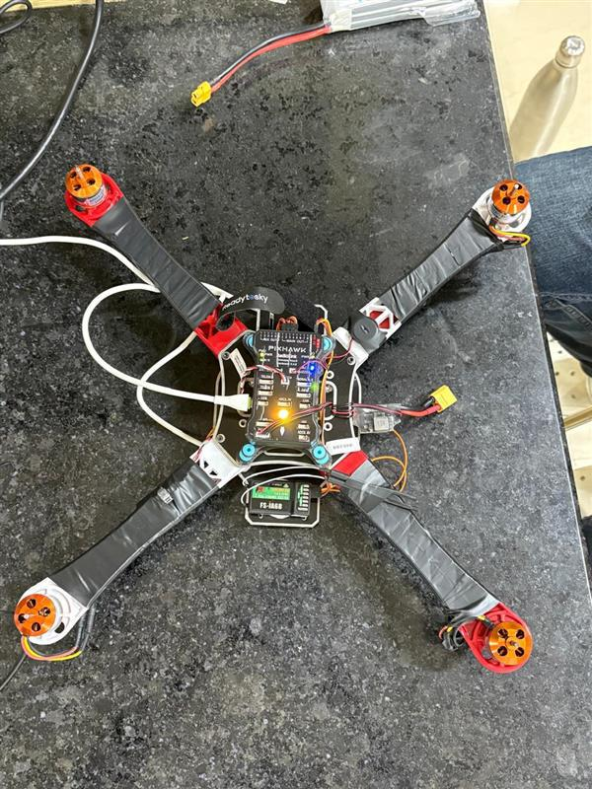

- Accelerometer Sensor Calibration
LEVEL
LEFT
RIGHT
NOSE DOWN
NOSE UP
DOWN

Orientation | How the vehicle was held | Result
LEVEL | Flat, top side up, nose pointing front | Calibrated
LEFT | Resting on its left side | Calibrated
RIGHT | Resting on its right side | Calibrated
NOSE DOWN | Front pointing down, vertical | Calibrated
NOSE UP | Front pointing up, vertical | Calibrated
DOWN (upside down) | Turned upside down | Calibrated

The vehicle was kept still in each position until QGroundControl showed the orientation as done; after the sixth one the message “Calibration complete” appeared.
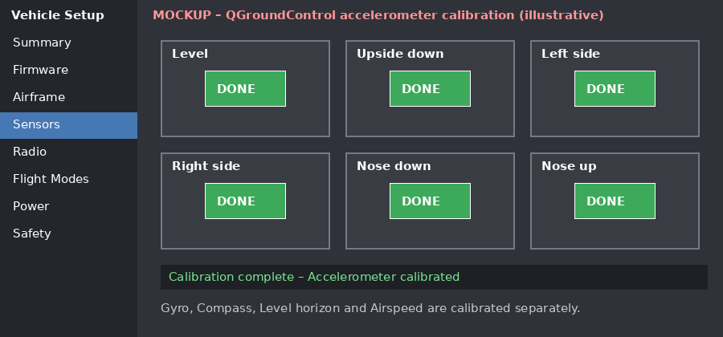
Fig. 1 (mockup): Accelerometer calibration screen – all six orientations done

- Verification & Testing
- Tilted and rotated the quadcopter by hand and checked that the roll, pitch and heading in the QGroundControl instruments moved correctly and returned to level on the table.
- Armed (propellers still removed) and raised throttle slowly: all motors accelerated together with equal sound/speed – confirming ESC calibration.
- Disarmed and disconnected the battery. Calibration is complete and the drone is ready for the first test flight after fitting propellers.

Observations and Learning:
- Uncalibrated ESCs can have different throttle ranges, so motors respond at different speeds and the drone becomes unstable; ESC calibration makes all the motors respond equally.
- ESC calibration has to be done with propellers removed because the motors may spin at full throttle.
- The accelerometer needs six orientations to determine its offset and scale on all axes; the vehicle must be still in each position.
- After calibration the horizon reading in the ground station follows the real tilt of the vehicle.

Conclusion:
The ESCs were calibrated so that all motors give a uniform response to the throttle command, and the accelerometer was calibrated in all six orientations using the ground control software (QGroundControl). Both learning outcomes were attained and the quadcopter is ready for further configuration and flight.

