PRACTICAL 8

Aim:
To draw the Data flow diagram for Student Recommendation Platform for New City Students:

Theory:
A data flow diagram (DFD) maps out the flow of information for any process or system. It uses defined symbols like rectangles, circles and arrows, plus short text labels, to show data inputs, outputs, storage points and the routes between each destination. Data flowcharts can range from simple, even hand-drawn process overviews, to in-depth, multi-level DFDs that dig progressively deeper into how the data is handled. They can
be used to analyse an existing system or model a new one. Like all the best diagrams and charts, a DFD can often visually “say” things that would be hard to explain in words, and they work for both technical and nontechnical audiences, from developer to CEO.
That’s why DFDs remain so popular after all these years. While they work well for data flow software and systems, they are less applicable nowadays to visualizing interactive, real-time or database-oriented software or systems.
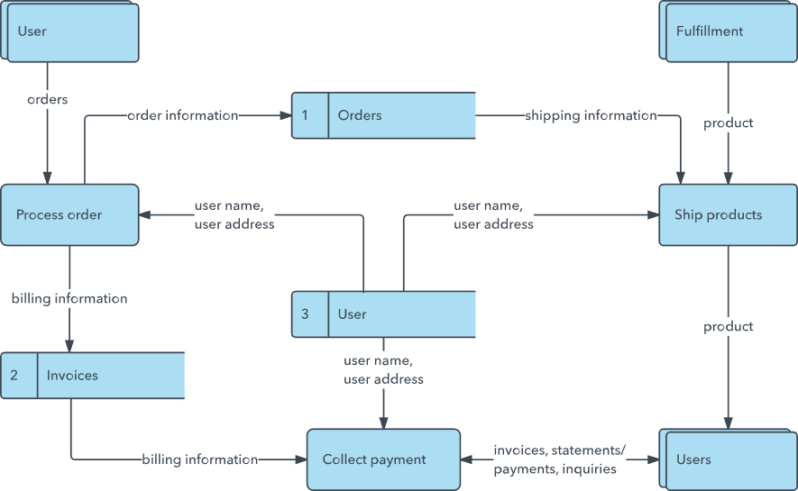

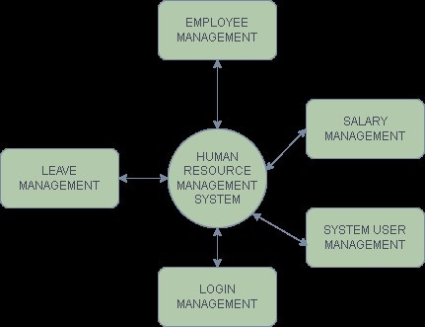
example Output: A data flow diagram of the system. Level 0

Level 1
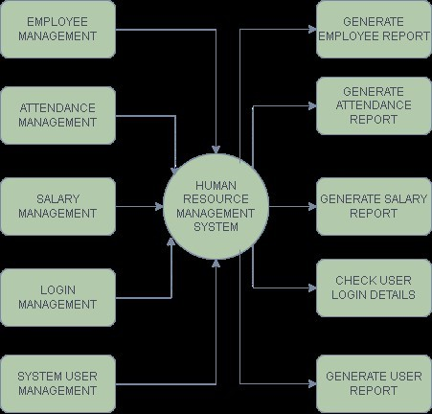

PART -B
DEVELOP DFD LEVEL 0 AND LEVEL 1 FOR YOUR MINI PROJECT

Name: Krishang Vikram Singh | Roll No: B106
Batch: C1 | Date: __/__/2026

Selected Application: Student Recommendation Platform for New City Students
The data flow diagrams below model how information moves through the platform for the same system analysed in the earlier experiments. The platform lets a new student register with a college email, search recommendations (PGs/hostels, restaurants, stationery shops, sports facilities and events), read and submit reviews, and lets an administrator moderate reviews and manage students, colleges, cities and recommendations. The external entities come from the actors of the use case diagram (Experiment 3), and the stored data comes from the classes of the class diagram (Experiment 5).
Symbols and Rules Used
The diagrams follow the Gane-Sarson notation of the examples in the theory section and the usual DFD rules:
External entity | Double-edged rectangle: a person or system outside the platform that sends data in or receives data out (Student, Administrator).
Process | Rounded rectangle with an identification number (Level 1) or a circle (Level 0 context diagram); it turns incoming data flows into outgoing data flows.
Data store | Open-ended rectangle with an identifier (D1 to D4); data at rest that processes read from or write to.
Data flow | Arrow labelled with the data it carries; every flow starts or ends at a process, so entities and stores never exchange data directly.
Levelling rule | Level 1 must show the same flows crossing the boundary with the external entities as Level 0 (balancing).

Elements Identified
Type | Name | Description
Entity | Student | Registers, logs in, searches, views recommendations, submits and reports reviews.
Entity | Administrator | Logs in, manages platform data and validates reviews.
Process | 1.0 Manage Accounts | Registers students, verifies the college email against the college domain and handles login.
Process | 2.0 Search and Recommend | Finds recommendations near the student, applies filters and returns results with their published reviews.
Process | 3.0 Manage Reviews | Stores submitted and reported reviews, lets the Administrator validate them and updates the average rating.
Process | 4.0 Administer Platform Data | Administrator login and management of students, colleges, cities and recommendations.
Store | D1 Users | Student and administrator accounts, college verification status and account status.
Store | D2 Colleges and Cities | College names, email domains and the cities they belong to.
Store | D3 Recommendations | PG/hostel, restaurant, stationery, sports and event records with their average rating.
Store | D4 Reviews | Reviews with rating, comment and status (Pending, Under Review, Published, Rejected).

Use cases of Experiment 3 covered by each process: 1.0 Register Account, Verify Student, Login, Logout; 2.0 Search Recommendations, View Recommendations, View Reviews; 3.0 Submit Review, Validate Review, Manage Reviews; 4.0 Admin Login, Manage Students, Manage Colleges, Manage Cities, Manage Recommendations. View College / City Information is not drawn as a separate flow at Level 1.

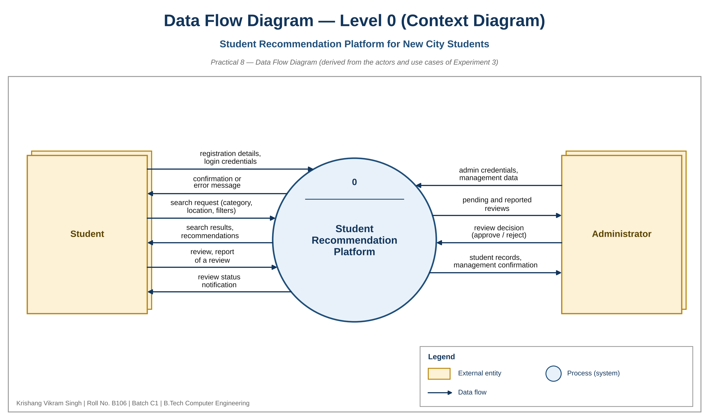
Figure 8.1 – Level 0 (Context) Data Flow Diagram

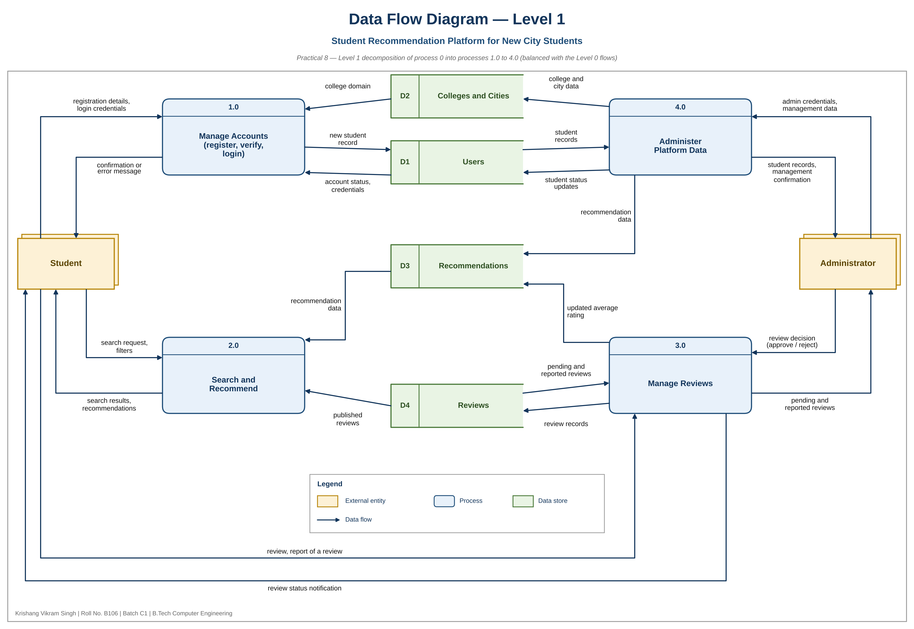
Figure 8.2 – Level 1 Data Flow Diagram

Data Flow Dictionary
Every flow of Figure 8.2, with its source, destination and content. Flows 1 to 6 and 19 to 22 cross the system boundary and are the same flows shown in Figure 8.1.
No. | Data flow | From | To | Data carried
1 | registration details, login credentials | Student | 1.0 | name, college email, password, college
2 | confirmation or error message | 1.0 | Student | result of registration or login
3 | search request, filters | Student | 2.0 | category, location, price, rating, distance
4 | search results, recommendations | 2.0 | Student | matching places with distance, rating and reviews
5 | review, report of a review | Student | 3.0 | recommendation, rating, comment, report reason
6 | review status notification | 3.0 | Student | Published, Rejected or Under Review
7 | college domain | D2 | 1.0 | email domain of the student's college
8 | new student record | 1.0 | D1 | student details, verified status
9 | account status, credentials | D1 | 1.0 | password hash, failed attempts, suspended flag
10 | recommendation data | D3 | 2.0 | place details and average rating
11 | published reviews | D4 | 2.0 | reviews shown with a recommendation
12 | review records | 3.0 | D4 | new review, validated or rejected review, reports
13 | pending and reported reviews | D4 | 3.0 | reviews waiting for validation
14 | updated average rating | 3.0 | D3 | recalculated average rating
15 | college and city data | 4.0 | D2 | new or updated colleges and cities
16 | student records | D1 | 4.0 | student list and status
17 | student status updates | 4.0 | D1 | verification, suspension, reinstatement
18 | recommendation data | 4.0 | D3 | new, updated or removed recommendations
19 | admin credentials, management data | Administrator | 4.0 | login details, college, city, recommendation and student changes
20 | student records, management confirmation | 4.0 | Administrator | student list, result of each change
21 | review decision (approve / reject) | Administrator | 3.0 | validation outcome for a review
22 | pending and reported reviews | 3.0 | Administrator | reviews waiting for a decision

Balancing Between Level 0 and Level 1
Level 0 has ten flows with the two external entities: three from the Student, three to the Student, two from the Administrator and two to the Administrator. Level 1 shows the same ten flows (numbers 1 to 6 and 19 to 22 in the dictionary), each ending at the same entity, and replaces process 0 with four processes and four data stores. No flow at Level 1 appears between two external entities, between two data stores, or between an entity and a data store, so the diagram follows the DFD rules.
Consistency with Previous Experiments
Experiment 1 | The registration, verification, login, search, review, reporting and administration stories are the flows 1 to 6 and 19 to 22.
Experiment 3 | The two actors are the external entities, and each use case belongs to one of the four processes.
Experiment 4 | The activity sequence register, verify, login, search, view, submit review and validate review follows the path through processes 1.0, 2.0 and 3.0.
Experiment 5 | The data stores hold the classes User/Student/Administrator, College and City, Recommendation and its subclasses, and Review.
Experiments 6 and 7 | The Database lifeline of the interaction diagrams corresponds to the four data stores D1 to D4.

Conclusion
The Level 0 context diagram shows the Student Recommendation Platform as a single process exchanging ten data flows with the Student and the Administrator. The Level 1 diagram divides it into Manage Accounts, Search and Recommend, Manage Reviews and Administer Platform Data, backed by the data stores Users, Colleges and Cities, Recommendations and Reviews. The two levels are balanced, and the processes, entities and stores match the use cases, activities and classes of Experiments 3 to 5. The diagrams show data movement only, so the order of messages and the conditions on them are left to the sequence and collaboration diagrams of Experiments 6 and 7.

