EXPERIMENT- 6

Aim: To draw the behavioral view diagram for Student Recommendation Platform for New City Students: Sequence diagram
Student Details
Name: Krishang Vikram Singh | Roll No.: B106 | Batch: C1
Class: B.Tech Computer Engineering | Date of Experiment: __/__/2026 | Date of Submission: __/__/2026

Theory:
What is Behavioral modeling?
All behavioural models really do is describe the control structure of a system. This can be things like:
- Sequence of operations
- Object states
- and Object interactions
Furthermore, this modelling layer can also be called Dynamic Modelling. The activity of creating a behavioural model is commonly known as behavioural modelling. As well as this, a system should also only have one behavioural model – much like functional modelling.
Two types of behavioral model are:
  - Data processing models that show how data is processed as it moves through the system;
  - State machine models that show the systems response to events.
  - These models show different perspectives so both of them are required to describe the system’s behavior.
How to draw Sequence diagrams?

A sequence diagram is a kind of interaction diagram that shows how processes operate with one another and in what order. It is a construct of a Message Sequence Chart. A sequence diagram shows object interactions arranged in time sequence. It depicts the objects and classes involved in the scenario and the sequence of messages exchanged between the objects needed to carry out the functionality of the scenario. Sequence diagrams are typically associated with use case realizations in the Logical View of the system under development. Sequence diagrams are sometimes called event diagrams, event scenarios, and timing diagrams.A sequence diagram shows, as parallel vertical lines (lifelines), different processes or objects that live simultaneously, and, as horizontal

arrows, the messages exchanged between them, in the order in which they occur. This allows the specification of simple runtime scenarios in a graphical manner.

If the lifeline is that of an object, it demonstrates a role. Note that leaving the instance name blank can represent anonymous and unnamed instances.

Messages, written with horizontal arrows with the message name written above them, display interaction. Solid arrows with full heads are asynchronous calls and dashed arrows with stick heads are return messages. This definition is true as of UML 2, considerably different from UML 1.x. a caller sends a synchronous message, it must wait until the message is done, such as invoking a subroutine. If a caller sends an asynchronous message, it can continue processing and doesn’t have to wait for a response. You see asynchronous calls in multithreaded applications and in message-oriented middleware. Activation boxes, or method-call boxes, are opaque rectangles drawn on top of lifelines to represent that processes are being performed in response to the message (ExecutionSpecifications in UML).

Objects calling methods on themselves use messages and add new activation boxes on top of any others to indicate a further level of processing.When an object is destroyed (removed from memory), an X is drawn on top of the lifeline, and the dashed line ceases to be drawn below it (this is not the case in the first example though). It should be the result of a message, either from the object itself, or another.

Procedure:
- Identify various elements such as controller class, objects, boundaries, messages etc. of the sequence diagram.
- Draw the sequence diagram as per the guidelines.
- Identify various elements needed for a collaboration diagram
- Identify the behavior of the systems element with the external interfaces.
- Draw the collaboration diagram and State chart diagram as per the guidelines.

Output: A Sequence diagram of the system.
Part B: Deliverable
Selected Application: Student Recommendation Platform for New City Students
Building on the use case diagram (Experiment 3), the activity diagram (Experiment 4) and the class diagram (Experiment 5), the behavioural view of the platform is modelled below as sequence diagrams. A sequence diagram shows how the actors and the objects of the system exchange messages in time order to realise a use case, so every message is named after an operation already identified in the class diagram of Experiment 5 (for example registerAccount(), verifyCollegeEmail(), searchRecommendations(), viewRecommendationDetails(), submitReview() and validateReview()).
Elements Identified
Following step 1 of the procedure, the lifelines were identified from the actors of Experiment 3 and the architectural roles needed to realise them:
- Student (actor) – registers, logs in, searches, views recommendations and submits reviews.
- Administrator (actor) – validates submitted reviews and decides whether they are published or rejected.
- Web Interface «boundary» – the screens through which the Student interacts with the platform; it carries user input to the controller and displays results and messages.
- Platform Controller «control» – coordinates each use case: it checks accounts and college email domains, authenticates users, runs searches, saves and validates reviews and notifies users.
- Database «entity» – persists the entities of the Experiment 5 class diagram (User/Student, College, City, Recommendation and its subclasses, Review).
Scenarios Modelled
- Scenario 1 – Registration, College Verification and Login: the Student registers, the college email is verified, and the Student logs in (Register Account, Verify Student and Login use cases; first part of the Experiment 4 activity flow).
- Scenario 2 – Search, View Recommendation and Submit / Validate Review: the logged-in Student searches and views a recommendation and optionally submits a review, which the Administrator validates (Search Recommendations, View Recommendations, Submit Review and Validate Review use cases; the «include» relationship of Experiment 3 and the swimlane hand-off of Experiment 4).
Notation Used
Solid lines with filled arrowheads are synchronous messages and are numbered in the order they occur; solid lines with open arrowheads are asynchronous messages (the sender does not wait for a reply); dashed lines with open arrowheads are return messages. A message from a lifeline to itself is a self-call. The alt fragment shows mutually exclusive alternatives, each guarded by a condition, and the opt fragment shows behaviour that happens only when its guard is true.
Sequence Diagram 1: Registration, College Verification and Login
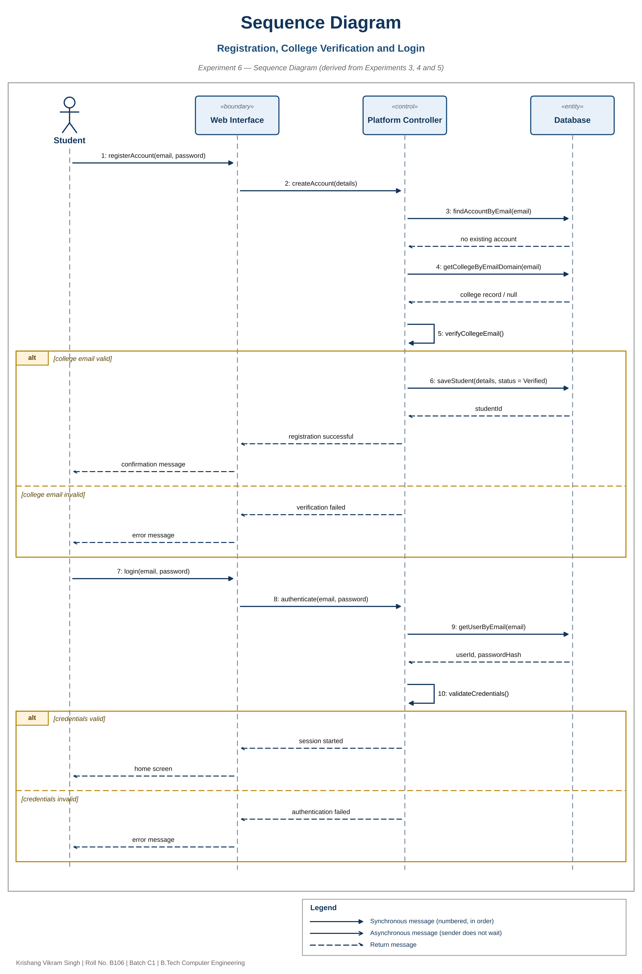
Figure 6.1 – Registration, College Verification and Login
Message Description – Scenario 1
No. | From to To | Message | Purpose
1 | Student to Web Interface | registerAccount(email, password) | Student submits the registration form
2 | Web Interface to Controller | createAccount(details) | Form data is passed to the controller
3 | Controller to Database | findAccountByEmail(email) | Checks that no account already exists for the email
4 | Controller to Database | getCollegeByEmailDomain(email) | Looks up the College record that matches the email domain
5 | Controller to Controller | verifyCollegeEmail() | Decides whether the college email is valid
6 | Controller to Database | saveStudent(details, status = Verified) | Valid branch: saves the Student with verificationStatus set to Verified; otherwise an error message is returned
7 | Student to Web Interface | login(email, password) | Student submits the login form
8 | Web Interface to Controller | authenticate(email, password) | Credentials are passed to the controller
9 | Controller to Database | getUserByEmail(email) | Fetches userId and passwordHash
10 | Controller to Controller | validateCredentials() | Valid branch: session starts and the home screen is shown; otherwise an error message is shown

Sequence Diagram 2: Search, View Recommendation and Submit / Validate Review
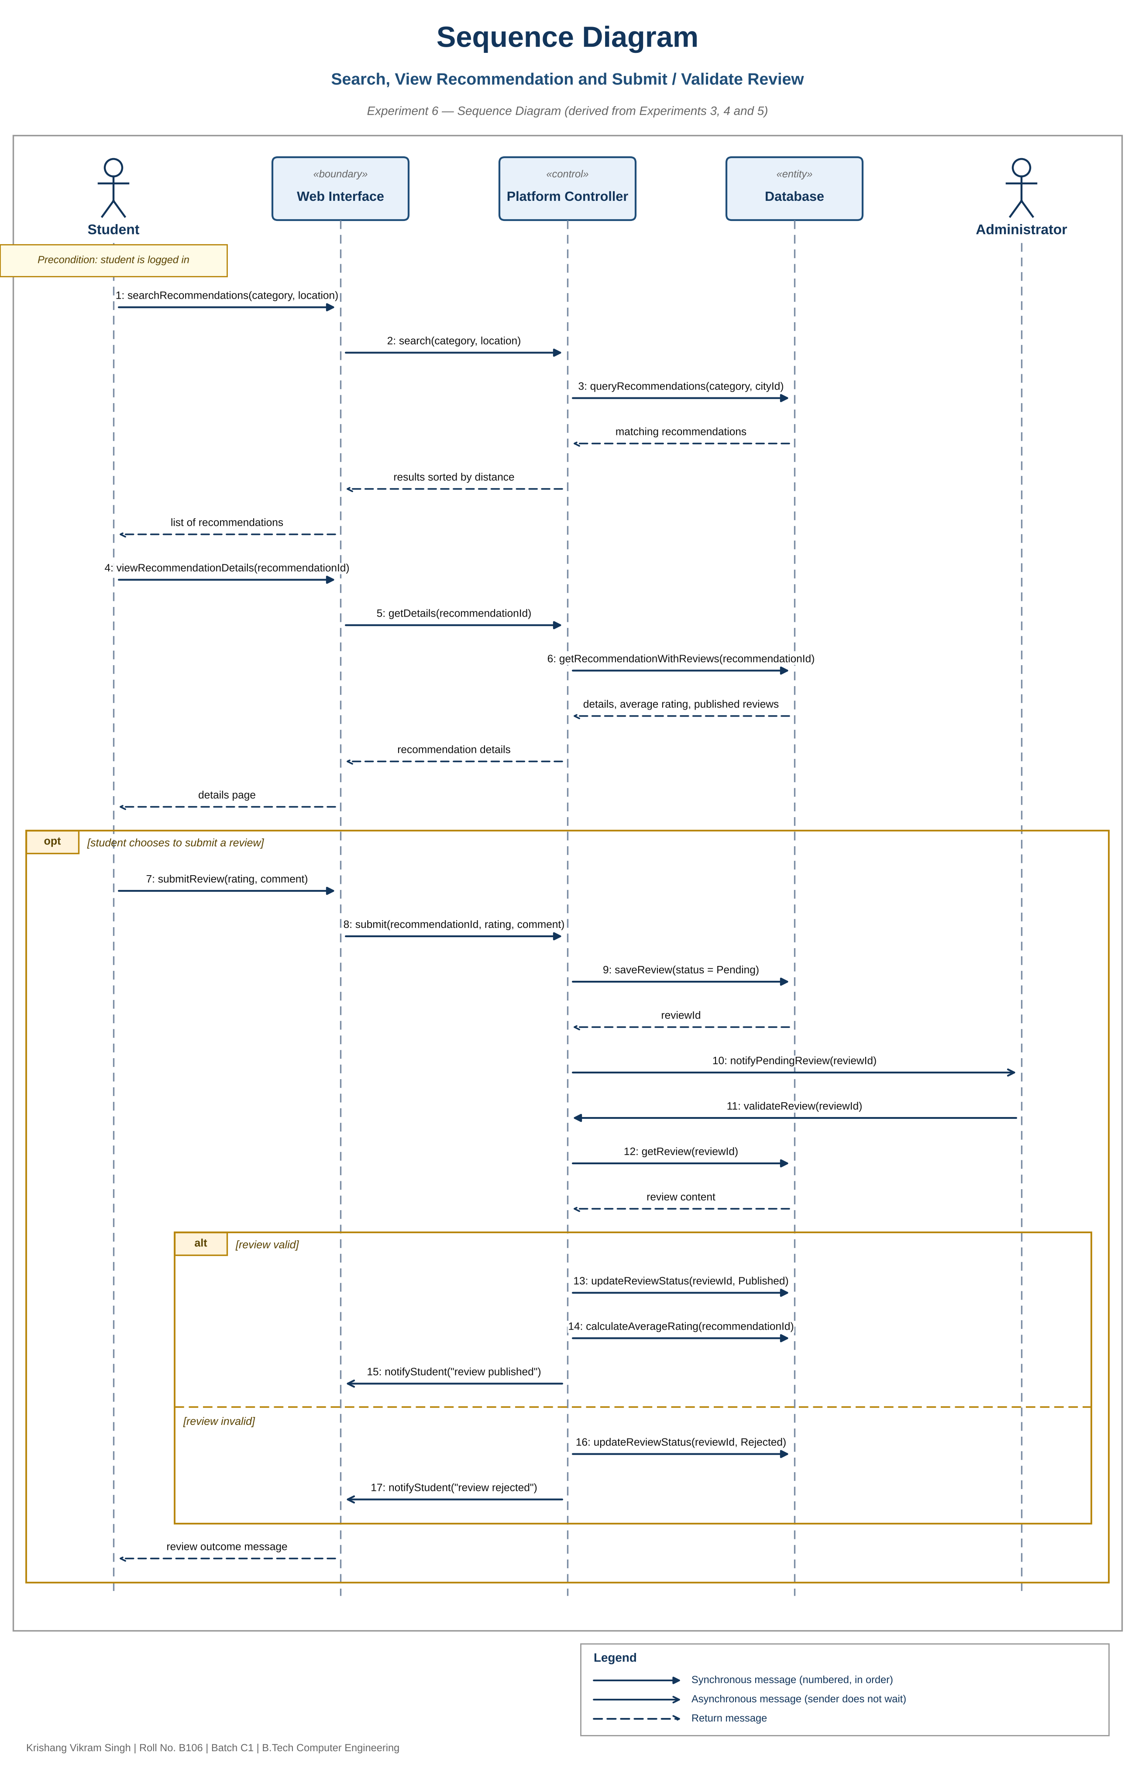
Figure 6.2 – Search, View Recommendation and Submit / Validate Review
Message Description – Scenario 2
No. | From to To | Message | Purpose
1 | Student to Web Interface | searchRecommendations(category, location) | Student searches a category near the selected location
2 | Web Interface to Controller | search(category, location) | Search request is passed to the controller
3 | Controller to Database | queryRecommendations(category, cityId) | Retrieves matching Recommendation records; results are returned sorted by distance
4 | Student to Web Interface | viewRecommendationDetails(recommendationId) | Student opens one recommendation
5 | Web Interface to Controller | getDetails(recommendationId) | Detail request is passed to the controller
6 | Controller to Database | getRecommendationWithReviews(recommendationId) | Returns details, average rating and published reviews
7 | Student to Web Interface | submitReview(rating, comment) | Optional branch: Student submits a rating and comment
8 | Web Interface to Controller | submit(recommendationId, rating, comment) | Review data is passed to the controller
9 | Controller to Database | saveReview(status = Pending) | Stores the Review with status Pending and returns reviewId
10 | Controller to Administrator | notifyPendingReview(reviewId) | Asynchronous: the Administrator is told a review awaits validation
11 | Administrator to Controller | validateReview(reviewId) | Administrator starts validation (the «include» of Experiment 3)
12 | Controller to Database | getReview(reviewId) | Fetches the review content for validation
13 | Controller to Database | updateReviewStatus(reviewId, Published) | Valid branch: Review.validate() – status becomes Published
14 | Controller to Database | calculateAverageRating(recommendationId) | Recomputes averageRating of the Recommendation
15 | Controller to Web Interface | notifyStudent("review published") | Asynchronous: the Student is informed of the outcome
16 | Controller to Database | updateReviewStatus(reviewId, Rejected) | Invalid branch: Review.reject() – status becomes Rejected
17 | Controller to Web Interface | notifyStudent("review rejected") | Asynchronous: the Student is informed of the outcome

Consistency with Previous Experiments
- Experiment 3 (Use Case Diagram): every message sequence realises one or more of its use cases, and Validate Review is invoked from Submit Review exactly as the «include» relationship specifies.
- Experiment 4 (Activity Diagram): the decisions College email valid?, Credentials valid? (login) and Review valid? appear as alt fragments, and the Student-to-Administrator swimlane hand-off appears as messages 10 and 11.
- Experiment 5 (Class Diagram): messages reuse the class operations (registerAccount, verifyCollegeEmail, searchRecommendations, viewRecommendationDetails, submitReview, validateReview, Review.validate/reject, calculateAverageRating) and the attributes verificationStatus, status and averageRating.
Conclusion
Sequence diagrams were drawn for the Student Recommendation Platform for New City Students to show the behavioural view of the system. Two scenarios were modelled with five lifelines (Student, Web Interface, Platform Controller, Database and Administrator): registration with college verification and login, and search, viewing a recommendation and submitting a review that the Administrator validates. Alt and opt fragments capture the branches already identified in Experiment 4, and the messages are named after the operations of the Experiment 5 class diagram, so the dynamic view stays consistent with the use case, activity and class models. The diagrams do not show every alternative flow described earlier, such as rejection of a duplicate account or the temporary lockout after five failed logins (Experiment 1), which could be added as further alt fragments.

