 | SVKM’s NMIMS  Mukesh Patel School of Technology Management & Engineering /  School of Technology Management & Engineering
B. Tech CE |  | Lab and Workbook | Academic Year- 2026-27
Year:-Third |  | Subject:- Drone Technology | Semester: Fifth
Experiment: 1
PART A
(PART A: TO BE REFERRED BY STUDENTS)
Aim: To understand the various components of a quadcopter, their functions, and how they work
together to achieve stable flight.

Prerequisite: Basic knowledge of UAVs & their applications, familiarity with drone communication protocols
Learning Outcome:
After completing the lab, students will be able to:
- Identify and explain the function of each quadcopter component.
- Understand how different parts work together for stable flight.
- Analyze the role of the flight controller
- Verify correct motor rotation and propeller orientation.
Theory:
A quadcopter is an unmanned aerial vehicle (UAV) that uses four rotors for lift and maneuverability. The quadcopter’s stability and control depend on its components, which include:
Frame
- The structural backbone that holds all components together.
- Made from materials like carbon fiber, aluminum, or plastic.

Motors
- Brushless DC motors (BLDC) provide thrust and control drone movement.
- Each motor’s rotation direction (clockwise or counterclockwise) is critical for stability.

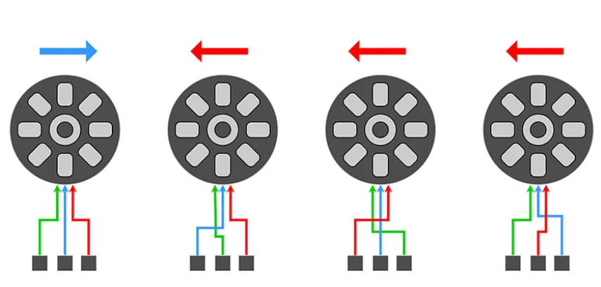
Electronic Speed Controllers (ESCs)
- Regulate power supply to motors based on flight controller signals.
- Convert throttle input into appropriate motor speed.
Flight Controller
- The brain of the quadcopter, processes sensor data and controls motor outputs.
- Examples: PX4, Betaflight, Ardupilot.
Propellers
- Generate thrust and lift; must be correctly paired (clockwise and counterclockwise).
- Made of plastic or carbon fiber.

Battery and Power Distribution Board (PDB)
- LiPo (Lithium Polymer) batteries provide power to motors and electronics.
- The PDB distributes power from the battery to different components.

Radio Transmitter and Receiver
- The transmitter (remote controller) sends commands, and the receiver interprets them.
- Works on protocols like SBUS, PPM, or DSM.
Sensors (IMU, GPS, etc.)
- IMU (Inertial Measurement Unit): Includes accelerometer and gyroscope for stability.
- GPS Module: Provides location data for autonomous navigation.

PART B

Roll No.: B106 | Name: Krishang Vikram Singh
Prog/Yr/Sem: B.Tech CE / Third Year / Fifth Sem | Batch: C1
Date of Experiment: 15/10/24 | Date of Submission: 15/10/24
Task to be performed
Task 1: Component Identification & Explanation
Task 2: Understanding System Integration
Task 3: Flight Controller Analysis
Task 4: Motor Rotation & Propeller Orientation Verification

Task 1: Component Identification & Explanation
Component | Function | Typical specification / example
Frame | Structural body that holds motors, battery, FC and payload; arms carry motors | X / H / + type; carbon fibre / aluminium / plastic (e.g. F450: 450 mm wheelbase)
BLDC motors (×4) | Produce thrust; speed variation gives control | 2212 / 920–1000 KV, 3-phase, 2 CW + 2 CCW
ESC (×4) | Convert FC’s PWM signal into 3-phase power for BLDC motor | 20–30 A, 2–4S, BEC optional
Flight Controller | Brain: reads sensors, runs stabilisation & navigation, drives ESCs | Pixhawk (ArduPilot / PX4), Betaflight boards
Propellers | Convert motor torque into lift; paired CW/CCW | 10×4.5 plastic or carbon fibre
LiPo battery + PDB | Battery supplies energy; PDB distributes it to ESCs and electronics | 3S/4S 11.1–14.8 V, 3000–5000 mAh, 20C+
TX / RX | Pilot commands sent wirelessly and decoded | 2.4 GHz, 6+ channels, SBUS / PPM / DSM
Sensors (IMU, GPS, baro, compass) | IMU = attitude & rotation; GPS = position; baro = altitude; compass = heading | MPU6000 IMU, u-blox GPS, MS5611 barometer

Task 2: Understanding System Integration
Signal and power flow of a quadcopter:
Pilot > Transmitter ))) 2.4 GHz ((( Receiver
Receiver --(SBUS/PPM)--> Flight Controller
Sensors (IMU, GPS, compass, baro) --> Flight Controller
Flight Controller --(PWM/DShot)--> 4 x ESC --> 4 x BLDC motor
BLDC motor --> Propeller --> Thrust and lift
LiPo battery --> PDB --> ESCs (high current)
LiPo battery --> Power module / BEC (5 V) --> FC, RX, GPS

- The pilot’s stick input is transmitted to the receiver and passed to the flight controller as roll, pitch, throttle and yaw commands.
- The IMU continuously measures the real angular rate and acceleration; the flight controller compares them with the commanded values using PID control.
- The FC computes a separate throttle value for each motor and sends it to the ESCs; the ESCs drive the motors at that speed.
- Stable flight is maintained by this closed loop that runs hundreds of times per second. GPS, barometer and compass add position, altitude and heading hold.
Motion by varying motor speed (Quad-X):
Movement | Motor speed change
Hover / climb / descend | All four motors increase / equal / decrease together
Roll (left / right) | Increase speed on one side’s motors, decrease on the other side
Pitch (forward / backward) | Increase rear (front) motors, decrease front (rear) motors
Yaw | Speed up the CW pair and slow the CCW pair (or vice-versa) – unbalances reaction torque

Task 3: Flight Controller Analysis
- The flight controller (e.g. Pixhawk running ArduPilot) has a 32-bit processor, an IMU (3-axis gyroscope + accelerometer), barometer and compass; external GPS is added through a serial port.
- Inputs: RC receiver (SBUS/PPM), sensors, battery monitor (power module), telemetry from ground station. Outputs: PWM / DShot signals on MAIN OUT 1–4 to the ESCs, plus telemetry and logs.
- Control: sensor fusion (EKF) estimates attitude and position; cascaded PID loops (angle → rate → motor mixer) calculate motor outputs.
- Safety: pre-arm checks, arming switch, failsafes for radio loss, low battery and GPS loss (RTL / Land).
- Examples compared: ArduPilot and PX4 (autonomous missions, GPS, Pixhawk hardware) and Betaflight (fast acro control, racing quads).
Task 4: Motor Rotation & Propeller Orientation Verification
In a Quad-X, diagonal motors rotate in the same direction. Looking from the top, with front of the drone at the top (ArduCopter motor order):
FRONT
3 (CW) 1 (CCW)
\ /
[FC]
/ \
2 (CCW) 4 (CW)
REAR

Motor | Position | Rotation | Propeller
1 | Front-right | CCW | CCW (reverse “R”) prop
2 | Rear-left | CCW | CCW (reverse “R”) prop
3 | Front-left | CW | CW (normal) prop
4 | Rear-right | CW | CW (normal) prop

Verification procedure (props removed):
- Remove all propellers and power the drone from a battery.
- Use Mission Planner → Initial Setup → Optional Hardware → Motor Test; run each motor at a low throttle (≈ 5–10 %) for a few seconds.
- Observe each motor’s rotation direction against the table above. If a motor spins the wrong way, swap any two of its three ESC–motor wires.
- Fit the propellers: CCW prop on CCW motors and CW prop on CW motors with the flat/curved leading edge facing the direction of rotation and the writing (size) facing up; tighten the nut.
Important: never test with propellers fitted while the drone is on a bench.

Observations and Learning:
- The quadcopter works as a system: frame → motors/ESCs → FC → sensors/RC → battery; every part depends on the others.
- Opposite-direction (CW/CCW) motor pairs cancel torque, so the drone yaws only when we deliberately change the speed of one pair.
- The flight controller is the brain: it combines IMU data and pilot commands using PID loops to keep the drone stable.
- ESCs convert the weak FC signal into the high-current 3-phase power required by the motors.
- Motor direction must be tested before fitting propellers, and propeller type must match the motor.
- The power module/BEC provides stable 5 V power to the FC and receiver independent of motor load.

Conclusion:
The components of a quadcopter – frame, BLDC motors, ESCs, flight controller, propellers, LiPo battery with PDB, transmitter/receiver and sensors – were identified and their functions explained. It was understood how they work together through a closed control loop to give stable flight, the role of the flight controller was analysed, and the motor rotation direction and propeller orientation were verified (diagonal motors same direction). All four learning outcomes were attained.

