
[Project Title: Wealth Intelligence: A Net Worth Tracker and Advisor Workbench for Indian Households]
Design Experience [I / II / III] Project Report
submitted in partial fulfilment of the requirements of
[Name of the Programme]
in
[Name of the Stream / Department]
Vertical: [VIP / EPICS / Industry Research / Technical Competition / Entrepreneurship]
by
Divya Arsewad (B162 / 70022300513)
Farhan Pardiwalla (L042 / 70112400037)
Arnav Talgaonkar (B113 / 70022400260)
Ziauddin Shaikh (D087 / 70062400111)
Nandini Chitlangia (I014 / 70412400067)
Asad Rizvi (B079 / 70022400139)
Mayank Deore (R074 / 70512300022)
Aditya Upadhyay (R069 / 70512400044)
Aryan Thakkar (D078 / 70062400099)
Krishang Vikram Singh (B106 / 70022400259)
Soham Kantharia ([Roll No.] / [SAP ID])
Under the supervision of
[Name of Faculty Mentor]
[Designation, Department, MPSTME]

MPSTME, SVKM’s NMIMS (Deemed-to-be University), Mumbai
Academic Year 2026–27
SVKM’s NMIMS University
(Deemed-to-be University)
MUKESH PATEL SCHOOL OF TECHNOLOGY MANAGEMENT & ENGINEERING (MPSTME)
Vile Parle (W), Mumbai-56
[Academic Year 2026–27]
CERTIFICATE
This is to certify that the Design Experience [I / II / III] project entitled “[Wealth Intelligence: A Net Worth Tracker and Advisor Workbench for Indian Households]” has been carried out by Divya Arsewad (B162 / 70022300513); Farhan Pardiwalla (L042 / 70112400037); Arnav Talgaonkar (B113 / 70022400260); Ziauddin Shaikh (D087 / 70062400111); Nandini Chitlangia (I014 / 70412400067); Asad Rizvi (B079 / 70022400139); Mayank Deore (R074 / 70512300022); Aditya Upadhyay (R069 / 70512400044); Aryan Thakkar (D078 / 70062400099); Krishang Vikram Singh (B106 / 70022400259); Soham Kantharia ([Roll No.] / [SAP ID]) under my guidance and supervision, and has been submitted in partial fulfilment of the requirements of [Name of the Programme] in [Name of the Stream] of MPSTME, SVKM’s NMIMS (Deemed-to-be University), Mumbai, India.

________________ ________________ ________________
Project mentor Vertical SPOC HoD
(name and signature) (name and signature) (name and signature)
(Internal Guide)
Date:
Place: Mumbai
ACKNOWLEDGEMENT
We thank our faculty mentor [Name of Faculty Mentor] for guiding this project from the first problem statement to the final demonstration, for pointing us to the original team workbook and for insisting that every number on screen be explainable. We thank the Design Experience vertical SPOC [Name] and the Head of Department [Name] for the framework and reviews that shaped the work, and our peers who tried the application and gave feedback during reviews.
We also acknowledge the open-source communities whose software this project stands on (Node.js, Express, React, Vite, Recharts, SQLite, Vitest and Playwright), and the Association of Mutual Funds in India for publishing the fund NAV data format used by our market-data adapter. [Add any industry / community partner, funding or resource provider, with the specific help received.]

Name | Roll No. | SAP ID
Divya Arsewad | B162 | 70022300513
Farhan Pardiwalla | L042 | 70112400037
Arnav Talgaonkar | B113 | 70022400260
Ziauddin Shaikh | D087 | 70062400111
Nandini Chitlangia | I014 | 70412400067
Asad Rizvi | B079 | 70022400139
Mayank Deore | R074 | 70512300022
Aditya Upadhyay | R069 | 70512400044
Aryan Thakkar | D078 | 70062400099
Krishang Vikram Singh | B106 | 70022400259
Soham Kantharia | [Roll No.] | [SAP ID]

DECLARATION
We declare that this report is our original work and reflects our own contribution in the semester of registration. We have acknowledged all contributors and cited all sources. The use of AI tools, if any, is disclosed in Section 5.5 and Appendix VII, and AI-generated content has been verified by us.
Signatures of students: ____________ ____________ ____________ Date: ____________

Abstract
Indian households typically hold wealth in many forms at once: property, gold, bank deposits, mutual funds, portfolio management services (PMS), alternative investment funds (AIF), direct shares and pension plans. The figures live in different statements, on different dates, and spreadsheets used to combine them silently treat an empty cell as zero. The result is a net worth that looks precise but is not, and risks (an equity share above plan, a concentrated stock, an idle cash balance, a missing nominee) that nobody is prompted to notice.
This report documents Wealth Intelligence, a working net worth tracker and advisor workbench built for the Design Experience subject. It records assets, liabilities, commitments, cash flow, goals, nominees and risk profile for a client; evaluates 19 configurable rules; keeps a persistent alert history with a stated reason and recommended action; computes an explainable 0 to 100 financial-health score; and proposes, but never executes, rebalancing options. Its central design rule is that an unknown must never be presented as a number: missing data is shown as “Awaiting data”, as a minimum to maximum range, or as “Not yet assessed”, and net worth is withheld until liabilities have been assessed.
The system is a single TypeScript package with a pure shared calculation engine, an Express API over SQLite with versioned migrations, and a React interface that installs as a phone app. Money is stored as integer paise. Security work includes hashed passwords, server-enforced roles, tenant isolation, optional two-factor sign-in, password reset and encrypted two-factor secrets. The product was designed through a heuristic review, an achromatic “ledger” visual system and an accessibility audit.
The outcome is a deployed-quality prototype of 8,143 lines of application code with 379 automated tests passing, 62 end-to-end browser checks, zero axe-core accessibility violations on 18 pages in light and dark themes at desktop and phone width, and Lighthouse scores of 99, 100, 100 and 100 on desktop. A live demonstration client (Priya Ramanathan) and three illustrative investor case studies show the behaviour. All data are synthetic; the tool is educational and is not investment, tax or legal advice. [Add one sentence on the vertical-specific outcome, for example customer discovery results, if applicable.]
Keywords: net worth tracking, wealth management, rule-based alerts, financial health score, asset allocation, data quality, explainable software, Indian personal finance.

Table of Contents
Abstract
Table of Contents
List of Figures
List of Tables
Abbreviations
Chapter 1 Introduction
1.1 Background of the project topic
1.1.1 Personal wealth in an Indian household
1.1.2 Why spreadsheets are not enough
1.1.3 The regulatory and technology context
1.2 Motivation and scope of the report
1.3 Problem statement, need and stakeholders
1.4 Objectives and expected outcomes
1.5 Project context and continuity
1.6 Organization of the report
Chapter 2 Background Study
2.1 Overview of the domain and its context
2.1.1 Net worth, assets, liabilities and commitments
2.1.2 Asset allocation, drift and concentration
2.1.3 Return measures
2.1.4 Risk profiling
2.1.5 Rules, alerts and explainability
2.2 Review of relevant sources
2.3 Gap identified and problem definition
Chapter 3 Design and Development Process
3.1 Stakeholder and user needs and specifications
3.1.1 Personas and the primary journey
3.1.2 Functional requirements
3.1.3 Non-functional requirements
3.1.4 Scope boundaries
3.2 Design alternatives considered and the decision
3.3 Selected design
3.3.1 Architecture
3.3.2 Data flow of a single edit
3.3.3 Database design
3.3.4 Engine design principles
3.3.5 Rules, score and risk model
3.3.6 Interface design
3.4 Standards, constraints, safety, ethical, societal and environmental considerations
3.4.1 Standards followed
3.4.2 Safety and security constraints
3.4.3 Ethical and societal considerations
3.5 Project plan: work breakdown, milestones, chart and task allocation
Chapter 4 Implementation, Results and Analysis
4.1 Implementation
4.1.1 Technology and size
4.1.2 Money, classification and look-through
4.1.3 Portfolio analytics and XIRR
4.1.4 Cash-flow forecast
4.1.5 Rules, alerts and notifications
4.1.6 Risk profile, nominees and tasks
4.1.7 Account security
4.1.8 Walk-through of the interface
4.1.9 How to operate the application
4.2 Testing, validation and verification
4.2.1 Test plan
4.2.2 Test data and boundary design
4.2.3 Mutation checking
4.3 Results and analysis
4.3.1 Functional results
4.3.2 Worked examples
4.3.3 Quality results
4.3.4 Own contribution brought out
4.4 Feedback received and iterations made
4.5 Advantages, limitations and applications
Chapter 5 Individual Contribution, Teamwork and Reflection
5.1 Team structure, roles and responsibilities
5.2 Individual contribution statements and evidence
5.2.1 Contribution statement: Divya Arsewad
5.2.2 Contribution statement: Farhan Pardiwalla
5.2.3 Contribution statement: Arnav Talgaonkar
5.2.4 Contribution statement: Ziauddin Shaikh
5.2.5 Contribution statement: Nandini Chitlangia
5.2.6 Contribution statement: Asad Rizvi
5.2.7 Contribution statement: Mayank Deore
5.2.8 Contribution statement: Aditya Upadhyay
5.2.9 Contribution statement: Aryan Thakkar
5.2.10 Contribution statement: Krishang Vikram Singh
5.2.11 Contribution statement: Soham Kantharia
5.4 Reflection by each student
5.4.1 Reflection: Divya Arsewad
5.4.2 Reflection: Farhan Pardiwalla
5.4.3 Reflection: Arnav Talgaonkar
5.4.4 Reflection: Ziauddin Shaikh
5.4.5 Reflection: Nandini Chitlangia
5.4.6 Reflection: Asad Rizvi
5.4.7 Reflection: Mayank Deore
5.4.8 Reflection: Aditya Upadhyay
5.4.9 Reflection: Aryan Thakkar
5.4.10 Reflection: Krishang Vikram Singh
5.4.11 Reflection: Soham Kantharia
Chapter 6 Conclusion and Future Scope
6.1 Brief report of the work carried out and conclusions drawn
6.2 Future scope and hand-over notes
6.2.1 What to do first
6.2.2 Build next, no outside input needed
6.2.3 Needs outside input
6.2.4 Deployment
6.2.5 Target direction
References
Appendix I
Summary of the IER and Evidence Register
Appendix II
Specifications: rules, database and score
Appendix III
Source code excerpts and sample tests
III.1 Exact money and stable percentages (money.ts)
III.2 XIRR that refuses to guess (xirr.ts, excerpt)
III.3 A property-based test (properties.test.ts, excerpt)
III.4 Worked calculations
Appendix IV
Meeting minutes, peer feedback forms and mentor feedback
Appendix V
Vertical-specific evidence
Appendix VI
Publications, competition certificates, patent and IP filings
Appendix VII
AI-tool use disclosure log
Appendix VIII
Viva question bank (supplementary)

List of Figures
Fig. 3.1: Layered architecture: browser, server, shared engine, persistence and external edges
Fig. 3.2: Sequence of a single edit from the user to the engine and back
Fig. 3.3: Entity relationships, simplified
Fig. 3.4: How incomplete inputs are handled: states a rule can return and what the user sees
Fig. 3.5: Information architecture of the interface
Fig. 3.6: Project plan and work breakdown by phase
Fig. 4.1: Wealth overview for Priya Ramanathan: gross assets ₹8.63 Cr, net worth and liabilities awaiting data
Fig. 4.2: Assets and liabilities: holdings with category, provisional flags and liquidity tiers
Fig. 4.3: Portfolio analytics with filters, exposure breakdowns and data-gap notices
Fig. 4.4: Cash-flow planner with the dated twelve-month forecast
Fig. 4.5: Rules and allocation: allocation basis, sample-policy warning, target versus actual
Fig. 4.6: Alert inbox with severity counts, tabs and persistent history
Fig. 4.7: Financial health score with components, weights and coverage
Fig. 4.8: Risk profile questionnaire and result
Fig. 4.9: Nominees and estate readiness
Fig. 4.10: Advisor view of all clients with attention queue
Fig. 4.11: Advisor task queue
Fig. 4.12: Account security: two-factor sign-in, recovery codes and sessions
Fig. 4.13: Overview in the dark theme
Fig. 4.15: Phone layout: overview
Fig. 4.15: Phone layout: alert list
Fig. 4.16: A typical advisory review in the application
Fig. 4.17: Automated tests by area

List of Tables
Table 1.1: Stakeholders and their interest in the system
Table 1.2: Structure of the report
Table 2.1: Review of existing products
Table 2.2: Academic and professional sources that shaped design decisions
Table 2.3: Standards and specifications followed
Table 3.1: Personas
Table 3.2: Functional requirements (FR) and where they are met
Table 3.3: Non-functional requirements structured by ISO/IEC 25010 characteristics
Table 3.4: Decision matrix for the kind of solution (weights sum to 100)
Table 3.5: Decision matrix for the data store
Table 3.6: Decision for the interface technology
Table 3.7: The eight core rules from the brief
Table 3.8: Design principles and their expression in the interface
Table 3.9: Milestones recorded in the repository
Table 3.10: Task allocation by work package
Table 4.1: Technology stack and size of the code base
Table 4.2: Operating guide
Table 4.3: Test layers, tools and what each verifies
Table 4.4: Definition-of-done checklist and evidence
Table 4.5: Iterations, their trigger and the change made
Table 4.6: Advantages, limitations and applications
Table 5.1: Team structure and allocation of report sections and slides
Table 6.1: Features blocked on external input
Table I.1: Evidence register
Table II.1: The 19 rules and their defaults
Table II.2: Risk profile bands and illustrative model allocations (percent of investable assets)
Table II.3: Health score components and default weights
Table III.1: Worked calculations
Table IV.1: Meeting minutes template
Table IV.2: Peer feedback form
Table IV.3: Mentor feedback record
Table V.1: Evidence by vertical
Table V.2: Competitive positioning summary (desk research, 23 Oct 2026)
Table VII.1: AI tools used, purpose and verification
Table VIII.1: Likely questions and model answers

Abbreviations
Abbreviation | Full form
2FA | Two-factor authentication
AA | Account Aggregator (RBI framework)
AIF | Alternative Investment Fund
AMFI | Association of Mutual Funds in India
API | Application Programming Interface
CAS | Consolidated Account Statement
CI | Continuous Integration
CSRF | Cross-Site Request Forgery
CSV | Comma-Separated Values
DX | Design Experience
EMI | Equated Monthly Instalment
FD | Fixed Deposit
IER | Individual Evidence Record
INR | Indian Rupee
MF | Mutual Fund
NAV | Net Asset Value
NFR / FR | Non-functional / Functional Requirement
PMS | Portfolio Management Service
PWA | Progressive Web App
RIA | Registered Investment Adviser (SEBI)
SEBI | Securities and Exchange Board of India
SPA | Single-Page Application
SQL | Structured Query Language
TOTP | Time-based One-Time Password (RFC 6238)
WCAG | Web Content Accessibility Guidelines
XIRR | Extended Internal Rate of Return
pp | Percentage points

Chapter 1
Introduction
This chapter introduces the subject of the project, explains why it was chosen and what the report covers, states the problem and the stakeholders it affects, lists the objectives, explains how this semester’s work relates to earlier work, and describes how the remaining chapters are organised.

1.1 Background of the project topic

1.1.1 Personal wealth in an Indian household
A middle- or upper-income Indian household rarely holds money in one place. A single family may own a flat, jewellery and gold coins, several fixed deposits, a dozen mutual-fund schemes bought through different platforms, a PMS account, a stake in an AIF, some directly held shares and a pension plan whose premiums are still being paid. Each of these is reported by a different institution, in a different format, on a different date and, for some (property, gold, an AIF), only when the owner chooses to estimate it. “What am I worth today?” therefore has no single place to be answered.
Spreading money across many asset types is itself sound practice; portfolio theory shows that holding assets whose returns do not move together lowers risk for a given return [1]. The practical difficulty is that diversification can only be judged if the whole picture is visible. A mutual fund shown as one line may be 90% equity or 10% equity; a PMS is a vehicle, not an asset class; a pension plan creates a promise to pay in the future that is not a loan today but is certainly a commitment.

1.1.2 Why spreadsheets are not enough
Most people, and many advisors, combine these numbers in a spreadsheet. A spreadsheet stores whatever is typed, adds whatever is in the cells, and treats an empty cell as zero. If liabilities have not been entered, net worth equals total assets, and nothing on the sheet says so. Rules of thumb such as “keep equity under 60%” or “no single stock above 10%” exist only in someone’s memory. When a fixed deposit matures or an insurance premium falls due, the spreadsheet does not tell anyone.

1.1.3 The regulatory and technology context
In India, giving personalised investment advice for a fee is regulated by SEBI under its Investment Advisers Regulations [2]. A tool that proposes actions must therefore be careful with wording and must leave the decision with a human; this project treats every recommendation as an option for an advisor to review and never executes anything. On the technology side, regulators have created the Account Aggregator framework for consented sharing of financial data [3] and the mutual-fund industry body publishes daily fund prices (NAVs) in an open text format [4]. These make automated data feeds possible in future; this project builds the analytical core that such feeds would plug into.

1.2 Motivation and scope of the report
The motivation is twofold. First, it is a real problem with a real audience: the advisor who prepares for a client review and the investor who wants one honest picture of what they own and owe. Second, it is a good test of engineering discipline for a Design Experience project. A tool that handles money invites the questions a faculty reviewer or a client would ask: where does this number come from, what happens if data is missing, who can change it, how do you know it is correct? Answering them forced decisions about data modelling, testing, security, accessibility and honest user-interface wording, all of which are documented here.
The report covers the work of this semester on the Wealth Intelligence application: requirements, design alternatives and the decision made, architecture, implementation, testing and results, the contribution of each team member, and what remains. It does not cover trading, tax filing, bank integration or document storage, which are outside the scope of the prototype (Section 3.1).

1.3 Problem statement, need and stakeholders
Problem statement. How can the scattered holdings, debts, commitments and cash flows of an Indian household be brought into one tool that calculates net worth and portfolio health correctly, warns about specific risks with a stated reason, proposes but never executes corrective action, and, above all, refuses to present an unknown as a number?
The need follows from the background above. Existing consumer apps focus on connecting accounts and show attractive totals; enterprise advisor platforms are costly and built for other markets; spreadsheets are free but silent about gaps (Chapter 2 compares them). A tool is needed that is honest about what it does not know, explains every alert, and fits Indian asset classes and conventions.
Table 1.1: Stakeholders and their interest in the system
Stakeholder | Who they are | What they need from the system
Investor (client) | A household such as the demonstration client, Priya Ramanathan, with ₹8.63 crore across seven positions | One truthful picture; to know what is missing; early warning when something drifts; no jargon
Advisor / relationship manager | A professional who reviews several clients and must defend each number | What changed, what needs action, repeatable checks, reports to hand over, an audit trail
Viewer (colleague, family member) | A read-only user | To read the same results without any ability to change them
Platform operator | The organisation running the deployment | Tenant isolation, user management, safe market-data handling
Faculty evaluator | Marks the project on rigour and usability | A clear demonstration, a documented method, honest limits

1.4 Objectives and expected outcomes
1. Track assets, liabilities and contractual commitments under a clear accounting convention in which commitments are not treated as debt.
2. Analyse a portfolio by asset class, instrument, issuer, liquidity and concentration, including look-through into funds and PMS.
3. Forecast cash flow for at least twelve months from actual due dates, not from averages.
4. Evaluate configurable rules and keep a persistent alert history in which an alert is created once, updated when it changes and resolved when it clears.
5. Score financial health on a transparent, editable method that never gives full or zero marks for missing data.
6. Propose rebalancing options and what-if scenarios without executing any trade or moving any money.
7. Provide three isolated investor case studies and a guided demonstration with a safe reset.
8. Protect client data: server-enforced roles, tenant isolation, two-factor sign-in, audit trail.
9. Verify the work: automated tests at unit, integration and browser level, an accessibility audit and a performance check.
Expected outcomes are a running application that a reviewer can operate end to end, a documented calculation method, a test suite that demonstrates correctness at and around every rule threshold, and an honest list of limitations. Chapter 4 reports how far each outcome was achieved.

1.5 Project context and continuity
Earlier work: the team’s original specification was a consolidated Excel workbook (Dashboard, Category Allocation, Data Collection and Category Mappings sheets) together with two reference images of the alerts and wealth-metrics screens. [State which earlier team or semester produced the workbook, and what part of it, if any, was built before this semester.] That workbook and the images were not available in the build environment, so the application was built from the written brief and the gap is recorded openly (Appendix I, evidence E14).
Work of this semester: everything described in Chapters 3 and 4, namely the calculation engine, the database, the API, the 20-page interface, the security features, the tests and the documentation, was carried out in this semester and is recorded as seven commits in the project repository between 23 and 24 October 2026. [Add the vertical, partner or competition context, if any, and the semester of registration.]

1.6 Organization of the report
Table 1.2: Structure of the report
Chapter | Content
1 Introduction | Background, motivation, problem, objectives, continuity
2 Background Study | Domain, review of existing products, standards and research; the gap
3 Design and Development Process | Requirements, alternatives and decision matrix, selected design, standards and ethics, project plan
4 Implementation, Results and Analysis | What was built, how it was tested, results, feedback and iterations, advantages and limits
5 Individual Contribution, Teamwork and Reflection | Roles, per-student contribution, teamwork, reflection, project management and AI-use disclosure
6 Conclusion and Future Scope | What was achieved, what remains, hand-over notes
References and Appendices I to VII | Sources in IEEE style; evidence register, specifications, code, minutes, vertical evidence, certificates, AI log

Summary. This chapter presented the household-wealth problem, why spreadsheets fail at it, the stakeholders, the nine objectives and the scope of the semester’s work. The next chapter studies the domain and existing solutions to establish the gap that this project fills.

Chapter 2
Background Study
This chapter explains the concepts the application relies on, reviews existing products, research and standards, compares them in a table and closes with the gap that defines the problem.

2.1 Overview of the domain and its context

2.1.1 Net worth, assets, liabilities and commitments
Net worth is what a person owns minus what they owe. The application distinguishes five amount types that are easily confused: market value (what an asset would fetch), invested capital (what was paid for it), account balance, outstanding principal (what is still owed on a loan) and commitment (a contractual future payment, such as the remaining premiums of a pension plan). Only the first, less confirmed outstanding principal, enters net worth. A commitment is shown beside net worth and in an adjusted net worth, never deducted as debt, because it is a future obligation rather than a debt today.

2.1.2 Asset allocation, drift and concentration
Asset allocation is the split of a portfolio across classes (Indian equity, global equity, debt, commodities, listed real assets, alternatives, real estate). A policy states a target for each class and a tolerance band; drift is the actual share minus the target in percentage points, so a move from 50% to 56% is a six-point drift, not a “12% change”. Concentration is the share of one holding, for example a single stock, in the portfolio. Both ideas descend from the diversification argument of portfolio theory [1].

2.1.3 Return measures
Absolute return compares current value with invested capital. XIRR (extended internal rate of return) is the annual rate that sets the net present value of dated cash flows to zero, so it respects when money went in and out [5]. The application computes XIRR only when dated transactions exist and otherwise reports “insufficient history” instead of guessing.

2.1.4 Risk profiling
Advisors judge how much market risk a client should take by combining willingness (temperament, experience, objective) and ability (horizon, income stability, reserves, obligations). Questionnaires for this purpose have a long history in the finance literature [6], and the observation that people weigh losses more heavily than equal gains [7] is why the questionnaire asks how a client would react to a 20% fall. Our implementation scores the two sections separately and takes the lower of the two (Section 4.1.6).

2.1.5 Rules, alerts and explainability
A rule is a condition on the data, such as “equity share above 60%”. An alert is the recorded event that the condition became true. A useful alert states what was measured, the threshold, why it fired, which records are involved and what action to consider. An alert system that re-creates the same warning on every refresh produces fatigue, so one live alert per condition with a history of changes is the better design.

2.2 Review of relevant sources
We reviewed products, research and standards under four headings: consumer net worth trackers, India-specific investment trackers, advisor platforms and open-source projects (Table 2.1); academic and professional literature that informed specific design decisions (Table 2.2); and the standards the build follows (Table 2.3). The product information comes from vendors’ public websites and comparison articles read on 23 October 2026. Comparison articles are often affiliate-style, so feature and pricing statements are indicative and should be re-verified on each vendor’s site before being quoted.
Table 2.1: Review of existing products
Product (group) | What it does well | Where it stops, relative to our aim
Kubera [8] (complex balance sheets) | Tracks crypto, private holdings and real estate; estate-planning feature for access after the owner | Tracking only; no configurable rules engine; paid; not India-first
Empower [9] (free US aggregator) | Links investment, retirement, cash, credit and loan accounts into one dashboard | US-centred; relies on account linking; advisor sales model
INDmoney [10] and Kuvera [11] (India trackers) | Import of consolidated statements, goals, tax reports, broad Indian coverage | Centred on mutual funds and broker data; totals shown without stating gaps; no advisor rules workbench
Addepar [12] (advisor platform) | Multi-custodian aggregation, performance reporting, client portals | Enterprise pricing and complexity; US-centred
Ghostfolio [13] (open source) | Self-hosted portfolio tracker, privacy-friendly | Investments only: no liabilities, cash flow, commitments or nominee view
Spreadsheet (status quo) | Free, flexible, familiar | Empty cell = zero; no rules, history or access control

Table 2.2: Academic and professional sources that shaped design decisions
Source | Contribution | How it was used
Markowitz, 1952 [1] | Diversification lowers risk for a given return | Allocation, drift and concentration measures and rules
Kahneman and Tversky, 1979 [7] | Losses weigh more than equal gains | Loss-reaction question in the risk questionnaire
Grable and Lytton, 1999 [6] | Scored questionnaire for financial risk tolerance | Questionnaire structure and scoring bands
Nielsen, 10 usability heuristics [14] | A checklist for judging interfaces | Heuristic self-review of the finished interface (Section 4.4)
Fowler, Money pattern [15] | Represent money so arithmetic is exact | Integer paise throughout; ratios derived only for display
Fielding, REST [16] | Architectural constraints for web APIs | Resource-style JSON API; reads never write

Table 2.3: Standards and specifications followed
Standard | Subject | Where applied
WCAG 2.1 [17] | Accessibility of web content, level AA | All pages; automated axe-core audit
OWASP ASVS 4.0.3 [18] | Application security requirements | Authentication, sessions, input validation, headers
RFC 6238 TOTP [19] | Time-based one-time passwords | Two-factor sign-in (SHA-1, 30 s, 6 digits)
RFC 7914 scrypt [20] | Memory-hard password hashing | Password storage
NIST SP 800-63B [21] | Authentication guidance | Minimum length, throttling, recovery codes
ISO/IEC 25010 [22] | Software quality model | Structure of non-functional requirements
OpenAPI 3.1 [23] | Machine-readable API description | Generated reference at /api/docs
DPDP Act 2023 [24] | Digital personal data protection in India | Least-exposure design; legal review still pending

2.3 Gap identified and problem definition
From the review, three things are not provided together by any single product we examined:
1. Honesty about unknowns. Consumer trackers show totals; they rarely say that liabilities were never entered or that a fund’s split between equity and debt is unknown. Spreadsheets show a confident total built on empty cells.
2. A transparent, configurable rules engine with an alert history. Consumer apps show insights they define; enterprise platforms are costly. Rules whose reason, threshold and action are visible and editable by the advisor are the missing middle.
3. India-specific completeness. Rupee-native money with lakh and crore formatting, Indian asset classes (PMS, AIF, SGB, REIT/InvIT), nominee and estate gap checks, and AMFI fund data.
This leads to the problem definition of Section 1.3. The claim is a gap in how existing capabilities are combined and presented, not a claim that individual calculations are new.
Summary. The chapter explained the domain concepts, compared six groups of existing solutions and the research and standards behind the design, and identified three gaps. Chapter 3 turns these into requirements and a design.

Chapter 3
Design and Development Process
This chapter turns the problem into requirements, compares the design alternatives with a decision matrix, presents the selected architecture and data design, lists the standards and ethical constraints followed, and gives the project plan.

3.1 Stakeholder and user needs and specifications

3.1.1 Personas and the primary journey
The personas below are proto-personas derived from the project brief and common advisory practice. They were not produced from user interviews and no user study was run; this is stated as a limitation in Section 4.5.
Table 3.1: Personas
Persona | Context | Needs | Pain point addressed
Priya Ramanathan (client) | Holds ₹8.63 crore across property, gold, FDs, funds, PMS, AIF and equity; pension plan with ₹20 lakh still to pay | One trustworthy view; know what is missing; see commitments | Aggregate holdings hide risk; liabilities unknown; premium dates unscheduled
Advisor (fictional) | Reviews several clients each month | Rules, drift, scenarios, shareable reports, a task queue | Manual spreadsheet checks; no history of what was flagged
Viewer (colleague) | Needs to read but not edit | A read-only login that cannot change anything | Shared files can be edited by anyone

The primary journey follows Priya’s review. She opens the overview and sees ₹8.63 Cr gross assets, liabilities “Not yet assessed” and net worth “Awaiting data”. She reviews seven holdings, adds a mutual-fund scheme and sees it classified live, records a loan and sees net worth appear as provisional, opens an alert to read why it fired, changes a threshold and sees the alert resolve while its history is kept, tries a rebalancing scenario, and exports a report. The advisor journey adds the clients overview, the task queue and e-mail alerts.

3.1.2 Functional requirements
Table 3.2: Functional requirements (FR) and where they are met
ID | Requirement | Met in
FR1 | Maintain assets, liabilities, commitments, income, expenses, insurance, goals and transactions with validation | Assets and liabilities, Cash-flow, Goals pages; zod validators
FR2 | Classify holdings automatically with override, review queue and look-through | Classification engine; Data collection review queue
FR3 | Compute net worth, returns, XIRR, allocation, concentration, debt ratios, savings rate and emergency cover | Overview, Portfolio analytics
FR4 | Forecast cash flow for at least twelve months using dated schedules | Cash-flow planner
FR5 | Evaluate the eight brief rules plus additional rules with editable thresholds and persistent alerts | Rules and allocation, Alerts
FR6 | Compute an explainable 0 to 100 health score with editable weights | Financial health
FR7 | Show target allocation, drift, rebalancing options and a what-if simulator | Rules and allocation
FR8 | Provide three isolated investor case studies | Investor case studies
FR9 | Import and export CSV and Excel; produce a printable report | Data collection, Reports and export
FR10 | Provide a market-data adapter layer with source and as-of dates | Market data
FR11 | Provide a guided demonstration with a safe reset | Guided demo
FR12 | Risk-profile questionnaire mapping to an illustrative model allocation | Risk profile
FR13 | Nominee registry and per-asset nomination coverage | Nominees and estate
FR14 | Opt-in e-mail alerts queued outside the request | Email notifications
FR15 | Advisor overview of all clients and a task queue | All clients, Tasks

3.1.3 Non-functional requirements
Table 3.3: Non-functional requirements structured by ISO/IEC 25010 characteristics
Characteristic | Requirement | How it is met
Functional correctness | Exact currency arithmetic | Integer paise [15]; percentages rounded to 9 decimals before comparison
Explainability | Every figure traceable | Methodology page, formulas on the score page, alert explanations, click-through drawers
Reliability | Survive restarts; no half-saved edits | SQLite with migrations; every multi-row change is one transaction; durability test re-opens the file
Security | Protect financial data | scrypt hashes, HttpOnly SameSite cookies, CSRF header, server-side roles, CSP, tenant guard, TOTP
Usability and accessibility | Usable by non-experts; WCAG 2.1 AA | Plain language, “Awaiting data” states, keyboard operation, table alternative to each chart
Performance efficiency | Whole-client evaluation fast enough to run on every read | Evaluate p95 5.5 ms and full state p95 100 ms with 5,000 holdings (budget 300 ms)
Maintainability | Separated layers; tests | Pure shared engine; typed API; 379 tests; CI on every push
Portability | Run on a laptop and in a container | Node 22.13+, no native build step; Dockerfile and docker-compose

3.1.4 Scope boundaries
Inside scope: manual and file-based data entry, calculations, rules, scoring, reporting and a market-data adapter layer. Outside scope: trade execution, bank or broker connections, tax computation and document storage. The application never moves money, redeems an investment or places a trade.

3.2 Design alternatives considered and the decision
Three levels of decision were made. The first is the kind of solution; the second is the data store; the third is the shape of the user interface. Each was scored against criteria weighted by what the problem needs most. The scores (1 poor to 5 excellent) are the team’s judgement and are shown so the reasoning can be challenged.
Table 3.4: Decision matrix for the kind of solution (weights sum to 100)
Criterion (weight) | A. Spreadsheet template | B. BI dashboard on a sheet | C. Custom web application
Honest handling of missing data (25) | 1 | 2 | 5
Configurable rules with history (20) | 1 | 2 | 5
Access control and audit trail (15) | 1 | 3 | 5
Demonstrable correctness by tests (15) | 1 | 1 | 5
Effort to build (10) | 5 | 4 | 2
Fit to Indian assets and formats (10) | 3 | 3 | 5
Accessibility and phone use (5) | 2 | 3 | 5
Weighted score (out of 5) | 1.7 | 2.3 | 4.7

Decision: option C. The two cheaper options fail exactly where the problem is hardest: they cannot refuse to show a number when its inputs are missing, and they cannot be tested the way code can. The weighted scores are computed as the sum of weight × score ÷ 100.
Table 3.5: Decision matrix for the data store
Criterion (weight) | SQLite (built-in node:sqlite) | PostgreSQL from day one
Zero-setup for a reviewer (30) | 5 | 2
Transactions and constraints (25) | 5 | 5
Multi-tenant scale and row-level security (20) | 2 | 5
No native build step (15) | 5 | 4
Operational cost (10) | 5 | 3
Weighted score (out of 5) | 4.3 | 3.8

Decision: SQLite in write-ahead-log mode [25] through the runtime’s built-in module [26], with the repository isolated so PostgreSQL can replace it later. The trade-off is accepted and recorded: isolation between organisations is enforced in application code, not by the database (Section 4.5).
Table 3.6: Decision for the interface technology
Option | Strength | Weakness | Verdict
Server-rendered pages | Simple, little client code | Hard to give instant feedback while typing (live classification preview); charts need scripts anyway | Rejected
Single-page app with React [27] | Component reuse, rich forms, charts, installable as a PWA | Larger bundle (mitigated by route-level code splitting: main chunk 295 kB) | Selected
Native mobile app | Best phone integration | Two code bases; app-store effort | Rejected for now; PWA gives install and offline shell

3.3 Selected design

3.3.1 Architecture
The application is one TypeScript package in five layers (Fig. 3.1). The decisive rule is that financial logic lives only in the shared engine, a set of pure functions with no input or output. The server calls the engine after every change and stores the resulting alert history; the browser renders the evaluation the server returns and performs no calculations of its own. Because the whole client is re-evaluated from stored data after each change, there are no cached totals that can become stale.
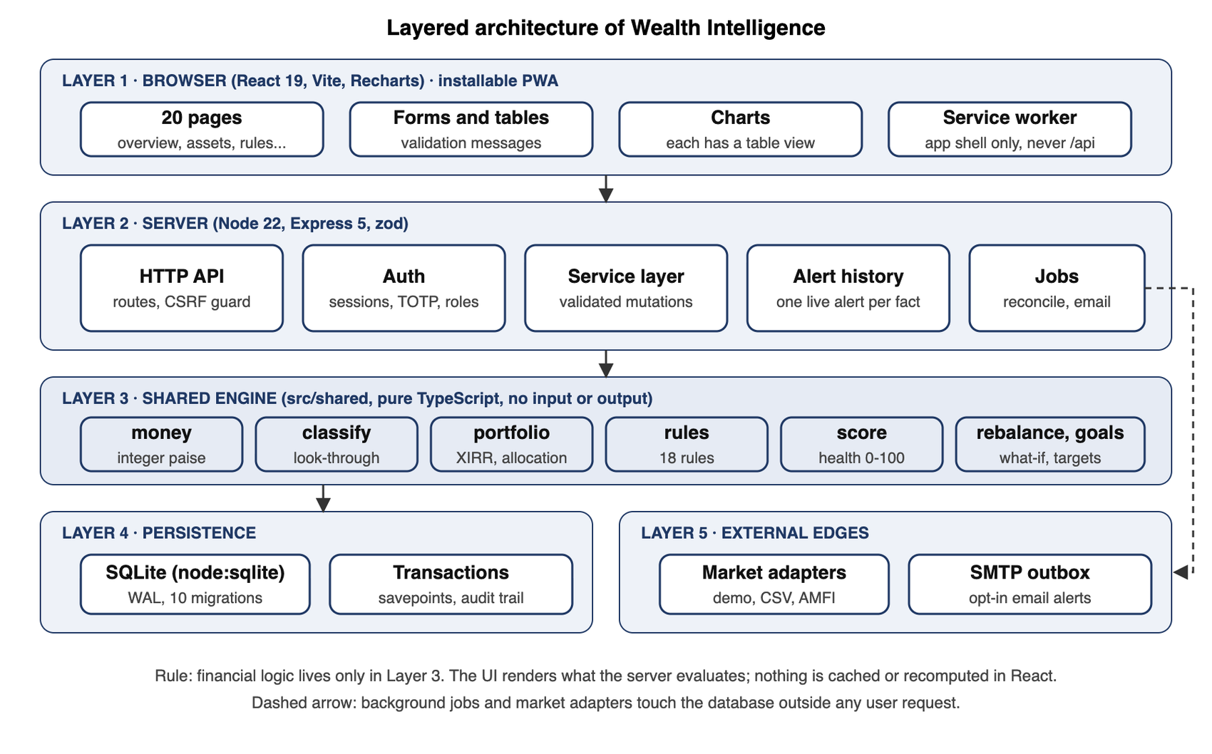
Fig. 3.1: Layered architecture: browser, server, shared engine, persistence and external edges

3.3.2 Data flow of a single edit
Fig. 3.2 shows what happens when a user edits a holding. The request is validated; if validation fails nothing is stored and field errors are returned. Otherwise classification, the row update, a new valuation row and an audit event are written in one transaction, the whole client is evaluated, and alert history is reconciled. A later read of the state returns data, evaluation and alerts together. Reads never write: a test spies on every SQL statement of every GET route to prove it.
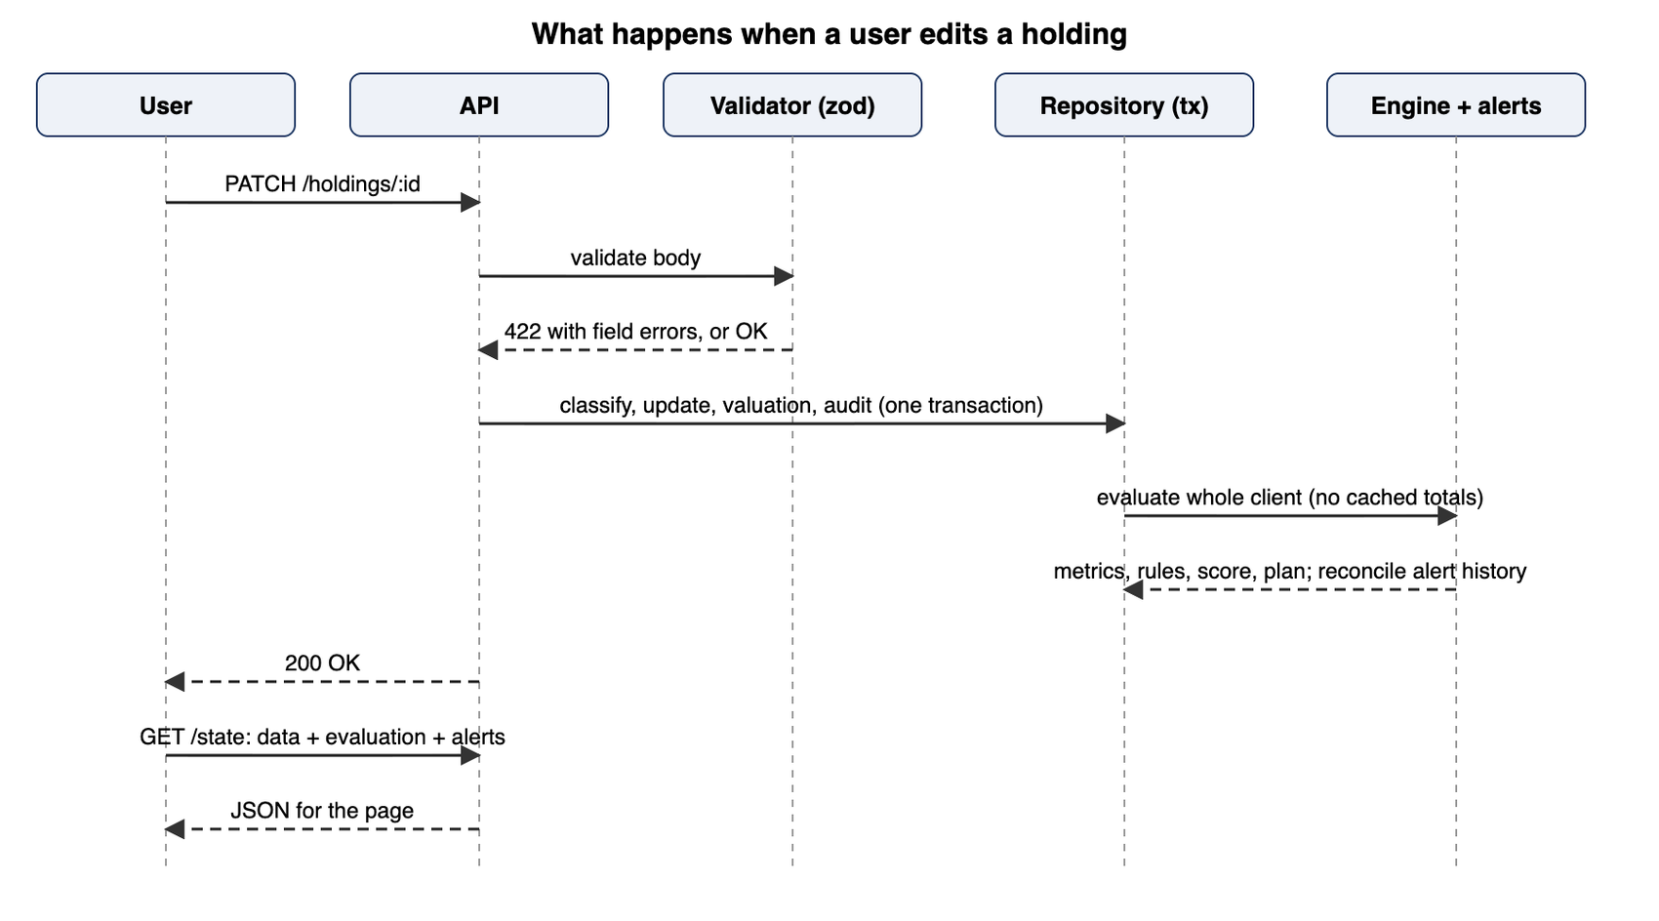
Fig. 3.2: Sequence of a single edit from the user to the engine and back

3.3.3 Database design
Every entity has a typed table with a foreign key to the client, and every client and user belongs to a tenant (an organisation), so that one deployment can serve several firms without mixing their clients (Fig. 3.3). Holdings link to themselves through a parent identifier so that an aggregate such as “Mutual-fund holdings” can be split into underlying schemes. A partial unique index on alerts, (client_id, fingerprint) WHERE status != 'resolved', makes a duplicate live alert impossible at the database level, whatever the application code does. Ten numbered SQL migrations create and evolve the schema, each applied in a transaction.
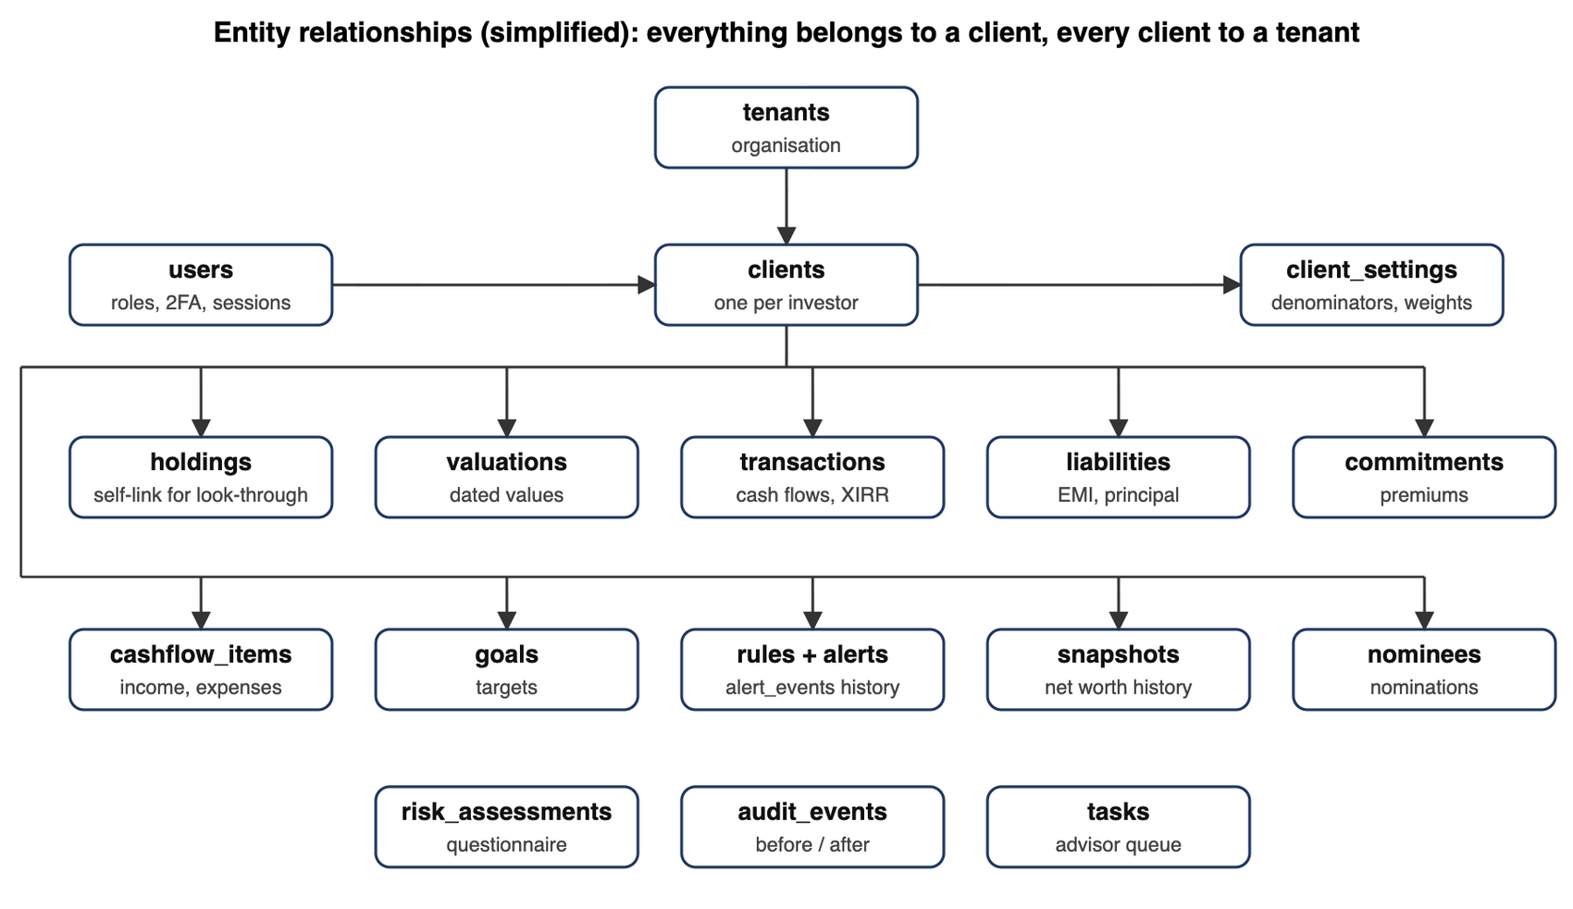
Fig. 3.3: Entity relationships, simplified

3.3.4 Engine design principles
- Exact money. Amounts are integer paise (1 rupee = 100 paise). JavaScript integers are exact up to about ₹9 × 10¹³, far above any household value, so sums never drift. Ratios are derived only at the end for display and thresholds.
- Unknown is not zero. Unresolved items widen results into [minimum, maximum] ranges, and every rule returns one of five states (Fig. 3.4): triggered, ok, possible, not evaluable or disabled.
- Aggregate versus underlying. An aggregate is replaced by its underlying positions and any remainder is kept as one unallocated line, so nothing is counted twice.
- Demo isolation. Fixtures are flagged, and a reset deletes and re-inserts only the fixture clients, never clients a user created.
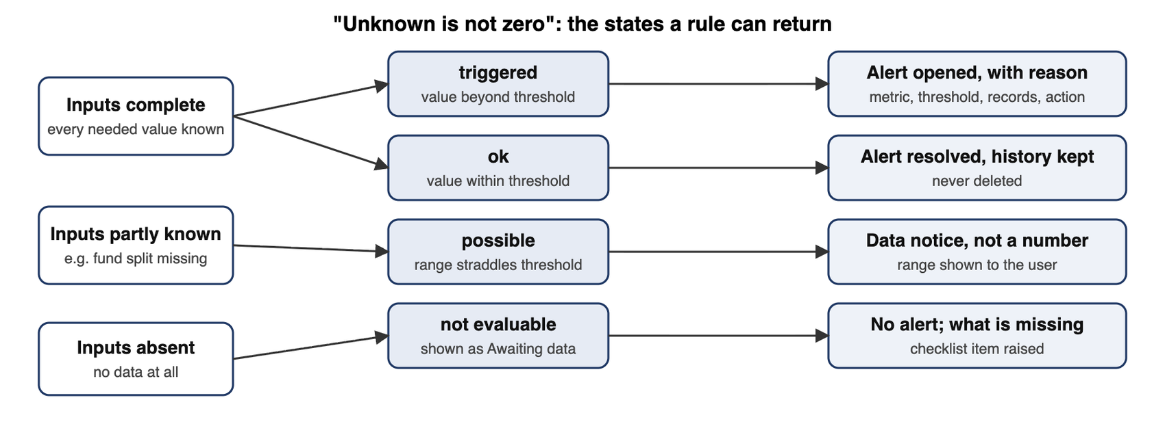
Fig. 3.4: How incomplete inputs are handled: states a rule can return and what the user sees

3.3.5 Rules, score and risk model
The engine evaluates 19 rules: the 8 core rules named in the brief and 11 additional safeguards (Appendix II lists defaults). Every rule can be disabled and has an editable threshold, severity and, where relevant, denominator. The threshold boundary is explicit: with the default strict setting a value exactly at the limit does not trigger, and an “inclusive” option changes that.
Table 3.7: The eight core rules from the brief
Rule | Formula | Default | Severity
Equity allocation | equity value ÷ denominator × 100 | > 60% | High
Single-stock concentration | stock value ÷ concentration denominator × 100 | > 10% | High
Debt allocation floor | debt value ÷ denominator × 100 | < 20% | Warning
Net worth falls | (current − previous) ÷ |previous| × 100, like-for-like snapshots only | fall > 5% | Critical
EMI-to-income | total EMI ÷ verified monthly gross income × 100 | > 40% (assumed) | High
Allocation drift | actual % − target %, in percentage points | > 5 pp | Warning
Idle cash | cash − emergency fund − next 90 days of outflows, held for N days | 10% / ₹5 L / 30 d | Warning
Maturity or renewal | days until FD, bond or policy date | within 60 days | Warning

The health score runs from 0 to 100 and has six components with editable weights: net-worth strength 20%, savings and cash flow 20%, emergency fund and liquidity 20%, debt burden 15%, diversification 15% and insurance coverage 10%. A component without enough data is shown as not assessed; it is excluded, the remaining weights are re-normalised, and the score is labelled provisional with the share of weight assessed. Below 50% coverage it is flagged low coverage and given no band label. Each component is scored by documented piecewise-linear anchors; for example the savings-rate anchors are 0% → 0, 10% → 50, 20% → 75 and 30% or more → 100. It is an educational indicator and not a credit-bureau score.
The risk questionnaire has eight questions: four on tolerance (reaction to a 20% fall, acceptable range of yearly outcomes, experience, objective) and four on capacity (horizon, income stability, reserves, obligations), each answered on a 0 to 3 scale. The profile is the lower of the two section results and is then capped by guard-rail answers (for example, “need the money within 3 years” caps the profile at Conservative). Unanswered questions yield a range, never a silent zero. A profile maps to an illustrative model allocation that can be applied as the target allocation; applying it never marks the policy as validated.

3.3.6 Interface design
The interface has 20 pages in six navigation groups (Fig. 3.5), so a user always knows whether they are looking at wealth, intelligence, data or project material. The design process followed five steps: understand the brief, define principles, design the information architecture, build a small design system, and review the screens against recognised heuristics.
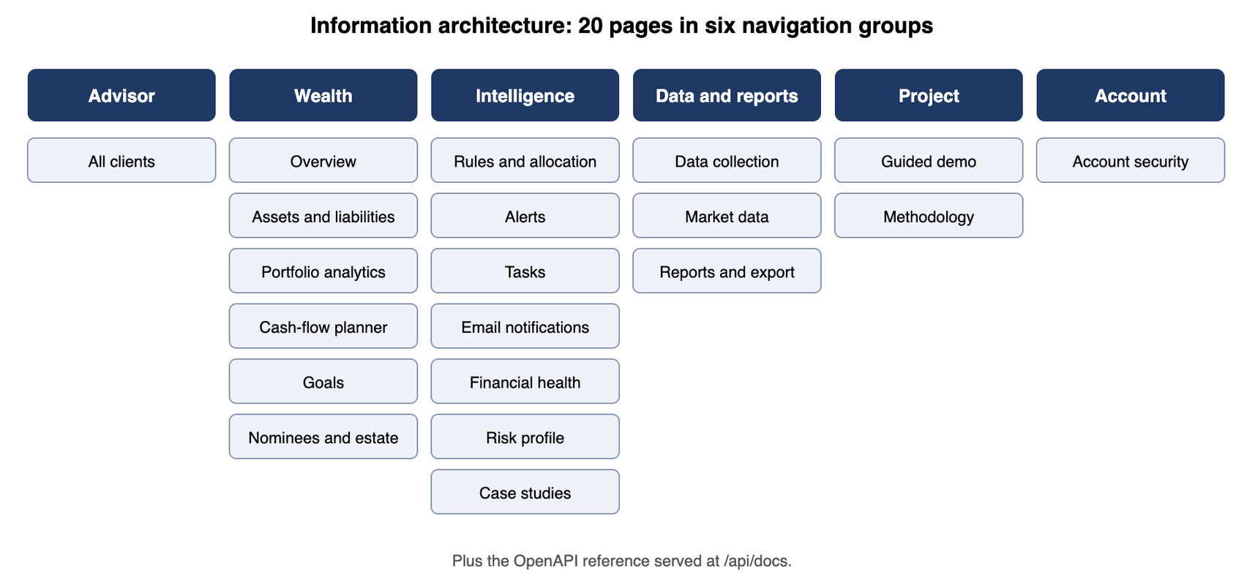
Fig. 3.5: Information architecture of the interface
Table 3.8: Design principles and their expression in the interface
Principle | What it means | Example
Unknown is not zero | Missing data has its own visual state | KPI card reads “Awaiting data” with a reason; hatched bar under net worth marks the unassessed part
Explain every alert | Metric, threshold, reason, records, action | Alert drawer with history
Show cause and effect | Edits visibly change dependent numbers | Add a liability and net worth appears as provisional
Separate amount types | Market value, cost, balance, principal, commitment are labelled differently | Assets table and amount-types card
Never act on the user’s behalf | Recommendations are options | Scenario simulator runs on a copy and executes nothing
Progressive disclosure | Headline first, detail on click | KPI cards open drawers with the records behind them
Accessible by default | Keyboard, labels, text alternatives | Table button on every chart; focus trap in dialogs

The visual system (called “achromatic ledger” in the project notes) uses ink-coloured chrome on a blue-grey ground, a near-black primary button and one blue reserved for the main data. Asset classes use blues, ink and greys; status colours (good, warning, serious, critical) are reserved and always paired with a label or icon, never colour alone. Type is Geist with tabular figures so columns of money align, and amounts use Indian digit grouping with lakh and crore forms. Motion follows a restraint rule: entrances under 300 ms with ease-out, no exit animation, and reduced-motion preferences respected. On a phone the sidebar becomes a tab bar and dialogs become bottom sheets.

3.4 Standards, constraints, safety, ethical, societal and environmental considerations

3.4.1 Standards followed
Accessibility targets WCAG 2.1 level AA [17]; security requirements are drawn from the OWASP Application Security Verification Standard [18]; two-factor sign-in implements RFC 6238 [19], verified against the RFC’s own test vector; passwords are hashed with scrypt [20] and authentication behaviour (minimum length, throttling, single-use recovery codes) follows NIST guidance [21]. The API description is generated in OpenAPI 3.1 from the live route table.

3.4.2 Safety and security constraints
- Sessions use a 256-bit opaque token stored only as a hash, expire after 12 hours and travel in an HttpOnly, SameSite=Strict (and, in production, Secure) cookie; every mutating request must also carry a custom header (CSRF defence).
- Viewers cannot write: the server returns an error for every mutating route; hiding buttons is only cosmetic.
- A client in another tenant answers exactly like a non-existent one (same 404, no probing of identifiers); one route guard covers every client-scoped route, and a test sweeps every route and method from other tenants.
- Two-factor secrets are sealed at rest with AES-256-GCM; password-reset and verification links take their host from configuration, never from the request, so a forged Host header cannot redirect a token.
- Logs are structured JSON without bodies, cookies or passwords; CSV export neutralises formula injection.

3.4.3 Ethical and societal considerations
No invented data. All data in the repository is synthetic, and where the brief did not supply a value the application says so instead of filling it. No advice. Recommendation wording has not had legal review and may have implications under the SEBI adviser rules [2]; the application therefore labels itself educational, proposes only, and never executes. Privacy. Client financial data is sensitive: e-mails omit figures unless the operator turns details on, the service worker never caches API responses, and nominee records contain names only, with a warning not to enter passwords. The Digital Personal Data Protection Act, 2023 [24] would apply to real client data; consent capture, export and deletion flows are listed in the roadmap and are not yet built. Inclusion. Plain-language labels, keyboard operation, text alternatives to charts and a layout that works on a phone widen who can use the tool. Environmental. The system is a lightweight single process with no GPU or large model, and the service worker avoids repeat downloads; there is no material environmental footprint beyond ordinary hosting.

3.5 Project plan: work breakdown, milestones, chart and task allocation
The work was organised in six phases that follow the repository history (Fig. 3.6). The figures below are the commit records, which are the only dated evidence of progress available to the report; if the team’s meeting schedule differs, replace the table with the real dates. [Add semester week numbers for each phase.]
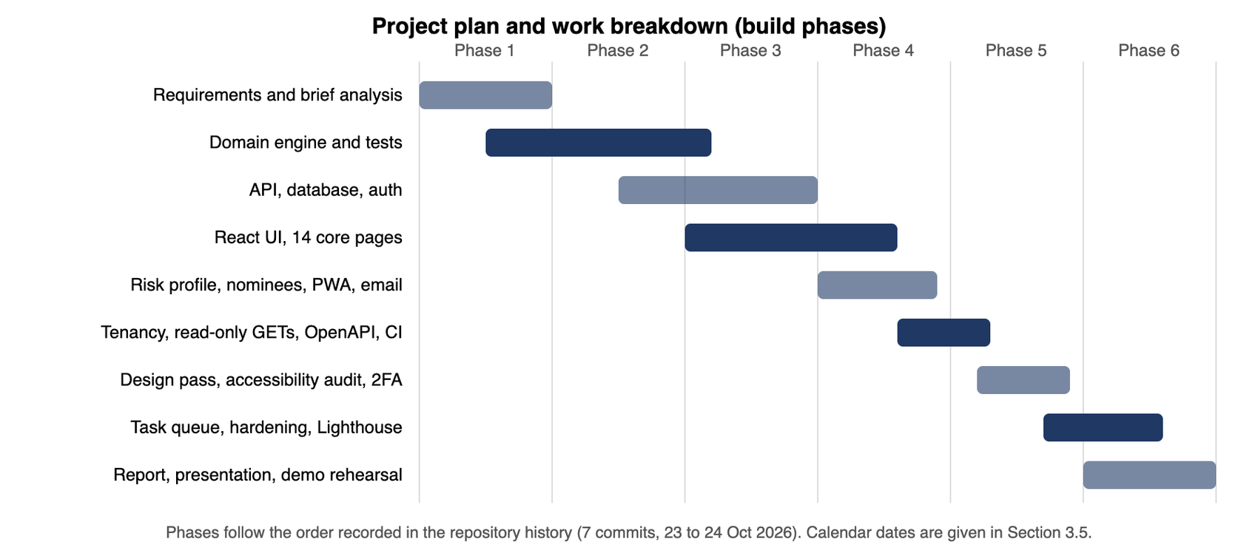
Fig. 3.6: Project plan and work breakdown by phase
Table 3.9: Milestones recorded in the repository
Date (2026) | Commit | Milestone
23 Oct | e5d7fa9 | Initial commit: engine, API, database, 14 core pages, 171 tests
23 Oct | b46f320 | Risk profile, nominees and estate, installable PWA, e-mail alerts
23 Oct | 4b09ac3 | Read-only GETs, tenant isolation, runtime state in the database, advisor overview, OpenAPI, CI and Docker, lint
23 Oct | cac557a | Design pass, accessibility audit, two-factor sign-in and password reset
23 Oct | a23425d | Polish pass: risk radios, health ring, awaiting-data colour, table overflow
23 Oct | 63879ae | Achromatic ledger restyle, PRODUCT.md, Geist type, design detector fixes
24 Oct | 7945eb8 | Task queue, account hardening, component and visual tests, Lighthouse fixes

Table 3.10: Task allocation by work package
Work package | Owner(s) | Evidence IDs
Requirements, personas, brief analysis, audit and traceability | Nandini Chitlangia; Farhan Pardiwalla | E01, E14
Data extraction: brief figures, fixtures, import files, market-data adapters | Farhan Pardiwalla; Soham Kantharia | E01, E04
Money, classification, look-through | Arnav Talgaonkar | E02, E03
Rules engine and alerts | Ziauddin Shaikh | E02, E03
Allocation, drift, rebalancing, risk profile | Divya Arsewad; Nandini Chitlangia | E02, E03
Cash-flow forecast | Asad Rizvi | E02, E03
Architecture, database, API, security, technical stack, integration | Krishang Vikram Singh | E04, E05, E08
UI/UX, feature suggestions, comparison with other software | Aryan Thakkar | E06, E07, E13
Testing, validation, verification (incl. security and accessibility tests) | Aditya Upadhyay | E09 to E12
Results and analysis | Mayank Deore | E09, E15
Report assembly, references, similarity check, presentation | Soham Kantharia; Krishang Vikram Singh | E15, E16

Summary. This chapter set out 15 functional and eight groups of non-functional requirements, compared alternatives with weighted decision matrices, presented the five-layer architecture, data and engine design, the rules, score and risk model, the interface principles, the standards and ethical constraints, and the plan. Chapter 4 shows how the design was implemented and tested.

Chapter 4
Implementation, Results and Analysis
This chapter describes what was built, how it was tested and validated, what the results show, what feedback led to changes, and the advantages, limitations and applications of the result.

4.1 Implementation

4.1.1 Technology and size
Table 4.1: Technology stack and size of the code base
Layer | Technology | Lines (approx.) | Role
Shared engine | TypeScript, pure functions | 2,349 | Money, classification, portfolio, XIRR, net worth, cash flow, rules, score, rebalancing, goals
Server | Node 22, Express 5, zod [28], node:sqlite | 2,623 | Validated API, authentication, alert history, import and export, market adapters, jobs
Interface | React 19, Vite, Recharts [27] | 3,171 | 20 pages, forms, charts, tables, dark mode, phone layout, service worker
Tests | Vitest [29], fast-check [30], Playwright [31] | 2,808 | 379 unit, component and API tests; browser walkthroughs
Database | SQLite, 10 migrations | n/a | Typed tables, transactions, partial unique index for alerts
Operations | Dockerfile, docker-compose, GitHub Actions | n/a | Container image and CI on every push

4.1.2 Money, classification and look-through
The money module defines amounts as integer paise, helpers for lakh and crore, a division that returns null instead of infinity, and a percentage function that rounds to nine decimals so a value exactly at a threshold is not tipped over by binary floating-point noise (55.00000000000001). Classification maps each instrument to an asset class and a liquidity tier using a mapping table that the advisor can edit; mutual-fund aggregates, PMS and AIF cannot be assigned until their underlying positions are known, so they are held as unresolved and reported as ranges. Overrides are logged with before and after values.

4.1.3 Portfolio analytics and XIRR
Portfolio analytics breaks exposure down by class, Indian versus global equity, direct versus indirect equity, instrument, issuer and sector, with filters that drive every figure. XIRR is solved with a bracketed hybrid of Newton’s method and bisection so it cannot diverge; it rejects series with invalid dates, with only one direction of flow, with all flows on one date, or with a holding period under 30 days, and returns a reason instead of a number. A test checks a 10% case exactly and intermediate flows with net present value near zero.

4.1.4 Cash-flow forecast
The planner builds a twelve-month forecast from actual dates including month-end clipping. A premium commitment stops when fully paid and the last instalment is trimmed to the remainder. An annual pension receipt with no date is listed as an unscheduled inflow instead of being spread over twelve months, and while income is not marked complete the surplus is labelled provisional and the savings rate is withheld.

4.1.5 Rules, alerts and notifications
Each rule is a definition (description, calculation, trigger, response, defaults) plus a function that returns findings. After every mutation the server evaluates the client and reconciles alert history: a new condition opens an alert, a changed one updates it and records an event, a cleared one is resolved and kept. When an existing alert becomes more severe it is e-mailed again, never on a decrease. New alerts are queued in the database inside the same transaction; a background job sends them, so a failing mail server cannot break an edit, and retries stop after three attempts.

4.1.6 Risk profile, nominees and tasks
The risk page shows eight questions, a live result panel with the tolerance and capacity scores, the resulting profile and an illustrative model allocation. The nominees page keeps a registry of nominees and per-asset shares that must total 100%; “not recorded” is shown as unknown rather than “no nominee”, and a nomination-gap rule reports when the fully nominated value falls below a threshold. The task queue lets an advisor create a task from an alert, assign it, set a due date and track its status, scoped to the organisation.

4.1.7 Account security
Passwords are hashed with scrypt. Two-factor sign-in is optional per user: after a correct password the server issues a five-minute challenge, not a session, and the session starts only after a valid code. A code is accepted once (the last accepted 30-second step is stored), a challenge allows five wrong codes, and eight single-use recovery codes are stored only as hashes. Password-reset links are valid for 30 minutes and once; the reply is identical whether or not an account exists. Each sign-in records device and address, and the account-security page lists and revokes sessions. An operator can require two-factor for advisors.

4.1.8 Walk-through of the interface
The figures below show the running application with the demonstration client, captured from a throwaway database on a desktop-width browser. The overview (Fig. 4.1) puts the honest headline first: gross assets, with calculated net worth and confirmed liabilities each reading “Awaiting data” and a hatched bar marking the unassessed part, then alerts with their recommended actions directly beneath.
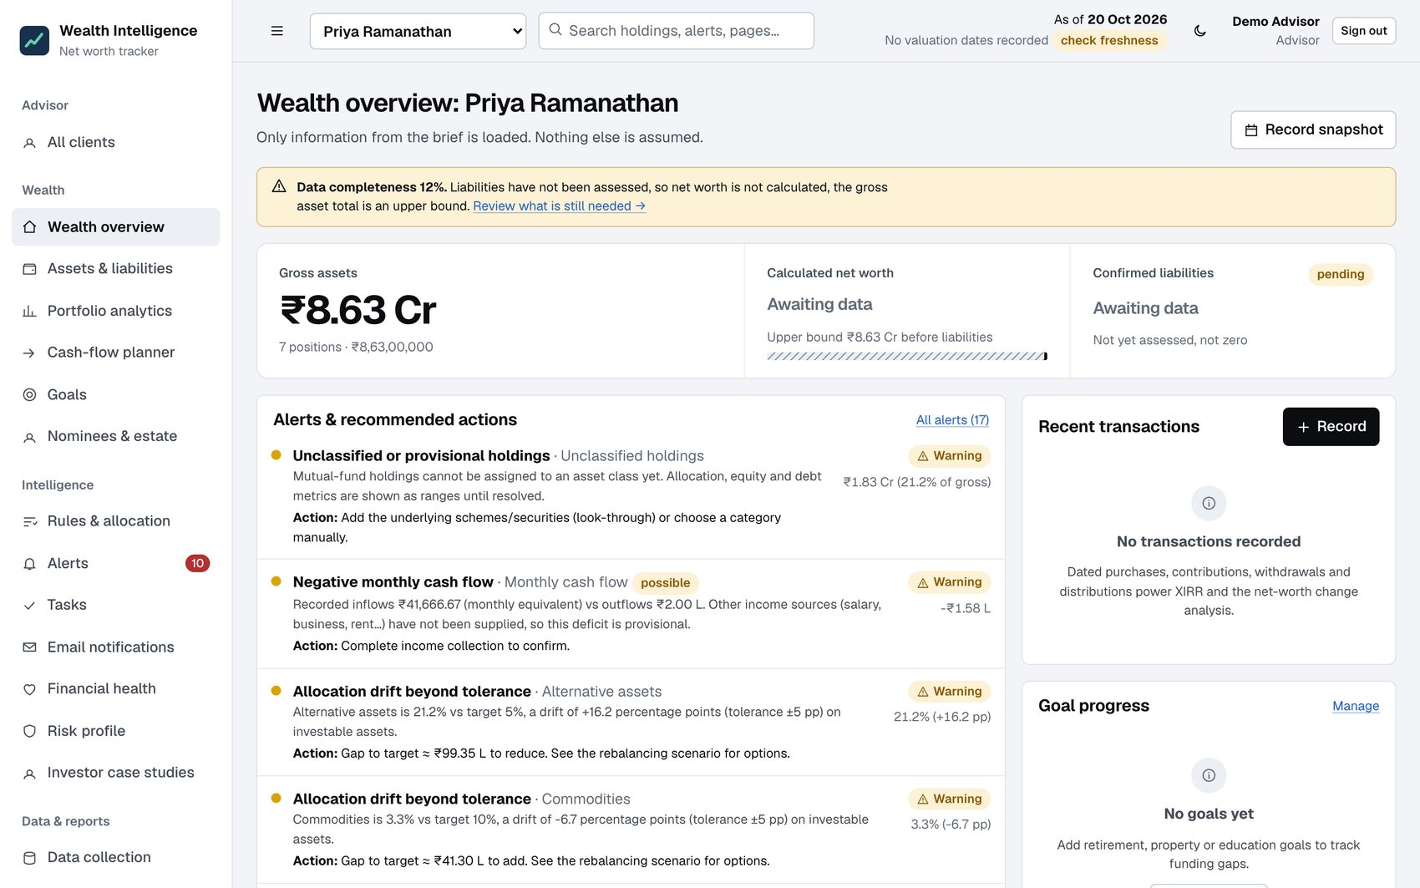
Fig. 4.1: Wealth overview for Priya Ramanathan: gross assets ₹8.63 Cr, net worth and liabilities awaiting data
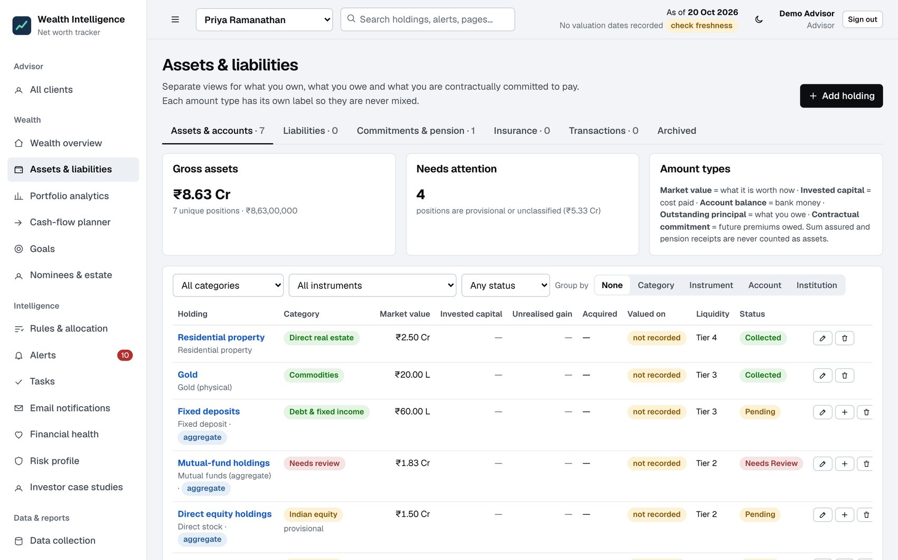
Fig. 4.2: Assets and liabilities: holdings with category, provisional flags and liquidity tiers
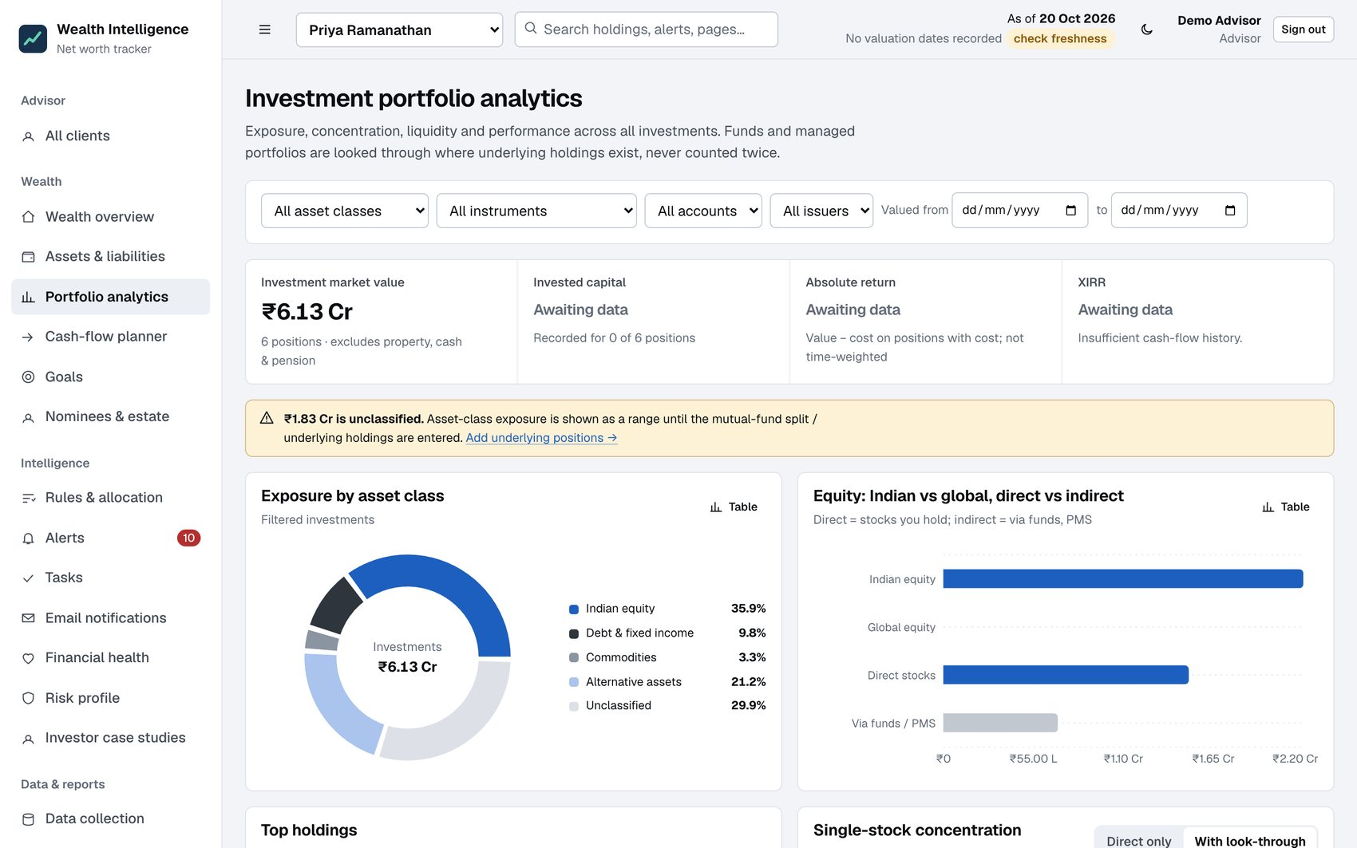
Fig. 4.3: Portfolio analytics with filters, exposure breakdowns and data-gap notices
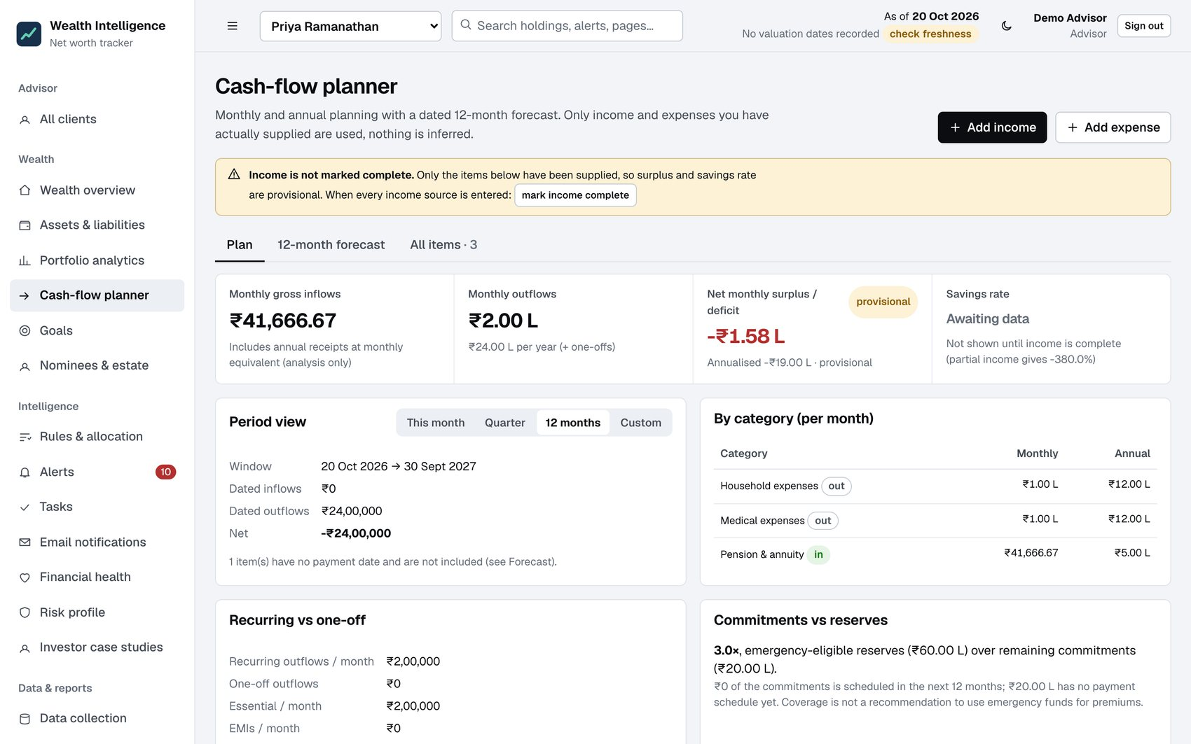
Fig. 4.4: Cash-flow planner with the dated twelve-month forecast
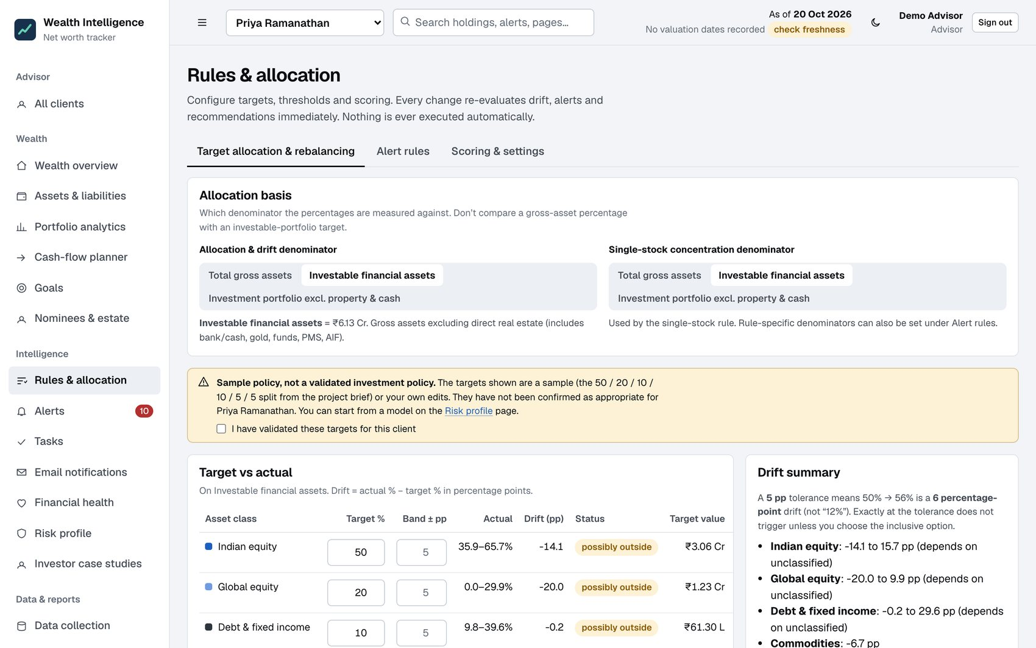
Fig. 4.5: Rules and allocation: allocation basis, sample-policy warning, target versus actual
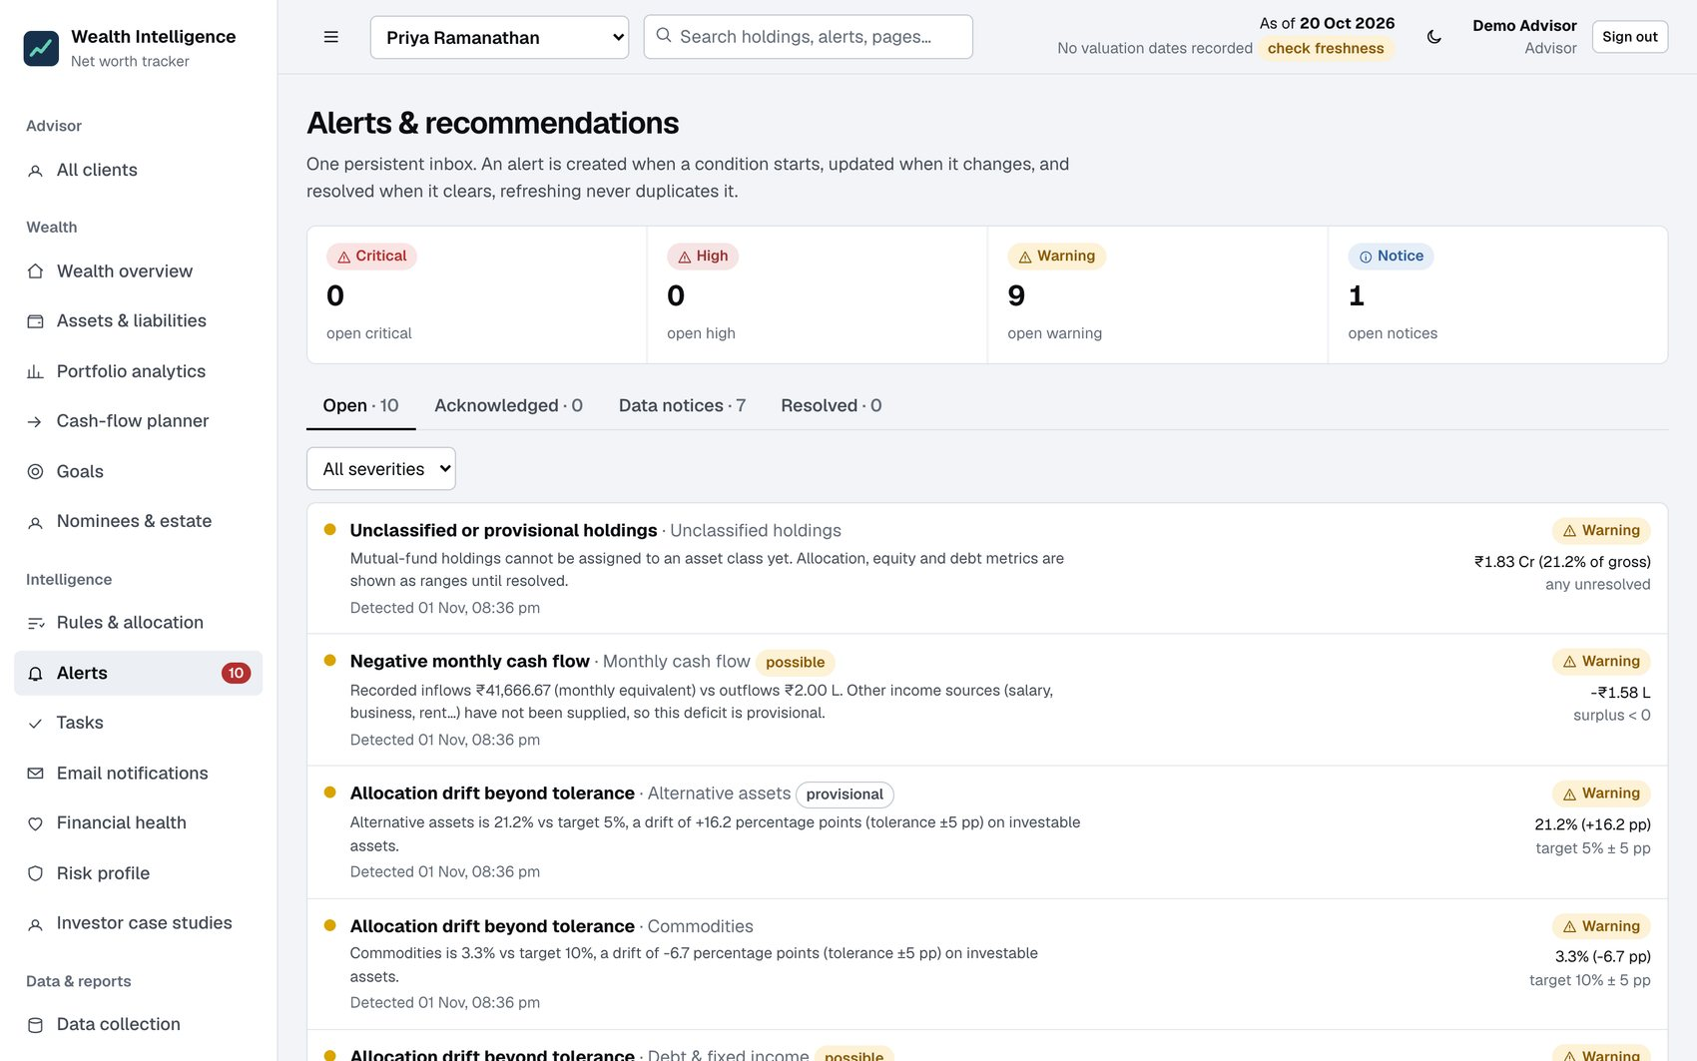
Fig. 4.6: Alert inbox with severity counts, tabs and persistent history
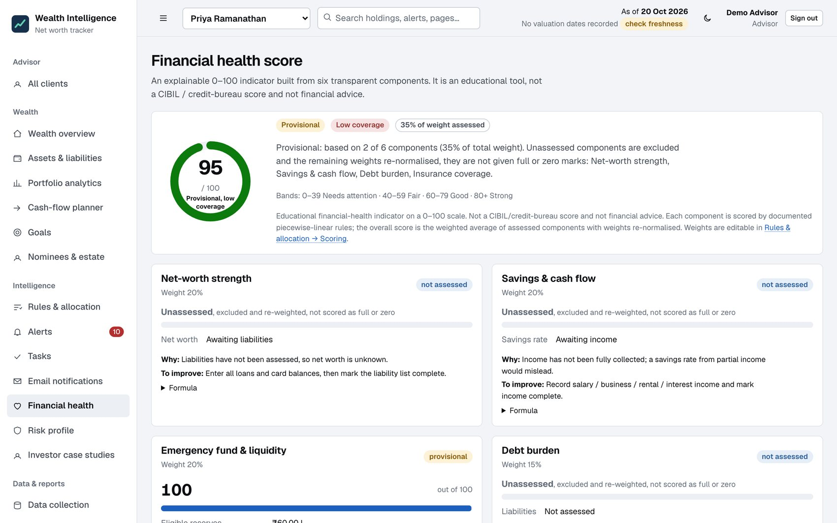
Fig. 4.7: Financial health score with components, weights and coverage
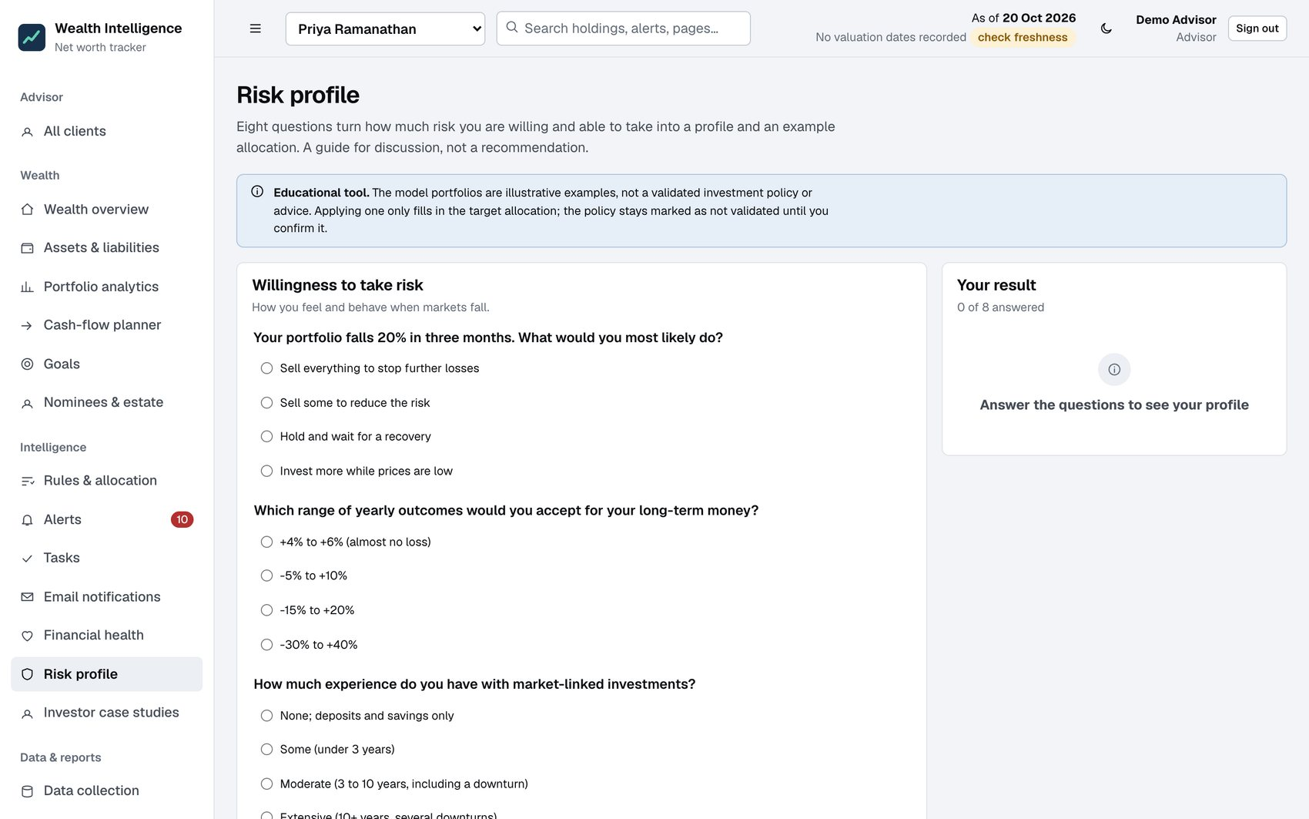
Fig. 4.8: Risk profile questionnaire and result
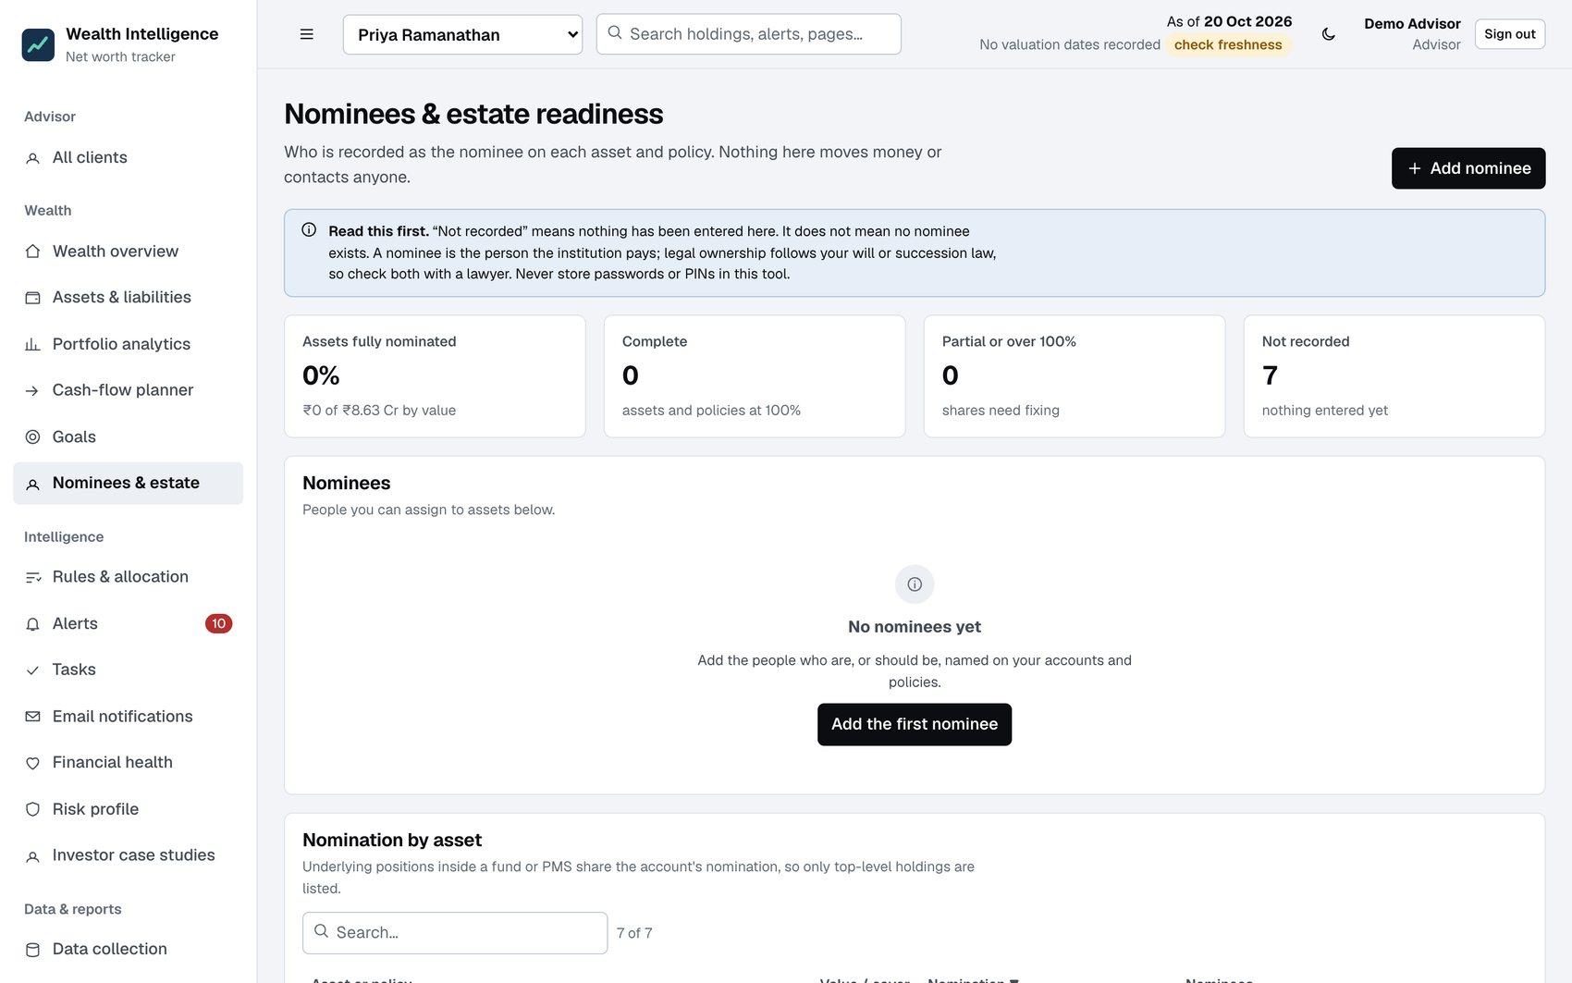
Fig. 4.9: Nominees and estate readiness
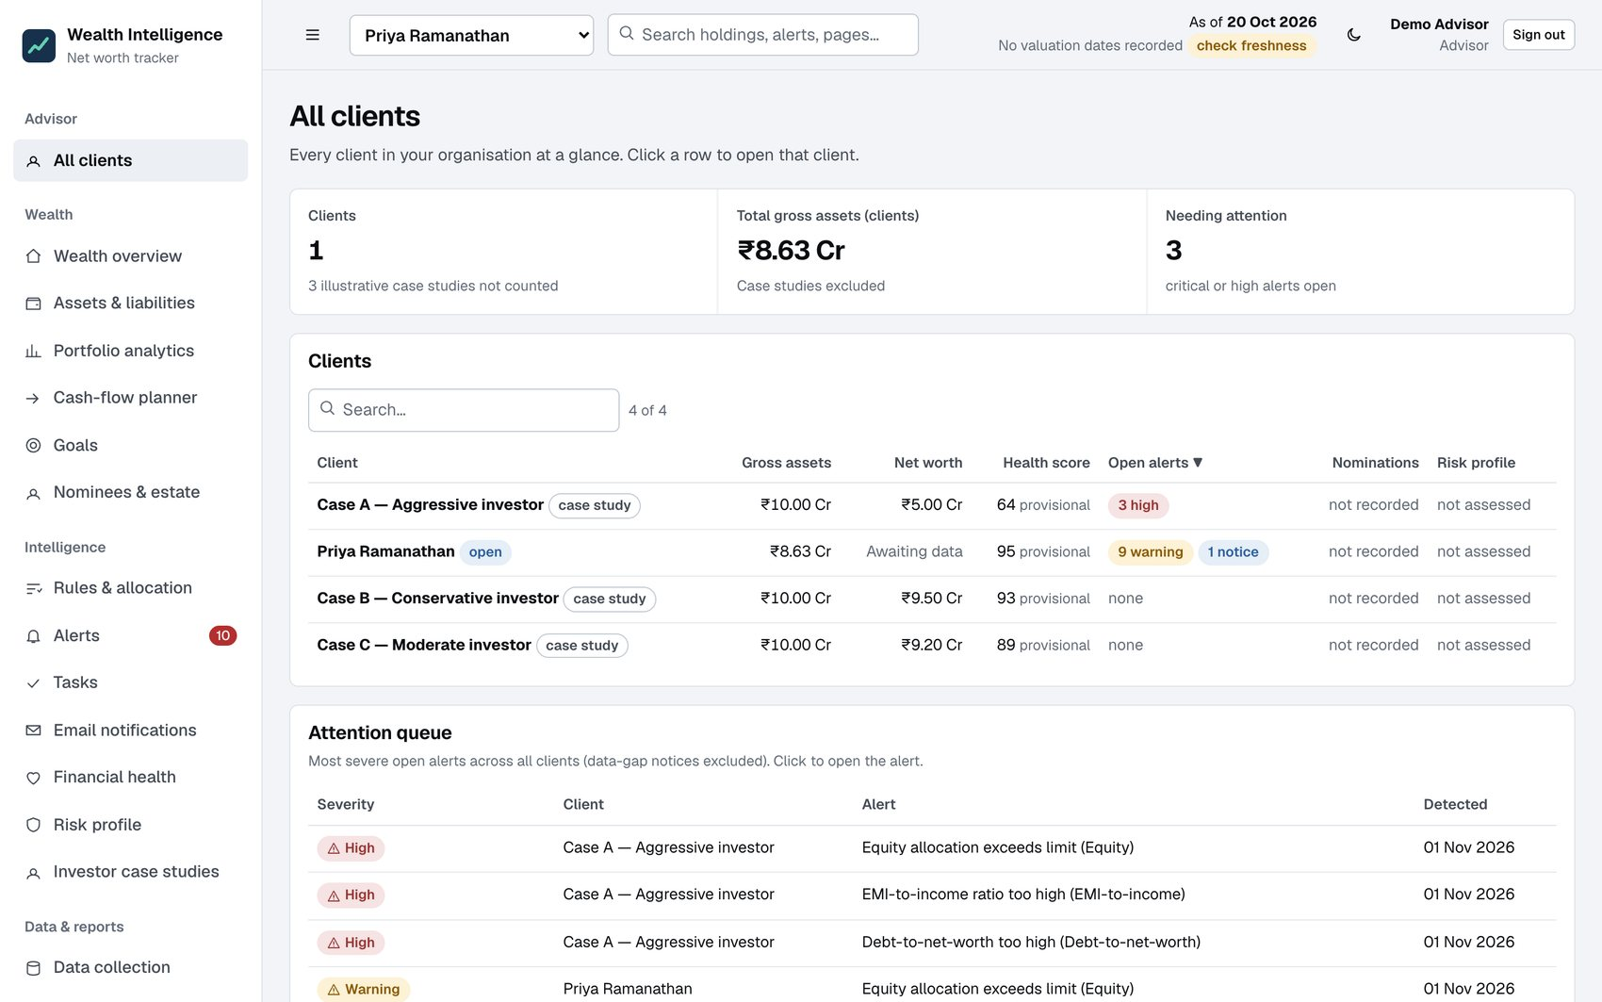
Fig. 4.10: Advisor view of all clients with attention queue
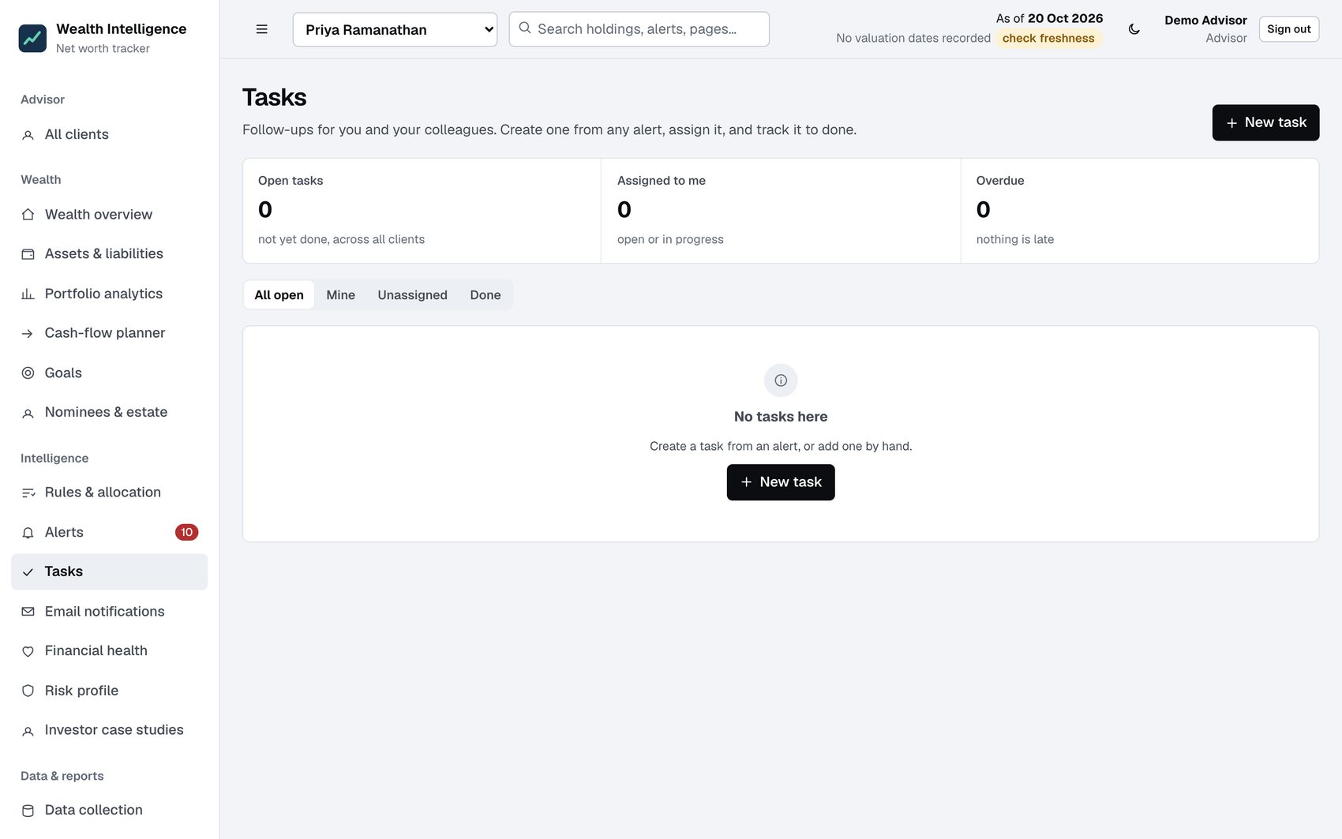
Fig. 4.11: Advisor task queue
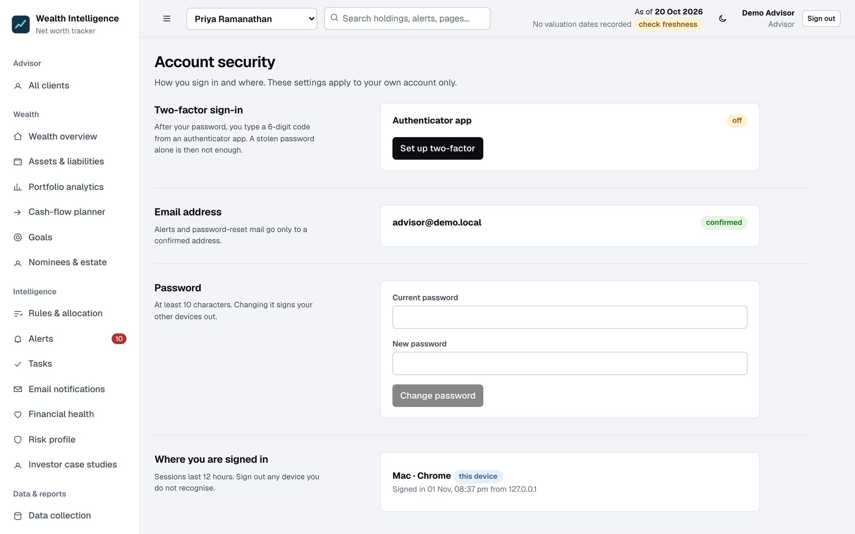
Fig. 4.12: Account security: two-factor sign-in, recovery codes and sessions
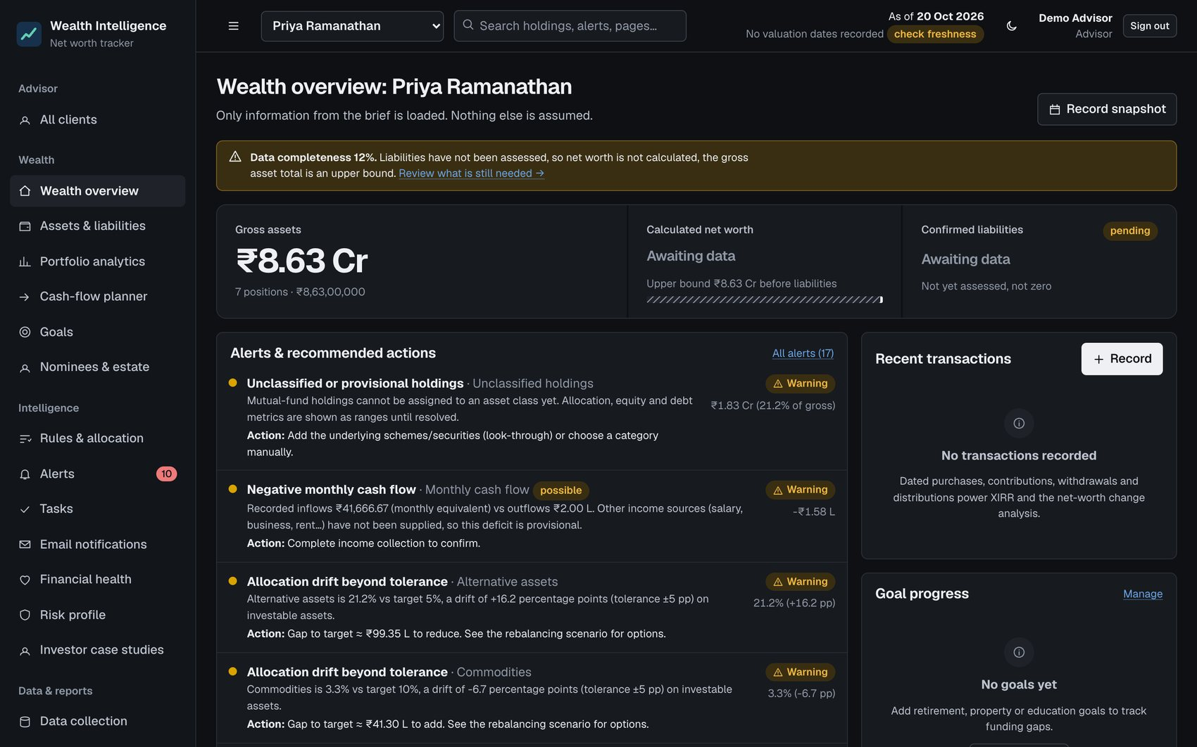
Fig. 4.13: Overview in the dark theme
On a phone-width screen (390 px) the same pages reflow into one column with a tab bar (Fig. 4.14) and the app can be installed to the home screen as a progressive web app; its service worker caches only the application shell and never the API.
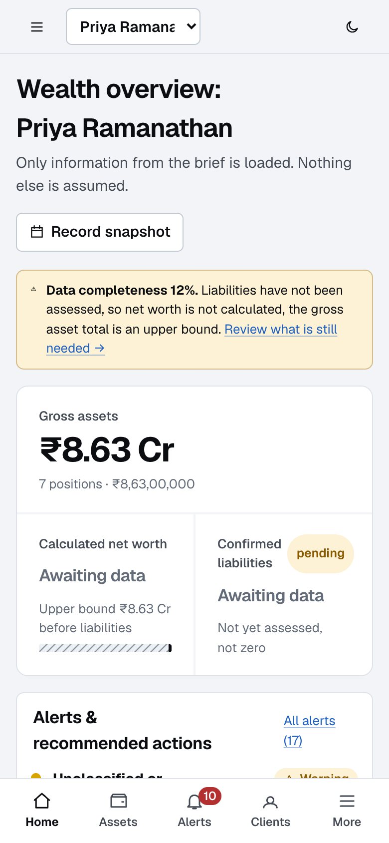
Fig. 4.15: Phone layout: overview
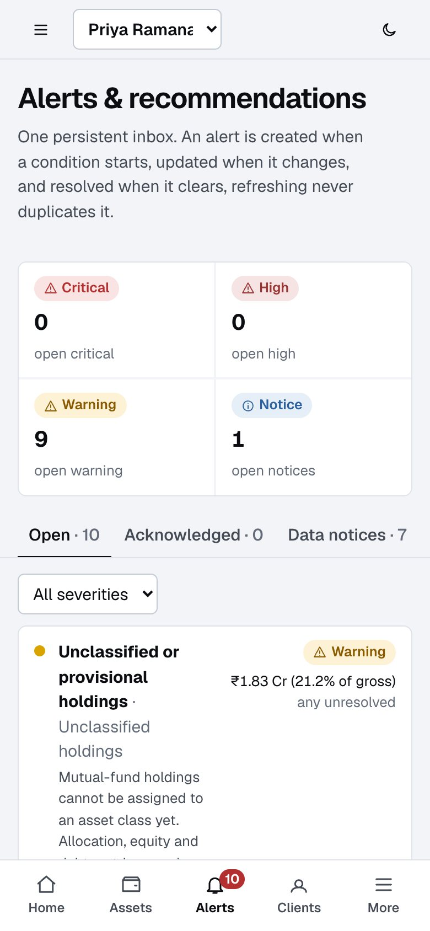
Fig. 4.15: Phone layout: alert list

4.1.9 How to operate the application
Fig. 4.16 shows the standard review flow; Table 4.2 gives the steps in detail. To run the software, install Node 22.13 or later, run npm install and npm start in the project folder, and open http://127.0.0.1:8787. On first start the application creates the database, applies the migrations, loads the demonstration client and three case studies and prints two synthetic accounts: an advisor with read and write access and a read-only viewer.
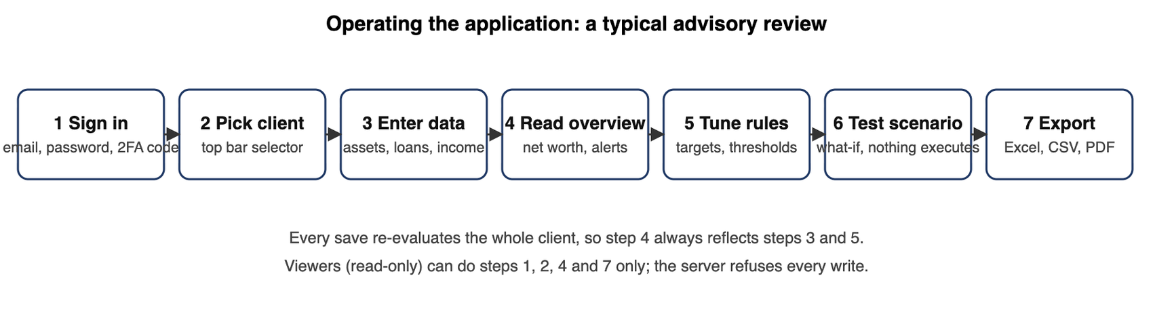
Fig. 4.16: A typical advisory review in the application
Table 4.2: Operating guide
Task | Where | Steps
Sign in | Login page | Enter e-mail and password; if two-factor is on, enter the six-digit code or a recovery code
Choose a client | Top bar | Pick from the client selector; “All clients” shows every client with open alerts and an attention queue
Enter a holding | Assets and liabilities → Add | Fill name, instrument type and value; the live preview shows how it will be classified; save
Split a fund into schemes | Assets → aggregate row | Add underlying schemes; the page shows what share is split and what remains unallocated
Record a loan | Assets and liabilities → Liabilities tab | Enter outstanding, EMI, rate, tenure; mark the list complete to move net worth from provisional to final
Import data | Data collection → Import | Upload CSV or Excel; review the dry run (accepted, rejected, duplicate, unresolved); confirm
Set targets | Rules and allocation → Target allocation | Choose the denominator, edit targets and bands (must total 100%), tick “validated” only when true
Tune a rule | Rules and allocation → Alert rules | Change threshold, severity or denominator, or disable the rule; alerts re-evaluate at once
Read an alert | Alerts | Open an alert for metric, threshold, reason, records, action and history; acknowledge or create a task
Test a what-if | Rules and allocation → Scenario | Enter purchases or sales; compare before and after allocation, score and rules; nothing is executed
Answer the risk questionnaire | Risk profile | Answer the eight questions; apply the model allocation as a target if wanted
Record nominees | Nominees and estate | Add nominees and set per-asset shares totalling 100%
Turn on e-mail alerts | Email notifications | Opt in, choose minimum severity; without SMTP settings messages go to a local outbox
Protect the account | Account security | Enrol an authenticator app, store the recovery codes, review and revoke sessions
Export | Reports and export | Download the nine-sheet Excel workbook or CSV files, or print the report to PDF
Demonstrate and reset | Guided demo | Follow the 15 steps; “Reset demo data” restores Priya and the case studies without touching clients you created

4.2 Testing, validation and verification

4.2.1 Test plan
The plan follows the risk. Because the engine decides what the user is told about their money, it has the most tests, and every rule is probed at, just below and just above its threshold. Layers above it are tested for the failures that matter there: security, tenancy and read-only behaviour on the server, rendering and keyboard behaviour in the interface, and end-to-end flows in a real browser.
Table 4.3: Test layers, tools and what each verifies
Layer | Tool | What it verifies | Result
Unit and API | Vitest [29] | Engine calculations, rules at/below/above thresholds, persistence, auth, import, reset, risk profile, nominees, e-mail alerts, tenant isolation, OpenAPI | 379 tests in 20 files, all pass
Property-based | fast-check [30] | 200 random portfolios per property: gross is the plain sum regardless of order; allocation shares sum to 100%; splitting an aggregate never changes gross; net worth = gross − liabilities; evaluation is deterministic | 7 properties, all pass
Scale | Vitest + load script | 5,000 holdings: evaluation time and whole-state request time | Evaluate p95 5.5 ms; full GET /state median 83 ms, p95 100 ms (budget 300 ms)
Component | Vitest, jsdom | Tables, dialogs, fields, money input, KPI tiles | 21 tests
End to end | Playwright [31] | Sign-in, add holding with live classification, add liability, validation errors, alert acknowledge, drawers, mobile width, service worker, offline | 62 checks pass, no console errors
Auth end to end | Playwright | Two-factor sign-in, recovery codes, password reset | 14 checks pass
Accessibility | axe-core [32] | WCAG 2.1 A/AA on 18 pages × light/dark × 1440 px and 390 px | 0 violations
Performance | Lighthouse [33] | Signed-in overview and assets | Desktop 99 / 100 / 100 / 100; slow-phone simulation performance 82 to 83, others 100
Visual regression | pixelmatch | 16 screens (8 pages × desktop and phone) against saved baselines | All match pixel for pixel; a deliberate radius change failed 15 of 16
Static checks | tsc, Biome | Types across server, engine, UI and tests; lint for correctness and accessibility | 0 errors
Continuous integration | GitHub Actions | Typecheck, tests, build, e2e, npm audit, secret scan, Docker build on every push | Green on recent runs

4.2.2 Test data and boundary design
Rule tests construct small portfolios whose result is known by hand. For the allocation-drift rule the three cases are 4.9, 5.0 and 5.1 percentage points against a 5-point tolerance: below does not trigger, exactly at the limit does not trigger under the default strict setting but does under the inclusive option, above triggers. For the net-worth-fall rule the cases are −4.9%, −5% and −5.1%, plus no snapshot, an incomparable basis, a stale snapshot, a new liability and an annual window. Priya’s baseline is pinned to the brief: gross ₹8.63 Cr, expenses ₹2 L a month (₹24 L a year), pension ₹80 L paid and ₹20 L remaining, ₹1 Cr in total, ₹5 L receivable, monthly equivalent ₹41,666.67; and no liabilities, snapshots, transactions or bank balances exist in her fixture, so return, XIRR and net-worth change are unavailable.

4.2.3 Mutation checking
A passing test only helps if it can fail. For most security and tenancy logic we broke the code on purpose (for example removed the tenant guard from one route) and confirmed that a test failed, then restored it. This is a manual practice, recorded in the project notes, not an automated mutation-testing tool.

4.3 Results and analysis

4.3.1 Functional results
Table 4.4: Definition-of-done checklist and evidence
Criterion | Evidence
Application launches from a clean database | npm start; migrations applied, fixtures seeded, demo users printed; the e2e suite drives it
Core pages implemented and persistent | 20 pages; SQLite persistence; a durability test re-opens the database file
Priya reconciles to the brief | tests/priya.test.ts (12 tests)
Required metrics shown or “Awaiting data” | e2e asserts net worth and liabilities show Awaiting data / Not yet assessed
Nothing invented | Tests assert no liabilities, snapshots, transactions or balances in the Priya fixture
Every brief rule implemented | 8 core + 11 additional rules; each core rule tested below, at, above, missing, disabled, changed threshold, resolved, duplicate prevention
Allocation and rebalancing respond to edits | API test (targets to drift); e2e (threshold change resolves the alert); simulator and illiquid-asset cap tests
Health score is transparent | Re-normalisation equals the manual weighted mean; custom weights test; no data gives null, not 100
Case studies isolated | Case A ₹10 Cr / ₹5 Cr / ₹5 Cr net worth verified; B 50:50, C 70:30; reset leaves user clients untouched
Missing data handled honestly | not_evaluable states, [min, max] ranges, provisional labels, data notices

4.3.2 Worked examples
Drift. With a Debt target of 10% and a 5-point band, an actual 15.1% is 5.1 points of drift and raises a warning; 15.0% does not raise one by default. The alert text reads, for example, “Alternative assets is 21.2% vs target 5%, a drift of +16.2 percentage points (tolerance ±5 pp)” with the action “Gap to target ≈ ₹99.35 L to reduce” (Fig. 4.1).
Ranges. Priya’s ₹1.83 Cr of mutual funds has no equity and debt split. The Indian-equity actual share therefore shows as the range 35.9% to 65.7% and the status “possibly outside” the band, instead of a single guessed value (Fig. 4.5). Supplying the schemes collapses the range.
Health score. With two of six components assessable for Priya, the score is computed from those two with re-normalised weights, shown as provisional with 35% coverage, and carries no band label.

4.3.3 Quality results
The first automated accessibility audit found 26 distinct issues across the pages (button names missing their visible text, links distinguished by colour alone, scrollable tables not reachable by keyboard, badge contrast in dark mode); all were fixed and the audit now reports zero violations. The 5,000-holding load test found a 6.4 MB response, so gzip compression was added and is asserted by a test. Below-the-fold charts now draw only when scrolled near, and hashed assets are cached for a year.
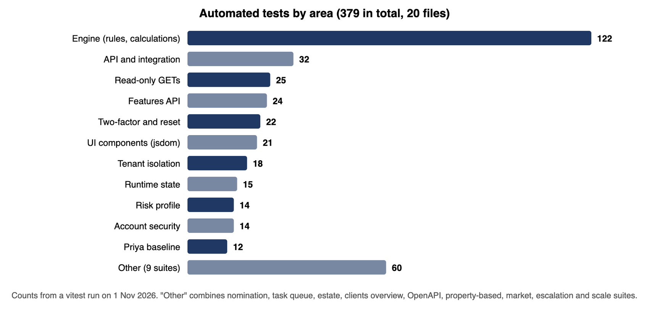
Fig. 4.17: Automated tests by area

4.3.4 Own contribution brought out
[Each student: state in two or three sentences which results above you produced yourself (for example the engine tests, the accessibility fixes or the security features) and cite the Evidence IDs from Appendix I. See Section 5.2.]

4.4 Feedback received and iterations made
Table 4.5: Iterations, their trigger and the change made
Iteration | Trigger | Change
1 | Review against the brief | Net worth is withheld until liabilities are assessed; commitments are shown beside, not inside, net worth
2 | A test of the nominee feature | A mutation that changed an evaluation did not call the refresh step; a rule was added and recorded: every mutation that can change an evaluation must call refresh
3 | Architecture review | GET /state wrote alert history, which made reads unsafe to repeat; moved reconciliation to mutations and a job, and added a SQL-spy test over every GET route
4 | Robustness review | Login throttle and idempotency keys lived in memory; moved to the database so restarts and multiple instances behave the same; savepoint-based transactions
5 | Accessibility audit (axe-core) | 26 issues fixed (see 4.3.3)
6 | Design critique and polish pass | Risk radios, health ring, “Awaiting data” colour (never good or bad), table overflow fixed
7 | Design-system review | Restyle to the achromatic ledger: one blue, hatched unknown bar, alerts directly under headline figures, em dashes removed from interface and server alert text
8 | Lighthouse run | Lazy-drawn charts, long-lived caching of hashed assets, valid robots.txt; phone performance 82 to 83
9 | Security review | Email verification, session list and revoke, encrypted two-factor secrets, optional mandatory two-factor for advisors
10 | Mentor and peer feedback | [Add the comments received at reviews and what was changed in response.]

Heuristic self-review. The finished interface was reviewed against Nielsen’s ten heuristics [14] by the authors. This is not a study with users. Strengths: visibility of status (toasts, as-of date, provisional labels), error prevention (validation, duplicate-import blocking, confirmations), recognition over recall (live classification preview, a checklist of what is missing). Known gaps: no general undo; no bulk edit or saved views; English only; no contextual help tour; the overview has many cards.

4.5 Advantages, limitations and applications
Table 4.6: Advantages, limitations and applications
Advantages | Limitations | Applications
Never shows an unknown as a number; every figure and alert is explainable | Not production-ready: tenant isolation is application-level (no row-level security); no automated backups; no external penetration test | Advisor-client review meetings
Exact money and a pure, tested engine (379 tests, property-based checks) | Market data: only the demo provider and manual CSV are verified; the AMFI adapter was never run against the live endpoint; NSE and S&P need licences | Self-review at month end
Persistent, de-duplicated alert history with escalation e-mails | No CAS import, bank connection, benchmark or time-weighted return, tax or exit-load modelling | Teaching: personal finance, data quality, explainable software
India-first: paise, lakh and crore, nominees, AMFI, EMI-to-income | Defaults (liquidity tiers, score bands, 40% EMI limit) are reasoned assumptions to be validated by a finance professional | Template for a multi-tenant advisor product (roadmap in Chapter 6)
Accessible (0 axe violations) and fast (Lighthouse 99 desktop) | No user study; personas are proto-personas; spec workbook and reference images were not available | Case-study material for the three investor profiles

Summary. This chapter described how each part was implemented, how the application is operated, how it was tested at every layer with the results, the iterations that testing and review produced, and the advantages and honest limits. Chapter 5 documents who did what.

Chapter 5
Individual Contribution, Teamwork and Reflection
This chapter records the team structure, what each student owned and produced, how the team worked together, each student’s reflection, and how the project was managed, including how AI tools were used. Assessment is individual, so each student completes their own subsections. The assigned areas below are the areas each member stated; the highlighted fields are for each student to complete in their own words.

5.1 Team structure, roles and responsibilities
The team has eleven members. Table 5.1 gives, for each member, the area they stated and the parts of this report and of the presentation they prepare. The software itself (architecture, database, API, interface, security and the technical stack) is developed and integrated by Krishang Vikram Singh, with interface, feature and comparison work by Aryan Thakkar; the other members own the study, explanation, verification and documentation of the engine areas named against their names.
Table 5.1: Team structure and allocation of report sections and slides
Name | Roll No. / SAP ID | Area (as stated by the member) | Report sections | Presentation slides
Divya Arsewad | B162  70022300513 | Data allocation and refinement | §2.1.2–2.1.3 and §2.1.4 (allocation, drift, returns, risk profiling); allocation and rebalancing text in §3.3.5; §4.1.3 portfolio analytics; §4.1.6 risk profile; Appendix III.4 drift, risk and score examples | Allocation and drift; Health score and risk profile
Farhan Pardiwalla | L042  70112400037 | Data extraction | §1.1–1.3 and Abstract; §4.3.1 definition-of-done and Priya reconciliation; data-extraction text in §4.1 (brief, fixtures, import) | Background; Problem statement; Objectives; Data extraction and import
Arnav Talgaonkar | B113  70022400260 | Money handling, classification and look-through | §3.3.4 engine design principles; §4.1.2 money, classification and look-through; Appendix III.1–III.2 code excerpts; Appendix III.4 money, percentage and XIRR examples | Core method: unknown is not zero; Money, classification and look-through
Ziauddin Shaikh | D087  70062400111 | Rules engine and alerts | §2.1.5 rules and alerts; rules table and rule text in §3.3.5; §4.1.5 rules, alerts and notifications; Appendix II rule table; Appendix III.4 idle-cash example | Rules engine; Alerts
Nandini Chitlangia | I014  70412400067 | Data allocation and refinement | §2.1.1 and §3.1 requirements and personas; data-quality and classification-review text in §4.1; nominees and tasks in §4.1.6; Appendix I evidence register | Requirements; Data refinement and look-through; Beyond the core
Asad Rizvi | B079  70022400139 | Cash-flow forecasting and implementation | §4.1.4 cash-flow forecast and its results; Appendix III.4 cash-flow example | Cash-flow forecast
Mayank Deore | R074  70512300022 | Results and analysis | §4.3.2–4.3.4 results and analysis; §4.4 iterations; §4.5 advantages, limitations and applications | Result 1: demonstration client; Result 2: what testing changed; Advantages, limitations, applications
Aditya Upadhyay | R069  70512400044 | Validation, testing and verification | §4.2 testing, validation and verification (including security and accessibility tests); Appendix III.3 test excerpt | Evaluation methodology; Verification; Security and accessibility results
Aryan Thakkar | D078  70062400099 | Software development: UI/UX, feature suggestions, comparison with other software | §2.2 and §2.3 review and gap; §3.3.6 interface design; heuristic review in §4.4; feature suggestions in §6.2 | Literature timeline; Comparative analysis; Research gap; User interface; Feature tour
Krishang Vikram Singh | B106  70022400259 | Whole software development and technical stack | §3.2 design alternatives; §3.3.1–3.3.3 architecture, data flow and database; §4.1.1 technology stack; §4.1.7 account security; §4.1.9 operating guide; Chapter 6; final merge and format check | Proposed solution; Design alternatives; Architecture; Database and data flow; Operating procedure; Conclusion and future scope
Soham Kantharia | [Roll No.]  [SAP ID] | Data extraction | §1.4–1.6; front matter (cover, certificate, acknowledgement, lists, abbreviations); References; similarity check; Appendices VI and VII compilation | Title; Presentation on; Team and contribution; References

Faculty mentor: [Name of Faculty Mentor]. The items originally planned for a twelfth member are held by Soham Kantharia (minutes, §5.3, plan) and Krishang Vikram Singh (standards and ethics, demonstration), and Aryan Thakkar covers Appendix V.
The repository is owned by one GitHub account and every commit carries that identity, so commit authorship cannot by itself show who did which task. Each member’s contribution must therefore be backed by their own outputs (sections, tests, examples, reviews, screens) and by the meeting minutes in Appendix IV.

5.2 Individual contribution statements and evidence
Each statement below must describe what the student actually did. Where a member’s area is an engine module that the software lead implemented, the honest contribution may be study, specification, test cases, worked examples, review or documentation of that module; say so in those words. Every member should be able to explain and defend their own section in the viva (Appendix VIII helps with preparation).

5.2.1 Contribution statement: Divya Arsewad
Assigned area: Data allocation and refinement. Report sections: §2.1.2–2.1.3 and §2.1.4 (allocation, drift, returns, risk profiling); allocation and rebalancing text in §3.3.5; §4.1.3 portfolio analytics; §4.1.6 risk profile; Appendix III.4 drift, risk and score examples. Slides: Allocation and drift; Health score and risk profile.
Tasks actually carried out: Studied and specified the allocation, drift, return and risk-profiling behaviour (target versus actual, a 5-point tolerance band, strict-at-threshold default, ranges instead of guesses when a mutual-fund split is unknown); wrote the matching report text; prepared the worked drift, risk and health-score examples; reviewed the engine's behaviour against its tests. The engine code itself was implemented by the software lead. Outputs produced: Report sections §2.1.2–2.1.4, allocation and rebalancing text in §3.3.5, §4.1.3 and §4.1.6; Appendix III.4 drift, risk and score examples; two presentation slides (Allocation and drift; Health score and risk profile). Evidence IDs from the IER: E02, E03. Hours or share of work: Equal share among the eleven members (1/11, about 9.1% each).

5.2.2 Contribution statement: Farhan Pardiwalla
Assigned area: Data extraction. Report sections: §1.1–1.3 and Abstract; §4.3.1 definition-of-done and Priya reconciliation; data-extraction text in §4.1 (brief, fixtures, import). Slides: Background; Problem statement; Objectives; Data extraction and import.
Tasks actually carried out: Analysed the written brief and extracted the client figures into fixtures and import files (Priya's baseline: gross ₹8.63 Cr, expenses ₹2 L a month, pension ₹1 Cr); wrote the background, problem statement and objectives; prepared the definition-of-done checklist and the reconciliation of the demonstration client to the brief; co-owned requirements and traceability. Outputs produced: Report §1.1–1.3 and Abstract, §4.3.1 definition-of-done table and Priya reconciliation, data-extraction text in §4.1; fixture and import data used by tests/priya.test.ts; slides Background, Problem statement, Objectives, Data extraction and import. Evidence IDs from the IER: E01, E04, E14. Hours or share of work: Equal share among the eleven members (1/11, about 9.1% each).

5.2.3 Contribution statement: Arnav Talgaonkar
Assigned area: Money handling, classification and look-through. Report sections: §3.3.4 engine design principles; §4.1.2 money, classification and look-through; Appendix III.1–III.2 code excerpts; Appendix III.4 money, percentage and XIRR examples. Slides: Core method: unknown is not zero; Money, classification and look-through.
Tasks actually carried out: Studied and documented the money, classification and look-through modules (integer paise, null instead of infinity on division, nine-decimal percentage rounding, editable classification table, unresolved aggregates reported as ranges); selected and explained the code excerpts and the money, percentage and XIRR worked examples; reviewed the related tests. The module code was implemented by the software lead. Outputs produced: Report §3.3.4 and §4.1.2; Appendix III.1–III.2 code excerpts and III.4 money, percentage and XIRR examples; slides Core method: unknown is not zero; Money, classification and look-through. Evidence IDs from the IER: E02, E03. Hours or share of work: Equal share among the eleven members (1/11, about 9.1% each).

5.2.4 Contribution statement: Ziauddin Shaikh
Assigned area: Rules engine and alerts. Report sections: §2.1.5 rules and alerts; rules table and rule text in §3.3.5; §4.1.5 rules, alerts and notifications; Appendix II rule table; Appendix III.4 idle-cash example. Slides: Rules engine; Alerts.
Tasks actually carried out: Studied and specified the rules engine and alert behaviour (rule definition, trigger, response and default thresholds; open, update and resolve of alert history; escalation-only e-mails); compiled the rule table; wrote boundary-case descriptions (below, at and above threshold) and the idle-cash worked example; reviewed rule tests. The rules code was implemented by the software lead. Outputs produced: Report §2.1.5, rules table and rule text in §3.3.5, §4.1.5; Appendix II rule table; Appendix III.4 idle-cash example; slides Rules engine; Alerts. Evidence IDs from the IER: E02, E03. Hours or share of work: Equal share among the eleven members (1/11, about 9.1% each).

5.2.5 Contribution statement: Nandini Chitlangia
Assigned area: Data allocation and refinement. Report sections: §2.1.1 and §3.1 requirements and personas; data-quality and classification-review text in §4.1; nominees and tasks in §4.1.6; Appendix I evidence register. Slides: Requirements; Data refinement and look-through; Beyond the core.
Tasks actually carried out: Wrote the requirements, personas and brief analysis; maintained the traceability of alerts and metrics to the brief; wrote the data-quality, classification-review, nominee and task text; compiled the evidence register; co-owned the allocation and refinement study. Outputs produced: Report §2.1.1 and §3.1, data-quality and classification-review text in §4.1, nominees and tasks in §4.1.6; Appendix I evidence register; slides Requirements; Data refinement and look-through; Beyond the core. Evidence IDs from the IER: E01, E14, E02, E03. Hours or share of work: Equal share among the eleven members (1/11, about 9.1% each).

5.2.6 Contribution statement: Asad Rizvi
Assigned area: Cash-flow forecasting and implementation. Report sections: §4.1.4 cash-flow forecast and its results; Appendix III.4 cash-flow example. Slides: Cash-flow forecast.
Tasks actually carried out: Studied and documented the cash-flow forecast (twelve-month dated forecast with month-end clipping, premium commitments that stop when fully paid, undated pension receipt listed as unscheduled, provisional surplus and withheld savings rate); prepared the cash-flow worked example and described the forecast results; reviewed the related tests. The planner code was implemented by the software lead. Outputs produced: Report §4.1.4 cash-flow forecast and results; Appendix III.4 cash-flow example; slide Cash-flow forecast. Evidence IDs from the IER: E02, E03. Hours or share of work: Equal share among the eleven members (1/11, about 9.1% each).

5.2.7 Contribution statement: Mayank Deore
Assigned area: Results and analysis. Report sections: §4.3.2–4.3.4 results and analysis; §4.4 iterations; §4.5 advantages, limitations and applications. Slides: Result 1: demonstration client; Result 2: what testing changed; Advantages, limitations, applications.
Tasks actually carried out: Analysed and wrote up the results: the worked examples, the quality results, the iterations table and the advantages, limitations and applications; compared results with the earlier report version; prepared the demonstration-client and testing-impact slides. Outputs produced: Report §4.3.2–4.3.4, §4.4 (Table 4.5) and §4.5 (Table 4.6); slides Result 1: demonstration client; Result 2: what testing changed; Advantages, limitations, applications. Evidence IDs from the IER: E09, E15. Hours or share of work: Equal share among the eleven members (1/11, about 9.1% each).

5.2.8 Contribution statement: Aditya Upadhyay
Assigned area: Validation, testing and verification. Report sections: §4.2 testing, validation and verification (including security and accessibility tests); Appendix III.3 test excerpt. Slides: Evaluation methodology; Verification; Security and accessibility results.
Tasks actually carried out: Documented and verified the test strategy: the test plan by layer, boundary design for rules, property-based checks, mutation checking, accessibility (axe-core), load, Lighthouse and visual-regression results; selected the test excerpt for the appendix; checked reported figures (379 tests, 0 axe violations) against the acceptance report and a re-run. Outputs produced: Report §4.2 testing, validation and verification (Tables 4.3 and following); Appendix III.3 test excerpt; slides Evaluation methodology; Verification; Security and accessibility results. Evidence IDs from the IER: E09, E10, E11, E12. Hours or share of work: Equal share among the eleven members (1/11, about 9.1% each).

5.2.9 Contribution statement: Aryan Thakkar
Assigned area: Software development: UI/UX, feature suggestions, comparison with other software. Report sections: §2.2 and §2.3 review and gap; §3.3.6 interface design; heuristic review in §4.4; feature suggestions in §6.2. Slides: Literature timeline; Comparative analysis; Research gap; User interface; Feature tour.
Tasks actually carried out: Carried out the literature and competitor review and the gap analysis; wrote the interface-design section; contributed interface and feature work, including the design brief and design decisions; ran the Nielsen-heuristic self-review of the finished interface; proposed features for the roadmap. Outputs produced: Report §2.2–2.3, §3.3.6, heuristic review in §4.4, feature suggestions in §6.2; PRODUCT.md and docs/COMPETITIVE_ANALYSIS.md, docs/ROADMAP.md; slides Literature timeline; Comparative analysis; Research gap; User interface; Feature tour. Evidence IDs from the IER: E06, E07, E13. Hours or share of work: Equal share among the eleven members (1/11, about 9.1% each).

5.2.10 Contribution statement: Krishang Vikram Singh
Assigned area: Whole software development and technical stack. Report sections: §3.2 design alternatives; §3.3.1–3.3.3 architecture, data flow and database; §4.1.1 technology stack; §4.1.7 account security; §4.1.9 operating guide; Chapter 6; final merge and format check. Slides: Proposed solution; Design alternatives; Architecture; Database and data flow; Operating procedure; Conclusion and future scope.
Tasks actually carried out: Software lead: designed the architecture, data flow and database (10 migrations); implemented and integrated the shared engine, Express API, React interface, account security (scrypt, two-factor, sessions), CI and Docker; chose the stack and weighed design alternatives; wrote the operating guide and Chapter 6; merged and format-checked this report. An AI coding assistant was used under his direction, as disclosed in §5.5 and Appendix VII. Outputs produced: Source code in src/shared, src/server and src/web; migrations/; docs/SECURITY.md and security tests; CI workflow; report §3.2, §3.3.1–3.3.3, §4.1.1, §4.1.7, §4.1.9 and Chapter 6; slides Proposed solution through Conclusion and future scope. Evidence IDs from the IER: E02, E04, E05, E06, E08, E17. Hours or share of work: Equal share among the eleven members (1/11, about 9.1% each).

5.2.11 Contribution statement: Soham Kantharia
Assigned area: Data extraction. Report sections: §1.4–1.6; front matter (cover, certificate, acknowledgement, lists, abbreviations); References; similarity check; Appendices VI and VII compilation. Slides: Title; Presentation on; Team and contribution; References.
Tasks actually carried out: Prepared the front matter (cover, certificate, acknowledgement, lists, abbreviations), the references and the similarity check; compiled Appendices VI and VII; wrote §1.4–1.6; contributed to data extraction for market-data adapters and import files; assembled the presentation. Outputs produced: Report §1.4–1.6, front matter, References, Appendices VI and VII; slides Title; Presentation on; Team and contribution; References. Evidence IDs from the IER: E04, E15, E16. Hours or share of work: Equal share among the eleven members (1/11, about 9.1% each).

5.3 Teamwork and leadership
Coordination tools actually used. The code base is kept in a GitHub repository; each change is a commit with a descriptive message (seven commits to date); a CI workflow runs the type check, 379 tests, the build, the browser walkthrough, a dependency audit, a secret scan and a Docker build on every push, so a change that breaks something is visible to everyone. Project knowledge is kept in the repository itself: the architecture note, the requirements audit, the security note, the acceptance report, the competitive analysis and a prioritised roadmap, so a new member can start from the documents.
Division of work. The team of eleven was organised by area: software development and integration; interface and comparison; engine modules (money and classification, rules and alerts, allocation, cash flow); data extraction and refinement; validation and testing; results and analysis; and documentation. The allocation is in Table 5.1.
Meetings, decisions and conflict handling: [Describe how often the team met, how tasks were assigned, one disagreement (for example scope, design direction or how much to build) and how it was settled.]
Stakeholder and mentor interaction: [Summarise reviews with the faculty mentor, what was asked and what changed.] Peer feedback: [Summarise comments from peers who tried the application.] Forms are in Appendix IV.

5.4 Reflection by each student
Project-level lessons the whole team can claim from the record. (1) Writing the rule “unknown is not zero” first made every later decision easier, from the data model to the colour of “Awaiting data”. (2) The tests found real defects that review had missed: a mutation that did not trigger re-evaluation, reads that wrote data, in-memory counters that reset on restart. (3) An automated accessibility audit found 26 problems that visual checking had not. (4) Documenting what could not be done (no workbook, no live market data, no real-phone test) protected the project from overclaiming and made the limitations section credible.

5.4.1 Reflection: Divya Arsewad
Key decisions and reasons: Showing the Indian-equity share as a range (35.9% to 65.7%) when the mutual-fund split is unknown, and treating a value exactly at the drift limit as not triggering by default, with an inclusive option. Challenges: Understanding why a range is more honest than one estimate, and how re-normalised weights give a provisional score (35% coverage) with no band label. Lessons learned: Allocation figures need their basis stated; an unknown must stay visibly unknown. Plans for improvement: Add worked drift cases for each asset class and validate the default tolerance bands with a finance professional.

5.4.2 Reflection: Farhan Pardiwalla
Key decisions and reasons: Pinning every baseline figure of the demonstration client to the brief and refusing to add liabilities, snapshots, transactions or balances that the brief does not give. Challenges: The workbook and reference images were unavailable, so the application had to be built from the written brief and the gap recorded (E14). Lessons learned: Reconciling output to source figures early exposes gaps; missing data should be recorded, not filled in. Plans for improvement: Obtain the original workbook and re-run the reconciliation against it.

5.4.3 Reflection: Arnav Talgaonkar
Key decisions and reasons: Storing money as integer paise and returning null rather than infinity on division, and rounding percentages to nine decimals. Challenges: Binary floating-point noise (55.00000000000001) could tip a value over a threshold; XIRR must not diverge. Lessons learned: Exact arithmetic and explicit handling of the undefined case prevent errors that are hard to see later. Plans for improvement: Extend the property-based checks to the classification and look-through functions.

5.4.4 Reflection: Ziauddin Shaikh
Key decisions and reasons: Keeping a persistent alert history that opens, updates and resolves alerts, and e-mailing again only when an alert becomes more severe. Challenges: Defining each rule's boundary precisely (below, at and above threshold) and avoiding duplicate alerts. Lessons learned: A rule is only trustworthy once its boundary cases are tested, and an alert should say what to do. Plans for improvement: Add more rule-threshold examples and review default thresholds with a domain expert.

5.4.5 Reflection: Nandini Chitlangia
Key decisions and reasons: Treating nominee 'not recorded' as unknown rather than 'no nominee', and tracing each requirement to the brief. Challenges: Personas are proto-personas, not research findings, and the original specification workbook was missing. Lessons learned: Requirements stay useful only when traceable to tests and evidence. Plans for improvement: Run a small user study with advisors and replace the proto-personas with evidence.

5.4.6 Reflection: Asad Rizvi
Key decisions and reasons: Building the forecast from real dates, listing an undated pension receipt as unscheduled, and labelling the surplus provisional while income is incomplete. Challenges: Month-end clipping, a final premium instalment trimmed to the remainder, and the pension with no date. Lessons learned: Forecasts should show what they do not know instead of spreading it across months. Plans for improvement: Add scenario comparison and tax effects to the forecast, as the roadmap suggests.

5.4.7 Reflection: Mayank Deore
Key decisions and reasons: Reporting results from the repository and re-run tests, including limits, instead of only strengths. Challenges: Keeping every figure in the results consistent with the acceptance report as the code changed. Lessons learned: Results need an evidence trail, and an honest limitations list makes the report stronger. Plans for improvement: Add the mentor and peer comments for iteration 10 and a short user study.

5.4.8 Reflection: Aditya Upadhyay
Key decisions and reasons: Testing each rule at, just below and just above its threshold, adding property-based checks, and breaking code on purpose to confirm tests fail. Challenges: The first axe-core audit found 26 issues, and the 5,000-holding load test exposed a 6.4 MB response. Lessons learned: A passing test proves little unless it can fail; accessibility and load testing find real faults. Plans for improvement: Automate mutation testing and arrange an external security review.

5.4.9 Reflection: Aryan Thakkar
Key decisions and reasons: Following an achromatic ledger design in which unknown values read as 'Awaiting data' and are never coloured good or bad. Challenges: Comparing with commercial tools whose features and data cannot be matched, and reviewing the interface without a user study. Lessons learned: Interface decisions should come from the product's honesty principle, and heuristic review is not user research. Plans for improvement: Add undo, bulk edit, saved views, help and test with real users.

5.4.10 Reflection: Krishang Vikram Singh
Key decisions and reasons: Choosing SQLite with typed tables over heavier options, keeping the engine as pure functions, and moving alert reconciliation from GET /state to mutations and a job. Challenges: Keeping reads safe to repeat, moving throttle and idempotency state into the database, and integrating the team's work. Lessons learned: A pure engine, tests and CI make change safe, and AI-generated code must be verified by the team. Plans for improvement: Add row-level security, backups, a penetration test and a licence decision before wider use.

5.4.11 Reflection: Soham Kantharia
Key decisions and reasons: Assembling the report from the repository and checking each citation and the similarity check before submission. Challenges: Keeping front matter, references and appendices consistent as sections changed. Lessons learned: Documentation needs the same discipline as code: one source and a final check. Plans for improvement: Automate the list of figures and tables, and the reference check.

5.5 Project management, professional conduct and AI-use disclosure
Project management. Work was planned in phases, tracked through commits and a written roadmap with checkboxes and acceptance criteria per task, and gated by CI. Risks were managed by writing them down: the roadmap, the security note and Section 4.5 list what is not production-ready. Professional conduct. Only synthetic data was used; no real client information was entered; the application states on its own screens that it is educational and not advice; third-party software is used under its open-source licences; and no licence has been chosen for this repository yet because ownership in a group project needs agreement first.
AI-use disclosure. An AI coding assistant, Claude Code from Anthropic (model Claude Sonnet 5.5 at the time of the final work), was used extensively under the software lead’s direction in this project: to write and revise source code and tests, to run the test, accessibility, visual and performance suites, to analyse the competitive landscape from public web sources, to draft the repository documentation and to draft this report and the presentation from the repository contents. It was also used to apply design skills for review (a design detector and an inspector). Verification: every claim in this report about counts, results and behaviour was checked against the repository and by re-running the tests (379 passing on 1 November 2026); the screenshots were captured from the running application on a throwaway database; the yellow placeholders mark what only the team can supply. [Each student: confirm and complete which parts you personally wrote, reviewed and ran, and whether you can explain and defend every module. Under the format rules the student must verify AI-generated work.] The full log is in Appendix VII.
Summary. This chapter set up the structure for individual evidence, allocated every report section and slide to a named member, recorded the coordination practices and project-level lessons that the repository supports, and disclosed AI use. The yellow fields must be completed by each student before submission.

Chapter 6
Conclusion and Future Scope
This chapter gives the single conclusion of the report and the notes needed to continue the project next semester.

6.1 Brief report of the work carried out and conclusions drawn
We set out to build a tool that gives an Indian household and its advisor one honest picture of what is owned, owed and committed, and that warns about specific risks without ever presenting an unknown as a number. The result is Wealth Intelligence: 20 pages, a pure calculation engine, 19 configurable rules with persistent, explainable alerts, an explainable health score, a risk questionnaire with an illustrative model allocation, nominee and estate checks, a task queue, e-mail alerts, an installable app and account security with optional two-factor sign-in.
The analysis in Chapter 4 supports four conclusions. First, the central design rule worked: the application withholds net worth until liabilities are assessed, shows ranges for unclassified holdings and labels partial scores provisional, and tests prove it. Second, correctness can be demonstrated: 379 automated tests, including boundary tests at every threshold and property-based checks over random portfolios, pass, and the 62-check browser walkthrough runs clean. Third, quality attributes were measured, not assumed: zero axe-core violations on 18 pages in two themes and two widths, Lighthouse 99/100/100/100 on desktop, and a state request under 100 ms at 5,000 holdings. Fourth, honesty about limits matters: the missing workbook, unverified market feed, unreviewed recommendation wording and application-level tenant isolation are stated rather than hidden. The tool is educational and is not investment, tax or legal advice.

6.2 Future scope and hand-over notes

6.2.1 What to do first
1. Obtain the original workbook and two reference images and reconcile (roadmap 0.1); update the traceability matrix to cite them.
2. Verify the AMFI adapter against the live file from a networked machine and save a real sample as a test fixture.
3. Test the installed app on a real iPhone and Android phone; verify e-mail against a real SMTP server.
4. Decide the licence and ownership (group project; university policy) before making the repository public for others to reuse.

6.2.2 Build next, no outside input needed
Self-sign-up (administrators create users today); per-account lockout, a password breach check and key rotation for the encryption key; an admin-forced password reset; a warning when the public URL is not set; component tests for the entity forms; task bulk actions, comments and assignment notifications; remaining small design warnings (risk-page column heights, overview below the fold).

6.2.3 Needs outside input
Table 6.1: Features blocked on external input
Feature | What it needs
CAS import (CAMS and KFintech) | Real sample statements to build and test the parser
Benchmark comparison and time-weighted return | Licensed index data
Tax-aware rebalancing | A tax professional to specify the rules
Account Aggregator data | A regulated partner and compliance work
PostgreSQL with row-level security | Needed before many organisations share one deployment
SMS and push notifications | A provider and consent flows
Legal review of recommendation wording | Counsel familiar with SEBI adviser rules
External penetration test | A third-party tester

6.2.4 Deployment
A Render blueprint and a deployment note exist in the working copy (not yet committed). SQLite requires a persistent disk, so a paid plan with a one-gigabyte disk is needed; serverless hosts without a persistent disk are unsuitable. Before sharing a link, change or delete the demonstration viewer and create real users with the provided command.

6.2.5 Target direction
The longer-term architecture is a shared PostgreSQL database with tenant identifiers and row-level security, background workers and a queue for price refresh, alert evaluation, reports and imports, object storage for documents and observability. The shared engine stays a pure library used by the API, the workers and the tests.
Summary. The project achieved its objectives within its stated scope, with evidence for every claim, and leaves a prioritised roadmap and clear hand-over notes.

References
[1] H. Markowitz, "Portfolio selection," J. Finance, vol. 7, no. 1, pp. 77–91, Mar. 1952.
[2] Securities and Exchange Board of India, "SEBI (Investment Advisers) Regulations, 2013," Gazette notification, Jan. 2013. [Online]. Available: https://www.sebi.gov.in
[3] Reserve Bank of India, "Master Direction – Non-Banking Financial Company – Account Aggregator (Reserve Bank) Directions, 2016," Sep. 2016. [Online]. Available: https://www.rbi.org.in
[4] Association of Mutual Funds in India, "NAV of mutual fund schemes," AMFI India. [Online]. Available: https://www.amfiindia.com (accessed Oct. 2026).
[5] Microsoft, "XIRR function," Microsoft Support documentation. [Online]. Available: https://support.microsoft.com (accessed Oct. 2026).
[6] J. Grable and R. H. Lytton, "Financial risk tolerance revisited: The development of a risk assessment instrument," Financial Services Review, vol. 8, no. 3, pp. 163–181, 1999.
[7] D. Kahneman and A. Tversky, "Prospect theory: An analysis of decision under risk," Econometrica, vol. 47, no. 2, pp. 263–291, Mar. 1979.
[8] Kubera, "Net worth tracker for complex balance sheets," product website. [Online]. Available: https://www.kubera.com (accessed 23 Oct. 2026).
[9] Empower, "Free financial tools and net worth dashboard," product website. [Online]. Available: https://www.empower.com (accessed 23 Oct. 2026).
[10] INDmoney, "Track net worth, mutual funds and stocks," product website. [Online]. Available: https://www.indmoney.com (accessed 23 Oct. 2026).
[11] Kuvera, "Mutual fund and portfolio tracking," product website. [Online]. Available: https://kuvera.in (accessed 23 Oct. 2026).
[12] Addepar, "Wealth management platform for advisors," product website. [Online]. Available: https://addepar.com (accessed 23 Oct. 2026).
[13] Ghostfolio contributors, "Ghostfolio: open source wealth management software," GitHub repository. [Online]. Available: https://github.com/ghostfolio/ghostfolio (accessed 23 Oct. 2026).
[14] J. Nielsen, "10 usability heuristics for user interface design," Nielsen Norman Group, 1994 (updated 2024). [Online]. Available: https://www.nngroup.com/articles/ten-usability-heuristics/
[15] M. Fowler, Patterns of Enterprise Application Architecture, ch. 18 "Money," pp. 488–490, Addison-Wesley, Boston, MA, USA, 2002.
[16] R. T. Fielding, "Architectural styles and the design of network-based software architectures," Ph.D. dissertation, Univ. California, Irvine, CA, USA, 2000.
[17] World Wide Web Consortium, "Web Content Accessibility Guidelines (WCAG) 2.1," W3C Recommendation, Jun. 2018. [Online]. Available: https://www.w3.org/TR/WCAG21/
[18] OWASP Foundation, "Application Security Verification Standard 4.0.3," 2021. [Online]. Available: https://owasp.org/www-project-application-security-verification-standard/
[19] D. M'Raihi, S. Machani, M. Pei, and J. Rydell, "TOTP: Time-Based One-Time Password Algorithm," IETF RFC 6238, May 2011.
[20] C. Percival and S. Josefsson, "The scrypt Password-Based Key Derivation Function," IETF RFC 7914, Aug. 2016.
[21] P. A. Grassi et al., "Digital Identity Guidelines: Authentication and Lifecycle Management," NIST Special Publication 800-63B, Rev. 3, Jun. 2017.
[22] ISO/IEC, "Systems and software engineering — Systems and software Quality Requirements and Evaluation (SQuaRE) — System and software quality models," ISO/IEC 25010:2011, 2011.
[23] OpenAPI Initiative, "OpenAPI Specification v3.1.0," Feb. 2021. [Online]. Available: https://spec.openapis.org/oas/v3.1.0
[24] Government of India, "The Digital Personal Data Protection Act, 2023," Act No. 22 of 2023, Aug. 2023.
[25] SQLite Consortium, "Write-Ahead Logging," SQLite documentation. [Online]. Available: https://www.sqlite.org/wal.html (accessed Oct. 2026).
[26] OpenJS Foundation, "Node.js documentation: SQLite (node:sqlite)," 2026. [Online]. Available: https://nodejs.org/api/sqlite.html (accessed Oct. 2026).
[27] Meta Open Source, "React documentation," 2026. [Online]. Available: https://react.dev (accessed Oct. 2026).
[28] C. McDonnell, "Zod: TypeScript-first schema validation," documentation. [Online]. Available: https://zod.dev (accessed Oct. 2026).
[29] Vitest contributors, "Vitest: a Vite-native testing framework," documentation. [Online]. Available: https://vitest.dev (accessed Oct. 2026).
[30] N. Dubien, "fast-check: property-based testing for JavaScript and TypeScript," GitHub repository. [Online]. Available: https://github.com/dubzzz/fast-check (accessed Oct. 2026).
[31] Microsoft, "Playwright: fast and reliable end-to-end testing," documentation. [Online]. Available: https://playwright.dev (accessed Oct. 2026).
[32] Deque Systems, "axe-core: accessibility testing engine," GitHub repository. [Online]. Available: https://github.com/dequelabs/axe-core (accessed Oct. 2026).
[33] Google, "Lighthouse: automated auditing for web page quality," documentation. [Online]. Available: https://developer.chrome.com/docs/lighthouse (accessed Oct. 2026).

Appendix I

Summary of the IER and Evidence Register
Each Evidence ID points to an artefact that exists in the project repository (github.com/krishangvikramsingh/networth-tracker) or in the submission folder. [Add or amend IDs to match your own IER.]
Table I.1: Evidence register
ID | Description | Location
E01 | Requirements and data-quality audit with traceability matrices for alerts and metrics | docs/AUDIT.md
E02 | Pure calculation engine (money, classify, portfolio, XIRR, net worth, cash flow, rules, score, rebalance, goals) | src/shared/
E03 | Engine and property-based tests (122 + 7) | tests/engine.test.ts, tests/properties.test.ts
E04 | Express API, service layer, alert history, import and export, jobs | src/server/
E05 | Database migrations 001 to 010 | migrations/
E06 | React interface, 20 pages, design system | src/web/
E07 | Product and design brief; design decisions | PRODUCT.md
E08 | Security note; two-factor, account, tenancy tests | docs/SECURITY.md, tests/mfa.test.ts, tests/account.test.ts, tests/tenancy.test.ts
E09 | Acceptance report: 379 tests, load, Lighthouse, visual, accessibility, e2e | docs/ACCEPTANCE_REPORT.md
E10 | End-to-end and authentication walkthrough scripts (62 + 14 checks) | scripts/e2e.mjs, scripts/e2e-auth.mjs
E11 | Accessibility audit script (axe-core) | scripts/a11y.mjs
E12 | Load test and visual regression | scripts/load.ts, scripts/visual.mjs, tests/visual/baseline/
E13 | Competitive analysis and roadmap | docs/COMPETITIVE_ANALYSIS.md, docs/ROADMAP.md
E14 | Record that the workbook and reference images were unavailable | README.md “Important notes”, docs/AUDIT.md §1
E15 | Earlier project report (version 2.0, 20 Oct 2026) | docs/Wealth_Intelligence_Project_Report.docx
E16 | This report and the final presentation | Submission folder
E17 | Commit history (7 commits) | git log

Appendix II

Specifications: rules, database and score
Table II.1: The 19 rules and their defaults
Key | Name | Group | Default | Severity
equity_allocation_max | Equity allocation exceeds limit | Core | > 60% | High
single_stock_max | Single-stock concentration | Core | > 10% | High
debt_allocation_min | Debt allocation below minimum | Core | < 20% | Warning
net_worth_decline | Net worth fell sharply | Core | fall > 5% | Critical
emi_to_income_max | EMI-to-income ratio too high | Core | > 40% | High
portfolio_drift_max | Allocation drift beyond tolerance | Core | > 5 pp | Warning
idle_cash | Large cash balance sitting idle | Core | 10% / ₹5 L / 30 d | Warning
maturity_window | Maturity or renewal approaching | Core | 60 days | Warning
credit_card_balance | Credit-card balance high | Additional | configurable | Warning
debt_to_net_worth | Debt-to-net-worth too high | Additional | configurable | n/a
negative_cash_flow | Negative monthly cash flow | Additional | surplus < 0 | Warning
emergency_fund_min | Emergency fund below target | Additional | configurable | n/a
pension_premium_window | Pension / premium commitment due | Additional | configurable | Warning
missing_valuation | Missing valuation dates | Additional | data notice | n/a
unclassified_holdings | Unclassified or provisional holdings | Additional | any unresolved | Warning
stale_data | Stale portfolio data | Additional | days since valuation | n/a
goal_shortfall | Goal funding shortfall | Additional | projected < target | n/a
health_score_drop | Financial-health score deterioration | Additional | configurable | n/a
nomination_gap | Nomination gaps | Additional | 100% default, info | Info

Severity “n/a” means the default severity is set in the rule definition and is editable; the table lists those the repository documents explicitly. Source: src/shared/rules.ts.
Table II.2: Risk profile bands and illustrative model allocations (percent of investable assets)
Profile | Min score | Indian eq. | Global eq. | Debt | Gold etc. | REIT/InvIT | Alt.
Conservative | 0 | 15 | 5 | 65 | 10 | 5 | 0
Moderately conservative | 25 | 25 | 10 | 50 | 10 | 5 | 0
Balanced | 45 | 35 | 15 | 30 | 10 | 5 | 5
Moderately aggressive | 65 | 45 | 20 | 15 | 10 | 5 | 5
Aggressive | 85 | 55 | 25 | 5 | 5 | 5 | 5

Table II.3: Health score components and default weights
Component | Weight | Metric examples
Net-worth strength | 20% | Net worth as a multiple of annual spending, interpolated on bands
Savings and cash flow | 20% | Savings rate: 0% → 0, 10% → 50, 20% → 75, 30%+ → 100
Emergency fund and liquidity | 20% | Months of essential expenses covered by emergency-eligible assets
Debt burden | 15% | EMI-to-income, debt-to-net-worth
Diversification | 15% | Spread across classes and concentration
Insurance coverage | 10% | Cover relative to income (simple multiple)

Database tables (migrations 001 to 010): tenants, users, sessions, notification_prefs, clients, client_settings, holdings, valuations, transactions, liabilities, cashflow_items, commitments, insurance_policies, goals, snapshots, allocation_targets, rules, alerts, alert_events, health_assessments, scenarios, audit_events, import_log, risk_assessments, nominees, nominations, notifications, notification_deliveries, instruments, market_observations, category_mappings, tasks, login attempts and idempotency keys. See docs/ARCHITECTURE.md for the entity-relationship diagram.

Appendix III

Source code excerpts and sample tests
The excerpts are copied from the repository (src/shared/money.ts, src/shared/xirr.ts and tests/properties.test.ts) and show the three ideas the design depends on: exact money, honest failure and testing by property.

III.1 Exact money and stable percentages (money.ts)
export type Paise = number;
export const PAISE_PER_RUPEE = 100;
export const LAKH = 100_000 * PAISE_PER_RUPEE;
export const CRORE = 10_000_000 * PAISE_PER_RUPEE;

/** Division that returns null instead of Infinity/NaN. */
export function ratio(n, d): number | null {
if (n == null || d == null || !Number.isFinite(n) || !Number.isFinite(d) || d === 0) return null;
return n / d;
}
/** Percentage (0-100 scale) or null if not meaningful. */
export function pct(n, d): number | null {
const r = ratio(n, d);
// round away binary float noise (55.00000000000001) so threshold comparisons at exactly the limit are stable
return r == null ? null : Math.round(r * 100 * 1e9) / 1e9;
}

III.2 XIRR that refuses to guess (xirr.ts, excerpt)
export function xirr(flows: DatedFlow[]): XirrResult {
...
if (nonZero.length < 2) return { ok: false, reason: "Insufficient cash-flow history." };
if (!nonZero.some((f) => f.amount < 0) || !nonZero.some((f) => f.amount > 0)) {
return { ok: false, reason: "Need at least one outflow (investment) and one inflow (withdrawal / valuation)." };
}
...
if (span < 30) return { ok: false, reason: "Holding period under 30 days; annualised XIRR is not meaningful." };
// bracketed hybrid Newton / bisection so it cannot diverge
}

III.3 A property-based test (properties.test.ts, excerpt)
it("gross assets is the plain sum of the holdings, whatever their order", () => {
fc.assert(fc.property(portfolio, fc.integer(), (rows, seed) => {
const sum = rows.reduce((a, r) => a + r.v, 0);
const shuffled = [...rows].sort((a, b) => ((a.v * 31 + seed) % 97) - ((b.v * 31 + seed) % 97));
expect(evaluateClient(build(rows), ASOF).netWorth.grossAssets).toBe(sum);
expect(evaluateClient(build(shuffled), ASOF).netWorth.grossAssets).toBe(sum);
}), { numRuns: 200 });
});

III.4 Worked calculations
The examples below use small illustrative numbers (except where the brief’s figures are named) so that a reader can repeat them by hand. Each has an owner who should be able to explain it in the viva.
Table III.1: Worked calculations
Topic (owner) | Inputs | Steps | Result
Percentage rounding (Arnav Talgaonkar) | 11 ÷ 20 as a share | 0.55 × 100 in binary floating point is 55.00000000000001. The percentage function multiplies by 100, then by 10⁹, rounds, and divides by 10⁹ | 55 exactly, so a value exactly at a 55% limit is not tipped over by noise
Indian digit grouping (Arnav Talgaonkar) | 123456789 rupees | Keep the last three digits; group the rest in twos from the right | 12,34,56,789
Integer paise (Arnav Talgaonkar) | ₹8.63 crore | 1 crore = 1,00,00,000 rupees = 100 × that in paise | Stored as 8,63,00,00,000 paise (an integer, so sums are exact)
Allocation drift (Divya Arsewad) | Target 50%, band 5 pp; actual 56%, 55%, 54.9% | Drift = actual − target; trigger when |drift| is greater than the band (strict) | 56%: +6 pp, triggers. 55%: +5 pp, no trigger (triggers only if “inclusive” is chosen). 54.9%: no trigger
XIRR (Arnav Talgaonkar) | −₹1,00,000 on 1 Jan 2025; +₹1,10,000 on 1 Jan 2026 | Days between = 365, so t = 1. Find r so that −100000 + 110000 ÷ (1 + r)¹ = 0 | r = 0.10, that is 10.00% a year
Dated instalments (Asad Rizvi) | Remaining commitment ₹12 L; instalment ₹5 L every quarter (illustrative) | Schedule instalments from the next due date until the remainder is used; trim the last to what is left | ₹5 L, ₹5 L, ₹2 L, then stop (no fourth payment)
Month-end clipping (Asad Rizvi) | Monthly EMI due on the 31st, starting 31 Jan 2027 | A month without a 31st uses its last day | 31 Jan, 28 Feb, 31 Mar
Monthly equivalent of an annual item (Asad Rizvi) | Annual pension receipt ₹5,00,000 with no date | Not placed in a month; for analysis only, ÷ 12 | ₹41,666.67 a month, listed as unscheduled
Idle cash (Ziauddin Shaikh) | Cash ₹40 L; emergency reserve ₹12 L; next-90-day outflows ₹6 L; investable assets ₹1.5 Cr (illustrative) | Idle = cash − reserve − 90-day outflows. Limit = larger of 10% of investable and the ₹5 L floor | Idle ₹22 L; limit ₹15 L; if held for at least 30 days the rule triggers
Savings-rate score (Divya Arsewad) | Savings rate 15% | Interpolate between anchors 10% → 50 and 20% → 75 | 50 + (15 − 10) ÷ (20 − 10) × 25 = 62.5
Score re-normalisation (Divya Arsewad) | Component A: score 100, weight 20. Component B: score 88, weight 15. Other four not assessable (illustrative) | Weighted mean of the assessed parts: (100 × 20 + 88 × 15) ÷ (20 + 15); coverage = 35 ÷ 100 | Score 94.9, shown as 95, provisional, 35% coverage, no band label
Risk profile (Divya Arsewad) | Tolerance answers scored 2, 2, 1, 2; capacity answers scored 3, 2, 2, 1; no guard-rail option chosen | Section score = round(sum ÷ 12 × 100): tolerance 7 → 58; capacity 8 → 67. Profile bands: 45 balanced, 65 moderately aggressive. Take the lower | Balanced (limited by tolerance). Had “need the money within 3 years” been chosen, the profile would be capped at Conservative

Further material to attach if required: raw outputs of npm test, npm run test:a11y and the load script, which are reproduced by the commands in the repository README.

Appendix IV

Meeting minutes, peer feedback forms and mentor feedback
[Attach signed minutes of team meetings and mentor reviews. A suggested layout is below.]
Table IV.1: Meeting minutes template
Date | Attendees | Agenda | Decisions | Actions and owners
[ ] | [ ] | [ ] | [ ] | [ ]
[ ] | [ ] | [ ] | [ ] | [ ]
[ ] | [ ] | [ ] | [ ] | [ ]

Table IV.2: Peer feedback form
Reviewer | Task tried | What worked | What was confusing | Change made
[ ] | [ ] | [ ] | [ ] | [ ]
[ ] | [ ] | [ ] | [ ] | [ ]

Table IV.3: Mentor feedback record
Review date | Feedback | Response
[ ] | [ ] | [ ]
[ ] | [ ] | [ ]

Appendix V

Vertical-specific evidence
Table 5 of the Design Experience format asks for different evidence per vertical. [Keep the block that matches your vertical and delete the others.] Material already available from the project is listed so it is not lost.
Table V.1: Evidence by vertical
Vertical | Typical evidence | Available from this project
VIP / Industry Research | Research gap, methodology, experiments, results, draft papers | Gap statement (Section 2.3); methodology of the rules, score and XIRR; test and performance results (Chapter 4)
EPICS | Community partner needs, needs assessment, stakeholder feedback, usability evaluation, social impact | Personas (proto, not interviewed); heuristic review; accessibility audit. Needs: real partner and feedback [ ]
Technical Competition | Rules, design report, build and test records, budget, results | Design report (Chapter 3); build and test records (Chapter 4). Needs: competition rules, budget, results [ ]
Entrepreneurship | Customer discovery, MVP, business model, market validation, financial plan | MVP (this application); competitive analysis and positioning (below). Needs: customer interviews, pricing test, financial plan [ ]

Table V.2: Competitive positioning summary (desk research, 23 Oct 2026)
Group | Examples | Where they stop
Free US aggregators | Empower | US-centred; sales outreach
Paid household apps | Monarch | Weak on complex or alternative assets
Complex-balance-sheet trackers | Kubera | Tracking only; no rules engine
India investment trackers | INDmoney, Kuvera, Groww | Mutual-fund or broker centred
Advisor platforms | Addepar, Morningstar Direct, Orion, eMoney | Enterprise pricing; US-centred
Open source | Ghostfolio, Actual Budget, Firefly III | Investments only, or no portfolio tracking

Recommended positioning from the analysis: do not compete on breadth of connectors; be the explainable advisor workbench, where every number is traceable to a rule, no assumption is hidden and a human reviews every recommendation. Open commercial decisions, which need an owner and customer evidence: first customer segment (independent advisors or self-directed investors), pricing model, data vendor and budget, and regulatory position on recommendations.

Appendix VI

Publications, competition certificates, patent and IP filings
None recorded at the time of writing. [Add any paper, competition certificate or IP filing, with the IPR approvals required by the SVKM’s NMIMS policy before public disclosure.] Note that the repository is public and carries no licence; confirm ownership and the university IP policy before choosing one.

Appendix VII

AI-tool use disclosure log
Table VII.1: AI tools used, purpose and verification
Tool | Purpose | How the output was verified
Claude Code (Anthropic), model Claude Sonnet 5.5 | Writing and revising source code, tests and migrations; running suites; fixing defects found by the suites | Type check, 379 tests, 62 and 14 browser checks, axe-core, Lighthouse, visual regression; manual review of behaviour in the running application; mutation checks for security and tenancy logic
Claude Code with design skills (detector and inspector) | Design critique, interface restyle, accessibility fixes | Detector and inspector report 0 failures; axe-core 0 violations; screenshots compared
Claude Code with web search | Desk research on competing products (23 Oct 2026) | Marked as indicative; items not confirmed are flagged; vendor sites to be re-checked before quoting
Claude Code | Drafting repository documentation (architecture, audit, security, acceptance report, roadmap) and this report and presentation | Counts and results re-checked against a fresh test run on 1 Nov 2026; screenshots captured from the running app; placeholders mark facts only the team can supply
[Other tools, e.g. grammar checker] | [ ] | [ ]

[Each student: confirm this log is complete for your own use of AI tools and sign below.]

Appendix VIII

Viva question bank (supplementary)
This appendix is not in the format’s list (Table 4) and may be removed. It prepares each member for questions on their own area. Answers are short; the section references give the full explanation.
Table VIII.1: Likely questions and model answers
Question | Model answer | Area / section
Why not a spreadsheet? | A spreadsheet treats an empty cell as zero, has no rules, history or access control, and cannot be tested. The app refuses to show a number when its inputs are missing. | Whole project, §1.1.2, §3.2
Why integer paise? | Floating-point sums drift; integers are exact up to about ₹9 × 10¹³. Ratios are derived only for display and thresholds. | Money, §3.3.4
What does “unknown is not zero” mean in practice? | Net worth is withheld until liabilities are assessed; unclassified funds give a [min, max] range; scores built on partial data are provisional with coverage shown. | Money, §3.3.4
How is a mutual fund with no known split treated? | As unresolved: it is held provisionally and allocation shows ranges until the underlying schemes are entered (look-through). | Classification, §4.1.2
How is double counting avoided between an aggregate and its schemes? | The aggregate is replaced by its underlying positions and any remainder stays as one unallocated line. | Classification, §3.3.4
Why a percentage function that rounds? | 0.55 × 100 is 55.00000000000001 in floating point; rounding to nine decimals makes a value exactly at a limit compare correctly. | Money, Appendix III.4
How does a rule decide to fire? | Each rule is a definition (formula, default, severity) plus a function returning findings; states are triggered, ok, possible, not evaluable or disabled. Strict comparison by default, inclusive optional. | Rules, §3.3.5, §4.1.5
How are duplicate alerts prevented? | A partial unique index on (client, fingerprint) where status is not resolved makes a second live alert impossible at the database level; changes update the existing alert and add an event. | Alerts, §3.3.3
When is an escalation e-mail sent? | Only when an existing alert becomes more severe; never on a decrease; queued in the same transaction and sent by a background job. | Alerts, §4.1.5
What is drift and why percentage points? | Actual minus target. 50% to 56% is a 6-point drift, not a 12% change, so tolerances are unambiguous. | Allocation, §2.1.2
Why three allocation denominators? | Percentages mean different things on gross assets, investable assets or investments excluding property and cash; the chosen basis is always displayed so targets and actuals are comparable. | Allocation, §4.1.3
How is the cash-flow forecast built? | From actual dates, with month-end clipping; commitments stop when fully paid and the last instalment is trimmed; undated items are listed as unscheduled, not spread across months. | Cash flow, §4.1.4
How is the health score computed when data is missing? | Unassessable components are excluded, remaining weights re-normalised, and the score is labelled provisional with coverage; below 50% coverage there is no band label. | Score, §3.3.5
How does the risk profile work? | Eight questions: tolerance and capacity each scored 0 to 100; the profile is the lower of the two, capped by guard-rail answers (short horizon, thin reserves). | Risk, §3.3.5
Why SQLite and not PostgreSQL? | Zero setup and built into the runtime for a reviewer to run; the repository is isolated so PostgreSQL can replace it; the trade-off is application-level tenant isolation. | Architecture, §3.2
Why is financial logic only in the shared engine? | One tested implementation is used by server and UI, so numbers cannot disagree and nothing is recomputed in the browser. | Architecture, §3.3.1
How do you stop reads from changing data? | GET handlers only evaluate; reconciliation of alert history runs in mutations and a background job. A test spies on every SQL statement of every GET route. | Architecture, §3.3.2
How is tenant isolation enforced? | A single route guard runs before every client-scoped route; another tenant’s client answers like a non-existent one; a test sweeps every route and method from other tenants. | Security, §4.1.7
How does two-factor work? | After the password the server issues a 5-minute challenge, not a session; the session starts only after a valid TOTP code; a code is accepted once; eight single-use recovery codes are stored as hashes. | Security, §4.1.7
How do you know the numbers are correct? | 379 tests including boundary tests at, below and above every threshold, property-based checks over 200 random portfolios, and a fixture pinned to the brief’s figures. | Testing, §4.2
What is a property-based test? | A test of a rule that must hold for any input; the tool generates many random inputs (for example, gross assets equals the sum of holdings in any order). | Testing, Appendix III.3
What did mutation checking show? | For security and tenancy logic we deliberately broke the code (for example removed the tenant guard) and confirmed a test failed, then restored it. It is a manual practice, not an automated tool. | Testing, §4.2.3
What did testing change? | A missed refresh after a nominee change, reads that wrote data, in-memory counters, 26 accessibility issues and a 6.4 MB response were found and fixed. | Results, §4.4
What are the main limitations? | Application-level tenant isolation, no automated backups or external penetration test, unverified live market feed, no CAS import, tax or benchmark, no user study, no legal review of wording. | Results, §4.5
How is this different from INDmoney or Kuvera? | It is an explainable advisor workbench: gaps are stated, rules and thresholds are editable, every alert has a reason and action. It does not try to match their breadth of connectors. | Comparison, §2.2, Appendix V
Is this investment advice? | No. It is educational, proposes options only, never executes, and recommendation wording has not had legal review under the SEBI adviser rules. | Ethics, §3.4.3
What was AI used for and how did you verify it? | Claude Code wrote and revised code, tests and documents under direction; results were verified by re-running suites, reviewing the running app and mutation checks. Each member must be able to explain their own section. | AI disclosure, §5.5, Appendix VII

