Q1 a) Develop an Android application to store and retrieve product information from a .csv file
MainActivity.java
package com.example.productcsv;

import android.os.Bundle;
import android.view.View;
import android.widget.EditText;
import android.widget.TextView;
import android.widget.Toast;

import androidx.appcompat.app.AppCompatActivity;

import java.io.BufferedReader;
import java.io.FileNotFoundException;
import java.io.FileOutputStream;
import java.io.IOException;
import java.io.InputStreamReader;

public class MainActivity extends AppCompatActivity {

private static final String FILE_NAME = "products.csv";

EditText etId, etName, etPrice, etQty;
TextView tvResult;

@Override
protected void onCreate(Bundle savedInstanceState) {
super.onCreate(savedInstanceState);
setContentView(R.layout.activity_main);

etId = findViewById(R.id.etId);
etName = findViewById(R.id.etName);
etPrice = findViewById(R.id.etPrice);
etQty = findViewById(R.id.etQty);
tvResult = findViewById(R.id.tvResult);
}

public void saveProduct(View v) {
String id = etId.getText().toString().trim();
String name = etName.getText().toString().trim();
String price = etPrice.getText().toString().trim();
String qty = etQty.getText().toString().trim();

if (id.isEmpty() || name.isEmpty() || price.isEmpty() || qty.isEmpty()) {
Toast.makeText(this, "Please fill all the fields", Toast.LENGTH_SHORT).show();
return;
}

name = name.replace(",", " ");
String line = id + "," + name + "," + price + "," + qty + "\n";

try {
FileOutputStream fos = openFileOutput(FILE_NAME, MODE_APPEND);
fos.write(line.getBytes());
fos.close();
Toast.makeText(this, "Product saved", Toast.LENGTH_SHORT).show();
etId.setText("");
etName.setText("");
etPrice.setText("");
etQty.setText("");
} catch (IOException e) {
Toast.makeText(this, "Could not save: " + e.getMessage(), Toast.LENGTH_LONG).show();
}
}

public void showAll(View v) {
tvResult.setText(readFile(null));
}

public void searchById(View v) {
String id = etId.getText().toString().trim();
if (id.isEmpty()) {
Toast.makeText(this, "Enter a product ID to search", Toast.LENGTH_SHORT).show();
return;
}
tvResult.setText(readFile(id));
}

private String readFile(String searchId) {
StringBuilder sb = new StringBuilder();
try {
BufferedReader br = new BufferedReader(new InputStreamReader(openFileInput(FILE_NAME)));
String line;
while ((line = br.readLine()) != null) {
String[] parts = line.split(",");
if (parts.length < 4) continue;
if (searchId == null || parts[0].equals(searchId)) {
sb.append("ID: ").append(parts[0])
.append("\nName: ").append(parts[1])
.append("\nPrice: Rs. ").append(parts[2])
.append("\nQuantity: ").append(parts[3])
.append("\n\n");
}
}
br.close();
} catch (FileNotFoundException e) {
return "No products saved yet.";
} catch (IOException e) {
return "Error reading file: " + e.getMessage();
}
if (sb.length() == 0) return "No matching product found.";
return sb.toString();
}
}

activity_main.xml
<?xml version="1.0" encoding="utf-8"?>
<ScrollView xmlns:android="http://schemas.android.com/apk/res/android"
android:layout_width="match_parent"
android:layout_height="match_parent">

<LinearLayout
android:layout_width="match_parent"
android:layout_height="wrap_content"
android:orientation="vertical"
android:padding="16dp">

<EditText
android:id="@+id/etId"
android:layout_width="match_parent"
android:layout_height="wrap_content"
android:hint="Product ID"
android:inputType="number" />

<EditText
android:id="@+id/etName"
android:layout_width="match_parent"
android:layout_height="wrap_content"
android:hint="Product Name"
android:inputType="text" />

<EditText
android:id="@+id/etPrice"
android:layout_width="match_parent"
android:layout_height="wrap_content"
android:hint="Price"
android:inputType="numberDecimal" />

<EditText
android:id="@+id/etQty"
android:layout_width="match_parent"
android:layout_height="wrap_content"
android:hint="Quantity"
android:inputType="number" />

<Button
android:layout_width="match_parent"
android:layout_height="wrap_content"
android:onClick="saveProduct"
android:text="Save Product" />

<Button
android:layout_width="match_parent"
android:layout_height="wrap_content"
android:onClick="searchById"
android:text="Search By ID" />

<Button
android:layout_width="match_parent"
android:layout_height="wrap_content"
android:onClick="showAll"
android:text="Show All Products" />

<TextView
android:id="@+id/tvResult"
android:layout_width="match_parent"
android:layout_height="wrap_content"
android:layout_marginTop="12dp"
android:textSize="16sp" />
</LinearLayout>
</ScrollView>

Output:
1. App launched  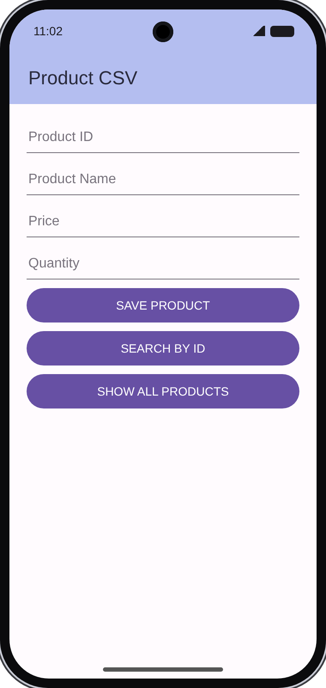 | 2. Save pressed with empty fields  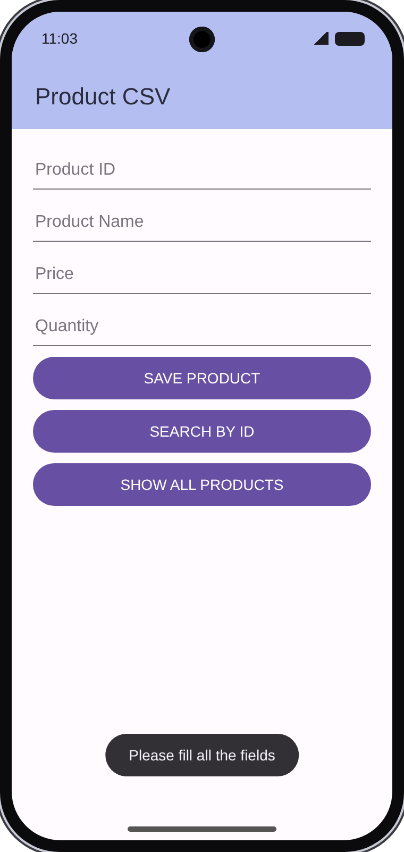 | 3. Product details entered  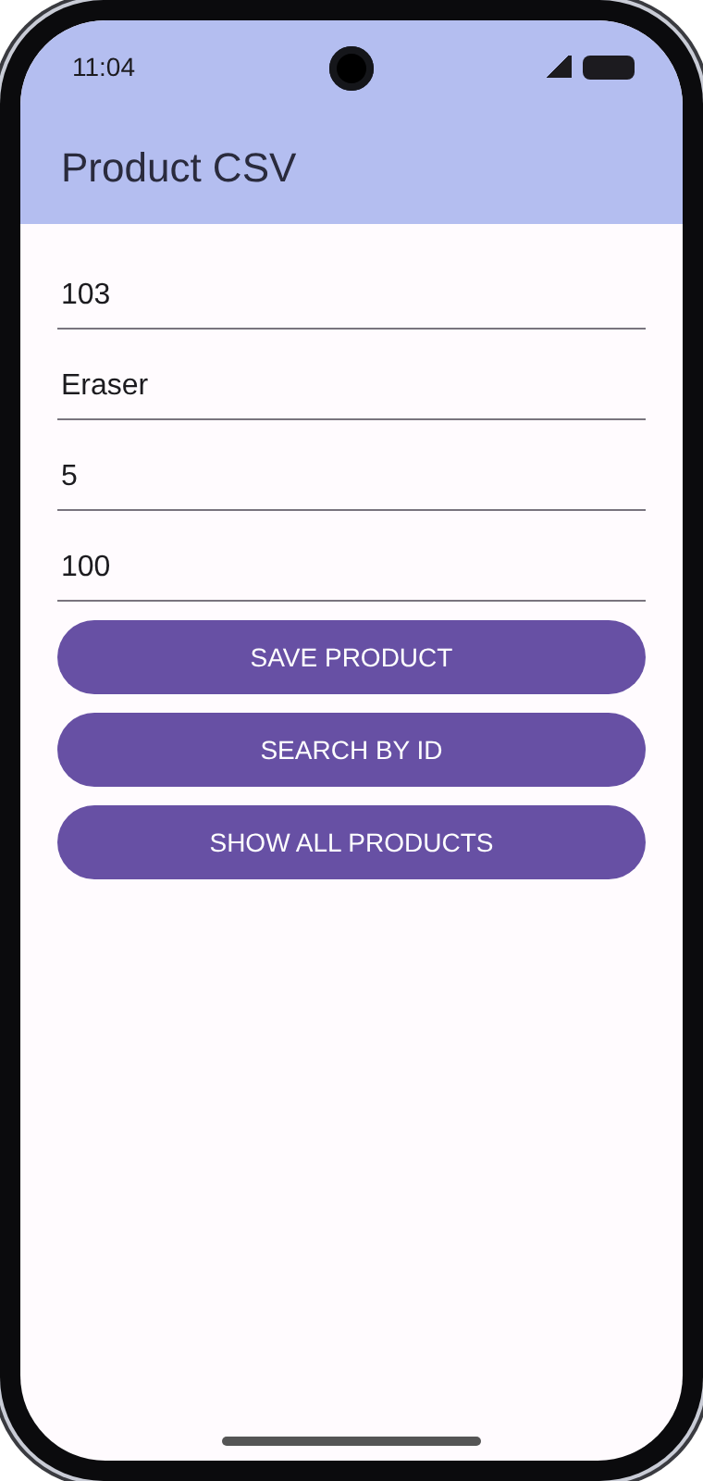
4. After pressing Save Product  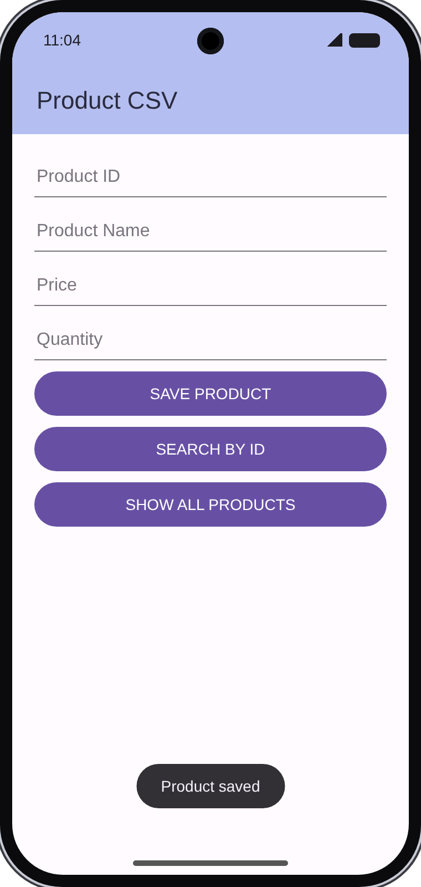 | 5. Show All Products  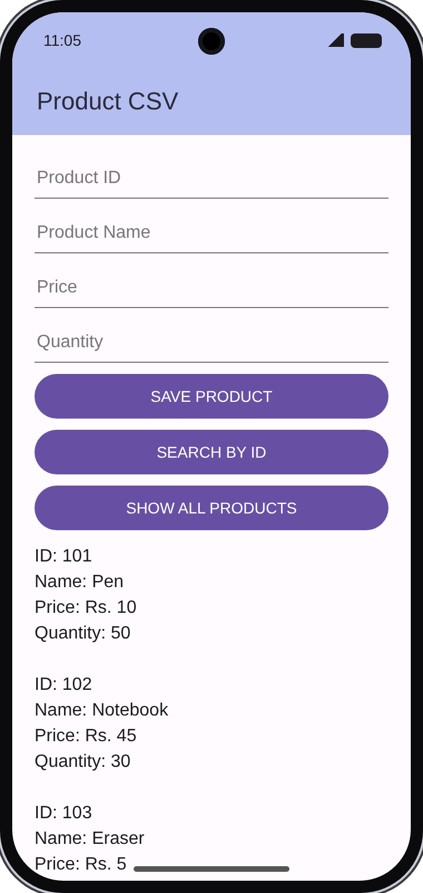 | 6. Search By ID (102)  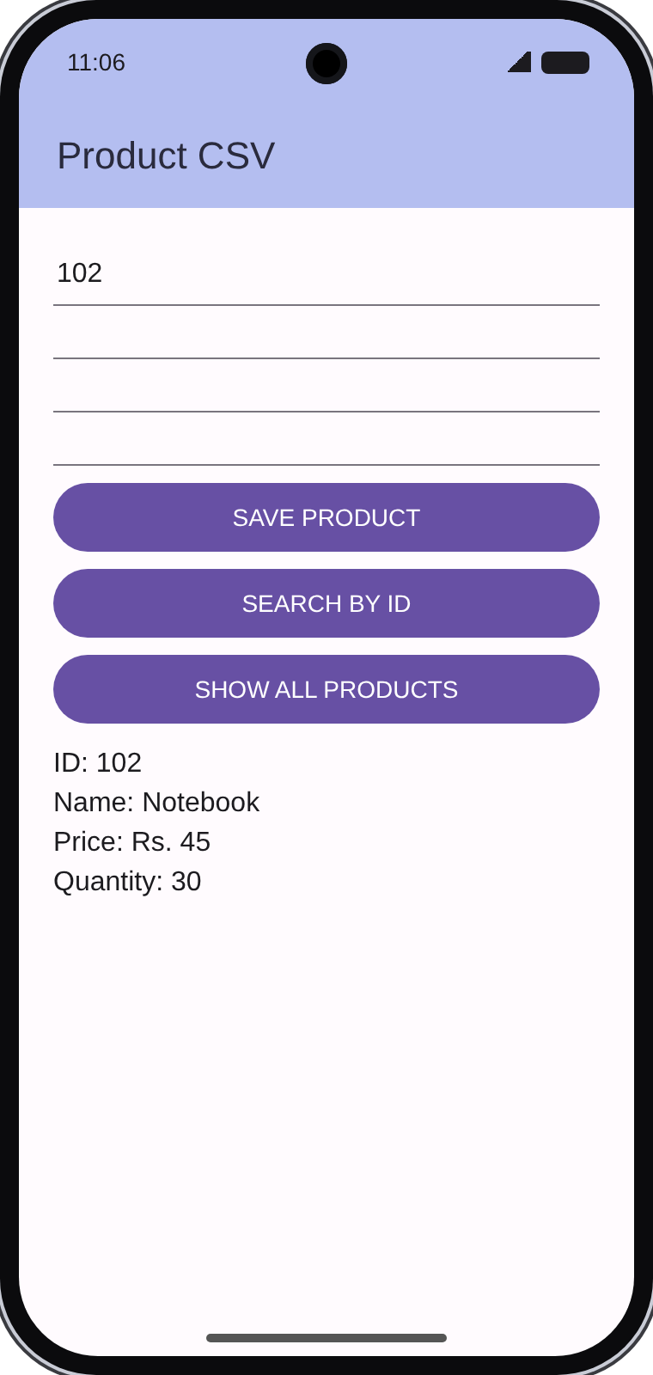
Q1 b) Develop an Android application to invoke the built-in camera using an implicit intent and capture an image
MainActivity.java
package com.example.camerademo;

import android.app.Activity;
import android.content.ActivityNotFoundException;
import android.content.Intent;
import android.graphics.Bitmap;
import android.os.Bundle;
import android.provider.MediaStore;
import android.widget.Button;
import android.widget.ImageView;
import android.widget.Toast;

import androidx.activity.result.ActivityResultLauncher;
import androidx.activity.result.contract.ActivityResultContracts;
import androidx.appcompat.app.AppCompatActivity;

public class MainActivity extends AppCompatActivity {

Button btnCapture;
ImageView imgPhoto;

ActivityResultLauncher<Intent> cameraLauncher = registerForActivityResult(
new ActivityResultContracts.StartActivityForResult(),
result -> {
if (result.getResultCode() == Activity.RESULT_OK && result.getData() != null) {
Bundle extras = result.getData().getExtras();
Bitmap photo = (Bitmap) extras.get("data");
imgPhoto.setImageBitmap(photo);
} else {
Toast.makeText(this, "Capture cancelled", Toast.LENGTH_SHORT).show();
}
});

@Override
protected void onCreate(Bundle savedInstanceState) {
super.onCreate(savedInstanceState);
setContentView(R.layout.activity_main);

btnCapture = findViewById(R.id.btnCapture);
imgPhoto = findViewById(R.id.imgPhoto);

btnCapture.setOnClickListener(v -> {

Intent intent = new Intent(MediaStore.ACTION_IMAGE_CAPTURE);
try {
cameraLauncher.launch(intent);
} catch (ActivityNotFoundException e) {
Toast.makeText(this, "No camera app found", Toast.LENGTH_SHORT).show();
}
});
}
}

activity_main.xml
<?xml version="1.0" encoding="utf-8"?>
<LinearLayout xmlns:android="http://schemas.android.com/apk/res/android"
android:layout_width="match_parent"
android:layout_height="match_parent"
android:gravity="center_horizontal"
android:orientation="vertical"
android:padding="16dp">

<Button
android:id="@+id/btnCapture"
android:layout_width="wrap_content"
android:layout_height="wrap_content"
android:text="Capture Image" />

<ImageView
android:id="@+id/imgPhoto"
android:layout_width="match_parent"
android:layout_height="0dp"
android:layout_marginTop="16dp"
android:layout_weight="1"
android:contentDescription="Captured photo" />
</LinearLayout>

AndroidManifest.xml
<?xml version="1.0" encoding="utf-8"?>
<manifest xmlns:android="http://schemas.android.com/apk/res/android">

<uses-feature
android:name="android.hardware.camera"
android:required="false" />

<queries>
<intent>
<action android:name="android.media.action.IMAGE_CAPTURE" />
</intent>
</queries>

<application
android:allowBackup="true"
android:icon="@mipmap/ic_launcher"
android:label="Camera Demo"
android:theme="@style/Theme.AppCompat.Light.DarkActionBar">
<activity
android:name=".MainActivity"
android:exported="true">
<intent-filter>
<action android:name="android.intent.action.MAIN" />
<category android:name="android.intent.category.LAUNCHER" />
</intent-filter>
</activity>
</application>
</manifest>

Q2) Develop an Android application to display static HTML content using WebView
MainActivity.java
package com.example.webviewdemo;

import android.os.Bundle;
import android.webkit.WebView;
import android.webkit.WebViewClient;

import androidx.appcompat.app.AppCompatActivity;

public class MainActivity extends AppCompatActivity {

WebView webView;

@Override
protected void onCreate(Bundle savedInstanceState) {
super.onCreate(savedInstanceState);
setContentView(R.layout.activity_main);

webView = findViewById(R.id.webView);

webView.setWebViewClient(new WebViewClient());

webView.loadUrl("file:/
}

@Override
public void onBackPressed() {
if (webView.canGoBack()) {
webView.goBack();
} else {
super.onBackPressed();
}
}
}

activity_main.xml
<?xml version="1.0" encoding="utf-8"?>
<WebView xmlns:android="http://schemas.android.com/apk/res/android"
android:id="@+id/webView"
android:layout_width="match_parent"
android:layout_height="match_parent" />

assets/index.html
<!DOCTYPE html>
<html>
<head>
<meta charset="UTF-8">
<meta name="viewport" content="width=device-width, initial-scale=1.0">
<title>My College</title>
<style>
body { font-family: sans-serif; margin: 16px; background: #f4f4f4; }
h1 { color: #b22222; }
table { border-collapse: collapse; width: 100%; }
th, td { border: 1px solid #999; padding: 6px; text-align: left; }
th { background: #ddd; }
</style>
</head>
<body>
<h1>NMIMS Mumbai</h1>
<p>This page is a plain static HTML file shown inside a WebView.</p>

<h2>Subjects this semester</h2>
<ul>
<li>Mobile Application Development</li>
<li>Database Management</li>
<li>Computer Networks</li>
</ul>

<h2>Timetable</h2>
<table>
<tr><th>Day</th><th>Subject</th></tr>
<tr><td>Monday</td><td>Mobile Application Development</td></tr>
<tr><td>Tuesday</td><td>Database Management</td></tr>
<tr><td>Wednesday</td><td>Computer Networks</td></tr>
</table>

<p><a href="https://www.nmims.edu">Visit the college website</a></p>
</body>
</html>

AndroidManifest.xml (add this line)
<uses-permission android:name="android.permission.INTERNET" />

Q3) Develop an Android application using DatePicker and TimePicker to select a date and time and display the result
MainActivity.java
package com.example.datetimedemo;

import android.os.Bundle;
import android.widget.Button;
import android.widget.DatePicker;
import android.widget.TextView;
import android.widget.TimePicker;

import androidx.appcompat.app.AppCompatActivity;

public class MainActivity extends AppCompatActivity {

DatePicker datePicker;
TimePicker timePicker;
Button btnShow;
TextView tvResult;

@Override
protected void onCreate(Bundle savedInstanceState) {
super.onCreate(savedInstanceState);
setContentView(R.layout.activity_main);

datePicker = findViewById(R.id.datePicker);
timePicker = findViewById(R.id.timePicker);
btnShow = findViewById(R.id.btnShow);
tvResult = findViewById(R.id.tvResult);

btnShow.setOnClickListener(v -> {
int day = datePicker.getDayOfMonth();
int month = datePicker.getMonth() + 1;
int year = datePicker.getYear();

int hour = timePicker.getHour();
int minute = timePicker.getMinute();

String date = String.format("%02d-%02d-%d", day, month, year);
String time = String.format("%02d:%02d", hour, minute);

tvResult.setText("Selected Date: " + date + "\nSelected Time: " + time);
});
}
}

activity_main.xml
<?xml version="1.0" encoding="utf-8"?>
<ScrollView xmlns:android="http://schemas.android.com/apk/res/android"
android:layout_width="match_parent"
android:layout_height="match_parent">

<LinearLayout
android:layout_width="match_parent"
android:layout_height="wrap_content"
android:gravity="center_horizontal"
android:orientation="vertical"
android:padding="16dp">

<DatePicker
android:id="@+id/datePicker"
android:layout_width="wrap_content"
android:layout_height="wrap_content"
android:calendarViewShown="false"
android:datePickerMode="spinner" />

<TimePicker
android:id="@+id/timePicker"
android:layout_width="wrap_content"
android:layout_height="wrap_content"
android:timePickerMode="spinner" />

<Button
android:id="@+id/btnShow"
android:layout_width="wrap_content"
android:layout_height="wrap_content"
android:text="Show Date and Time" />

<TextView
android:id="@+id/tvResult"
android:layout_width="wrap_content"
android:layout_height="wrap_content"
android:layout_marginTop="16dp"
android:textSize="18sp" />
</LinearLayout>
</ScrollView>

Output:
1. App launched  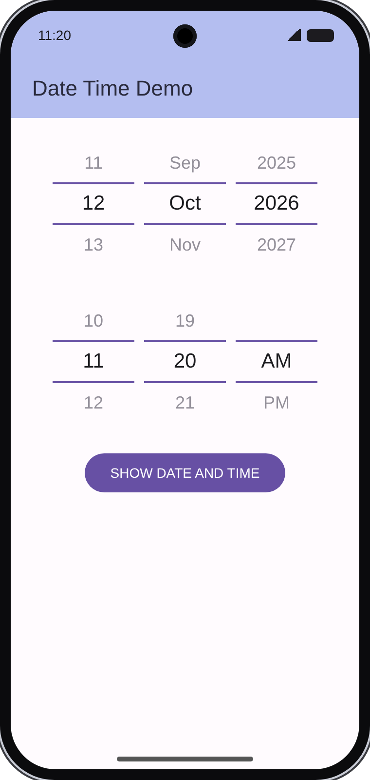 | 2. Date selected (15 Aug 2026)  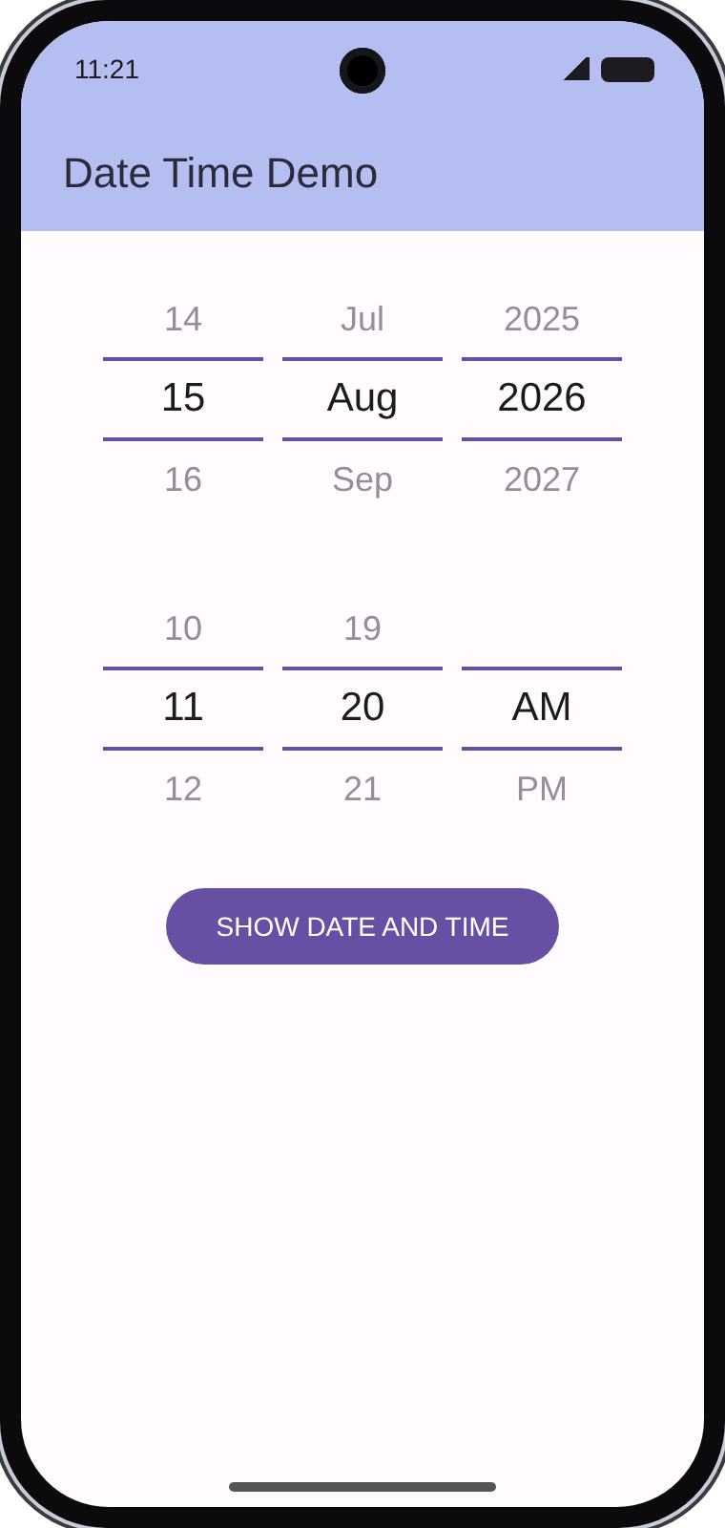
3. Time selected (3:30 PM)  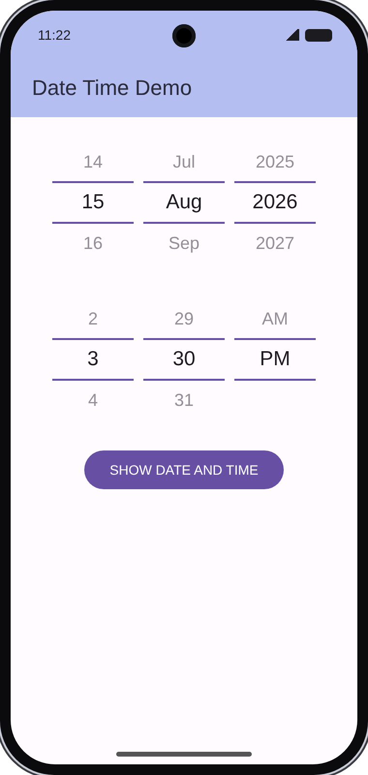 | 4. After pressing Show Date and Time  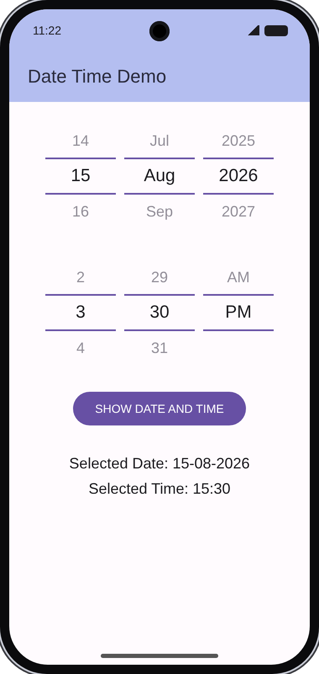
Q5) Develop an Android application to locate a given college/hospital/place using Google Maps
MainActivity.java
package com.example.placefinder;

import android.location.Address;
import android.location.Geocoder;
import android.os.Bundle;
import android.widget.Button;
import android.widget.EditText;
import android.widget.Toast;

import androidx.appcompat.app.AppCompatActivity;

import com.google.android.gms.maps.CameraUpdateFactory;
import com.google.android.gms.maps.GoogleMap;
import com.google.android.gms.maps.OnMapReadyCallback;
import com.google.android.gms.maps.SupportMapFragment;
import com.google.android.gms.maps.model.LatLng;
import com.google.android.gms.maps.model.MarkerOptions;

import java.io.IOException;
import java.util.List;
import java.util.Locale;

public class MainActivity extends AppCompatActivity implements OnMapReadyCallback {

GoogleMap myMap;
EditText etPlace;
Button btnSearch;

@Override
protected void onCreate(Bundle savedInstanceState) {
super.onCreate(savedInstanceState);
setContentView(R.layout.activity_main);

etPlace = findViewById(R.id.etPlace);
btnSearch = findViewById(R.id.btnSearch);

SupportMapFragment mapFragment =
(SupportMapFragment) getSupportFragmentManager().findFragmentById(R.id.map);
mapFragment.getMapAsync(this);

btnSearch.setOnClickListener(v -> searchPlace());
}

@Override
public void onMapReady(GoogleMap googleMap) {
myMap = googleMap;
myMap.getUiSettings().setZoomControlsEnabled(true);

LatLng mumbai = new LatLng(19.0760, 72.8777);
myMap.moveCamera(CameraUpdateFactory.newLatLngZoom(mumbai, 10));
}

private void searchPlace() {
String place = etPlace.getText().toString().trim();
if (place.isEmpty()) {
Toast.makeText(this, "Enter a place name", Toast.LENGTH_SHORT).show();
return;
}

Geocoder geocoder = new Geocoder(this, Locale.getDefault());
try {

List<Address> list = geocoder.getFromLocationName(place, 1);
if (list == null || list.isEmpty()) {
Toast.makeText(this, "Place not found", Toast.LENGTH_SHORT).show();
return;
}

Address address = list.get(0);
LatLng point = new LatLng(address.getLatitude(), address.getLongitude());

myMap.clear();
myMap.addMarker(new MarkerOptions().position(point).title(place));
myMap.animateCamera(CameraUpdateFactory.newLatLngZoom(point, 15));
} catch (IOException e) {
Toast.makeText(this, "Network problem, try again", Toast.LENGTH_SHORT).show();
}
}
}

activity_main.xml
<?xml version="1.0" encoding="utf-8"?>
<LinearLayout xmlns:android="http://schemas.android.com/apk/res/android"
android:layout_width="match_parent"
android:layout_height="match_parent"
android:orientation="vertical">

<LinearLayout
android:layout_width="match_parent"
android:layout_height="wrap_content"
android:orientation="horizontal"
android:padding="8dp">

<EditText
android:id="@+id/etPlace"
android:layout_width="0dp"
android:layout_height="wrap_content"
android:layout_weight="1"
android:hint="Enter college / hospital / place"
android:inputType="text" />

<Button
android:id="@+id/btnSearch"
android:layout_width="wrap_content"
android:layout_height="wrap_content"
android:text="Search" />
</LinearLayout>

<fragment
android:id="@+id/map"
android:name="com.google.android.gms.maps.SupportMapFragment"
android:layout_width="match_parent"
android:layout_height="match_parent" />
</LinearLayout>

AndroidManifest.xml
<?xml version="1.0" encoding="utf-8"?>
<manifest xmlns:android="http://schemas.android.com/apk/res/android">

<uses-permission android:name="android.permission.INTERNET" />

<application
android:allowBackup="true"
android:icon="@mipmap/ic_launcher"
android:label="Place Finder"
android:theme="@style/Theme.AppCompat.Light.DarkActionBar">

<meta-data
android:name="com.google.android.geo.API_KEY"
android:value="YOUR_API_KEY_HERE" />

<activity
android:name=".MainActivity"
android:exported="true">
<intent-filter>
<action android:name="android.intent.action.MAIN" />
<category android:name="android.intent.category.LAUNCHER" />
</intent-filter>
</activity>
</application>
</manifest>

Output:
