NMIMS MPSTME · DESIGN EXPERIENCE
Wealth Intelligence
Professional Net Worth Tracker and Personal Wealth Intelligence Platform

Project report: requirements, design, architecture, calculation methods, testing and future roadmap
Live demonstration client: Priya Ramanathan, with three isolated investor case studies
Report date: 20 October 2026
Version 2.0 · Synthetic demonstration data · Educational use only
This report describes the application as built and tested. It is not investment, tax or legal advice.

Contents
1. Executive summary
2. Background and problem statement
3. Objectives, scope and requirements
4. Users, personas and journeys
5. Design process and rationale
6. System architecture
7. Feature walkthrough
8. Calculation methodology and worked examples
9. Rules and alert lifecycle
10. Classification and look-through
11. Priya Ramanathan: starting position
12. Investor case studies
13. Requirements traceability matrix
14. Testing and evaluation
15. Security and threat model
16. Market-data integrations
17. Advantages
18. Limitations
19. Future work: path to a SaaS product
20. How to run the application
Appendix A: Glossary
Appendix B: Repository structure

1. Executive summary
Wealth Intelligence is a working personal wealth platform. It tracks net worth, checks holdings and cash flow against configurable rules, explains every figure it shows, and proposes rebalancing options for a person to review. It was built for the Design Experience subject at NMIMS Mukesh Patel School of Technology Management and Engineering, and is intended to withstand detailed questioning from a faculty evaluator in a live demonstration.
The application is not a static dashboard or a spreadsheet copy. Every edit is validated, saved to a database and followed by a full recalculation covering net worth, allocation, alerts, the cash-flow forecast and the health score. The initial client, Priya Ramanathan, is loaded only with the figures given in the project brief. Where information is missing, the application says so instead of inventing it.

Headline results
Measure | Result
Pages | 14: overview, assets and liabilities, portfolio analytics, cash-flow planner, goals, rules and allocation, alerts, financial health, case studies, data collection, market data, reports, guided demo, methodology
Rules | 18 configurable rules: 8 from the brief plus 10 additional safeguards
Case studies | 3 isolated investor profiles: aggressive, conservative (50:50) and moderate (70:30)
Automated tests | 171 unit and API tests plus a 28-check browser walkthrough; type check and production build pass
Priya reconciliation | Gross assets Rs 8.63 crore; expenses Rs 2 lakh a month; pension Rs 80 L paid and Rs 20 L remaining
Data handling | Unknown values appear as Awaiting data, ranges or provisional labels, never as zero

Three main advantages
- Honest about gaps. A net worth figure is withheld until liabilities are assessed, and a health score built on partial data is labelled provisional with its coverage.
- Proactive. Alerts state why they fired, which holdings are involved and what to review. They are stored with a history, so refreshing never duplicates them.
- Defensible. Amounts are stored as exact integer paise, formulas are documented, changes leave an audit trail, and tests probe every rule at, below and above its threshold.

How to read this report
Sections 2 to 5 explain what was built and why. Sections 6 to 12 describe how it works, with diagrams and worked numerical examples. Sections 13 to 16 show how requirements were verified and secured. Sections 17 to 19 cover advantages, limits and a roadmap for turning the prototype into a product.

2. Background and problem statement
A typical investor with real assets, funds, PMS and AIF exposure and pension commitments faces three recurring problems.
- Net worth is uncertain. Values arrive from different statements on different dates, aggregate holdings hide their composition, and liabilities are often not captured at all.
- Risk is hidden inside totals. An aggregate mutual-fund line does not reveal its equity share. A PMS or AIF is a vehicle, not an asset class, so a portfolio can be more concentrated than it looks.
- Obligations are easy to miss. Premium due dates, FD maturities and EMIs sit in separate places, and spreading annual items across twelve months misstates the real cash pattern.
Spreadsheets store numbers but do not check them. When data is incomplete they quietly produce confident totals, because an empty cell behaves as zero. Rules that should flag a risk depend on someone remembering to look.

Why a dynamic application instead of a spreadsheet
Concern | Conventional spreadsheet | Wealth Intelligence
Missing data | Blank cells count as 0 | Awaiting data, ranges, provisional labels
Rules and alerts | Static formulas; manual review | Configurable rules, explanations, alert history
Classification | Manual lookup tabs | Deterministic engine, review queue, logged overrides
Scenarios | Copy the file and edit | Simulator recomputes allocation, rules and score
Data integrity | Free-form cells | Validated records, audit trail, duplicate-import blocking
Access control | File sharing | Sign-in, roles, server-enforced read-only

3. Objectives, scope and requirements

Objectives
- Track assets, liabilities and contractual commitments with a clear accounting convention.
- Analyse an investment portfolio across asset class, instrument, issuer, liquidity and concentration.
- Plan cash flow with a forecast that respects real due dates.
- Evaluate configurable rules and keep a persistent alert history.
- Score financial health with a transparent, editable method.
- Recommend rebalancing options without executing anything.
- Demonstrate three investor profiles separate from the live client.
- Provide a market-data architecture that is honest about what is live.

Scope boundaries
Inside scope are manual and file-based data entry, calculations, rules, scoring, reporting and a market-data adapter layer. Outside scope are trade execution, bank or broker connections, tax computation and document storage. The application never moves money, redeems an investment or places a trade.

Functional requirements
ID | Requirement
FR1 | Maintain assets, liabilities, commitments, income, expenses, insurance, goals and transactions with validation
FR2 | Classify holdings automatically with override, review queue and look-through
FR3 | Compute net worth, returns, XIRR, allocation, concentration, debt ratios, savings rate and emergency cover
FR4 | Forecast cash flow for at least twelve months using dated schedules
FR5 | Evaluate eight brief rules plus additional rules, with editable thresholds and persistent alerts
FR6 | Compute an explainable 0 to 100 health score with editable weights
FR7 | Show target allocation, drift, rebalancing options and a what-if simulator
FR8 | Provide three isolated investor case studies
FR9 | Import and export CSV and Excel; produce a printable report
FR10 | Provide a market-data adapter layer with source and as-of dates
FR11 | Provide a guided demonstration with a safe reset

Non-functional requirements
Area | Requirement | How it is met
Correctness | Exact currency arithmetic | Integer paise; percentages rounded before comparison
Explainability | Every figure traceable | Methodology page, formulas on the score page, alert explanations
Persistence | Survive restarts | SQLite with migrations; durability test
Security | Protect financial data | Hashed passwords, HttpOnly cookies, CSRF header, server-side roles, CSP
Usability | Faculty-demo ready | Guided demo, clear empty and error states, keyboard-friendly dialogs
Responsiveness | Desktop first, usable on phone | Responsive layout verified at 390 px
Maintainability | Separated layers, tests | Pure shared engine, typed API, 171 tests

4. Users, personas and journeys
The personas below are proto-personas derived from the project brief and common advisory practice. They were not produced from user interviews, and no user study was run.
Persona | Context | Needs | Pain points addressed
Priya Ramanathan (client) | Holds Rs 8.63 crore across property, gold, FDs, funds, PMS, AIF and equity; pension plan with Rs 20 lakh still to pay | One trustworthy view; know what is missing; see commitments | Aggregate holdings hide risk; liabilities unknown; premium dates unscheduled
Advisor (fictional) | Reviews several clients; needs repeatable checks | Rules, drift, scenarios, shareable reports | Manual spreadsheet checks; no history of what was flagged
Evaluator (faculty) | Marks the project on rigour and usability | Clear demonstration, documented method, honest limits | Prototypes that hide gaps or show fake data

Primary journey: Priya reviews her position
Step | User action | System response | Design intent
1 | Opens the overview | Shows Rs 8.63 Cr, liabilities Not yet assessed, net worth Awaiting data | Honesty first: no false precision
2 | Reviews holdings | Seven aggregates with provisional and needs-review badges | Make uncertainty visible
3 | Adds a mutual-fund scheme | Live classification preview; aggregate splits with a remainder | Teach the model while entering data
4 | Records a loan | Net worth appears as provisional | Show cause and effect immediately
5 | Opens an alert | Reason, records, action, history | Explain, never just warn
6 | Changes a threshold | Alert resolves; history keeps it | Rules are the user's to tune
7 | Tries a scenario | Before and after allocation, rules and score | Test before acting; nothing executes
8 | Exports a report | Excel, CSV or print to PDF | Take the result away

Advisor journey
The advisor opens the client, checks the data-completeness list, resolves classification items in the review queue, reviews alerts and drift, uses the simulator to test a proposal, then exports a report that states its methodology and data gaps. The viewer role lets a colleague read the same results without any ability to change them.

5. Design process and rationale
The design aims for a premium wealth-management feel that stays dense without clutter, and above all never presents an uncertain number as a certain one. The process followed five steps: understand the brief, define principles, design the information architecture, build a small design system, then review the screens against recognised usability heuristics.

Design principles
Principle | What it means in the interface | Example
Unknown is not zero | Missing data has its own visual state | KPI card reads Awaiting data with a reason; allocation shows a range
Explain every alert | Each alert states the metric, threshold, reason, records and action | Alert drawer with history
Show cause and effect | Edits visibly change dependent numbers | Add a liability and net worth appears
Separate amount types | Market value, cost, balance, principal and commitment are labelled differently | Assets table and amount-types card
Never act on the user's behalf | Recommendations are options for review | Simulator and plan carry a disclaimer
Progressive disclosure | Headline first, detail on click | KPI cards open drawers; formulas sit in expandable panels
Accessible by default | Keyboard, labels and a table alternative to every chart | Table toggle on each chart

Information architecture
Fourteen pages sit in four navigation groups, so a user always knows whether they are looking at wealth, intelligence, data or project material.
Group | Pages | Question answered
Wealth | Overview, Assets & liabilities, Portfolio analytics, Cash-flow planner, Goals | What do I have, owe and expect?
Intelligence | Rules & allocation, Alerts, Financial health, Investor case studies | What should I watch, and how healthy am I?
Data & reports | Data collection, Market data, Reports & export | What is missing, how fresh is it, how do I share it?
Project | Guided demo, Methodology | How do I demonstrate and justify it?

Visual system
- Colour. A restrained navy and blue palette on a warm neutral surface. Status colours (good, warning, serious, critical) are reserved and always paired with a label or icon, never colour alone. Light and dark themes are both defined.
- Chart colours. Asset classes use a fixed order of categorical colours taken from a published, colour-vision-checked palette, so a class keeps the same colour on every page. Legends are always present and charts have a table view.
- Typography. A single sans-serif family with tabular figures, so columns of money align. Amounts use Indian digit grouping, and compact forms show rupees, lakh and crore.
- Components. Cards, badges, tables with sort and search, drawers, dialogs, segmented controls, meters and form fields share spacing, radii and borders.
- States. Loading skeletons, empty states with a next step, field-level errors, success toasts and a retry banner for load failures.
- Responsiveness. A fixed sidebar on desktop becomes a slide-in menu on narrow screens. Grids collapse to one column and tables scroll inside their cards. The layout was checked at 1440 px and 390 px.

Key design decisions
Decision | Alternative rejected | Reason
Withhold net worth until liabilities are assessed | Show assets minus zero | A missing liability list is not the same as no debt
Show ranges for unclassified holdings | Assume mutual funds are all equity or all debt | Any single assumption can trigger or hide an alert wrongly
Treat the Rs 20 L pension balance as a commitment | Deduct it as a loan | It is a future contractual outflow, not debt today
One alert per condition with history | Re-create alerts on each refresh | Prevents alert fatigue and keeps an audit record
Provisional score with coverage shown | Score missing parts as full or zero marks | Avoids false comfort and false alarm
Recommendations only, no execution | One-click rebalancing | Suitability, tax and liquidity need human judgement

Heuristic self-assessment
The table applies Nielsen's ten usability heuristics to the finished interface. It is the author's own review, not a study with users.
Heuristic | How the interface responds | Known gap
Visibility of system status | Toasts, as-of date, freshness badge, provisional labels | No background-job indicator because there are no jobs yet
Match with the real world | Rupee, lakh and crore; plain finance terms | English only
User control and freedom | Archive and restore; dry-run import; saved scenarios are never executed | No general undo
Consistency and standards | One design system; consistent badges and tables | Some pages are dense
Error prevention | Validation, duplicate-submit and duplicate-import blocking, confirmations | None known
Recognition over recall | Live classification preview; checklist of what is missing | None known
Flexibility and efficiency | Search, sort, filters, group-by, keyboard-friendly dialogs | No bulk edit or saved views
Aesthetic and minimal design | Headline then detail; recessive grid lines | Overview has many cards
Help with errors | Field-level messages explaining the fix | None known
Help and documentation | Methodology page, guided demo, tooltips and formulas | No contextual help tour

Accessibility measures
Dialogs trap focus and close on Escape. Controls have labels and error messages are announced. Status is never colour-only. Every chart has a table alternative and a text label. Reduced-motion preferences are respected. No automated audit such as axe or Lighthouse has been run yet, so conformance to WCAG 2.1 is not claimed.

6. System architecture
The application is a single TypeScript package in three layers. All financial logic lives in a pure shared module with no input or output. The server calls it after every change and persists alert history, and the browser renders the evaluation the server returns.
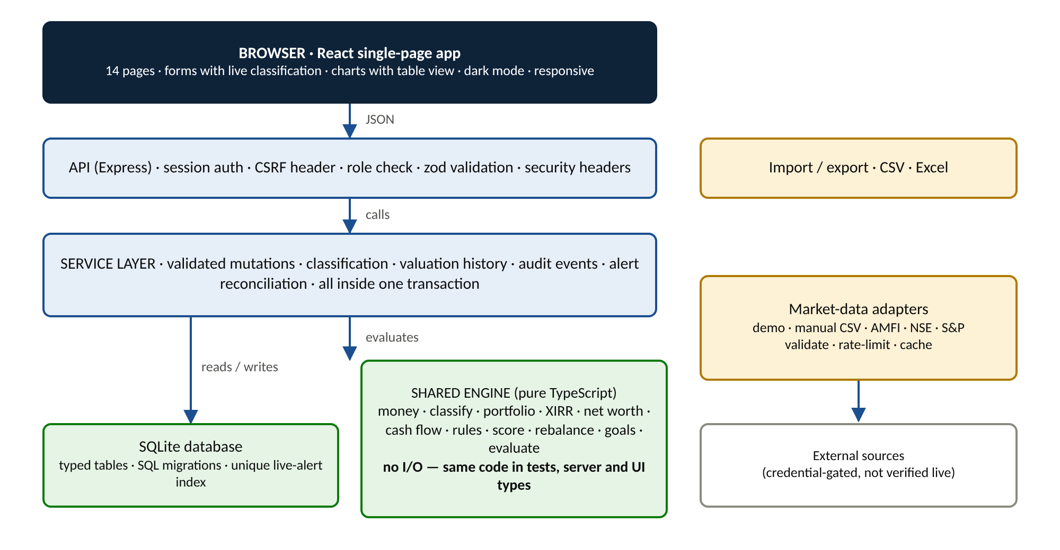
Figure 1. Layered architecture: browser, API, service layer, shared engine, database and market adapters
Layer | Technology | Role
Shared engine | TypeScript, pure functions | Money, classification, portfolio, XIRR, net worth, cash flow, rules, score, rebalancing, goals
Server | Node 22, Express, zod | Validated API, authentication, authorisation, audit, import and export, market adapters
Persistence | SQLite (node:sqlite) with SQL migrations | Typed tables, transactions, partial unique index for alerts
Interface | React, Vite, Recharts | 14 pages, forms, charts, tables, dark mode, responsive layout
Quality | Vitest, Playwright (Chromium) | 171 tests and a 28-check browser walkthrough

Data flow for a single edit
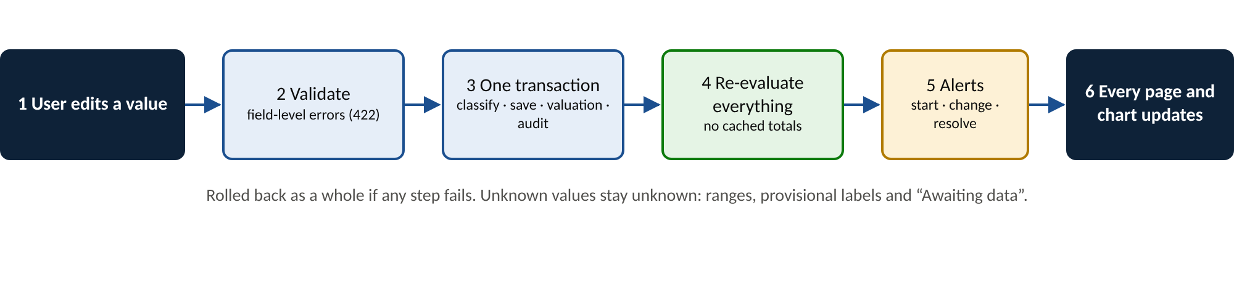
Figure 2. What happens when a user edits a value
The sequence is atomic. If validation, classification, saving or audit fails, nothing is stored. Because the whole client is re-evaluated from stored data after each change, there are no cached totals that can become stale.

Database design
Each entity has its own typed table, with foreign keys to the client. Holdings link to themselves so an aggregate can be split into underlying positions. Money columns are integers in paise. A partial unique index on alerts allows only one unresolved alert per client and condition.
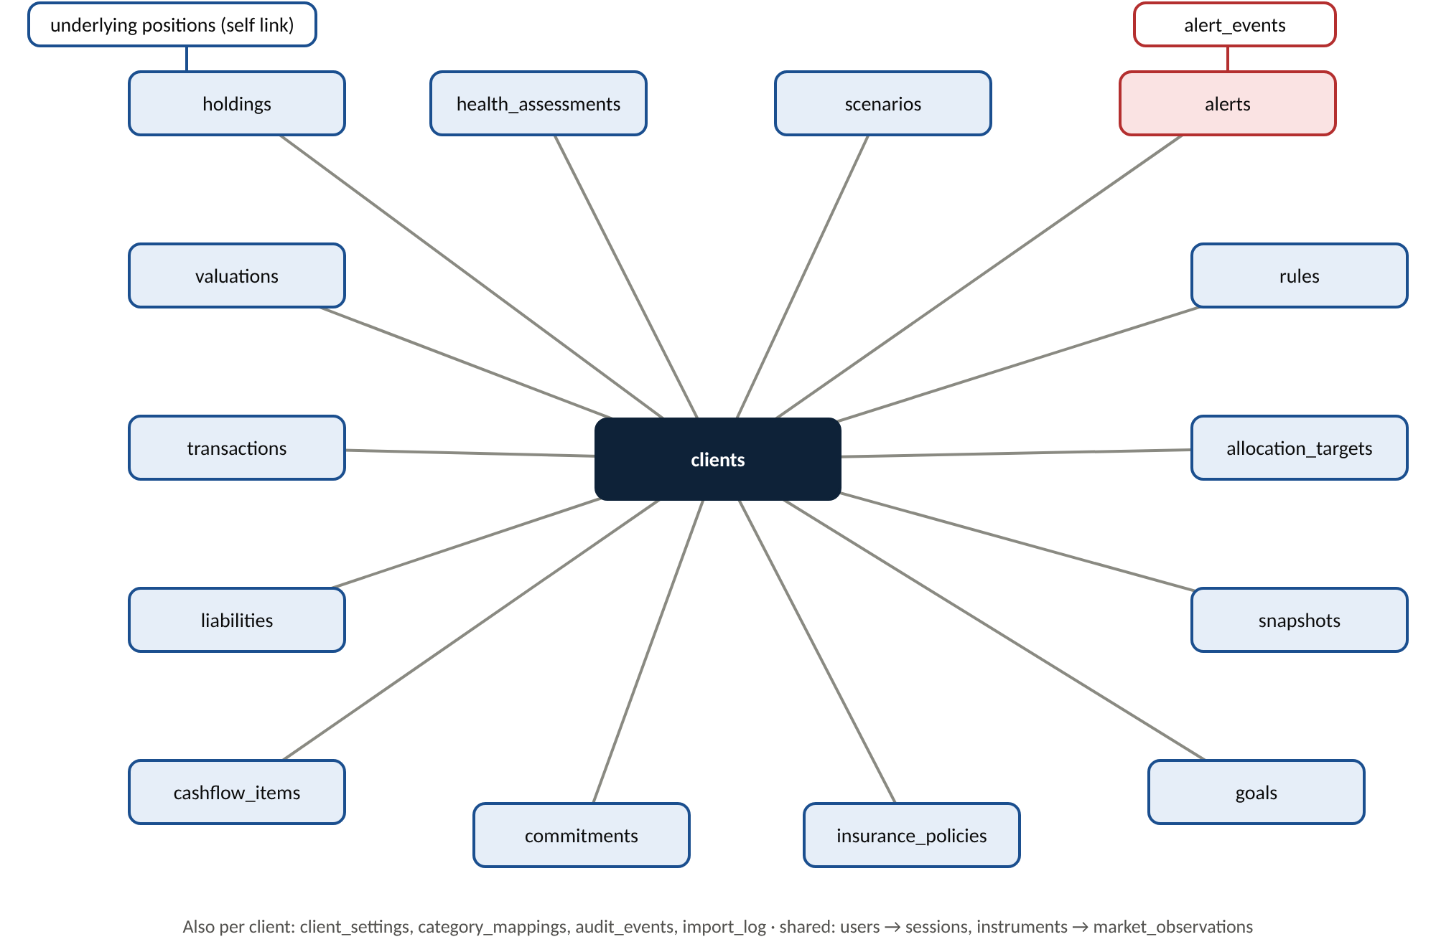
Figure 3. Entity relationships: every table belongs to a client

Design principles for the engine
- Exact money. Amounts are integer paise, so sums never drift.
- Unknown is not zero. Unresolved items widen results into minimum and maximum ranges, and rules return triggered, possible, awaiting data, ok or disabled.
- Aggregate versus underlying. An aggregate is replaced by its underlying schemes, and any remainder stays as one unallocated line, so nothing is double counted.
- Isolation. Demo fixtures are flagged, and reset only touches those, never clients created by the user.

7. Feature walkthrough

7.1 Wealth overview
The landing page shows fifteen KPI cards in four groups: wealth, investments, cash flow and resilience. Each card either shows a figure or states why it cannot. Clicking a card opens a drawer with the records behind it.
- Wealth: gross assets, confirmed liabilities, calculated net worth, one-month change, remaining commitments, liquid assets, emergency-fund coverage, health score.
- Investments: invested capital, investment market value, absolute return and XIRR.
- Cash flow: monthly income, expenses and surplus or deficit, with the savings rate.
Charts cover the net-worth trend (from recorded snapshots only), allocation donut with a denominator switch, exposure ranges, allocation against target, assets against liabilities, income against expenses and the dated 12-month cash flow. Every chart has a Table button for its underlying numbers.
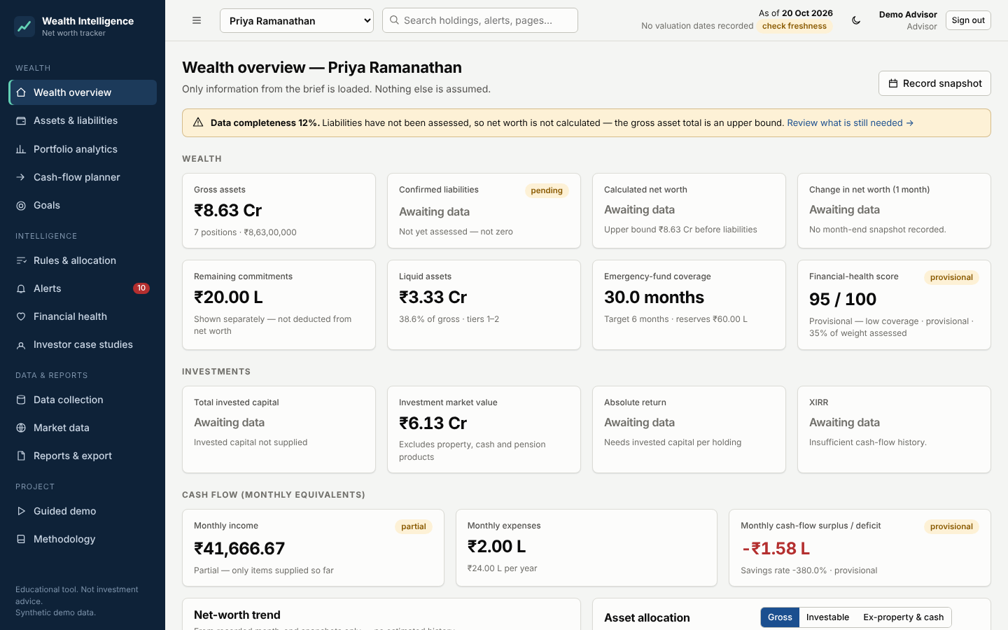
Figure 4. Wealth overview for Priya Ramanathan: gross assets Rs 8.63 Cr; liabilities and net worth awaiting data

7.2 Assets and liabilities
Six tabs separate what is owned, owed and committed. Assets can be grouped by category, instrument, account or institution and filtered by status. Each holding keeps its original description, classification result, method and status, and can be overridden with a logged change.
- Underlying positions. An aggregate such as Mutual-fund holdings can be split into schemes. The page shows how much is split and how much remains unallocated, and offers a confirm step if the underlying total exceeds the aggregate.
- Amount types. Market value, invested capital, account balance, outstanding principal and contractual commitment are labelled separately. Insurance sum assured and future pension receipts are never treated as assets.
- Liabilities. Loans carry EMI, rate and tenure; credit cards carry only a balance. A declaration marks the list complete, which moves net worth from provisional to final.
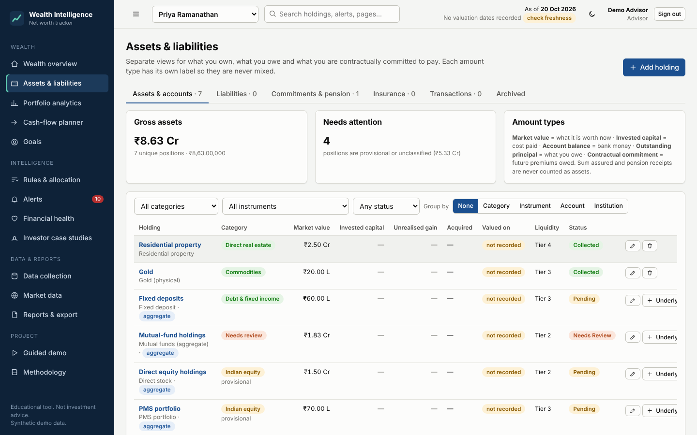
Figure 5. Assets tab: seven aggregate holdings with category badges, provisional flags and liquidity tiers

7.3 Portfolio analytics
Filters by asset class, instrument, account, issuer and valuation date drive every figure. The page reports investment value, invested capital, absolute return and XIRR, then breaks exposure down by class, Indian versus global equity, direct versus indirect equity, instrument, issuer and sector.
- Single-stock concentration. Direct holdings and look-through exposure through funds or PMS are shown separately. An aggregate such as Direct equity holdings is never treated as one stock, so the rule reports a data gap until individual stocks are entered.
- Liquidity. Four tiers run from immediate cash to illiquid assets such as property and AIFs.
- Freshness. Each position is marked fresh, stale or undated, and delayed-valuation instruments are flagged.
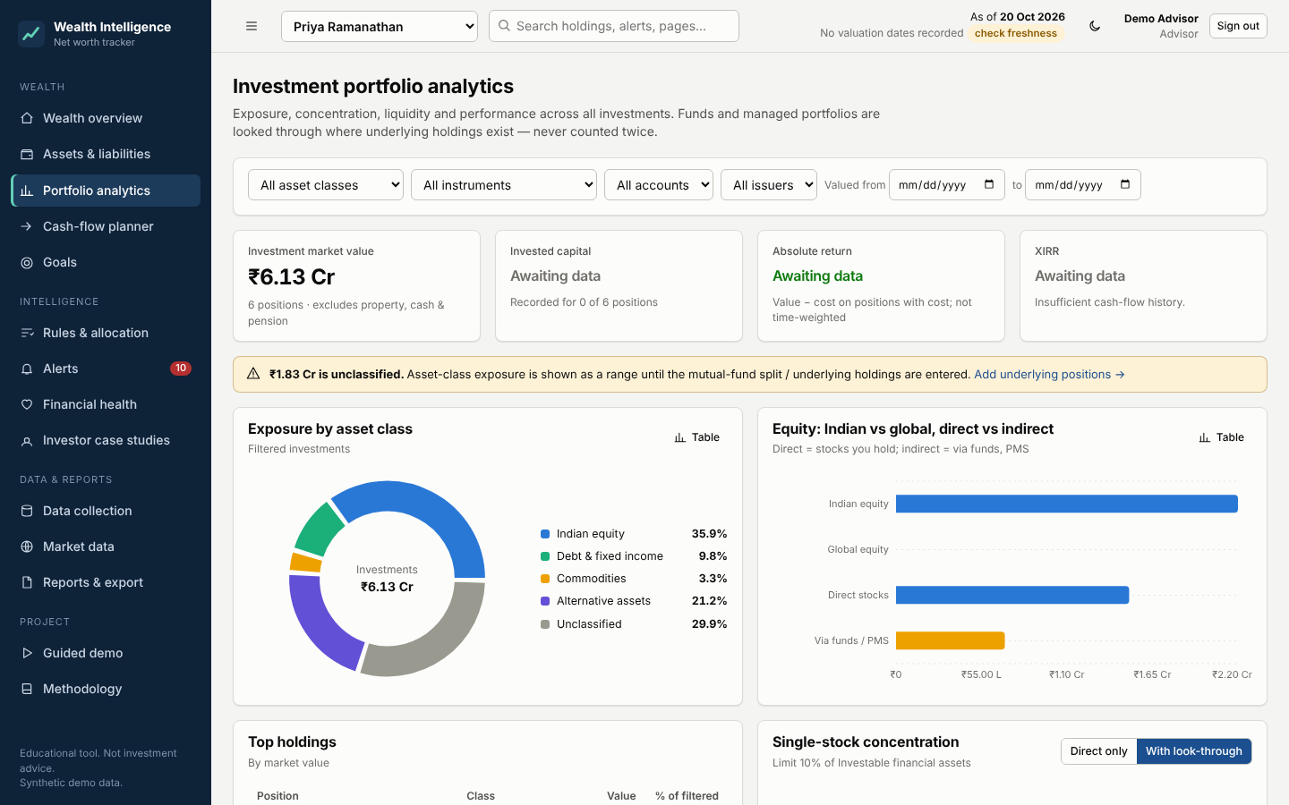
Figure 6. Portfolio analytics with filters, KPIs and a notice about unclassified holdings

7.4 Cash-flow planner
Income and expense categories follow the brief: salary, business, rental, interest, dividends, pension and other income; household, medical, personal, business, EMIs, insurance premiums, pension premiums, investment contributions and other scheduled payments. Period views run monthly, quarterly, annual and custom.
- Dated forecast. Occurrences come from actual dates, including month-end clipping. Premium instalments stop when the commitment is fully paid, and the last instalment is trimmed to the remainder.
- Unscheduled items. An annual pension receipt or a premium balance with no date is listed as unscheduled instead of being spread over twelve months.
- Provisional results. While income is not marked complete, the surplus is labelled provisional and the savings rate is withheld.
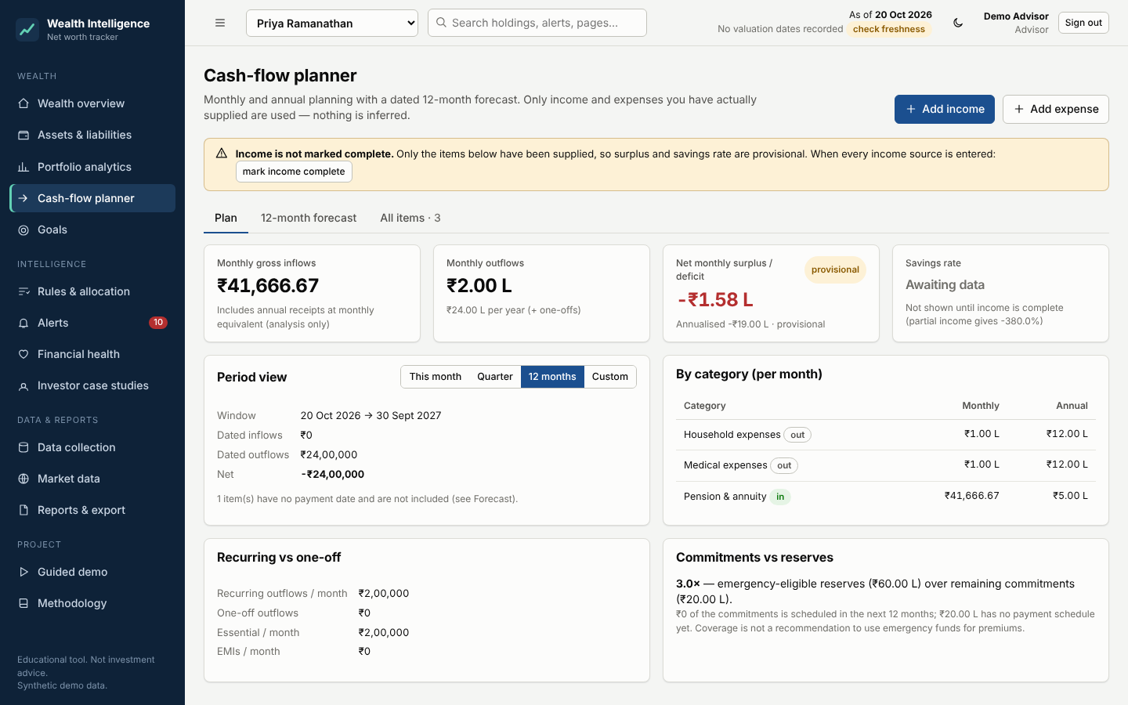
Figure 7. Cash-flow planner: Rs 41,666.67 monthly equivalent of the Rs 5 L annual pension against Rs 2 L expenses

7.5 Rules and allocation
This page configures targets, thresholds and scoring. Changing any value immediately re-evaluates drift, alerts and recommendations.
- Allocation basis. The denominator is selectable: gross assets, investable assets (excluding direct property) or investments excluding property and cash. The chosen basis is always displayed.
- Targets. Targets and per-class bands are validated to total 100%. The brief's 50/20/10/10/5/5 sample is loaded but marked as not validated for Priya.
- Drift. Drift is measured in percentage points. Fifty to fifty-six is a six-point drift, and a value exactly at the tolerance does not trigger unless the inclusive option is chosen.
- Rebalancing. Eight listed steps. Suggestions respect a liquidity reserve covering the emergency fund and the next ninety days of outflows, never propose selling illiquid assets, and cap additions into equity at the equity limit. Only definite breaches receive an action.
- Scenario simulator. Purchases and sales run on a copy of the data. The page shows before and after allocation, gross assets, health score, emergency cover and which rules change state. Scenarios can be saved but are never executed.
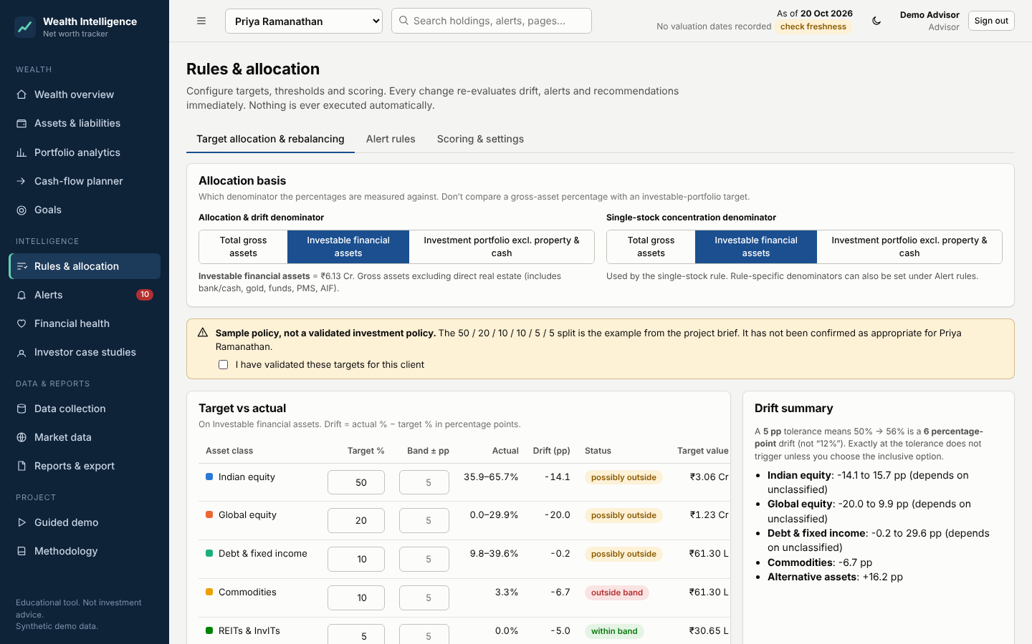
Figure 8. Target and actual allocation with ranges, drift, band status and gap to target

7.6 Alerts and recommendations
The inbox has open, acknowledged, data-notice and resolved views and filters by severity. Opening an alert shows the triggering metric, current value, threshold, dates, why it fired, relevant records, the recommended action, expected effect and its full event history.
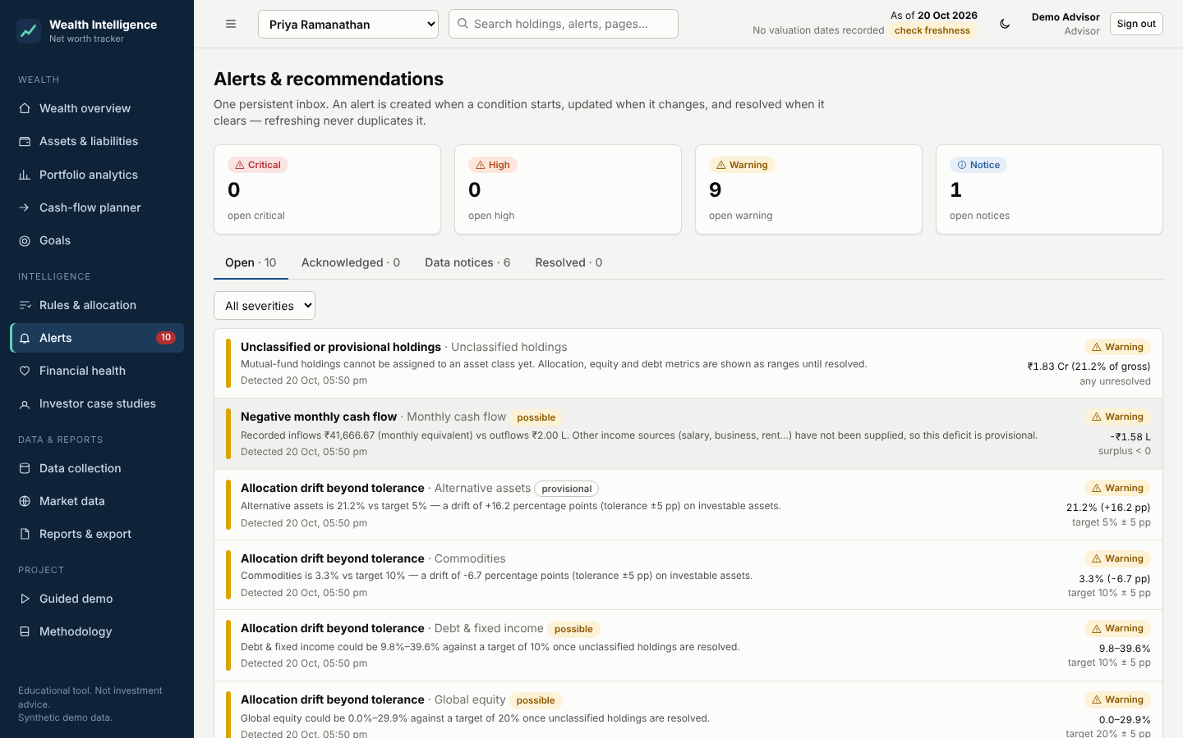
Figure 9. Alert inbox with severity counts and persistent history

7.7 Financial health score
The score runs from 0 to 100 and has six components with editable weights: net-worth strength 20%, savings and cash flow 20%, emergency fund and liquidity 20%, debt burden 15%, diversification 15% and insurance coverage 10%. Each component shows its metrics, formula, reason and suggested improvement.
Handling of missing data
A component without enough data is shown as not assessed. It is excluded and the remaining weights are re-normalised. It is never given full or zero marks. The overall score is labelled provisional with the share of weight assessed, and below 50% coverage it is flagged as low coverage and given no band label.
The score is an educational indicator. It is not a credit-bureau score and does not predict one.
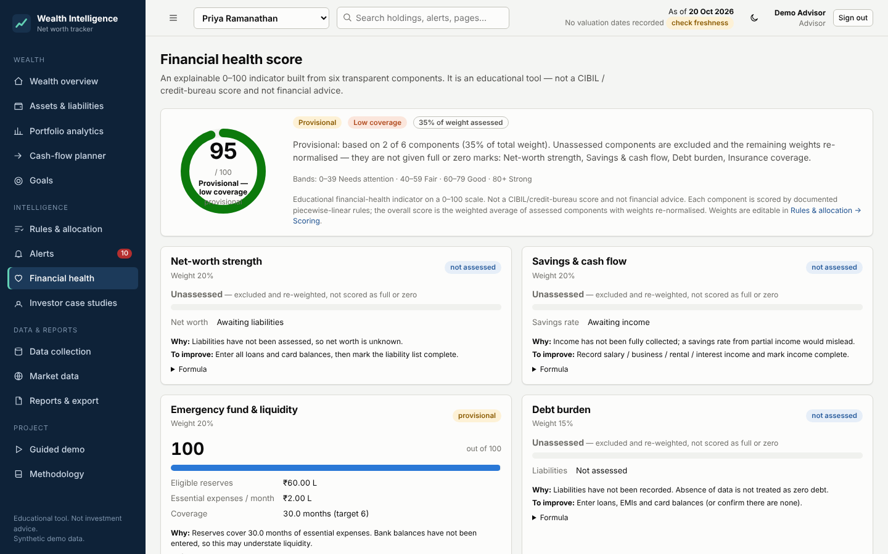
Figure 10. Health score for Priya: 95 on two assessed components, flagged provisional with low coverage

7.8 Goals
Goals store a target amount and date, the amount currently earmarked, planned monthly contribution and an optional return assumption. The page separates actual progress from a projection that uses only the assumption entered (zero by default). It shows the funding gap, the projected shortfall and the monthly amount that would close it. Earmarking is bookkeeping only and does not change net worth.

7.9 Investor case studies
Three profiles are stored as separate clients and compared side by side with charts. They are described in Section 12.
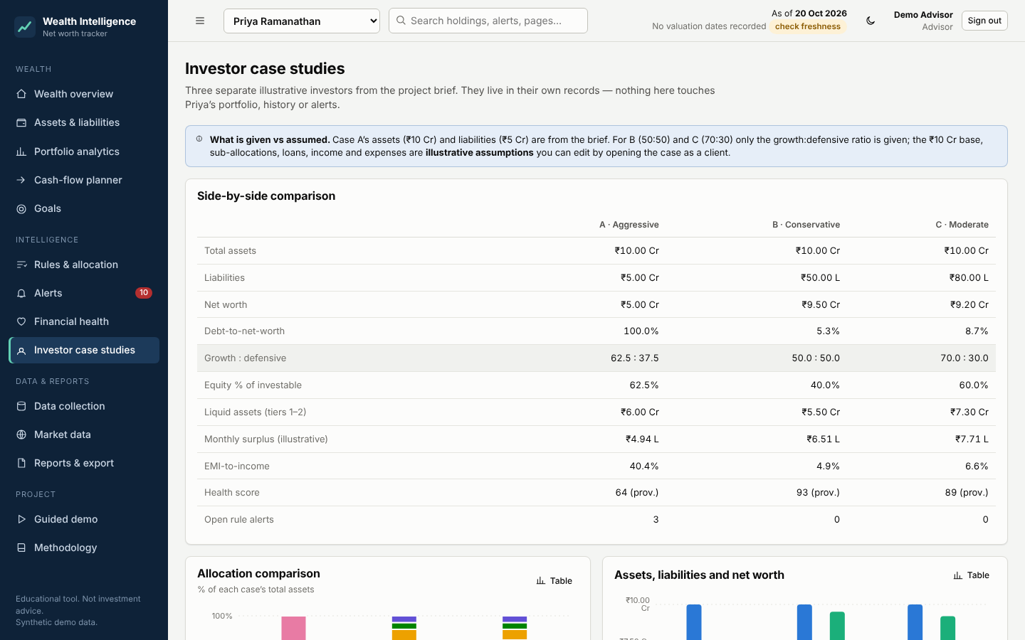
Figure 11. Side-by-side comparison of the three case studies

7.10 Data collection, market data, reports and demo
- Data collection. A checklist of seventeen items with Collected, Pending, Needs Review and Not Applicable statuses; CSV and Excel import with a dry run that reports accepted, rejected, duplicate and unresolved rows; past snapshot entry; a classification review queue; and an editable category mapping table.
- Market data. Shows each provider's honest status, latest observations with source, as-of date and staleness flags. Holdings with a symbol and quantity can be revalued from prices after the user confirms.
- Reports and export. An Excel workbook with nine sheets, seven CSV files and a print-ready report containing the summary, allocation, performance, cash flow, score, alerts, commitments, data-quality notices and methodology.
- Guided demo. Fifteen steps, with progress detected where possible and a reset that restores Priya and the case studies.
- Methodology. In-app documentation of definitions, rules and limitations.
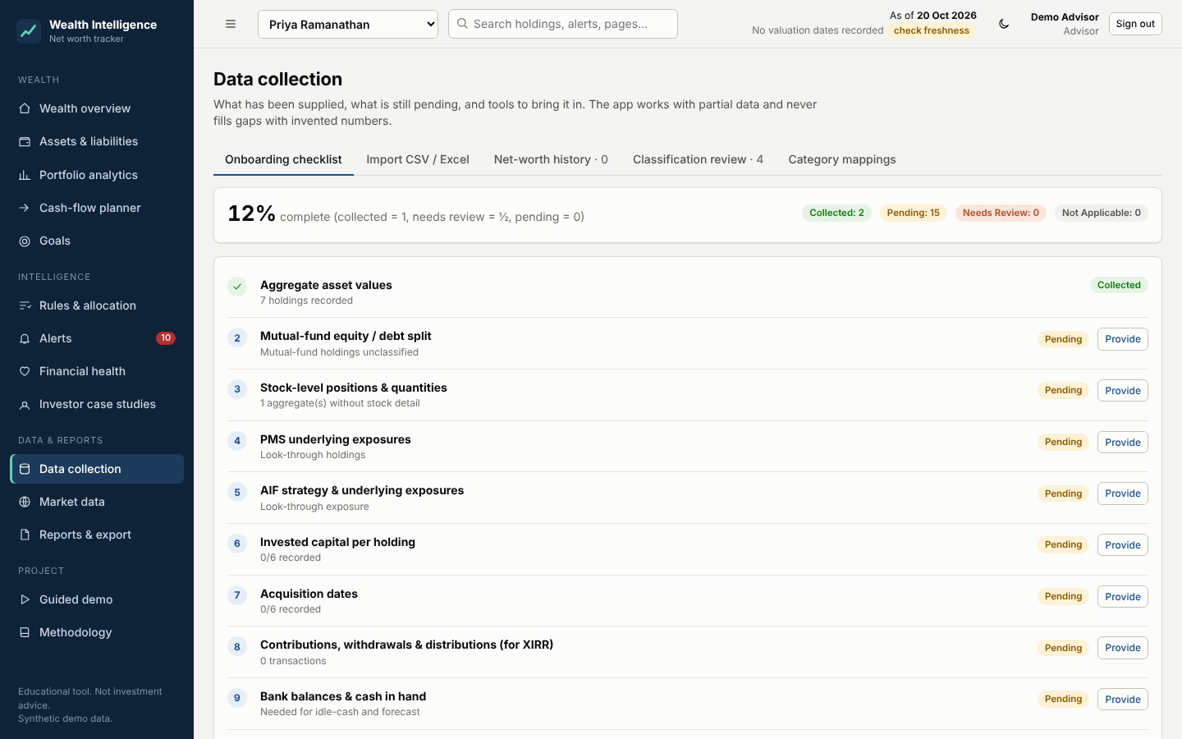
Figure 12. Data collection checklist showing what is still needed

8. Calculation methodology and worked examples
All calculations live in one shared module and are covered by automated tests. Money is stored as integer paise and displayed with Indian digit grouping, with rupee, lakh and crore formats.
Measure | Definition
Gross assets | Sum of current values of unique positions. Aggregates are replaced by underlying records; any unexplained remainder is kept once.
Net worth | Gross assets minus confirmed outstanding liabilities. Withheld while liabilities are not assessed; provisional while partly recorded.
Commitments | Remaining contractual premiums shown separately and in an adjusted net worth. They are not deducted as debt.
Absolute return | (Current value minus invested capital) divided by invested capital, on holdings with cost recorded, with coverage disclosed. Not time-weighted.
XIRR | Rate r solving: sum of cash flow divided by (1+r) to the power (days from first date / 365) equals zero. Uses dated purchases, withdrawals, distributions and today's valuation; otherwise reports insufficient history.
Allocation | Class value divided by the chosen denominator.
Drift | Actual percentage minus target percentage, in percentage points.
Concentration | Stock value divided by the concentration denominator; direct and look-through shown separately.
Debt to net worth | Confirmed debt divided by net worth, only when net worth is positive.
EMI to income | Sum of loan EMIs divided by verified monthly gross income. Credit-card balances are excluded.
Savings rate | (Income minus spending) divided by income; categories marked as saving are excluded from spending.
Emergency cover | Eligible liquid reserves divided by monthly essential expenses, in months.
Net-worth change | Current minus previous, divided by the absolute previous value, using like-for-like snapshots within tolerance; attribution to liabilities, withdrawals and valuation.

Worked example 1: XIRR
An investor puts Rs 1,000 in on 1 Jan 2020, another Rs 1,000 on 1 Jul 2020, and the holding is worth Rs 2,300 on 1 Jan 2021. Outflows are negative and the ending value is positive. The engine solves for the rate that makes the net present value zero and returns 20.21% a year. A simple return would say 15% (Rs 300 on Rs 2,000) and ignore that the second Rs 1,000 was invested for only half the time. A test checks that the net present value at the solved rate is below 0.0001.

Worked example 2: allocation range for unclassified funds
Priya's investable assets are Rs 8.63 Cr minus Rs 2.50 Cr of property, which is Rs 6.13 Cr. Classified equity (direct equity Rs 1.50 Cr plus equity-oriented PMS Rs 0.70 Cr) is Rs 2.20 Cr, or 35.9%. The Rs 1.83 Cr mutual-fund aggregate is unclassified, so if all of it were equity the share would be Rs 4.03 Cr, or 65.7%. Equity is therefore shown as 35.9% to 65.7%. Because the limit is 60% and only the upper bound exceeds it, the rule shows possible, not triggered.

Worked example 3: aggregate reconciliation and a definite alert
A demonstration scheme of Rs 1.5 Cr is added under the mutual-fund aggregate. The aggregate's remainder becomes Rs 33 L, and gross assets stay at Rs 8.63 Cr because nothing is counted twice. Classified equity is now Rs 3.70 Cr, or 60.4% of Rs 6.13 Cr. Even in the best case it exceeds 60%, so the equity rule moves from possible to triggered.

Worked example 4: drift in percentage points
Alternative assets (the Rs 1.30 Cr AIF) are 21.2% of investable assets against a 5% target, a drift of +16.2 points. Commodities are 3.3% against 10%, a drift of -6.7 points. REITs are 0% against 5%, a drift of exactly -5.0 points. With a strict 5-point tolerance that is not a breach. Percentages are rounded to nine decimals before comparison, so a value exactly at a limit is not pushed over by floating-point noise.

Worked example 5: EMI to income
Case A has three loans with illustrative terms (business Rs 2 Cr at 10.5% over 120 months, home Rs 2 Cr at 8.5% over 240 months, vehicle or personal Rs 1 Cr at 12% over 96 months). Their EMIs total Rs 6.06 L a month against an assumed verified income of Rs 15 L, giving 40.4%, which is above the 40% default, so the rule triggers.

Worked example 6: health-score weighting
For Priya only two components can be assessed: emergency fund (100, weight 20) and diversification (about 88, weight 15). The overall score is (100 x 20 + 88 x 15) divided by 35, about 95. Because only 35% of the total weight was assessed, the score is labelled provisional and low coverage and is not given a band.

Worked example 7: monthly equivalent of an annual receipt
Priya's annual pension of Rs 5,00,000 is shown as Rs 41,666.67 a month for analysis only. In the dated forecast it stays an annual receipt, and because its payment date is unknown it is listed as unscheduled.

Numerical reliability
A test caught floating-point noise on the first run (55 percent computed as 55.00000000000001, which wrongly exceeded a 5-point tolerance). The fix is to round ratios to nine decimals, and it is covered by the drift and concentration tests.

9. Rules and alert lifecycle
Every rule has a name, description, editable value, unit, enable switch, severity, calculation, trigger and recommended response, and records when it was last evaluated. Thresholds can be changed in the interface and take effect immediately.

Core rules from the brief
Rule | Default | Trigger
Equity allocation | 60% | Equity share above the limit; shown as possible if only the upper bound exceeds it
Single-stock concentration | 10% | Any single stock above the limit; aggregates give a data notice
Debt allocation floor | 20% | Debt share below the minimum (strict or inclusive)
Net worth falls | 5% | Fall versus a comparable snapshot; skipped when no comparable snapshot exists
EMI to income | 40% | EMI ratio above the limit; missing income gives a data notice, never a number
Portfolio drift | 5 pp | Any asset class outside its band
Idle cash | 10% / Rs 5 L / 30 days | Cash above the emergency reserve and 90-day outflows, held long enough
Maturity or renewal | 60 days | FD, bond or policy date within the window or overdue

Additional rules
Credit-card balance (Rs 1 L), debt-to-net-worth (50%), negative monthly cash flow, emergency fund below target (6 months), pension premium due (30 days), missing valuation dates, unclassified holdings, stale data (45 days), goal funding shortfall and health-score deterioration (10 points).

Evaluation outcomes
State | Meaning
Triggered | The limit is breached even in the best case for the unresolved data
Possible | The limit may be breached depending on holdings that are not yet classified
Awaiting data | The rule cannot run; a data notice explains what is missing
OK | Within the limit
Disabled | Switched off by the user; open alerts for it are resolved

Alert lifecycle
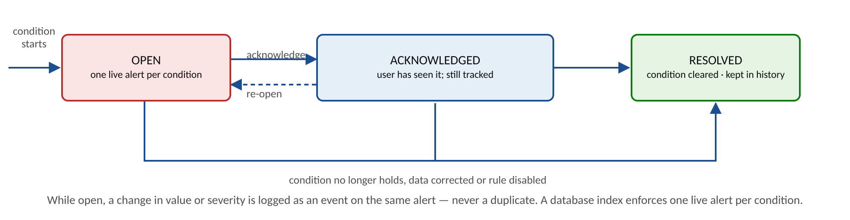
Figure 13. Alert lifecycle: one live alert per condition, with a history of events
Severity is critical, high, warning or notice. A possible breach is capped at warning, and a data notice is informational. A database index makes duplicate live alerts impossible, and tests confirm that repeated refreshes do not create new rows.

10. Classification and look-through
The classification engine is deterministic. It applies the first matching step and records which one. Every record retains its original description, the resulting category, the method used and a status of confirmed, provisional or needs review.
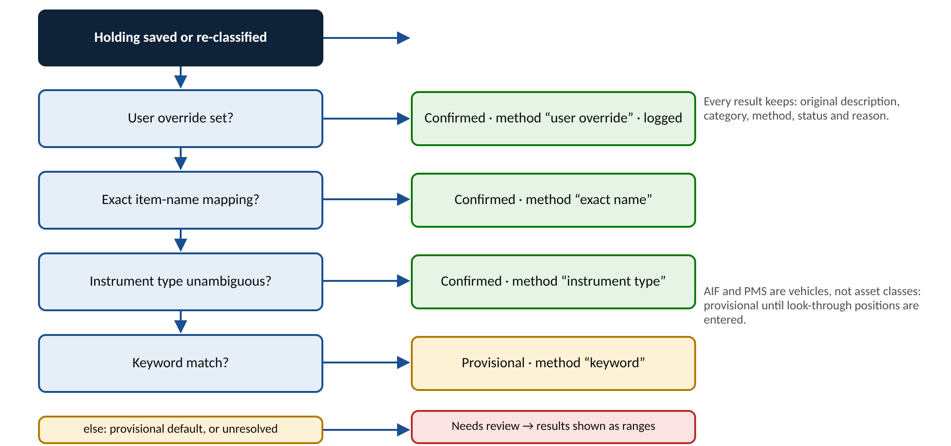
Figure 14. Classification order and the result recorded at each step
Instrument | Default treatment
Stocks, equity funds, SIFs, equity-oriented PMS | Indian equity (provisional until geography and look-through are entered)
Fixed deposits, bonds, debt funds, cash and bank balances | Debt and fixed income
Gold, commodity funds | Commodities
Residential and commercial property | Direct real estate (excluded from investable denominators)
REITs and InvITs | Listed real assets
AIFs and unlisted equity | Alternative assets (provisional); an AIF is a vehicle, not an asset class
Mutual-fund aggregate, hybrid funds, ETFs | Needs review until the equity and debt split is entered

When underlying positions are entered they replace the aggregate in every total. The page keeps the difference as an unallocated remainder and asks for explicit confirmation if the underlying positions exceed the aggregate. Income categories map to salary, business and variable income; expense categories map to fixed, variable and business expenses, as described in the brief.

11. Priya Ramanathan: starting position
Priya is loaded with exactly the figures in the brief. Nothing else is assumed, which is why several metrics read Awaiting data.
Asset | Value (Rs) | Treatment
Residential property | 2.50 crore | Direct real estate; illiquid
Gold | 20 lakh | Commodities; form assumed physical, noted on the record
Fixed deposits | 60 lakh | Debt; emergency-eligible; maturity dates pending
Mutual-fund holdings | 1.83 crore | Needs review; equity and debt split not supplied
Direct equity holdings | 1.50 crore | Indian equity (provisional); stock list pending
PMS portfolio | 70 lakh | Indian equity (provisional); look-through pending
AIF holdings | 1.30 crore | Alternative assets (provisional); exposures pending
Total gross assets | 8.63 crore | Reconciles to the brief

Obligations and cash flow
- Pension plan: Rs 1 crore total commitment, Rs 80 lakh paid, Rs 20 lakh remaining, treated as a future contractual outflow with no payment schedule yet.
- Annual pension receivable Rs 5 lakh, shown at Rs 41,666.67 a month for analysis only while keeping its annual schedule.
- Household and medical expenses of Rs 1 lakh each per month: Rs 2 lakh monthly and Rs 24 lakh annually.

What the application concludes
Metric | Result | Why
Net worth | Awaiting data | Liabilities not assessed; Rs 8.63 crore shown only as an upper bound
Equity (investable) | 35.9% to 65.7% | Mutual-fund split unknown, so the 60% rule reads possible
Debt (investable) | 9.8% to 39.6% | Same reason; the 20% floor reads possible
Alternatives | 21.2% vs 5% target | Definite drift of +16.2 points (provisional classification)
Commodities | 3.3% vs 10% target | Definite drift of -6.7 points
Emergency cover | 30 months | FDs Rs 60 L over Rs 2 L a month; provisional as no bank balance entered
Health score | Provisional | Two of six components assessable (35% of weight)
Data completeness | 12% | Most onboarding items still pending

Demonstration sequence
Adding a demonstration scheme moves classified equity above 60%, so the equity rule changes from possible to a definite alert. Raising the threshold in the rules page resolves that alert immediately, and the history keeps the record. Recording a demonstration home loan switches net worth from Awaiting data to a provisional figure. Reset restores the original state without touching other clients.

12. Investor case studies
Three profiles are stored as separate clients and never mix with Priya's records. Only the figures in the brief are treated as given. Everything else is an illustrative assumption, marked as such and editable by opening the case as a client.
 | Case A: aggressive | Case B: conservative | Case C: moderate
Basis in the brief | Assets Rs 10 Cr; liabilities Rs 5 Cr | 50:50 growth to defensive | 70:30 growth to defensive
Assets | Equity 5, debt 2, real estate 2, commodities 1 (Rs Cr) | Rs 10 Cr financial portfolio (assumed) | Rs 10 Cr financial portfolio (assumed)
Liabilities | Business 2, home 2, vehicle or personal 1 (Rs Cr) | Rs 50 L home loan (assumed) | Rs 80 L home loan (assumed)
Net worth | Rs 5.00 Cr | Rs 9.50 Cr | Rs 9.20 Cr
Debt to net worth | 100% | 5.3% | 8.7%
Equity of investable | 62.5% | 40.0% | 60.0%
Rule alerts open | 3: equity, debt to net worth, EMI | 0 | 0
Health score | 64 (provisional) | 93 (provisional) | 89 (provisional)

Growth is defined as Indian and global equity, REITs and InvITs and alternatives. Defensive is debt and commodities. Direct real estate is excluded from the split. The grouping is editable. Figures are as computed by the application on 20 October 2026 from the illustrative assumptions, so changing an assumption changes the results.

13. Requirements traceability matrix
The matrix links each requirement from the brief to its implementation, location and verification. Items from the two reference images could not be checked because the images were not available; those rows follow the written brief.
Requirement | Implementation | Where | Verified by
Gross assets Rs 8.63 Cr | Unique-position sum with aggregate handling | Overview | Priya reconciliation test
No invented liabilities, income, balances or history | Fixture contains none; checks assert it | Data collection | Priya tests
Net worth withheld until liabilities assessed | Liabilities status; upper bound shown | Overview, assets | Net-worth tests, browser test
Pension commitment shown separately | Commitment record; adjusted net worth | Assets, overview | Priya and net-worth tests
Automatic classification with override and review queue | Ordered engine; logged override | Assets, data collection | Classification tests, API test
No double counting of aggregates | Parent-child reconciliation | Assets | Aggregate tests, API test
Rule: equity above 60% | Range-aware evaluation | Alerts, rules | Threshold tests; browser test
Rule: single stock above 10% | Direct and look-through | Portfolio, alerts | Concentration tests
Rule: debt below 20% | Strict and inclusive | Alerts, rules | Debt tests
Rule: net worth falls over 5% | Comparable snapshots; attribution | Alerts, overview | Net-worth decline tests
Rule: EMI to income | Verified income; cards excluded | Alerts, cases | EMI tests
Rule: drift above 5 points | Percentage points; band per class | Rules, portfolio | Drift tests
Rule: idle cash | Reserve and duration logic | Alerts | Idle-cash tests
Rule: maturity approaching | Lead-time window; overdue | Alerts | Maturity tests
Absolute return and XIRR | Coverage-aware; dated flows only | Overview, portfolio | Return and XIRR tests
12-month forecast with dated items | Occurrence generator; unscheduled list | Cash-flow | Forecast tests
Explainable health score | Six components; editable weights | Health | Score tests
Target allocation and rebalancing | Plan with liquidity guard; simulator | Rules | Rebalancing tests
Three isolated case studies | Separate clients; illustrative flags | Cases | Case tests; reset test
Market-data architecture | Provider interface; validation; labels | Market data | Market and API tests
Import and export | Dry run, duplicates, safe CSV | Data collection, reports | Import and export tests
Persistence | SQLite with migrations | All pages | Durability test
Authentication and roles | Sessions; server-enforced read-only | Sign-in | Auth tests
Demo and reset | Guided steps; flagged fixtures | Demo | Reset test; browser test

14. Testing and evaluation
The test suite has 171 tests across four files plus a 28-check browser walkthrough. The type check and production build pass.
Area | Coverage
Financial calculations | Gross assets, aggregates versus underlying, liabilities, net worth, absolute return, XIRR (exact, intermediate flows, negative, six invalid cases), allocation, drift, concentration, ratios, savings rate, emergency cover, forecast placement, goals
Rules | Each core rule below, at and above its threshold; missing data; disabled; changed threshold; resolved; inclusive comparison
API and persistence | Authentication, read-only role, CSRF, validation, alert history without duplicates, import dry run and duplicate blocking, export, demo reset, durability across database reopen
Market data | AMFI parser, observation validation, manual CSV, provider failure handling
Browser | Login, KPI drill-down, adding a scheme, alert acknowledge, threshold change, liability and net-worth recalculation, validation errors, every page, reset, phone width

Selected test cases
Test | Input | Expected | Result
Equity at the limit | Equity exactly 60% of investable | Rule OK (strict comparison) | Pass
Equity above the limit | 60.01% | Rule triggered | Pass
Drift exactly at tolerance | 55% against 50%, band 5 | Within band; breach if inclusive | Pass
Net worth fall boundary | -4.9%, -5.0%, -5.1% | OK, OK, triggered | Pass
Different liability basis | Snapshot taken when liabilities were incomplete | Not comparable; no alert | Pass
Aggregate is not one stock | Direct equity aggregate of Rs 1.5 Cr | Data notice, not a breach | Pass
Underlying exceeds aggregate | Children larger than parent | Flagged; confirm to update | Pass
XIRR invalid inputs | One flow; same-date flows; bad date; NaN | Clear failure reason | Pass
Duplicate alert prevention | Refresh state repeatedly | One live alert per condition | Pass
Viewer role | Viewer attempts a change | Refused (403) by the server | Pass
Missing CSRF header | Change without header | Refused (403) | Pass
CSV formula injection | Name beginning with = | Exported with a leading apostrophe | Pass
Duplicate import | Same file twice | Second import blocked | Pass
Demo reset isolation | Reset with a user-created client present | User client untouched | Pass
Persistence | Close and reopen the database | Data and alert history present | Pass

Evaluation against the brief
Each item in the brief's definition of done was checked against evidence: the application launches; core pages are connected to persistent data; Priya reconciles to the supplied figures; required metrics are shown or marked unavailable; every brief alert is implemented and tested; allocation and rebalancing respond to edits; the score is transparent; case studies are isolated; forms, tables, charts and navigation work in a real browser; and missing data is handled honestly. Not done: verification against the original workbook and images, live market data, an automated accessibility audit and user testing.

15. Security and threat model
Area | Implementation
Passwords and sessions | Salted scrypt hashes; opaque session tokens stored hashed; 12-hour expiry; login throttling; generic error for unknown users
Cookies and CSRF | HttpOnly, SameSite Strict; custom header required on all changes
Authorisation | Viewer role is read-only and enforced on the server
Input and output | zod validation on every entity; prepared SQL statements; strict content security policy; formula-injection-safe CSV export
Logging and audit | Structured logs without bodies or secrets; audit trail of create, update, archive, override, import, export and reset
Backup | SQLite file copy or online backup; documented in the security notes

Threat model (STRIDE)
Threat | Example | Mitigation | Residual risk
Spoofing | Guessing a password or reusing a session | Hashing, throttling, expiry, HttpOnly cookie | No multi-factor authentication
Tampering | Cross-site request changing data | SameSite Strict and CSRF header; validation | Low
Repudiation | Denying a change | Audit events with user and before/after | Audit table is editable by a database administrator
Information disclosure | Another user reading a client | Authentication; reports scoped to a client | Single-tenant: all users see all clients
Denial of service | Flood of requests or huge uploads | Body size limits; login throttle | No global rate limit
Elevation of privilege | Viewer calling a change endpoint | Server-side role check on every change route | Low

This is not production-ready. It is single-tenant, uses demonstration credentials, has no multi-factor authentication, no encryption at rest and no automated backups.

16. Market-data integrations
The application handles data you enter in real time: every change is saved and everything is recalculated at once. It does not stream market prices, and it has no bank or broker connection.
Provider | Covers | Status | To make live
Demo data | NIFTY 500, S&P 500, USD/INR, sample funds, REIT, InvIT, G-Sec | Working; labelled sample | Not applicable
Manual CSV | Any symbol | Working | Upload symbol, date, value
AMFI NAV file | Indian mutual funds | Implemented; parser tested; live endpoint not verified | Run with internet; set scheme code and units on holdings
NSE | NIFTY 500, REITs, InvITs, bonds | Adapter slot; licensed data | Set NSE_DATA_API_KEY and implement the vendor call
S&P 500 | S&P 500 | Adapter slot; licensed data | Set SP500_DATA_API_KEY and implement the vendor call

Behaviour guarantees
- Values are validated: positive, not future-dated, and no jump above 50% from the previous value.
- A failed refresh keeps the previous valid value and records the error.
- Requests are rate limited and cached.
- Every value shows its source, as-of date and staleness; simulated data is never presented as live.
- Manual valuations are protected from automatic overwrite; foreign holdings need a USD/INR observation.

17. Advantages

For clients
- A single honest picture of wealth, including what is not yet known.
- Early warning on concentration, allocation drift, idle cash, EMI burden and approaching maturities.
- Clear visibility of contractual commitments without mistaking them for debt.
- A forecast that shows when money actually leaves and arrives.

For advisors
- Repeatable rules instead of ad hoc spreadsheet checks.
- A scenario simulator to test a proposal and show its effect on every metric before anything is done.
- Rebalancing options that respect liquidity, lock-ins and the client's own limits, with reasons.
- Reports that state their methodology and data gaps.

For faculty evaluators and the project
- Every figure is traceable to a documented formula and a test.
- The brief's requirements are mapped to features in a traceability matrix.
- A guided, resettable demonstration with deliberate failure paths such as missing data and invalid input.
- Honest labelling of what is live, simulated or unverified.
Benefit | How it is delivered
Fewer silent errors | Validation, exact arithmetic and missing-data states
Faster review | Alerts with reasons, affected records and actions in one inbox
Auditability | Audit events with before and after values for each change
Lower risk of false comfort | Ranges and provisional labels when classification is incomplete
Portability | Excel and CSV export; CSV and Excel import
Low setup cost | One Node package, SQLite, no external services needed

18. Limitations
- Input files. The Excel workbook and both reference images named in the brief were not available when the application was built. Rules follow the written brief, and any thresholds beyond it, such as the 40% EMI limit, are editable assumptions.
- Market data. No live provider has been verified. Prices change only when a user refreshes or applies them.
- Tenancy and security. Single-tenant with demonstration accounts; no multi-factor authentication or automated backups.
- Scope. No document attachments, no tax or exit-load modelling, and no bank or broker integration.
- Reporting. PDF output uses the browser's Print and Save as PDF.
- Evaluation. No user study or automated accessibility audit has been run. The usability review in Section 5 is the author's own.
- Domain defaults. Liquidity tiers, score bands and the diversification formula are reasoned assumptions that a finance professional should validate.

19. Future work: path to a SaaS product
The prototype's calculation engine is already separate from storage and interface, which suits a multi-tenant service. The roadmap below summarises the work needed. Timelines are planning estimates.
Phase | Goal | Main work
0: Foundation (weeks 0 to 6) | Safe for real data | Check against the workbook; Postgres; tenant isolation; MFA and password reset; CI/CD; accessibility audit; penetration test
1: Private beta (weeks 6 to 16) | 5 to 10 advisors using real data | Scheduled AMFI refresh; licensed index and bond data; statement import; documents; notifications; immutable audit log; DPDP consent and deletion
2: Paid launch (months 4 to 8) | First revenue | Advisor console; tax and exit-load modelling; loan schedules; time-weighted returns; billing; support
3: Scale (months 8 to 18) | Differentiate | Account Aggregator; Monte-Carlo goals; public API; mobile app; SOC 2 readiness

Target architecture: shared database with a tenant identifier and row-level security, the pure engine kept as a library, a background worker and queue for price refresh, alerts and reports, object storage for documents, and full observability. Pricing would follow client count in tiers for solo advisors, small firms and enterprises, to be tested with design partners. The main risks are regulatory classification of recommendations, data-vendor cost and licensing, and trust after any data error.

20. How to run the application
Install Node.js 22.13 or newer. Unzip the delivered package, open a terminal in the folder and run:
cd networth-tracker
npm install
npm start
Open http://127.0.0.1:8787. The first start creates the database, applies migrations, seeds Priya and the three case studies and prints the demonstration accounts.
Role | Email | Password | Access
Advisor | advisor@demo.local | Demo@2026-Advisor | Read and write
Viewer | viewer@demo.local | Demo@2026-Viewer | Read only

Other commands: npm run dev (hot reload at http://localhost:5173), npm test (171 tests), npm run typecheck, npm run build and npm run test:e2e (browser walkthrough against a running server).

Troubleshooting
- An error mentioning node:sqlite means Node is older than 22.13.
- If port 8787 is busy, start with PORT=9000 npm start and open that port.
- To start fresh, stop the server, delete data/networth.db and the matching WAL files, then start again.

Appendix A: Glossary
Term | Meaning
AIF | Alternative investment fund; a pooled private vehicle, treated here as a vehicle not an asset class
PMS | Portfolio management service; a managed account of securities
XIRR | Annualised return on irregularly dated cash flows
Drift | Actual allocation minus target, in percentage points
Denominator | The base that percentages are measured against: gross, investable, or investments excluding property and cash
Look-through | Counting the securities inside a fund or PMS instead of the fund itself
Provisional | A result that depends on data not yet supplied or confirmed
Paise | One hundredth of a rupee; the unit in which all amounts are stored
EMI | Equated monthly instalment on a loan
Commitment | A future contractual payment, such as remaining pension premiums, which is not debt today

Appendix B: Repository structure
Path | Contents
src/shared | Pure engine: money, classification, portfolio, XIRR, net worth, cash flow, rules, score, rebalancing, goals, fixtures
src/server | API, authentication, repository, alerts, import and export, market adapters, seed
src/web | Interface: pages, charts, forms, design system
migrations | SQL schema migrations applied in order
tests | Engine, Priya baseline, API and market tests
scripts | Development launcher and browser walkthrough
docs | Audit and traceability, architecture, market data, security, acceptance report

