CONTENTS

Chapter Number. | Name | Page No.
1. | Introduction | 3
2. | Objectives | 5
3. | Tools/Environment Used | 7
4. | Analysis Document | 25
5. | SRS  - E-R diagrams  - Data flow diagrams  - Data dictionary | 38
6. | Testing | 52
7. | Input and Output Screens | 63
8. | Implementation of Security for the Software developed | 68
9. | Conclusion | 71
10. | Future Application of the Project | 73
11. | Bibliography | 75
Signature:

CHAPTER 1
INTRODUCTION

Introduction

The Online Job Portal can be entered using a username and password. It is accessible by an administrator. Only they can add data into the database. The data can be retrieved easily. The interface is very user-friendly. The data are well protected for personal use and makes the data processing very fast. Hence, there is a need of reformation of the system with more advantages and flexibility. The Online Job Portal eliminates most of the limitations of the existing software. It has the following objectives:
• Enhancement:
The main objective of Online Job Portal is to enhance and upgrade the existing system by increasing its efficiency and effectiveness. The software improves the working methods by replacing the existing manual system with the computer-based system.
• Automation:
The Online Job Portal automates each and every activity of the manual system and increases its throughput. Thus the response time of the system is very less and it works very fast.
• Accuracy:
The Online Job Portal provides the uses a quick response with very accurate information regarding the users etc. Any details or system in an accurate manner, as and when required.
• User-Friendly:
The software Online Job Portal has a very user-friendly interface. Thus the users will feel very easy to work on it. The software provides accuracy along with a pleasant interface.Make the present manual system more interactive, speedy and user friendly.

• Availability:
The transaction reports of the system can be retried as and when required. Thus, there is no delay in the availability of any information, whatever needed, can be captured very quickly and easily.
• Maintance Cost:
Reduce the cost of maintenance.

CHAPTER 2
OBJECTIVES
Objective

The main objective of this project is to make Online Job Portal system easy. The system should have a provision for the administrator to accept/reject the request by the candidate. This process will make Secret Online Job Portal system . Person who is working we only give command to design his work this will reduce the human effort and make the system fast.
BRIEF ANALYSIS: After strategizing, I gathered specific information, analyzed the specific requirements of the Online Job Portal and then produce a set of clear cut functional requirements that the system must address. This stage focuses largely on filling in the details for the system element. Information gathered are analyzed and systematically dealt in detail by using DFD.
Other Objectives
- User friendly interface.
- A central database holds the key to system.
- All forms are html templates driven
- Integration among all functional areas.
- The availability of the information is easy.
- Routine tasks are easily performed.
- It automates the redundant tasks.
- It will save time and money.
- In summary we can say that main objective of the project is to make the work easy and smooth.
- It will provide the better customer service and enhance the profit of the organization.

CHAPTER-3

Tools/Environment Used

PROJECT CATEGORY
ABOUT PHP:-

PHP: Hypertext Preprocessor is a widely used, general-purpose scripting language that was originally designed for web development to produce dynamic web pages. For this purpose, PHP code is embedded into the HTML source document and interpreted by a web server with a PHP processor module, which generates the web page document. As a general-purpose programming language, PHP code is processed by an interpreter application in command-line mode performing desired operating system operations and producing program output on its standard output channel. It may also function as a graphical application. PHP is available as a processor for most modern web servers and as a standalone interpreter on most operating systems and computing platforms.
PHP was originally created by Rasmus Lerdorf in 1995 and has been in continuous development ever since. The main implementation of PHP is now produced by the PHP Group and serves as the de facto standard for PHP as there is no formal specification. PHP is free software released under the PHP License.
PHP is a general-purpose scripting language that is especially suited to server-side web development where PHP generally runs on a web server. Any PHP code in a requested file is executed by the PHP runtime, usually to create dynamic web page content. It can also be used for command-line scripting and client-side GUI applications. PHP can be deployed on most web servers, many operating systems and platforms, and can be used with many relational database management systems. It is available free of charge, and the PHP Group provides the complete source code for users to build, customize and extend for their own use.
PHP primarily acts as a filter, taking input from a file or stream containing text and/or PHP instructions and outputs another stream of data; most commonly the output will be HTML. Since PHP 4, the PHP parser compiles input to produce byte code for processing by the Zend Engine, giving improved performance over its interpreter predecessor.
Originally designed to create dynamic web pages, PHP now focuses mainly on server-side scripting, and it is similar to other server-side scripting languages that provide dynamic content from a web server to a client.
The LAMP architecture has become popular in the web industry as a way of deploying web applications. PHP is commonly used as the P in this bundle alongside Linux, Apache and My SQL.. WAMP packages (Windows/ Apache/ MySQL / PHP) and MAMP packages (Macintosh / Apache / MySQL / PHP) are also available.
As of April 2007, over 20 million Internet domains had web services hosted on servers with PHP installed and mod_php was recorded as the most popular Apache HTTP Server module.

Significant website are written in PHP including the user-facing portion of Facebook.

ADVANTAGES OF PHP:-
•Open Source, readily available (you can be using it today) and dual-
licensed - if you are doing non-profit work or not licensing, there is no cost.
•Very Easy to understand Syntax, some really cool features (arrays
are something else!)
• Interfaces very easily with Apache/MySQL
• Server side .
• Lots of good source code out there to use and/or learn from, as well
as many useful libraries for working with PDFs, graphics, etc.
• Lots of good books and on-line help (php.net is great)
• Platform agnostic, can run on Windows Linux or Mac servers. Also
very scalable.
• Lots of hosting services have it ready to use, no special
configuration (except if you have special security needs)
• Pretty easy to access other web-based tools through PHP (i.e. google
maps, etc

HOW PHP WORKS.

* Profile of problem:-
Problems with conventional system
1. Lack of immediate retrievals: -The information is very difficult to retrieve
and to find particular information like- E.g. - To find out about the patient’s
history, the user has to go through various registers. This results in inconvenience
and wastage of time.
2. Lack of immediate information storage: - The information generated by
various transactions takes time and efforts to be stored at right place.
3. Lack of prompt updating: - Various changes to information like patient
details or immunization details of child are difficult to make as paper work is
involved.
4. Error prone manual calculation: - Manual calculations are error prone and
take a lot of time this may result in incorrect information. For example
calculation of patient’s bill based on various treatments.
5. Preparation of accurate and prompt reports: - This becomes a difficult
task as information is difficult to collect from various registers.

Introduction to HTML

The hypertext markup language (HTML) is a simple markup language. Used to create a hypertext documents that are portable from one platform to another HTML documents are SGML (Standard generalized mark up language) documents with generic semantics that are appropriate for representing information from a wide range of applications. This specification defines HTML version 3.2. HTML 3.2 aims to capture recommended practice as of early ’96 and as such a replacement for HTML2.0 (RFC 1866).
A set of instructions embedded in a document is called mark up language. These instructions describe what the document text means and how it should look like in a dPaper Less Hospitallay. Hyper Text Mark Up language (HTML) is the language used to encode World Wide Web documents.

WHY TO USE HTML?

Website is a collection of pages, publications, and documents that reside on web server. While these pages publications and a document as a formatted in a single format, you should use HTML for home page and all primary pages in the site. This will enable the millions of web users can easily access and to take advantage of your website.
HTML is considered first for formatting any new material you plan to publish on the web. HTML documents are platform independent, meaning that they don’t confirm to any standard. If they are created properly you can move home page to any server platform or you can access them with any complaint www browser.
STRUCTURE OF HTML
HTML elements perform a defined task. HTML uses two types of elements

. Empty Tags
. Container Tags
These tags differ because of what they represent. Empty tags represent formatting constricts such as line breaks and horizontal rules. Container tags define a section of text, formats and dot all of the selected text. A container tag has both a beginning and an ending.

HTML LAYOUT:
An HTML document consists of text, which comprises the content of the document and tags, which, defines the structure, and appearance of the document. The structure of an HTML document is simple, consists of outer.

<HTML>tag enclosing the document header and body
<HTML>
<HEAD>
<TITLE>the title of HTML document</TITLE>
</HEAD>
<BODY>
This is where the actual HTML documents
Text lies, which is dPaper Less Hospitallayed in the browser
</BODY>
</HTML>

Each document has a head and body delimited by the <HEAD> and <BODY> tag. The head is where you give your HTML document a title and where you indicate other parameters the browser may use when dPaper Less Hospitallaying the document. This includes the text for Paper Less Hospitallaying the text. Tag also references special and indicates the hot spots that link your document to other documents.

HTML FORMS:

Creating a form usually involves two independent steps: Creating the layout for the form itself and then writing a script program on the server side to process the formation you get back from a form.

To create a form, You use the <FORM> tag. Inside the opening and closing FORM tags are each of the individual form elements plus any other HTML content to create a layout for that form.

The opening tag of the FORM element usually includes the attributes: METHOD and ACTION. The METHOD attributes can be either GET or POST which determines how your form data is sent to the script to process it.

The ACTION attribute is a pointer to the script that processes the form on the server side. The ACTION can be included by a relative path or by a full URL to a script on your server or somewhere else. For example, the following <FORM> tag would call a script called form-name in cgi-bin directory on server www.myservser.com

<FORM Method= post action=http://www.mytservser.com/cgi-bin/form-name.pl>
……………….
</FORM>

METHOD ATTRIBUTE:

The other required attribute for the <form> tag sets the methods by which the browser form’s data to the server for processing. There are two ways: the POST method and GET method. With POST method, the browser sends the data in two steps: the browser first contacts the form-processing server specified in the action attributes, and once contact is made, sends the data.

The GET method in the other hand, contacts the form processing server and sends the form data in a single transaction step: the browser appends the data to the form’s action URL, separated by the question mark (?) character.

Introduction to JavaScript

JavaScript:

JavaScript is a new scripting language for WebPages. Scripts written with java script can be embedded into your HTML pages. With java script you have many possibilities for enhancing your HTML page with interesting elements. For example you are able to respond to user-initiated events quite easily. Some effects that are now possible with java script were some time ago only possible with CGI. So you can create really sophisticated pages with the helps of java script on the Internet.

Difference between java and Java Script
Although the names are almost the same Java is not the same as Java Script. These are two different techniques for Internet programming. Java Paper Less Hospitalrogramming language. JavaScript is a scripting language as the name implies. The difference is that we can create real programs with java. But java script in not real programming. Java Script is meant to be easy to understand and easy to use. JavaScript authors should not have to care too much about programming. We could say that Java Script is rather an extension to HTML than a separate computer language. Of course this is not the official definition but it makes it easier to understand the difference between java and java script.

How can Java Script scripts run?
The first browser to support java script was the Netscape Navigator 2.0 of course the higher versions do have java script as well. You might know that java does not run on all Netscape Navigators 2.0 (or higher versions) versions. But this is not true for java script -although there are some problems with the different versions.
The Mac version for example seems to have many bugs. In the near future there are going to be some other browsers, which support java script. The Microsoft Internet explorer 3.0 is going to support java script. JavaScript enabled browsers are going to spread soon - it is worth learning this new technique now. You might realize that is really easy to write Java Script scripts. We have to know is some basic techniques and some work-around for problems you might encounter. Of course we need a basic. Understanding HTML before reading this tutorial you can find many really good online resources about HTML. Best you make an online search about ‘html’ at yahoo if you want to get informed about HTML. Now I want to show some small scripts so you can learn how they are implemented into HTML-documents and to show which possibilities you have with the new scripting language. The following is a very small script, which will only print a text into an HTML document.

<html>
<head>
My first JavaScript
</head>
<body><br>
This is a normal HTML document
<br>
<script language=”JavaScript”>
Document.write (“this is a java script”)
</script><b r>
Backing HTML again
</body>
</html>

If you are using a java script enabled-browser at the moment then you will have the possibility to see this script working. If your browser doesn’t support Java Script then this output might be some kind of strange…
This is a normal HTML document
This is java script!
Back in HTML again.

Functions

Functions are bet declared between the <Head> tag of HTML page. Functions are called by user-initiated events. Seems reasonable to keep the functions between the <Head> tags. They are loaded first before a user can do anything that might call a function. Scripts can be placed between inside comment fields to ensure that older browser do not dPaper Less Hospitallay the script itself.

<html>
<head>
<script language=”JavaScript”>
function pushbutton (){
alert (“Hello!”);
}
</script>
</head>
<body>
<form>
<input type=”button” name=”Button1” value=”push me” onclick=”pushbutton ()”>
</form>
</body></html>

If we want to test this one immediately and you are using a Java Script enabled browser then please go ahead and push the button.
This script will create a button and when you press it a window will pop up saying “hello!”. In fact we have a lot of possibilities just by adding functions to our scripts. The common browsers transmit the form information by either method: here’s the complete tag including the GET transmission method attribute for the previous form
Example
<Form method =GET action=http://www.mycompany.com/cgi-bin/upfdate.pl>……</form>

Input elements.

Use the <input> tag to define any one of a number of common form elements including text fields multiple choice lists click able images and submission buttons. There are many attributers for this tag only that types and name attributes are required for each element, each type of input element uses only a subset of the followed attributes. Additional <input> attributes may be required based upon which type of the form element you specify.

Submit button:
The submit button (<input type=submit> ) does what its name implies, settings in motion the form’s submission to the server from the browser. We many have more than submit buttons will be added to the parameter list the browser sends along to the server.

Example
< Input type =”submit”>
<Input type=”submit” value=”submit” name=”name”>
Reset button:
The reset button if firm <input> button is nearly self- explanatory; it lets the user reset erase or set to some default value all elements in the form. By default the browser dPaper Less Hospitallays a reset button worth the label “reset”. We can change that by specifying a value attribute with tour own button label.

INTRODUCTION TO JDBC

JDBC (Java Database connectivity) is a front-end tool for connecting to a server to ODBC in that respect, however JDBC can connect only java client and it uses ODBC for the connectivity. JDBC is essentially a low-level API since any data manipulation, storage and retrieval has to be done by the program itself. Some tools, which provide a higher-level abstraction, are expected shortly.
The next question that needs to be answered is why we need JDBC, once we have ODBC on hand. We can use the same ODBC to connect the entire database and ODBC is a proven technology.
Problem for doing this is ODBC gives a ‘c’ language API, which uses pointers extensively. Since java does not have any pointes and is object-oriented sun Microsystems, inventor of java developed to suit its needs.

Requirements to use JDBC:
To use JDBC you need a basic knowledge of databases and SQL.A part from this you need the jdk1.1 (Java Development Kit1.1 available javasoft’s website) or a version of Java since jdk1.1 and above come bundled with JDBC software.
After that you need to have a back-end database engine for which a JDBC driver is available. When JDBC drivers are not available JDBC-ODBC bridge drivers are used to access the database through ODBC. Back-end is not needed when JDBC driver is capable of storing and retrieving the data itself, or if JDBC-ODBC Bridge and the ODBC driver can be used to store and retrieve the information.

Introduction To MySql

Modern relational database management systems can perform a wide range of tasks. It has got the following advantages-
  - Define a database
  - Query the database
  - Add, edit and delete data.
  - Modify the structure of the database
  - Secure data from public access.
  - Communicate within networks
  - Export and import data
MySql is one such RDBMS. It provides a set of functional programs that we use a tool to build structure and performs tasks, in mysql data is stored and displayed in tables. A table is a data structure that holds data in a relational database. A table comprises of rows and columns. Table can also show relationship between entities. The formal name of table is relation, hence the name Relational Database Management System.

Access of data in mysql
SQL is a structured query language that we use to communicate with mysql. It consists of a set of English words like Select, Create etc. The standard set of SQL command fall into the following category-
  - Queries using select clause
  - Data definition language (DLL) commands which are for creating and altering the structure of database.

Salient Features of MySql
  - Open Source
  - Efficient multi-user support and consistency
  - Powerful security feature
  - Fault tolerance
  - Ease of administration
  - Application development tools
  - Networking
  - SQL compatibility

About SQL
SQL is a structured query language that we use to communicate with oracle. It consists of a set of English words like Select, Create etc. The standard set of SQL command fall into the following category-

Chapter-3

Tools / Platform, Hardware and Software
Requirement specifications

HARDWARE SPECIFICATION

VIRTUAL MEMORY
PROCESSOR : 64 BIT, i5

RAM : 4 GB
HARD DISK : 1 TB
MONITOR : BuiltIn Display
(1366 * 768 RESOLUTION)
CLOCK SPEED : 1033 MHz

SOFTWARE SPECIFICATION

OPERATING SYSTEM : Windows 10
FRONT END : PHP
BACK END : MySql

CHAPTER-4

Analysis Document

SYSTEM ANALYSIS
PRELIMINARY INVESTIGATION
Things are expected to get even more critical since the company’s growing numbers of clients and related requirements have been projected to demand a massive number of employees in the coming future from the past and the today’s date. Such events and projections have forced a strong need for modification in the current way of handling activities. it is better to implement the latest of it rather than to go through the pain of updating the system over and over again. Also the solution would be developed by in-house developers. Their time have to be managed with their other client dependent schedules.
FEASIBILITY STUDY
Depending on the results of the initial investigation, the survey is expanded to a more detailed feasibility study. Feasibility study is a test of system proposal according to its workability, impact on the organization, ability to meet user needs, and effective use of resources. The objective of the feasibility study is not to solve the problem but to acquire a sense of its scope . During the study, the problem definition is crystallized and aspects of the problem to be included in the system are determined.

Consequently, costs and benefits are described with greater accuracy at this stage. It consists of the following:

Statement of the problem: A carefully worded statement of the problem that led to analysis.

TECHNICAL FEASIBILITY
This involves financial considerations to accommodate technical enhancements. If the budget is a serious constraint, then the project is judged not feasible.

ECONOMICAL FEASIBILITY
With the help of banking application it will lead to decrease in cost of opening and maintaining offices which will be more than the cost of developing and maintaining the Application.
OPERATIONAL FEASIBILITY
This Application is very easy to operate as it is made user friendly. Main consideration is user’s easy access to all the functionality of the Application.

IDENTIFICATION OF NEED
To identify the need for software we use the Principles of Requirement Engineering. Requirement engineering provides the appropriate mechanism for understanding what the customer wants, analyzing need, assessing feasibility, negotiating a reasonable solution, specifying the solution unambiguously, validating the specification and managing the requirement as they are transformed into an operational system. The requirement engineering process can be described in five distinct steps: -
- Requirement elicitation.
- Requirement analysis & negotiation.
- Requirement specification.
- System Modeling.
- Requirement validation.
- Requirement Management.
In other words we can say that requirement analysis is a software task that bridges the gap between system level requirement engineering and software design. Requirement analysis allows the software engineering to refine the software allocation and build models of the data, functional and behavioral domains that will be treated by software. Requirement analysis provides the software designer with a representation of information, function and behavior that can be translated into data, architectural, interface and component level design; finally the requirement specification provides the developer and the customer with the means to assess quality once software is built.
The most commonly used requirement elicitation technique is to conduct a meeting or interview. The first meeting between a software engineer and customer can be likened to the awkwardness of a first date between to adolescents. Neither person knows what to say or ask, Both are worried that what they do say will be misinterpreted, both are thinking about where it might lead (Both likely have radically different expectation here) Both want to get the think over with, but at the same time, both want it to be a success.Here according to this principle the analyst starts by asking context-free-questions. That is a set of question that will lead to a basic understanding of the problem, the people who want a solution, the nature of solution that is desired, and the effectiveness of the first encounter itself. The first set of Context-free question focuses on the customer, the overall goals, and the benefits. For example, the analyst might ask: -
- Who is behind the request for this work?
- Who will use the solution?
- What will be economic benefit of a successful solution?
- Is there another source for the Solution that you need?
The next set of the questions enables the software engineer to gain a better Understanding of the problem and the customer to voice his or her perceptions about a solution: -
- How would you characterize “good” output that would be generated by a successful solution?
- What problem(s) will this solution address?
- Can you show me (or describe) the environment in which the solution will be used?
- Will special performance issues or constraints affect the way of the solution is approached?
- Are you the right person to answer these questions? Are your answers? Official”?
- Are my questions relevant to the problem that you have?
- Am I asking too many questions?
- Can anyone else provide additional information?
- Should I be asking you anything else?
According to the above concepts I went to the various IT companies and met its staffs, management, and some persons related with the organizational work, which advised me related with my project.

Preliminary Investigation
The first step in the system development life cycle is the preliminary investigation to determine the feasibility of the System. The purpose of the preliminary investigation is to evaluate project requests. It is neither a design study nor does it includes the collection of details top describe the business system in all respect. Rather, it is collecting of information that helps committee members to evaluate the merits of the project request and make an informed judgment about the feasibility of the proposed project.
Here for the “TOUR AND TRAVEL”, I have worked on the preliminary investigation that accomplished the following objectives:
- Clarify and understand the project request.
- Determine the size of the project.
- Assess costs and benefits of alternative approaches.
- Determine the technical and operational feasibility of alternative approaches.
Report the findings to management with recommendation outlining the acceptances or rejection of the proposal.
Considering above criteria I also keep in mind that the requirements are clearly understandable when the clarification of project request is enquired. The data of the IT Companies which are collected by me during preliminary investigation, are: -

- Reviewing organization Documents
- Onsite observation and
- Conducting interviews.

Feasibility Study
Not everything imaginable is feasible, not even in software, evanescent as it may appear to outsiders. Feasibility is the determination of whether or not a project is worth doing. On the contrary, software feasibility has seven solid dimensions as below: -
- Technical feasibility.
- Operational feasibility.
- Economic feasibility.
The process followed in making this determination is called a feasibility study. This type of study determines when a project can or should be taken. Once it has been determined that the project is feasible, and then analyst can go ahead and prepare the project specification, which finalizes project requirements. Generally, feasibility studies are undertaken within tight time constraints and normally culminate in a written and oral feasibility report. The contents and recommendation of such a study will be used as a sound basis for deciding whether to proceed, postpone or cancel the project. Thus, since the feasibility study may lead to the commitment of large resources, it becomes necessary that it should be conducted competently and that no fundamental errors of judgment are made.
In other words we can say that a feasibility study is conducted to select the best system that meets performance requirement. This contains and identification description, an evaluation of candidate system and the selection of best system for the job. The system required a statement of constraints; the identification of specific system objective and a description of outputs define performance.

a) Technical Feasibility
Technical feasibility is concerned with specifying equipment and software that will successfully satisfy the user requirements. My project is fit in technical feasibility because it requires neither too much heavy configuration system for its run nor in its development.
b) Economical Feasibility
Economic analysis is the most frequently used technique for evaluation of the effectiveness of a proposed system. More commonly known as Cost/Benefit analysis, the procedure is to determine the benefits and saving that are expected from a proposed system and compare them with costs. If benefits outweigh costs, a decision is taken to design and implement the system. Other weight costs, a decision is taken to design and implement the system. Otherwise, further justification or alternative in the proposed system will have to be made if is to have a chance of being approved. This is an on going effort that improves in accuracy at each phase of the system life cycle.
c) Operational Feasibility
My project is also fit in Operational Feasibility Study. As I have explained before this about Technical Feasibility and Economical Feasibility, this Software is very easy and user-friendly.
I have used a very easy menu system and also used some control buttons in the easy way by which one can choose the options on his desire. Though this is fully protected with the security by word (Password and user name),If both are matched only then one can get access of this software. Various Reports, Forms and Queries can be generated on the fingertips for the user. In nutshell we can say that it has following operational features:

- It is User-Friendly.
- It is having less paperwork.
- Efficient tractability.
- Query can be generated.
Project Planning
The planning, design, and installation of a system termed a project and is directed by a project leader who uses the available resources to produce a new or better system for the organisations.
Thus, project planning for any company has the following four main steps:
1. Organising the resources available for the project.
2. Scheduling the events of the project.
3. Evaluating the progress.
4. Establishing standards for the project.
An effective manager is essential for successful project planning. The techniques of project planning are not a substitute for good management, but merely a tool to be used by managers to achieve better results. Only effective management can complete the project on time, within budget, and with satisfactory results.
Project Scheduling
In project management, a schedule consists of a list of a project's terminal elements with intended start and finish dates. Terminal elements are the lowest element in a schedule, which is not further subdivided. Those items are often estimated in terms of resource requirements, budget and duration, linked by dependencies and scheduled.
The charting techniques are the scheduling tools of the project planner. Even the simplest project should be charted so that progress can be measured. The Gantt chart is effective in simple projects, especially when the interrelationships among events are not too complex. Complicated scheduling usually requires a PERT chart.
A schedule must be flexible because unexpected events may occur that may affect the schedule of development of the system. Seldom do systems projects meet the original schedule at each milestone. This does not imply that schedules are made to be broken, but a schedule cannot be so rigid that when the unexpected occurs, subsequent events cannot be rescheduled.
A schedule has two primary functions, it is both a plan and a device for measuring progress. The key steps in a schedule are called milestones, or checkpoints. As the project progresses, the date on which each milestone is completed is compared with the date for which it was projected. In any project, frequent progress reviews take place in which the status of events is reported and evaluated.
When a project is behind schedule, corrective steps must be taken. Establishing milestones is meaningless unless the project manager can enforce adherence to schedule. Enforcement is a normal managerial duty. If a project leader cannot enforce a schedule, someone else should be leading the project. The following are variety of options that are open to the project leader:
• Increase the budget.
• Increase manpower in the form of overtime or additional people.
• Add equipment.
• Change priorities.
• Replace the individual responsible.

GANTT CHART OF THE ACTIVITY
A Gantt chart is a type of bar chart, developed by Henry Gantt, that illustrates a project schedule. Gantt charts illustrate the start and finish dates of the terminal elements and summary elements of a project. Terminal elements and summary elements comprise the work breakdown structure of the project. Some Gantt charts also show the dependency (i.e., precedence network) relationships between activities.

Gantt charts are useful tools for planning and scheduling projects.
Gantt charts allow you to assess how long a project should take.
- Gantt charts lay out the order in which tasks need to be carried out.
- Gantt charts help manage the dependencies between tasks.
- Gantt charts determine the resources needed.
- Gantt charts are useful tools when a project is under way.
- Gantt charts monitor progress. You can immediately see what should have been achieved at a point in time.
- Gantt charts allow you to see how remedial action may bring the project back on course.

TASKS | Apr 1’st & 2’nd  Week | Apr3’rd & 4’th  Week | May 1’st  & 2’nd  Week | Jun 3’rd-July 1’st  Week | July 2’nd &  Augt 3’rd  Week | Aug 4’rd & Sept 1’st  Week | Sept 1’st  & Sept 3’rd  Week | Sept  3’rd & 4’th  Week | Sept  4’th  Week
  Problem  Analysis | Day  1-12  12 Days

Analysis of  Existing  Systems  like the proposed on |  | Day  13-22  10 Days
Selection & Learning the S/W  To be used |  |  | Days  23-32  10 Days
Understanding  Database |  |  |  | Days  33-47  15 Days
Coding |  |  |  |  | Days 48-62  15 days
Page Designing |  |  |  |  |  | Days  63-72  10 days
Testing |  |  |  |  |  |  | Days  73-82  10 Days
Evaluation |  |  |  |  |  |  |  | Days-83-92  10 Days
Implemetation |  |  |  |  |  |  |  |  | Days  93-98  6 Days

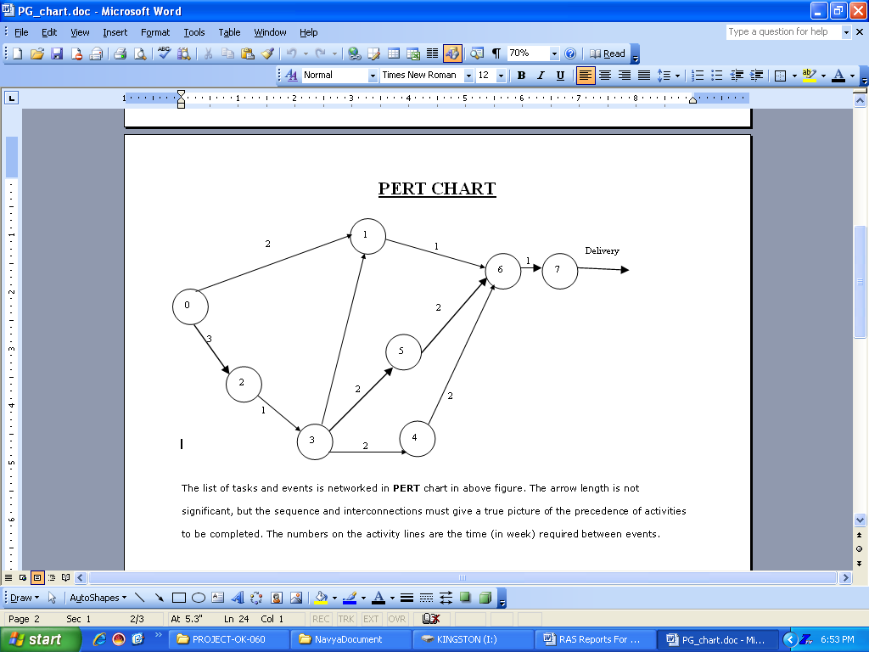
The list of tasks and events is networked in PERT chart in above figure. The arrow length is not significant, but the sequence and interconnections must give a true picture of the precedence of activities to be completed. The numbers on the activity lines are the time (in week) required between events.
Duration (in weeks) 2 + 3 + 1 + 2 + 2+ 2 + 2 + 1+1 = 16 weeks
The critical path is the longest path through the network. No. task on the critical path can be held up without delaying the start of the next tasks and, ultimately, the completion of the project. So the critical path determines the project completion date.

CHAPTER:5
SOFTWARE REQUIREMENTS SPECIFICATION

SRS is software requirement specification it contains the s/w requirement details like what is front-end technology, backend technology, os and hardware architecture of the project.
SRS stands for Software Requirement Specification. It establishes the basis for agreement between customers and contractors or suppliers on what the software product is expected to do, as well as what it is not expected to do.
Some of the features of SRS are –
• It sets permits a rigorous assessment of requirements before design can begin.
• It sets the basis for software design, test, deployment, training etc. It also sets pre-requisite for a good design though it is not enough.
• It sets basis for software enhancement and maintenance.
• It sets Basis for Project plans like Scheduling and Estimation.
Thus, SRS should be consistent, correct, unambiguous & complete, document. The developer of the system can prepare SRS after detailed communication with the customer. An SRS clearly defines the following:
• External Interfaces of the system: They identify the information which is to flow ‘from and to’ to the system.
• Functional and non-functional requirements of the system. They stand for the finding of run time requirements.
• Design constraints:

The SRS outline is :
1. Introduction
1.1 Purpose
1.2 Scope
1.3 Definitions, acronyms, and abbreviations
1.4 References
1.5 Overview
2. Overall description
2.1 Product perspective
2.2 Product functions
2.3 User characteristics
2.4 Constraints
2.5 Assumptions and dependencies
3. Specific requirements
3.1 External Interfaces
3.2 Functional requirements
3.3 Performance requirements
3.4 Logical Database requirements
3.5 Design Constraints
3.6 Software system attributes
3.7 Organising the specific requirements
3.8 Additional Comments
4. Supporting information
2.1 Table of contents and index
2.2 Appendixes

The requirements gathering process is intensified and focused specifically on software. To understand the nature of the program(s) to be built, the software engineer (“analyst”) must understand the information domain for the software, as well as required function, behavior, performance, and interface. Requirements for both the system and the software are documented and reviewed with the customer.
DESIGN
Software design is actually a multi step process that focuses on four distinct attributes of a program data structure, software architecture, interface representations, and procedural (algorithmic) detail. The design process translates requirements into a representation of the software that can be accessed for quality before coding begins. Like requirements, the design is documented and becomes part of the software configuration.

Code Generation: -
The design must be translated into a machine-readable form. The code generation step performs this task. If design is performed in a detailed manner, code generation can be accomplished mechanistically.
Testing: -
Once code has been generated, program testing begins. The testing process focuses on the logical internals of the software, ensuring that all statements have been tested and on the functional externals, that is, conducting tests to uncover errors and ensure that defined input will product actual results that agree with required results.
Waterfall Model
It is the simplest, oldest and most widely used process model. In this model, each phase of the life cycle is completed before the start of a new phase. It is actually the first engineering approach of software development.
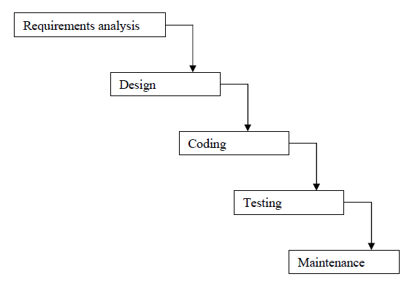
The waterfall model provides a systematic and sequential approach to software development and is better than the build and fix approach. But, in this model, complete requirements should be available at the time of commencement of the project, but in actual practice, the requirements keep on originating during different phases. The water fall model can accommodate the new requirements only in maintenance phase. Moreover, it does not incorporate any kind of risk assessment. In waterfall model, a working model of software is not available. Thus, there is no methods to judge the problems of software in between different phases.
A slight modification of the waterfall model is a model with feedback. Once software is developed and is operational, then the feedback to various phases may be given.

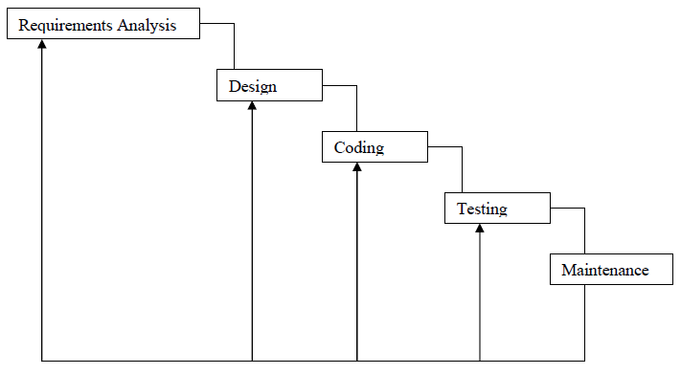

SOFTWARE ENGINEERING PARADIGM
Linear Sequential Model has been used in carrying out this project work. The Linear Sequential Model is the oldest and the most widely used paradigm for Software Engineering. Linear Sequential Model is called sometimes the Classic Life Cycle or the Waterfall Model.
The Linear Sequential Model suggests a systematic, Sequential approach to software development that begins at the system level and progresses through Analysis, Design, Coding, Testing and Support.

Linear Sequential Model contains the following activities:
System / Information Engineering and Modelling: -
Because software is always part of a larger system (or business), work begins by establishing requirements for all system elements and then allocating some subset of these requirements to software. This system view is essential when software must interact with other elements such as hardware, people and database. System engineering and analysis encompass requirements gathering at the system level with a small amount of top-level design and analysis. Information engineering encompasses requirements gathering at the strategic business level and at the business area level.
In this project, very first I get to know how the processing is done in the social network system. When I had accepted this project the purpose is to develop software that should assists to generate the report. The software will serve them as an automated system in performing all the operation of the Online Job Portal.
Before starting this project or system there are some information’s needed, they are:
- First one is that understand about the working mechanism of The social site.
- Find out that which type of functionality should be adopted by the proposed project.
- Which type hardware and software platform will be most suitable for the proposed project?
As the proposal system was being maintained onto the form of paper based, literature relating to this system was available in the forms of various reports. Various documents were available to collect data about the shortcoming of the existing system. The system provides information that how the work is being done and how data are maintained which are useful for the user, what changes need to be made.
- Requirement specification
Problem clarifications in this case are much more difficult. In either case, before any further steps can be taken, the project requests must be clearly states.
This phase (initial study) involves estimating whether or not a development project is worthwhile. Problems with the current automated or manual system are identified, as well as the benefits and costs of an alternative system. If the benefits seem to outright the costs (especially when compared with competing projects), a green signal may be given to continue the project, and detailed plans and schedules are drafted for making the system a reality.
The proposed solution to the user’s problem may involve something between dramatic change (completely new system) and slight change to the present system. If the present system is manual and a computer system is proposed, the development project will probably be very large.

DATA FLOW DIAGRAM

The Data flow diagram can be explained as the separate levels indicating the individual complexity in the each level of the system and gives a detailed explanation in the further levels that are following them.
LEVEL 0
Initially in the first level of the Data flow the level 0 explains the basic outline of the system. The end-user sends the packets to the system to determine the source and destination address. The diagram marked as the 0 represents the complete Packet watching system which simply represents the basic operation that is being performed by it in the initial level.
LEVEL 1
The level 1 of the Data flow diagram given explains in detail about the Packet watching system which was marked as 0 in the previous level. In this level the end-user who passes the request for the system enters into the first process, the capturing process and then to the processing module. After processing the packets it was send for storing.
LEVEL 2
The level 2 provides the clear explanation about the whole system. In this level first we have to select the packet and perform test over that selected packets. Then identify the end address of the packet and send that packet for processing. After processing the packet it was send to the identity content. Then send the processed packet for storing and display the source and destination addresses.

DATA FLOW DIAGRAMS

Context Level DFD

USER

Company

Online Job Portal
REPORT
Administrator
Enters or update users data
Administrate the entire process
Generates the entire processes reports

ITS TRAINING AND PLACEMENT CELL
REPORT
Administrator
Enters or update users data
Administrate the entire process
Generates the entire processes reports
Data Flow Diagram (Level-1)
1.0
Admin Module
2.0
User Module
3.0
Reports Module
Administrator
Info about Admin

Generate reports

Admin login
User Profile

Give permission

User A/c details
Jobs List
Company
Placement
Second level DFD

2nd Level DFD for Admin Module
1.0
Admin Module
Admin login
Administrator

1.1
Data Entry of Jobs

Jobs

1.2
Update Jobs

1.3
Placement

1.4
User Details

User

ER- Diagram

dob
Add
pwd
roll
id
name
company
Discription
id
type
id
Name

User A/c

Company

Jobs

Has
View
create
message
Mess_id

send
message
Admin
name

Login
id
roll
User_login

Search

site
Placement

login
Search Jobs
admin

CHAPTER-6

TESTING

The testing of software means measuring or accessing the software to determine the quality. Testing is a measuring instrument for software quality with the unit of measurement being the number of defects found during testing.
Testing activities also help to achieve software quality. Testing is essential in the development of any system software. Testing is essential in the development of any software system. Testing is in order to access what the system actually does and how well expected to spend approximately40% of development cost and time in testing in order to achieve reasonable quality levels.

Levels of Testing
- Unit Testing
- Component Integration Testing
- System Testing
- Acceptance Testing
Unit Testing
Unit testing comprises the set of tests performed usually by the programmers prior to the integration of the unit in to a large Program. This is the lowest level of testing and is done by the programmer (Who develops it) who can test it in great detail. The function is done in isolation. This is where the most detailed investigation of internal working of the individual unit is carried out.

Component Integration Testing
When two or more tested components are combined into a larger structure, the testing process should look for errors in two ways:-
- In the interface between the components
- The functions, which can be performed by the new group
System Testing
After in integration testing is completed, the entire system is tested as whole. The functional specifications or requirements specification are used to derive the test case. At this level the system testing looks for errors in the end-to-end functional quality. Attributes such as performance, reliability,
Volume, stress tolerance, usability, maintainability, security etc. Independent testers can carry out this testing.
Acceptance Testing
After system testing was complete, the system was handed over to the training section. Acceptance testing mark the transaction from ownership by the develop to ownership by the users. The acceptance test is different in nature to the development testing in three ways.
Firstly, it is a responsibility of the accepting section rather than development department (computer Centre).
Secondly, the purpose of the acceptance testing was to find out whether the software is working rather than trying to find errors.
Thirdly, it also includes the testing of user’s department’s working practices to ensure that the computer software will fit into clerical & administrative procedures of the concerned section well.
Acceptance testing gave confidence to the user that the system is ready for operational use.

Security concern of computer where software is to be installed:
- Use of name-brand hardware with extensive fault-tolerance. Fault-tolerance features can keep the computer from going down even if a single piece of hardware inside of it fails.
- Hardware and software maintenance.
- Facility security, network security, and firewall services.
- Guaranteed service level agreement. Remember to insist on the highest level of service available – 99% availability might seem great, but it means that our computer might be down for than three days a year.
- Battery and generator power.
- Backup devices like tap drive/zip drive or cd writer should install. User should keep backup of database every day so that it could save data during crisis time
Protecting the database
To secure the database, the following steps are taken:-
- The server logged off and physically locked up when it has not use.
- The database must be not shared on network. If it is shared then change the properties.
- The database on oracle provides fine-grained permission mechanism that allows protecting particular database tables and columns. The table and column must be the restricted to administrator of database so that it is not update by the any one.
- Using NTFS (NT file system) security to further access to the database, it is used by using ntfs permission dialog to further protect sensitive information.

Testing objectives
- No bugs blocks the execution of tasks
- System states are visible
- All factors affecting the output are visible
- Functional simplicity
- Distinct output is generated for each input

Debugging
Debugging occurs as a consequence of successful testing. Debugging refers to the process of identifying the cause for defective behavior of a system and addressive that problem. In less complex terms- fixing a bug. When a test case uncovers an
Error, debugging is the process that results in the removal of the error. The debugging process begins with the execution of a test case. The debugging process attempts to match symptoms with cause, thereby leading to error correction. The following are two alternative outcomes of the debugging:
- the cause will be found and necessary action such as correction or removal will be taken.
- The cause will not be found.
Characteristics of bugs
- The symptoms ant the cause may be geographically remote. That is, the symptoms may appear in one part of a program. While the cause may actually be located at a site that is far removed. Highly coupled program structures exacerbate this situation.
- The symptoms may disappear (temporarly) when another error is connected.
- the Symptom may actually be caused by non error(e.g, round-Off inaccuracies).
- The symptoms may be caused by human error that is not easily traced.
- The symptom may be a result of timing problems, rather than processing problems.
- It may be difficult to accurately reproduce input conditions(e.g, a real-time application in which input ordering is indeterminate).
- The symptom may be intermittent. This is particularly common in embedded systems that couple hardware and software inextricably.
- The symptoms may be due to causes that are distributed across a number of tasks running on different processors.

Validation Checks
There are six types of validations:
- Intrinsic control: In this control text Box, label, drop down list are use for simple input and output.
- Rich control: Rich control have a two control `Add Repeater` and ‘Calendar Control’.
- Transfer Control: This control used to redirect pages to next page like, Buttton, Hyperlink, linkButtons.
- Validation control: There are six control:-
  - Required Filled Validator:- this control are using for check the requirement is fulfill or not.
  - Compare Validator:- This control are used for comparing two values with help of controlToValidate and CompareToValidate.
The Type are taken in compare Validator are following:-
- String
- Integer
- Double
- Date
- Currency

Operator is used to specify a type are following:-
- Equal
- No Equal
- Greater Than
- Greater than equal
- Less than
- Less than equal
- RangeValidator:- the range validator is used to check if the value of control lies within a range. The Range can be specified with the help of two control
- Min
- Max
- RegularExpressionValidator:- a pre specified format can excepted only if they form a part of a particular pattern, this usually occurs in Phone no., credit card number or E-mail
Address from user. The phone no. should be numeric. This is made possible by regular Expression Validator Control. The pattern to which the value must specified in validationExpression property. The value can be checked agains mini Pattern or expressions by separating each expressions with a pipe Sign and enclosed expression in round bracket.
- CustomValidator:- custom validator control can be used to provide validator in case all validator control are not enough to validate the input.
- Validation Summary:- validation error message on the Web page can be display in two way. The errors can either be displayed as when the user line the control or summary of error can be display together. This control can be use to produce such as summery. The error can be view in the form of list bullet by setting display made.
CODE EFFICIENCY
MEASURES OF CODE EFFICIENCY
The code is designed with the following characteristics in mind.
- Uniqueness: The code structure must ensure that only one value of the code with a single meaning is correctly applied to a give entity or attribute.
- Expandability: The code structure are designed for in a way that it must allow for growth of it’s set of entities or attributes, thus providing sufficient space for the entry of new items with in each classification.
- Conciseness: The code requires the fewest possible number of positions to include and define each item.
- Uniform size and format: Uniform size and format is highly desirable in mechanized data processing system. The addition of prefixes and suffixes to the root code should not be allowed especially as it is incompatible with the uniqueness requirement.
- Simplicity: The codes are designed in a simple manner to understand and simple to apply.
- Versatility: The code allows modifying easily to reflect necessary changes in conditions, characteristics and relationship of the encoded entities. Such changes must result in a corresponding change in the code or coding structure.
- Sortability: Reports are most valuable for user efficiency when sorted and presented in a predetermined format or order. Although data must be sorted and collaged, the representative code for the date does not need to be in a sortable form if it can be correlated with another code that is sortable.
- Stability: Codes that do not require to be frequently updated also promote use efficiency. Individual code assignments for a given entity should be made with a minimal likelihood of change either in the specific code or in the entire coding structure.
- Meaningfulness: Code is meaningful. Code value should reflect the characteristics of the coded entities, such as mnemonic features unless such a procedures results in inconsistency and inflexibility.

OPTIMIZATION OF CODE
A good program is not the one that solves the intended problem alone but the one that does it efficiently. An ideal compiler should produce target code that is as good as can be written by hand crafted meticulously to run on the target machine in the most efficient manner both in terms of time of execution and memory requirements. The reality however is that this goal is achieved only in limited, cases and that too with difficulty. Nonetheless, the code produced by straight forward compiling algorithms can often be made more space and time efficient. This is accomplished by applying transformations on the produced code. These transformations aiming at optimization of compiled code are known as code optimization and compilers that apply code improving transformations are called optimizing compilers.
The optimization may be machine dependent or machine independent. A machine independent optimization is a set of program transformations that improve the target code without taking into consideration any properties of the target machine. Machine dependent optimizations, such as register allocation and utilization of special machine instruction sequences, on the other hand, depend on the target machine.
The overall performance of a program can be effectively improved if we can identify the frequently executed parts of a program and then make these parts as efficient as much as possible. According to Pareto principle, most programs spend ninety per cent of their execution time in ten percent of the code. While the actual percentages may vary, it is often the case that a small fraction of a program accounts for most of the running time. Profiling the run-time execution of a program on representative input data accurately identifies the heavily traveled regions of a program. Unfortunately, a compiler does not have the benefit of sample input data, so it must make best guess as to where the program hot spots are.
In practice, the program's inner loops are good candidates for improvement. In a language that emphasizes control constructs like while and for statements, the loops may be evident from the syntax of the program; in general, a process called contra/flow analysis identifies loops in the flow graph of a program.
The best technique for deciding what transformations are worthwhile to put into a compiler is to collect statistics about the source programs and evaluate the benefit of a given set of optimizations on a representative sample of real source programs

CHAPTER-7
Input and Output Screens

ABOUT PAGE
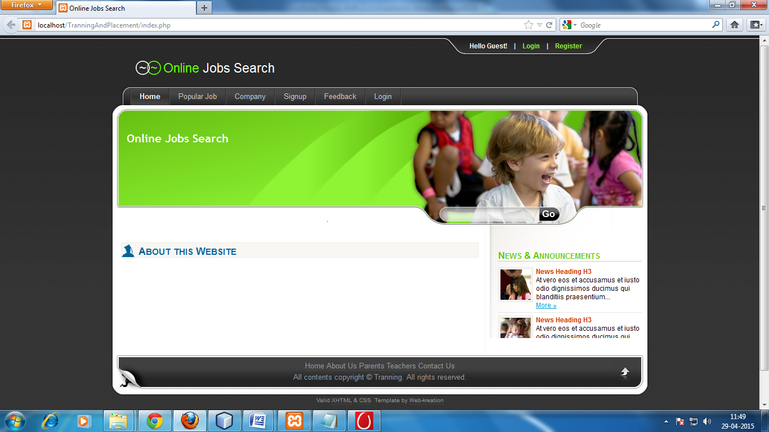

POPULAR JOBS
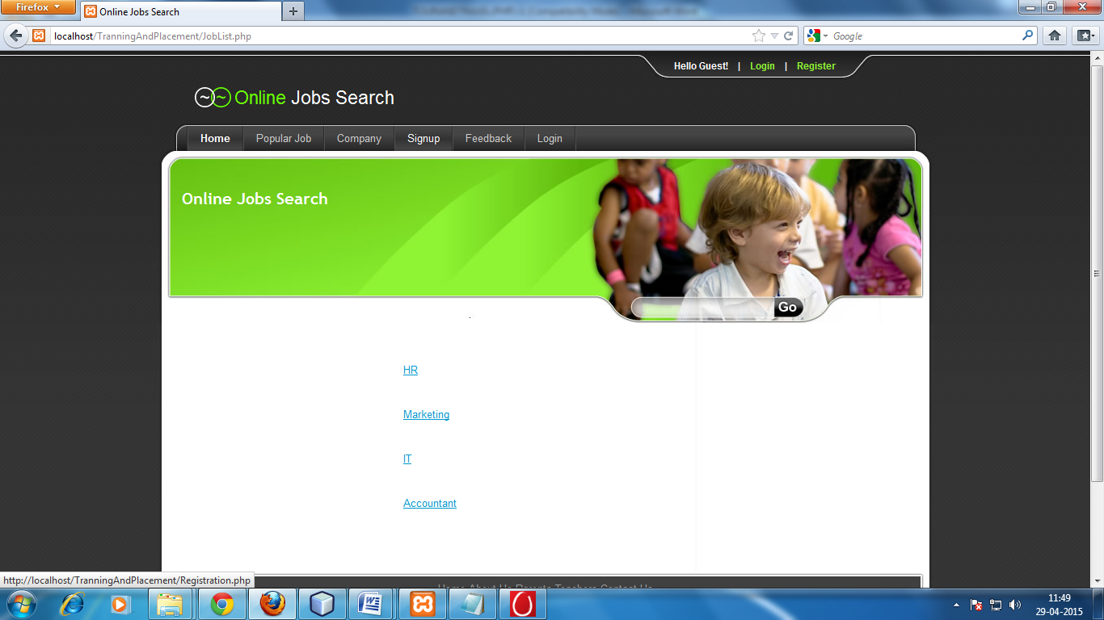

REGISTRATION PAGE
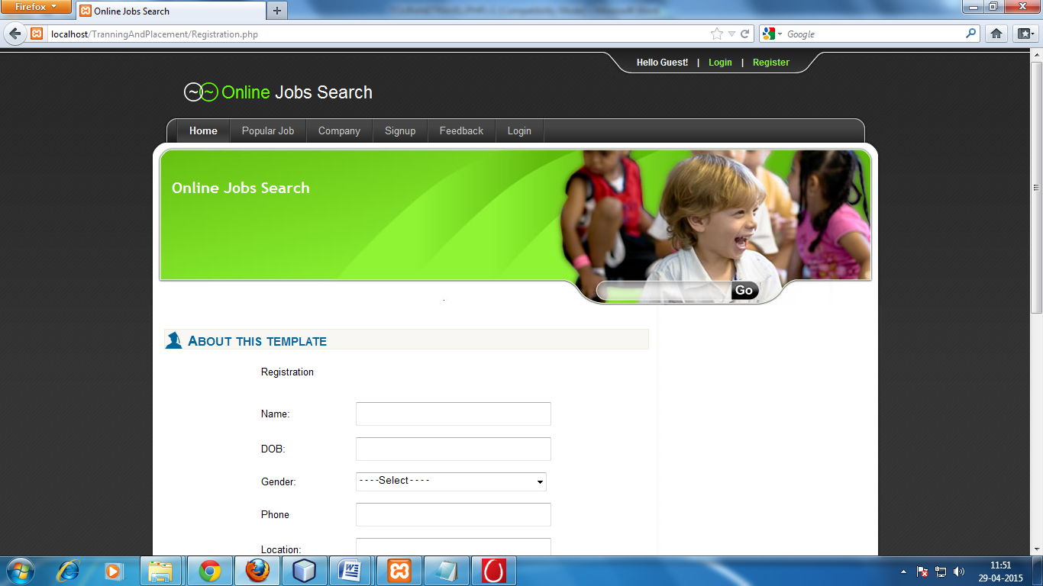

Job list HOME
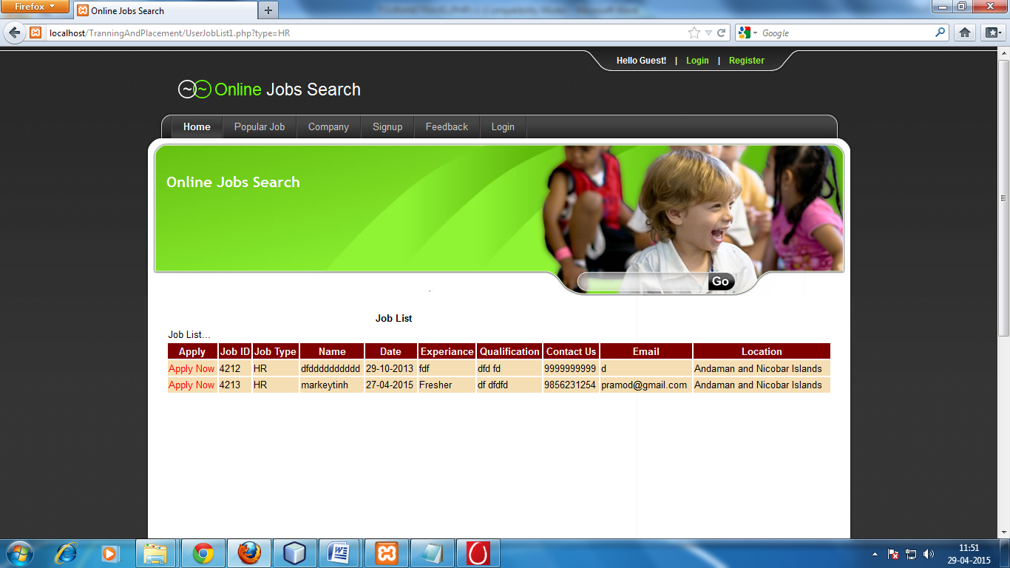

Vacancy list
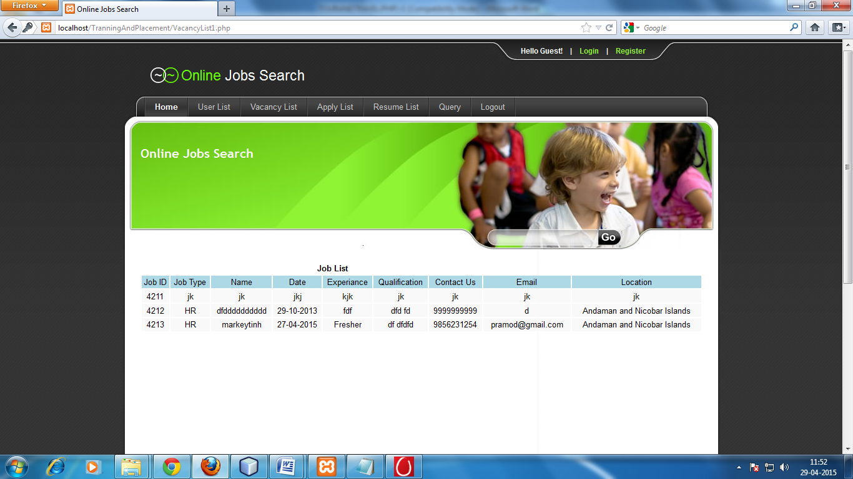

CHAPTER-8
Implementation of Security
for the Software developed

SYSTEM SECURITY MEASURES

To do an adequate job on security, a systems analyst must analyze the risk, exposure

, and costs and specify measures such as passwords and encryption to provide protection. The backup copies of software and recovery restart procedures must be available when needed.

SECURITY AGAINST UNAUTHORIZED ACCESS:

(1) Use of administrator passwords

The password provides security to the administrator of Associates user so that unauthorized user can not access the facility of Associates User.
(2) User related checks and validations: For this
software, The developer uses user related checks and
validations from the user.

(3) User authorization keys: Password checking for logging

of Users.

SECURITY AGAINST DATA LOSS:
- Provision of efficient data backup system : In this software an efficient system is used for adequate backup facility .

- Offline data storage : this system is capable for offline data Storage.

- Multiple database backup : the efficient system is use for this Software to give multiple data backup.

User Level:
User are does not change Health, Transport Information. Its only View Information and it’s allowed after fill own profile and then insert username and password. User is sending Matrimonial information view any other user by allow administrator.

Administrator Level:
Administrator is able to change Health, Transport Information. Administrator is allowing matrimonial information any Change. And also allow user view bride picture and groom picture information.

Chapter 9
Conclusion
The objective of this project was to build a program for maintaining the details of all the members who want to search job online. The system developed is able to meet all the basic requirements. The management of the records will be also benefited by the proposed system, as it will automate the whole procedure, which will reduce the workload. The security of the system is also one of the prime concerns.
There is always a room for improvement in any software, however efficient the system may be. The important thing is that the system should be flexible enough for future modifications. The system has been factored into different modules to make system adapt to the further changes. Every effort has been made to cover all user requirements and make it user friendly.
❑ Goal achieved: The System is able provide the interface to the owner so that he can replicate his desired data. .
❑ User friendliness: Though the most part of the system is supposed to act in the background, efforts have been made to make the foreground interaction with user(owner) as smooth as possible. Also the integration of the existing system with the project has been kept in mind throughout the development phase.

CHAPTER-10
Future Application of the Project

The job portal is for the manage process can be further developed into a separate, automated system with the following enhancements:
- Help file can be included. The system, as of now, does not support any help facility for the users of the system. A help menu can be provided with a special function key and help command in the main page itself. Help can be either introduced as a separate window, a reference to a printed manual or as one or two line suggestion produced in a fixed screen location.
- The system can use typed commands, as they were once the most common mode of communication with the system. The typed command can be provided through control sequence or function keys or typed word.
- A training module can be included in the system. This module can be used to train the users of the system about the systems usage.

CHAPTER-11
Bibliography

- Software Engineering, A Practitioner’s Approach, Pressman McGraw Hill.
- An Introduction To Database Systems by Bipin C Desai
- Object-Oriented Modelling and Design by James Rambagh
- Microsoft SQL Server by NIIT
- Java Complete Reference by Patrick Naughton, Herbert Schildt
- Jdbc Database Access With Java By Graham Amelton

