Tuesday deliveries
The route for Tuesday deliveries is shown below.
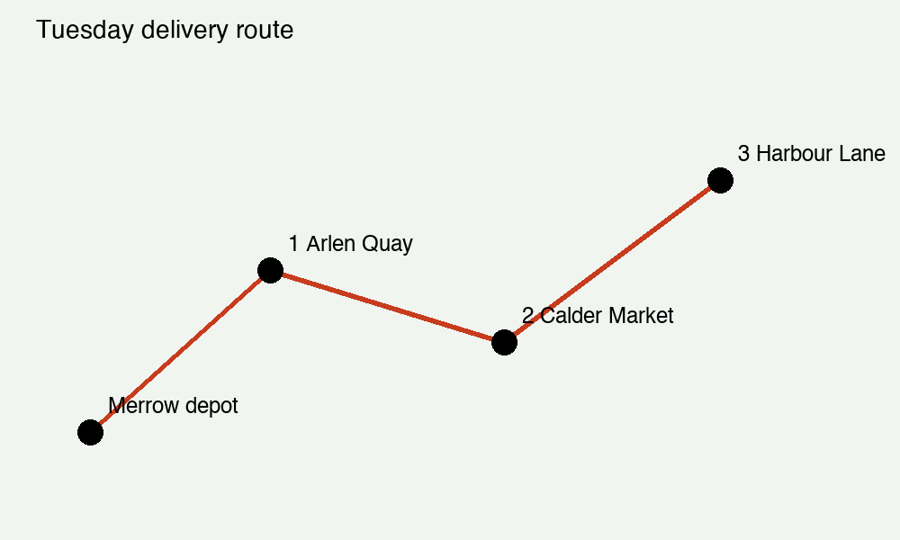
Drivers return to the depot by 17:00.

